Ordino System Documentation

Table of Contents

1. Preface
2. User
   1. Checkout
   2. Return
   3. Contact
3. Administrator
   1. User Authentication & Dashboard
   2. Messaging
   3. Request Approval
   4. Hardware Management
   5. Account Management

Preface

Ordino is a hardware inventory system for Georgia Southern University’s Information Technology Department. Room 2208 is used exclusively for our proof of concept . The goal of Ordino is to help students check out and return the hardware in the IT department when needed while also providing faculty with a meaningful way to manage this process. Ordino is designed to be a simple and clean system for a consistent end user experience.

User

Checkout

The user will first enter the system from the home page. Once the user enters the system, the “Find Hardware” page will appear. In this page, the user is able to filter their search by category, or search for a specific hardware ID, type of hardware, model, or location to best determine if there is hardware available to suit their needs.

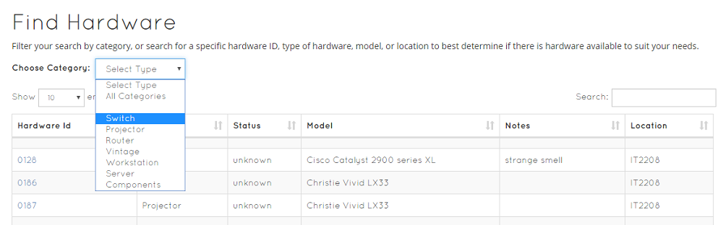

If the user would like to browse by category, they can use the dropdown labeled “Choose Category” and click on the category they want to browse. This will change the table to display only hardware listed under that category. If the user already knows what item they want to checkout, they can type a keyword in the search bar at the top right corner of the table and then find the item they were looking for in the table.

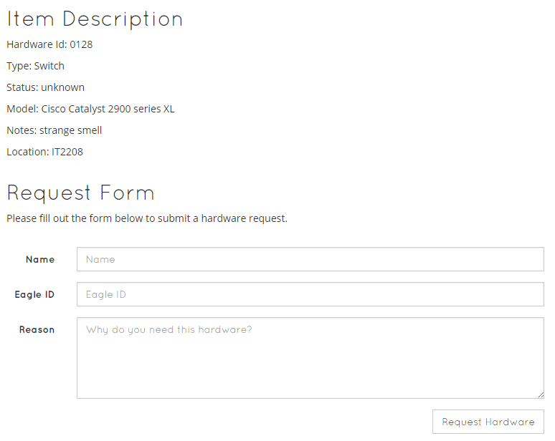

Once the hardware item is known to checkout, click on the hardware ID of the item. This will then lead the user to a “Request Hardware Checkout” page. All the details of that hardware chosen will be available to view on this page. A request form will be at the bottom of the page where the user will type their name, eagle ID, and reason for checkout in the correct fields. Once the request form is filled, the user may submit the form to be sent to the administrator by clicking the ‘Request Hardware’ button at the bottom of the form.

Return

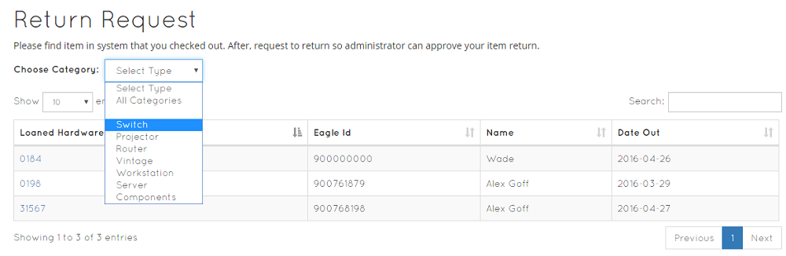

To return hardware, the user will enter the “Return Request” page by clicking the “Returns” link in the navigation at the top of the page. Once entered, there will be a table with a list of hardware that is currently checked out. Please find the hardware that you need to return and click on the “Loaned Hardware ID”. The user can use the “Choose Category” dropdown or the search bar to filter through the tables the same way as the “Checkout” page.

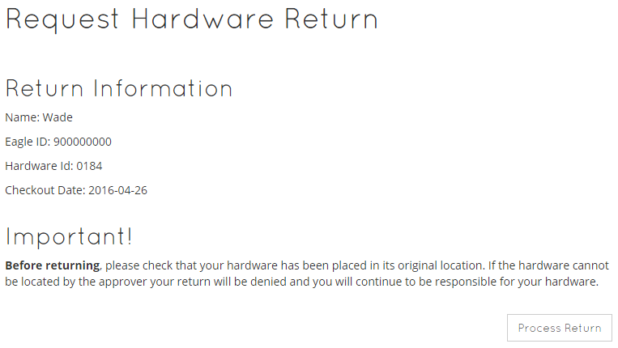

The page will now be entered to the “Request Hardware Return” page. All of the information from the hardware that is clicked will be available to view. Make sure that before returning, to check that the hardware has been placed in its original location. If the hardware cannot be located by the approver, your return will be denied and you will continue to be responsible for your hardware.   
On the bottom, there will be a “Process Return” button. Click the button, and the request of the hardware return will be processed to the administrator.

Contact

To contact our administrators, navigate to the “About” page. The “About” page will have information on how Ordino started, how it works, and a contact form for sending any messages.

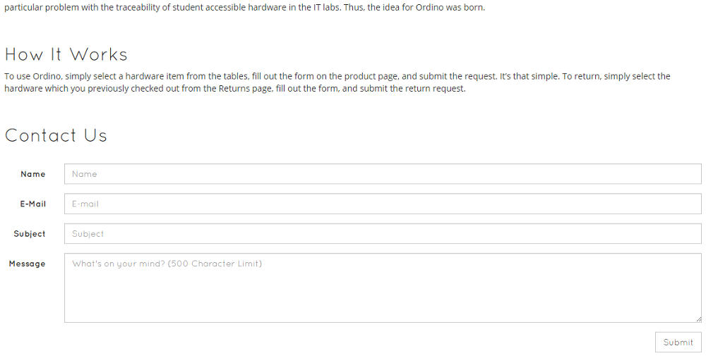  
  
Scroll to the “Contact Us” section. Fill out the form by providing your Name, Email, Subject, and Message. Once the form is filled out, please click the “Submit” button. The message will now be sent to the administrator.

Administrator

User Authentication & Dashboard

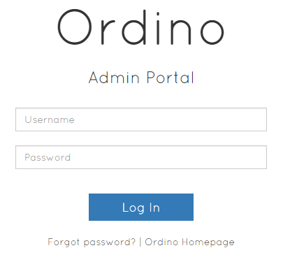

The administration side of Ordino is very simple and straightforward. You are first presented with a login form to enter your credentials. If you forget this information there is a page where you may request a password change.

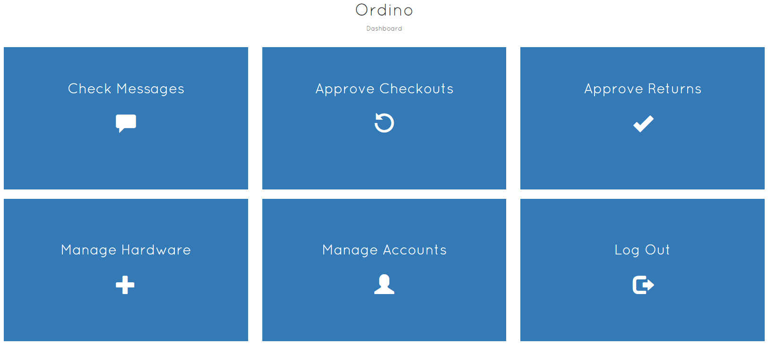

Upon successful login you are presented with 6 tiles. These tiles lead to each module of the administrator portal. Upon navigation to the modules you will have a sidebar with which to continue navigation. This sidebar becomes a drop-down nav if you are on a mobile device. Simply click ‘Ordino’ at the top of the page to trigger the drop-down.

Additionally, you may click ‘Ordino’ at the top of the screen to navigate to the front-end at any time.

Messaging

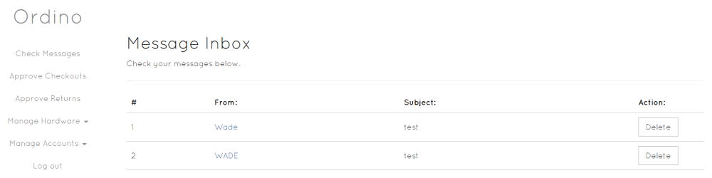

The messaging module is a simple inbox to maintain messages. Any messages from the ‘About Me’ section and any password reset request will be sent here. Simply click on the name of the contact to open their message. Replies are not currently implemented so simply click ‘Delete’ to delete the messages.

Request Approval

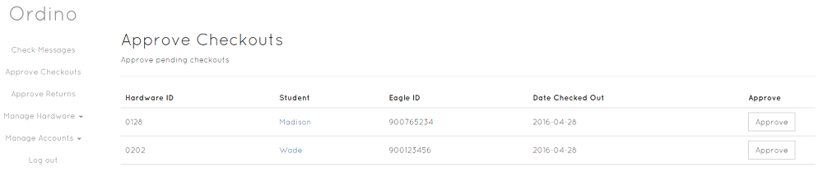

The approval module is split between ‘Checkout’ and ‘Return’ approvals. It operates very similarly to the message inbox. Simply click on an item to view the details. Then click ‘Approve’ to approve the transaction. This will move the hardware to the appropriate table for the front-end user.

Hardware Management

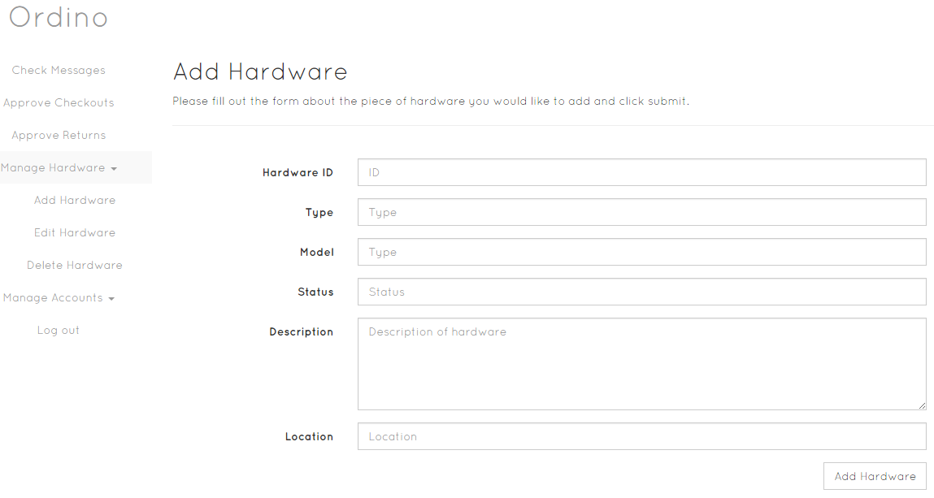

The hardware management module allows the admin to interact with the database. You may add, edit, or delete hardware. For these functions simply enter the information into the appropriate fields and submit. The code is designed in such a way to intelligently determine queries based on input so the admin doesn’t have to worry about blank fields beyond the required information.

Account Management

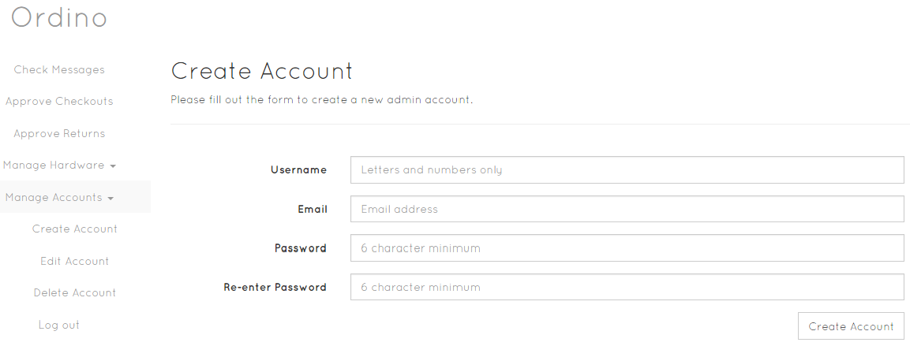

The account management module allows the admin to maintain administrator accounts. You may add, edit, or delete accounts. In the same vein as the hardware module, you simply enter information into the appropriate fields, submit the form, and the code intelligently handles the request.