**Project 4: Neuroimaging of Alzheimer’s Disease**

Shuyao Wang

**Abstract** Github: https://github.com/Ginawsy/ADNI

In this project, I created a high-performance classifier to diagnose the presence of Alzheimer’s disease by comparing it with other traditional machine learning methods including Multinomial Logistic Regression, Linear Discriminant Analysis, and SVM after segmentation of the brain images into grey matter and white matter. The results indicate that all methods leave better recall scores for gray matter images and the pre-trained ResNet50 indicates the best performance for the AD class with a 92.9% recall score and its overall performance works better than Multinomial Logistic Regression, Linear Discriminant Analysis, and SVM. Cohen’s Kappa data also shows that all methods have a higher than 0.7 rate which indicates an agreement between raters. Future studies could consider implementing data argumentation for Multinomial Logistic Regression/ Linear Discriminant Analysis for further exploration of overall performance for the classification.

**Introduction**

Alzheimer's disease is a prevalent form of dementia that usually commences with minor memory loss, eventually leading to impaired conversational skills and the inability to react to one's surroundings. According to recent data, in 2020, a substantial 5.8 million American individuals were afflicted by Alzheimer's disease, and this number is expected to double every 5 years beyond age 65. The cost of managing the disease is expected to soar to between $379 and more than $500 billion annually by 2040. Therefore, it is crucial for us to establish early diagnosis protocols to reduce the expenses of medical and long-term care for families and the U.S. government. Early detection also plays a significant role in preventing the advancement of the disease to a critical stage, and it allows people to take appropriate measures early on, increasing their chances of benefiting from treatment.

The objective of this project is to create a high-performance classifier to determine the presence of Alzheimer’s disease utilizing the MRI image by comparison with different kinds of machine learning methods. To accomplish this goal, I found the Alzheimer's Disease Neuroimaging Initiative (ADNI) dataset from Kaggle, which is a research program focused on the progression of Alzheimer's disease.

**Data Processing**

To process the data, I initially used Google Colab but later transferred it to the group SCF, which applied through the Department of Statistics at UC Berkeley, given the raw file size exceeded 12GB. For the neuroimaging data, I used the preprocessing data by ADNI which was already done with Gradwarp, B1, N3, and scaled.

For the rest of the preprocessing steps for MRI images, I took a reference of methods proposed by Saman et.al in 2023. I first unzipped all the NIFTI files into memory and read them into the ANTs objective which includes the mask to read the image. To maintain consistency across scans, I standardized the voxel spacing to (1.5 mm, 1.5 mm, and 1.5 mm) to ensure that the scans are not distorted and enable easier mapping to the reference template. Afterward, I resized all images to the smallest common dimension of 240 x 256 x 160 and cropped them to eliminate unnecessary black space. After utilizing N4 correction to normalize intensity variation to [0,1], I used the BEaST library to generate a mask and removed extraneous elements such as the skull, scalp, fat, and muscle from the raw images. Then I employed the FSL-VBM library for brain image segmentation, separating the images into grey matter (GM), white matter (WM), and cerebrospinal fluid (CSF). I then employed a linear affine transformation with 6 degrees of freedom to register the GM images to the GM ICBM-152 standard template. The registered brain images were combined, flipped along the x-axis, and subsequently averaged to create a study-specific template as per the standard approach. Finally, I conducted smoothing on the structural MRI data using a range of Gaussian kernels with sigma values of 3 and 4. This step was supported by research indicating that the smoothing process significantly influenced the performance of the modeling.

Fig1. Preprocessing images of Cognitively Normal (CN) Fig2. Preprocessing images of Alzheimer's Disease (AD)

Once the MRI images have been preprocessed, a design matrix is generated, where each image is represented as a row containing approximately 2.2 million columns that correspond to flattened 3D image arrays. The intensity of the images is converted into matrices ranging from 0 to 1, with higher values denoting higher density. Next, the design matrix is subjected to feature selection in order to eliminate columns that represent the black space surrounding the segmented brain. This process reduces the dimensionality to 1.1 million features, which is still a considerable number. Before applying classification methods, I also used PCA for the dimensionality reduction because Neuroimaging datasets contain a large number of features (e.g., voxels or regions of interest), which can lead to the curse of dimensionality. High-dimensional data can be challenging to analyze and can increase the computational complexity of machine learning algorithms. PCA helps address this issue by reducing the dimensionality of the data while retaining most of the information which I achieved by removing near-zero variance columns.

**Data Analysis**

For this project, I tried to use some traditional classification methods such as Multinomial Logistic Regression, Linear Discriminant Analysis, and SVM after doing PCA to compare with a pre-trained ResNet50 model to see their classification accuracy.

Fig3. The loss function of Multinomial Logistic Regression

For the Multinomial Logistic Regression, a balanced weighting was added to the loss function(Fig3) to account for the group imbalance. I also added an elastic net regularization penalty for the model. Since my primary concern is to ensure that all individuals with Alzheimer's are identified, I pay more attention to the outcome of the recall scores. The results have better performance of recall scores for the gray matter with 96.67% for the CN class, 90.24% for the MCI class, and 81.25% for the AD class. For the Linear Discriminant Analysis, I have exactly the same result for gray matter as Multinomial Logistic Regression.

For SVM, I first chose to use the accuracy metric to determine the best kernel. The linear kernel was found to be optimal to use. Then I used SMOTE oversampling to deal with the imbalanced dataset. The result leaves a better performance of recall scores for the gray matter with 72.35% for the CN class, 76.55% for MCI class, and 69.89% for the AD class. Since the results do not look very promising, I also trained a KNN model based on the predictions of the Linear SVM model. The results do not show a great difference for the CN and the MCI class but indicated a significant improvement for the AD class from 69.89% to 84.44%.

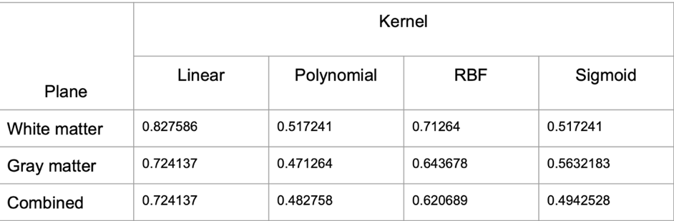

Fig4. Comparison of different kernels for SVM

Fig5. Demonstration of ElasticTransform (left)original image (middle) α=50,σ=5 (right)α=100,σ=5

In addition, I also chose the pre-trained ResNet50 model for the classification of brain images and then fine-tuned the parameters in my task since the ResNet50 model is a well-established model that has been trained on ImageNet. I selected this model because the residual block has proven to be highly effective in addressing the issue of gradient vanishing and improving the model's ability to learn. Furthermore, Resnet has been a state-of-the-art (SOTA) model in numerous image-related tasks in the past according to the literature review.

For the rest of fine-tuning steps, since my images are grayscale instead of the color scale, I specially fine-tuned the early layers of the network to capture low-level features that may be affected by a distribution shift and unfrozen the first convolutional block. Additionally, I normalize the images using the mean and standard deviation of the grayscale images in the training set, deviating from the conventional approach of using statistics from the imagenet dataset. In addition, I also employ classical methods like early stopping, ADAM optimizer, and label smoothing to mitigate overfitting considering the limited dataset I have.

However, the results perform very poorly with only a 77.8% recall score in the AD class. Thus, I further used data augmentation which includes random resized crop, elastic transform, and data normalization to prevent potential overfitting. The recall scores increased to 90.3% for the CN class, 97.7% for MCI class, and 92.9% for the AD class after implementing the data augmentation.

**Discussion**

My methods all lead to better performance of classification for gray matter in AD class. Since I pay more attention to the recall score, the pre-trained ResNet50 has the highest recall score for the AD class and its overall performance works better than KNN SVM and Multinomial Logistic Regression/ Linear Discriminant Analysis. I further used Cohen’s Kappa to examine the model’s accuracy. All methods have a higher than 0.7 rate which shows an agreement between raters. Since Multinomial Logistic Regression/ Linear Discriminant Analysis since it only shows a small difference from the pre-trained ResNet50 model and data augmentation indicated a great improvement in the recall score for the pre-trained ResNet50 model, future studies could consider using data augmentation for Multinomial Logistic Regression/ Linear Discriminant for further exploration of overall performance as well.

**Reference**

[1]Selvaraju, Ramprasaath R., et al. "Grad-cam: Visual explanations from deep networks via gradient-based localization." *Proceedings of the IEEE international conference on computer vision*. 2017.

[2]Lee, Yoonho, et al. "Surgical fine-tuning improves adaptation to distribution shifts." *ICLR 2023.*

[3]  Sarraf S, Sarraf A, DeSouza DD, Anderson JAE, Kabia M, The Alzheimer’s Disease Neuroimaging Initiative. OViTAD: Optimized Vision Transformer to Predict Various Stages of Alzheimer’s Disease Using Resting-State fMRI and Structural MRI Data. *Brain Sciences*. 2023; 13(2):260.