NetEase Cloud Music
  - User research → scoped product requirements | Aug–Sep 2026
A mobile-product study connecting survey evidence, public feedback, QQ Music and Spotify comparisons to three proposals for music discovery, uninterrupted listening, and report-status transparency.
159 responses collected | 110 retained responses | 30 public feedback items | 12 requirement groups

My work
Survey design and synthesis, issue classification and association analysis, requirement scoring, competitive comparison, and a three-feature PRD. This case reorganizes the local project artifacts for public review.

Delivery status
Research and requirements are complete. Screens are conceptual wireframes. Current-version checks, technical review, usability validation and rollout remain future work; metrics describe a validation plan.

Sample boundaries
19 survey questions. Ages 18–30: 101 (91.8%); students: 83 (75.5%); men: 79. Recruitment used personal networks and forwarding. Findings describe this sample.

How evidence is used
Survey results estimate reach and segment differences. Thirty public feedback items provide task-level context. Associations inform hypotheses with explicit limits on causal interpretation.

Separate friction from behavioral consequences
  - Findings from the 110 retained responses
Evidence | Sample finding | Product implication
Search usage | 109 of 110 respondents | Protect the path from discovery to playback
Promotion friction | 51 (46.4%); 2.50 / 5 rating | Unify timing, frequency, dismissal and task recovery
Navigation friction | 37 (33.6%); usability 2.95 / 5 | Prioritize stable core entry points and configurable modules
Catalog problems | 25; 23 reported behavior/payment changes | Distinguish licensing dependencies from interface scope
Lapsed membership | 30 of 32 used competing apps | Evaluate renewal value as a separate segment
Repeated recommendations | 24 of 64 recommendation users | Preserve matching strengths; improve exploration and control

Analysis method
3,000 permutation tests for associations; Cramer’s V for categorical relationships and epsilon-squared for score/intention differences. Benjamini–Hochberg FDR correction covered 34 tests. Public artifacts contain aggregates only.

Interpretation limits
Advertising was frequent and poorly rated, but its association with reported behavioral change did not remain significant after FDR adjustment. Repetition complaints came from active recommendation users; exposure affects the pattern.

Preserve existing strengths
Positive feedback highlighted preference matching, synchronized lyrics, stable playback, and comment stories. Proposed improvements target specific gaps within user tasks.

From 12 requirement groups to three proposals
  - Keep the original scoring record and final PRD scope distinct
Final proposal | Requirement lineage | Scope decision
Complete artist catalog browsing | R07 | P1; accessible entries, filters, sort order and explicit batch scope
Promotion control and module management | R02 / R03 | P1; current-version and membership checks precede development
Report progress and interaction safety | R09 / R10 | P0; prioritize a traceable safety and trust workflow

Prioritization framework
Reach, task impact, behavioral impact and evidence strength each receive 1–3 points. Core-task blockers and safety issues qualify for P0. R01 has A/B subrequirements: 12 groups and 13 scored entries.

Scope revision
Early drafts explored licensing explanations, cloud-library batch tools and cross-device synchronization. Rechecking existing capabilities and concrete feedback removed complex mechanisms with weak evidence or heavy dependencies from the final scope. Original scores remain decision history.

Competitive lenses
QQ Music is the domestic direct competitor for retrieval, content and memberships. Spotify is the product-model reference for library organization, recommendation control and cross-device tasks. Observations retain the August 20, 2026 research cutoff.

Turn comparisons into decisions
Evaluate whether users can identify operation scope, resume listening, and track report handling. List licensing supply, synchronization and commercial revenue as dependencies with validation gates.

Find the catalog. Confirm the operation scope.
  - P1 | Complete artist catalog browsing and organization

Main path
Artist page → all songs/albums → filter by type and release date → play current results or add them to a playlist → review outcome details.

Business rules
Label the popular section “Top 50” and expose the complete catalog. Unknown metadata goes to “Other.” Deduplicate batch additions and report added, existing, unavailable and failed items separately.

Recovery behavior
Pagination and background tasks keep large catalogs usable. Preserve filters and scroll position when returning. Retry failed items only, using idempotency to avoid duplicate successful writes.

Acceptance and measures
Check entry visibility, filtering, playback scope and batch outcomes. Track full-catalog entry reach, task completion, batch success and failed-item recovery.
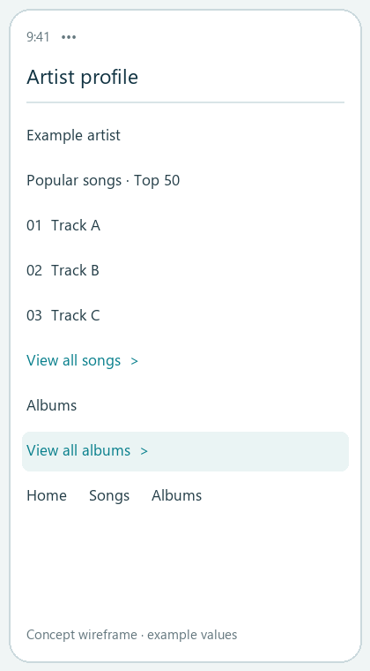 | 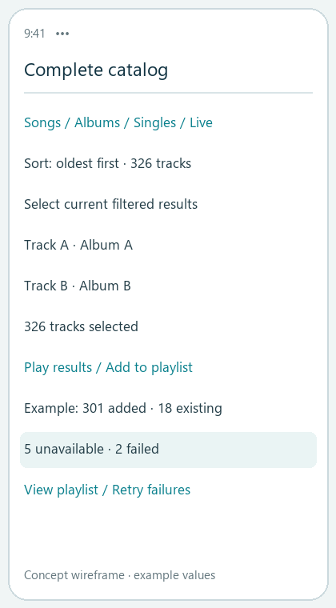

Dismiss the promotion. Resume the task.
  - P1 | Current-release checks are a prerequisite

Display decision
Check task context, playback, session/day limits, recent dismissal, membership entitlement and creative validity. Defer ordinary promotions or use a non-blocking area when interruption is inappropriate.

Dismissal and frequency
After dismissal, the same promotion stays suppressed for the session. A session ends after more than 30 minutes in the background. Separate dismissal from navigation; the PRD specifies a fixed hit area of at least 44 × 44 pt.

Modules and entitlements
Keep search, playback, safety and account entries accessible. Optional modules can be hidden, reordered and reset. Entitlement failures use a low-interruption fallback; safety notices use separate rules.

Validation and measures
Retest signed-out, free, VIP and SVIP accounts across launch/return/track-change scenarios and network conditions. Compare repeat exposure, task recovery, accidental navigation and commercial conversion together.
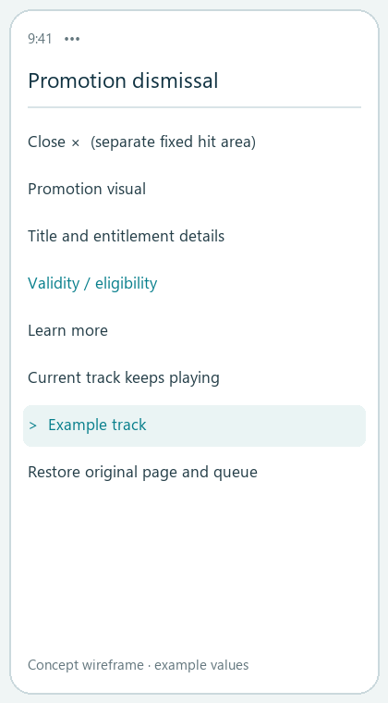 | 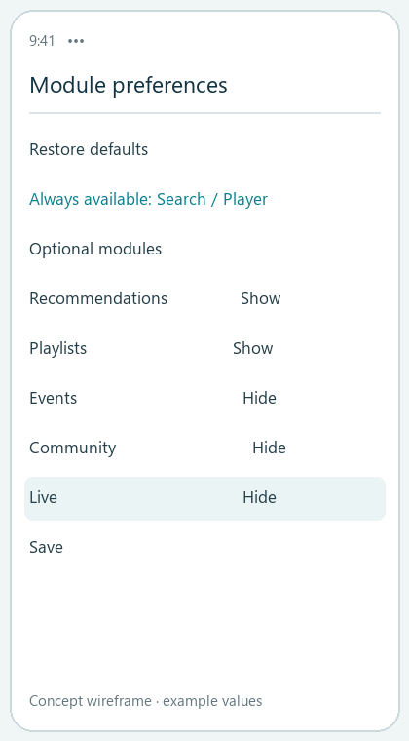

Make report handling visible and traceable.
  - P0 | Comment and stranger-interaction safety

Routing and state
Violations go to reporting; unrelated content goes to quality feedback; personal dislikes go to preference controls. Show “Accepted” only after the server returns a case ID, followed by review, additional-information requests and an outcome.

Immediate protection
Exit and local blocking take effect first. During network failure, isolate locally and sync later. Blocking is personal contact control. Moderation uses evidence and rules; report volume supports triage.

Privacy and failures
Keep unsuccessful submissions as drafts. Repeated submissions open the existing case with an option to add evidence. Disclose necessary outcome categories; the record center remains available when notifications fail.

Acceptance and measures
Check IDs, consistent states, evidence supplementation, queryable outcomes and offline isolation. Measure acceptance success/latency, handling time, outcome visibility and post-block contact failures.
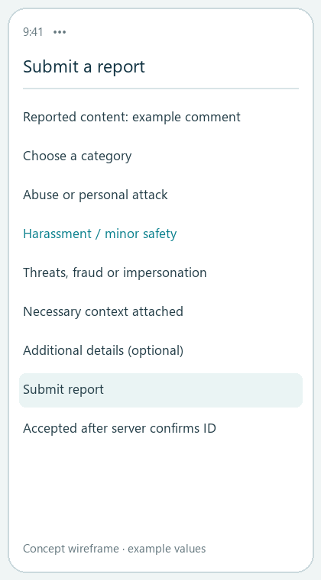 | 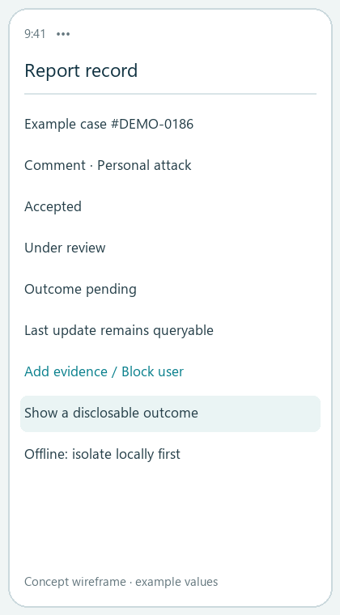

Validation plan and delivery evidence
  - Define reviewable next steps
Stage | Checks | Decision gate
Baseline | Current-release verification and 14-day measures | Remove resolved or unreproducible issues
Limited rollout | Release in stages with rollback switches | Evaluate task experience, performance, revenue and safety
Evaluation | Success rates, failures, handling times and guardrails | Set targets from baseline; pause expansion on serious failures

Artifacts
Research synthesis; needs analysis and priority matrix; QQ Music/Spotify comparison; full Chinese PRD; this bilingual case and six visual concept wireframes reorganized from the final PRD.

Traceability
Scenario → flow → prototype → event → acceptance criterion. Section 16 of the full PRD contains the mapping; this case explains the three task chains separately.

Implementation dependencies
Content metadata and playlist services, client/ad SDK behavior, membership entitlements, moderation-state APIs, customer operations and analytics. Each dependency has a failure-handling rule.

Public scope
The repository contains aggregate results and product documents. Individual survey rows, contacts, private verification documents and working caches stay local. This is a personal product-analysis exercise studying NetEase Cloud Music.

Project repository
https://github.com/Ginga2003/netease-cloud-music-product-case

