# Midterm Exam Questions

Please answer all of the following questions.

(10 pts) 1. What factors have caused a paradigm shift from communication in cartography with a focus on explanatory approaches to exploration and knowledge construction in geovisualization. Also, what is the impact of this paradigm shift in geovisualization?

The emerging of interactive maps and digitally-enabled exploratory data analysis lead to the paradigm shift.

According to reading *CV-35-Geovisualization*, the impact is that maps do not only serve a role for communicating the results of research and analysis but also become a core tool for visual thinking, for the scientific discovery process, and hypothesis generation. Geovisualization gets boosted broadly to multidisciplinary studies.

(5 pts) 2. what are the common features of GeoVISTA Studio, CommonGIS, GeoViz Toolkit, and GeoAnalytics Visualization?

All of them support multiple linked views and animation. Most important, they’re all interactive.

(5 pts) 3. what are the open-source development environments including programming languages and libraries for building geovisualizaton and visual analytics? (please list at least 3)

Open-source development environments: Visual studio code, Atom, Bracket, Git

Libraries we could use: leaflet, D3, Google Maps API

(5 pts) 4. What method do you need to use to get coordinates of the marker location in Leaflet?

We need to use getter functions. The corresponding getter function for marker location in leaflet is

getLatLng()

(5 pts) 5. What method do you need to use to calculate the distance between two coordinates in Leaflet? Write code to calculate the distance between the two markers below.

**var** marker1 = L.marker([41.875782, -87.618961]).addTo(map);

**var** marker2 = L.marker([41.890100, -87.611356]).addTo(map);

(15 pts) 6. Use the layerGroup in Leaflet to add markers below on the map in Leaflet. Documentation in terms of LayerGroup is available here: <https://leafletjs.com/reference-1.7.1.html#layergroup>

**var** Buckingham_Fountain = ([41.875782, -87.618961]);.

**var** The_Art_Institute_of_Chicago = ([41.875782, -87.618961]);

**var** Millenium_Park = ([41.882570, -87.622513]);

**var** Lake_Shore_East_Park = ([41.885971, -87.617680]);

**var** Navy_Pier = ([41.890100, -87.611356]);

(15 pts) 7. Write a loop to add markers like below on the map in Leaflet. (You must use a loop to get the full credit)

**var** markersArray = [

["Buckingham Fountain", 41.875782, -87.618961],

["The Art Institute of Chicago", 41.8796, -87.6237],

["Millennium Park", 41.882570, -87.622513],

["Lake Shore East Park", 41.885971, -87.617680],

["Navy Pier", 41.890100, -87.611356]

];

(20 pts) 8. Write code to selectively visualize Museums or Parks in features.properties.type of GeoJSON data like below. By using the layer control on the top right corner of the map, the user should have an option to visualize markers representing Museums or Parks, or both together. The result map will look like an image below.

var ChicagoAttractions = {

"type": "FeatureCollection",

"name": "ChicagoAttractions",

"crs": { "type": "name", "properties": { "name": "urn:ogc:def:crs:OGC:1.3:CRS84" } },

"features": [

{ "type": "Feature", "properties": { "type": "Park" }, "geometry": { "type": "Point", "coordinates": [ -87.618961, 41.875782 ] } },

{ "type": "Feature", "properties": { "type": "Museum" }, "geometry": { "type": "Point", "coordinates": [ -87.6237, 41.8796 ] } },

{ "type": "Feature", "properties": { "type": "Park" }, "geometry": { "type": "Point", "coordinates": [ -87.622513, 41.882570 ] } },

{ "type": "Feature", "properties": { "type": "Park" }, "geometry": { "type": "Point", "coordinates": [ -87.617680, 41.885971 ] } },

{ "type": "Feature", "properties": { "type": "Park" }, "geometry": { "type": "Point", "coordinates": [ -87.611356, 41.890100 ] } },

{ "type": "Feature", "properties": { "type": "Museum" }, "geometry": { "type": "Point", "coordinates": [ -87.616903, 41.866181 ] } },

]};

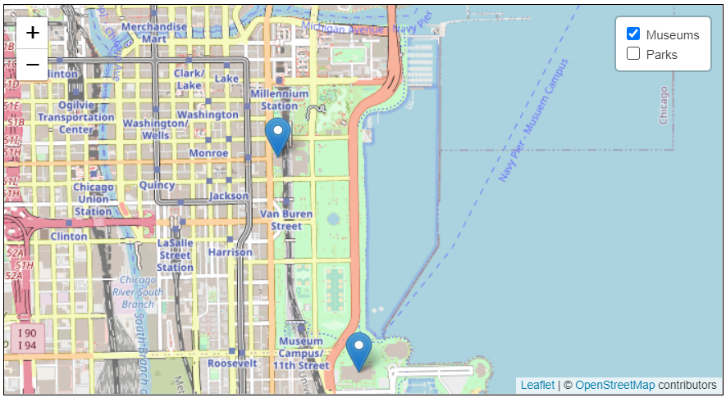

(20 pts) 9. Write code to read GeoJson like below and visualize a table below as an output.

var Attractions = {

"type": "FeatureCollection",

"name": "attractions",

"crs": { "type": "name", "properties": { "name": "urn:ogc:def:crs:OGC:1.3:CRS84" } },

"features": [

{ "type": "Feature", "properties": { "name": "Grant Park", "type": "Park", "city": "Chicago" }, "geometry": { "type": "Point", "coordinates": [ -87.618961, 41.875782 ] } },

{ "type": "Feature", "properties": { "name": "The Art Institute of Chicago", "type": "Museum", "city": "Chicago" }, "geometry": { "type": "Point", "coordinates": [ -87.6237, 41.8796 ] } },

{ "type": "Feature", "properties": { "name": "Millennium Park", "type": "Park", "city": "Chicago" }, "geometry": { "type": "Point", "coordinates": [ -87.622513, 41.882570 ] } },

{ "type": "Feature", "properties": { "name": "Lake Shore East Park", "type": "Park", "city": "Chicago" }, "geometry": { "type": "Point", "coordinates": [ -87.617680, 41.885971 ] } },

{ "type": "Feature", "properties": { "name": "Navy Pier", "type": "Park", "city": "Chicago" }, "geometry": { "type": "Point", "coordinates": [ -87.611356, 41.890100 ] } },

{ "type": "Feature", "properties": { "name": "Field Museum", "type": "Museum", "city": "Chicago" }, "geometry": { "type": "Point", "coordinates": [ -87.616903, 41.866181 ] } },

{ "type": "Feature", "properties": { "name": "Redondo Beach", "type": "Beach", "city": "Los Angeles" }, "geometry": { "type": "Point", "coordinates": [ -118.394204, 33.845212 ] } },

{ "type": "Feature", "properties": { "name": "Universal City", "type": "Amusement Park", "city": "Los Angeles" }, "geometry": { "type": "Point", "coordinates": [ -118.351740, 34.138165 ] } }

]};

|  |  |  |  |  |
| --- | --- | --- | --- | --- |
| name | type | city | latitude | longitude |
| Grant Park | Park | Chicago | 41.875782 | -87.618961 |
| The Art Institute of Chicago | Museum | Chicago | 41.8796 | -87.6237 |
| Millennium Park | Park | Chicago | 41.88257 | -87.622513 |
| Lake Shore East Park | Park | Chicago | 41.885971 | -87.61768 |
| Navy Pier | Park | Chicago | 41.8901 | -87.611356 |
| Field Museum | Museum | Chicago | 41.866181 | -87.616903 |
| Redondo Beach | Beach | Los Angeles | 33.845212 | -118.394204 |
| Universal City | Amusement Park | Los Angeles | 34.138165 | -118.35174 |