1. Please describe your findings in terms of the visualization in the two images below. Include the description of the data distribution of the two variables in both maps and charts. What are the commonalities and differences between the distribution of % White and % Poverty as well as the distribution of %Hispanics and % Poverty? What is the implication of your findings? What are the common findings in both maps and charts? Also, what is the difference in terms of findings between maps and charts?

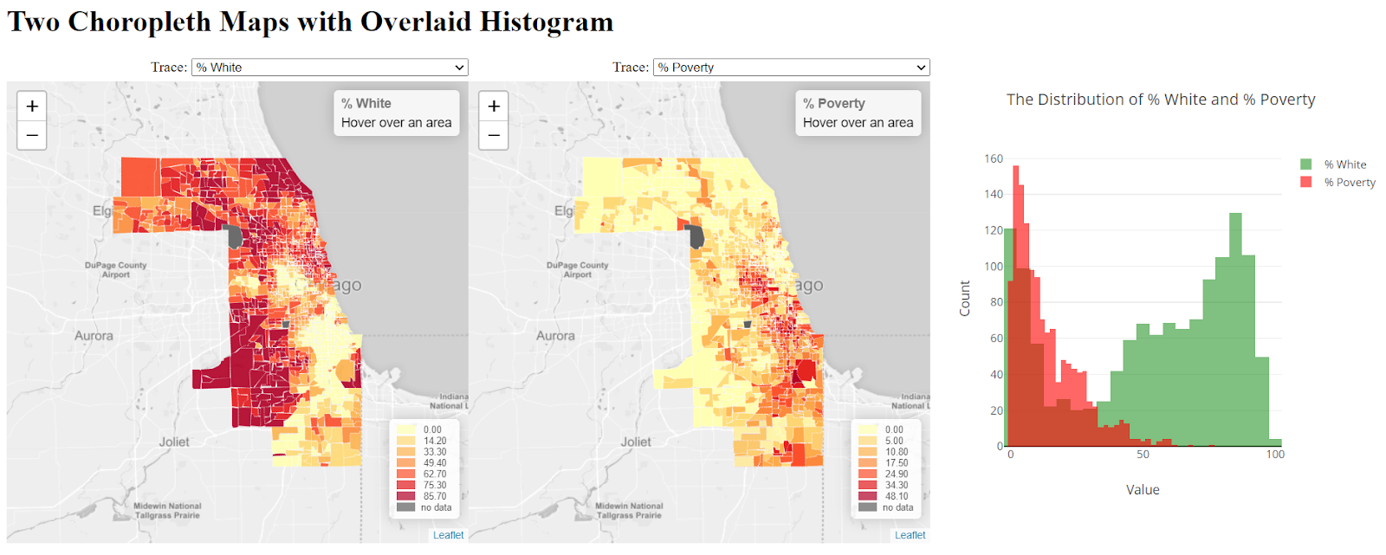

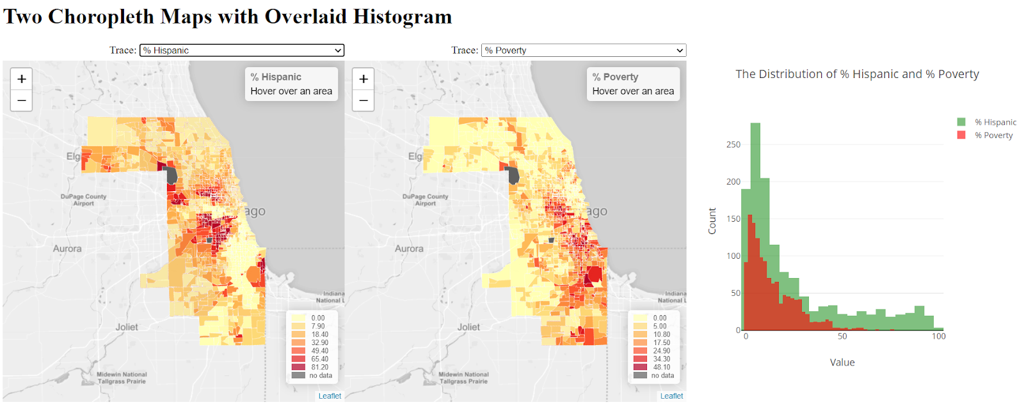

From the histograms, we could see the commonalities of distributions is that the races(hispanic and white) distribution trend are same positively with poverty distribution from 0% to 35% along the x axis. The difference is that hispanic keeps being low after 35% but the white spikes after 35% and opposite with the poverty distribution.

The common findings in maps and charts are the pattern of hispanic population and poverty rate are similar, and the pattern of white population and poverty rate are opposite. The different findings between maps and charts are that it’s much more straightforward to compare the date of the same geo-area but it’s hard to compare that from the overlaid histogram.

1. If you add more functions to enhance the visualization and exploratory aspect of this visualization tool, what do you want to add? Please describe the interactivity and visualizations that you would like to add.

I want to add a function to overlay two map tracks and the opacity of map could be adjusted so that we could easily know which geo-area has the most similar data and most opposite data and we could pick the most segregated area from the overlaid map.