

**MULTIMEDIA UNIVERSITY OF KENYA**

FACULTY OF COMPUTING & INFORMATION TECHNOLOGY

DEPARTMENT OF INFORMTION TECHNOLOGY

BURSRY INFORMTION MNGEMENT SYSTEM

BY

**NAME: DENNIS MBUGUA NGANGA  
REG. No: CIT-222-043/2018**

**SUPERVISOR: TR KARIS**

Submitted in partial fulfillment of the requirements of Third Year Bachelor of Science in Computer Technology

# DECLARATION

I hereby declare that this project is my own work and has, to the best of my knowledge, not been submitted to any other institution of higher learning.

**Student: _________________ Registration Number: _________________**

**Signature: ............................................... Date: .....................................................**

This project has been submitted as a partial fulfillment of requirements for the Bachelor of Science in Computer Technology of Multimedia University of Kenya with my approval as the University supervisor.

**Supervisor: _________________________**

**Signature: .................................................. Date: ..................................................**

DECLARATION 2

ACKNOWLEDGEMENT 6

ABSTRACT 7

CHAPTER THREE: METHODOLOGY 14

**3.1** **Introduction** 14

**3.2** **Methodology** 14

Waterfall model 14

**3.3** **Disadvantages** 15

**3.4** **Justification** 15

**3.5** **Data collection methods and tools** 16

Data collection methods 16

Data collection tools 16

CHAPTER FOUR – SYSTEM ANALYSIS 17

**4.1Detailed analysis of current system** 17

4.1.1 Data Flow Diagram 17

4.1.2 Flowchart for BAMS system 18

4.1.3 Use case Diagram 19

4.2.1 Functional requirements 19

4.2.2 Nonfunctional requirements 19

CHAPTER FIVE: SYSTEM DESIGN 215.0.2 Data Flow Diagrams 21

5.0.3 Use Case Diagram 22

5.2 Erd Diagram 24

5.2.0 Database Tables’ Names and Description 24

5.3 User Interface Design 25

5.3.1 Page before logging in 25

5.3.2 Login Page 26

5.3.3 Home Page after logging in 26

5.3.4 Users Data Entry page/registrations 27

CHAPTER SIX: IMPLEMENTATION AND TESTING 27

**6.1** **Development environment** 27

**6.2 System components** 27

6.2.1 User interface 27

6.2.2 User Registration 27

6.2.3 Login 28

6.2.4 User Dashboard 28

**6.3** **Test plan** 28

6.3.1 Test cases and results. 28

CHAPTER SEVEN: CONCLUSION 29

**7.1** **Achievements and lessons learnt** 29

**7.2** **Conclusions** 29

**7.3** **Recommendations** 29

# 

# ACKNOWLEDGEMENT

I express my gratitude to my respected lecturer, supervisor and guide of my project TR Karis, Faculty of Computing and Information Technology, Multimedia University, for his full guidance and entire support in completing this project successfully. I am thankful for the constant encouragement and continuous inspiration that he has given to me.

Finally, a special thanks to all my friends and family members for their unconditional support and encouragement during my project work without which I would hardly be capable of producing this huge work.

# ABSTRACT

Technology is Cleary changing how business operations are being conducted in the current world. To be able to generate profits and full marginalization in the industry technology must be implemented and so does our government need to utilize public funds being disbursed to the community.

Various Information Management systems can be used to manage data and critical information through technology to allow keeping records for future use

Bursary information Management system will ensure a fully organized storage based system for various details involving allocation of bursaries countrywide to avoid poor record keeping and enhance faster accessibility of the critical data.

**Chapter 1 - Introduction**

**1.1 Background of the problem**

Bursary information management system plays a very crucial role in allowing easy organization of information concerning government bursary allocation. The manual process of storing these documents involving vetting students and bursary staffs is very tedious thus coming up with a database management system will allow faster and easy retrieval of critical data that could have been lost by using manual storage systems

**1.2 Problem Statement**

The previous manual means of record keeping has received many complaints from both administrators and people involved in the bursary allocation. Various hardcopy documents are involved in the process and storing these documents in the manual file system have become a nightmare. It is also very hard to retrieve information on persons who had been involved in a previous bursary transaction using the old system.

The manual means of record keeping has following disadvantages

* Takes a lot of space
* Prone to damage and being misplaced
* Hard to make changes
* Lack of security
* Higher cost of maintaining manual records

**1.3 Proposed solutions**

Bursary information management system will provide effective data integration making it easy to see how process in one segment affect other segments.it will provide consistent data that complies with regulations of reducing data inconsistencies as manual filing systems do, The Bursary information management system will help I providing a framework to facilitate data quality initiatives also the system will improve data sharing and data security by increasing accessibility of data which in turn will help database users to share data quickly and effectively across the bursary organization

**1.4 Aim of the study**

The general objective of this study is to assess how Bursary information management system is implemented and its effectiveness what can be done to improve on that.

**1.4.1 Research objectives.**

The main purpose of this study is to develop a system that will achieve the following:

1. To ensure availability of data to be managed and stored in the system
2. To provide data integrity and make sure data available in the database will be reliable.
3. To speed up the process of bursary allocation in the government.
4. To ensure safety of critical information being stored in the database.
5. provide regular reports on bursary allocation

**1.5 Significance/Justification of the study**

There has been a little progress in the integration of Bursary information management system in the. Manual means of records keeping is known to cause data loss and increased data redundancies, which are known to cause data security issues therefore implementation of effective and timely Bursary information management system, has the potential to address that. This study will help understand the ways in which we can improve ways of managing data required for bursary registration and keeping records of people/students/staff that are involved in the allocation process. The study will fill gaps in the time and effort used when allocating bursary and mould ways for effective ways of managing the allocation system.

**1.5 Scope**

Bursary information management system is a system that will help in managing all the data that is required in the process of allocating bursaries. The system allows administrators to key in details of students applying for bursaries either from higher institutions or high school students, the system also stores parent’s information and links them with the student as well as the Location of a bursary registration.

This management system also allows administrators to store and manage Schools and institutions information including bank accounts, name, location school ids and the system is able to store and manage this information for future references. The system will also allow collection of chiefs and bursary staff who are involved in the bursary allocation and for future references also by using the BAMS system administrators will be able to collect current fee statements for students and their statuses thus improving and speeding up the process of bursary allocation.

**1.6 Assumptions**

The speculation we are holding on system administrators and users are:

* They are able to get access to the internet.
* They have access to students information
* They adhere to the specified time.

**1.7 Limitations**

However, the system will still have its own issues despite the get optimization and convenience:

* Database users should be connected to the internet
* Database users should have a computer or laptop loaded with Ms Access.
* The administrators are expected to have basic knowledge of database management systems

**CHAPTER TWO: LITERATURE REVIEW**

**2.1 INTRODUCTION**

Managing the bursary application details manually has become a major challenge in the country, having over 50million bursary applicants every season have even adversely affected the process of collecting, managing and organizing data and information that is required for this process.

Well there should be no more worries because the BAMS system allows for an easy and secure way of storing and managing this information, providing both data security and data integrity and allowing easy retrieval of information that will be stored for future use and references.

The system will also allow generating of reports for confirmation of bursary applicants to avoid various malpractices that have been known to happen in the bursary allocation process in Kenya.

**2.2 RELATED SYSTEMS**

Management Information Systems is one out of several information systems that are used in business. To better understand Management Information Systems, let us look at the different types of information systems available in business.

**Transaction Processing Systems**. These systems have been designed to collect process and store transactions that occur in the day-to-day operations of a company. The system can also be used to cancel or modify transactions done in the past if the need arises. One property of this system that enables them to work effectively is the ability to accurately record multiple transactions even if the different transactions take place simultaneously. They are built to be able to handle large volumes of transactions. Examples include stock control systems, payroll systems, order processing systems etc.

**Decision Support Systems**. These systems help decision makers to make the best decisions by generating statistical projections from analysed data. Although it does not eliminate the need for the manager’s judgment, it significantly improves the quality of the decision by offering forecasts that help determine the best course of action. These systems compile information from several sources for purposes of aiding in decision-making. Examples of these systems include computer supported cooperative work, group decision support systems, logistics systems and financial planning systems.

**Executive Information Systems**. Also known as Executive Support System, this is a tool used for reporting enterprise-wide data to top executives. These systems provide quick and easy to use reports that are presented in graphical displays that are easy to compare. They can be taken as specialized decision support systems because they provide information necessary to help improve the quality of decisions. Owing to the high expectations from such a system, these systems need to be highly individualized hence they are usually custom made for specific clients. They are also customizable to fit the specific needs of the clients.

**Management Information Systems**. These systems make use of information technology to help managers ensure a smooth and efficient running of the organization. Information collected by these systems is structured so that the managers can easily evaluate the company’s current performance vis-à-vis previous outputs. Some of the common types of Management Information Systems include process control systems, human resource management systems, sales and marketing systems, inventory control systems, office automation systems, enterprise resource planning systems, accounting and finance systems and management reporting systems.

**2.3 LIMITATIONS OF THESE SYSTEMS**

* In decision-making, MIS cannot take the place of managerial decisions. It is merely a valuable method for top-level executives in making decisions and solving problems.
* An MIS does have limitations, like its developing cost, employee training time, lack of versatility, and the storage of incorrect or incomplete data.
* For businesses looking to improve their operations management, MIS implementation may be prohibitively costly.
* The output quality of MIS is directly proportional to the input and process quality.
* Only those employees who have been educated and well trained are able to work on MIS, hence the employees who are not educated cannot work with MIS.
* Non-programmed decisions are less useful for MIS.
* Depending on the MIS style and functionality, making improvements quickly to represent changing business operations can be impossible.
* The most serious fault in an MIS is when sometimes in few instances, it provides inaccurate or incomplete information to the management executives. This issue causes heavy costs to the company and sometimes-wrong decisions can be carried out due to this MIS treated as knowledge flaws.
* MIS is less effective to those organizations, where information is not important and not sharing with others.

**2.4 HOW THE PROPOSED SYSTEM WILL SOLVE THE WEAKNESSES?**

The system will allow:

* Better data transferring
* Better data security
* Better data integrity
* Minimized data inconsistencies
* Faster data access
* Better decision making
* Increased end user productivity

# CHAPTER THREE: METHODOLOGY

## **Introduction**

Having the system requirements is not enough since there are varying needs and change becomes constant. As such, a methodology of choice was one that could allow changes to be made incrementally.

## **Methodology**

### Waterfall model

The waterfall model derives its name due to the cascading effect from one phase to the other as is illustrated in the figure below. In this model, each phase well defines starting and ending point, with identifiable deliveries to the next phase. This model is sometime referred to as the software life cycle model.

Starting from the existing situation, we proceed towards the desired solution in a number of steps.  At each of these steps, the Waterfall Model is followed. Consider a *Linear sequential Model* lifecycle model, which consists of repeating the following five, phases in sequence:

1. **Requirements**
2. **Design**
3. **Implementation**
4. **Verification**
5. **Maintenance**

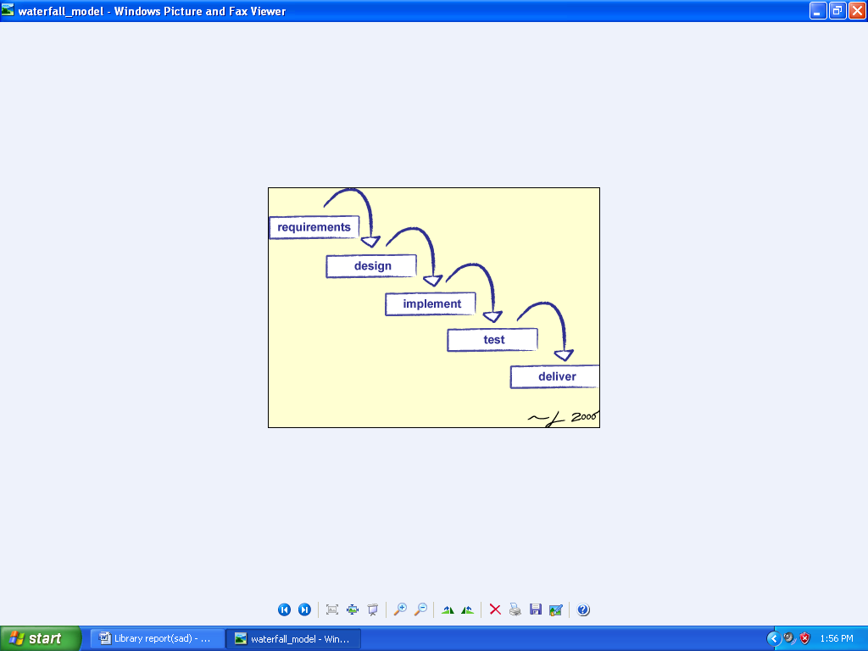

**Figure 1-Waterfall model**

#### Requirements

In the requirement phase, the need to create the application is specified. What is the need of the system is defined and the information to be feeder to create the application will come under the requirement phase?

#### Design:

After the requirement phase, the next phase is the Design phase where the application is designed according to the forms and other modules created. This phase is much important phase because it will structure the layout of your application.

#### Implementation

Implementation is the process of having a system personnel phase check out and put new equipment into use, train users, install new application and construct any file of data need to use it.

#### Verification

After the whole application is being the developed, the main phase is the verification phase where the whole application tested and verified to check the whole application.

#### Maintenance

After the successful verification of the application, the main phase is the maintenance phase where the application needs to be maintained for its successful operation in future.

## **Disadvantages**

* It is difficult for the users to state the requirements clearly at the beginning. There is always certain degree of natural uncertainty at beginning of each project.
* Difficult and costlier to change when the changes occur at later stages.
* Users can see the working version only at the end. Thus, any changes suggested here are not only difficult to incorporate but also expensive. This may result in disaster if any undetected problems are precipitated to this stage

## **Justification**

We have implemented waterfall model because of following features:

* The Design phase goes much faster, as designs are only done on the items in the current release (Release 1.0 for example).
* Coding and Testing go much faster because there are less items to code and test.  If major design flaws are found, re-work is much faster since the functional areas have been greatly reduced.
* As the software is implemented, various stakeholders can make recommendations for the next iteration due to experiences learned in the past iteration.
* It is flexible and easy to manage
* Risk Management and Testing is easy

## **Data collection methods and tools**

### Data collection methods

1. Surveys - Google forms helped a big deal in collecting remote data. This helped in gathering of diverse data.
2. Written sources – Books and journals are a great reference point especially on what is the data of the specific domain that is documented already.

### Data collection tools

**Stratification -** The technique takes a large amount of data from multiple sources and puts it into subgroups, allowing patterns to emerge

It was used to separate data gathered from the various sources so that patterns can be seen and differentiated such as students, staff and administrators

# CHAPTER FOUR – SYSTEM ANALYSIS

## **4.1Detailed analysis of current system**

New users are registered manually and documents filed in the storage systems for future reference

### 

### 4.1.1 Data Flow Diagram

**0 Level Data Flow Diagram**

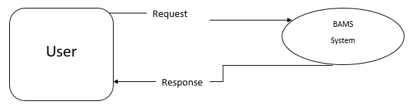

**1 Level Data Flow Diagram**

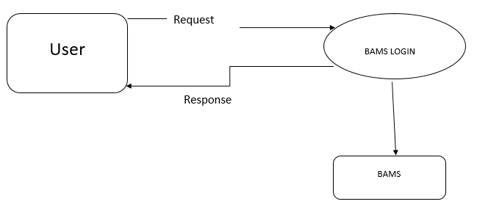

### 

### 4.1.2 Flowchart for BAMS system

### 

Unlike manual systems, the bursary information system provides a user-friendly interface that enable all the users to access it comfortably and input data plus generation of reports very easily

### 

### 4.1.3 Use case Diagram

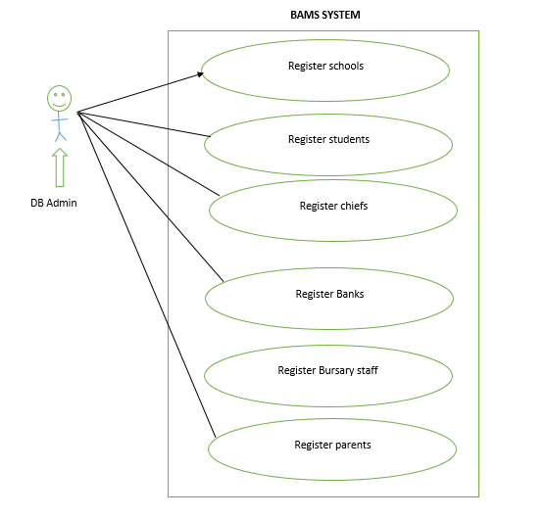

**4.2 System requirements**

### 4.2.1 Functional requirements

Both database user and admin should be able to:

1. Login into the system.
2. Add or delete entries
3. Generate reports

Additionally, the database admin should be able to:

1. Add database users
2. Update user passwords
3. Maintain and update records

### 4.2.2 Nonfunctional requirements

For the system to achieve the defined objectives, the following need be present:

* Microsoft access installed on the pc
* A PC with at least 1GB RAM.
* Database host.
* Working internet connection if database is not locally hosted otherwise XAMPP server.
* Secure storage of confidential data should be provided
* Clear working monitor.

# CHAPTER FIVE: SYSTEM DESIGN

## 5.0 Architectural Design

## **5.0.1 Component Diagram**

### 

### The component diagram contains s components and dependencies.  Components represent the physical packaging of a module of code.  The dependencies between the components show how changes made to one component may affect the other components in the system. A line between two or more components represents dependencies in a component diagram.  Component diagrams can also show the interfaces used by the components to communicate to each other.

### 5.0.2 Data Flow Diagrams

***0 Level DFD***



***1 Level DFDs***



### 5.0.3 Use Case Diagram

It shows the functions of the various system users at a very precise perspective as shown on the next page



**5.0.4 Users flowchart**

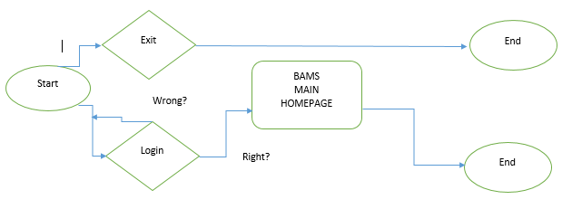

From the flowchart above, any user can be able to login to the system as long as the login credentials are right else, the system will not allow unauthorised user to login.

**5.1 ERD Diagram**

ERD diagram of the system

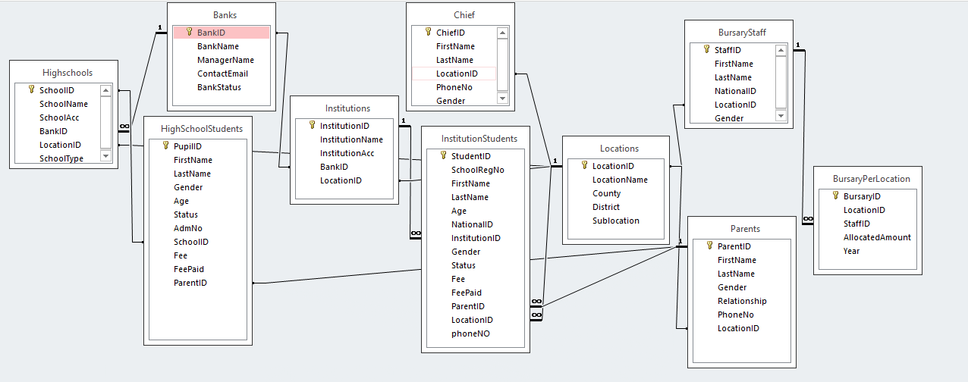

## Erd Diagram

### 5.2.0 Database Tables’ Names and Description

The screenshot below shows my model for my database,

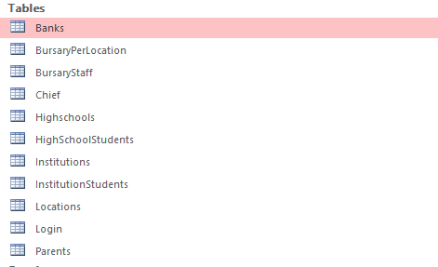

Figure 12-tables screenshot

|  |  |
| --- | --- |
| **Table name** | **Table description** |
| table login | Stores all the information of the user upon registration |
| table high schools | Stores all information about high schools |
| table institutions | Stores all info about institutions |
| table location, parents | Stores all information about locations and parents |
| table banks | Stores bank account, names and bank region of operation |

## User Interface Design

### Page before logging in

The user has several ways of interacting with the system:

1. Viewing and printing reports
2. Logging in
3. Entering the required data in different forms



Figure 13-welcome page screenshot

### Login Page

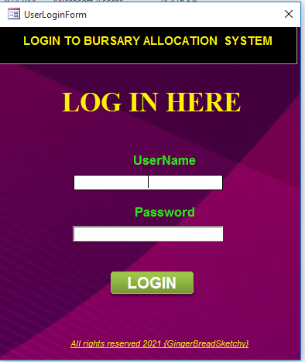

Figure 14-login page

The system user is prompted to enter their username and password to allow for validation.

### Home Page after logging in

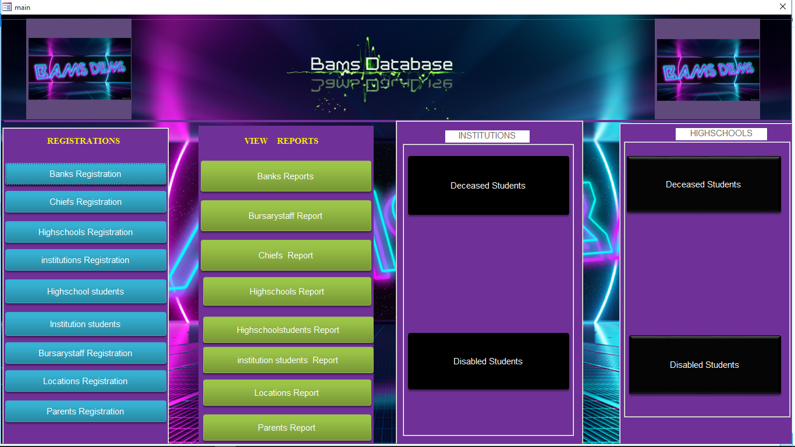

Figure 15-Logged_in page

Homepage on logging in.

### Users Data Entry page/registrations

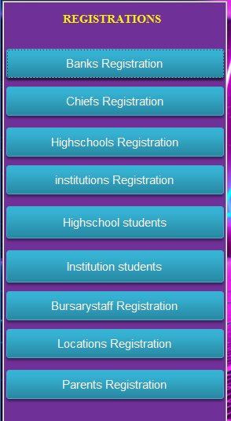

Figure 16-registrations page

# CHAPTER SIX: IMPLEMENTATION AND TESTING

## **Development environment**

BAMS system was developed using Visual Basic code and Ms Access to implement the database part of the system. Various forms were coded with vs. such as welcome progress bar page and the login page to verify users. The tables and queries are the major backend features of the system whereas outputs of the system are generated reports, which can be printed and presented.

## **6.2 System components**

### 6.2.1 User interface

Precisely on the homepage, buttons submenus, which allow users to open forms for inputs and view concurrent generated various navigation, reported

### User Registration

Only database has the privilege of assigning new database users manually at the backend for security purposes.

### Login

This page will take user’s username and password and after querying the database for validation of the credentials, it redirects a user to the main homepage and one can only get to the homepage once the credentials are verified by the system. In cases of incorrect credentials, the user will have to either make second attempt again or consult database administrator in case of forgotten passwords.

### User Dashboard

The user dashboard, which is also the main home page, consists of a navigation bars for form entries and registration to add new information into the database and generate reports.

## **Test plan**

To ascertain for proper functionality of the system, system test was inevitable. We opted for the Testing Level Specific Plans since by the low-level modules having correctness, then the bigger system they make up should be well functioning.

### 

### Test cases and results.

**Table 2-Test cases & Results**

|  |  |  |  |  |
| --- | --- | --- | --- | --- |
| **TEST** | **Test ID** | **Inputs** | **Expected output** | **Actual output** |
| **LOGIN** | 1 | Invalid Credentials | *False* | *False* |
| 2 | Valid Credentials | *True* | *True* |
| 3 | Back key after *logout* | *False* | *False* |
| **REGISTRATION** | 4 | All valid element entered | *True* | *True* |
| 5 | Some element missing | *False* | *False* |
| **DATA ENTRY** | 6 | All necessary info entered | *True* | *True* |
| 7 | Edited entries | *True* | *True* |
| 9 | Invalid entries | *False* | *False* |
| 10 | Review of details | *True* | *True* |

Based on the test cases and test results above, the system showed high level of integrity and functional support. Having actual results matching with the expected results is a clear indication that what was there theoretically is achieved by the system practically.

There could not be any better results.

# CHAPTER SEVEN: CONCLUSION

## **Achievements and lessons learnt**

A working software is a great achievement. We have learnt that handling files is becoming easy and there are more than enough tools for web development.

Having challenging modules and digging into research for solutions has made optimal use of my knowledge and has helped build up in web-development domain.

## **Conclusions**

This application is made for the whole bursary allocation process initiated by the wonderful government of Kenya to help the needy students. With great data, management comes good data integrity and security also faster access of services as proven by the BAMS system. A proved and efficient way of storing and managing information in an organized manner for future references.

## **Recommendations**

1. A biometric(fingerprint) that one can use when accessing his/her own account
2. Auto generated password instead of manual user administrator entry
3. SQL based database
4. A web application version of the system for web access