

SCHOOL OF ARCHITECTURE COMPUTING AND ENGINEERING

DISSERTATION (DS7010)

Title : Predictive Modelling for Student Dropout Prevention in Higher Education Institutions : A Machine Learning Approach

GINJO JOHNY - u2358034
MSC DATA SCIENCE 2023 -24
Tutored By : Dr. Yang Li
Abstract

The study is centered on determining the optimal machine learning technique to tackle the pressing issue of student attrition in early stages of higher education. The objective is to pinpoint the most optimal predictive model capable of identifying students at risk of dropping out before the event occurs through the application of data analytics. Determine the best model by carefully examining the body of existing research and by applying different machine learning techniques to real-world student dropout data.

By giving higher educational institutions the finest machine learning model for early intervention, this project hopes to help them allocate resources more wisely and put in place focused support systems that will increase student success and retention rates. Providing data-driven insights to institutions so they can implement proactive intervention measures, establishing a nurturing environment in the classroom that promotes academic success and student well-being. With the ultimate goal of promoting student achievement and institutional excellence, "Predictive Modeling for Student Dropout Prevention in Higher Education Institutions" is a pioneer attempt to use machine learning to address an important issue in higher education.

In order to begin this effort, an in-depth study of the literature on student dropout in higher education as well as machine learning methodologies for early dropout prediction from research and educational sites was conducted. Later, searches were conducted on other data sites, including UCI, Kaggle, and public data repositories, to obtain the data needed for testing and practical application. Next, a selection of data is made from Kaggle. This data includes demographics, academic achievement, social-economic characteristics, and behavioural patterns that can be utilized to investigate potential predictors of student dropout and academic success. Data pre-processing and exploratory analysis of the variables are done and machine learning algorithms including Support Vector Machine(SVM), Logistic Regression and K Nearest Neighbour(KNN) models are used to train and testing purpopses. Subsequently, thorough evaluation, which employs cross-validation techniques like ROC curve and AUC calculation, ensures the predictability and stability of the prediction models in precisely identifying students who are in danger of quitting university. After evaluation of the ML models using ROC curve and AUC calculation, Logistic regression model had the highest AUC value of 1 where SVM had a value of 0.86 and KNN had only 0.74 respectively.

Hence this dissertation concludes that Logistic regression is the optimal machine learning models among the three models (SVM, Logistic regression, KNN) implemented on the student dropout data set for predicting the dropout prediction.

Keywords : Student dropout, machine learning, Support vector machine, Logistic Regression, k-Nearest Neighbour,

Table of Contents

Chapter 1 : Introduction 5
1.1 Introduction 5
1.2 Research Area 6
1.3 Aim(s) and Objectives 7
1.4 Expected Practical Output 7
Chapter 2 : Review of Literature 8
2.1 Introduction 8
2.2 Higher Education 8
2.3 Student Dropout 8
2.4 Machine Learning 9
2.5 Review Summary 11
Chapter 3 : Methodology 12
3.1 Introduction 12
3.2 Research Design 12
3.3 Data Collection 12
3.4 Data Pre-processing 13
3.5 Exploratory Data Analysis (EDA) 13
3.6 Feature Selection and Engineering 13
3.7 ML Model Selection and Evaluation 14
3.8 ML Model Implementation 15
Chapter 4 : Practical Implementation 16
4.1 Introduction 16
4.3 Data Preparation and Quality Check 16
4.4 Data Cleaning 17
4.5 Exploratory Data Analysis 17
4.6 Factor Analysis and Feature Selection 18
4.7 Machine Learning Models Implementation 19
Chapter 5 : Results Interpretation and Discussion 21
5.1 Introduction 21
5.2 Data Preparation and Quality Check 21
5.3 Data Cleaning 27
5.4 Exploratory Data Analysis 28
5.5 Factor Analysis and Feature Selection 34
5.6 Machine Learning Models Implementation 37
Chapter 6 : Critical Evaluation 42
Chapter 7 : Conclusion 43
References 44
Appendices 46

Chapter 1 : Introduction

1.1 Introduction

In today's educational landscape, the challenge of student attrition looms large, posing a significant obstacle to both individual academic success and institutional effectiveness. Every dropout represents not just a loss of potential, but also a failure of the educational system to support and nurture its students adequately. Recognizing the critical importance of addressing this issue, our project delves into the realm of predictive modeling, harnessing the power of machine learning to develop proactive strategies for student dropout prevention.

The history of student dropout prediction can be traced back to the early efforts of educational researchers and policymakers to understand the factors influencing student attrition. While formal predictive modelling using advanced statistical and machine learning techniques is a more recent development, the groundwork for identifying risk factors associated with dropout has been laid over several decades. The earliest studies on student dropout focused on demographic characteristics such as socioeconomic status, race, and gender. Researchers sought to identify correlations between these factors and dropout rates to inform educational policies and interventions.

During the 1980s and 1990s, researchers expanded their focus to include academic performance, school climate, family background, and psychological factors as potential predictors of dropout. Longitudinal studies helped identify early warning signs and risk factors associated with students who were more likely to disengage from school. With the proliferation of data analytics and machine learning techniques, predictive modelling for student dropout prediction gained momentum in the 21st century. Researchers began using sophisticated statistical methods and machine learning algorithms to analyze large-scale educational data and develop predictive models capable of forecasting student dropout with greater accuracy.

In recent years, the proliferation of data in educational institutions has opened up new avenues for understanding and addressing challenges such as student attrition. Traditional approaches to dropout prevention have often been reactive, relying on identifying at-risk students only after they have begun to show signs of struggle or disengagement. However, with the advent of advanced data analytics and machine learning techniques, we now have the opportunity to shift towards a more proactive and personalized approach.

The goal of our project, "Predictive Modeling for Student Dropout Prediction: A Machine Learning Approach," is to leverage the wealth of available data – encompassing academic performance, demographic information, socio-economic factors, and more – to develop predictive models capable of identifying students at risk of dropping out before it happens. By analyzing patterns and trends within this data, our aim is to uncover subtle indicators and predictive signals that may not be immediately apparent to human observers.

This introduction sets the stage for a comprehensive exploration of how predictive modeling and machine learning can revolutionize the way we approach the challenge of student dropout prevention. Through the development of sophisticated algorithms and data-driven insights, we aspire to empower educational institutions with the tools they need to intervene early, provide targeted support, and ultimately, foster an environment where every student has the opportunity to thrive and succeed.

1.2 Research Area

According to UNESCO Institute for Lifelong Learning, Institutions of higher education (HEIs) play a crucial role in advancing lifelong learning (LLL). They possess an exceptional ability to cultivate knowledge and skills, as well as the capability to mobilize educational resources and offer learning opportunities to a variety of people (UNESCO WHEC, 2022). Everybody is interested in learning about how the world is changing, but higher education is particularly affected. Academic institutions investigate transformation, impart knowledge on it, and frequently influence both present-day and upcoming changes. For those of working in higher education, the goal is to prepare students for life in this dynamic world at both the undergraduate and graduate levels with sound and pertinent instruction (Dianne F. Harrison, 2017). A competitive graduate population is the primary output of higher education institutions as a result of globalization, the advanced technology industry, and an uncertain labor market. Institutionalists contend that universities have been essential in creating the framework for society, the economy, the government, and science (Heinz-Dieter Meyer and Powell, 2018).

In higher education, academic achievement is essential for employment, social fairness, and economic expansion. The most significant issue that higher education institutions need to address in order to increase student success is dropout. The most complicated and important problem facing the educational system is thought to be student dropout (Kim & Kim, 2018). Since the measures implemented thus far have not had a positive impact on this issue, this problem damages the primary agents of education in financial, educational, social, and economic policies and domains.These agents, which include students as well as administrative and marketing organizations, are looking for practical and efficient ways to lower the rates of school dropout (Martinho et al., 2013). Scholarly literature has produced diverse definitions of student dropout. According to Jovial et al. (2022) the most prevalent definition centers on whether or not students will stay active through the end of the week or if this is their final week of activity. The issue of student dropout is one of great global concern since it has an impact on the economy of the nation as well as on students, their families, labor unions, colleges, and government agencies (Véliz Palomino et al., 2023).

Del Bonifro et al. (2020) state that machine learning is a promising method for developing a predictive model for student dropout and provides notifications to those in charge so they can take alternative actions with kids who are at risk of leaving school. Data mining (DM) and machine learning (ML) models have been used to predict students' performance in a number of recent research. The largest known dataset on higher education attrition, for instance, was used to predict student dropout in higher education. At one of the biggest public institutions in the nation, the dataset tracks the demographics and transcript records of nearly 32,500 students. Overall, the findings demonstrated that ML models significantly affect student retention and achievement while suggesting a number of interesting avenues for further investigation (Aulck et al., 2016). Analyzing junior year dropouts also involved the use of DM techniques. Out of the several DM techniques employed, including logistic regression, decision trees, and neural networks, the decision trees exhibited the highest precision in predicting student dropout (Jadrić et al., 2010).

1.3 Aim(s) and Objectives

Aim(s) : Use machine learning predictive modelling to reduce or prevent student dropout in higher educational institutions.

Objectives

- Literature Review
- Methodology
- Practical Implementation
- Results Interpretation and Discussion
- Critical Evaluation
- Conclusion

1.4 Expected Practical Output

This dissertation aims to find out the best machine learning model for predicting student dropout in higher educational institutions. So it is clear that the expected output for this study is the test results of different machine learning models and need to find out the best model by comparing these results. In this study, the machine learning models going to be used are SVM , KNN and Logistic regression models and to evaluate performance accuracy of these classification models, ROC curve and AUC calculation. From the performance evaluation, the best model among these two will be get for predicting the student dropout accurately.

Chapter 2 : Review of Literature

2.1 Introduction

Here in this chapter, the main focus is on reviewing existing literature on different aspects like higher education, student dropout and predictive modelling techniques using machine learning.

2.2 Higher Education

According to UNESCO Institute for Lifelong Learning, Institutions of higher education (HEIs) play a crucial role in advancing lifelong learning (LLL). They possess an exceptional ability to cultivate knowledge and skills, as well as the capability to mobilize educational resources and offer learning opportunities to a variety of people (UNESCO WHEC, 2022). Everybody is interested in learning about how the world is changing, but higher education is particularly affected. Academic institutions investigate transformation, impart knowledge on it, and frequently influence both present-day and upcoming changes. For those of working in higher education, the goal is to prepare students for life in this dynamic world at both the undergraduate and graduate levels with sound and pertinent instruction (Dianne F. Harrison, 2017). A competitive graduate population is the primary output of higher education institutions as a result of globalization, the advanced technology industry, and an uncertain labor market. Institutionalists contend that universities have been essential in creating the framework for society, the economy, the government, and science (Heinz-Dieter Meyer and Powell, 2018).

2.3 Student Dropout

In higher education, academic achievement is essential for employment, social fairness, and economic expansion. The most significant issue that higher education institutions need to address in order to increase student success is dropout. The most complicated and important problem facing the educational system is thought to be student dropout (Kim & Kim, 2018). Since the measures implemented thus far have not had a positive impact on this issue, this problem damages the primary agents of education in financial, educational, social, and economic policies and domains. These agents, which include students as well as administrative and marketing organizations, are looking for practical and efficient ways to lower the rates of school dropout (Martinho et al., 2013). Scholarly literature has produced diverse definitions of student dropout. According to Jovial et al. (2022) the most prevalent definition centers on whether or not students will stay active through the end of the week or if this is their final week of activity. The issue of student dropout is one of great global concern since it has an impact on the economy of the nation as well as on students, their families, labor unions, colleges, and government agencies (Véliz Palomino et al., 2023).

Since the 1930s, researchers have examined the phenomenon of college student dropout, including its causes and effects (Bardach et al., 2020). Currently, the tendency to examine college student dropout persists, as it is a complex phenomenon in which numerous academic and social variables interact (Bernardo et al., 2022). An excessive number of students leave higher education before completing their courses, according to an independent report prepared for the European Commission (Quinn et al., 2013). Merely 80% of students in Denmark, the nation with the highest level of success, finish their education; in Italy, this percentage is as low as 46%. Likewise, higher education organizations attempt to reduce dropout rates due to the significant economic cost to families and states (Castro-Lopez et al., 2022), seeking to improve the number of academically qualified persons in the job market (Bargmann et al., 2022). Depending on how dropout is defined, the data source, and the computation techniques, the percentage of students who drop out differs between research (Behr et al., 2021). Research literature frequently analyzes dropout depending on when it occurs (early vs. late) (Kehm et al., 2020).

Academic performance is often viewed as a critical factor contributing to student dropout rates; however, social and family influences also significantly impact this issue. Numerous studies highlight the importance of social integration and family support in student dropout rates. A recent study conducted by (Sosu et al., 2019) found that students lacking family support were 1.32 times more likely to drop out each semester. Additionally, financial factors such as the economic status of the student's family and the availability of financial aid or scholarships from the university are crucial determinants of dropout decisions (Aina et al., 2018). Furthermore, the escalating tuition fees can further compound the economic ramifications of student dropouts (Lee et al., 2020). Recent research has also identified personal factors contributing to university dropouts. For instance, Stinebrickner et al. (2014) observed that a student's chosen major significantly influences their intentions to drop out, emphasizing that overconfidence in completing a science degree can lead to higher dropout rates.

2.4 Machine Learning

Machine learning is a branch of artificial intelligence (AI) that builds self-learning models—models that can predict outcomes and categorize data without the need for human intervention—by training algorithms on data sets. There are many types of machine learning ie, supervised learning, unsupervised learning, semi-supervised learning, and reinforcement learning. Supervised machine learning involves training algorithms on labeled data sets with tags that describe individual data points. Stated differently, the algorithms receive data together with a "response key" that indicates how the data ought to be understood. Algorithms are trained using unlabeled data sets in unsupervised machine learning. The program must find patterns on its own without external assistance because it is fed data without tags during this procedure. Unlabeled and labeled data sets are used in semi-supervised machine learning to train algorithms. A tiny quantity of labeled data is typically supplied to algorithms during semi-supervised machine learning to guide their development, and significantly larger amounts of unlabeled data are then fed to the algorithms to finish the model. Reinforcement learning trains algorithms and builds models by means of trial and error. Algorithms are trained in certain environments and receive feedback after every result. Supervised learning is the most common method used as it is trained on labelled data, the input data is paired with the correct output. Figure 1 shows the pictorial representation of machine learning and its classifications in different levels.

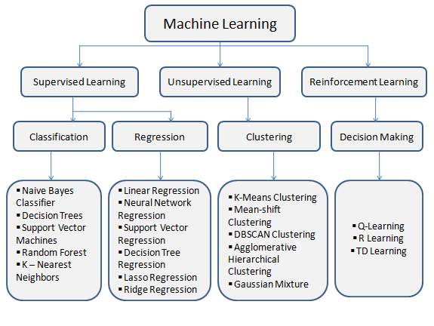
Fig 1

Del Bonifro et al. (2020) state that machine learning is a promising method for developing a predictive model for student dropout and provides notifications to those in charge so they can take alternative actions with kids who are at risk of leaving school. Data mining (DM) and machine learning (ML) models have been used to predict students' performance in a number of recent research. The largest known dataset on higher education attrition, for instance, was used to predict student dropout in higher education. At one of the biggest public institutions in the nation, the dataset tracks the demographics and transcript records of nearly 32,500 students. Overall, the findings demonstrated that ML models significantly affect student retention and achievement while suggesting a number of interesting avenues for further investigation (Aulck et al., 2016). Analyzing junior year dropouts also involved the use of DM techniques. Out of the several DM techniques employed, including logistic regression, decision trees, and neural networks, the decision trees exhibited the highest precision in predicting student dropout (Jadrić et al., 2010).

To avoid student dropout in distant learning, ML approaches were also highlighted (Kotsiantis et al., 2003). The optimal technique to forecast student dropout, according to data from the Hellenic Open University's informatics course, is the Naïve Bayes algorithm (Kotsiantis et al., 2003). Moreover, dropout and school failure were predicted using DM methods. In order to complete the tasks given, white-box classification techniques such as decision trees and induction rules were used on 670 middle school pupils from Zacatecas, México. The classification accuracies were then compared in order to determine which model performed the best. Overall, the findings showed that decision trees perform better than benchmark models constructed using induction rules (Márquez-Vera et al., 2013).

Alternatively, white-box models like decision trees and rule-based classifiers are easier to comprehend and analyze since they reveal the underlying reasoning process behind the predictions. Other choices are association rule mining and clustering techniques. Studying the correlation between course grades and characteristics that define the credits students receive and their mean scores could be beneficial as well (Lang et al., 2017). Lang et al. (2017) state that the student performance prediction problem may be resolved by using logistic regression, support vector machines, neural networks, Bayesian networks, classification and regression techniques, and linear regression. Due to their difficulty in comprehension and interpretation, these models are commonly referred to as "black-box" models. Each of them depends largely on feature extraction. The process of compiling a subset of distinct predictive features for the prediction issue in modeling is called feature extraction, sometimes referred to as attribute selection. For example, the process assists in identifying relevant features in the dataset which enhance the prediction model's reliability by predicting a dropout based on the student's latest participation in the relevant course (Queiroga et al., 2020). Methods that work well for one type of dataset may not work well for a different one. This means that creating new feature extraction techniques by hand is usually required (Li, 2018).

To anticipate student dropouts in higher education, supervised classification algorithms were also created (Serra et al., 2018). Students at high risk of dropping out of university were identified using data from the University of Bari Aldo Moro (2013) and the Osservatorio Studenti-Didattica of Miur-Cineca (2018). According to a comparison of supervised machine learning algorithms, support vector machines outperformed traditional machine learning models, along with logistic regression and Gaussian Naïve Bayes classifiers (Serra et al., 2018). Additionally, Martinho et al. (2013) claimed that artificial neural networks were used as a clever way to identify school dropout risk groups in higher education classes. One AI method called the Fuzzy-ARTMAP Neural Network is specifically designed to take into account a wider range of factors, including each student's living circumstances and family status. The study's findings demonstrated the accuracy and dependability of the system with a 92% success rate for the dropout group and an overall accuracy of over 85% (Martinho et al., 2013).

In the study of Chen et al. (2020), 3963 articles published in Computers & Education during the previous 40 years are analyzed structurally using topic modeling. Significant queries concerning the emerging themes and patterns in educational technology have been examined throughout the work. To sum up, helpful perspectives and consequences have been offered, which can serve as strong manuals for those involved in computer science and education. The impact of AI in education, contributors, collaborations, research topics, challenges, and future directions over the last 20 years have all been presented in a comprehensive study using topic-based bibliometrics (Chen et al., 2022). This study fills in the gaps of various aspects not yet presented by other researchers on the subject. The study's conclusions show that the academic community is growing increasingly interested in using artificial intelligence (AI) for educational purposes. These include topics such as smart tutoring systems for students with special needs, language processing algorithms for instruction in languages, robotic devices for AI learning, EDM for performance forecasts, discussion analysis in computer-supported interactive learning, neural networks in instructional assessment computational psychology for learner recognition, and recommended systems for tailored instruction (Chen et al., 2022).

Despite the fact that several DM/ML algorithms have been employed to predict school dropout, they are inherently limited. Orooji and Chen (2019) suggest that utilizing machine learning to forecast school dropout may provide challenges in certain situations due to class imbalance. The proportions of the two classes—dropouts and non-dropouts—in the binary result that represents students' dropout rates typically have an unbalanced distribution (for example, in a Korean high school in 2016, 1.4 percent of dropouts and 98.6 percent of non-dropouts). (Lee & Chung, 2019). From the above studies, it is obvious that the future researches should be more compatible with the class imbalance and more precise in the student dropout prediction among the existing models. Usage of large data from various educational institutions from different regions or countries may result more accurate results.

2.5 Review Summary

From the above studies it is clear that majority of the works are done based on supervised learning methods because the output that is going to predict is very clear from the dataset itself. Some of the above studies are based on white-box or black-box models which refers to the transparency of the process of predictive modelling. Algorithms classified as black-box or white-box differ mostly in their transparency. Black-box models offer minimal to no information regarding the decision-making process, whereas white-box models offer complete transparency. Generally speaking, black-box models are more accurate than white-box models, especially when working with complicated data sets. Also from the above literature, it is evident that SVM is the most effective prediction model among other models and most of the people experimented with this model. Hence this study will be focus on to find out if there is any other model that is more accurate than SVM model. This dissertation is going to be evaluate the test results of SVM, KNN and Logistic regression models because, there is only less studies belongs to KNN and logistic regression models and want to experiment the performance of both these models over SVM model. Also Support vector machine, Logistic regression and k-Nearest neighbour algorithms are comes under black-box model and it will be more accurate according to the studies.

Research is now being done on the concept of utilizing machine learning to forecast student dropout and propose interventions. The idea is exciting since it makes use of data analytics to find patterns and trends that could point to a student who is about to drop out. Teachers or administrators can intervene and support those pupils by receiving notifications, which may stop them from leaving higher educational institutions early. But much like any prediction model, there are obstacles and ethical issues to deal with, like privacy issues and the possibility of bias in the data or algorithm. Therefore, even while the idea seems promising, it also needs to be carefully implemented and evaluated to make sure it is fair and successful.

Chapter 3 : Methodology

3.1 Introduction

The main purpose of this dissertation is to use machine learning predictive modelling to identify/ prevent the students at risk of dropout in the higher education institutions. This study will help the higher educational institutions to enhance their prevention measures against the student attrition and hence to increase their academic success rates.

3.2 Research Design

The review of existing literature is done as a systematic review and it covers all the main areas of this study including higher education, student dropout and machine learning models for predicting dropout rates. This review insights into the best machine learning models and describes each model with its own specifications and comparisons. From this study on these experiments, it is evident that SVM and Logistic regression have great performance accuracy over others for predicting student dropout rates. Hence this dissertation will be focused on comparing the performances of the models, SVM and Logistic regression along with KNN algorithms.

3.3 Data Collection

The dataset used in this study is from Kaggle and contains data from a university. The dataset comprises of 3630 objects and 34 variables. An all-encompassing picture of students enrolled in different undergraduate programs at a university is provided by this dataset. This data can be utilized to examine potential determinants of student dropout and academic success, including demographics, socioeconomic characteristics, and academic performance data. This dataset includes numerous separate databases with specific information that was accessible at the time of enrolment, including the kind of application, marital status, course selection, and more. By evaluating the curricular units credited/enrolled/evaluated/approved together with their corresponding grades, this data may also be utilized to estimate total student performance at the end of each semester. The region's GDP, unemployment rate, and inflation rate are the last three statistics that can assist us better understand how economic issues affect student dropout rates.

Kaggle: Kaggle is a platform for data science competitions, machine learning projects, and datasets. It hosts a wide range of challenges where participants compete to produce the best models for predicting or analysing data.

3.4 Data Pre-processing

Data handling mainly focuses on data manipulation and preprocessing techniques. This includes data cleaning, handling missing values, feature scaling, encoding categorical variables, and splitting data into training and testing sets. At first the data preparation and quality check need to be done by checking the missing values, checking duplicate rows and by visualizing all variables through bar-plots, frequency tables, boxplots and histograms. After that data cleaning is the next step to be done if there is any errors, Clean the data to remove any errors, inconsistencies, or missing values. This might involve imputing missing data, correcting formatting issues, and removing outliers. Rstudio is going to be used for data handling processes. Figure 2 describes the processes that involves in ML analysis and implementation.

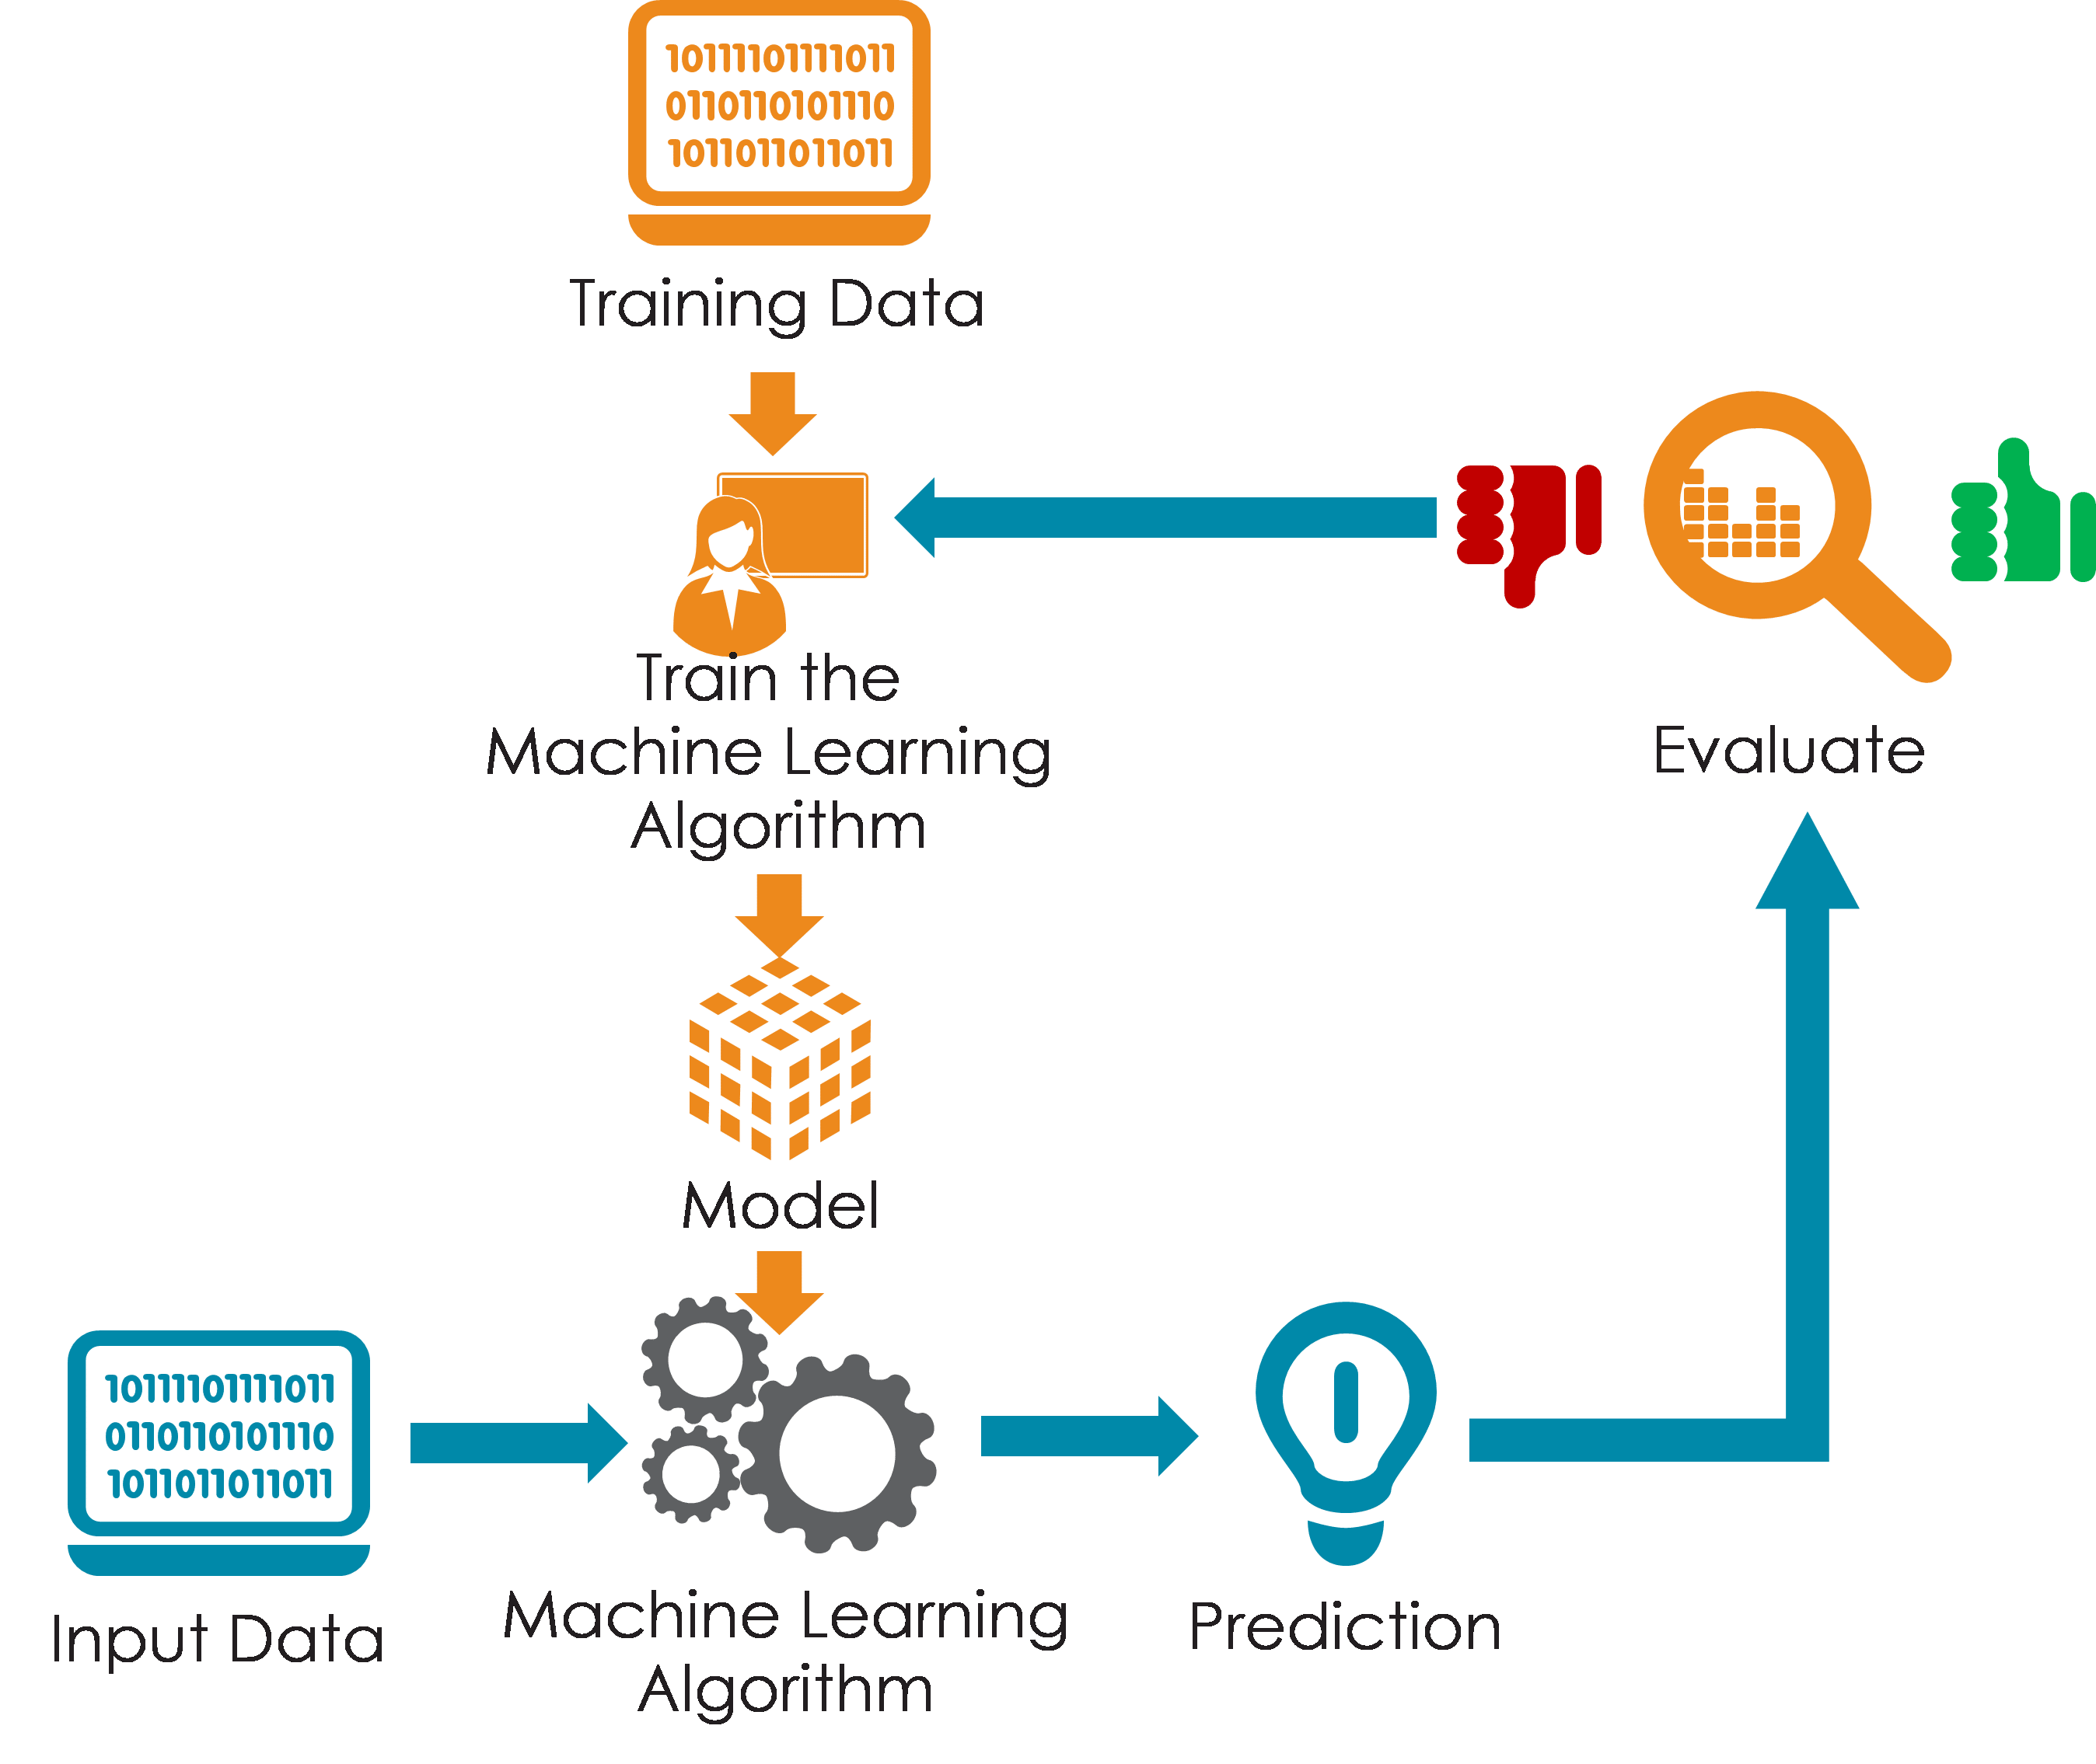

Fig 2

3.4.1 R Studio

RStudio is an integrated development environment (IDE) for R, a programming language and environment primarily used for statistical computing and graphics. RStudio provides a user-friendly interface with various tools and features to enhance the R programming experience.

3.4.2 R package: dplyr

A package for data manipulation and preprocessing, which can help in preparing your dataset for modeling. It provides a set of functions that make it easier to work with data frames and data tables in R.

3.5 Exploratory Data Analysis (EDA)

EDA helps to understand the structure and characteristics of the data. One should know how to perform data visualization, summary statistics, and identify patterns or correlations in the data. Data exploration is the next step to be done for better understanding of the data and to find out if there is any patterns. The different plotting methods including bar-plots, boxplots, histograms, heatmaps, frequency tables etc. will be used to visualize the variables and to find out the correlation between dependent and all other independent variables.

3.5.1 ggplot2

ggplot2 is an R package for data visualization, particularly well-known for its implementation of the grammar of graphics, which allows for highly customizable and layered plots. It can create complex plots by adding layers of data, aesthetics, and transformations.

3.6 Feature Selection and Engineering

After the detailed data exploration analysis, the next step to be done is feature selection and find the patterns that underlies within the dataset. Here the data set is going to be undergo with Spearman correlation test, Factor analysis and Varimax rotation component analysis for extracting the most effective variables for dropout prediction.

3.6.1 Spearman correlation test

The Spearman's rank correlation coefficient, alternatively referred to as the Spearman correlation test, is a non-parametric indicator of the correlation between two variables. It evaluates the degree to which a monotonic function can adequately depict the connection between two variables.

3.6.2 Factor analysis

This is a valuable tool for uncovering the underlying structure of complex datasets, identifying hidden patterns, and gaining insights into relationships among variables.

3.6.3 Varimax rotation component analysis

Varimax rotation is a technique used to simplify and improve the interpretability of factor loadings in factor analysis by rotating the axes to achieve a simpler structure. It is particularly useful when dealing with complex factor loadings matrices.

3.7 ML Model Selection and Evaluation

The next process after data exploration and feature selection is the selection of machine learning algorithms and evaluation matrices for these models. Based on the review of existing literature, it is obvious that SVM and Logistic regression model posses more accurate performance over other experimented models. The dataset is suitable for supervised machine learning techniques and this study will be focus on finding the best model among SVM, Logistic regression and KNN algorithms. These models are solely under supervised category as well as classification algorithms. This study will use ROC curve and AUC for model evaluation purpose.

3.7.1 Support Vector Machine (SVM)

SVM is a potent classification technique that may be applied to applications involving both binary and multiclass classification. It operates by locating the hyperplane in the feature space that best divides various classes. SVM seeks to increase generalization to new data by maximizing the margin between the closest data points of various classes.

3.7.2 Logistic Regression

Rather than being a regression procedure, logistic regression is a classification algorithm. When there are only two classes in the categorical output variable, it is utilized in binary classification tasks. Using a logistic (or sigmoid) function that transfers the input properties to a probability value between 0 and 1, logistic regression predicts the likelihood that a given input belongs to a specific class.

3.7.3 K-Nearest Neighbour (KNN)

KNN is an easy-to-understand technique that may be applied to regression and classification problems. Predictions in KNN are based on the median value of the k nearest neighbor in the feature set or the largest class. Because KNN is a passive learning algorithm and non-parametric, it does not make any inferences about the statistical pattern of the underlying data while it is being trained.

3.7.4 ROC curve and AUC

Receiver Operating Characteristic (ROC) curves are useful for visualizing the performance of binary classification models across different thresholds. The Area Under the ROC Curve (AUC) provides a single scalar value representing the model's ability to discriminate between positive and negative instances. A higher AUC value indicates better performance.

3.8 ML Model Implementation

After deciding which models or methods to be used, the next process is implementation of machine learning algorithms on the pre-processed dataset. For easy handling of the data, it should be sub divided into training and test datasets and after that each models (SVM, Logistic regression, KNN) need to apply on the training data. After obtaining the model results, an evaluation using ROC curve and AUC should be calculated and plot against each result using the test data. By comparing these ROC curves and AUC values we can easily conclude that which model is the best fit for predicting student dropout in higher educational institutions.

Chapter 4 : Practical Implementation

4.1 Introduction

Practical implementation chapter includes the steps that is done throughout the data analysis and machine learning process. It starts from loading the required libraries, preparing and cleaning the data, exploring through the data set and implementing the machine learning models like random forest sampling methods. The implementation is done using Rstudio.

4.2 Importing and loading the required libraries

Here the required R packages or libraries to carried out this implementations were installed or updated on Rstudio. This includes packages for data exploration, factor analysis, svm model, logistic regression and knn model.

4.3 Data Preparation and Quality Check

In this step the data is loaded into Rstudio and prepared for the data exploration by inspecting rows of the data, checking dimensions, getting variable names and the structure and data types of the variables. Also done the quality check by performing the missing value checking as well as duplicate rows checking. Summary of data and displaying the variable names also part of this section.

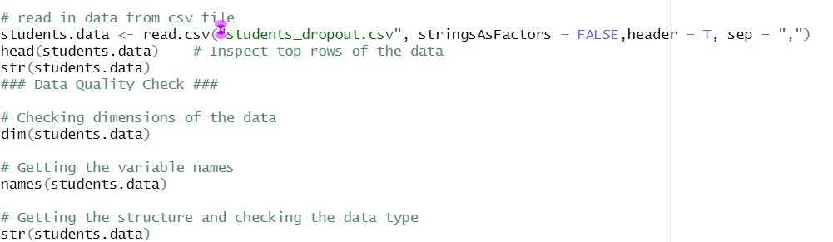

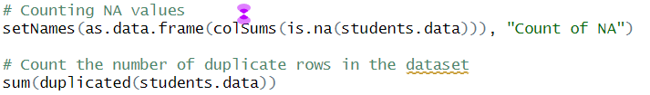

This step also includes the visualization of the variables using barplots, frequency tables, boxplots and histograms after splitting the variables into categorical and numerical columns for more detailed quality checking of each variable.

4.4 Data Cleaning

By checking each variables using barplots and frequency tables, it was found that the variable application order 0 has a frequency of 1, which does not match the metadata. So the data need to be cleaned before further analysis and hence replaced the 0 values by mode value of the application order column.

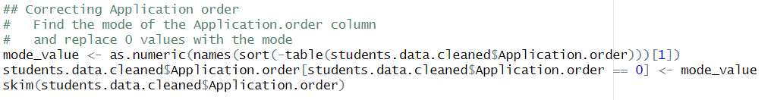

Defined a minimum frequency and combined categories with low frequency and created frequency tables for every categorical variables. Normalization also done with the numerical columns using min-max scaling.

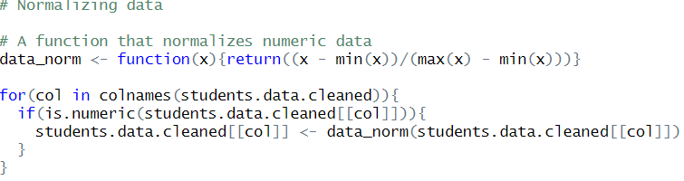

4.5 Exploratory Data Analysis

This section includes the exploratory analysis of independent variables with the target variable ie whether the student is dropped out or not. Barplots and boxplots are used here to visualize the distribution of the independent variables with the target variable.
Also summary of the dependent variable student.status checked through the barplot.

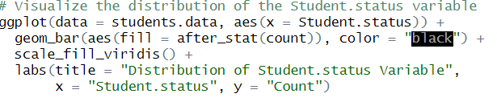

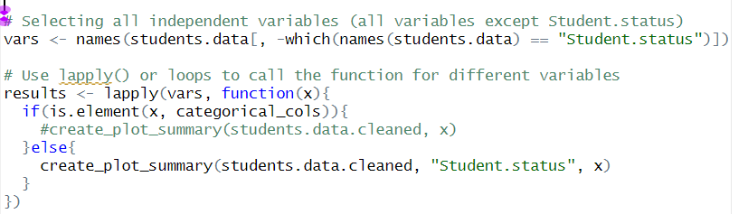
Scaling was done on numerical variables and a correlation matrix was created and heatmap is generated based on this correlation matrix.

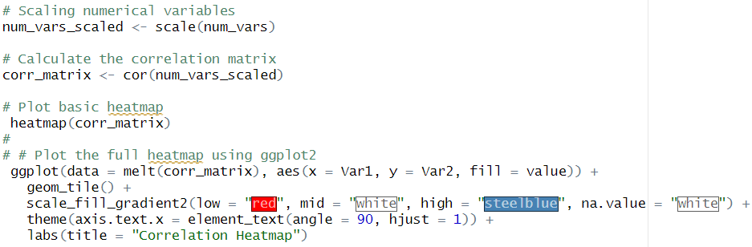

4.6 Factor Analysis and Feature Selection

Before implementing the machine learning models on the data, it is necessary to find out the most important factors that will affect the prediction student.status and to avoid unnecessary variables from the data set for the better performance of the models.
For that first generated a correlation matrix using Spearman correlation test and removed some of the variables with low correlation coefficient values with the target variable, student.status. Then a factor analysis is done using the Varimax rotation component analysis and plotted the number of components with cumulative proportion using the eigen values.

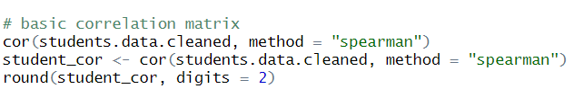
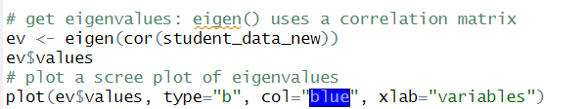
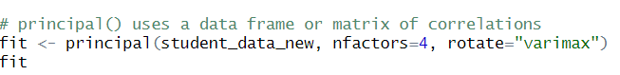

From the result of varimax rotation analysis, some variables that are not much reliable were omitted and again run the varimax rotation for fine tuning the dataset. Hence the final set of variables that will undergone ML algorithms were sorted.

4.7 Machine Learning Models Implementation

In this section, the first process was converting the variables into factors for easy processing of the mL models. Then the data was divided into two as training and testing test and undergone through different ML models like SVM, Logistic Regression and k-Nearest Neighbour algorithms. Each model results and prediction accuracy were generated and compared. ROC curve and AUC calculation were used to evaluating these model results and each model’s ROC curves were plotted and calculated AUC values against each of them.

4.7.1 SVM Model
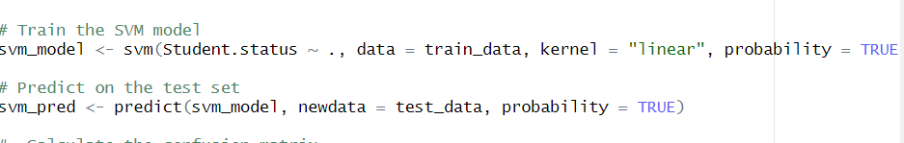

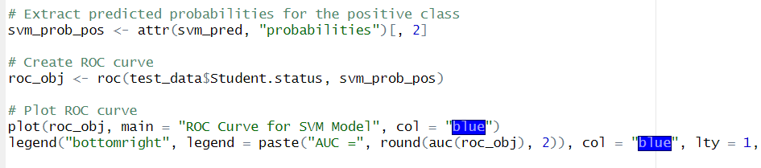

4.7.2 Logistic Regression Model
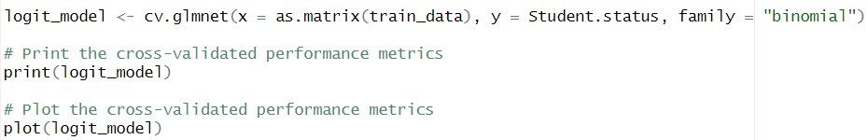

4.7.3 KNN Model

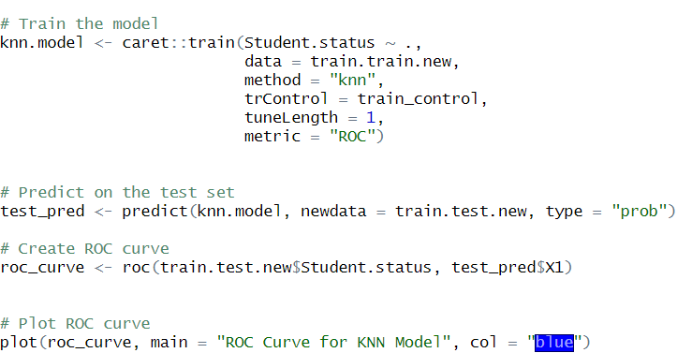

Chapter 5 : Results Interpretation and Discussion

5.1 Introduction

The results of the practical implementation are illustrating and discussing in this section. This includes the data set details, variable descriptions, results of data cleaning process, data exploration graphs like barplots, boxplots, heatmaps, histograms etc., correlation matrices, frequency tables, results of factor analysis, the ML model results interpretations and the ROC curves and AUC values of each models.

5.2 Data Preparation and Quality Check

The data set contains 3630 objects and 34 variables including one dependent variable ie, student.status and 33 independent variables. The variable names and the datatype are shows in the below image.

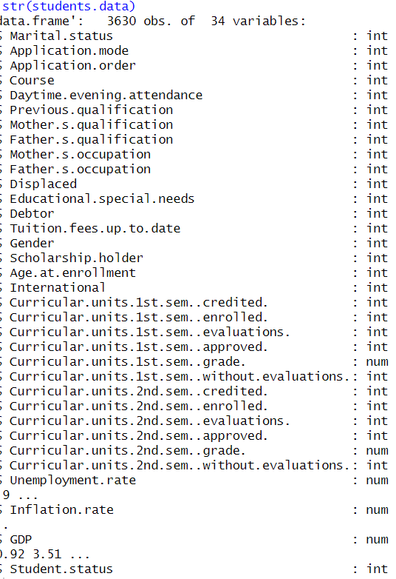
The datatypes of these variables are int and num. Int refres to integer type and num for number type.

After checking the variable details checked if there is any missing values and that was zero for all the variables. The resulted table is shown below.

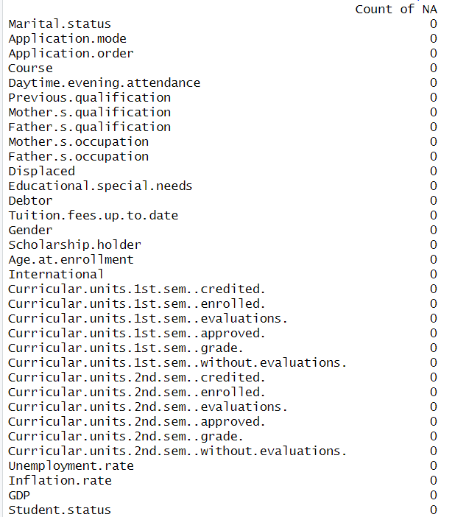

If there was any missing values for any variable in the list it will show the number of missing values instead of 0 against that variable.

Then the different variables frequency distributions are checked and generated the bar plots for each of them. The number of students with status unmarried are higher in number while compared to married or divorced.

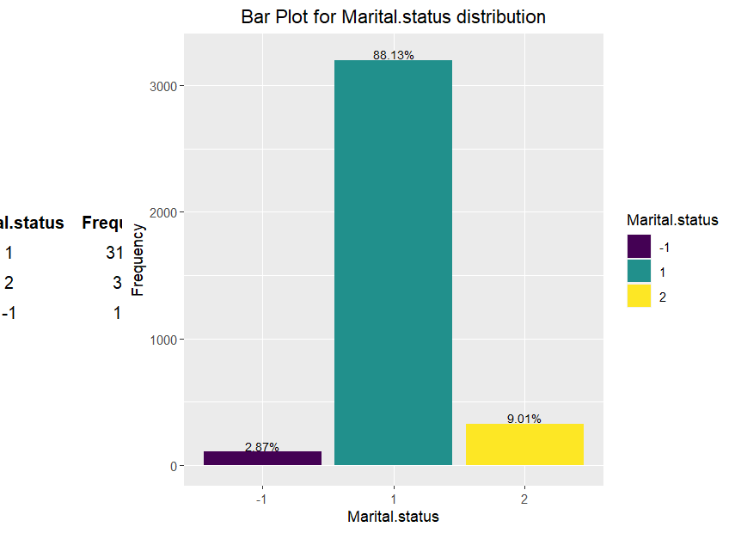
The frequency distribution for different types of application mode are illustrated below. The application mode with value 1 is higher in distribution rate and application mode 14 and 15 have the lowest rates of distribution.
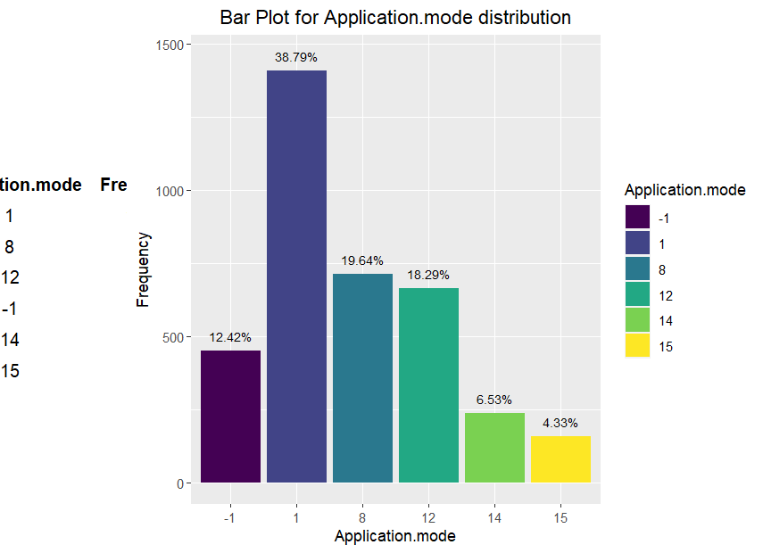
Application order distribution is shown in below image and the value 1 has arate of 67.82 while others are below 20%. That means most of the students joined the course trough the application order type 1.

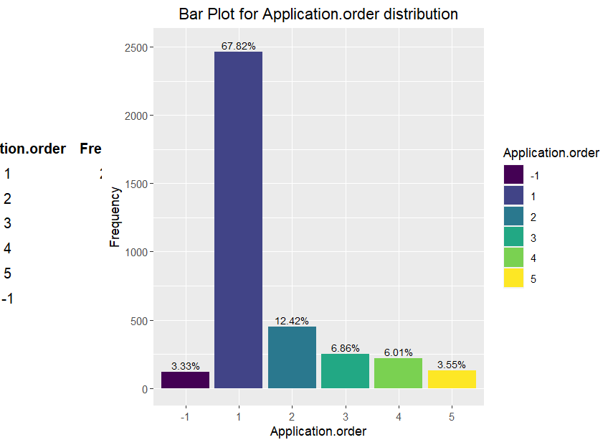
Below image shows the distribution rates of various courses that students chosen. Course number 12 has the higher number of ditribution rates and has a frequency of 666 that means, 666 students among 3350 are opted for this course. The second place is for course number 10 as it got 313 students.

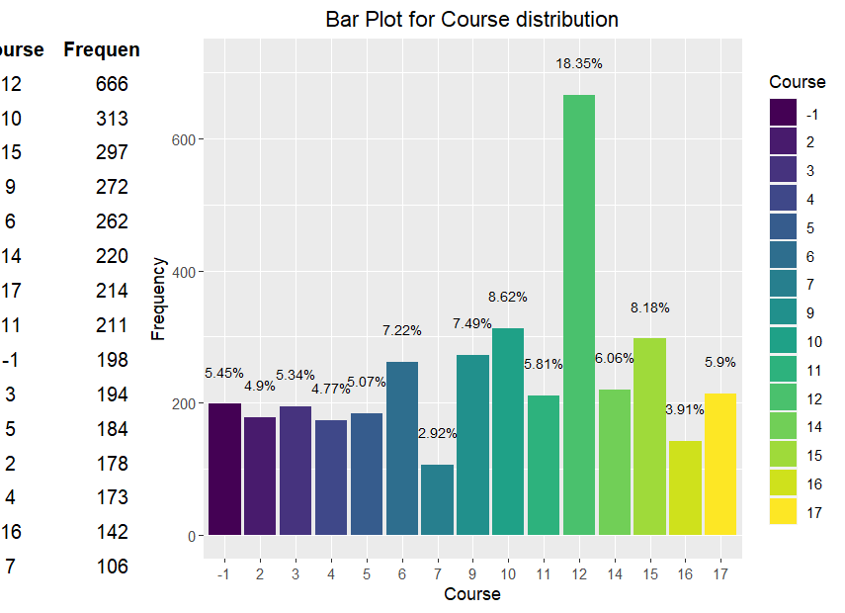

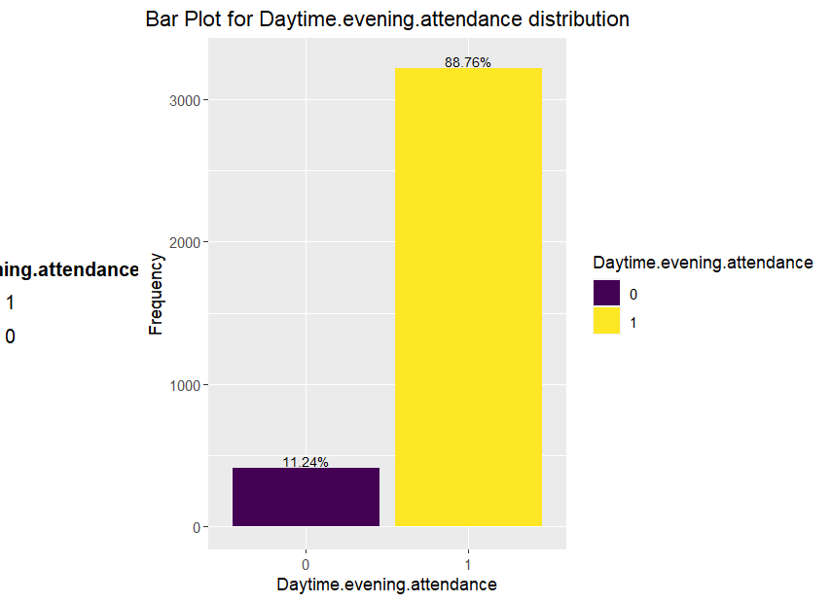
Above image shows the attendance ratio where 1 indicates the daytime attendance pattern whereas 0 shows the evening attendance. Daytime attendenace rate is higher than the other one.

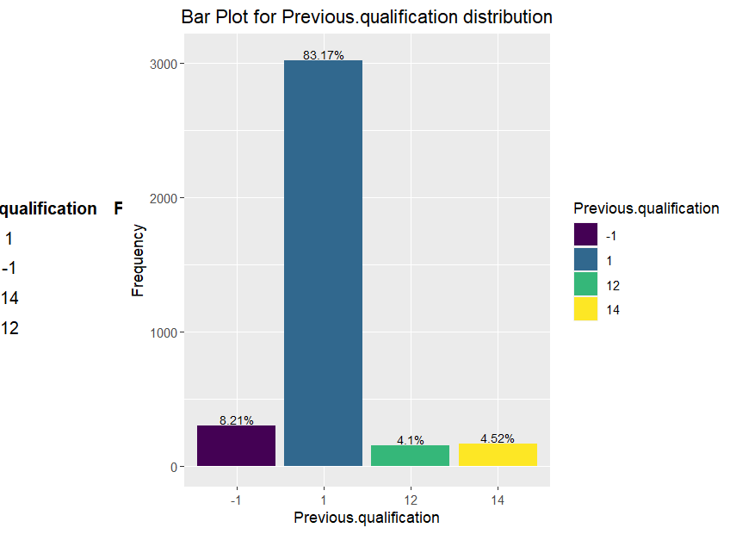

The previous qualification distribution shows that the rate is higher for category 1 and most of the students comes under this category.

5.3 Data Cleaning

During the data preparation process, it is found out that there is a mismatch in application order that order 0 has a frequency of 1 and it does not match the metadata. So data cleaning need to be done to overcome this for that the mode value of application order is found out and replaced 0 with mode value. The summary of application order after data cleaning is shown below.

skim(students.df.cleaned$Application.order)
── Data Summary ────────────────────────
Values
Name students.df.cleaned$Appli...
Number of rows 3630
Number of columns 1
_______________________
Column type frequency:
numeric 1
________________________
Group variables None

── Variable type: numeric ──────────────────────────────────────────────────────────────────────
skim_variable n_missing complete_rate mean sd p0 p25 p50 p75 p100 hist
1 data 0 1 1.52 1.17 -1 1 1 2 5 ▁▇▂▁▁

Below shoeing the details of the components that were within low frequency threshold that is below 150. So combined categories with low frequencies into one for application order and course variables.

5.4 Exploratory Data Analysis

Data exploration is the next step after data cleaning and here the distribution of target variable as well as the relations between independent and target variable are represented through graphs and correlation matrices.

5.4.1 Exploration of Student.status

The statistics for the target variable, student.status is shown below

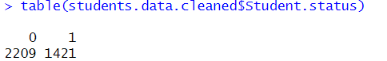

Here the value 0 indicates the number of students not dropped out and 1 indicates the number of students dropped out. So as per the data, 1421 students are dropped out from their studies.

The below image shows the distribution of target variable, student status.

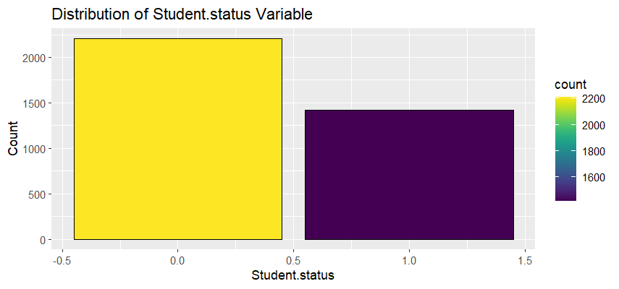

5.4.2 Boxplots - Categorical Variables Vs Student.status

The first boxplot describes the relation between age at enrollment with student.status. There are so many outliers for this variable and it has a negative skewness with the distribution of the data.

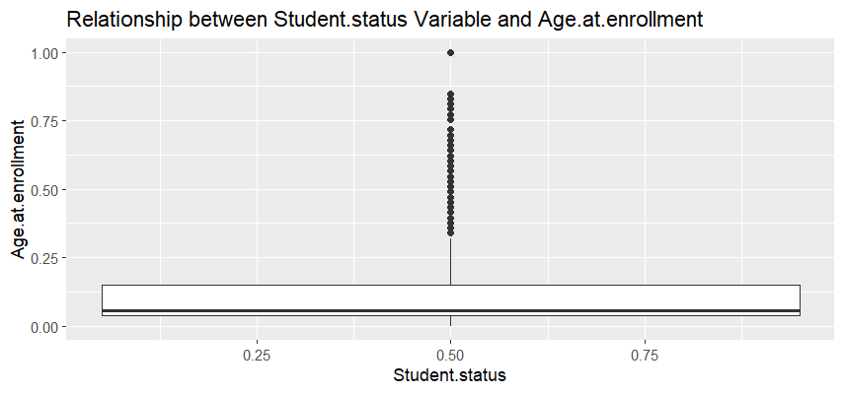
The relation between curricular units 1st sem credited and student status is shown below. Most of the values are as outliers and the median line shown as zero.
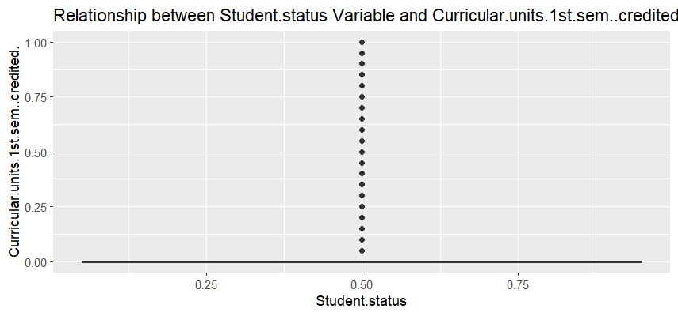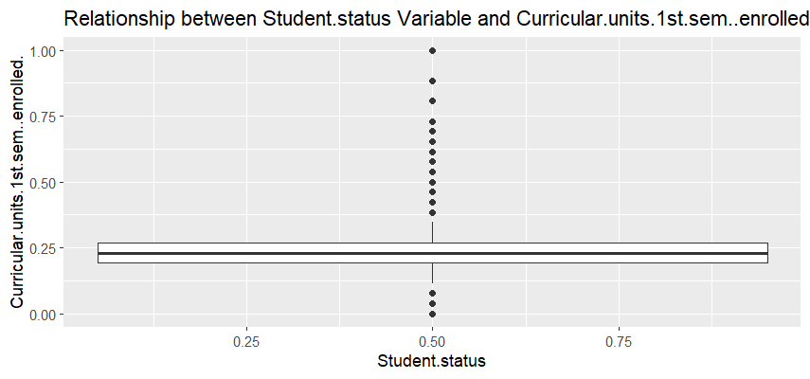
Image shown above is the relation between 1st sem enrolled and student status has a median of almost 0.23 and there is lot of outliers present.

The median value of 1st sem evaluation is 0.23 and it also have many outliers within the values and not normally distributed.
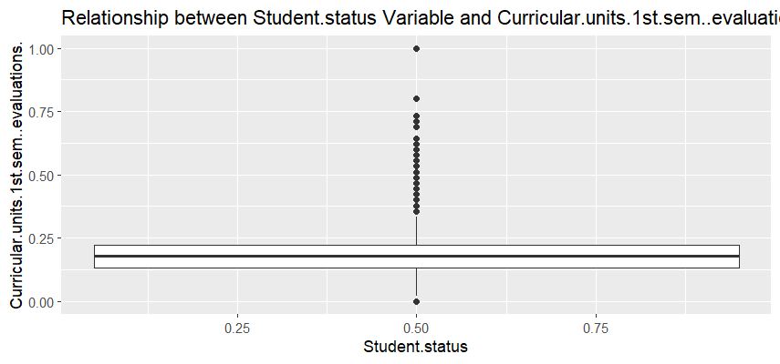
Below image shows the relationship of stident status and 1st sem without evaluations and has a 0 median value and there are outliers too in this set of data.
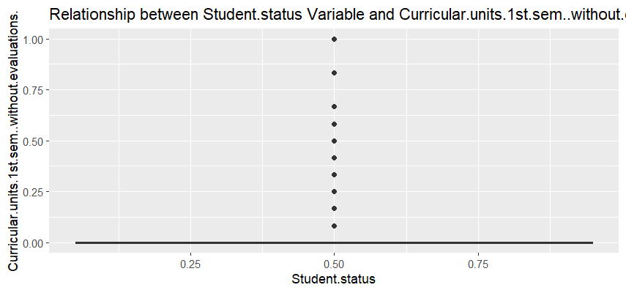

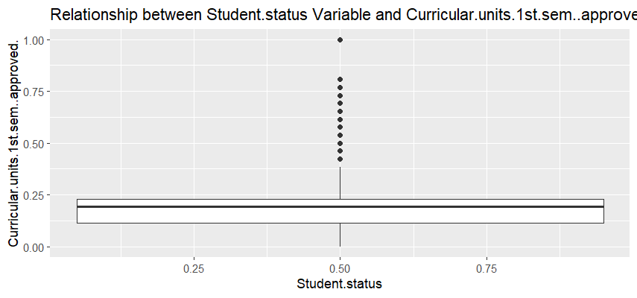
The relation of 1st sem approved and student status has a median value of 0.23 and have a positive skewness.
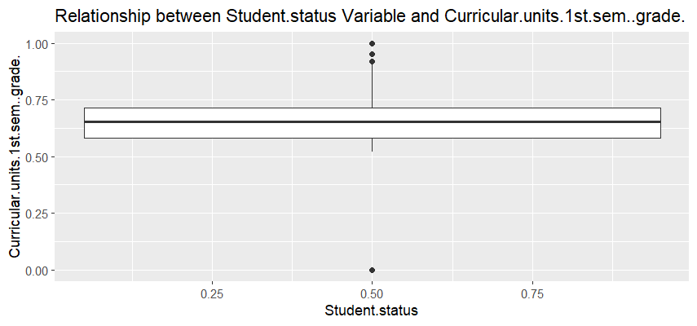
Curricular units 1st sem grade has a median around 0.65 and the median line is in central position. There are only less number of outliers are presented hence this is normally distributed.

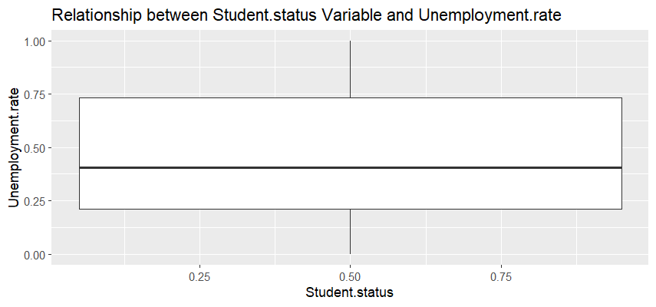
Above image shows the relation between unemployment rate and student status. The median value is around 0.4 and it indicates negative skewness.
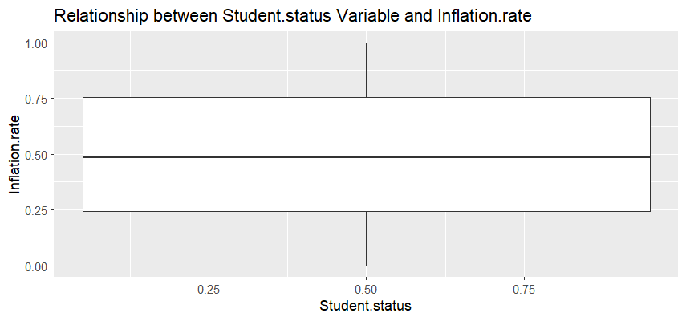
Inflation rate has a median value nearest to 0.5 and the median line is centralised so it is normally distributed. There is no outliers shown and the box is large hence there is wide variance in values,

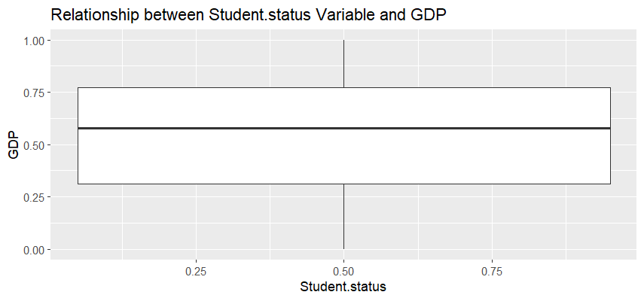

The relation between GDP and student status is shown above and the median value is 0.54 and the line is towards the upward direction so it represents the positive skewness.

5.4.3 Correlation Heatmaps

After exploring the variables through boxplots, a basic correlation matrix was generated and then plotted a heatmap against the matrix values. That heatmap is shown below.
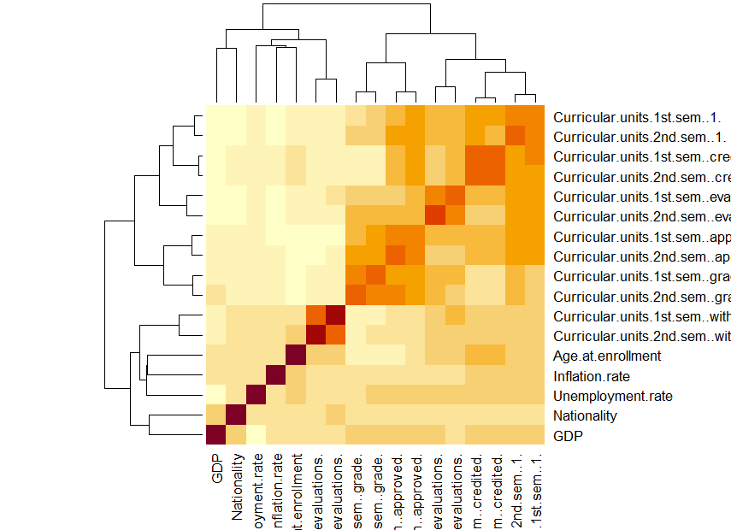
From this heatmap, the variables that correlated with each other can be found out and some of them are highly intercorrelated and need to be removed from the data set.

5.5 Factor Analysis and Feature Selection

5.5.1 Spearman Correlation Test

For selecting the relevant variables, a spearman correlation test is done and from the result the variables need to be omitted are found out and removed from the dataset. The variables include, marital status, nationality, mother’s qualification,educational special needs, International, father’s qualification, mother’s occupation, father’s occupation, 1st sem credited, 1st sem evaluations, 1st sem without evaluations, 2nd sem evaluations,2nd sem without evaluations, unemployment rate,inflation rate and GDP.

After removing these variables, correlation matrix is generated again and a heatmap is created.

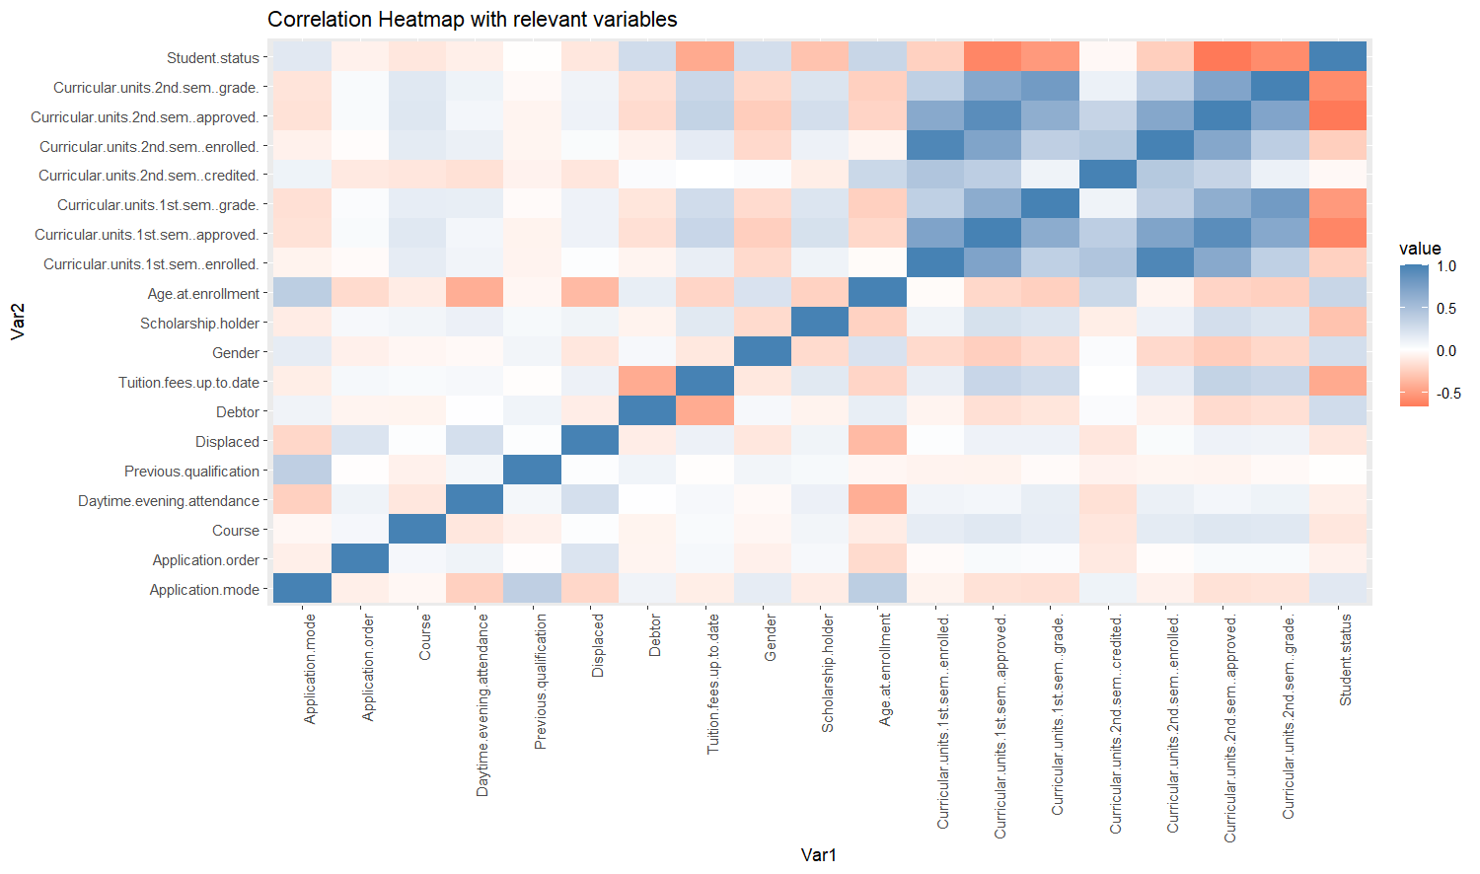

5.5.2 Factor Analysis using Varimax Rotation

Before conducting factor analysis, Kaiser-Mayer-Olkin (KMO) factor adequacy analysis is done and the result is showing below. The overall accuracy of the variables is 0.77 and according KMO, if the overall accuracy value is greater than 0.6 further processing for factor analysis can be done.
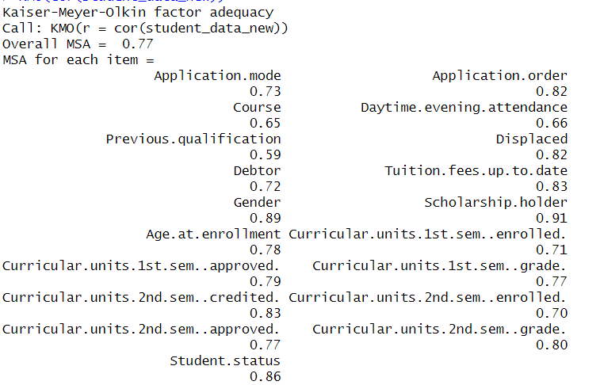

Here the eigen values are calculated for each components and plotted these values against the variables . The eigen values are shown in the below image for each variable.

The screeplot of eigen values and the variables are shown below. The highest value is for the first component, marital status.
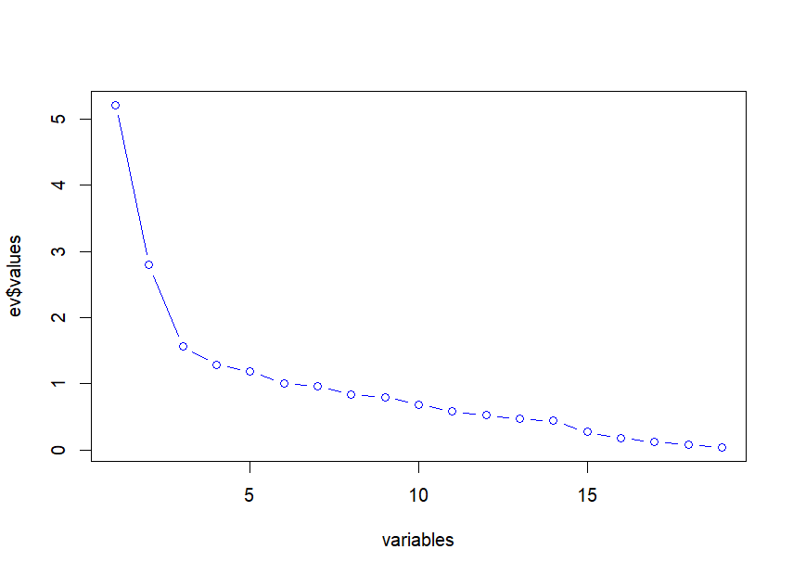

After that the cumulative proportions are calculated and plotted against the number of components.

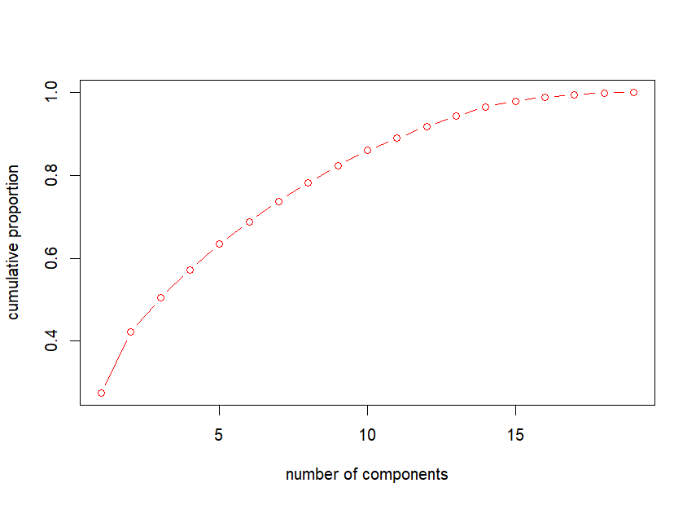

Then varimax rotation component analysis is done and from the result of rotated components, more variables are removed with low correlation with the student status and have higher inter-correlation with other variables. The variables omitted are, application mode, application order, course, gender, 1st sem approved, 2nd sem approved. After that the variamax rotation analysis is done again and rotated components are genarated for the selected variables only.

The screeplot for selected variables and their corresponding eigen values are shown below.

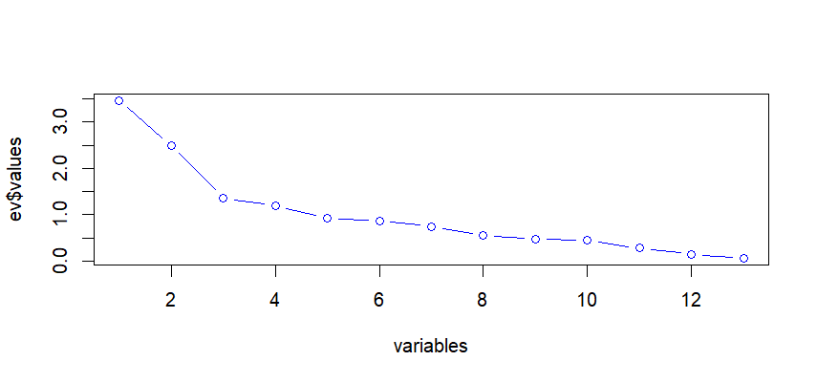

The result of second variamx rotation analysis is shown below:

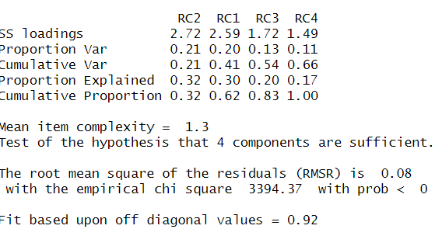

5.6 Machine Learning Models Implementation

Machine learning models that are implemented for predicting the student dropout prediction, in this study are SVM, Logistic regression and KNN models. First the data set is converted as factors for better performance of these models. And then splitted the dataset into training and test data sets and applied each model algorithms and generated ROC curve as well as AUC value and compared between the results to obtain the final prediction output.

5.6.1 SVM Model

After applying the svm algorithm, the below confusion matrix is generated and it shows the accuracy value as 0.82 for this model. The kappa value is 0.60 , sensitivity is 0.90 and specificity is 0.68. The result indicates that the positive class as 0. Mcnemar’s test p value is 9.40. The result also includes the prediction values for corresponding reference values, 0 and 1.

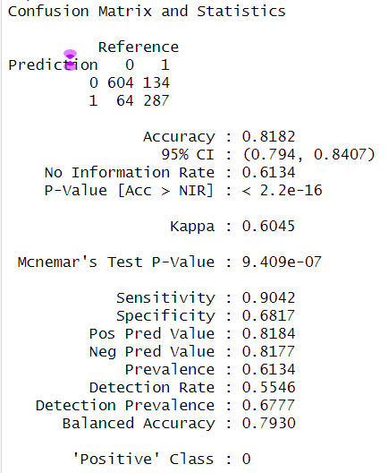

After calculating predictions with the test data ROC curve is generated and the AUC value is calculated against this. The image is shown below. The AUC value is 0.86 and it can be consider as a high predictability value and can accept the model for predicting the student dropout from higher educational institutions.

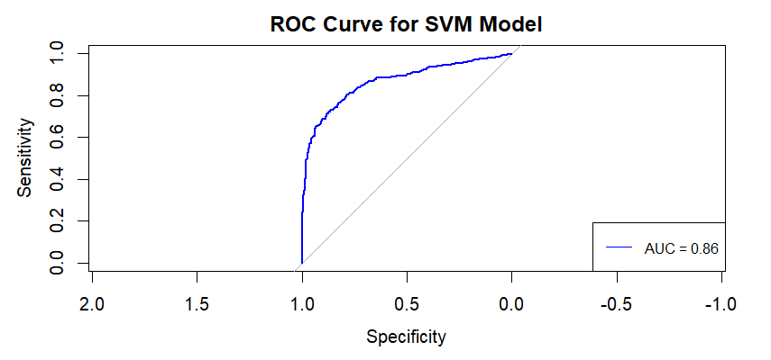

5.6.2 Logistic Regression Model

Next ML model that implemented on the data set is logistic regression. After splitting the data set into training and test set, the logistic algorithm function is applied on the training data set for training the data. The result of logistic model is shown below.

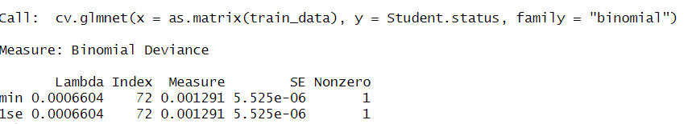

The cross-validated performance matrix is plotted and shown below.

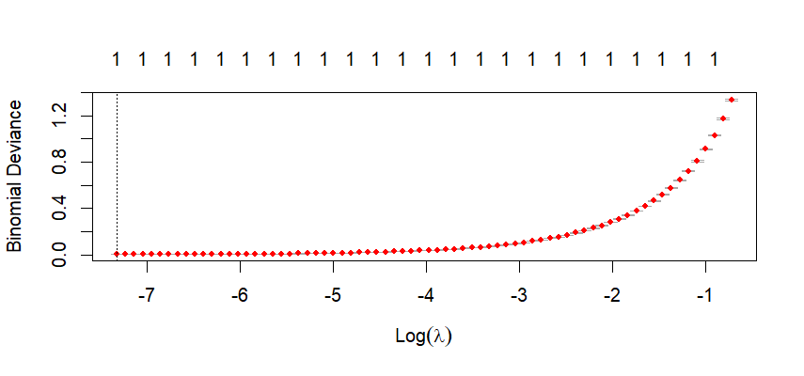
The plot represents the lambda values against the binomial deviance values and it is in an upward direction. The confusion matrix for the predictors are generated and shown below.

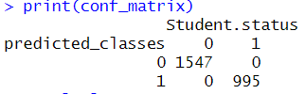

Based on the matrix, 995 students will be dropped out from their courses and the remaining will be retained. The ROC curve for logistic model is shown below.

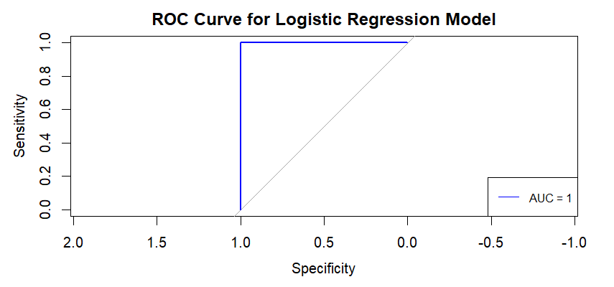

The AUC value , specificity and sensitivity all are comes as 1. It shows the logistic model is more accurate than SVM model and hence one of the best model for student dropout prediction.

5.6.3 KNN Model

At last the k-nearest neighbour algorithm is implemented on the training and test data set for optimizing the results.

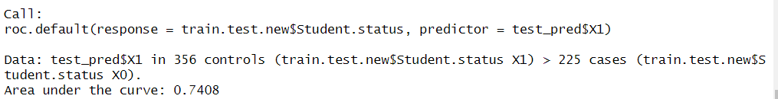

Image above is the interpretation of the ROC curve calculation. Area Under the Curve (AUC) value is 0.74.
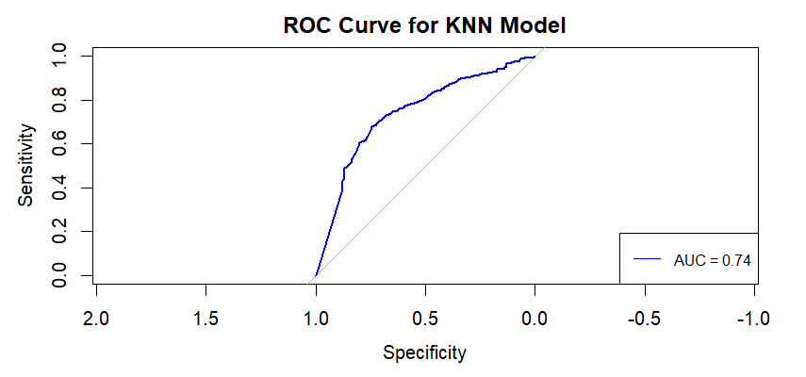
The ROC curve for the KNN model is shown above and the AUC value is 0.74 which is the lowest AUC values among these three models. Hence KNN modle is the least predictor model among these three ML models.

Chapter 6 : Critical Evaluation

This dissertation mainly focused on a study on predictive analytics for student dropout in higher educational institutions using machine learning techniques. So the first process that was done for this study was a detailed literature review on existing studies about student dropout, higher education, predictive analytics and machine learning techniques that already employed on student dropout prediction. From this study it is concluded that, there are lot of models were implemented and experimented already and the best models among them are SVM and Logistic regression in most of the studies. So it is decided to find out which is the best model for predicting student dropout and to work with the models SVM, Logistic regression and include KNN model too with these. Then the next step was data collection and it done by searching on different public data sites like UCI, Kaggle, government sites etc. And got the data set from the Kaggle. Then using Rstudio loaded and explored through the data for better understanding of the variables. Data processing and cleaning are done with the help of R packages and exploration analysis was done by plotting different types of graphs like bar plots, boxplots, histograms and frequency tables. Factor analysis and feature selection were done using Spearman correlation test and Varimax rotation component analysis. Some variables are omitted from the list for better performance of the ML models. Then each model were implemented on the datasets for results. For SVM the AUC value is 0.86 , for logistic regression AUC is 1 and for KNN AUC is 0.74. Based on the AUC values, Logistic regression is the optimal model among these and it can be used as a predictive model for student dropout prediction in higher educational institutions. From the literature review it was evident that logistic model is one of the best model for predicting the student dropout rates and from this study it is proved but it will need more accurate evaluation techniques like hyper parameter tuning for the assurance of this prediction. Eventhough it is not evaluated with more techniques, it is clear that Logistic Regression is one of the best models among all ML algorithms. In this study the maximum effort is taken for exploring through each variables but one of the important challenges faced during this study was the class imbalance problem. Eventhough there is class imbalance of the output variable, managed to train and test all the ML models with optimal accuracy. The future works should be focus on to overcome the class imbalance issue as well as fine tuning the Ml model results with more precise techniques.

Chapter 7 : Conclusion

To conclude this dissertation, our aim was to study on predictive analytics for student dropout prediction in higher educational institutions using machine learning approach. That was done clearly and effectively with the support of existing literature review and implemented the models SVM, Logistic regression and KNN and found out Logistic regression as the optimal machine learning model for predicting the student dropout rates in higher educational institutions. These models are evaluated through ROC curve and AUC. If necessary more enhanced and accurate decision about this can be find out in the future using more effective evaluation techniques .

References

- Kaggle: Higher education predictors of student retension [Online].Available: https://www.kaggle.com/datasets/thedevastator/higher-education-predictors-of-student-retention
- UNESCO Institutions for Lifelong Learning .(2022). The Role of Higher Education Institutions for Lifelong Learning. https://www.uil.unesco.org/en/role-higher-education-institutions-lifelong-learning.
- Dianne F. Harrison (2017). The Role of Higher Education in the Changing World of Work . https://er.educause.edu/articles/2017/10/the-role-of-higher-education-in-the-changing-world-of-work.
- Heinz-Dieter, M., & Powell, J. W. (2018). The new institutionalism in higher education. The SAGE Encyclopedia of Higher Education. https://scholar.google.com/scholar_lookup?hl=en&publication_year=2018&author=M.+Heinz-Dieter&author=J.+W.+Powell&title=The+new+institutionalism+in+higher+education.
- Behr, A.; Giese, M.; Teguim Kamdjou, H.D.; Theune, K. Motives for Dropping out from Higher Education—An Analysis of Bachelor’s Degree Students in Germany. Eur. J. Educ. 2021, 56, 325–343.
- Kehm, B.M.; Larsen, M.R.; Sommersel, H.B. Student Dropout from Universities in Europe: A Review of Empirical Literature. Hungarian Educ. Res. J. 2020, 9, 147–164.
- Quinn, J. Dropout and Completion in Higher Education in Europe among Students from Under-Represented Groups; An Independent report authored for the NESET network of experts; European Commission: Brussels, Belgium, 2013.
- Realinho, Valentim, Jorge Machado, Luís Baptista, and Mónica V. Martins. 2022. "Predicting Student Dropout and Academic Success." Data 7, no. 11: 146. https://doi.org/10.3390/data7110146.
- Véliz Palomino J. C., Ortega A. M. (2023) ‘Dropout Intentions in Higher Education: Systematic Literature Review’, Journal on Efficiency and Responsibility in Education and Science, vol. 16, no. 2, pp. 149-158. http://dx.doi.org/10.7160/eriesj.2023.160206.
- Bardach, L., Lüftenegger, M., Oczlon, S., Spiel, C. and Schober, B. (2020) ‘Context-related problems and university students’ dropout intentions — The buffering effect of personal best goals’, European Journal of Psychology of Education, Vol. 35, No. 2, pp. 477–493. https://doi.org/10.1007/s10212-019-00433-9.
- Bernardo, A. B., Tuero, E., Cervero, A., Dobarro, A. and Galve-González, C. (2020) ‘Bullying and cyberbullying: Variables that influence university dropout//Acoso y ciberacoso: Variables de influencia en el abandono universitario’, Comunicar, Vol. 28, No. 64, pp. 63–72. https://doi.org/10.3916/C64-2020-06.
- Bargmann, C., Thiele, L. and Kauffeld, S. (2022) ‘Motivation matters: predicting students’ career decidedness and intention to drop out after the first year in higher education’, Higher Education, Vol. 83, No. 4, pp. 845–861. https://doi.org/10.1007/s10734-021-00707-6.
- Castro-Lopez, A., Cervero, A., Galve-González, C., Puente, J. and Bernardo, A. B. (2022) ‘Evaluating critical success factors in the permanence in Higher Education using multi-criteria decision-making’, Higher Education Research & Development, Vol. 41, No. 3, pp. 628–646. https://doi.org/10.1080/07294360.2021.1877631.
- Sosu, E.M.; Pheunpha, P. Trajectory of University Dropout: Investigating the Cumulative Effect of Academic Vulnerability and Proximity to Family Support. Front. Educ. 2019, 4, 6.
- Aina, C.; Baici, E.; Casalone, G.; Pastore, F. The Economics of University Dropouts and Delayed Graduation: A Survey. SSRN Electron. J. 2018.
- Lee, Y.H.; Kim, K.S.; Lee, K.H. The effect of tuition fee constraints on financial management: Evidence from Korean private universities. Sustain. 2020, 12, 5066.
- Stinebrickner, R.; Stinebrickner, T.R. A Major in Science? Initial Beliefs and Final Outcomes for College Major and Dropout. Rev. Econ. Stud. 2014, 81, 426–472.
- Jovial Niyogisubizo, Lyuchao Liao, Eric Nziyumva, Evariste Murwanashyaka, Pierre Claver Nshimyumukiza, Predicting student's dropout in university classes using two-layer ensemble machine learning approach: A novel stacked generalization, Computers and Education: Artificial Intelligence, Volume 3, 2022, 100066, ISSN 2666-920X, https://doi.org/10.1016/j.caeai.2022.100066.
- D. Kim, S. Kim Sustainable education: Analyzing the determinants of university student dropout by nonlinear panel data models Sustainability, 10 (4) (2018), p. 954.
- V.R.D.C. Martinho, C. Nunes, C.R. Minussi An intelligent system for prediction of school dropout risk group in higher education classroom based on artificial neural networks 2013 IEEE 25th international conference on tools with artificial intelligence (2013).
- M. Jadrić, Ž. Garača, M. Čukušić. Student dropout analysis with application of data mining methods. Management: Journal of Contemporary Management Issues, 15 (1) (2010), pp. 31-46.
- S. Lee, J.Y. Chung, The machine learning-based dropout early warning system for improving the performance of dropout prediction Applied Sciences, 9 (15) (2019), p. 3093.
- M. Orooji, J. Chen, Predicting Louisiana public high school dropout through imbalanced learning techniques, 2019, 18th IEEE international conference on machine learning and applications, (ICMLA) (2019).
- F. Del Bonifro, M. Gabbrielli, G. Lisanti, S.P. Zingaro, Student dropout prediction International conference on artificial intelligence in education, (2020).
- L. Aulck, N. Velagapudi, J. Blumenstock, J. West, Predicting student dropout in higher education (2016) arXiv preprint arXiv:1606.06364.
- S.B. Kotsiantis, C. Pierrakeas, P.E. Pintelas Preventing student dropout in distance learning using machine learning techniques International conference on knowledge-based and intelligent information and engineering systems (2003).
- C. Lang, G. Siemens, A. Wise, D. Gasevic Handbook of learning analytics SOLAR, Society for Learning Analytics and Research, New York (2017).
- C. Márquez-Vera, C.R. Morales, S.V. Soto Predicting school failure and dropout by using data mining techniques IEEE Revista Iberoamericana de Tecnologias del Aprendizaje, 8 (1) (2013), pp. 7-14.
- E.M. Queiroga, J.L. Lopes, K. Kappel, M. Aguiar, R.M. Araújo, R. Munoz, R. Villarroel, C. Cechinel A learning analytics approach to identify students at risk of dropout: A case study with a technical distance education course Applied Sciences, 10 (11) (2020), p. 3998.
- Y. Li Feature extraction and learning effect analysis for MOOCs users based on data mining International Journal of Emerging Technologies in Learning (iJET), 13 (10) (2018), pp. 108-120.
- V.R. Martinho, C. Nunes, C.R. Minussi Prediction of school dropout risk group using neural network 2013 federated conference on computer science and information systems (2013).
- A. Serra, P. Perchinunno, M. Bilancia Predicting student dropouts in higher education using supervised classification algorithms International conference on computational science and its applications (2018).
- X. Chen, D. Zou, G. Cheng, H. Xie Detecting latent topics and trends in educational technologies over four decades using structural topic modeling: A retrospective of all volumes of computers & education Computers & Education, 151 (2020), Article 103855 View PDFView articleView in ScopusGoogle Scholar.
- Chen et al., 2022 X. Chen, D. Zou, H. Xie, G. Cheng, C. Liu Two decades of artificial intelligence in education: Contributors, collaborations, research topics, challenges, and future directions Journal of Educational Technology & Society, 25 (1) (2022).

Appendices

- Rscript : DISSERTATION-Rscript.docx (sharepoint.com)ss
- Dataset : students_dropout.csv (sharepoint.com)

