Project Overview
I am extending my student directory API with courses and enrollments. The API uses Express, MongoDB Atlas, and JWT authentication. Students and courses are stored separately, and each enrollment connects one student to one course. A student’s small Cloudinary avatar reference is saved with the student record.
Collection | What I store
Student | Student details and an embedded avatar URL and public ID
Course | Course title, unique code, and credit count
Enrollment | Student and course references plus enrollment status, grade, and date
User | Login email, hashed password, and role

Question 1: Embedding and Referencing
Relationship A: Course and Enrollment
I use references. Each enrollment stores the IDs of its student and course, so I can query enrollments from a student, a course, or the statistics endpoint.
Factor | Why referencing fits my project
Access patterns | I need a student’s course list, a course roster, and course grade statistics. A separate Enrollment collection supports each query.
Cardinality | A course can have many enrollments, and that number can keep growing.
Data volatility | Enrollment status and grades can change, so I can update a small enrollment record without rewriting a large course document.
Duplication tolerance | I avoid copying student names or course titles into every enrollment, which could become outdated.

Growth risk: Keeping enrollments separate avoids a growing embedded array reaching MongoDB’s 16 MB document limit. As the collection grows, queries may need indexes. The compound student/course index prevents duplicate enrollment pairs. If a student or course is deleted, its enrollments should also be removed or archived so they do not become orphaned.
Relationship B: Student and Avatar
I embed the avatar reference in the Student document as a small object with a Cloudinary URL and public ID. The image itself stays in Cloudinary.
Factor | Why embedding fits my project
Access patterns | The avatar is usually displayed with the student, so one student query returns both.
Cardinality | Each student has at most one avatar, so the data stays small and bounded.
Data volatility | A student’s avatar does not change often.
Duplication tolerance | The avatar belongs to one student, so I do not need to duplicate it elsewhere.

Growth risk: One URL and public ID are small, so the 16 MB limit is not a concern. If I later support a gallery of many images, I would move uploads into their own collection and reference the student. A stored URL could become stale if an image is deleted, so keeping the public ID helps manage it.

Question 2: Many-to-Many Relationship
Students and Courses have a many-to-many relationship: a student can take several courses, and each course can have several students. I model this with an Enrollment join collection. Each enrollment stores the two references and the information that belongs to that pair: status, grade, and enrollment date.
I chose a join collection because grades and status describe a specific student in a specific course. A unique compound index prevents duplicate pairs, and the collection makes it straightforward to query and aggregate enrollment data. Arrays on both Student and Course would grow over time and require keeping two lists in sync.

Question 3: Aggregation Pipeline Strategy
Insight: I want the dashboard to show up to five courses with the highest average grades, along with the number of completed enrollments and the highest grade in each course.
- Pipeline pseudocode, starting from Enrollment:
- $match completed enrollments with a grade
- $group by course; calculate count, average grade, and highest grade
- $lookup course details from courses
- $unwind the matching course
- $project course code, title, count, rounded average, and highest grade
- $sort by average grade descending
- $limit to 5 results
I put $match first so later stages process only completed enrollments with grades. The group stage calculates one summary per course, and the lookup adds readable course details. Sorting and limiting gives the dashboard its top five.

Part 3: Reflection
What is the N+1 Query Problem, and how did populate() help?
The N+1 problem happens when an app fetches a list and then makes another database request for each item to load its related data. In my enrollment route, populate() batches the student and course lookups instead of making a separate request for every enrollment. I selected only the fields the response needs, such as the student name and email and the course title, code, and credits. This reduces extra database round trips and avoids returning unrelated fields.
Why should $match be the first stage?
Putting $match first filters out records before the later aggregation stages do more work. MongoDB may also be able to use an index for that filter. If the match comes last, the pipeline may group, join, and sort many records that will eventually be discarded, which can waste time and memory.

Screenshot 1 — Populated Enrollments
GET /api/enrollments — show student name/email and course title/code/credits.
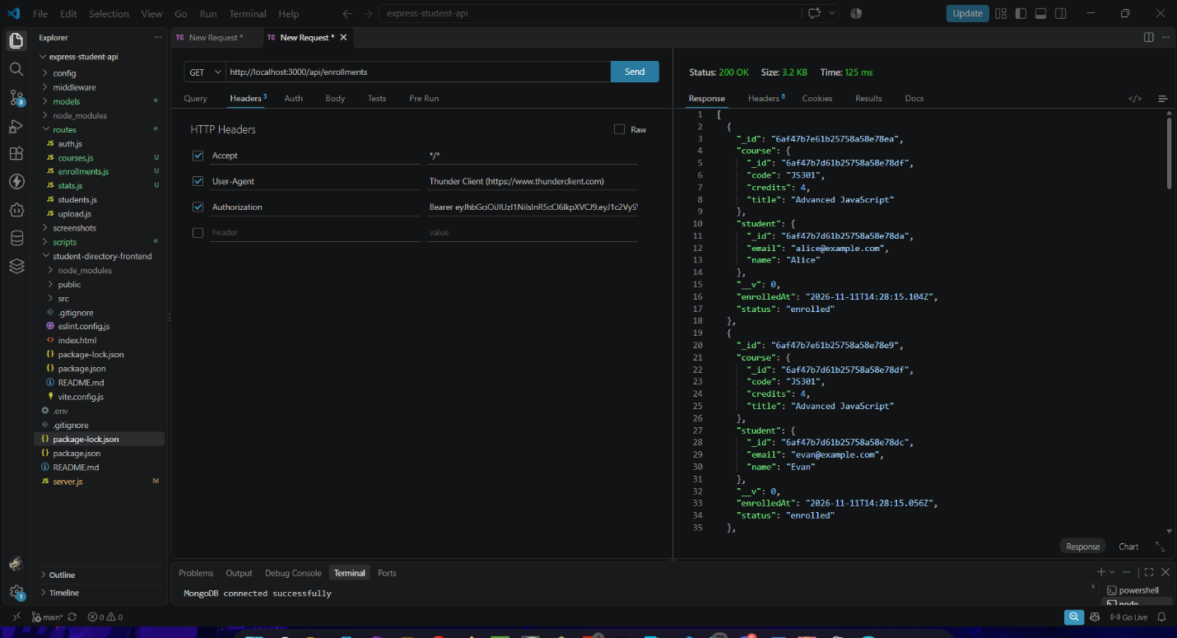
Screenshot 2 — Course Statistics
GET /api/stats/courses — show averageGrade, completedCount, and highestGrade.


