HRMS Project: Detailed Module Breakdown

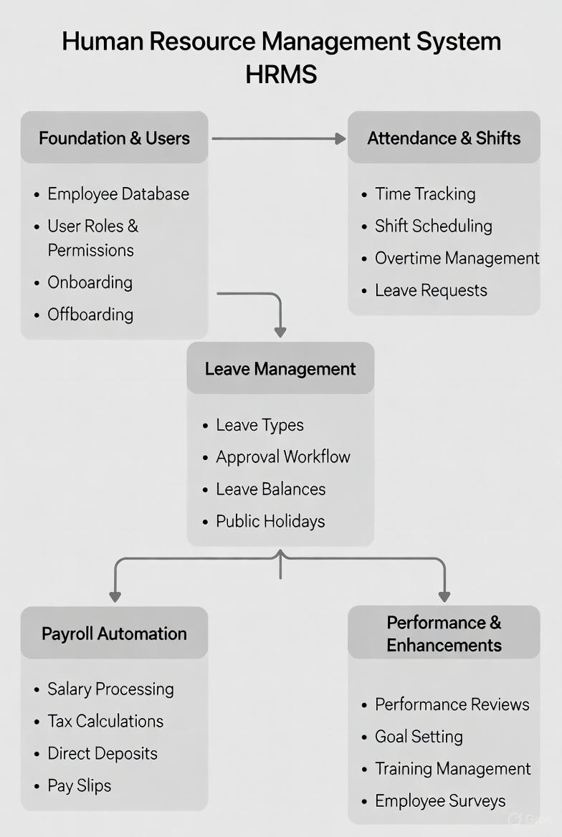

📊Module Summary

Module | Purpose | Key Complexity
1. Foundation & Users | Set up the company, roles, and onboard employees | Medium (User access controls and database links)
2. Attendance & Shifts | Track daily time in/out and apply rules | High (Location checks, smart logic, and validations)
3. Leave Management | Handle time-off requests and approvals | Medium (Date calculations and balance tracking)
4. Payroll Automation | Calculate salaries and create payslips | High (Math formulas and PDF creation)
5. Performance (PMS) | Yearly reviews and growth tracking | Low (Simple add/edit and rating system)

📦 Module 1: Foundation & User Management (The Base) Goal: Get the app ready so everyone can log in and build the basic data setup.
A. Admin / HR Features (Setup Side)
- Organization Profile Setup:
  - A simple form to add company name, logo, website, GST/Tax ID, and registered address.
  - Why? This info will show up on payslip headers with the logo and address.
- Masters Setup (Add/Edit/Delete):
  - Departments: Add things like IT, Sales, HR.
  - Designations: Add job titles with levels (e.g., Level 1 - Intern, Level 5 - Manager).
  - Hierarchy: Set up which job level reports to which one.
- Role & Permissions (User Access Controls):
  - Create roles like "Super Admin", "HR Manager", "Employee".
  - Permission grid: A checkbox table where you tick yes/no for things like "Can HR edit attendance?"
- Employee Onboarding Wizard (Step-by-Step Form):
  - Step 1: Basic info (name, email, phone, date of birth).
  - Step 2: Job details (department, designation, join date, pick reporting manager).
  - Step 3: Salary setup (assign total pay package).
  - Step 4: Create account (auto-make employee code and temporary password).
B. Employee Features (User Side)
- Login System:
  - Log in with email/employee code and password.
  - First login? Must change password right away.
  - Forgot password? Easy reset flow.
- My Profile:
  - View personal details (read-only for private stuff).
  - Request changes: Submit a form to update address or phone number.
- Document Vault:
  - Upload docs like Aadhar, PAN, resume.
  - Check status: "Verified by HR" or "Rejected" .
📦 Module 2: Attendance & Shift Configuration (The Daily Logic) Goal: Track who comes and goes every day, and enforce simple rules.
A. Admin / HR Features
- Shift Master:
  - Set up shifts like General (9 AM - 6 PM) or Night (8 PM - 5 AM).
  - Rules: Allow 15-min grace for lateness, or mark half-day if less than 4 hours worked.
- Location Master (Geo-fencing):
  - Set office location (latitude/longitude) and radius (e.g., 100 meters).
  - Add static IP for WiFi-only check-ins.
- Attendance Reports:
  - Daily: Who's absent today? Who's late?
  - Monthly: Total present/absent days for each person.
B. Employee Features
- Smart Dashboard Widget:
  - Check-In Button: Tap it – app checks location and IP.
    - Success: "You're marked present!"
    - Fail: "Not at office location."
  - Timer: Starts after check-in to show hours worked.
  - Check-Out Button: Tap at end of day.
- Break Management:
  - Buttons for "Start Lunch Break" / "End Lunch Break" (to calculate real work hours).
- My Attendance History:
  - Calendar view: Green for present, red for absent, yellow for late.
- Regularization Request:
  - Missed a punch? Fill a form like "Forgot ID card, please mark me present" – sends to manager.
📦 Module 3: Leave Management System (LMS) Goal: Manage vacations without endless emails.
A. Admin / HR Features
- Leave Type Configuration:
  - Set types like CL (Casual Leave), SL (Sick Leave), PL (Privilege Leave).
  - Rules: "Can't take more than 2 CL days in a row."
- Holiday Calendar:
  - Add public holidays (Diwali, Eid, Christmas).
  - Logic: No "absent" mark on these days for attendance.
- Leave Allocation:
  - Auto-script to add leaves (e.g., 1 CL per month).
B. Employee Features
- Apply Leave:
  - Pick date range (from-to).
  - Choose type (CL/SL).
  - Add reason and attachment (like medical cert for sick leave).
  - Preview: "After this, you'll have X days left."
- Leave Balance Card:
  - Quick view: Total: 12 | Used: 2 | Available: 10.
- Manager Approval Inbox:
  - Managers see a list: "Nikhil requested leave."
  - Options: Approve or reject (with a reason).
📦 Module 4: Payroll Automation (The Calculation) Goal: Turn attendance and leave data into salary payouts.
A. Admin / HR Features
- Salary Components Master:
  - Set up parts like Basic, HRA, DA (earnings) and PF, Tax (deductions).
- Employee Salary Structure:
  - Assign amounts: Nikhil's Basic = ₹20,000, HRA = ₹10,000.
- Adhoc Payments:
  - Add one-time stuff like bonus, incentive, or reimbursement for a month.
- Run Payroll (The Main Engine):
  - Step 1: Pick month (e.g., Nov 2025).
  - Step 2: Pull attendance data (paid days).
  - Step 3: Calculate: (Fixed salary / 30) x paid days.
  - Step 4: Subtract tax/PF.
  - Step 5: Generate everything.
- Payslip Management:
  - View payslips and email them to everyone at once.
B. Employee Features
- My Payslips:
  - List of past months.
  - Download as PDF button.
- Tax Declaration (Investment Proofs):
  - Upload proofs for tax savings (like LIC or PPF docs) to lower your tax.
📦 Module 5: Performance & Enhancements (The Growth) Goal: Build a review system and add nice extras.
A. Admin / HR Features
- Appraisal Cycle Setup:
  - Create periods like "Annual Review 2025-26".
  - Set dates: "Starts April 1, ends April 30."
- WFH Configuration:
  - Allow certain employees to work from home.
B. Employee Features
- Goal Setting (KRA):
  - Add your yearly goals at the start.
- Self Appraisal:
  - Rate yourself (1-5 stars) and write comments.
- Manager Review:
  - Manager views your self-rating and adds theirs.
- WFH Request:
  - Ask to work from a specific spot – manager approves.

