Reason evaluation in Argentina and Colombia
  - Integrated results for Gino and Anto | Interim data through 21 October 2026
These studies extend our work on political reasons to Argentina and Colombia. Agreement with a reason’s position was strongly related to its perceived quality. Favorable evaluations of opponents’ reasons also accompanied warmer feelings and lower affective polarization, although this pattern did not extend clearly to every attitude measure.
Participants reported their political alignment and issue positions, then rated 20 distinct reasons on a 0–100 quality scale. Reasons were sampled from topics on which they had a clear position; author camp was concealed. After exclusions, there were 1,256 eligible participants in Argentina and 1,311 in Colombia. The primary Argentine sample comprised the 870 who named a unique opponent; the remaining 386 are considered separately on page 4.
The registered stopping target is 1,500 qualifying cases per country. This snapshot contains 811 in Argentina and 1,197 in Colombia; qualifying cases must have all required primary measures and covariates. The findings below are interim and do not change that stopping rule.

Agreement and political camp
In the preregistered models, reasons supporting positions participants endorsed received higher ratings (Argentina: b = 22.91, 95% CI [21.15, 24.68]; Colombia: b = 20.84, 95% CI [19.29, 22.39]). A smaller own-camp advantage remained after accounting for agreement (Argentina: b = 3.19, 95% CI [1.61, 4.77]; Colombia: b = 3.21, 95% CI [2.11, 4.32]; all four Holm p < .001).
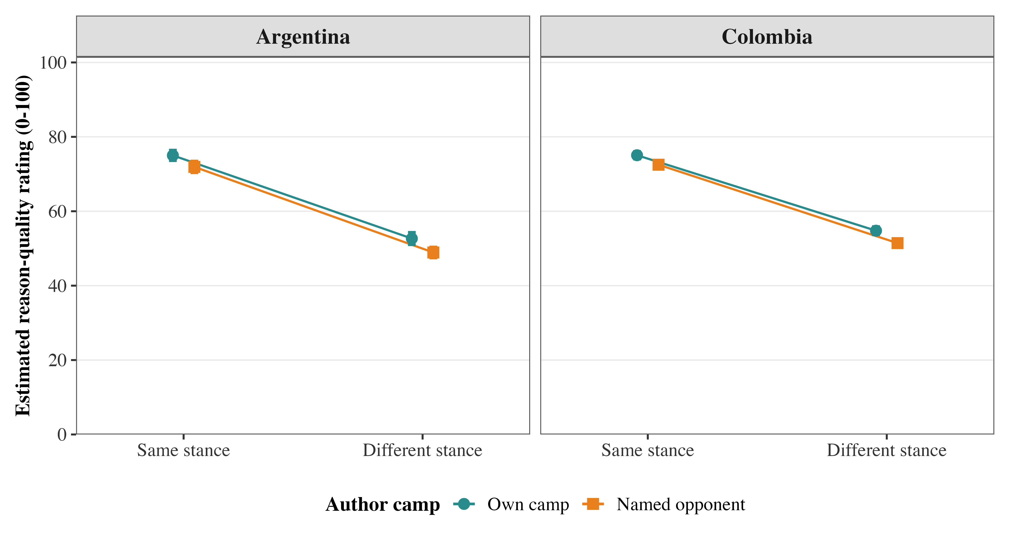
Figure 1. Follow-up 2 × 2 models show estimated ratings by issue agreement and author camp, with 95% confidence intervals. These crossed evaluator and reason random-intercept models include presentation order. Argentina: 870 evaluators, 8,794 own/opponent ratings; Colombia: 1,311 evaluators, 26,220 ratings. Argentina’s other-camp ratings are excluded from this display but retained in the primary model.
The follow-up factorial analysis did not show a clear agreement × camp interaction (Argentina: b = −0.66, 95% CI [−3.27, 1.95], Holm p = .619; Colombia: b = −0.79, 95% CI [−2.22, 0.65], Holm p = .564). Because author camp was hidden, the camp association does not establish an effect of displaying partisan labels.

Reason quality and attitudes toward opponents
Each line shows the association with mean opponent-reason quality, adjusting for own-camp quality and the preregistered covariates. Higher scores indicate more favorable attitudes, except for anger and API, where lower scores indicate less hostility. Engagement measures the respondent’s willingness to interact with an opponent.
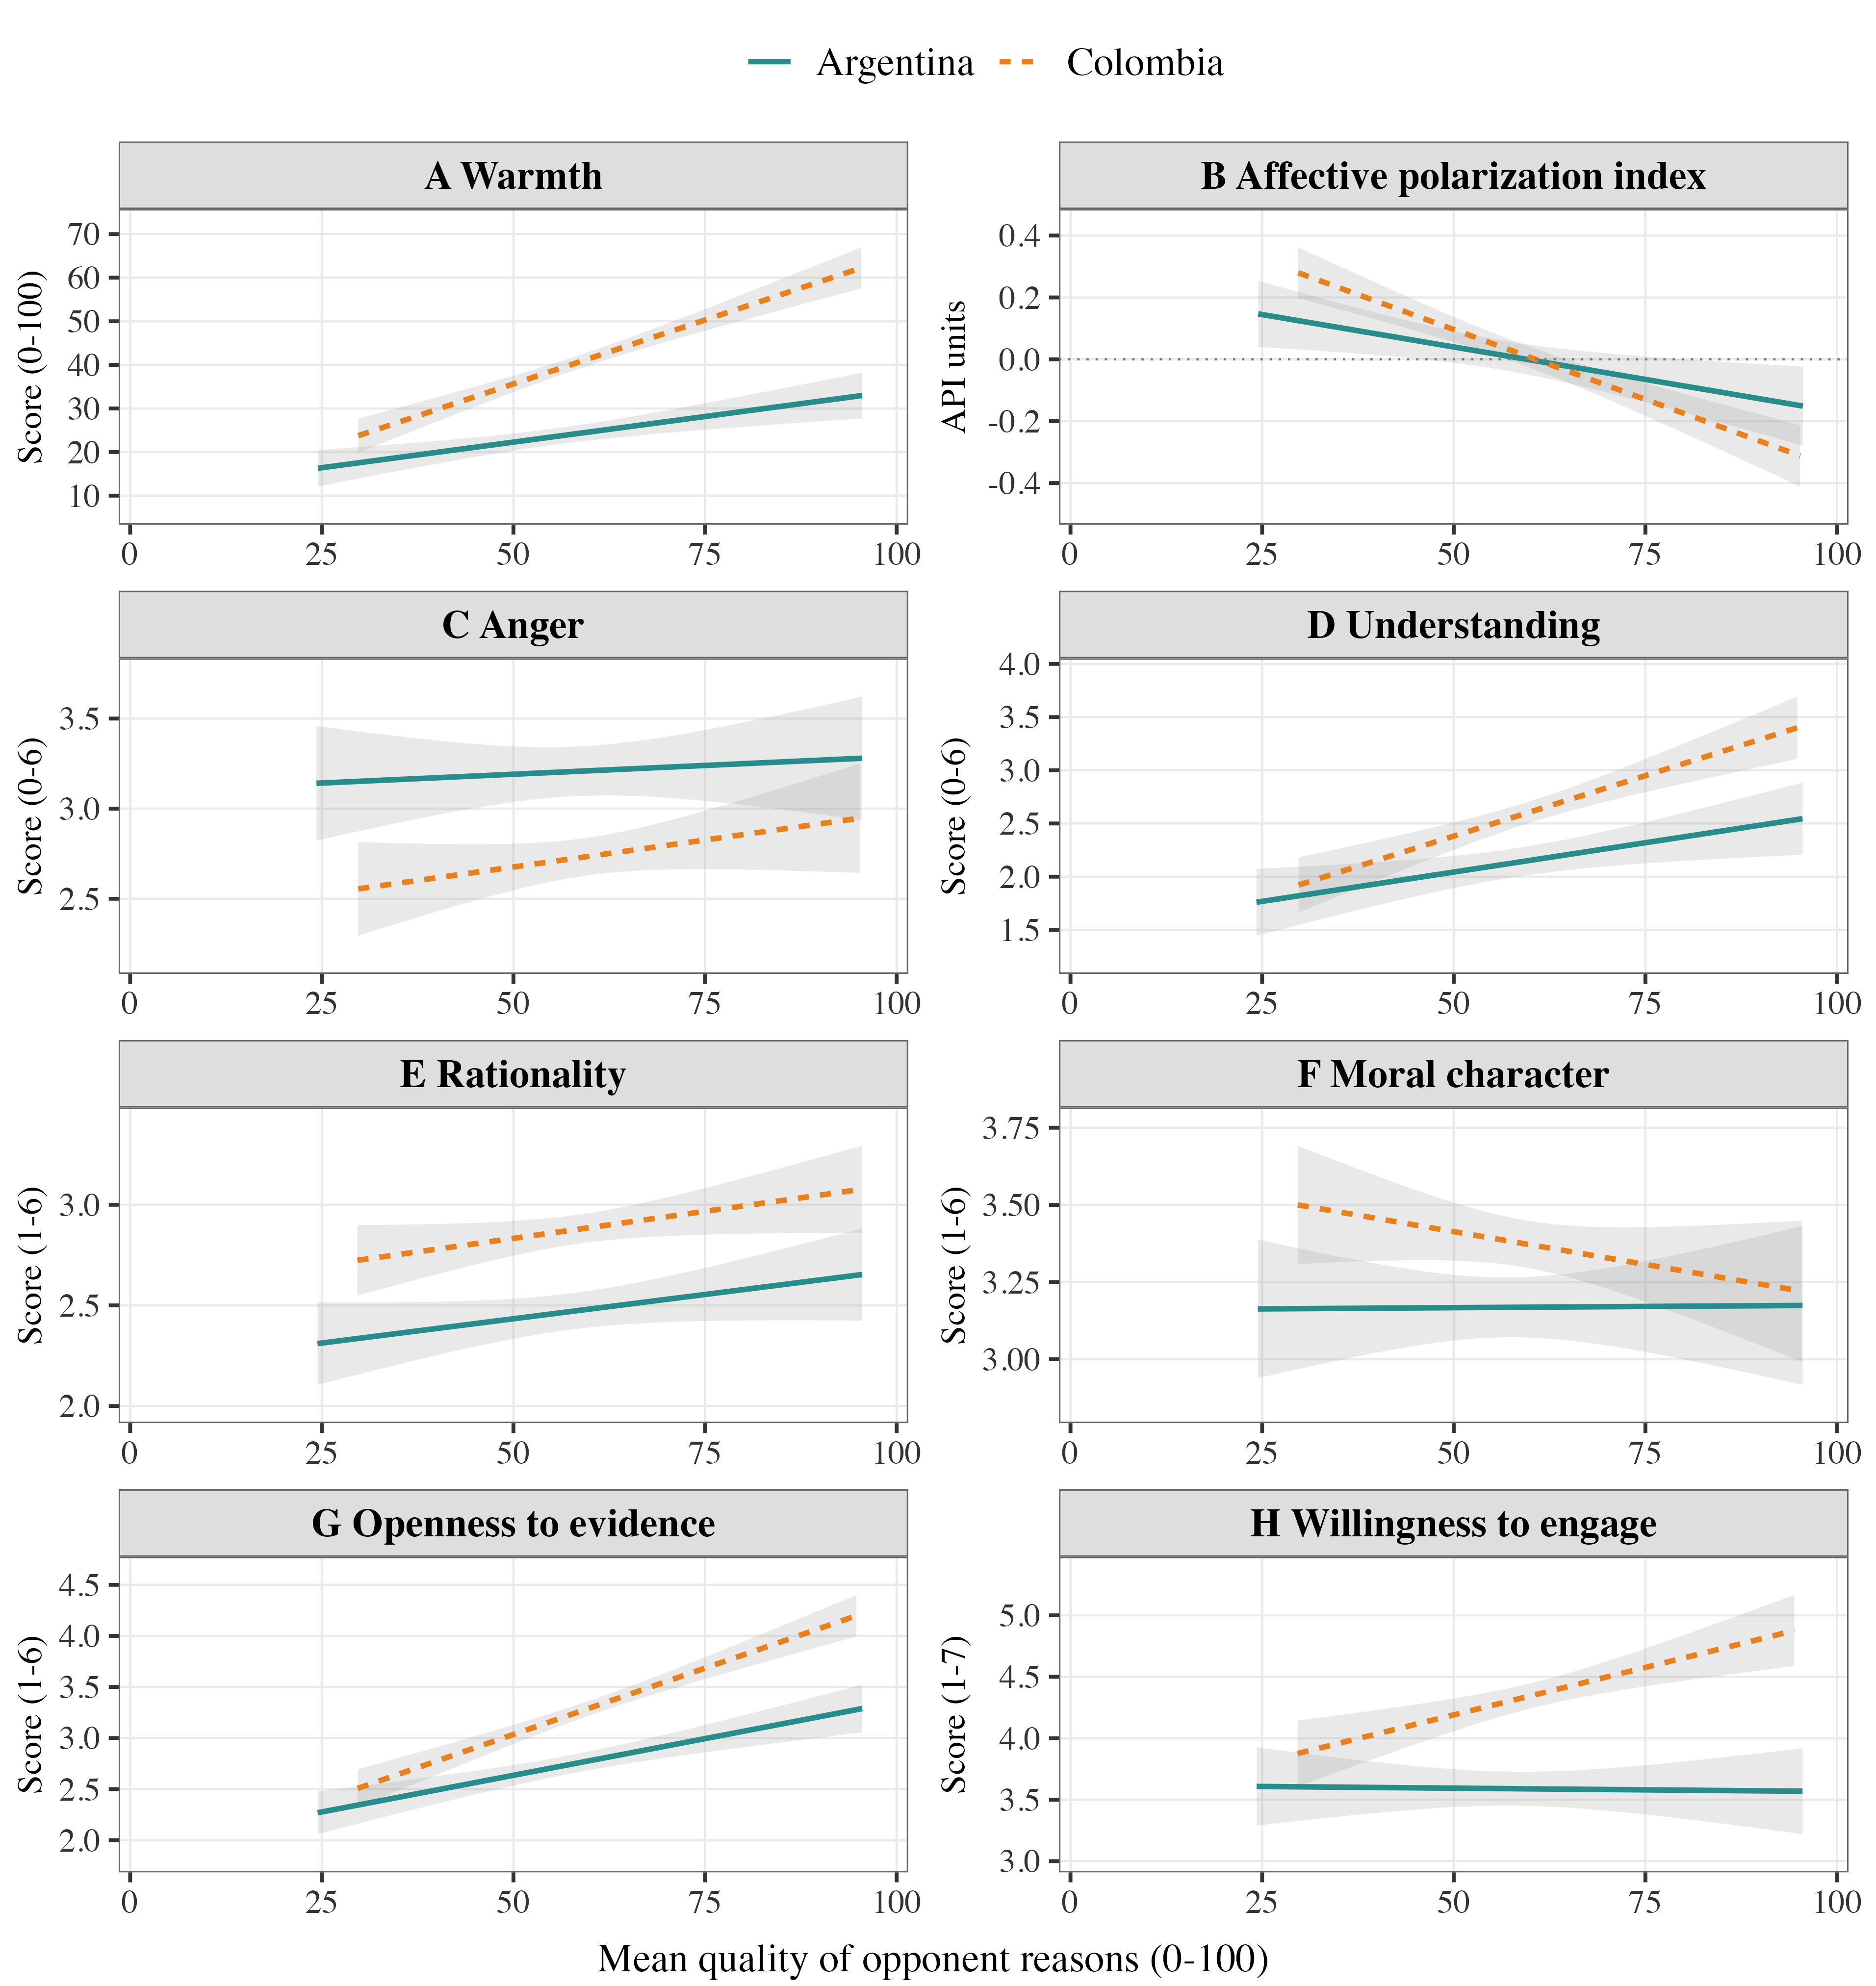
Figure 2. Adjusted means and pointwise 95% HC3 confidence bands, over each model’s 5th–95th percentiles of opponent-reason quality. Y axes are zoomed and use different units. Warmth, API, and rationality are primary outcomes; the other panels are exploratory. Model samples range from 828–856 in Argentina and 1,223–1,288 in Colombia. Countries were fitted separately; these plots do not test cross-country differences. API components are standardized within country. Coefficients are index units, not standard deviations of the final index, and API levels are not an absolute comparison between countries.

What the attitude measures show
All coefficients in this section are changes in the outcome associated with 10 points higher mean reason quality. Intervals are unadjusted 95% intervals. Primary p values use the registered ten-test Holm correction; exploratory p values use the separate 26-test correction described on page 4.

Warmth and affective polarization
More favorable evaluations of opponents’ reasons were associated with warmer feelings toward that camp in Argentina (b = 2.35, 95% CI [1.14, 3.56], p < .001; n = 843) and Colombia (b = 5.87, 95% CI [4.64, 7.09], p < .001; n = 1,269).
The API associations were negative in Argentina (b = −0.042, 95% CI [−0.072, −0.012], p = .019; n = 838) and Colombia (b = −0.090, 95% CI [−0.116, −0.065], p < .001; n = 1,261). Here, negative means less polarized: the index averages standardized coldness, anger, and lack of understanding. It can therefore fall without a corresponding decline in anger. Warmth contributes to the API, so these are overlapping findings.

Rationality and character
The rationality estimates were positive but uncertain (Argentina: b = 0.048, 95% CI [−0.007, 0.104], p = .113; n = 828; Colombia: b = 0.054, 95% CI [−0.001, 0.109], p = .113; n = 1,223). Favorable character judgments showed no clear association either (Argentina: b = 0.002, 95% CI [−0.060, 0.064]; Colombia: b = −0.043, 95% CI [−0.102, 0.017]).
Both surveys included six negative moral-character descriptions for one’s own camp and the comparison camp: not a good person, immoral, bad intentions, many immoral traits and behaviors, willing to harm others, and indifferent to others’ welfare. Favorable character and rationality each use 7 minus the mean of at least five of six items, giving 1–6 scales. This character scoring choice was exploratory. The opponent-character scales had high internal consistency (α = .953 in Argentina; .949 in Colombia). Neither trait scale enters the API.

Understanding and engagement
Anger showed no clear association with opponent-reason quality in either country. Understanding was positively associated in both estimates, but only Colombia passed the exploratory correction (Argentina: b = 0.110, p = .204; Colombia: b = 0.227, p < .001). Perceived openness to evidence increased in both countries (Argentina: b = 0.144; Colombia: b = 0.260; both p < .001). Willingness to engage increased in Colombia (b = 0.154, p = .004), with little clear association in Argentina (b = −0.005, p = 1.000). A clearer association in one country does not establish a difference between countries.
Openness measures whether opponents consider contrary evidence, change their views for good reasons, and acknowledge possible error. Engagement measures willingness to listen, discuss disagreement respectfully, and exchange explanations. These exploratory scores average all three items, using 1–6 and 1–7 scales, respectively.

Evaluations of own camp reasons
The same models also estimate associations with own-camp quality. These did not show a consistent link to greater polarization. Most were uncertain after the exploratory correction; the exception was lower perceived opponent openness in Colombia (b = −0.105, 95% CI [−0.169, −0.040], p = .032), holding opponent-reason quality constant.

Argentina without a unique opponent
We kept “Todos por igual” (all equally; n = 278) and “Ninguno” (none; n = 108) separate, as preregistered. Their comparison target was Kirchnerista/Peronista or Libertario, excluding their own camp and choosing randomly when both remained possible. These targets should be described as assigned comparisons, not self-identified principal opponents.
Table 1. Separate Argentine analyses. Entries are b [95% CI] and model N. Rating contrasts use the 0–100 scale; post-outcome slopes are per 10 assigned-comparison quality points. Intervals and tests are unadjusted.
Outcome or contrast | All equally | None
Agreement | 19.74 [16.11, 23.38]  n = 278 | 9.89 [1.07, 18.71]  n = 108
Own versus comparison camp | 4.25 [0.05, 8.46]  n = 278 | 1.13 [−11.41, 13.66]  n = 108
Warmth | 2.66 [0.13, 5.18]  n = 269 | 3.53 [−4.97, 12.03]  n = 94
API | −0.082 [−0.138, −0.027]  n = 265 | −0.010 [−0.228, 0.209]  n = 92
Rationality | 0.093 [−0.012, 0.199]  n = 252 | 0.001 [−0.400, 0.401]  n = 85
The all-equally group showed greater warmth and lower API with more favorable comparison-camp evaluations. The none group’s post-outcome estimates were much less precise: only 85–94 cases entered these models. Their wide intervals leave substantial uncertainty, rather than establishing an absence of association. Neither group enters the primary named-opponent tests or the stopping count.

Checks and limits
Agreement, average own-camp advantage, and warmth persisted when we tightened attention/assistance exclusions, removed fast or invariant responses, or treated age categorically. Argentina’s API association did not pass Holm after removing responses under five minutes or with identical ratings (b = −0.031, p = .119); Colombia’s API association persisted. The Argentine camp contrast among different-stance ratings was also uncertain under the factorial fixed-effects check. Retaining other Argentine camps in a 2 × 3 check preserved the average own-versus-opponent pattern. Topic-specific camp contrasts were imprecise; all their intervals included zero.

Analysis notes
The governing plan is AsPredicted #317907, approved 16 October 2026. We excluded tests, incomplete or invalid records, reported lack of seriousness, and outside help deciding ratings. All retained participants supplied 20 valid assigned ratings. Primary rating models use evaluator and reason fixed effects, presentation order, and standard errors clustered by evaluator and author. Post-outcome models include both quality means, evaluator camp, ordinal age, identification strength, and separate agreement and topic fractions within each mean, with HC3 errors. Cases enter each model when its required values are available; no values were imputed. API scaling stays fixed across checks and the separate Argentine groups.
Holm correction covers ten primary tests jointly, six tests in the follow-up factorial models, and a separate exploratory family of 26 attitude slopes. The latter includes both quality predictors for five added outcomes per country and the six own-quality slopes for the original outcomes. Separate all/none analyses are outside these families. The factorial presentation and added outcome scoring were analysis-stage choices; they do not replace the registered tests. The registered correction does not cover repeated interim looks. These associations do not establish that evaluating opponents’ reasons reduces polarization.

