Fontys ICT Survey FHICT App

Toni Dimitrov, Bojidar Belov, Kaloyan Lozanov, Gino Stock, Yani Bogdanov

ICT, Fontys

P-CB10: EDO

CB10- Group 1

Corrie Wolf

20th of September

**Content list**

*1.Introduction*………………………………………………………………. 3

1.1 Targeted User Group

1.2 Problems we focus on

*2. Survey*…………………………………………………………………......3

2.1 Questions

2.2 Results

2.3 Analysis and conclusion

2.4 List with improvements

*3. Interviews*……………………………………………………………….12

3.1 Tsvetan’s interview transcript

3.2 Bryan’s interview transcript

3.3 About schedule

3.4 About hello talent

3.5 About settings

*4. Personas*……………………………………………………….….…….16

4.1 Persona 1

4.2 Persona 2

*5.* *Conclusion*…………………………….……………………….….…….20

**1.Introduction**

We chose to do a survey about the FHICT phone app in order to see what changes need to be made. We let people give us recommendations about improving the app, a question format

where they can express their feelings about the app and overall satisfaction with it.

**1.1 Targeted User Group**

Our survey was specifically targeting users of the mobile app (such as first year students at ICT in Fontys), so that we could ensure accurate results that would help in the troubleshooting process. For this reason, we asked about their feedback.

**1.2 Problems we focus on**

The problems we focused on are mainly the design of the app and its functionality.

**2.Survey**

All questions in the form were specifically tailored around the app, in order to get as accurate results as possible:

**2.1 Questions**

The questions that we asked the users were the following:

1. Do you have the Fontys ICT app currently installed on your mobile device?

* Yes
* No

If the user has chosen “Yes” as an option than the following set of questions followed:

1. How often do you use the Fontys ICT app?
   * Every day
   * Once a week
   * Not that often
   * I just have it installed, never used it
2. How would you grade the interface of the app?

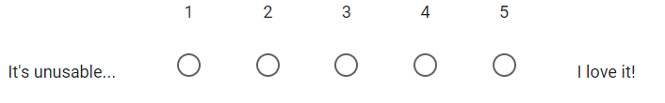

1. Do you think the app needs overall improvement?

* Yes
* No
* Maybe

1. Which features would you like to be improved?

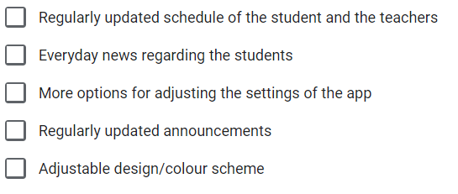

1. Is there anything else that you like/dislike about the app?
2. Did you have any trouble finding your way in the app? You can give an example or leave this blank.
3. Do you think additional languages should be added? (e.g. Dutch)

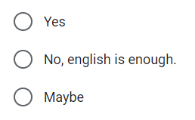

1. What do you think should be improved/added to the app?
2. How likely are you to recommend the app to another student?

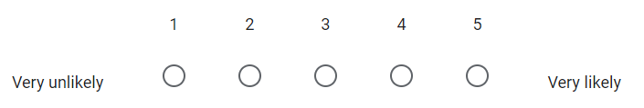

If the user has chosen “No” as an option than the following set of questions followed:

2. How would you grade the design of the app?



3. Would you download the app if it becomes more useful and regularly updated?

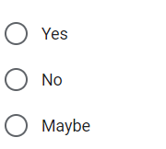

4. What are your suggestions for improvements or additions in the app?

**2.2 Results**

1. Do you have the Fontys ICT app currently installed on your mobile device?

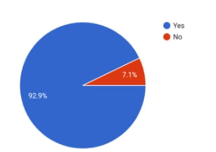

The questions with the answer “Yes”:

1. How often do you use the Fontys ICT app?

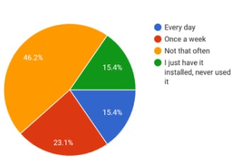

1. How would you grade the interface of the app?

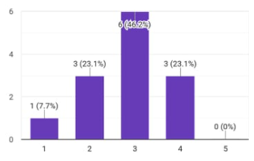

1. Do you think the app needs overall improvement?

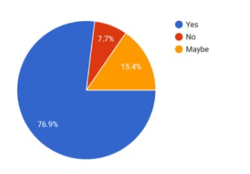

1. Which features would you like to be improved?

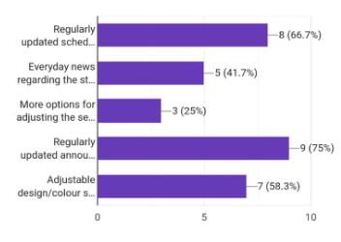

1. Is there anything else that you like/dislike about the app?

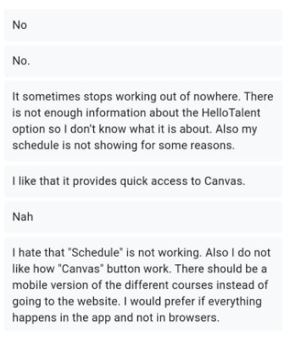

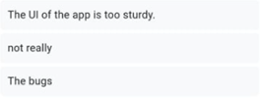

1. Did you have any trouble finding your way in the app? You can give an example or leave this blank.

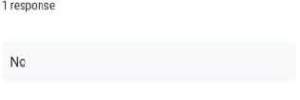

1. Do you think additional languages should be added? (e.g. Dutch)

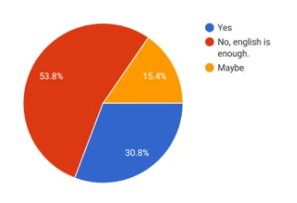

1. What do you think should be improved/added to the app?

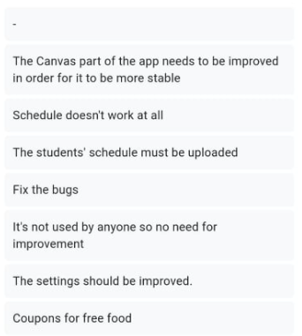

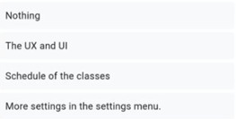

1. How likely are you to recommend the app to another student?

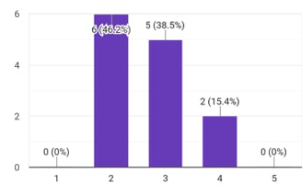

The questions with the answer “NO”:

2. How would you grade the design of the app?

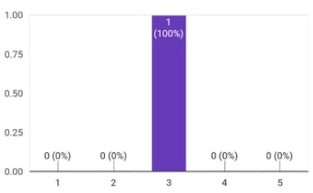

3. Would you download the app if it becomes more useful and regularly updated?

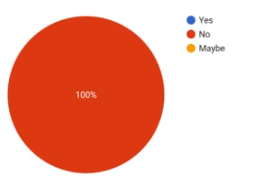

4. What are your suggestions for improvements or additions in the app?



**2.3 Analysis and conclusion**

The results that we received were *not very positiv*e!

One of the main issues that the clients faced were the missing schedule, little to no options to play around, the settings and overall - the design of the app. Many users describe the design of the app to be mundane and average (76% of the votes showed that the app needs a total overhaul of its design). Regularly updated announcements (75%) and regularly updated schedules (66.7%) are top priority in the eyes of the voters, as well. Sudden and frequent crashes, bugs and missing options are also part of the complaints that we received. Although 53,8% of the responses said that no additional languages should be added, there are lots of complaints about the app not having Dutch as an option in the open question format.

The conclusion that we can make out of this survey is that currently the users are dissatisfied with the app. Lots of bugfixes need to be implemented into the program before usage increases.

**2.4 List with improvements**

According to the survey, the users would like these changes and upgrades to be implemented into the app:

* + - Fixing the schedule feature in the app
    - Adding more options to the settings menu
    - Adjusting the color scheme of the app
    - Improvements to the news and announcements sections
    - Adding more languages (more specifically adding Dutch)

**3. Interviews**

To get more familiar with what features needs to be improved we interviewed two first year students from the ICT program at Fontys. The names of the students are Tsvetan and Bryan. We chose these two particular students, because Tsvetan uses the app for a while already, while Bryan just started using it.

The topics that stood up from both interviews were the usage of the following features: schedule, hello talent and the settings.

**Link for Tsvetan’s interview:** [Interview 1](https://www.youtube.com/watch?v=SA2Al6AyXAo)

**Link for Bryan’s interview:** [Interview 2](https://www.youtube.com/watch?v=Dg2Rm2vU6CY)

**3.1 Tsvetan’s interview transcript**

Kaloyan: Please, bear in mind before we begin this interview that we will be recording, and we do ask for your consent. Are you OK with us recording you?

Tsvetan: Yeah of course, I have no problem.

Kaloyan: OK, great.

Toni: Hi, can you introduce yourself?

Tsvetan: My name is Tsvetan, I am from Bulgaria, I am a student in Fontys and I am studying ICT in my first year

Toni: Thank you, did you fill in the survey?

Tsvetan: Yes, I did.

Toni: Are you familiar with the FHICT app?

Tsvetan: I have it on my phone, but I am not really using it.

Toni: OK, do you find any features in the app to be missing?

Tsvetan: I don’t really use all of the features because I don’t know how to use them, and most of the time they are not loading for me. I find them useless and some of them to be missing.

Toni: OK, what do you think about the settings tab in the loading loop?

Tsvetan: I tried using the settings tab, but they never appeared.

Toni: What settings would you like to see integrated into the app?

Tsvetan: Maybe I would like to see my schedule and the projects I have done, and the ones I must do in the future.

Toni: Have you used the “Hello Talent” feature?

Tsvetan: I have seen it, but I have never used it.

Toni: You don’t know how it works?

Tsvetan: No, I have no idea how it works.

Toni: OK, for what do you use the app mainly?

Tsvetan: I use it rarely, but when I do I use it to scan my student card for the vending machines

Toni: According to the survey, a lot of people think the calendar needs improvement. What is your opinion on this?

Tsvetan: I totally agree with them, because I also don’t know how to use the calendar, and if there are more features in it, I would be very grateful.

Toni: OK, thank you!

Tsvetan: Thank you!

**3.2 Bryan’s interview transcript**

Kaloyan: Alright, before we begin this interview, please bear in mind that we will be recording, and we do ask for your consent. Are you OK with us recording you?

Bryan: I am OK with it.

Kaloyan: OK, great.

Toni: Hello, please introduce yourself.

Bryan: I am Bryan, I am doing ICT in Fontys.

Toni: Thank you, did you fill in the survey?

Bryan: No.

Toni: Are you familiar with the FHICT app?

Bryan: I am not familiar with it.

Toni: OK, it is right in front of you. Do you find any features in the app to be missing or to be completely useless?

Bryan: Schedule doesn’t show anything, the talent feature does not work, and the settings tab doesn’t offer many features.

Toni: OK, while you are there what do you think about the loading loop?

Bryan: I think it’s useless

Toni: OK, what would you like to see integrated into the app?

Bryan: A working schedule, and information about what “Hello Talent” does.

Toni: For what would you use the app if those worked?

Bryan: To see my schedule and maybe see the mails of teachers.

Toni: According to the survey, a lot of people think the calendar needs improvement. What is your opinion on this?

Bryan: The schedule needs to be added and calendar needs improvement.

Toni: OK, thank you!

**3.3 About schedule**

According to the survey the schedule is the feature that needs improvement the most! From the interviews we got confirmation about that. Both participants in the interviews made clear that it doesn’t work properly. We asked both of them to open the feature on their devices and in both cases the following error occurred:



So, according to the survey and the interviews the schedule feature needs a serious makeover.

**3.4 About hello talent**

According to Tsvetan and Bryan’s answers it came clear that none of them know what the hello talent feature is supposed to be! They were not sure how does it work and what kind of results should be shown from the searching bar.

From their answers it came clear that hello talent needs to be either explained in the introduction week how it works or add a description to it when it starts up.

**3.5 About settings**

The settings section has a strange design, because of which we asked Tsvetan and Bryan to tell us their opinion about it.

The results were interesting. Both of them thought that something was loading, because the design of the feature contains a GIF of two rolling screws, which apparently makes the illusion in people that something is loading, while in reality that is not the case.

Also, according to the survey the users of the app want more options and customization.

Options like: dark mode, more languages, etc. should be added.

So, to make the app better for the users the settings menu needs upgrades in terms of design and functionality.

**4. Personas**

**4.1 Persona 1**

**Name:** Mike Horvat

**Home country:** Croatia

**Age:** 20

**Gender:** Male

**Occupation:** student

**Lives in:** Eindhoven

**Short bio**

Mark is a first year student in the ICT program at Fontys. He has a basic knowledge of working with computers, but he never studied and used programing languages before, so he has a bit of a struggle with the school material and sending his homework in time. Mark also trains soccer or watches various sports on the TV in his free time.

**Quote**

“Remember why you are here and do anything you can to achieve your goals. It might be hard at the beginning, but this is just part of the process.”

**Behaviors**

* Sometimes he stays to play extra when his soccer training session is over.
* Uses the FHICT app to quickly access canvas and the schedule to see what he has to do when he gets back home or to submit certain assignments.
* Although he struggles with the school material, he occasionally goes out, so that is why he uses the FHICT app.

**Goals**

* Becoming a good computer specialist.
* Staying in good shape by playing soccer.

**Frustrations**

* Sometimes the schedule feature in the app does not work properly, so he is unable to stay in touch with his assignments all the time.
* He doesn’t understand half of the features in the FHICT app.

**Ranking the school subjects, based on favorability:**

1. EDO
2. IEO
3. DDO
4. ADO
5. ESO

**Favorite brands**

* Nike
* Gucci
* Apple
* Supreme
* Dior

**4.2 Persona 2**

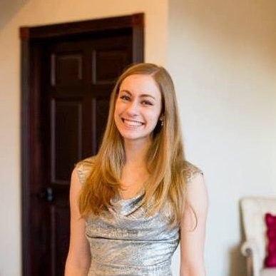**Name:** Alex Asenova

**Home country:** Bulgaria

**Age:** 19

**Gender:** Female

**Occupation:** student

**Lives in:** Eindhoven

**Short bio**

Alex is a first year student in the ICT program at Fontys. In her previous school she studied programing, so she does not have any problems with the school material. She even finds it pretty useful, because now she fills in gaps from her previous experience with the programing. In her free time Alex prefers to either go to a party with friends, or to read some books.

**Quote**

“Programing can be tough and confusing at the beginning, but if you manage to handle it you will find the adventure in it!”

**Behaviors**

* Likes to program in different languages such as: C#, Python, Java and C++.
* Uses the FHICT to quickly find the details of her teachers and mentors with the Employees feature and to borrow something from the ISSD with her digital student app.
* She prefers to use dark mode on her applications.

**Goals**

* Becoming a leading Software engineer in a big company.
* Make as much friends as possible, while in the Netherlands.
* Make great memories in Eindhoven.

**Frustrations**

* Doesn’t know what is the talent feature.
* She doesn’t like that the app does not have a Dark mode in the settings menu and the general design of the settings menu

**Ranking the school subjects, based on favorability:**

1. ADO

2. IEO

3. ESO

4. DDO

5. EDO

**Favorite brands**

* Xiaomi
* Samsung
* DSQUARED
* Victoria secret
* Puma
* Versace

1. **Conclusion**

From the whole research we can conclude that overall the FHICT application requires an update to its functionality and design. The main features that require an overhaul are the schedule, the settings menu and the UI design of the app. Also, some pieces of the app need a description and overview.

Users are not happy with the current state of the app. They make bad reviews of it in our survey, interviews and Google Play store, as well. And as long as these things are not improved the bad reviews will continue.