Inyo — Before & After Edits
original/ → exact/ · left = before, right = after

Edits list
# | Edit | Change
01 | Favicon | Black wave + “inyo” text → wave on yellow circle #f5ff66
02 | Chat PFPs | Missing/broken phone header avatar → yellow-circle logo mark
03 | Logo on slide lock | Always opaque → 100% between slides, 0% when a slide locks (home stays visible)
04 | Web Logic scroll-lock | Free scroll → sticky pin; bottom nav hides while locked
05 | Legal titles | {{Title}} — inyo → Privacy Policy / Terms & Conditions — inyo

01 — Favicon
Wave mark alone on Inyo’s yellow circle (wordmark removed).
BEFORE FAVICON · AFTER FAVICON · AFTER CHAT AVATAR
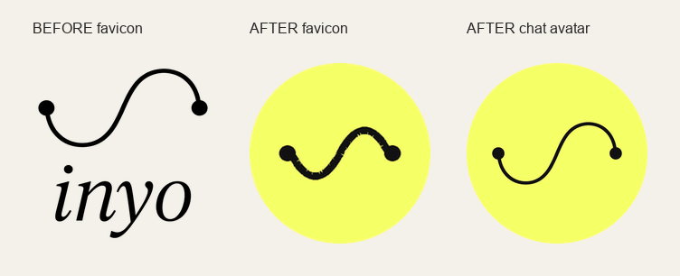

02 — Chat simulation profile pictures
Phone chat header top-left PFP was missing/broken; replaced with yellow-circle Inyo mark.
PHONE CHAT HEADER — BEFORE | AFTER
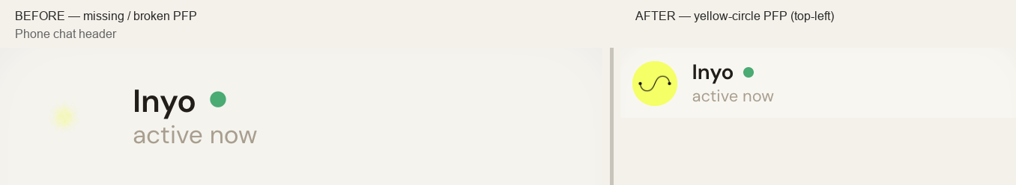

03 — Logo fades on slide lock
Logo stays fully visible while scrolling between slides and on the home slide; fades to 0% when a later slide locks in.
LOGO ZOOM — BEFORE OPAQUE | AFTER HIDDEN
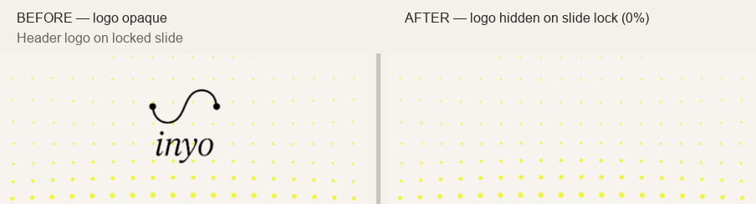
LOCKED SLIDE VIEWPORT — BEFORE | AFTER
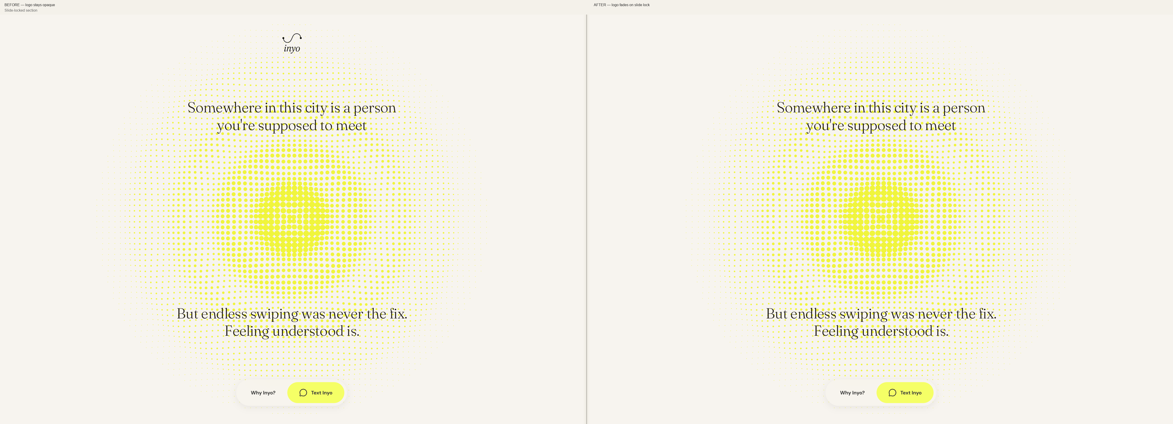

04 — Web Logic scroll-lock
“A simple chat, over a complex web of logic” is now a sticky scroll-lock slide; bottom nav hides while locked; cream edge blend kept.
WEB LOGIC — BEFORE | AFTER
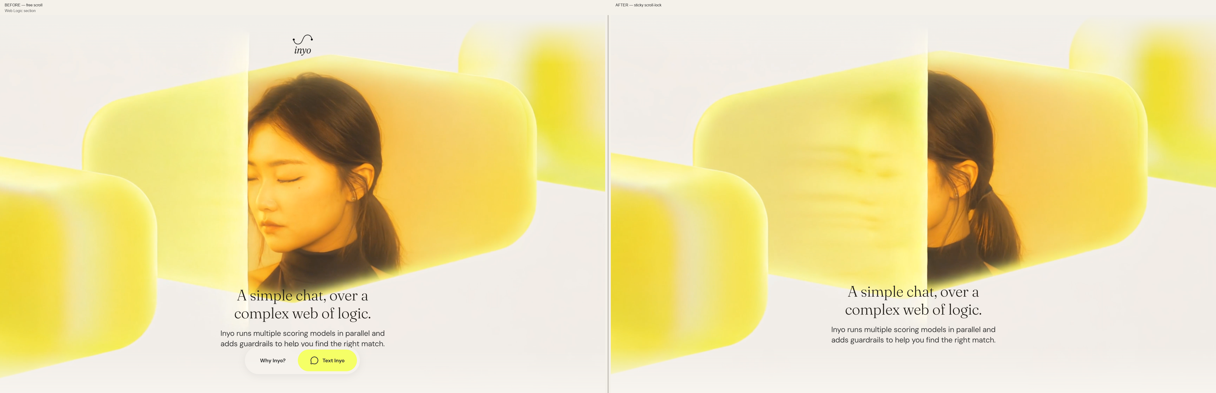

05 — Legal page titles
Unsubstituted Framer {{Title}} placeholder fixed in exact/ and site/.
DOCUMENT <TITLE> — BEFORE | AFTER
