

**Class: House**

Behaviour/Method:

* Shelter(): void
* Cook(): void
* Sleep(): void

Properties:

* Design: String
* Size: Int
* Colour: String



**Class: Book**

Properties:

* Thickness: Int
* Size: Int
* Colour: String

Behaviour/Method:

* Jotting notes(): void
* Record informations(): String



**Class: Pencil**

Properties:

* Type: String
* Size: Int
* Brand: String

Behaviour/Method:

* Drawing(): void
* Sketching(): void
* Writing(): void

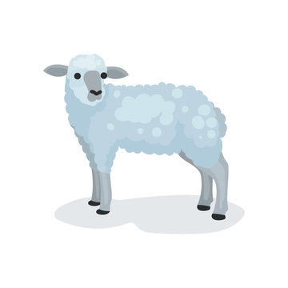

**Class: Sheep**

Properties:

* Size: Int
* Colour: String
* Age: Int

Behaviour/Method:

* Produce milk(): num
* Produce wool(): num
* Born goat(): num



**Class: Hair Dryer**

Behaviour/Method:

* Dry(): void
* Style(): void
* Dusting(): void

Properties:

* Size: Int
* Colour: String
* Brand: String
* Wattage: Int