**Software Requirements Specification(SRS)**

**for**

**Community Pharmacy Software Solution**

**Version 2.0**

**Prepared by Group Name: []**

|  |  |  |
| --- | --- | --- |
| **GM** | **ID** | **EMAIL** |

|  |  |
| --- | --- |
| **Instructor:** | **[]** |
| **Course:** | **[]** |
|  |  |
|  |  |
| **Date:** | **4/25/2024** |

**Table of Contents**

**1. Introduction 1**

1.1 Purpose 1

1.2 Document Conventions 1

1.3 Intended Audience and Reading Suggestions 1

1.4 Product Scope 2

1.5 References 3

**2. Overall Description 5**

2.1 Product Perspective 5

2.2 Product Functions 6

2.3 User Classes and Characteristics 7

2.4 Operating Environment 8

2.5 Design and Implementation Constraints 9

2.6 Assumptions and Dependencies 9

**3. Functional Requirements 10**

3.1 Dispensing System 10

3.2 Prescription System 12

3.3 Medication System 13

3.4 Health Insurance System 14

3.5 Medical Inventory System 16

**4. Nonfunctional Requirements 17**

4.1 Performance Requirements 17

4.2 Safety Requirements 18

4.3 Security Requirements 18

4.4 Software Quality Attributes 19

**5. Other Requirements 20**

**6. Requirements Validation and Verification 21**

6.1 Requirements Validation and verification Tools and Techniques 21

6.2 NASA ARM Requirements Analyzer Tool 22

6.3 Goal/Question/Metric (GQM) Analysis 22

6.4 Readability Statistics 26

**Revision History**

|  |  |  |  |
| --- | --- | --- | --- |
| **Name** | **Date** | **Reason For Changes** | **Version** |
| **Assignment 1** | 2/22/2024 | Functional and Nonfunctional Requirements + Research | 1 |
| Assignment 2 | 3/29/2024 | Use Case and Class Diagrams | 1.1 |
| Beginning SRS | 4/14/2024 | Starting Sections 1, 2, 6 | 1.2 |
| Requirements Adding | 4/18/2024 | Sections 3, 4, 5 | 1.3 |
| UML adding | 4/19/2024 | Added UML to Appendix B | 1.4 |
| Assignment 3 Finish | 4/23/2024 | Complete SRS Document | 2.0 |

# Introduction

## Purpose

Our product is the community pharmacy’s management system (CPMS) which includes database, dispensing, medication, inventory, purchasing, prescription, and offsite database. The SRS outlines the functional and nonfunctional requirements for the CPMS. The scope of the document is to encompass the entire CPMS, which would include all of the modules and functionalities necessary for efficient operation. The release number being specified in this document is 2.0.

## Document Conventions

The SRS is in American Psychological Association (APA) format, which includes all references, citations, and formatting. All requirements are in compliance with the Health Insurance Portability and Accountability (HIPAA) regulations to ensure patient data privacy and security. Specific conventions relevant to pharmacy operations and terminology are utilized throughout the document to accurately represent the needs of the community pharmacy. This includes the use of different font sizes to display importance and boldness.

## Intended Audience and Reading Suggestions

The intended audience is for anyone that wants to further educate themselves in the CPMS. Specifically the requirements and conventions behind it. This will most likely be viewed by developers, project managers, users, testers and documentation writers. The SRS will mainly cover the functional and nonfunctional requirements within the CPMS, but there is much more the document will cover. The overview will provide a high-level introduction for the CPMS’ objectives and scope. The next topics that are covered are the functional and nonfunctional requirements. The functional requirements describe the functional capabilities and features of the CPMS in detail. The nonfunctional requirements outline the quality attributes and constraints of the CPMS. The SRS document will then cover the other requirements that necessarily do not fit in either category. The next topic the SRS document will cover is the requirements validation and verification section. This will mainly contain the usage of NASA’s ARM tool to assist in the confirmation of the requirements. This tool will analyze the requirements and ensure readers that the requirements used are verified and valid. The final section is the Appendix section, which is split up into three different sections. Appendix A covers the glossary, which covers the definitions of terms. Appendix B covers the class diagrams and use case diagrams. Appendix C is the references for the information gathered.

## Product Scope

The software being specified in this document is the CPMS is designed to streamline and optimize the operational processes of community pharmacies. The primary purpose of the CPMS is to improve the quality and efficiency of pharmacy operations while ensuring compliance with regulations such as HIPAA. Enhanced patient safety is a primary goal for the CPMS. This will be achieved by maintaining comprehensive patient profiles, medication history, and allergy information. The CPMS facilitates accurate prescription dispensing and medication counseling, which will ultimately improve patient safety and outcomes. The CPMS will also have optimized inventory control. Through real-time tracking of medication stock levels and expiration dates the CPMS helps minimize stockouts and reduce waste. The development and implementation of the CPMS align with the corporate goals and business strategies of community pharmacies by increasing operational efficiency and reducing costs through automation and process optimization.

Enhancing patient care and safety through accurate prescription dispensing and medication management. It also improves regulatory compliance and risk management through strong security measures and reporting capabilities.

## References

**Health Insurance Portability and Accountability Act (HIPAA)**

“The Health Insurance Portability and Accountability Act of 1996 (HIPAA) is a federal law that requires the creation of national standards to protect sensitive patient health information (PHI) from being disclosed without the patient’s consent or knowledge” (CDC, 2022, para. 1). The HIPAA Privacy Rule explains what is covered by HIPAA and extra details about it (CDC, 2022, para. 2). This covers healthcare providers, health plans, healthcare clearinghouses, and business associates (CDC, 2022, para. 3). One important note is that “healthcare providers are considered any “providers of service”, regardless of size, who electronically transmit health information in connection with certain transactions' ' (HHS, 2022, para. 10).

**National Archives Code of Federal Regulations**

These regulations are taken from the United States Code. They are relevant to access control and data management for the system.   
 § *1306.06 Persons entitled to fill prescriptions.

This law covers all the potential positions a registered pharmacist may take and assigns the power of prescription solely to them.

2. § *1311.200 Pharmacy responsibilities (f).

This clarifies that the same responsibilities in a paper prescription still exist for an electronic prescription. The system should be able to handle and store this extra information for each prescription.

**Drug Enforcement Administration (DEA)**

A prescription can only be transferred once in unaltered electronic form, directly between two licensed pharmacists, between two different pharmacies (DEA, 2023, para. 4).

**(DEA): electronic prescribing of controlled substances (EPCS) House Bill 831 in FL**

This bill requires all prescribers to generate and transmit all prescriptions electronically upon license renewal or by July 1, 2021, whichever is earlier (Florida Board of medicine, 2020, para. 1). The bill also introduced new exceptions to this case (stated in the bill).

**Florida Laws for pharmacies**

* 64B16-28.140 Record Maintenance Systems for All Pharmacy Permits

This section defines requirements for records maintained in a data processing system (Florida pharmacy, 2020a). Pharmacies are required to keep both hard copies of the original prescription and carry out business strictly with their electronic counterpart (Florida pharmacy, 2020a).

*64B16-28.141 Requirements for use of an Automated Pharmacy System by a Community Pharmacy

This section goes over who may use the system, how the system functions in the pharmacy and how the data is handled by the system.

**General Data Protection Regulation (GDPR)**

The European Union's General Data Protection Regulation (GDPR) is the strictest, strongest data protection law in the world (GDPR1). All companies, even those outside the EU, are subject to the GDPR if they hold private information of a citizen of the EU (GDPR2). This is mandatory for larger, national pharmacies, and will become mandatory if a community pharmacy handles patients who are citizens of the EU.

***Food and Drug Administration (FDA)***

FDA is responsible for approving and regulating the drugs sold in pharmacies. Some pharmacies also use compound drugs (FDA 2017). Any pharmacy must be sure that the drugs it has are FDA approved.

# Overall Description

## Product Perspective

The software system described in this SRS serves as a comprehensive management solution tailored specifically for the CPMS. This system is designed as a standalone product, providing essential functionalities for managing various aspects of pharmacy operations efficiently. This product will mainly focus on enhancing workflow and productivity of CPMS. The need for this system arose from the need of a CPMS. Traditional methods of managing inventory, prescriptions and data have become error-prone and tedious. This CPMS will be a response to these challenges, aiming to automate pharmacy processes, while complying with regulatory standards. While the software system is a standalone system, this could be implemented into other larger systems. Integration with such systems allows seamless exchange of patient information, prescription data, and other relevant information, thereby enhancing interoperability and facilitating comprehensive patient care. Interfaces between this pharmacy management software and external systems will be established using standard protocols and APIs to ensure compatibility and data integrity.

## Product Functions

## Dispensing

* + Ensuring that medication dispensing processes are accurate and efficient is crucial
  + Pharmacy staff should be guided through verification, selection and documentation steps
  + Keep records of dispensed medications and pharmacist authorizations.
  + Integrating seamlessly with electronic prescription systems can help streamline workflow
* Prescription
  + Providing detailed instructions for patient prescription
  + Keep records of all filled prescriptions at the pharmacy
  + Offering real time updates on prescription status and error improving efficiency
* Medication:
  + Managing the database to provide information on usage, side effects and contraindications for patient safety
  + Performing checks for drug interactions and patient allergies to help ensure medication safety
  + Tracking medication expiration dates and monitoring inventory availability
  + Providing pricing information to aid pharmacy staff in order to make informed decisions
* Health Insurance:
  + Simplifies coverage verification and claims for a faster processing time
  + Accurately calculates copayments based on insurance coverage to avoid any billing errors
  + Generates documentation like Explanation of Benefits (EOB) statements to ensure transparency in billing practices
* Medical Inventory:
  + Efficiently managing medication inventory levels, expiration dates and reorders
  + Keeping records of inventory transactions to support audits for compliance purposes
  + Ensure updates on the availability of stock and synchronize with procurement systems
  + Ensure the disposal of unused medications to adhere to regulatory requirements

## User Classes and Characteristics

The CPMS is designed to serve the needs of various users involved in pharmacy operations. Pharmacists are expected to use the system extensively throughout their daily workflow. Pharmacists typically possess a high level of technical expertise meaning they are capable of navigating the software system. Pharmacists require elevated privileges to access and manage patient information, prescriptions and inventory data. Pharmacy technicians use the system regularly to assist pharmacists in various tasks. Pharmacy technicians require access to specific functions related to prescription processing, inventory management and customer service. Administrative staff may use the CPMS for tasks such as generating reports, managing user accounts, and system maintenance. Administrative staff may have basic to moderate technical skills, depending on their specific roles and responsibilities. Administrative staff require access to administrative functions such as user management, system configuration, and data backup. The most important user classes for this product are pharmacists and pharmacy technicians, as they directly interact with the system to fulfill critical pharmacy functions such as prescription processing, medication dispensing, and patient counseling. While administrative staff play a vital role in system maintenance and data management, their interaction with the system is less frequent and may not directly impact pharmacy operations on a day-to-day basis.

## Operating Environment

The pharmacy software system is created to work in modern pharmacy landscape supporting devices, like desktop computers, tables and mobile devices commonly used by pharmacists and pharmacy technicians. It is tailored to operate on operating systems like Windows 10, macOS Catalina (or newer) and Ubuntu 2004 LTs (or newer) ensuring compatibility across diverse platforms. By catering to these operating systems and their specific versions the software enhances accessibility and user acceptance while reducing compatibility issues.

Apart from being compatible with hardware and operating systems the pharmacy software system must coexist effectively with other software components and applications commonly employed in pharmacy environments. This involves integration with health record (EHR) systems such as Epic, Cerner and Allscripts to enable data exchange and interoperability between pharmacy operations and patient health records. Moreover the system should integrate with insurance processing procedures and ensure patient coverage verification. Additionally compatibility with inventory management of medication stock levels and inventory tracking, within the pharmacy. Overall the software is designed to blend with these software components facilitating smooth workflow integration and optimized pharmacy operations

## Design and Implementation Constraints

Several constraints will influence the design and implementation of the CPMS. There are regulatory compliances that are set forth by healthcare authorities such as HIPAA for patient data privacy and security. As well as the FDA (Food and Drug Administration) regulations for prescription drug handling and dispensing. Hardware limitations also exist within the system. This includes timing and memory requirements, which should be scalable to handle varying levels of data processing and storage demands without compromising performance. The development team will be constrained to use specific technologies, tools, and databases mandated by the client or organization. This may include programming languages, development frameworks, database management systems, and version control tools. The final constraint is the state laws that must be followed by the CPMS. For example, * 64B16-28.140 Record Maintenance Systems for All Pharmacy Permits

## Assumptions and Dependencies

The pharmacy software system is created to smoothly function in a contemporary pharmacy setting supporting hardware platforms and operating systems, like Windows 10 macOS Catalina (or newer) and Linux Ubuntu 20.04 LTS (or newer). The system functionality is built upon assumptions about integrating third party software ensuring hardware compatibility and complying with regulations. It's essential for the operation that third party components like health record (EHR) systems and insurance verification tools are seamlessly integrated. Any changes in hardware specs or OS updates could affect performance and compatibility. While adherence to regulations like HIPAA and FDA standards is expected any alterations in requirements may demand updates or modifications for compliance.

The softwares development and functionality are also impacted by dependencies on vendor support, user training and integration with systems. Ongoing support from third party vendors user training simplicity and seamless integration with legacy systems play roles in determining the softwares reliability and interoperability. Moreover, reliance on APIs and services like medication databases and insurance claim processing systems highlights the importance of availability and reliability to sustain essential functionalities.

# Functional Requirements

Please note that the functional requirements below are a sample size of all the functional requirements we created. These sample requirements are meant to be seen in conjunction with the Use Case Diagrams in Appendix B. To see the full list of requirements please refer to the ARM Report in the appendix.

## Dispensing System

3.1.1 Description and Priority of dispensing System

The Dispensing System holds importance due to its role in patient care and pharmacy functions. Its smooth operation directly influences patient well being, operational effectiveness and adherence to regulations. When it comes to ranking components by priority the benefit scores a 9 for ensuring precise and efficient medication dispensing thereby enhancing safety and satisfaction. The penalty receives an 8 rating since incorrect medication dispensing can have consequences for patients and legal implications for the pharmacy. The cost is rated at 7 as the expenses linked to implementation and upkeep are substantial but justifiable given the systems function in pharmacy operations. Lastly the risk is scored at 9 due to dangers posed by dispensing errors and non compliance with regulations, on safety and the pharmacy reputation.

3.1.2 Dispensing System Functional Requirements

3.1.2.1 The dispensing system shall guide the Pharmacist Technicians through the dispensing process by providing sequential instructions for each step which includes:

3.1.2.1.1.1 Patient verification, Prescription validation, Medication selection, Labeling, Documentation, and Counseling.

3.1.2.1.2 The dispensing system shall allow pharmacist technicians to verify medication name, ID, and expiration date before dispensing.

3.1.2.1.3 The dispensing system shall allow pharmacist technicians to verify medication dosages before dispensing.

3.1.2.1.4 The dispensing system shall alert the pharmacist technician for potential drug allergies during the dispensing process.

3.1.2.1.5 The dispensing system shall generate accurate labels for dispensing medications including the following information:

3.1.2.1.5.1 Medication name, Dosage instructions, Warnings, Expiration date, Quantity, Patient name, Prescriber’s name, Prescription number, Pharmacy contact information.

3.1.2.2 The dispensing system shall maintain a record of all medications that are dispensed.

## 3.2 Prescription System

3.2.1 Description and Priority of Prescription System

The Prescription System plays a role in streamlining the submission and handling of prescriptions from healthcare providers to pharmacies. Due to its importance in managing medications and ensuring patient well being the Prescription System is highly valued. In terms of priority rating for its components the benefit score stands at 8 showcasing an enhancement in prescription and patient safety. The penalty score is 7 taking into account the impact of errors or delays on health and the pharmacy standing. The cost score is 6 reflecting the investment for implementation and upkeep. Lastly the risk score is 8 because any compromise in prescription accuracy or security could have consequences.

3.2.2 Prescription System Functional Requirements

3.2.2.1 The prescription system shall allow healthcare providers to electronically submit prescriptions to the pharmacy.

3.2.2.1.1.1 Other Healthcare providers include Physicians, Dentists, etc.

3.2.2.1.2 The prescription system shall allow pharmacists to verify the accuracy of prescriptions, including Medication, dosage, and patient information.

3.2.2.1.3 The prescription system shall require pharmacists’ authorization through a secure login before finalizing the prescription of a medication.

3.2.2.1.4 The prescription system shall maintain a record of all prescriptions filled at the pharmacy.

3.2.2.2 The prescription system shall generate transactional documentation, including prescription details and transaction records, for all prescription transactions.

3.2.2.2.1 The prescription system shall store transactional documentation in the system’s database, for all prescription transactions.

3.2.2.3 The prescription system shall allow for the transfer of prescriptions between pharmacies through secure electronic data interchange (EDI) systems.

## 3.3 Medication System

3.3.1 Description and Priority of Medication System

The Medication Systems plays a role in overseeing the pharmacy medication inventory and ensuring the distribution of drugs to patients. By implementing this system it helps in tracking medications providing guidance and complying with regulatory standards all of which greatly benefit well being and adherence to regulations. The positive impact is rated at 9 showcasing the enhancement in medication safety and inventory management efficiency. The penalty is rated at 8 due to the risks associated with medication errors or inventory mishandling of patient health and regulatory conformity. The cost factor is 7 to signify the investment for setting up and sustaining the Medication System. Lastly the risk factor receives a rating of 8 since any lapses in medication safety or inventory precision could lead to implications.

3.3.2 Medication Functional Requirements

3.3.2.1 The medication system shall maintain a database, accessible to pharmacy staff, of all medications stored, which includes generic brands, named brands, strength, and dosage.

3.3.2.1.2 The medication system shall allow pharmacists and pharmacist technicians to retrieve medication information, which includes usage instructions, side effects, and *contraindications.

3.3.2.1.2.1 The medication system shall perform checks for drug interactions based on patients’ prescription profile.

3.3.2.1.2.2 The medication system shall perform checks for patient allergies to medications based on the patient’s allergy profile.

3.3.2.1.3 The medication system shall provide patients with pricing information for medications, which includes retail price, co-pay, and discounts.

3.3.2.1.4 The medication system shall send an alert to pharmacist technicians when a medication is nearing expiration, providing a notification one week in advance.

3.3.2.1.5 The medication system shall check for any medications that are affected by recalls and safety alerts.

## 3.4 Health Insurance System

3.4.1 Description and Priority of Health Insurance System

The healthcare system insurance component plays a role in our infrastructure by aiding in medication distribution and simplifying insurance claim procedures. It serves as a connection between health providers, patients and insurers receiving a rating of 8 for its valuable contributions to improving patient care and streamlining pharmacy processes. However there are risks involved with potential penalties rated at 7 stemming from errors or delays in insurance coverage or claims processing that could impact satisfaction levels and financial outcomes negatively. Setting up and maintaining this system comes with costs rated at 7 due to development and operational needs. In addition there are dangers rated at u such as data breaches and verification eros that pose threats to patient privacy and the overall integrity of pharmacy operations.

3.4.2 Health Insurance Functional Requirements

3.4.2.1 The Health Insurance system shall generate documentation for insurance coverage, which shall include Explanation of Benefits (EOB) statements and Claim Denials.

3.4.2.2 The Health Insurance system shall alert pharmacists and pharmacists technicians when a medication is not covered by the patient's insurance and needs authorization.

3.4.2.3 The Health Insurance system shall calculate the patients’ copayments ‘accurately’ based on their insurance coverage on the medication(s) prescribed to them.

3.4.2.3.2 The Health Insurance system shall verify patient insurance coverage by checking policy details and eligibility.

3.4.2.3.3 The Health Insurance system shall allow a pharmacist to choose a medication that is pre approved by a patient’s insurance company.

3.4.2.3.4 The Health Insurance system shall request insurance *formularies to determine coverage for the patient.

3.4.2.3.5 The Health Insurance system shall handle verifying patient eligibility for health insurance claims.

## 3.5 Medical Inventory System

3.5.1 Description and Priority of Medical Inventory System

The Medical Inventory System holds importance as it helps in monitoring medication levels ensuring timely restocking and sending alerts, for low supplies. Sharing real time data assists in making purchasing choices and improving inventory control. The automated storage system boosts efficiency by decreasing the time taken to fill prescriptions. Annual audits with batch scanning are conducted to maintain data precision. The proper disposal features adhere to standards reducing risks. Benefits rated at 7, Drawbacks at 3, Expenses at 6 and Risk at 8.

3.5.2 Medical Inventory Functional Requirements

3.5.2.1 The Medical Inventory system shall track medication inventory levels, which includes stock quantities, expiration dates, and reorders.

3.5.2.1.1 The Medical Inventory system shall generate alerts when a medication falls below a 30% threshold.

3.5.2.1.2 The Medical Inventory system shall replenish a medication when it falls below a 30% threshold.

3.5.2.2 The Medical Inventory system shall share real time inventory data between the medical inventory and purchasing system to aid in the purchasing of medication from Wholesalers.

3.5.2.3 The Medical Inventory system shall include an automated medication storage system to optimize inventory organization, to reduce prescription fill time to 10 minutes.

3.5.2.4 The Medical Inventory system shall support yearly inventory audits with *batch scanning to align with physical inventory counts with the system’s record.

3.5.2.5 The Medical Inventory system shall support the proper disposal of expired and unused medication that complies with Florida’s Regulation Requirements.

3.5.2.5.2 The Medical Inventory system shall allow pharmacist technicians to dispose of medications that are recalled in the inventory in accordance with Florida’s disposing regulations.

# Nonfunctional Requirements

## Performance Requirements

The pharmacy software is designed to work in scenarios ensuring quick response. It takes 2 seconds to dispense medication and 1 second to access medication details helping pharmacists make decisions. Processing insurance claims is fast, with transactions completed in 5 seconds which reduces waiting times at the pharmacy. Checking inventory is also swift taking 3 seconds making medication dispensing and management smooth. These features guarantee operation meeting user requirements effectively and improving the user experience.

4.1.1 The dispensing function shall respond to pharmacist technician actions within 2 seconds under standard conditions.

4.1.2 Medication information retrieval shall take no longer than 1 second.

4.1.3 Health insurance claims processing, initiated by the pharmacist assistant, shall be completed within 5 seconds per transaction.

4.1.4 Inventory item lookups shall execute within 3 seconds per transaction.

## Safety Requirements

The pharmacy software system places a priority on protecting privacy and following strict safety regulations. By complying with the Security Rule of HIPAA the prescription features ensure that patient information is safe from access enhancing privacy and reducing the risk of data branches. Similarly adhering to CMS regulations for processing health insurance claims helps minimize errors and enhances safety. These safety measures demonstrate the system dedication to promoting well being complying with regulations and safeguarding data security. This builds trust and reliability in healthcare data management by proctoring confidentiality and regulatory compliance.

4.2.1 The prescription function shall comply with HIPAA regulation of the Security Rule for patient data protection.

4.2.2 The health insurance function shall comply with CMS regulations for Medicare claims processing.

4.2.3 All changes to health insurance data shall be logged and auditable for the use of pharmacy assistants.

## Security Requirements

The security measures for the pharmacy software system involve encrypting prescription data both during transmission and storage using AES 256 encryption with management protocols. To enhance data protection encryption keys need to be created, stored and changed regularly. In addition a daily automated backup system is in place for the medication database to maintain data integrity and prevent loss in case of file corruption or unexpected events such as disasters. Access to health insurance information is limited based on user roles permitting authorized users like pharmacists to access and modify insurance details. These steps are put in place to maintain data security and privacy standards adhering to regulations like HIPAA and safeguarding the confidentiality and integrity of information

4.3.1 Prescription data shall be encrypted during ‘transmission’ using AES-256 encryption with secure key management.

4.3.1.1 Encryption keys shall be securely generated, stored, and rotated.

4.3.2 Prescription data shall be encrypted during ‘storage’ using AES-256 encryption with secure key management.

4.3.3 The medication database shall include a daily automatic data backup feature to ensure data integrity and prevent any data loss in a case of file corruption and unforeseen events such as natural disasters.

4.3.4 Health insurance data access shall be restricted based on user roles, making sure that only authorized users such as a pharmacist shall view and modify insurance information.

## Software Quality Attributes

Requirements for software quality attributes need to be availability, reliability, and usability. The software will be used by multiple types of actors with varying experience in a demanding work environment. Specific metrics will be provided to assess software performance and which actors have access to the different functions.

4.4.1 The dispensing function shall have a system uptime of at least 99% over a 30-day time frame.

4.4.1.1 This shall exclude scheduled maintenance times.

4.4.2 The dispensing UI’s usability shall let new pharmacist technicians to dispense medication to patients with around 30 minutes of training.

4.4.3 The dispensing function shall be scaled to support an increase in prescription volume by at least 50% within a 5-month period.

4.4.4 The prescription service shall be available 98% of the time during designated operating hours, with the exception of scheduled maintenance windows announced in advance.

4.4.5 Medication information shall be accessible to patients with disabilities, to comply with WCAG 2.0 accessibility.

4.4.6 The medication function shall scale to accommodate an increase in medication database size by at least 100%.

4.4.7 The inventory function of medication storage shall be scaled to allow for an increase in the number of medication items by at least 50%.

# Other Requirements

These additional requirements, not covered in previous sections, cover more specific features on how data is stored and modified. They have specific laws, policies, and definitions. All of the following are non-functional requirements.

5.1 The prescription function shall integrate with electronic health record (EHR) systems using HL7 standards.

5.2 Inventory data backups shall be done every 7 days, adhering to a data retention policy of reducing data loss.

5.3 The inventory management UI shall support group updates for *Bulk Inventory updates.

# Requirements Validation and Verification

## Requirements Validation and verification Tools and Techniques

**Walkthroughs** -

Our team gathered in meetings both in person and virtually through Discord video calls. We examined each requirement for ambiguities, inconsistencies, and testability. We looked for corrections and outside-the-box solutions.

**Requirement understanding** -  
Researched industry standards, codes, and laws to eliminate ambiguity within terms and definitions of words and requirements

**Validating requirement use cases** -

Asked questions such as: Are there any actors not represented? any activities not represented? Can the use case be simplified? Are each actor's goals not being met?

We used these questions to fix our use case diagrams that we made for our requirements. We found out that some of our use cases had missing actors and that some use cases could be simplified.

## NASA ARM Requirements Analyzer Tool

We used the Nasa arm tool which is an automatic text based analysis tool used to correct requirements. It shows data for certain parameters that are key for good requirements to find weak points in each requirement. These parameters are: imperatives*, continuances*, directives*, options*, weak phrases*, incompletes*. and depth*

When we first put in our requirements we found that they had multiple flaws. Only 70% of imperatives were strong commands. An many optional “can” allowed unnecessary flexibility. Many weak phrases also allowed for ambiguity. The greatest depth was only two which made the requirements not as well organized as we would have preferred. The ARM tool did not detect any incompleteness.

After updating the requirements, we were able to remove all instances of options, weak phrases, and incompleteness. The new depth averaged around 4 with a maximum depth of 6. This resulted in a more coherent and well-structured set of requirements for the software.

## Goal/Question/Metric (GQM) Analysis

DO GQM for one requirement in each category - lecture 19

**Dispensing**

3.1.2.1.2 The dispensing system shall allow pharmacist technicians to verify medication name, ID, and expiration date before dispensing.  
**Question**: “Verify”, in this case means to be able to view the information of the medication that will be dispensed.  
**Metric**: Given a test sample of randomly selected pharmacist technicians, with an hour of training in the dispensing process with the software, each participant should be able to find and view the medication name.

**Prescription**

3.2.2.1.3 The prescription system shall require pharmacists’ authorization through a secure login before finalizing the prescription of a medication.  
**Question**: Pharmacist authorization is defined in this case with a username and password.

**Metric**: Given a username and password, when an authorized username and password are provided, the system shall admit that user access for all instances.

**Medication**

3.3.2.1.4 The medication system shall send an alert to pharmacist technicians when a medication is nearing expiration, providing a notification one week in advance.  
**Question**: The range for how “near” a medication is to expiration will be determined by law for each medication. This range is measured in days from the current date to the expiration date plus seven days. The medications that are about to expire will be added to a list with the name, ID, and expiration date for each medication. The notification will contain this list and will be sent to a specified e-mail address.

**Metric**: Create a sample of different medications with varying expiration dates. For the test, manually change the system date. When a medication is nearing expiration within the range, it will be added to the list. This should happen in every instance. The list shall be sent to the email at the end of each day. This should happen in every instance. After all the medications have reached their expiration date this way. The test is done.

**Health insurance**

3.4.2.3 The Health Insurance system shall calculate the patients’ Copayments ‘accurately’ based on their insurance coverage on the medication(s) prescribed to them.  
**Question**: ‘Accurately’ means that payment calculation is correct and precise. The Copayment is looking at how much an insurance company will cover the patient's medication bill and then deducting that amount from the total price.

**Metric**: Have a data pool of pre-calculated Copayments of various plans and comparing them to how the system calculated the same payment. The system’s calculations should match the pre-calculated Copayments at every instance.

**Medical inventory**

3.5.2.1.2 The Medical Inventory system shall replenish a medication when it falls below a 30% threshold.  
**Question**: “Replenish” means to purchase additional medication to reach maximum capacity. This process is automatic and will activate once a medications inventory level reaches 30% of its maximum capacity. A human auditor is mandatory to validate this threshold,

**Metric**: Each medication in storage will have a simulated test of it reaching a 30% threshold, the test will see whether or not the automated system was able to order said medication by sending an auditor to look at the system's order. Each medication level must match the threshold and must be verified.

**Performance**

4.1.1 The dispensing function shall respond to pharmacist technician actions within 2 seconds under standard conditions.   
**Question**: ‘under standard conditions’ means that the system is working during normal operating hours. Action is an input that the system can respond to.

**Metric**: Create a test scenario where we reflect a pharmacist technician's actions / inputs in a controlled environment. Measuring the system's response time, each time an action is taken.

This is repeated 20 times for each input.

**Safety**

4.2.3 All changes to health insurance data shall be logged and auditable for the use of pharmacy assistants.  
**Question**:Auditable means that it can be used in an audit. An audit is an official inspection of an organization. Logged means stored in a database.

**Metric**: Perform an initial test audit with controlled, manual changes to the health insurance data. Compare manual audit to the system audit. The automatic system audit should match the manual one. Perform this test every 3 months to ensure that it works reliably.

**Security**

4.3.1 Prescription data shall be encrypted during ‘transmission’ using AES-256 encryption with secure key management.  
**Question**: ‘AES-265 Encryption’ - standard method of encryption and decryption using symmetric key ciphers. ‘Transmission’ - sending data to databases or to authorized users.

**Metric**: Have the system AES-256 to encrypt sample data. Run this data through various decrypting softwares. If the system successfully implements AES-265, then it will not be decrypted without the keys (keys can’t be taken unless there's a fault in the encryption process). Repeat this 100 times.

**Software quality attributes**

4.4.4 The prescription service shall be available 98% of the time during designated operating hours, with the exception of scheduled maintenance windows announced in advance.  
**Question**: ‘Designated operating hours'' - the times that the pharmacy is open, listed on the website. ‘Scheduled maintenance’ per-planned task used to maintain any system that needs maintenance.

**Metric**: Perform an availability test on the prescription system over a month’s period aiming for 98% availability.

**Other Requirements**

5.1 The prescription function shall integrate with electronic health record (EHR) systems using HL7 standards.  
Question: EHR - a digital version of a patient's medical history, identical to the physical copy. HL7 - rules and standards that help different healthcare computer systems share information between each other safely and accurately.

Metric: Upload 50 EHRs to the system and verify that said data is transmitted securely and meets each of the HL7 standards.

## Readability Statistics



**Appendix A: Glossary**

**Batch Scanning**: allows multi-page PDF documents to be split into a series of smaller documents.

**Bulk Inventory Updates**: updates that do various operations such as adding, updating, or deleting inventory items.

**Contraindications**: a valid reason why a patient might not use medication.

**Continuances**: Phrases such as 'the following:' that follow an imperative and precede the definition of lower level requirement specifications (for example, figure I.E., etc).

**Directives**: Words or phrases that indicate that the document contains examples or other illustrative information

**Formularies**: a list of drugs that are covered by a company’s plan.

**Imperatives**: Words and phrases that command that something must be provided.

Options: Words that give the developer latitude in the implementation of the specification that contains them.

**Incompletes**: The category of words and phrases that indicate that the specification of requirements is not fully developed or provides a basis for expansion or addition of new requirements at a later date.

**Numbering structure depth**: Provides a count of the numbered statements at each level of the source document. These counts provide an indication of the document's organization and consistency and level of detail.

**Weak phrases**: Clauses that are apt to cause uncertainty and leave room for multiple interpretations.

**§ 1306.06 Persons entitled to fill prescriptions.**

“A prescription for a controlled substance may only be filled by a pharmacist, acting in the usual course of his professional practice and either registered individually or employed in a registered pharmacy, a registered central fill pharmacy, or registered institutional practitioner”. (Nation Archives, 2024a).

**§ 1311.200 Pharmacy responsibilities (f).**

a. “When a pharmacist fills a prescription in a manner that would require, under [part 1306](https://www.ecfr.gov/current/title-21/part-1306), the pharmacist to make a notation on the prescription if the prescription were a paper prescription, the pharmacist must make the same notation electronically when filling an electronic prescription and retain the annotation electronically in the prescription record or in linked files (National Archives, 2024b). When a prescription is received electronically, the prescription and all required annotations must be retained electronically”. (Nation Archives, 2024b).

**64B16-28.140 Record Maintenance Systems for All Pharmacy Permits**

a. This section defines requirements for records maintained in a data processing system (Florida pharmacy, 2020a). Each section states the specific regulations these standards are bound to. In part 64B16-28.140-1a, it goes over how data in a system should be managed. Part 64B16-28.140-3b states the standard form of prescription format. Pharmacies are required to keep both hard copy of the original prescription and carry out business strictly with their electronic counterpart (Florida pharmacy, 2020a).

**2. 64B16-28.141 Requirements for use of an Automated Pharmacy System by a Community Pharmacy**

a. This section goes over who may use the system, how the system functions in the pharmacy and how the data is handled by the system. Section 64B16-28.141-b states that a pharmacy develops and maintains a policy and procedure manual and proceeds to list mandatory methods a system must provide (Florida pharmacy, 2020b).

**Appendix B: Analysis Models**

Dispensing system Functional Requirements:

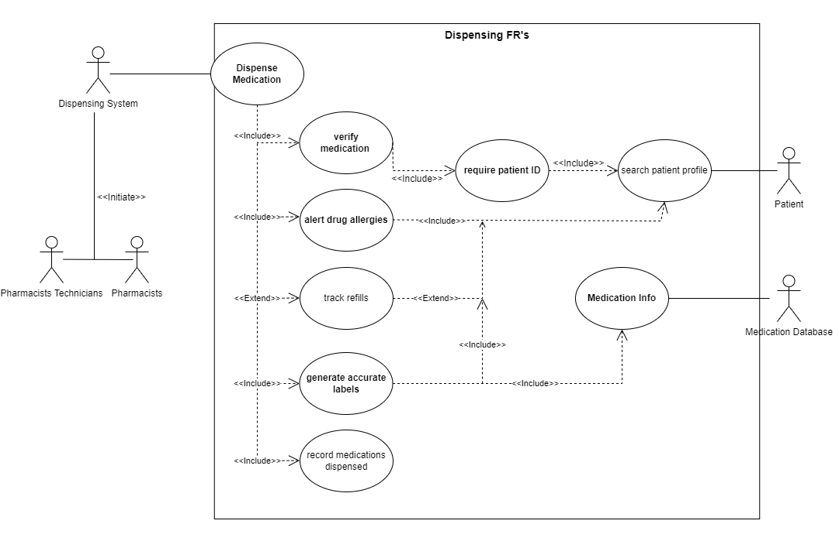

Dispensing system Non Functional Requirements:

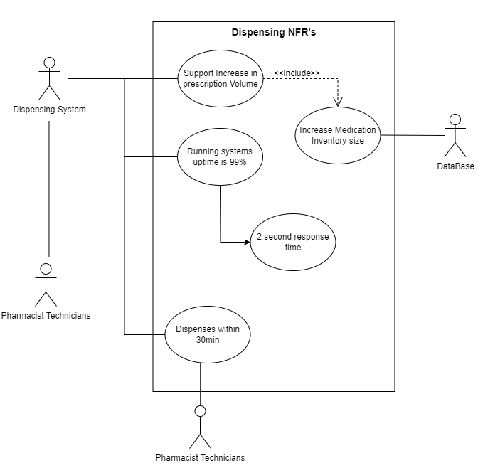

Prescriptions system Functional Requirements:

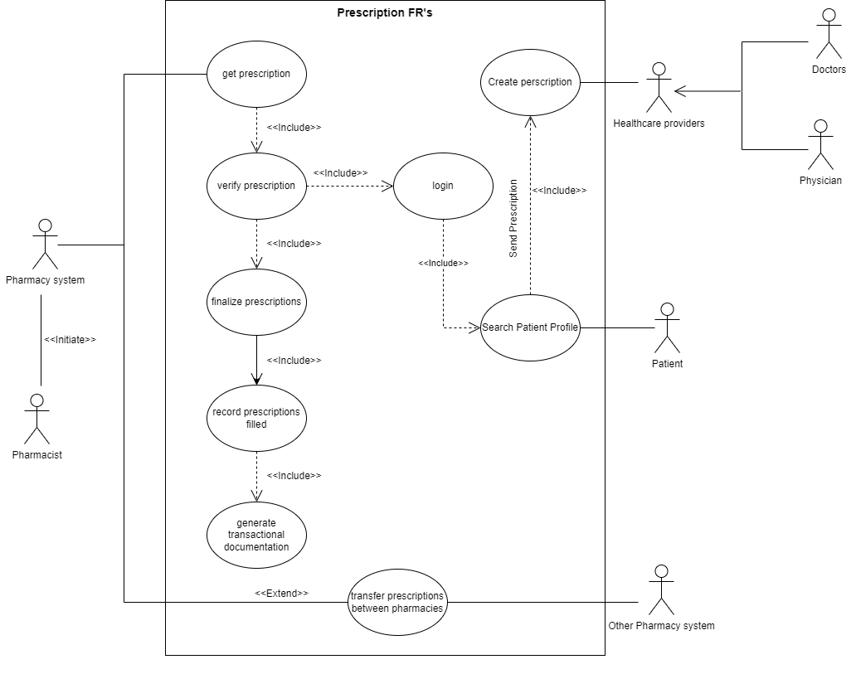

Prescriptions system Non Functional Requirements:

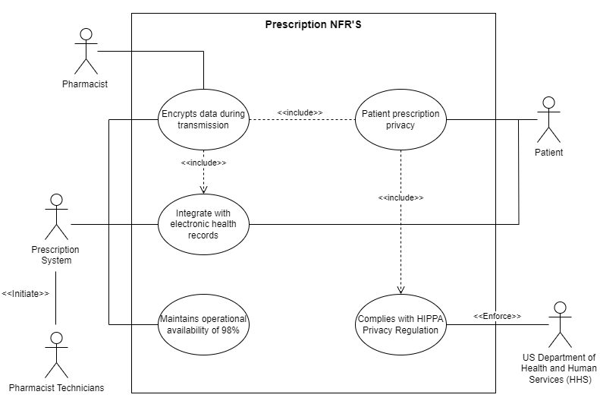

Medication system Functional Requirements:

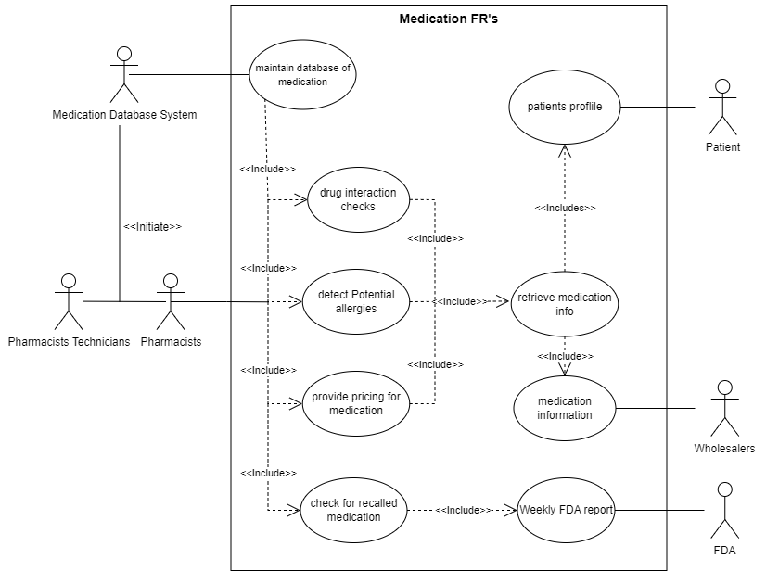

Medication system Non Functional Requirements:

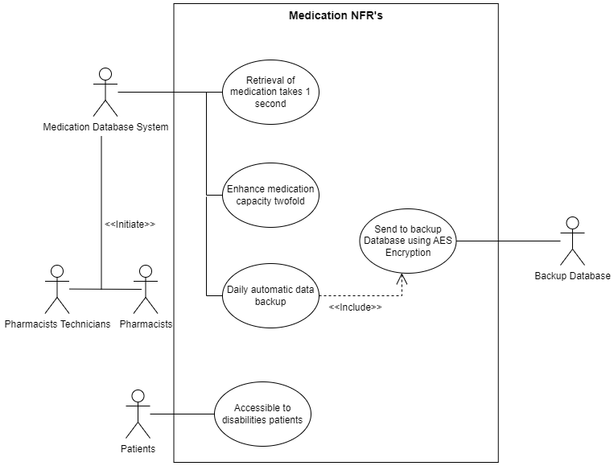

Health Insurance system Functional Requirements:

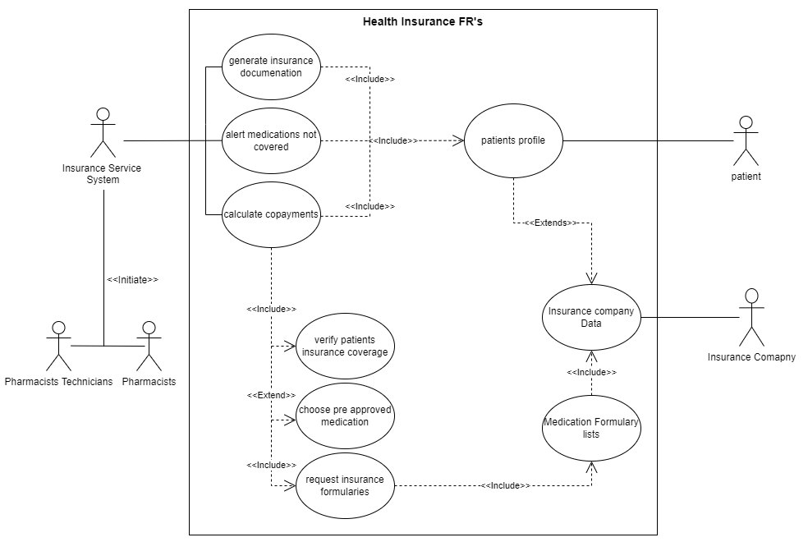

Health Insurance system Non Functional Requirements:

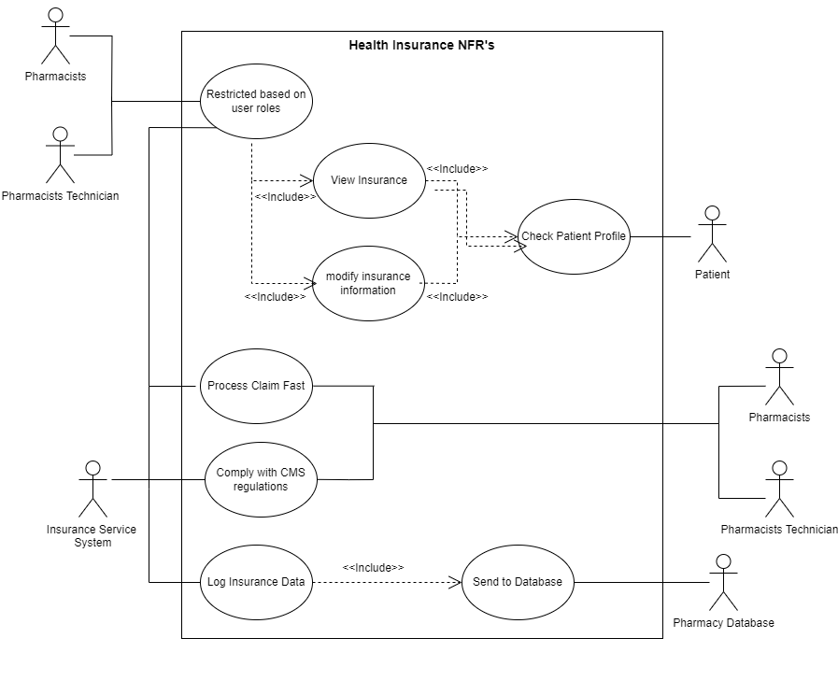

Medical Inventory system Functional Requirements:

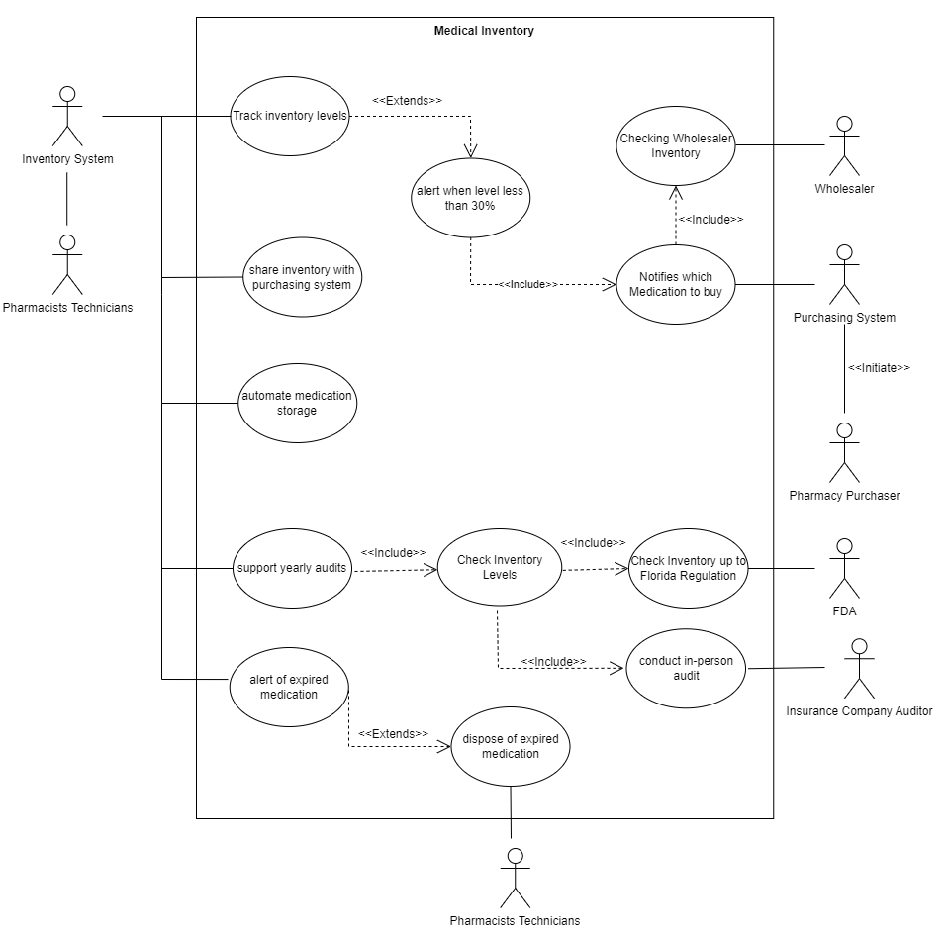

Medical Inventory system Non Functional Requirements:

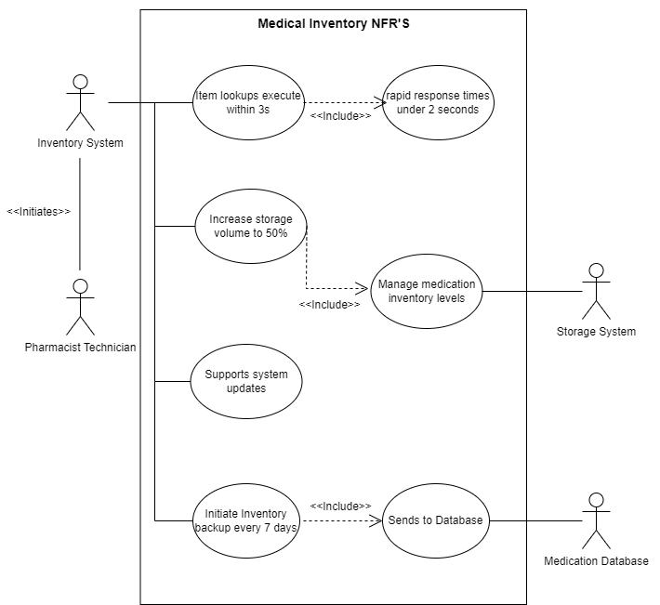

Class Diagram:

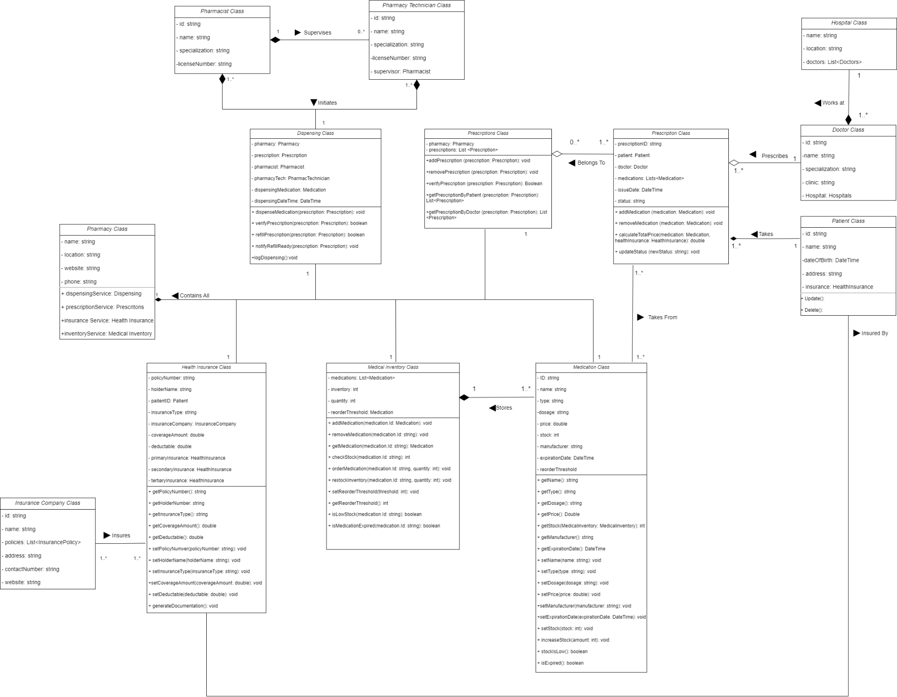

Class Diagram Description:

**Pharmacy** **class**: This class serves as the main pillar or the class diagram. It manages the main areas of insurance, dispensing, medications, inventory, and prescriptions. Has relationships with the key classes in the system.

Relations:

· Health Insurance class: *Relation: Composition; Multiplicity: 1 to 1*

· Dispensing class: *Relation: Composition; Multiplicity: 1 to 1*

· Medical Inventory class: *Relation: Composition; Multiplicity: 1 to 1*

· Prescriptions class: *Relation: Composition; Multiplicity: 1 to 1*

· Medication class: *Relation: Composition; Multiplicity: 1 to 1*

**Pharmacist** **class**: This is for an actor with the role of a pharmacist. Their information is provided by the pharmacist class. This information is used in the dispensing class. A pharmacist can act as a supervisor to none or more pharmacy technicians.

Relations:

· Pharmacy Technician class: *Relation: Composition; Multiplicity: 1 to 0...\**

· Dispensing class: *Relation: Composition; Multiplicity: 1...* to 1*

**Pharmacy** **Technician** **class**: This is for an actor with the role of a pharmacy technician. Their information is provided by the pharmacy technician class. This information is used in the dispensing class. A pharmacy technician is supervised by a pharmacist. They are supervised by pharmacists and use the dispensing system.

Relations:

· Pharmacist class: *Relation: Composition; Multiplicity: 1 to 0...\**

· Dispensing class: *Relation: Composition; Multiplicity: 1...* to 1*

**Dispensing** **class**: This class oversees dispensing medication for new prescriptions or refill prescriptions. It also verifies prescriptions, dispenses medications, and logs each dispensing action. These actions require a pharmacist or a pharmacy technician to occur. This information is retrieved from the pharmacist and pharmacy technician classes, respectively.

Relations:

· Pharmacist class: *Relation: Composition; Multiplicity: 1...* to 1*

· Pharmacy Technician class: *Relation: Composition; Multiplicity: 1...* to 1*

· Pharmacy class: *Relation: Composition; Multiplicity: 1 to 1*

**Prescriptions** **class**: This class manages prescriptions. It holds information about prescriptions such as the prescription id, patient, what medications they need, and the doctor who prescribed it. This class gets prescriptions from the prescription class by the doctor and patient. Its functionalities are to add, remove, and verify prescriptions.

Relations:

· Prescription class: *Relation: Aggregation; Multiplicity: 0…* to 1…\**

· Pharmacy class: *Relation: Composition; Multiplicity: 1 to 1*

**Prescription** **class**: This class holds information about individual prescriptions, including details about the prescribing doctor and the patient. It can add and remove medications from a patient’s prescription. It can also calculate the total price of the prescription. Gives prescription data to the prescriptions class. A patient can have many prescriptions. Gets Medication information from Medication class.

Relations:

· Doctor class: *Relation: Aggregation; Multiplicity: 1…* to 1*

· Patient class: *Relation: Composition; Multiplicity: 1…* to 1*

· Prescriptions class: *Relation: Aggregation; Multiplicity: 0…* to 1…\**

· Medication class: *Relation: Association; Multiplicity: 0…* to 1…\**

**Hospital** **class**: Represents hospitals where doctors from other hospitals can send prescriptions.

Relations:

· Doctor class: *Relation: Composition; Multiplicity: 1 to 1…\**

**Doctor** **class**: Represents individual doctors who issue prescriptions. Relations with hospital class where they work. Also in relations with prescriptions class where they send patients prescriptions to.

Relations:

· Hospital class: *Relation: Composition; Multiplicity: 1 to 1…\**

· Prescription class: *Relation: Aggregation; Multiplicity: 1…* to 1*

**Patient** **class**: Represents patients who receive prescriptions from the pharmacy. They are also customers of the pharmacy, who tell their primary health providers to send in their prescriptions to our pharmacy. They pay and aid in the growth of our pharmacy

Relations:

· Prescription class: *Relation: Composition; Multiplicity: : 1…* to 1*

· Health Insurance: *Relation: Association; Multiplicity: 1 to 1*

**Insurance Company class**: This class represents an insurance company that provides health insurance policies.

Relations:

· Health Insurance class: *Relation: Aggregation; Multiplicity: 1...* to 1…\**

**Health** **Insurance** **class**: This class manages health insurance policies and their association with insurance companies. This class receives all insurance information such as policies from the insurance company class. Then it connects an insurance company to a patient. Generates legal documents.

Relations:

· Insurance Company class: *Relation: Aggregation; Multiplicity: 1...* to 1…\**

· Pharmacy class: *Relation: Composition; Multiplicity: 1 to 1*

· *Patient class* : *Relation: Association; Multiplicity: 1 to 1*

**Medical Inventory** **class**: This class manages the inventory of medical supplies and medications within a pharmacy. Takes Medication information from the Medication class. It receives medication and stores it and its respective place. Monitors its expiration date and threshold. Orders more medication when its threshold is under 30%.

Relations:

· Medication class: *Relation: Composition; Multiplicity: 1 to 1…\**

· Pharmacy class: *Relation: Composition; Multiplicity: 1 to 1*

**Medication** **class**: This class represents individual medications and holds information about them, including their association with medical inventory. Gets this information so that prescriptions can be accurately labeled by the dispensing system once its prescribed to a patient.

Relations:

· Medical Inventory class: *Relation: Composition; Multiplicity: 1 to 1…\**

· Pharmacy class: *Relation: Composition; Multiplicity: 1 to 1*

· Prescription class: *Relation: Association; Multiplicity:*

**Appendix C: To Be Determined List**

*Centers for Disease Control and Prevention. (2022, June 27). Health Insurance Portability and accountability act of 1996 (HIPAA). Centers for Disease Control and Prevention.* [*https://www.cdc.gov/phlp/publications/topic/hipaa.html*](https://www.cdc.gov/phlp/publications/topic/hipaa.html)

*Data Protection under GDPR. Your Europe. (2022, June 7). https://europa.eu/youreurope/business/dealing-with-customers/data-protection/data-protection-gdpr/index_en.htm*

*Laws-and-rules-booklet.pdf. (n.d.).* [*https://floridaspharmacy.gov/Forms/laws-and-rules-booklet.pdf*](https://floridaspharmacy.gov/Forms/laws-and-rules-booklet.pdf) *The General Data Protection Regulation - consilium.europa.eu. (n.d.-b). https://www.consilium.europa.eu/en/policies/data-protection/data-protection-regulation/*

*Medicine, C. for V. (n.d.). What FDA does and does not regulate. U.S. Food and Drug Administration.* [*https://www.fda.gov/animal-veterinary/animal-health-literacy/what-fda-does-and-does-not-regulate#:~:text=FDA%20is%20responsible%20for%20approving,Some%20pharmacies%20also%20compound%20drugs*](https://www.fda.gov/animal-veterinary/animal-health-literacy/what-fda-does-and-does-not-regulate#:~:text=FDA%20is%20responsible%20for%20approving,Some%20pharmacies%20also%20compound%20drugs)

*Medicine, F. B. of. (n.d.-a). Electronic prescribing requirements. Florida Board of Medicine.* [*https://flboardofmedicine.gov/latest-news/electronic-prescribing-requirements/*](https://flboardofmedicine.gov/latest-news/electronic-prescribing-requirements/)

*(OCR), O. for C. R. (2022, October 19). Summary of the HIPAA privacy rule. HHS.gov.* [*https://www.hhs.gov/hipaa/for-professionals/privacy/laws-regulations/index.html*](https://www.hhs.gov/hipaa/for-professionals/privacy/laws-regulations/index.html)

*Revised regulation allows DEA-registered pharmacies to transfer electronic prescriptions at a patient’s request. DEA. (n.d.).* [*https://www.dea.gov/stories/2023/2023-09/2023-09-01/revised-regulation-allows-dea-registered-pharmacies-transfer*](https://www.dea.gov/stories/2023/2023-09/2023-09-01/revised-regulation-allows-dea-registered-pharmacies-transfer)

*The Federal Register. Federal Register :: Request Access. (n.d.-b).* [*https://www.ecfr.gov/current/title-21/chapter-II/part-1306/subject-group-ECFR1eb5bb3a23fddd0/section-1306.06*](https://www.ecfr.gov/current/title-21/chapter-II/part-1306/subject-group-ECFR1eb5bb3a23fddd0/section-1306.06)

*The Federal Register. Federal Register :: Request Access. (n.d.-a).* [*https://www.ecfr.gov/current/title-21/part-1311/section-1311.200#p-1311.200(f)*](https://www.ecfr.gov/current/title-21/part-1311/section-1311.200#p-1311.200(f))

**ARM REPORTS:**

Due to their incredible length we uploaded the ARM reports to our GitHub Repository. There you can see the Full ARM report PDF’s without it affecting the length and quality of our SRS document.

[***LINK TO BAD ARM REPORT***](https://github.com/GioMonci/Community-Pharmacy-Requirements-Engineering/blob/main/ARM_REPORTS/Bad_ARM_analysis.pdf)

[**LINK TO FIXED ARM REPORT**](https://github.com/GioMonci/Community-Pharmacy-Requirements-Engineering/blob/main/ARM_REPORTS/FINAL_ARM_Report.pdf)