North Quay Gifts · Online Retail II
Peak Season Plan: Sales Forecast, Repurchase and Customer Segments
Learning Activity 4 · Modeling and Commercial Strategy. Team: Jorge Luis Castillo Ruz, Saralet Chan Ramos, Karime Pacheco Gallegos, Giovanni Soriano Pacheco.
All amounts are in GBP and follow Route B: purchases net of recorded credits, as in Activities 2 and 3. The case history ends on December 9, 2011; the periods below are past data, not current sales.

1. Priority recommendation: a win-back pilot with a control group
What we propose. Contact customers who are drifting away with an offer to come back. Before contacting them, split the audience at random: 3 in 4 receive the offer and 1 in 4 receive nothing.
How we measure it. 90-day repurchase rate = customers in the group with at least one valid purchase within 90 days of the contact ÷ all customers assigned to that group, whether they respond or not. The campaign effect is the difference between the contacted group and the control group over the same 90 days.
Why a test and not a rollout. Our model identifies who tends not to come back; it does not prove that an offer causes a purchase. The control group tells us how many would have returned anyway. We do not estimate profit or return because we have no campaign costs or measured effects yet.

Evidence. Among customers who bought in the six months before July 1, 2011, the group with small net spend (£275.60 or less) and 101 to 157 days without buying had the lowest repurchase rate of all large groups: 199 customers in training, only 23.1% bought again in the next 90 days (23.9% of 46 customers in the test set). In the test set the model selects 300 customers for win-back: 204 of them indeed did not buy again (precision for class 0: 68.0%), and it finds 204 of the 263 non-repurchasers (recall for class 0: 77.6%).
Accepted errors. 96 test customers who did buy again would be contacted unnecessarily (false negatives); we accept this because the cost is one extra contact or discount. The more serious error is the 59 non-repurchasers predicted as loyal (false positives), who would be left out of the win-back audience.

2. Essential evidence

2.1 Sales forecast (daily revenue, October 17 to December 9, 2011)
We forecast the next business day's net revenue at the close of each business day. The store records no sales on Saturdays and on UK holidays, so we worked with observed business days and did not fill missing dates with zeros. The model was chosen with five chronological validation cuts inside the training period, and the last 47 business days were used only once, as a final test.
Model (test, 47 business days) | MAE | RMSE | R² | vs. reference
Selected: regression with lags and calendar | £10,481 | £15,002 | 0.26 | 21% less error
Initial: regression with lags only | £11,572 | £15,483 | 0.21 | 13% less error
Reference: same weekday last week | £13,236 | £17,704 | −0.04 | —
Reference: last observed day | £17,864 | £23,718 | −0.86 | 35% more error
Average daily revenue in the test period: £51,868. MAE = average absolute error per day.
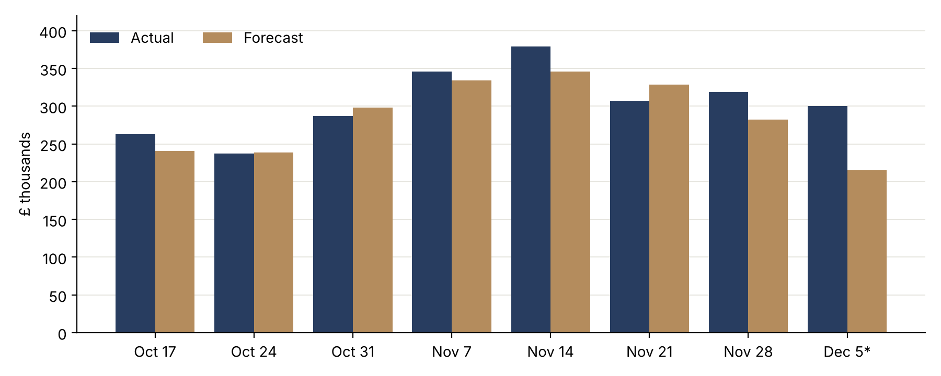
Weekly sums of the daily forecasts. *The last week covers December 5 to 9 only, where the history ends.
What it means for planning. Summed by week, the forecast is off by 9.0% on average, compared with 13.0% for the reference, so it is most useful for weekly capacity planning. Its two largest errors were underestimates: on November 14, 2011 the store sold £111,959 against £58,038 forecast (about 100 orders, with an average order of £525), and on December 7 it sold £74,953 against £39,244, because the model learned from a single previous December that included the Christmas closure. The model underestimated 27 of the 47 days. In peak season, underestimating is the costlier error (stockouts and late orders when demand is highest), so we recommend planning with the forecast plus an extra buffer in November.

2.2 Repurchase propensity (customers as of July 1, 2011)
A decision tree with depth 4 and at least 50 customers per leaf, chosen by cross-validation on the training set using F1 for class 1, reached F1 = 0.706 and accuracy = 71.6% on the test set, with almost the same values in training (0.704 and 70.2%). The unrestricted initial tree memorized the training data (100% in training, 61.8% in test). Two rules support the audiences:
- Loyalty: net spend between £685.93 and £2,182.20 with more than 4 orders in six months: 130 customers, 87.7% bought again (93.1% of 29 in test). Action to test: a loyalty program rather than discounts.
- Win-back: net spend of £275.60 or less and 101 to 157 days without buying: 199 customers, 23.1% bought again (23.9% of 46 in test). Action to test: the pilot in Section 1.

2.3 Customer segments (full history, as of December 10, 2011)
We grouped all 5,878 identified customers by recency, frequency and net spend. We used a signed logarithm so the 35 customers with zero or negative net spend could stay in the analysis, and chose five groups (silhouette 0.374, against 0.357 for four groups) because the fifth group isolates customers whose returns cancel or exceed their purchases. This group has 43 customers: the 35 with zero or negative net spend plus 8 whose purchases and credits nearly cancel out (net spend under £3).
Segment | Customers | Median recency | Median orders | Median net spend | Share of net revenue | Action to test · indicator
Key customers | 1,122 (19.1%) | 16 days | 13 | £4,961 | 71.9% | Priority service · % ordering within 60 days vs. control
Cooling down | 1,391 (23.7%) | 158 days | 5 | £1,558 | 17.3% | Reminder with a deadline · 90-day repurchase vs. control
New and growing | 1,286 (21.9%) | 25 days | 3 | £699 | 6.5% | Second and third order series · % with 2 more orders in 90 days
One-time buyers | 2,036 (34.6%) | 405 days | 1 | £292 | 4.4% | One low-cost offer · response within 60 days vs. control
Net zero or negative | 43 (0.7%) | 429 days | 1 | ≈ £0 | −0.2% | No campaign; customer service review of returns
Medians describe purchase behavior only; RFM includes no margins or costs, so it says nothing about profitability or motivations.
The two most different strategies are for key customers, who are one in five customers but bring 71.9% of net revenue, and one-time buyers, who are a third of the base and bring 4.4%: most of them (65%) bought only once, and 63% have not bought in more than a year.. The first group must be protected; with the second we would test only a cheap action.

3. Limitations that could change the decision
- Only one previous peak season. The forecast learned November and December from 2010 alone, which explains the underestimate in early December 2011. Promotion calendars and confirmed large orders would improve it.
- Class 0 is not permanent churn. 462 of the 1,315 customers who did not buy in the 90-day window (35%) bought again later, as shown in Activity 3.
- Propensity is not effect. The tree describes who tends to come back; only the control group in the pilot can show what the campaign adds.
- Different snapshots. The repurchase analysis is set in July 2011 and the segmentation uses data up to December 2011; the segments are not applied retroactively to a July campaign.
- No costs. Without campaign costs or measured effects we do not report profitability or return on investment.

