Guide Questions

1. What is the purpose of using document.getElementById() in the calculator?
document.getElementById() is used to find a specific HTML element using its ID. In this calculator, JavaScript uses it to get the values entered in the number fields and to change the result displayed on the webpage. It allows JavaScript to communicate with and control the HTML elements.

2. Why do we use Number() before performing the calculation?
The values received from HTML input fields are treated as text or strings. Number() converts those values into actual numerical values so JavaScript can perform mathematical operations correctly. Without converting them, some operations such as addition could produce unexpected results because JavaScript may treat the values as text.

3. How do HTML, CSS, and JavaScript work together in this activity?
HTML creates the structure of the calculator, including the input fields, buttons, and result area. CSS controls the appearance and layout of the calculator, such as its colors, spacing, size, and button design. JavaScript provides the functionality by reading the numbers, performing the selected calculation, displaying the result, and clearing the calculator.

Screenshot of the following, showing the working calculator

Addition: Subtraction:
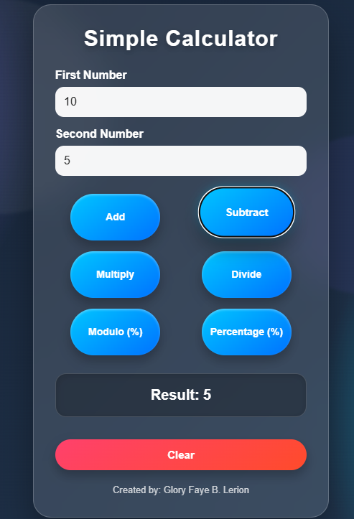
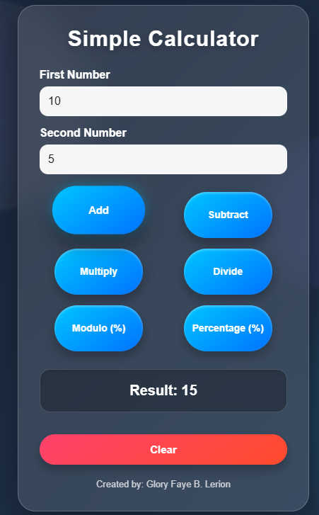

Multiplication: Division:
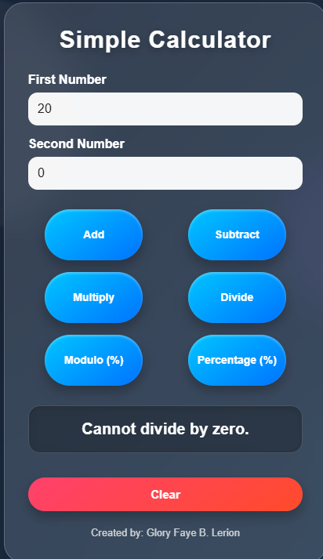
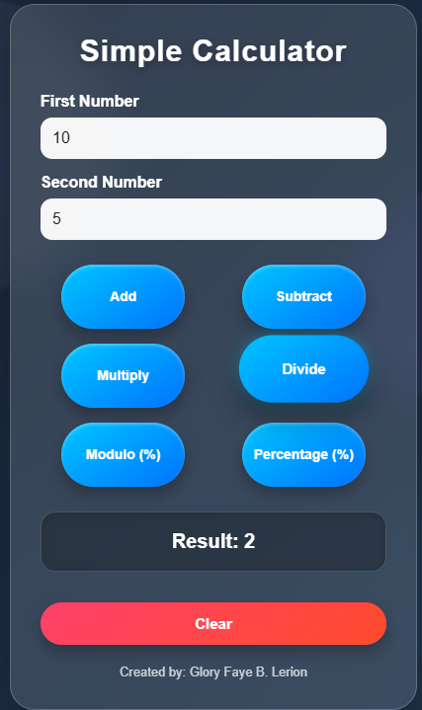
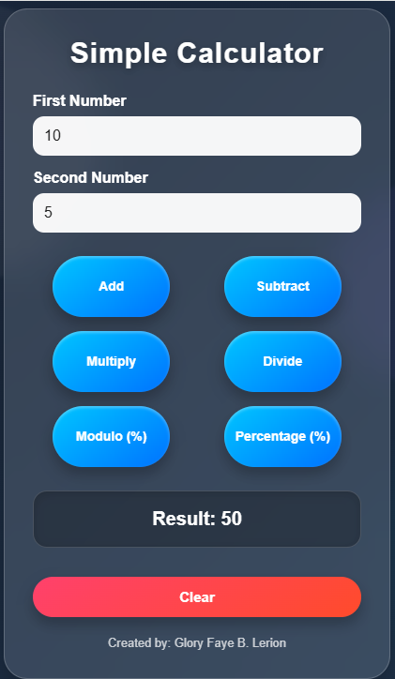

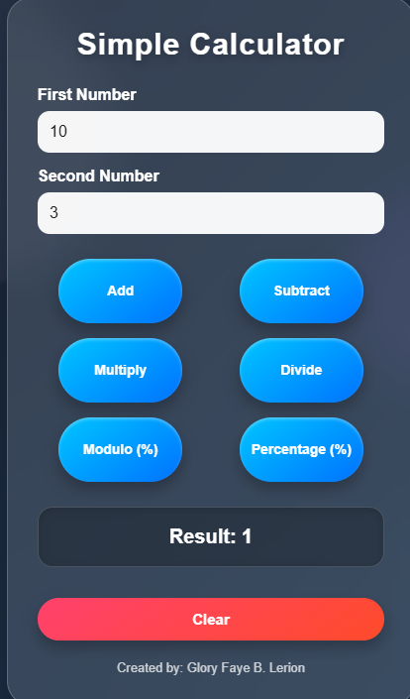
Modulo: Percentage:
