INTRODUCTION

DESCRIPTION OF THE GIVEN PROBLEM

Our project is about PowerEnJoy, a system of car-sharing that employs only electric cars. It provides users to reserve and use shared cars of the system in a specific area, paying in function of the time of driving. The interface to communicate to the system is a mobile app or a web page that make the renting simply and clear. After reserve a car and enter it with a few tap on the smartphone app, a monitor in the car helps the driver with some available command and suggestions, and show the amount of money to be paid in real time. All the interaction between the user and the system are managed by the mobile app and the monitor on the car. They guide the user to the correct use of the sistem.

For the inscription is necessary a valid document and the driver’s licence. To be able to use the service the user has to associate a valid credit card to its profile, with which he will pay the travel. Every time the user wants to use the service has to insert his credentials. Through the app he is able to get in the car. There are 5 minutes for the driver to get himself comfortable in the car after which the payment will start. At the end of the travel the driver has to leave the car in the available area, and the payment will be automatically charged from the user’s credit card. In particular he can respect some constraints to get some bonuses on the rate. In fact the system wants to reward the virtuous users with some discount: for example if they transport other people or leave the car in a recharging area, they manifest a particular attention at the environment and at the system. The payment will be automatically charged from the user’s credit card.

The repositioning of the cars and their recharging are managed by a group of assistant that can see, reserve and use the cars freely, in order to offer a good and equally sparse service.

**GOALS**

* [G1] Clients are allowed to register to the system giving their credentials and payment information.
* [G2] Registered clients are able to see through an interactive map the positions of the available cars near a specific address (current position or inserted).
* [G3] Registered clients can reserve a single electric car for at most an hour before picking it up
* [G4] Clients that get the reservation countdown expired are punished with a fee of one euro
* [G5] Clients can open the reserved car scanning the qr code
* [G6] Clients can monitor the amount of money to be payed, updated in real time on car display [G7] Clients can leave the car locked in break continuing to pay, keeping it reserved
* [G8] Cars are blocked automatically when client ends his travel
* [G9] Client are charged proportionally to the driving time with some penalties or discounts

**DOMAIN PROPERTIES**

These are the main properties of our world that we need to be always true:

* GPS always give the right position
* The service is always available
* User cannot switch off the car information system
* The connection of car information system never fail
* Course time is always positive
* The sensors system in each car always detects a positive number (or zero) of clients
* Countdowns cannot be stopped
* Car’s qr codes are unique
* A car can only be in one place at a time
* Any technological failure (for example a problem in locking system) is readily communicated to the direction by the car itself
* Broken cars are not available
* In case of accident, our insurance is able to operate directly with the client, making use of data provided by us
* Drivers never stop in the road with 0% of battery
* Drivers do not come with the car out from the authorized area

GLOSSARY

Client: he is a person who uses PowerEnJoy (serve davvero??)

Registered client: he is a client who have already done the procedure for signing in. He provided to the system all the necessaries data: his credentials and payment information

Reserving client: he is a “registered client” who reserved a single electric car through PowerEnJoy. He has at most one hour for picking it up

Serve il client che sta usando la macchina?

Dismounted client: he is a “registered client” who doesn’t have any reservations on PowerEnJoy. Then he is allowed to reserve available electric cars

Client in break: he is a “registered client” who exits the car, but decides to keep it reserved. For this reason he continues to pay for the car.

Electric car: it is an automobile owned by PowerEnJoy that is propelled by one or more electric motors, using electrical energy stored in rechargeable batteries

Available car: it is an “electric car” which currently doesn’t have any reservations. It is in a safe area with more than 80% of battery and in good conditions. Then registered clients can reserve them

Reserved car: it is an “electric car” which is currently reserved by a “reserving client”. As a consequence, in this state it cannot be reserved by other clients

Car in break: it is an electric car which is locked and turned off. It continues to be reserved and to charge the client.

Reservation countdown: it is a one-hour countdown that starts when the client reserves an available car and ends when he picks it up. During this time the car continues to be considered a “reserved car”

Courtesy countdown: it is a five minutes countdown that starts when the client opens the car and ends with the engine ignition. In this period the client, before starting to drive, can get himself comfortable, put in a proper positions his bag, adjust car mirrors and fast security belt.

Current position: it is the position detected by the GPS of the client device.

Virtuous behaviour: a way in which a person behaves respecting the environment. Examples of virtuous behaviours are: sharing the car with other passengers or leaving the car in the special parking areas where they can be charged

Zone: it is a zone of approximately 1km2. The town is divided in several zones

Available constraints: the car must have more than 80% of battery, be in good conditions (clean and without damages) and locate in an available area

Available area: it is any parking accessible through an electric car located in the territory of Milan.

Special parking area: it is an “available area” in which there are plugs and so electric cars can be recharged

power plugs

workers (SLAVE)

TEXT ASSUMPTIONS

There are few points that are not very clear in the specification document, or not completely specified. So we will have to make some assumption and choices:

* The system is able, in the moment of the registration, to assure that the provided credentials are consistent and the client has a regular and active driving licence (scriviamo della connessione con un particolare ente?). This is true also for payment information: only credit (not debit) cards are accepted and the system is able to verify with principal bank circuit (ex. Visa or Mastercard) the actual validity of the card itself.
* The method for opening cars is to scan a qr code that each car has on its left door.
* In order to avoid that people could enter in the car and be stationed inside without paying, we put in the system a 5 minutes countdown, starting from the moment in which client enters in the car. After these 5 minutes user start to be charged, even if the engine is switched-off.
* All the cars used by our clients are provided to weight sensors, one for each possible passenger. It is the way in which our system is able to count passengers and verify if someone is still in the car.
* The discounts are combinable. If a client reaches more than one objective, he will be discounted subsequently from the highest to the lower discount.
* In order to assure an always active service and an equal distribution of the car in the city the society must assume some workers. They can access to a special area of the application, seeing where all cars are placed and their current state. This allows them to turn constantly around the city, recharging cars with their special equipment and redistributing vehicle in the city. Workers can’t open cars by application, they are equipped with a *passepartout.*

COSTRAINTS

* REGULATORY POLICIES

Sensitive data such as the credentials, informations about payment and movements of the client must be used respecting the privacy law.

Furthermore the system in order to work correctly must require the client permission to get his position.

Finally notifications (not SPAM) can be sent to the client for exchanging necessary information between the application and the system.

* HARDWARE LIMITATIONS
  + Mobile application:
    - 3G connection
    - GPS
    - Space for app package
    - Photo camera for scanning QR code
  + Car application:
    - 3G connection
    - GPS
* INTERFACES TO OTHER APPLICATIONS
* PARALLEL OPERATIONS

The system must manage the interactions with several different client applications at the same time. For this reason, it must handle concurrent operations.

* PROPOSED SYSTEM

We decided to implement a client-server architecture in which there is a mobile application that interacts with an application server. This server receives essential information also from a different application situated in the car. At the same time, it stores and uses information in a database server. We will speak about architecture more precisely in the following documents.



IDENTIFYING STAKEHOLDERS

Our project is commissioned by the minister of the transport of Milano in agreement with the Minister of the Environment. They request the project documentation until the end of February. The documentation consists in the Requirements Analysis and Specification Document for have a general and complete idea of the system in exam, the Design document for have a functional description of the system, the Integration Test Document that describes how to accomplish the integration tests and the Project Plan.

With this system the minister of the environment wants to sensitize the inhabitants at a sustainable system for how concerns the transport. In the system, moreover, are introduced some bonuses for the people who respect some constraints, for reward their virtuous behaviour.

**ACTORS IDENTIFYING**

The actors involved in the system, are:

* The user: is registered in the system and logged when we mention him in this document. He uses the system for personal purpose. He uses the app in his smartphone, and can offers the travel to four other people at the same time.
* Assistant: is an employee that have a special account that enable him to move the car without paying. He is delegate to redistribute the cars in the available area and recharge the car with low battery.

**REQUIREMENTS:**

1. Clients are allowed to register to the system giving their credentials and payment information
   1. The system controls if credentials are correct
   2. The system controls if payment information are correct
   3. Conferma?
   4. The system sends a password to the new client
2. Registered clients are able to see through an interactive map the positions of the available cars near a specific address (current position or inserted)
   1. The system checks if the client is “appiedato”
   2. The system gets the position from the GPS or from the position input
   3. The system obtains the actual position of the electric cars
   4. System generates a map with a marker for each available car in the selected zone
3. Registered clients can reserve a single electric car for at most an hour before picking it up
   1. The system modifies the state of the electric car from “available” to “reserved”
   2. The system changes the client state from “appiedato” to “reserving”
   3. The system stores the relationship between the car selected and client
   4. The system starts the one hour reservation countdown for the client
4. Clients that get the reservation countdown expired are punished with a fee of one euro
   1. The system changes the state of the car from reserved to available
   2. The system changes the state of the client from “reserving” to “appiedato”
   3. The system charges the client one euro
5. Clients can open the reserved car scanning the qr code
   1. The system controls the correspondence between qr code and reserved car
   2. The system unlocks the reserved car
   3. The system changes the car state from reserved to occupied
   4. The system changes the client state from “reserving” to “aboard”
   5. The system starts the five minutes courtesy countdown for starting payment (when the countdown expires the system starts to charge the user even if engine is still switched off)
6. Clients can monitor the amount of money to be payed, updated in real time on car display
   1. The system calculates the amount of money that has to be payed by the client starting from engine ignition (or courtesy countdown end)
   2. The amount of money is displayed on car monitor and is continuously updated
   3. The system stops charging the client at travel conclusion
7. Clients can leave the car locked in break continuing to pay, keeping it reserved
   1. The system asks the client if he wants to end his travel or to leave the car in break, sending him a notification through the app. This happen when sensors detect that all passengers are out of the car, engine is turned off and doors are closed
   2. Both the client and the car states are set to “in break”
   3. The system locks the car
   4. The system unlocks the car after the client rescans the qr code through the application
   5. The system changes the client and car states
8. Cars are blocked automatically when client ends his travel
   1. The system asks the client if he wants to end his travel or to leave the car in break, sending him a notification through the app. This happen in the same way of point 7.a
   2. The system locks the car
   3. The system adds the car at the set of available cars if it respects the available constraints.
9. Client are charged proportionally to the driving time with some penalties or discounts
   1. SCONTI

**NON FUNCTIONAL REQUIREMENTS**

* Service always available, 24 hours a day and 7 days a week
* Client and car state updated in the order of 1 second
* Client information and payment data are reserved
* System must be able to support multiple connections at once
* Client interface is intuitive and easy to use

Below we report some examples of how we would like our interface to be

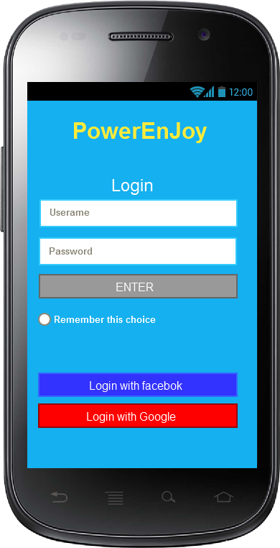

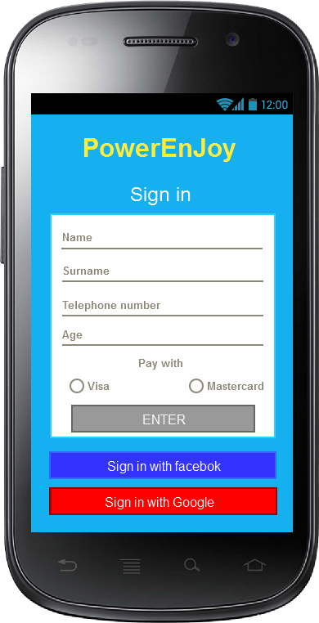

*This two picture show the login and sign in page*

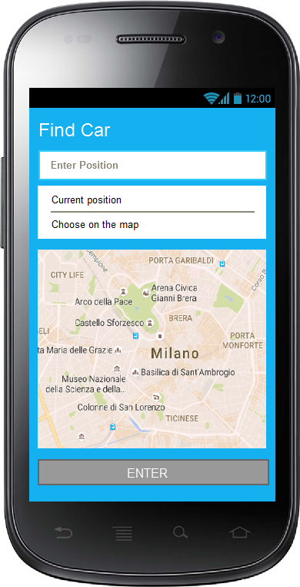

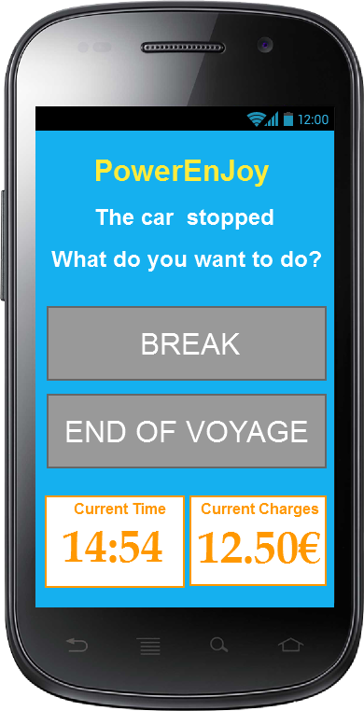

*The first pictures show the page in which a client can insert the position where he wants to take the car.*

*In the second one there is the notifications in which clients can decide if end their travel or leave the car in break.*

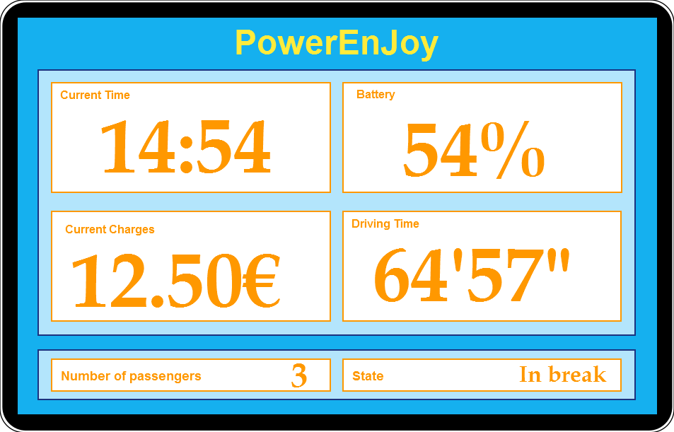

*This pictures shows the car application in which clients can see the battery, the driving time, the current charges and time continuously updated*

**SCENARIO IDENTIFYING**

SCENARIO 1 (servizio continuo, pause)

Jack and his girlfriend Mary are two students that decided to get a trip. They bought the cheapest fly at 5 in the morning. To reach the airport they have to take the train from the central station. At this hour in the morning there are not public transport to reach the central station, so Jack decides to use PowerEnJoy, that assures the service 24 to 24, 7 to 7. After having booked a car in the special parking area nearest to his home, Jack goes with his baggage to the vehicle. There he opens the car with his smartphone, gets in, sets the seat in the right position and straights mirrors. So he goes to Mary house. Once arrived, Jack parks the car in break state, selecting the correspondent option on his smartphone, and goes up to Mary`s apartment in order to help her with her baggage. After having again unlocked the car, they all get in and drive to the central station where a special parking area is placed. Once arrived to the airport and took off their baggage, Jack close the doors and confirms on his smartphone the end of the race. Only in this moment he stops paying and the system executes the transaction from client’s credit card.

SCENARIO 2 (countdown, sconti speciali)

Tonight Bob wants to go to a disco with 2 friends, who live in the same city but in different districts. This evening is cold and it’s raining so they don’t want to take public transport. As they want to save some money, Bob, who has heard of this service from other friends purposes them to rent a PowerEnJoy car, instead of taking a taxi. In fact Bob knows that, sharing the ride, they will get a special discount. In the afternoon Bob registers to the application and then, at 21.00 he logins and reserves the nearest car to his house. At 21.30 he goes out and takes his car before that the 1 hour countdown expires. After taking his friends, when they are almost near to the disco, Bob is very happy to find through the application a special parking area just next to the discotheque. Indeed he know that by leaving the car in recharging state they will be able to increase their special discount. Therefore, they reach the area and, after having put the car in charge, they select the park option from the application. The system applies the discount and executes the transaction. Now Bob and his friends can enjoy their night.

SCENARIO 3 (penalità e schiavi)

Mohammed, after being looking for a job for many years, has finally found an employment as SLAVE in PowerEnJoy enterprise. He is a fundamental part of the system. In fact, today, an unvirtuous client has left the car even 6 km far from the nearest special parking area and with only 5% of power left. No one will be able to use a car in this condition. For this reason, the car has been put in NON AVAILABLE state and the client has been charged with a penalty of 30% on the total amount of his last ride. So Mohammed logins to the system with his special employee account and here he can see both the state and the position of all not available cars. Once found the mentioned vehicle, he goes immediately on the site, recharges the car on site with his special equipment, opens the car with his *passepartout* and moves the car to the nearest recharging area. The system identifies the recharging car and when the vehicle reaches at least 50% of battery is able to change again its state and set it available. Mohammed can now open his map again in order to find another car to move.

SCENARIO 4 (saving money option)

Steve is a 18 years old boy, who has obtained his driving license just last week but doesn’t have an own car yet. Today Steve wants to reach his girlfriend Anna on the opposite side of the city and in order to preserve the environment he decides to use PowerEnjoy electric car. Once inserted his personal credential and credit card data he is finally registered to the system and he can reserve his car. By reading the rules of the service he comes to know of the money saving option and decides to try this advanced function. So he gets in the car and before starting his travel he inserts in the system Anna’s address. After few seconds the app shows him that there is a recommended parking area at about 1km far from his girlfriend’s house with lots of power grid free. In order to save some money Steve decides to follow the advice and gets to the place in about 15 minutes. Once arrived and plugged the car into the grid, the system applies him a special discount of 30% on the price of the ride. Steve, glad for this discount, promises himself to use again this convenient functionality offered by PowerEnjoy application.

5) Percorso a tappe per commissioni, il taxi è scomodo. Possibilità di controllare di continuo la spesa

For Christmas rosy has cook some biscuits for her friends. She wants to do a surprise, so decides to pass at midnight to deliver the presents. To pass to all her friends that are in the quarter she decides to use an electric car of the powerEnJoy, becouse it is too cold for the bycicle and to expansive use a taxi. Using the system rosy can stops and leave the car in break at each friend’s houses, differently that with the taxi.

6) Occasione (magari di lavoro) in cui devo presentarmi per forza con la macchina