Special Work Performance 1

Giorgi Modebadze (StudentID:602191), Radoslav Evtimov (StudentID: 570341)

**Summary**

The purpose of this report is to describe and give an overview of the survey data that was collected regarding different chocolate bars on German Market from 50 people.

It analyzes the consumption habits: why and how often participants eat chocolate and where they buy it. Social Demographics: Age, Marital Status, living place and whether they follow sport. Respondents perception toward 10 different chocolate with 13 different variables (l creamy, crunchy, sweet and so on) and which bar they prefer over other.

**Demographics of the participants**

The participants represent 10 out of 16 states of Germany, with majority from Berlin and Sachsen-Anhalt, 38% and 22% respectively. The vast majority of respondents live in cities (92%). The female/male ratio is 58% to 42%, while the age varies between 18 and 31 with a mean of 25.56. Regarding the occupation, most of them are student (52%) and employees(42%).

58% of the respondents do sport 1-3 times per week, followed by 4-7 times per week with 24%. As the data reveals there is no significant relation between marital status and consumption reasons and people tend to enjoy chocolate same way.

Most of the participants were willing to reveal answers to all question about their Social-Demographics. Least answered question was regarding number of children, with 8 missing values.

**General consumption data**

Most of the people eat chocolate once a week. Only one person out of 50 gave up eating chocolate.

Ein Bild, das Screenshot enthält.

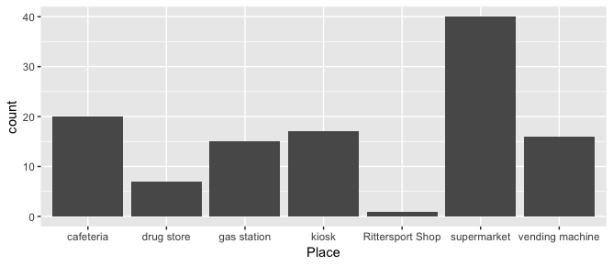People tend to buy chocolate mostly in Supermarkets.

People in villages compared to cities are more likely to use vending machines 25% vs 13% and drug-stores 12% vs 6% to buy chocolate.

50% of participants would name hunger as the one of the reasons for consumption, followed by being under pressure with 46%, travelling - 42%. Being bored was reason for 30% of people for consuming chocolate.

Most of the people tasted almost all chocolate bars. Duplo was tasted by all participants, while Balisto Korn-Mix was least tasted, only by 40 people.

Ein Bild, das Screenshot enthält.

**Preference Ratings**

The survey tried not only to evaluate the qualities of the different products, but also measure which of them are more preferred by customers. For this person there was a question to the participants to give preference rating to each of the products. This was made with a scale from 1 to 7 (1 – not preferred at all, 7 – greatly preferred).

Ein Bild, das Screenshot enthält.

Using this data, we can conclude that the Kinderriegel is on the top of the table with an average preference rating of 5.86. On the hand, Mars scored only 3.9. A general comparison could be made with the following boxplot (Plot 3)

Plot 3

It is worth noting that participants give ratings in different ways – some of them are more critical towards the notes and others give them much easier. The preference ratings data for example shows there is one person who gave an average rating of 7 (maximum in this scale) and there is a person whose average amounts to only 2.10. To understand better the difference between participants the following boxplot (Plot 4) could be useful.

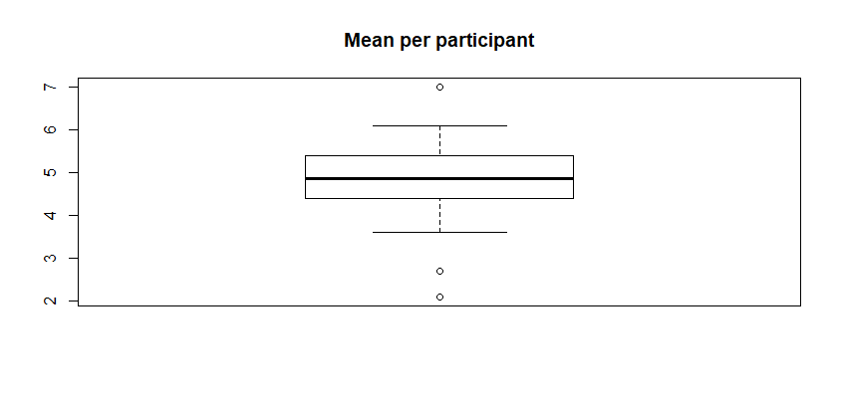

Plot 4

**Attribute Ratings**

Other than direct comparison with each other, participants also were asked to assess 13 different quality of each brand. As it is a complicated task and as some users did not test some brands in their lifetime. As expected, most of the people considered chocolate bars unhealthy. The most healthy option for respondents was Balisto. Kinder Bueno got most point for creaminess, while Kinder Riegel dominated most of the categories . Full overview can be seen below:



More General overview of the data can be seen here:

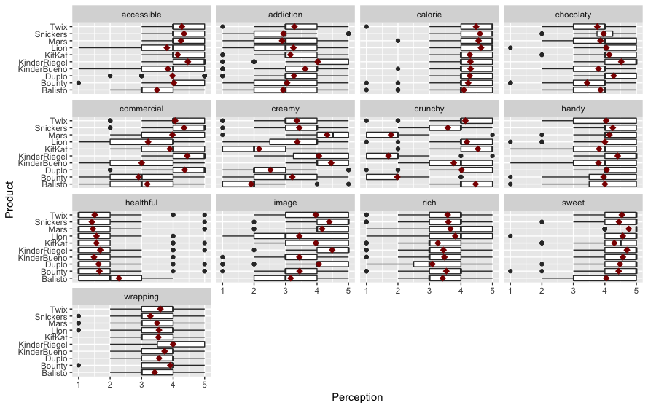

On the average people tend to see less difference in healthfulness, calories, sweetness and wrapping of the chocolate bars. While creaminess, image and commercial are big differentiators.