Coastal urban ecology. Exploring tendencies of research in a developing world.

Graells G1,2, Nakamura N3, Lagos N4, Celis-Diez Juan L.5 Gelcich S1,2

1 Pontificia Universidad Católica de Chile, Departamento de Ecología, Santiago, Chile.

2 Center of Applied Ecology and Sustainability (CAPES).

3 Australian Research Council Centre of Excellence for Coral Reef Studies, James Cook University, Townsville, QLD 4811 Australia.

4

5 Pontificia Universidad Católica de Valparaíso, Escuela de Agronomía, Quillota, Chile.

Marzo 2020

## Abstract

Coastal urban centres have dramatically increased during the last decades. In spite of global pressures, coastal research integrating urban areas are still very scarce. To examine what aspects have been investigated in this area, a systematic revision of literature under the concept of *coastal urban ecology* was made. Articles were selected following a decision tree and data was classified using the Pickett’s paradigms *in-*, *of-*, and *for- the city* plus other categories of classification. A total of 237 publications, developed in 51 countries fitted our criteria. Most of 36% of the articles were made in only three countries. Human dimension research in coastal urban areas emerged as a critical gap. Results suggest that multiple aspects of *coastal urban ecology* are developing slowly and present a big challenge to integrate marine and terrestrial studies to represent coastal ecosystems. Further research should explore social-ecological linkages and stewardship incentives in coastal urban areas to generate sustainable cities and conserve the remaining natural areas on the coast.

### In a nutshell:

• Population in coastal urban cities is increasing over the years, generating one of the biggest perturbation to a marine-terrestrial ecotone.

• The literature review shows that urban coastal studies have been increasing. Most of the research have focused on ecology and few in human dimensions, such as social-ecological interactions and environmental policy-planning.

• Coastal urban ecology studies show an important bias in where the research is made, marine ecosystems within coastal environments have been under looked.

• One of the biggest challenges for coastal urban ecology research is to begin research in countries with high rate of population growing, to understand city expansion and to guarantee sustainable coastal cities in the future.

## Urban ecology in a developing world

The world’s population is increasing annually. By 2018, 55% of people lived in urban areas (United Nations and Social Affairs 2018), where cities grow in number and size, forming large mega-cities (United Nations and Social Affairs 2014). This high level of urbanisation stress presented during the last years have required science-based information about the effects of humans over natural areas and the change of patterns and processes linking cities and natural elements (e.g. Lubchenco *et al.* 1991; Grimm *et al.* 2008). Initial research in urban environments believed these areas were not able to sustain wildlife and the complex processes involved. However, this idea started to change in the first part of the ’70s when urban ecology began studying species distributions in cities and its drivers (Sukopp 1998; Grimm *et al.* 2008).

Historically, urban ecology studies were centred in ecological research, focusing on natural gradients and biotic homogenization (Blair 1996; McKinney and Lockwood 1999; Marzluff 2001; McKinney 2006). In these studies, abundance and species richness, mostly birds or plants, harnessed attention (Ulrich 1984; Shanahan *et al.* 2015). However, urban ecology research topics have changed over the past years, extending towards different ecosystem approaches, which include people’s interactions with the urban environment, environmental policies and planning, through interdisciplinary social-ecological research approaches. Recently, Pickett *et al.* (2016) introduced three phases in urban ecology evolution, as belonging to different paradigms which were termed: *in*, *of*, and *for* the city. Each one of these paradigms expose historical differences according to changes in urban ecology research, and result by the comparison of three variables or axes: chronology, model approach, and complexity.  
With this, studies under the paradigm *in the city* are mainly ecological, studies *of the city* are social-ecological, and studies *for the city* represent research about environmental policies and planning. The urban ecology paradigms also represent increasing complexity of the types of knowledge synthesised in the research questions. Studies which subscribe to the *of the city* paradigm contemplate interdisciplinary research; the urban ecology *for the city* is more intricate and includes *in* and *of the city* studies, engaging scientific knowledge in practice for action (Pickett *et al.* 2016).

## Coastal urban areas growth and research

Within urban environments, coastal cities seem to be one of the preferred places for people to settle (Weinstein 2009). In fact, 40% of the world’s population live less than 100 Km from the sea (United Nations 2017), with coastal cities growing 6.6 times between 1945 and 2012 (Barragán and Andrés 2015). If coastal urban environments have been increasing over the years, we would expect that the need of research in this ecosystems would be also incremented. In this case, is possible to suggest that these studies has focused on marine pollution (Wang and others 2010; Naidoo *et al.* 2016), urban impacts (Buggy and Tobin 2008; Arruti *et al.* 2011), changes in shoreline (Wu *et al.* 2003; Alberico *et al.* 2018), habitat use, (Eguchi *et al.* 2010; Smith and Munro 2010), human adaptation and sustainability (Lebassi *et al.* 2013; Villagra *et al.* 2016), demographic changes (Race *et al.* 2010; Abarca-Álvarez *et al.* 2018), and city design (Garcez and Braga Carmello 2017; Conticelli and Tondelli 2018), among other concerns regarding coastal urban development.

This article reviews coastal urban ecology scientific publications with the aim of examining spatial and temporal changes and its primary focus. Knowing coastal urban ecology research gives the opportunity to determine the gaps between the level of coastal urbanization and the concern to know the effects of urbanization, embracing from theoretical to applied approaches in one of the most human-dominated ecosystems.

## Literature search

A systematic review of the literature was performed through the Web of Science (<https://webofknowledge.com/>). Eligibility criteria included any publication following keywords in topic: (“urban ecology” or “urban environment”) and (coast or marine), where words as “environment” and “coast” were truncated to use their derivations. The period of the search included from 1975 until December 2019. Selection of articles was made with a decision tree (Fig. 1), where the research areas urban centre, marine studies, and biodiversity approach had to be checked for any articles to be included. Fulfilling the requirement to be a “coastal urban ecology” study, publications were classified in ecology *in the city*, ecology *of the city* or ecology *for the city* following the paradigms established by Pickett *et al.* (2016). Grey-literature was not incorporated in the selection.

## Classification and data analysis

Each article collected was categorized in 16 sections: publication year, author’s name, type of publication, author´s affiliation country, study country, study city, city size, model, habitat, ecological paradigm, type of analysis, disciplinary focus, component, approximation, and study subject. In particular, categories as publication year, author’s name, type of publication, author´s affiliation country, study country, and study city were factors obtained directly from each paper, the rest of them had to be checked with further reading.

City’s population data were obtained from Brinkhoff (2018). Urban centres classification was modified from United Nations and Social Affairs (2014) and Barragán and Andrés (2015). This classification comprehends 1) Non-urban areas, which have less than 100,000 inhabitants, 2) small cities, between 100,000 and 500, 000 inhabitants, 3) medium cities, between 500,000 and 1 million, 4) large cities, between 1 and 5 million, 5) very large cities, between 5 and 10 million, and 5) megacities, with more than 10 million.

The rest of the categories (model, habitat, type of analysis, disciplinary focus, study component, approximation of the research, study subject, and ecological paradigms) were classified through a conscious reading of the authors. Study model refers to the minimum unit which was studied in each article, including three significant areas: physical, biological, and social. Here, physical space comprises research with different kind of pollutants, remote sensing data, water resources, physical risk models, and anthropogenic constructions, among others; social with human activities, perceptions and reactions, health, aspects of demography, and hcity development, among others; and biological with different taxa as birds, plants, invertebrates, mammals, and fishes, among others. “Others” category include environmental management, theoretical ecology, ecosystems.

Study habitat were divided in relation with the coastal environment where the research was done or which ecosystem was focused on. The classification includes four main areas according to Burke *et al.* (2001): 1) Near-shore terrestrial, which includes dunes, coastal xeromorphic habitats, rocky and sandy shores, urban, agricultural and industrial landscapes; 2) Intertidal, with estuaries, deltas, mangrove forests, lagoons, salt marshes, other coastal wetlands, marinas and ports; 3) Benthic, with seagrass beds, artificial structures and soft bottom environments above the continental shelf; 4) Pelagic, with open waters above the continental shelf. To this classification the component “urban atmosphere” was added because the amount of studies focused in this area.

On the other hand, study subject summarises the central theme of each article. Study subject was catergorized into eight sections: 1) Anthropogenic pollution, 2) urban impacts, 3) changes in shoreline, 4) habitat use, 5) human adaptation and sustainability, 6) demographic changes , 7) natural disaster, 8) and city design.

Disciplinary focus was categorized into five sections where inter-disciplines were considered. The five disciplinary focus were: 1) Ecology: Study of relationships and interaction between organisms and their coastal urban environment, 2) Sociology: Study of social behavior, including its origin, evolution and organization within a coastal urban environment, 3) Study of interaction between humans and their coastal urban environment, multidiscipline including anthropology, geography, sociology and ecology, 4) Environmental policy: Study of environment, to organize, manage the laws, regulations or find a solution, 5) Social-policy: Provides practical guidelines and principles to improve human welfare.

Study component was divided in three classes: abiotic, biotic, and human. These three presented combinations that were considered as well: abiotic-biotic, abiotic-human, biotic-human, and abiotic-biotic-human.

Study approximation was categorised in three: temporal, spatial, spatiotemporal, and experimental (referring to laboratory studies). Type of analysis comprises quantitative (descriptive analysis), qualitative (collecting and evaluating measurable data) or modelling studies (mostly computational simulations). Finally, type of analysis comprehended modeling, qualitative and quantitative analysis.

Classification, data analysis, and figures were prepared in R (Team R Core 2018). For data analysis, packages tidyverse (Wickham 2017a), dplyr (Wickham *et al.* 2017), purrr (Henry and Wickham 2017), broom (Robinson 2017), and stringr (Wickham 2017b) were used. Graphs and maps were plotted with ggplot2 (Wickham 2009) and gridextra (Auguie 2016). Network analysis was developed with package bibliometrix (Aria and Cuccurullo 2017) which allowed modifications in the code to create a new relationship between articles and their co-citations.

## Coastal urban ecology tendencies

Coastal urban ecology studies that meet defined keywords presents a total of 237 articles developed in 51 countries over the world, reaching 137 coastal cities where research has been performed (Fig. 2). The timeline of publications shows that coastal urban ecology appeared for the first time in 1979. However, it was not until 1993 that another study related to the field was published. After that year, two periods can be defined: between 1993 and 2000, and between 2002 and the present. During the first period, the number of publications was below five articles per year. During the second period, articles were increasing with time. Particularly, years 2016 and 2019 showed more than 20 publications per year. The publications are mostly journal articles with 84.97% of the total, proceedings papers represented 9.7%, book chapters 2.11%, and reviews 2.11%, as well.

During the years, most of the articles published in coastal urban ecology have been developed in urbanized areas between 1 and 5 million inhabitants, considered in this article as “large cities”. Exploring city size, non-urban areas which resume places with less than 100,000 inhabitats presented the lowest number of publications in coastal urban ecology (Fig. 3). The distribution of research according to cities’ population and country showed that coastal urban ecology research has studies in the smallest place of Shishmaref in the US, with 254 people, and the largest city of Tokio, Japan, with more than 20 million. Some countries showed a hight dispersion in city’s population given research was done in more than one city. Highest dispersion was shown by Japan (areas between 990,285 and 22 million people), India (areas between 201,026 and 15,8 million people), and China (areas between 555,693 and 14,7 million people) (Fig. 4).

According to study models (or study subjects) in coastal urban ecology, a significant number of publications were focused on physical aspects (52.74%), biological (21.94%), social (16.03%) (Fig. 5). Pollutant measurments were the study subject with the highest number of articles (16.46%), followed by risk measurments (9.71%), and birds (9.28%).  
Habitats where coastal urban ecology publications were developed showed a decreasing tendency where near shore terrestrial environment was the most frequent, with more than 160 articles (Fig. 6). This is followed by intertidal areas, coastal atmosphere, benthic, and pelagic environments.

## Coastal urban ecology *in*, *of*, and *for the city.*

Paradigms *in*, *of*, and *for the city* have been addressed globally (Fig. 7). The focus *in the city* is presented in at least 60.34% of articles selected, including 37 countries, from all continents and it has a count from one to 29 publications for each country, with the maximum number of articles is presented by the United States. The focus *of the city* is shown at a lower percentage than the previous paradigm. With 20.25% of publications, in 21 countries, and some articles between one and nine, being the maximum number also presented by the United States. Investigations focused on *for the city* showed (19.41%) are presented in 25 countries. China presents six articles, which is the highest number of papers in a country which addresses this paradigm.

During the years, paradigms *in*, *of*, and *for the cities* have shown differences, not only in the total number of articles published (143, 48, and 46, respectively), also in their first year of publishing and tendencies (Fig. 8). In this way, it is not until 2004 that the paradigm *for the city* was developed in coastal urban ecology studies. Before that, the paradigm *in the city* (since the beginning in 1979) dominated this research area, with some occurrence of the paradigm *of the city* only since 1997. The three paradigms showed to be increasing the number of publications during the years, although paradigm *in the city* is doing it faster than the others.

Evidence suggests that the three paradigms are different according to study subject, disciplinary focus, and study components presented in their articles, and similarities between paradigms *of* and *for the city* on type of analysis. On the contrary, study approximation of articles is similar among the three paradigms (Fig. 9).

Study subject is presented differently depending on each paradigm. Urban impacts and changes in habitat use are dominant themes in studies under the paradigm *in the city*. Human adaptation and urban impacts are the most prominent themes in studies under the paradigm *of the cities*. Human adaptation and city design are the mayor subjects in investigations under the paradigm *for the cities*, reflecting the focus on policy and planning implications of these studies.

Categorization by discipline showed thar paradigm *in the city* is mostly focus in ecological research, paradigm *of the city* in socio-ecological research, and paradigm *for the city* is divided in socio-ecological studies and social an enironmental policies.

Study components of research show interesting tendencies where some elements are present in every paradigm. That is the case of the human component, being more important for the paradigm *for the city*. The paradigm *in the city* evaluates more articles with abiotic and biotic components (and both at the same time). Paradigms *of* and *for* the city present mostly articles with the human part. The paradigm *in* shows a significant proportion of articles examining abiotic and humans, while *for the city*, shows a bigger percentage of the only human component.

Approximation of studies is similar for each one of the paradigms. In all the cases, spatial studies are the most comun in coastal urban ecology, over temporal research. Spatio-temporal approximation is also present, without many differences among paradigms.

Considering the type of analysis of publications, there is a greater number of quantitative analysis in studies *in the city*. Studies *of* and *for the city* show similar proportions between quantitative and qualitative analysis.

When analysing the whole database of coastal urban ecology articles, only 34 publications presented connections among citations, presenting a total of 24 interactions (Fig. 10). Besides the publication that cited only one other article, there are three other cases: when four articles cited the same article (Leclerc and Viard 2018, Heery et al. 2018, Bertocci et al. 2017, Bugnot et al. 2019), when three articles cited the same article (Shepard et al. 2016, Washburn et al. 2013, Campbell 2010), and when two articles cited the same article (Chen et al. 2018, Lopes *et al.* 2011). On the contrary, there are six cases where one unique article cited two articles.

Network analysis showed a marginal interaction among articles’ paradigms. The paradigm *in* quoted seven *in* articles, two *of*, and seven *for the cities* studies. Only one article *of* quoted *of the cities* articles, three cited *for* articles, and three *in the city* studies. Only one article was classified as a paradigm *for* and it cited paradigm *of the cities*. These results suggest that coastal urban ecology article quotation have a sutil connection among publications, however this is not reinforced when the three paradigms are considered, and they do not show an order of complexity.

## Conclusions

In this study, we performed a systematic review of articles published under the concept of coastal urban ecology and assessed tendencies and gaps. Our results seem to demonstrate that most of the research developed in coastal urban ecology are more related to countries with large population as China and the US, and most of the articles are centred in large urban areas with populations between 1 and 5 million people.

In specific, more than half of the articles correspond to the paradigm *in the cities*, which highlights the focus in ecological research, non-human components, spatial and quantitative analysis (Fig. 9). Most of its topics are related to urban impacts and changes in habitat use. These results are consistent at the moment to check study models presented in publications, where physical and biological aspects prevailed over those centred in people.

As Pickett *et al.* (2016) proposed for urban ecology, the three paradigms present specific characteristics of research and are connected through an incremental complexity which could be seen in the quotation of articles. However, in this review we found a prevalence of ecological research (urban ecology *in the city*) over other paradigms (*of* and *for*), indicating coastal urban ecology does not present an intricate network of quotation (Fig. 10). Moreover, there is lack of connection among authors quotation and even the lack of a network of citation among paradigms may also reflect that coastal urban ecology does not operates quoting itself. Coastal urban ecology citations seems to be based mostly in terrestrial urban ecology. China and Australia are the only two countries that have been studied harmonising the three paradigms in their research (Fig. 7), alluding the presence of some development of research under the pressure or concern for urban and coastal transformations.

## Gaps in coastal urban ecology studies

The fact that only 20% of the articles in coastal urban ecology were classified under the paradigm *of the city* represents an important research gap associated to the lack of social knowledge in a system where man uses space to live, extract subsistence and non-subsistence resources, perform recreational activities, and deposits waste, among others (Weinstein 2009). Because of that, a lack of research in human dimensions represents the loss of an integral part of the ecosystem (McDonnell *et al.* 1993; Rees 1997; Collins *et al.* 2000). For example, in studies on the complexity of the human-wildlife conflict in urban areas (Soulsbury and White 2016), the importance of considering the social factor in the conflict have been declared (Dickman 2010). In these cases, human perceptions can provide important information about differences between what there is and what people can see of urban nature (Lindemann-Matthies *et al.* 2010; Celis-Diez *et al.* 2017) or its value in terms of the well-being provided (Fuller *et al.* 2007; Dallimer *et al.* 2012). Also, knowing people’s perception could mean a tool for conservation and management of resources, for example when considering the availability of participating in new ideas of management or implementation of new environmental policies (Gelcich *et al.* 2005, 2009).

Another gap identified in coastal urban ecology is the fact that most of the research developed in this area is focused in near-shore habitats and inland (Fig. 6), this includes mainly terrestrial environments. The lack of information in coastal-marine urban environments, revealed a lack of integration in a relevant interphase for urban areas (seawater-land configuration and dimensionality). The results can be translated as marine environments in urban areas are not fully recognised as a conservation biology priority generating segregation between urban and marine ecology (Bulleri 2006).

We have been discussing coastal urban ecology is far from “terrestrial” urban ecology development. Even when it has been described the need for studies in marine ecosystems that are also affected by urbanization (Bulleri 2006; Shochat *et al.* 2006). Thus, coastal urban ecology may help to transparent the impacts of urbanization on both terrestrial areas where are settled but also the impacts on the interface of both ecosystems: the shoreline and upon the whole benthic ecosystems. A large portion of ecosystems services are benefiting the coastal communities, but much of these benefits are disregarded or treated as externalities for inland urban areas. Thus, coastal urban ecology research that regard the integration across marine and terrestrial ecosystems, may help to close the loop about the spatial extent at which the basic ecological knowledge, the human dimensions and the development of urban policies and planning must be approached.

## Challenges in coastal urban ecology

Our results provide compelling evidence in how coastal urban ecology has been developed in countries with high level of population. Hence, one of the biggest challenges in coastal urban ecology is to investigate in that countries where the demographic change is occurring rapidly. Given increment in urbanization could be seen as a consequence of population growth, countries where rate population growth is high presents an opportunity of knowledge. This scenario presents the possibility of finding variables with both natural and perturbed settings.

Future research in coastal urban ecology should focus population growth and the consequent city expansion, human dimension studies, and the integration of marine and terrestrial studies to better describe coastal ecosystems. Considering this diversification and interdisciplinary work, sustainable development of coastal cities can be achieve, joining also well-being and biological conservation.

**References**

Abarca-Álvarez FJ, Campos-Sánchez FS, and Reinoso-Bellido R. 2018. Signs of gentrification using artificial intelligence: Identification through the dwelling census. Bitácora Urbano Territorial 28: 103–14.

Alberico I, Cavuoto G, and Di Fiore V et al. 2018. Historical maps and satellite images as tools for shoreline variations and territorial changes assessment: The case study of volturno coastal plain (southern italy). Journal of coastal conservation 22: 919–37.

Aria M and Cuccurullo C. 2017. Bibliometrix: An r-tool for comprehensive science mapping analysis. Journal of Informetrics 11: 959–75.

Arruti A, Fernández-Olmo I, and Irabien A. 2011. Regional evaluation of particulate matter composition in an atlantic coastal area (cantabria region, northern spain): Spatial variations in different urban and rural environments. Atmospheric research 101: 280–93.

Auguie B. 2016. GridExtra: Miscellaneous functions for "grid" graphics.

Barragán JM and Andrés M de. 2015. Analysis and trends of the world’s coastal cities and agglomerations. Ocean & Coastal Management 114: 11–20.

Belant JL. 1997. Gulls in urban environments: Landscape-level management to reduce conflict. Landscape and urban planning 38: 245–58.

Bertocci I, Arenas F, and Cacabelos E et al. 2017. Nowhere safe? Exploring the influence of urbanization across mainland and insular seashores in continental portugal and the azorean archipelago. Marine pollution bulletin 114: 644–55.

Blair RB. 1996. Land use and avian species diversity along an urban gradient. Ecological applications 6: 506–19.

Bolton D, Mayer-Pinto M, and Clark G et al. 2017. Coastal urban lighting has ecological consequences for multiple trophic levels under the sea. Science of The Total Environment 576: 1–9.

Branoff BL. 2017. Quantifying the influence of urban land use on mangrove biology and ecology: A meta-analysis. Global Ecology and Biogeography 26: 1339–56.

Brinkhoff T. 2018. City populationhttp://www.citypopulation.de. Viewed 16 Mar 2019.

Buggy CJ and Tobin JM. 2008. Seasonal and spatial distribution of metals in surface sediment of an urban estuary. Environmental Pollution 155: 308–19.

Bugnot AB, Hose GC, and Walsh CJ et al. 2019. Urban impacts across realms: Making the case for inter-realm monitoring and management. Science of the Total Environment 648: 711–9.

Bulleri F. 2006. Is it time for urban ecology to include the marine realm? Trends in ecology & evolution 21: 658–9.

Burke lautetta, Payne Y Kura, and Kassem K et al. 2001. Pilot analysis of global ecosystems: Coastal ecosystems. World Resources Institute.

Campbell M. 2010. An animal geography of avian foraging competition on the sussex coast of england. Journal of Coastal Research: 44–52.

Celis-Diez JL, Muñoz CE, and Abades S et al. 2017. Biocultural homogenization in urban settings: Public knowledge of birds in city parks of santiago, chile. Sustainability 9: 485.

Chen Y-C, Yao C-K, Honjo T, and Lin T-P. 2018. The application of a high-density street-level air temperature observation network (hisan): Dynamic variation characteristics of urban heat island in tainan, taiwan. Science of the Total Environment 626: 555–66.

Collins JP, Kinzig A, and Grimm NB et al. 2000. A new urban ecology: Modeling human communities as integral parts of ecosystems poses special problems for the development and testing of ecological theory. American scientist 88: 416–25.

Conticelli E and Tondelli S. 2018. Regenerating with the green: A proposal for the coastal landscape of senigallia. TRIA-TERRITORIO DELLA RICERCA SU INSEDIAMENTI E AMBIENTE 11: 91–104.

Dallimer M, Irvine KN, and Skinner AM et al. 2012. Biodiversity and the feel-good factor: Understanding associations between self-reported human well-being and species richness. BioScience 62: 47–55.

Dickman AJ. 2010. Complexities of conflict: The importance of considering social factors for effectively resolving human–wildlife conflict. Animal conservation 13: 458–66.

Dominick D, Latif MT, and Juneng L et al. 2015. Characterisation of particle mass and number concentration on the east coast of the malaysian peninsula during the northeast monsoon. Atmospheric Environment 117: 187–99.

Eguchi T, Seminoff JA, and LeRoux RA et al. 2010. Abundance and survival rates of green turtles in an urban environment: Coexistence of humans and an endangered species. Marine Biology 157: 1869–77.

Fuller RA, Irvine KN, and Devine-Wright P et al. 2007. Psychological benefits of greenspace increase with biodiversity. Biology letters 3: 390–4.

Garcez GS and Braga Carmello MV. 2017. City statute and master plan: Urban environmental instruments for the development of sustainable cities with area at coastal zone. REVISTA DIREITO AMBIENTAL E SOCIEDADE 7: 109–33.

Gelcich S, Edwards-Jones G, and Kaiser MJ. 2005. Importance of attitudinal differences among artisanal fishers toward co-management and conservation of marine resources. Conservation Biology 19: 865–75.

Gelcich S, Godoy N, and Castilla JC. 2009. Artisanal fishers’ perceptions regarding coastal co-management policies in chile and their potentials to scale-up marine biodiversity conservation. Ocean & Coastal Management 52: 424–32.

Grimm NB, Faeth SH, and Golubiewski NE et al. 2008. Global change and the ecology of cities. science 319: 756–60.

Heery EC, Olsen AY, Feist BE, and Sebens KP. 2018. Urbanization-related distribution patterns and habitat-use by the marine mesopredator, giant pacific octopus (enteroctopus dofleini). Urban Ecosystems 21: 707–19.

Henry L and Wickham H. 2017. Purrr: Functional programming tools.

Lebassi B, González J, and Bornstein R. 2013. On the environmental sustainability of building integrated solar technologies in a coastal city. Journal of Solar Energy Engineering 135: 040904.

Leclerc J-C and Viard F. 2018. Habitat formation prevails over predation in influencing fouling communities. Ecology and Evolution 8: 477–92.

Lindemann-Matthies P, Junge X, and Matthies D. 2010. The influence of plant diversity on people’s perception and aesthetic appreciation of grassland vegetation. Biological Conservation 143: 195–202.

Li Y, Qiu J, and Zhao B et al. 2017. Quantifying urban ecological governance: A suite of indices characterizes the ecological planning implications of rapid coastal urbanization. Ecological indicators 72: 225–33.

Lopes A, Lopes S, Matzarakis A, and Alcoforado MJ. 2011. The influence of the summer sea breeze on thermal comfort in funchal (madeira). A contribution to tourism and urban planning. *Meteorologische Zeitschrift* **20**: 553–64.

Lubchenco J, Olson AM, and Brubaker LB et al. 1991. The sustainable biosphere initiative: An ecological research agenda: A report from the ecological society of america. Ecology 72: 371–412.

Marzluff JM. 2001. Worldwide urbanization and its effects on birds. In: Avian ecology and conservation in an urbanizing world. Springer.

McDonnell MJ, Pickett ST, and Pouyat RV. 1993. The application of the ecological gradient paradigm to the study of urban effects. In: Humans as components of ecosystems. Springer.

McKinney ML. 2006. Urbanization as a major cause of biotic homogenization. Biological conservation 127: 247–60.

McKinney ML and Lockwood JL. 1999. Biotic homogenization: A few winners replacing many losers in the next mass extinction. Trends in ecology & evolution 14: 450–3.

Naidoo T, Smit A, and Glassom D. 2016. Plastic ingestion by estuarine mullet mugil cephalus (mugilidae) in an urban harbour, kwazulu-natal, south africa. African Journal of Marine Science 38: 145–9.

Pickett ST, Cadenasso ML, and Childers DL et al. 2016. Evolution and future of urban ecological science: Ecology in, of, and for the city. Ecosystem Health and Sustainability 2.

Race D, Luck GW, and Black R. 2010. Patterns, drivers and implications of demographic change in rural landscapes. In: Demographic change in australia’s rural landscapes. Springer.

Rees WE. 1997. Urban ecosystems: The human dimension. Urban ecosystems 1: 63–75.

Robinson D. 2017. Broom: Convert statistical analysis objects into tidy data frames.

Shanahan DF, Fuller RA, and Bush R et al. 2015. The health benefits of urban nature: How much do we need? BioScience 65: 476–85.

Shepard EL, Williamson C, and Windsor SP. 2016. Fine-scale flight strategies of gulls in urban airflows indicate risk and reward in city living. Philosophical Transactions of the Royal Society B: Biological Sciences 371: 20150394.

Shochat E, Warren PS, and Faeth SH. 2006. Future directions in urban ecology. Trends in Ecology & Evolution 21: 661–2.

Smith AC and Munro U. 2010. Seasonal population dynamics of the australian white ibis (threskiornis molucca) in urban environments. Emu 110: 132–6.

Soulsbury CD and White PC. 2016. Human–wildlife interactions in urban areas: A review of conflicts, benefits and opportunities. Wildlife research 42: 541–53.

Sukopp H. 1998. Urban ecology-scientific and practical aspects. In: Urban ecology. Springer.

Team R Core. 2018. R: A language and environment for statistical computing. dim (ca533) 1: 34.

Ulrich RS. 1984. View through a window may influence recovery from surgery. Science 224: 420–1.

United Nations TOC. 2017. Concept paper. Partnership dialogue 2: Managing, protecting, conserving and restoring marine and coastal ecosystems.

United Nations D of E and Social Affairs PD. 2014. World urbanization prospects: The 2014 revision. Highlights.

United Nations D of E and Social Affairs PD. 2018. World urbanization prospects: The 2018 revision. Key facts.

Villagra P, Herrmann G, Quintana C, and Sepúlveda RD. 2016. Resilience thinking and urban planning in a coastal environment at risks of tsunamis: The case study of mehuı'n, chile. Revista de Geografı'a Norte Grande: 63–82.

Wang Z and others. 2010. Mechanisms of cadmium toxicity to various trophic saltwater organisms. Nova Science Publishers.

Washburn BE, Bernhardt GE, and Kutschbach-Brohl L et al. 2013. Foraging ecology of four gull species at a coastal-urban interface: Ecologı'a de forrajeo de cuatro especies de gaviota en una interface costera-urbana. The Condor 115: 67–76.

Weinstein MP. 2009. The road ahead: The sustainability transition and coastal research. Estuaries and Coasts 32: 1044–53.

Wickham H. 2009. Ggplot2: Elegant graphics for data analysis. Springer-Verlag New York.

Wickham H. 2017a. Tidyverse: Easily install and load ’tidyverse’ packages.

Wickham H. 2017b. Stringr: Simple, consistent wrappers for common string operations.

Wickham H, Francois R, Henry L, and MÃ¼ller K. 2017. Dplyr: A grammar of data manipulation.

Wu W, Courel M-F, and Le Rhun J. 2003. Coastal geomorphological change monitoring by remote sensing techniques in nouakchott, mauritania. In: Remote sensing for environmental monitoring, gis applications, and geology ii. International Society for Optics; Photonics.

**Figures**

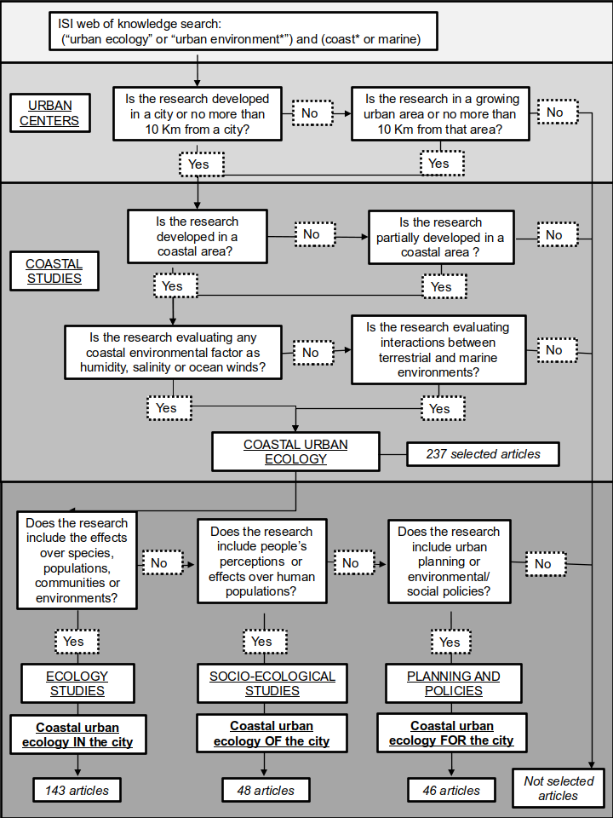Fig 1 : Decision tree of articles selected for coastal urban ecology in literature.

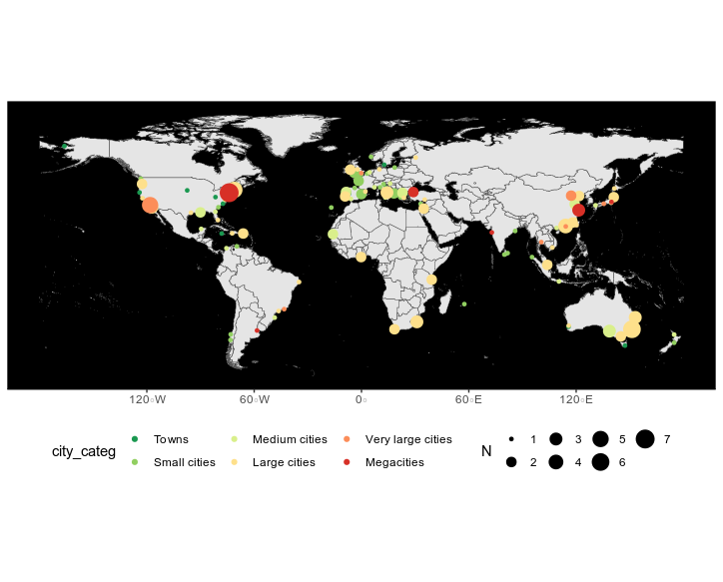*Fig 2. Comparative maps of world’s population, demografic growth (based in 2018), and the total of articles published for each country.*

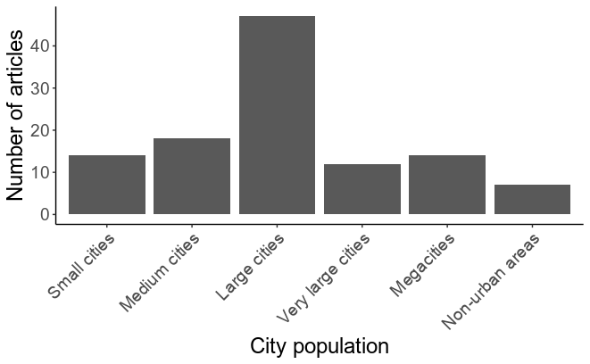Fig. 3: Number of articles for five types of urban centers classification in the world, where research in coastal urban ecology was made.

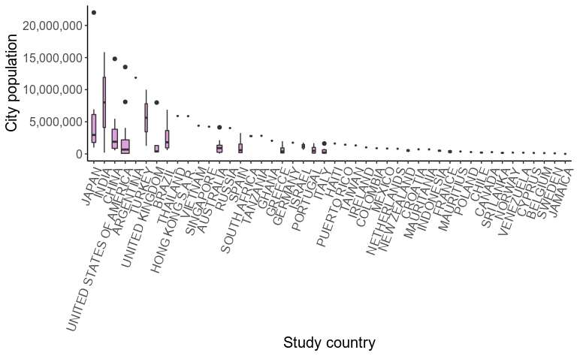Fig 4. Population distribution of studied cities in coastal urban ecology research, for each studied country.

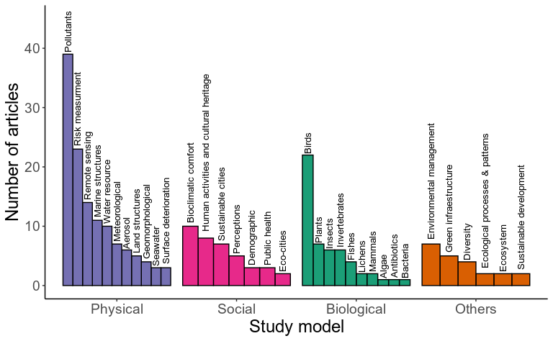

Fig 5. Distribution of articles, according to study models of research

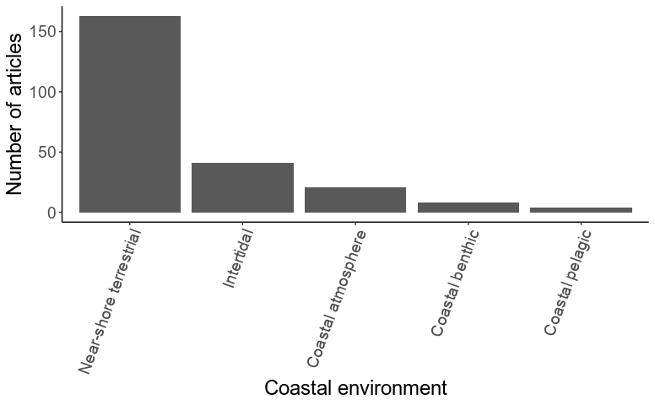

Fig 6. Distribution of articles, according to coastal environments, where research was done.

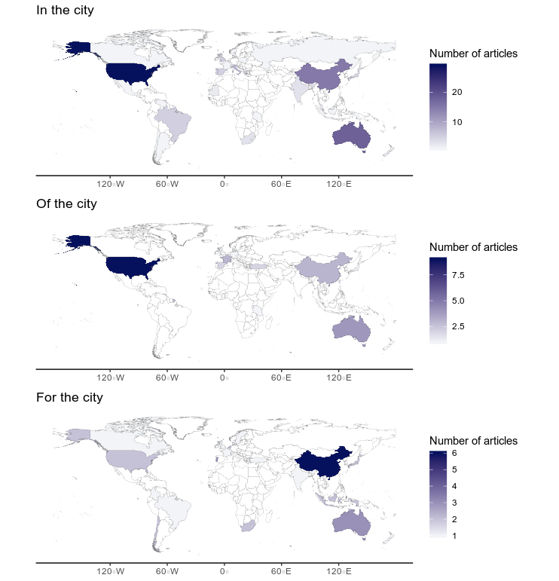

Fig 7. Ecological paradigms in, of, and for the city for coastal urban ecology, according to the number of studies developed in each country (from white with zero articles to dark blue which is the maximum number of articles for each paradigm).

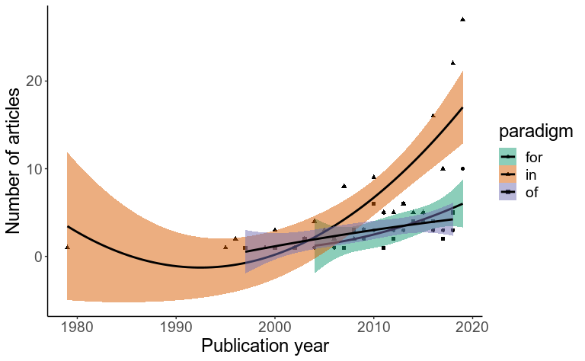

Fig 8. Number of articles published during the years considering paradigms in, of, and for the cities. Trend lines represent quadratic regression fit, colour areas represent the 95% confidence interval.

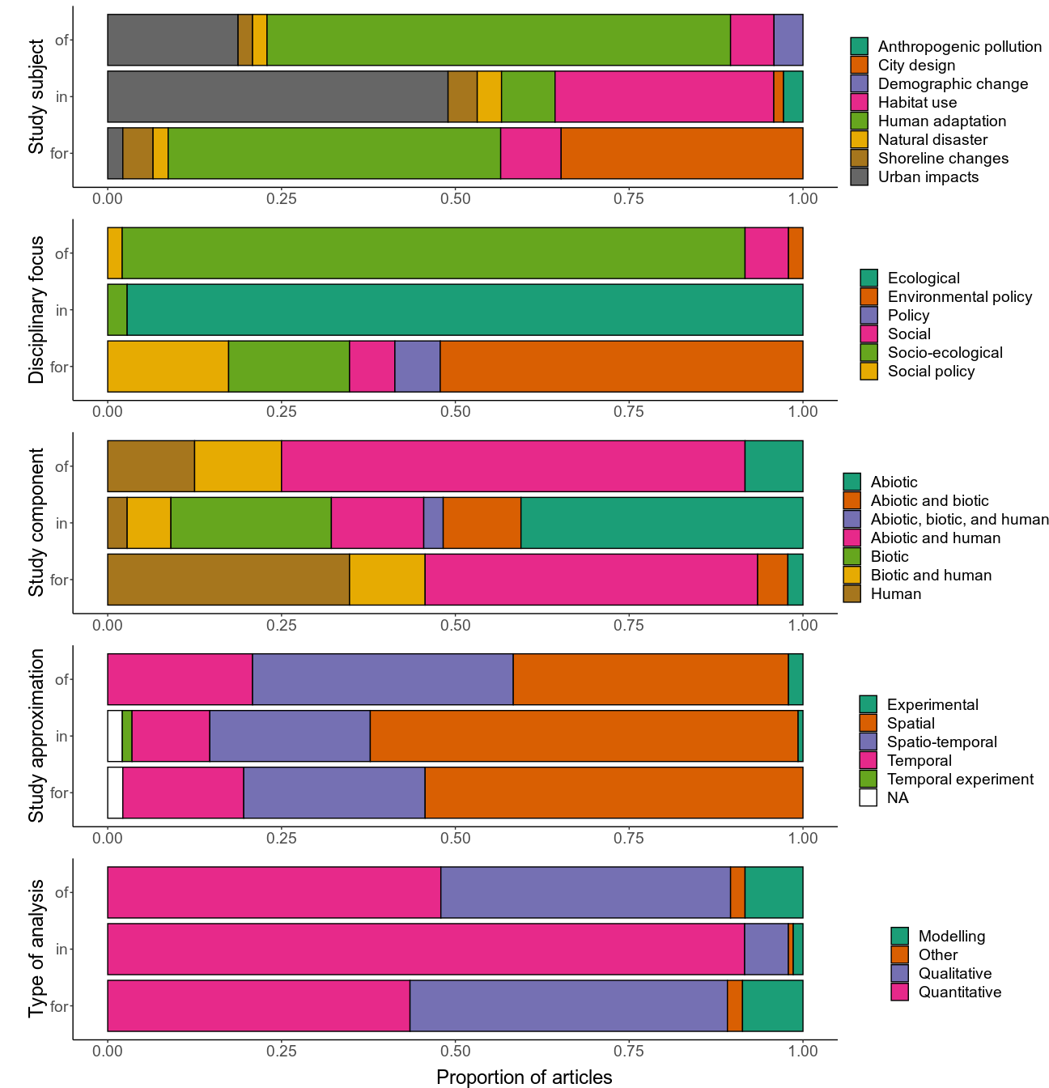

Fig 9. Distribution of articles’ paradigms according to study subject, study discipline, study component, approximation of the study, and type of analysis.

.

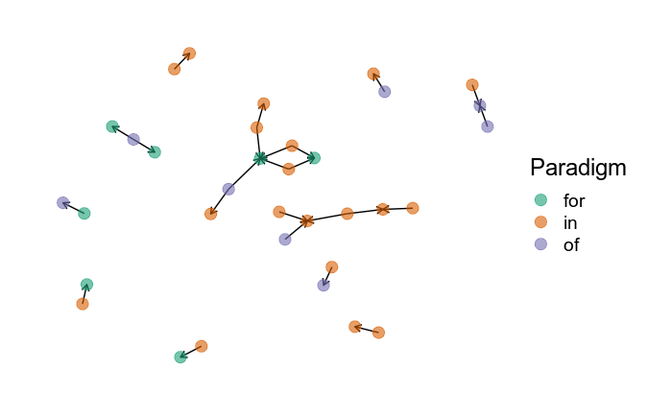

Fig 10. Network analysis for co-citations of articles presented in this coastal urban ecology review, considering the three paradigms proposed. Each dot represent a study and the colour indicates the paradigms (in-, of- and for- the cities). Directed edges go from the article citing to the article being cited.