Coastal urban ecology: Research gaps, challenges and needs.

Graells G1,2, Nakamura N3, Celis-Diez Juan L.5 Lagos N4, Marquet PA, Pliscoff P, Gelcich S1,2

1 Pontificia Universidad Católica de Chile, Departamento de Ecología, Santiago, Chile.

2 Center of Applied Ecology and Sustainability (CAPES).

3 Australian Research Council Centre of Excellence for Coral Reef Studies, James Cook University, Townsville, QLD 4811 Australia.

4 Centro de Investigación e Innovación para el Cambio Climático, Facultad de Ciencias, Universidad Santo Tomás, Santiago, Chile

5 Pontificia Universidad Católica de Valparaíso, Escuela de Agronomía, Quillota, Chile.

Junio 2020

## Abstract

Coastal urban areas have dramatically increased during the last decades, however, coastal research integrating urban areas are still scarce. To examine research advances and critical gaps, a systematic review of the literature on coastal urban ecology was performed. Articles were selected following a structured decision tree and data were classified into study disciplines, approaches, type of analysis, main research objectives, and Pickett’s paradigms *in-*, *of-*, and *for- the city*, among other categories. From a total of 237 publications, results show that most of the research comes from USA, China, and Australia, and has been carried out mostly in large cities with populations between 1 and 5 million people. Focus has been placed on ecological studies, spatial and quantitative analysis and pollution in coastal urban areas. Most of the studies on urban ecology in coastal zones were developed at near shore terrestrial environments and only 22.36% included the marine ecosystem. Urban ecology in coasts has mainly performed research under the paradigm *in the city* which is consistent with the focus on disciplines of biology and ecology. Results suggest a series of disciplinary, geographical, and approach biases which can present a number of risks. Foremost among these is a lack of knowledge on social dimension which can impact on sustainability. A key risk relates to the fact that lessons and recommendations of research are mainly from developed countries and large cities which might have very different institutional, planning and cultural settings in developing and mid-income countries. Scientific research on coastal urban areas needs to diversify towards an ecology *of* and *for the cities*, in order to support coastal development in a diversity of countries and settings.

### In a nutshell:

• Population in coastal urban cities is increasing, however research has lagged behind.

• A literature review on coastal urban ecology shows that while studies have been increasing, most focus on ecological aspects. Few studies target social-ecological interactions and environmental policy-planning.

• Studies are disciplinary, geographically, and environmentally biased.

• Addressing critical biases in coastal urban ecology research is key to inform ongoing urbanization trends, especially in developing and mid-income countries.

## Introduction

The world’s population is increasing annually. In 2018, 55% of the human population lived in urban areas. Cities have been constantly growing in number and size, forming large mega-cities with 10 million inhabitants or more (United Nations 2018). The high levels of urbanisation during the last decades have triggered increasing research and policy interest on the impacts and sustainability of these human-dominated ecosystems (Grimm *et al.* 2000, Griggs *et al.* 2013). Initial research hypothesized urban areas were not able to sustain wildlife and complex ecological processes. However, this changed in the first part of the ’70s when urban ecology began studying species distributions in cities and its drivers (Sukopp 1998; Grimm *et al.* 2008). Since then, urban ecology research topics have evolved to include ecological and social science approaches (Grimm *et al.* 2000) and currently, urban ecosystems are recognized as a complex coupling of ecological processes and human dynamics (Alberti 2008). Research on urban ecology is diverse and includes studies on biodiversity patterns (e.g. urban biodiversity in Faeth *et al.* 2011; biotic homogenization in, McKinney 2006), species distributions (e.g. birds in Marzluff 2001), ecosystem functions (Alberti 2005, Rosenzweig *et al.* 2018), development processes (e.g. Antrop 2004), drivers of change (e.g. Grimm *et al.* 2008), ecosystem services (Bolund and Hunhammar 1999, Daily 2003), human wellbeing (Pacione 2003, Van Kamp *et al.* 2003), social-ecological systems (Barthel *et al.* 2010, Grimm *et al.*  2013), and sustainability (Wu 2008, Wu 2014).

Recently, Pickett *et al.* (2016) introduced three phases in the way urban ecology has evolved. They provide a typology of paradigms for urban ecology, which were termed: *in*, *of*, and *for* the city. Each one of these paradigms expose historical differences according to changes in urban ecology research, and resulted by the comparison of three variables: chronology, model approach, and complexity. Studies under the paradigm *in the city* fall mainly into using ecological approaches, studies *of the city* are mainly based on social-ecological interactions, and studies *for the city* represent research about environmental policies and planning. The urban ecology paradigms also represent increasing complexity of the types of knowledge synthesised in the research questions. Studies which subscribe to the *of the city* paradigm contemplate interdisciplinary research; the urban ecology *for the city* is more intricate and includes *in* and *of the city* studies, engaging scientific knowledge in practice for action (Pickett *et al.* 2016).

Most of the theoretical and empirical developments in urban ecology have used green areas (e.g. Chiesura 2004, Tzoulas *et al.* 2007, Wolch *et al.* 2014), freshwater streams (e.g. Allan *et al.* 1997, Paul & Meyer 2001, Walsh *et al.* 2005), and organisms as birds (e.g. Blair *et al.* 1996, Chace & Walsh 2006) or plants (e.g. Ulrich 1984, Donovan & Prestemon 2012, Donovan *et al.* 2013) as their preferred research subjects. Coastal settings and species have not received the attention they deserve. This is unfortunate as coastal cities seem to be one of the preferred places for people to settle (Weinstein 2009). In fact, 40% of the world’s population live less than 100 Km from the sea (United Nations 2017), with coastal cities growing 6.6 times between 1945 and 2012 (Barragán and Andrés 2015). Accordingly, there is a need to synthesize urban ecology research that has been carried out on the coast. This article reviews coastal urban ecology scientific publications with the aim of examining spatial and temporal changes in time. Studies are classified according to theoretical and empirical dimensions of urban ecology. Biases in the literature are highlighted as a way to call attention on the needs for developing coastal urban ecology studies that can inform ongoing urbanization trends, especially in developing and mid-income countries.

**Methods**

A systematic review of the literature was performed through the Web of Science (<https://webofknowledge.com/>). Eligibility criteria included any publication following keywords in topic: (“urban ecology” or “urban environment”) and (coast or marine), where words as “environment” and “coast” were truncated to use their derivations. The period of the search included from 1975 until December 2019. Selection of articles was made with a decision tree (Fig. 1), where the research areas urban centre, marine studies, and biodiversity approach had to be checked for any articles to be included. Fulfilling the requirement to be a “coastal urban ecology” study, publications were classified in ecology *in the city*, ecology *of the city* or ecology *for the city* following the paradigms established by Pickett *et al.* (2016). Grey-literature was not incorporated in the selection.

Each article collected was categorized in publication year, author’s name, type of publication, author´s affiliation country, study country, and study city. Categories that required further reading were disciplinary focus, study approach, type of analysis, main research object, study model, and coastal environment. A list of categories, their definitions and example references can be found in Table 1. Articles were classified by two of the authors independently. Results were then compared and discrepancies resolved with the participation of a third author.

City’s population data were obtained from United Nations (2019). Urban centres classification was modified from United Nations (2014) and Barragán and Andrés (2015). This classification comprehends: 1) Non-urban areas, which have less than 100,000 inhabitants, 2) small cities, between 100,000 and 500, 000 inhabitants, 3) medium cities, between 500,000 and 1 million, 4) large cities, between 1 and 5 million, 5) very large cities, between 5 and 10 million, and 5) megacities, with more than 10 million. A map was made using this information and the total number of articles published under coastal urban ecology selected in this review.

Characterization of articles according to urban ecology paradigms included number of studies found for each paradigm, countries, year of publications, disciplinary focus, research approach, type of analysis, and main research objective. To examine interaction among articles paradigms through quotation, a network analysis was made with the information provided by Web of Science. The analysis included extracting every reference from each article that was selected in this review and the selection of quoted articles that were already part of the article selection. Consequently, there was a tagging for each article quoted with corresponding paradigm classification and these were plotted with the relationship among paradigm quotations.

Classification, data analysis, and figures were prepared in R (Team R Core 2018). For data analysis, packages tidyverse (Wickham 2017a), dplyr (Wickham *et al.* 2017), purrr (Henry and Wickham 2017), broom (Robinson 2017), and stringr (Wickham 2017b) were used. Graphs and maps were plotted with ggplot2 (Wickham 2009) and gridextra (Auguie 2016). Network analysis was developed with package bibliometrix (Aria and Cuccurullo 2017), which allowed modifications in the code to create a new relationship between articles and their co-citations.

## Results: Coastal urban ecology tendencies

Coastal urban ecology studies that met the defined keywords included a total of 237 articles from 51 countries, involving 137 different coastal cities. Most of the research was carried out in three countries: USA presenting 38 articles published, which included 20 different cities, China with 20 articles from 10 different cities, and Australia also with 20 articles, including 10 different cities (Fig. 2). The timeline of publications shows that urban ecology in coasts appeared for the first time in 1979, however, it was not until 1995 that another study related to the field was published. Between 1995 and 2005, the number of publications was below five articles per year (Fig. 3). After 2005 more articles can be found, particularly in years 2016, 2018, and 2019, which showed more than 20 publications per year. According with the type of publication found at Web of Science, publications are mostly journal articles with 84.97% of the total, proceedings papers represented 9.7%, book chapters 2.11%, and reviews 2.11%.

General aspects and tendencies since 1995 are shown in Figure 3. The main disciplinary focus of research has consistently come from ecology with an average representation of 48.79% of studies for the whole study period. Social-ecological studies came second (24.47%), research in this discipline has remained relatively constant during the years (an average 2.2 publications per year between 2005 and 2009, a 4.4 between 2010 and 2014, and a 3.8 between 2015 and 2019; Fig 3a).

Coastal ecology research has mainly considered spatial approaches searching for patterns based on differences in urban morphology (Mgelwa *et al.* 2019, Kantamaneni *et al.* 2019, Heery *et al.* 2018, Hosannah *et al.* 2014, Schwartz *et al.* 2013) and have increasingly included temporal dimensions (Fig. 3b). Quantitative studies have dominated the literature during the past 20 years and modelling studies which include simulation of urban conditions, have begun to be included in the past six years (Fig. 3c. When looking at the main research objectives it is interesting to note that the study of pollution and human impacts have dominated the literature (Fig. 3d). These articles mainly focus on the effects of stressors over coastal urban ecosystems and cities. Habitat use and city design are less frequent, but they have been increasing the last 10 years.

According to study models, a significant number of publications focused on physical aspects (48.10%) such as pollutants and risk towards natural hazards (Fig.4). The second most frequent study model was biological, centred on specific species (21.94%). In this group birds were the most studied, followed by invertebrates (marine and terrestrial) and plants, leaving other marine species such as fishes and algae behind. Studies centred on ecosystems, social and social-eco-tecnological systems showed fewer articles published (less than 10).

Most of the articles published in coastal urban ecology have been developed in “large cities” of 1 to 5 million inhabitants (Fig. 5). More than 65% of articles were carried out in cities with more than 1 million people, including “very large cities” and “megacities” with more than 10 million people. Coastal areas with less than 100,000 inhabitants presented the lowest number of publications with only seven articles.

Research in coastal urban ecology has focused mostly in near shore terrestrial environments, presenting more than 68% of articles (Fig. 6). Intertidal areas presented 17.30% of the publications, near-shore coastal benthic a 3.38%, and coastal pelagic environments only a 1.69%. Coastal atmosphere showed 8.86% of total articles published.

## Coastal urban ecology *in*, *of*, and *for the city.*

Paradigms *in*, *of*, and *for the city* have been addressed globally (Fig. 7). The focus *in the city* is presented in more than 60% of articles, including 37 countries. The US showed the highest number of articles with 29 publications. The focus *of the city* is shown at a lower percentage than the previous paradigm, with 20.25% of publications and performed in 21 countries. The US also dominated this paradigm with 9 articles. Research addressing the *for the city* paradigm represented 19.41% of total articles and came from 25 different countries. China presents six articles, which is the highest number of papers in a country which addresses this paradigm.

Paradigms *in*, *of*, and *for the cities* have shown differences, not only in the total number of articles published (143, 48, and 46, respectively), but also in their first year of publishing and tendencies (Fig. 8). In this way, it is not until 2004 that the paradigm *for the city* appeared in coastal urban ecology studies. Before that, the paradigm *in the city* (since the beginning in 1979) dominated this research area, with some occurrence of the paradigm *of the city* since 1997. The three paradigms show to be increasing in the number of publications during the years, although paradigm *in the city* is doing it faster than the others.

Evidence suggests that the three paradigms are different according to disciplinary focus, research approach, type of analysis, and the main research objectives presented in their articles (Fig. 9). As expected, categorization by discipline showed that the paradigm *in the city* is mostly focused in ecological research, paradigm *of the city* in socio-ecological research, and paradigm *for the city* in environmental policies, and also some social-ecological and social policies. Research approaches are similar among paradigms, spatial approach of studies is the most common, followed by spatio-temporal approach. Temporal approaches are generally lacking in coastal urban ecology studies. Studies *in the city* presented almost only quantitative assessments, however studies presented under paradigms *of* and *for the city* showed similar proportions between quantitative and qualitative analysis. The paradigm *of the city* has centred research on themes related to human adaptation, being this topic also taken by paradigm *for the city* added to city design, reflecting the focus on policy and planning implications of these studies.

When analysing the whole database of coastal urban ecology articles, only 34 publications showed connections among citations, presenting a total of 24 interactions (Fig. 10). These interactions where presented when one article quotes a single article, two cited the same article (Chen et al. 2018, Lopes *et al.* 2011), three cited the same article (Shepard et al. 2016, Washburn et al. 2013, Campbell 2010), or four cited the same article (Leclerc and Viard 2018, Heery *et al.* 2018, Bertocci *et al.* 2017, Bugnot *et al.* 2019). Network analysis showed a marginal interaction among articles’ paradigms. Here the paradigm *in the city* quoted only seven *in the city* articles from a total of 16 citations, the paradigm *of the city* quoted three articles *in the city* and one *of the city* from a total of seven citations, paradigm *for the city* quoted only one article under the paradigm *of the city.* These results suggest that coastal urban ecology article quotation have a subtle connection among publications, and it is not reinforced when the three paradigms are considered.

## Discussion

Coastal urban ecology encompasses a diversity of disciplines and research models aimed at understanding the links between the natural and built environments. Results show that coastal urban ecology has focused primarily on ecological studies and those studying physical characteristics of urban coasts, dominated by research on pollution. However, there is an increasing contribution of studies on social dimensions. Studies that address the coastal urban ecology from an *in the city* perspective have significantly increased during the last three decades. Interestingly, results show coastal urban ecology is beginning to address issues which relate to planners and policy makers through some key studies on green infrastructure (Chen *et al.* 2015, Zhang *et al.* 2016, Conticelli and Tondelli 2018), eco-cities (Surjan and Shaw 2008, Wong 2011), and sustainable cities (Pizarro 2008, Song *et al.* 2016, Arif 2017). Despite the diversity of research on coastal urban ecology there are still important geographic and disciplinary gaps in the main focus of research.

Coastal urban ecology research has drawn from ecological studies more than any other discipline (Fig. 3). Even when it seems that social dimensions have been integrated slowly during the years under the knowledge of human-nature coupling (Liu *et al.* 2007a, Lui *et al.* 2007b) and the importance to include people and their relationship with the urban environment (Redman et al. 2004), interdisciplinary studies are still infrequent. An interesting interdisciplinary line of research is emerging associated to designing new infrastructures in coastal cities aimed at the provision of sustainable alternatives (Brundtland et al. 1987, Loucks 1994, Kates et al. 2001).

Coastal urban ecology has centered mainly in understanding spatial patterns and variability, showing a bias towards short time scale research (Fig. 3). Consequently there has been a loss of a dynamic perspective in the study of coastal cities. This is unfortunate as urban systems have been describes as highly dynamic scenarios (Ramalho and Hobbs 2012). Results show research is also biased towards quantitative approaches with few qualitative analysis (e.g. Giovene di Girasole 2014, Cleland *et al.* 2015, Guerrero *et al.* 2018, Villagra *et al.* 2016). This supports the results which show little social science research based on methods such as grounded theory or ethnography (Creswell *et al.* 2007). Coastal urban ecology would benefit from encouraging these dimensions.

Many coastal urban ecology studies focus on pollutants. The focus on pollution has been maintained during the whole period analysed, with a 35% of total articles dealing with this issue. Accordingly, the effects of urbanization over sea breeze and the reactions of aerosols have had an important boom in this line of research (Castro *et al.* 1999, Mejia & Morawska 2009, Shanquan *et al.* 2016, Pushpawela *et al*. 2018). Focus in pollution is not difficult to understand in coastal urban ecology given urbanization and increases in CO2 emissions (Cole & Neumayer 2004). Water pollution also has an important number of articles published (27.7% from the total of articles that mentioned pollution), considering marine (23 articles: e.g. Wang 2010, Noble et al. 2006) and river basin pollution (4 articles: e.g. Mgelwa et al. 2019, Abdul-Aziz & Ahmed 2019), both important elements in coastal environments.

Risk assessments towards natural disasters and particularly flooding represented approximately 18% of the studies (Fig. 5; e.g. Goh 2019, Patel *et al* 2019), which were performed mainly in USA and Japan. Expansion of coastal cities undermine natural protection (Sherbinin et al 2007), thus natural disasters relate to a city’s vulnerability (Chang & Huang 2015). While research has been performed in developed countries, developing ones are the most vulnerable in terms of natural disasters in coastal zones, particularly with flooding events (Ogie *et al.* 2020). This same tendency is repeated in relation to studies which address mitigation strategies, with projections to make cities more resilient to natural disasters (Watson & Adams 2010, Serre *et al.* 2010, Aerts *et al.* 2014, Sutton-Grier *et* *al.* 2015). As a consequence, there is an urgent need to extend this type of research towards developing and mid-income countries.

Our review shows that research on coastal urban ecology has mainly focused in cities between 1 and 5 million people in 51 different countries. However, more than a third of articles have been performed in USA, China and Australia (Fig. 2). While results from these specific studies can be important to develop theoretical frameworks and assess specific impacts, the focus on these high GDP countries makes it hard to extend insights to other cities in developing and mid-income countries, where growth dynamics, institutional support and adaptive capacity are very different (Chauvin *et al.* 2017, Nagendra *et al.* 2018). We therefore strongly advocate for the need of support programs for coastal urban ecology research in these settings. In addition, research in cities smaller than 1 million inhabitants or larger than 10 million would extend the variation of conditions in terms of the size of the human group and configuration of variables.

Research has been mainly performed in near-shore terrestrial environments, resulting in a lack of information in coastal-marine urban environments that reveals the limited integration in the coastal urban interface (seawater-land configuration and dimensionality). This bias can have negative consequences such as generating false dichotomies for conservation (Bulleri 2006) which can undermine the effect and need for healthy marine ecosystems in urban areas (Bulleri 2006, Shochat *et al.* 2006). It is key to extend research on the interaction between marine and terrestrial realms associated to urbanization.

Results show more than half of the reviewed articles can be classified as belonging to the paradigm *in the cities*. Studies contributing to this paradigm have been growing in number, faster than the other paradigms, during the last years (Fig. 8). This result synthesizes the main biases found in this review which relate to the focus on ecological research, understanding urban impacts such as pollution, the non-human components, spatial and quantitative analysis found in most of the articles reviewed (Fig. 9). Only 20% of the articles in coastal urban ecology focused on interdisciplinary research such as socio-ecological studies (included in the paradigm *of the city).* This represents an important research gap associated to the lack of social knowledge in a system where humans are both objects and subjects of urbanization, who use space to live, extract subsistence and non-subsistence resources, perform recreational activities, and deposit waste, among other activities (Weinstein 2009). Because of that, a lack of research on people with nature represents the loss of an integral part of the ecosystem (McDonnell *et al.* 1993, Rees 1997, Collins *et al.* 2000), decoupling human dynamics and ecological processes of this urban ecosystem (Alberti 2008). Lessons from urban ecology in other systems has shown the importance of transitioning towards these interdisciplinary dimensions. Accordingly, coastal research in urban areas must advance toward an urban sustainability-centred perspective, transdisciplinary in terms of focuses and approaches, with the ability to be applied through urban design and planning (Wu 2014). Current imbalance among paradigms and the lack of network of citation among articles must improve in urban ecology studies in coastal zones as a way for research framed under the different paradigms to effectively act as building blocks for improving urban coastal sustainability.

**Conclusion**

While biophysical and ecological approaches to coastal urban systems are important, urban ecology necessarily operates in a human context. Therefore, coastal cities need to be seen from the point of view of people, their interaction with the environment and the implementation of concepts that contribute to sustainability in cities through public policies and planning. More research is needed focusing on the three paradigms In addition, a better consideration of the diversity of cities, the integration across marine and terrestrial ecosystems, and the inclusion of developing country coastal urban areas will allow to support ongoing urbanization trends in coastal zones across the globe.

**References**

Abarca-Álvarez, F. J., Campos-Sánchez, F. S., & Reinoso-Bellido, R. (2018). Signs of gentrification usin g Artificial Intelligence: identification through the Dwelling Census. *Bitácora Urbano Territorial*, *28*(2), 103-114.

Aerts JC, Botzen WW, Emanuel K, Lin N De Moel H, & Michel-Kerjan EO. 2014. Evaluating flood resilience strategies for coastal megacities. *Science*, *344*(6183), 473-475.

Alberico, I., Cavuoto, G., Di Fiore, V., Punzo, M., Tarallo, D., Pelosi, N., ... & Marsella, E. (2018). Historical maps and satellite images as tools for shoreline variations and territorial changes assessment: the case study of Volturno Coastal Plain (Southern Italy). *Journal of Coastal Conservation*, *22*(5), 919-937.

Alberti M 2005. The effects of urban patterns on ecosystem function. International regional science review, 28(2), 168-192.

Alberti M 2008. Advances in urban ecology: integrating humans and ecological processes in urban ecosystems (No. 574.5268 A4). New York: Springer.

Alcoforado, M. J., Andrade, H., Lopes, A., & Vasconcelos, J. (2009). Application of climatic guidelines to urban planning: the example of Lisbon (Portugal). *Landscape and urban planning*, *90*(1-2), 56-65.

Allan D, Erickson D, Fay J. 1997. The influence of catchment land use on stream integrity across multiple spatial scales. Freshwater biology. 37(1):149-61.

Antrop M 2004. Landscape change and the urbanization process in Europe. Landscape and urban planning, 67(1-4), 9-26.

Aria M and Cuccurullo C. 2017. Bibliometrix: An r-tool for comprehensive science mapping analysis. Journal of Informetrics 11: 959–75.

Arif, A. A. (2017). Green city Banda Aceh: city planning approach and environmental aspects. In *IOP Conference Series: Earth and Environmental Science* (Vol. 56, No. 1, p. 012004). IOP Publishing.

Arruti, A., Fernández-Olmo, I., & Irabien, A. (2011). Regional evaluation of particulate matter composition in an Atlantic coastal area (Cantabria region, northern Spain): Spatial variations in different urban and rural environments. *Atmospheric research*, *101*(1-2), 280-293.

Auguie B 2016. GridExtra: Miscellaneous functions for "grid" graphics.

Barragán JM and Andrés M de. 2015. Analysis and trends of the world’s coastal cities and agglomerations. Ocean & Coastal Management 114: 11–20.

Barthel, S., Folke, C., & Colding, J. (2010). Social–ecological memory in urban gardens—Retaining the capacity for management of ecosystem services. *Global Environmental Change*, *20*(2), 255-265.

Belant, J. L. (1997). Gulls in urban environments: landscape-level management to reduce conflict. *Landscape and urban planning*, *38*(3-4), 245-258.

Bertocci I, Arenas F, and Cacabelos E et al. 2017. Nowhere safe? Exploring the influence of urbanization across mainland and insular seashores in continental portugal and the azorean archipelago. Marine pollution bulletin 114: 644–55.

Blair RB. 1996. Land use and avian species diversity along an urban gradient. Ecological applications 6: 506–19.

Bolton, D., Mayer-Pinto, M., Clark, G. F., Dafforn, K. A., Brassil, W. A., Becker, A., & Johnston, E. L. (2017). Coastal urban lighting has ecological consequences for multiple trophic levels under the sea. *Science of the Total Environment*, *576*, 1-9.

Bolund, P., & Hunhammar, S. (1999). Ecosystem services in urban areas. *Ecological economics*, *29*(2), 293-301.

Branoff, B. L. (2017). Quantifying the influence of urban land use on mangrove biology and ecology: A meta‐analysis. *Global ecology and biogeography*, *26*(11), 1339-1356.

Brundtland, G. H., Khalid, M., Agnelli, S., Al-Athel, S., & Chidzero, B. (1987). Our common future. *New York*, 8.

Bugnot AB, Hose GC, and Walsh CJ et al. 2019. Urban impacts across realms: Making the case for inter-realm monitoring and management. Science of the Total Environment 648: 711–9.

Bulleri F. 2006. Is it time for urban ecology to include the marine realm? Trends in ecology & evolution 21: 658–9.

Burke L, Payne YK, and Kassem K et al. 2001. Pilot analysis of global ecosystems: Coastal ecosystems. World Resources Institute.

Campbell M. 2010. An animal geography of avian foraging competition on the sussex coast of england. Journal of Coastal Research: 44–52.

Castro LM, Pio CA, Harrison RM, & Smith DJT. 1999. Carbonaceous aerosol in urban and rural European atmospheres: estimation of secondary organic carbon concentrations. *Atmospheric Environment*, *33*(17), 2771-2781.

Chabas, A., Fouqueau, A., Attoui, M., Alfaro, S. C., Petitmangin, A., Bouilloux, A., ... & Zapf, P. (2015). Characterisation of CIME, an experimental chamber for simulating interactions between materials of the cultural heritage and the environment. *Environmental Science and Pollution Research*, *22*(23), 19170-19183.

Chace JF, & Walsh JJ 2006. Urban effects on native avifauna: a review. *Landscape and urban planning*, *74*(1), 46-69.

Chang LF, & Huang SL. 2015. Assessing urban flooding vulnerability with an emergy approach. *Landscape and Urban Planning*, *143*, 11-24.

Charalambous, K., Bruggeman, A., & Lange, M. A. (2012). Assessing the urban water balance: the Urban Water Flow Model and its application in Cyprus. *Water Science and Technology*, *66*(3), 635-643.

Chauvin, J. P., Glaeser, E., Ma, Y., & Tobio, K. (2017). What is different about urbanization in rich and poor countries? Cities in Brazil, China, India and the United States. *Journal of Urban Economics*, *98*, 17-49.

Chen, Y-C., Pei, L., & Shiau, Y. C. 2015. Application of coastal vegetation to green roofs of residential buildings in Taiwan. *Artificial Life and Robotics*, *20*(1), 86-91.

Chen Y-C, Yao C-K, Honjo T, and Lin T-P. 2018. The application of a high-density street-level air temperature observation network (hisan): Dynamic variation characteristics of urban heat island in tainan, taiwan. Science of the Total Environment 626: 555–66.

Chiesura A. 2004. The role of urban parks for the sustainable city. Landscape and urban planning. 68(1):129-38.

Childers, D. L., Cadenasso, M. L., Grove, J. M., Marshall, V., McGrath, B., & Pickett, S. T. (2015). An ecology for cities: A transformational nexus of design and ecology to advance climate change resilience and urban sustainability. *Sustainability*, *7*(4), 3774-3791.

Clarkson, T. S., Martin, R. J., Rudolph, J., & Graham, B. W. L. (1996). Benzene and toluene in New Zealand air. *Atmospheric Environment*, *30*(4), 569-577.

Cleland, V., Hughes, C., Thornton, L., Venn, A., Squibb, K., & Ball, K. (2015). A qualitative study of environmental factors important for physical activity in rural adults. *PLoS One*, *10*(11).

Cohen, P., Potchter, O., & Matzarakis, A. (2013). Human thermal perception of Coastal Mediterranean outdoor urban environments. *Applied Geography*, *37*, 1-10.

Cole, M. A., & Neumayer, E. (2004). Examining the impact of demographic factors on air pollution. *Population and Environment*, *26*(1), 5-21.

Collins JP, Kinzig A, and Grimm NB et al. 2000. A new urban ecology: Modeling human communities as integral parts of ecosystems poses special problems for the development and testing of ecological theory. American scientist 88: 416–25.

Conticelli, E., & Tondelli, S. 2018. Regenerating with the green: a proposal for the coastal land-scape of Senigallia. *Direttore scientifico/Editor-in-Chief*, 91.

Creswell, J. W., Hanson, W. E., Clark Plano, V. L., & Morales, A. (2007). Qualitative research designs: Selection and implementation. *The counseling psychologist*, *35*(2), 236-264.

Cui, H., & Yuan, L. (2009). Study on thermal environmental distribution in coastal city using ASTER data. In *2009 Joint Urban Remote Sensing Event* (pp. 1-6). IEEE.

Daily, G. 2003. What are ecosystem services. *Global environmental challenges for the twenty-first century: Resources, consumption and sustainable solutions*, 227-231.

Dodman, D. (2009). Globalization, tourism and local living conditions on Jamaica's north coast. *Singapore Journal of Tropical Geography*, *30*(2), 204-219.

Dominick, D., Wilson, S. R., Paton-Walsh, C., Humphries, R., Guérette, E. A., Keywood, M., ... & Marwick, B. (2018). Characteristics of airborne particle number size distributions in a coastal-urban environment. *Atmospheric Environment*, *186*, 256-265.

Donovan GH, & Prestemon JP. 2012. The effect of trees on crime in Portland, Oregon. Environment and behavior, 44(1), 3-30.

Donovan G H, Butry DT, Michael YL, Prestemon JP, Liebhold AM, Gatziolis D, & Mao MY. 2013. The relationship between trees and human health: evidence from the spread of the emerald ash borer. American journal of preventive medicine, 44(2), 139-145.

Eddy, E. N., & Roman, C. T. (2016). Relationship between epibenthic invertebrate species assemblages and environmental variables in Boston Harbor's intertidal habitat. *Northeastern Naturalist*, *23*(1), 45-66.

Faeth SH, Bang C & Saari S 2011. Urban biodiversity: patterns and mechanisms. Annals of the New York Academy of Sciences, 1223(1), 69-81.

Gardner, E. A. (2003). Some examples of water recycling in Australian urban environments: a step towards environmental sustainability. *Water Science and Technology: Water Supply*, *3*(4), 21-31.

Giovene di Girasole, E. (2014). The hinge areas for urban regeneration in seaside cities: the High Line in Manhattan, NYC. In *Advanced Engineering Forum* (Vol. 11, pp. 102-108). Trans Tech Publications Ltd.

Goh K. 2019. Urban Waterscapes: The HydroPolitics of Flooding in a Sinking City. *International Journal of Urban and Regional Research*, *43*(2), 250-272.

Griggs D, Stafford-Smith, M., Gaffney, O., Rockström, J., Öhman, M. C., Shyamsundar, P., ... & Noble, I. 2013. Policy: Sustainable development goals for people and planet. *Nature*, *495*(7441), 305.

Grimm NB, Grove JG, Pickett ST, & Redman CL. 2000. Integrated approaches to long-term studies of urban ecological systems: Urban ecological systems present multiple challenges to ecologists—pervasive human impact and extreme heterogeneity of cities, and the need to integrate social and ecological approaches, concepts, and theory. BioScience, *50*(7), 571-584.

Grimm NB, Faeth SH, and Golubiewski NE et al. 2008. Global change and the ecology of cities. Science 319: 756–60.

Grimm, N. B., Redman, C. L., Boone, C. G., Childers, D. L., Harlan, S. L., & Turner, B. L. (2013). Viewing the urban socio-ecological system through a sustainability lens: Lessons and prospects from the central Arizona–Phoenix LTER programme. In *Long term socio-ecological research* (pp. 217-246). Springer, Dordrecht.

Grossmann, I. (2008). Perspectives for Hamburg as a port city in the context of a changing global environment. *Geoforum*, *39*(6), 2062-2072.

Guerrero Valdebenito, R. M., & Alarcon Rodriguez, M. L. (2018). Neoliberalism and socio-spatial transformations in urban coves of the Metropolitan Area of Concepcion. The cases of Caleta Los Bagres and Caleta Cocholgue, Tome. *REVISTA DE URBANISMO*, *38*.

Gumusay, M. U., Koseoglu, G., & Bakirman, T. (2016). An assessment of site suitability for marina construction in Istanbul, Turkey, using GIS and AHP multicriteria decision analysis. *Environmental monitoring and assessment*, *188*(12), 677.

Heery EC, Olsen AY, Feist BE, and Sebens KP. 2018. Urbanization-related distribution patterns and habitat-use by the marine mesopredator, giant pacific octopus (enteroctopus dofleini). Urban Ecosystems 21: 707–19.

Henry L and Wickham H. 2017. Purrr: Functional programming tools.

Holt, A. R., Mears, M., Maltby, L., & Warren, P. (2015). Understanding spatial patterns in the production of multiple urban ecosystem services. *Ecosystem services*, *16*, 33-46.

Hosannah, N., & Gonzalez, J. E. (2014). Impacts of aerosol particle size distribution and land cover land use on precipitation in a coastal urban environment using a cloud-resolving mesoscale model. *Advances in Meteorology*, *2014*.

Ip, C. C., Li, X. D., Zhang, G., Wai, O. W., & Li, Y. S. (2007). Trace metal distribution in sediments of the Pearl River Estuary and the surrounding coastal area, South China. *Environmental Pollution*, *147*(2), 311-323.

Jonkman, S. N., Hillen, M. M., Nicholls, R. J., Kanning, W., & van Ledden, M. (2013). Costs of adapting coastal defences to sea-level rise—new estimates and their implications. *Journal of Coastal Research*, *29*(5), 1212-1226.

Kantamaneni, K., Gallagher, A., & Du, X. (2019). Assessing and mapping regional coastal vulnerability for port environments and coastal cities. *Journal of coastal conservation*, *23*(1), 59-70.

Kates, R. W., Clark, W. C., Corell, R., Hall, J. M., Jaeger, C. C., Lowe, I., ... & Faucheux, S. (2001). Sustainability science. *Science*, *292*(5517), 641-642.

Kehl, C., & de Haan, G. (2013). Interactive simulation and visualisation of realistic flooding scenarios. In *Intelligent Systems for Crisis Management* (pp. 79-93). Springer, Berlin, Heidelberg.

Kuhnlein, H. V., Johns, T., & Peoples, I. T. F. O. I. (2003). Northwest African and Middle Eastern food and dietary change of indigenous peoples. *Asia Pacific journal of clinical nutrition*, *12*(3).

Kuwae, T., Kanda, J., Kubo, A., Nakajima, F., Ogawa, H., Sohma, A., & Suzumura, M. (2016). Blue carbon in human-dominated estuarine and shallow coastal systems. *Ambio*, *45*(3), 290-301.

Leclerc JC and Viard F. 2018. Habitat formation prevails over predation in influencing fouling communities. Ecology and Evolution 8: 477–92.

Li, Y., Yang, X., Zhu, X., Mulvihill, P. R., Matthews, H. D., & Sun, X. (2011). Integrating climate change factors into China's development policy: Adaptation strategies and mitigation to environmental change. *Ecological Complexity*, *8*(4), 294-298.

Lim, H. C., & Sodhi, N. S. (2004). Responses of avian guilds to urbanisation in a tropical city. *Landscape and Urban Planning*, *66*(4), 199-215.

Liu, J., Dietz, T., Carpenter, S. R., Alberti, M., Folke, C., Moran, E., ... & Ostrom, E. (2007a). Complexity of coupled human and natural systems. *Science*, *317*(5844), 1513-1516.

Liu, J., Dietz, T., Carpenter, S. R., Folke, C., Alberti, M., Redman, C. L., ... & Taylor, W. W. (2007b). Coupled human and natural systems. *AMBIO: a journal of the human environment*, *36*(8), 639-649.

Lopes A, Lopes S, Matzarakis A, and Alcoforado MJ. 2011. The influence of the summer sea breeze on thermal comfort in funchal (madeira). A contribution to tourism and urban planning. *Meteorologische Zeitschrift* 20: 553–64.

Marzluff JM. 2001. Worldwide urbanization and its effects on birds. In: Avian ecology and conservation in an urbanizing world. Springer.

McDonald, R. I., Mansur, A. V., Ascensão, F., Crossman, K., Elmqvist, T., Gonzalez, A., ... & Huang, K. (2019). Research gaps in knowledge of the impact of urban growth on biodiversity. *Nature Sustainability*, 1-9.

McDonnell MJ, Pickett ST, and Pouyat RV. 1993. The application of the ecological gradient paradigm to the study of urban effects. In: Humans as components of ecosystems. Springer.

McKinney ML. 2006. Urbanization as a major cause of biotic homogenization. Biological conservation 127: 247–60.

Mejia JF, & Morawska L. 2009. An investigation of nucleation events in a coastal urban environment in the Southern Hemisphere. *Atmospheric Chemistry and Physics*, *9*(1), 2195-2222.

Mgelwa, A. S., Hu, Y. L., Liu, J. F., Qiu, Q., Liu, Z., & Ngaba, M. J. Y. (2019). Differential patterns of nitrogen and δ15N in soil and foliar along two urbanized rivers in a subtropical coastal city of southern China. *Environmental pollution*, *244*, 907-914.

Musacchio, L. R. (2009). The scientific basis for the design of landscape sustainability: a conceptual framework for translational landscape research and practice of designed landscapes and the six Es of landscape sustainability. *Landscape Ecology*, *24*(8), 993.

Nagendra, H., Bai, X., Brondizio, E. S., & Lwasa, S. (2018). The urban south and the predicament of global sustainability. *Nature Sustainability*, *1*(7), 341-349.

Naidoo, T., Smit, A. J., & Glassom, D. (2016). Plastic ingestion by estuarine mullet Mugil cephalus (Mugilidae) in an urban harbour, KwaZulu-Natal, South Africa. *African Journal of Marine Science*, *38*(1), 145-149.

Noble, R. T., Griffith, J. F., Blackwood, A. D., Fuhrman, J. A., Gregory, J. B., Hernandez, X., ... & Schiff, K. (2006). Multitiered approach using quantitative PCR to track sources of fecal pollution affecting Santa Monica Bay, California. *Appl. Environ. Microbiol.*, *72*(2), 1604-1612.

Nunkoo, R., & Ramkissoon, H. (2010). Small island urban tourism: a residents' perspective. *Current Issues in Tourism*, *13*(1), 37-60.

Ogie RI, Adam C & Perez P. 2020. A review of structural approach to flood management in coastal megacities of developing nations: current research and future directions. *Journal of Environmental Planning and Management*, *63*(2), 127-147.

Pacione, M. (2003). Urban environmental quality and human wellbeing—a social geographical perspective. *Landscape and urban planning*, *65*(1-2), 19-30.

Pallarés, S., Gómez, E., Martínez, A., & Jordán, M. M. (2019). The relationship between indoor and outdoor levels of PM10 and its chemical composition at schools in a coastal region in Spain. *Heliyon*, *5*(8), e02270.

Patel, P., Ghosh, S., Kaginalkar, A., Islam, S., & Karmakar, S. (2019). Performance evaluation of WRF for extreme flood forecasts in a coastal urban environment. *Atmospheric research*, *223*, 39-48.

Paul MJ, & Meyer JL. 2001. Streams in the urban landscape. Annual review of Ecology and Systematics, *32*(1), 333-365.

Peng, F., Wong, M. S., Wan, Y., & Nichol, J. E. (2017). Modeling of urban wind ventilation using high resolution airborne LiDAR data. *Computers, Environment and Urban Systems*, *64*, 81-90.

Pickett ST, Cadenasso ML, and Childers DL et al. 2016. Evolution and future of urban ecological science: Ecology in, of, and for the city. Ecosystem Health and Sustainability, *2*(7), e01229.

Pizarro, R. E. (2008). Sustainable planning for poor communities: urban design studios as a catalyst for development in Colombia. *Dialogues in Urban Planning: Towards Sustainable Regions*, 175.

Pushpawela B, Jayaratne R & Morawska L. 2018. Differentiating between particle formation and growth events in an urban environment. *Atmospheric Chemistry and Physics*, *18*(15), 11171-11183.

Race, D., Luck, G. W., & Black, R. (2010). Patterns, drivers and implications of demographic change in rural landscapes. In *Demographic change in Australia's rural landscapes* (pp. 1-22). Springer, Dordrecht.

Ramalho, C. E., & Hobbs, R. J. (2012). Time for a change: dynamic urban ecology. *Trends in ecology & evolution*, *27*(3), 179-188.

Redman, C. L., Grove, J. M., & Kuby, L. H. (2004). Integrating social science into the long-term ecological research (LTER) network: social dimensions of ecological change and ecological dimensions of social change. *Ecosystems*, *7*(2), 161-171.

Rees WE. 1997. Urban ecosystems: The human dimension. Urban ecosystems 1: 63–75.

Reyes-López, J., & Carpintero, S. (2014). Comparison of the exotic and native ant communities (Hymenoptera: Formicidae) in urban green areas at inland, coastal and insular sites in Spain. *European Journal of Entomology*, *111*(3), 421.

Robinson D. 2017. Broom: Convert statistical analysis objects into tidy data frames.

Rosenzweig, B. R., Groffman, P. M., Zarnoch, C. B., Branco, B. F., Hartig, E. K., Fitzpatrick, J., ... & Parris, A. (2018). Nitrogen regulation by natural systems in “unnatural” landscapes: denitrification in ultra-urban coastal ecosystems. *Ecosystem Health and Sustainability*, *4*(9), 205-224.

Santos, T., & Freire, S. (2015). Testing the contribution of Worldview-2 improved spectral resolution for extracting vegetation cover in urban environments. *Canadian Journal of Remote Sensing*, *41*(6), 505-514.

Schwartz, M. W., Smith, L. M., & Steel, Z. L. (2013). Conservation investment for rare plants in urban environments. *PloS one*, *8*(12).

Semadeni-Davies, A., Hernebring, C., Svensson, G., & Gustafsson, L. G. (2008). The impacts of climate change and urbanisation on drainage in Helsingborg, Sweden: Combined sewer system. *Journal of Hydrology*, *350*(1-2), 100-113.

Serre D, Barroca B, & Diab Y. 2010. Urban flood mitigation: Sustainable options. *WIT Trans. Ecol. Environ*, *129*, 299-309.

Shanquan L, Zhang G, Yang J & Nan J. 2016. Multi-source characteristics of atmospheric deposition in Nanjing, China, as controlled by East Asia monsoons and urban activities. *Pedosphere*, *26*(3), 374-385.

Shepard EL, Williamson C, and Windsor SP. 2016. Fine-scale flight strategies of gulls in urban airflows indicate risk and reward in city living. Philosophical Transactions of the Royal Society B: Biological Sciences 371: 20150394.

Sherbinin, A. D., Carr, D., Cassels, S., & Jiang, L. (2007). Population and environment. *Annu. Rev. Environ. Resour.*, *32*, 345-373.

Shochat E, Warren PS, and Faeth SH. 2006. Future directions in urban ecology. Trends in Ecology & Evolution 21: 661–2.

Smith, A. C., & Munro, U. (2010). Seasonal population dynamics of the Australian White Ibis (Threskiornis molucca) in urban environments. *Emu*, *110*(2), 132-136.

Song, X., Chang, K. T., Yang, L., & Scheffran, J. (2016). Change in environmental benefits of urban land use and its drivers in Chinese cities, 2000–2010. *International journal of environmental research and public health*, *13*(6), 535.

Su, X., Liu, T., Beheshti, M., & Prigiobbe, V. (2019). Relationship between infiltration, sewer rehabilitation, and groundwater flooding in coastal urban areas. *Environmental Science and Pollution Research*, 1-11.

Sukopp H. 1998. Urban ecology-scientific and practical aspects. In: Urban ecology. Springer.

Surjan, A. K., & Shaw, R. (2008). ‘Eco-city’to ‘disaster-resilient eco-community’: a concerted approach in the coastal city of Puri, India. Sustainability Science, 3(2), 249-265.

Sutton-Grier AE, Wowk K, & Bamford H. 2015. Future of our coasts: The potential for natural and hybrid infrastructure to enhance the resilience of our coastal communities, economies and ecosystems. *Environmental Science & Policy*, *51*, 137-148.

Tait, C. J., Daniels, C. B., & Hill, R. S. (2005). Changes in species assemblages within the Adelaide metropolitan area, Australia, 1836–2002. *Ecological Applications*, *15*(1), 346-359.

Team R Core. 2018. R: A language and environment for statistical computing. dim (ca533) 1: 34.

Tu, W., & Shi, C. (2006). Urban environmental management in Shanghai: achievements, problems, and prospects. *Environmental Management*, *37*(3), 307-321.

Tzoulas K, Korpela K, Venn S, Yli-Pelkonen V, Kaźmierczak A, Niemela J, James P 2007. Promoting ecosystem and human health in urban areas using Green Infrastructure: A literature review. Landscape and urban planning. 81(3):167-78.

Ulrich RS. 1984. View through a window may influence recovery from surgery. Science 224: 420–1.

United Nations. 2017. Concept paper. Partnership dialogue 2: Managing, protecting, conserving and restoring marine and coastal ecosystems.

United Nations. Department of Economics and Social Affairs Population Dynamics. 2014. World urbanization prospects: The 2014 revision. Highlights.

United Nations. Department of Economics and Social Affairs Population Dynamics. 2018. World urbanization prospects: The 2018 revision. Key facts.

United Nations. Department of Economics and Social Affairs Population Dynamics. 2019. World population prospects: Download Files. <https://population.un.org/wpp/Download/Standard/CSV/>

Van Kamp, I., Leidelmeijer, K., Marsman, G., & De Hollander, A. (2003). Urban environmental quality and human well-being: Towards a conceptual framework and demarcation of concepts; a literature study. *Landscape and urban planning*, *65*(1-2), 5-18.

Vye, D., & Rousseaux, F. (2010). Evaluation of urban planning strategies with a versatile urban growth model. *The Sustainable City VI: Urban Regeneration and Sustainability*, *6*, 227.

Walsh CJ, Roy AH, Feminella JW, Cottingham PD, Groffman PM & Morgan RP. 2005. The urban stream syndrome: current knowledge and the search for a cure. Journal of the North American Benthological Society, 24(3), 706-723.

Wang, Z. (2010). *Mechanisms of cadmium toxicity to various trophic saltwater organisms*. Nova Science Publishers.

Washburn BE, Bernhardt GE, and Kutschbach-Brohl L et al. 2013. Foraging ecology of four gull species at a coastal-urban interface: Ecologıa de forrajeo de cuatro especies de gaviota en una interface costera-urbana. The Condor 115: 67–76.

Watson, J. (2015). Practical precautions, reasonable responses: How South Australia's planning regime adapts to the coastal impacts of climate change. *Environmental and Planning Law Journal*, *32*, 256-277.

Watson D, & Adams M. 2010. *Design for flooding: Architecture, landscape, and urban design for resilience to climate change*. John wiley & sons.

Weinstein MP. 2009. The road ahead: The sustainability transition and coastal research. Estuaries and Coasts 32: 1044–53.

Whisson, D. A., Weston, M. A., & Shannon, K. (2015). Home range, habitat use and movements by the little raven (Corvus mellori) in a coastal peri-urban landscape. *Wildlife research*, *42*(6), 500-508.

Wickham H. 2009. Ggplot2: Elegant graphics for data analysis. Springer-Verlag New York.

Wickham H. 2017a. Tidyverse: Easily install and load ’tidyverse’ packages.

Wickham H. 2017b. Stringr: Simple, consistent wrappers for common string operations.

Wickham H, Francois R, Henry L, and MÃ¼ller K. 2017. Dplyr: A grammar of data manipulation.

Videla, H. A., & Herrera, L. K. (2017). A comparative study on biodeterioration and weathering effects in three sites of the Latin American cultural heritage. In *Molecular Biology and Cultural Heritage* (pp. 253-258). Routledge.

Villagra, P., Herrmann, G., Quintana, C., & Sepúlveda, R. D. (2016). Resilience thinking and urban planning in a coastal environment at risks of tsunamis: the case study of Mehuín, Chile. *Revista de Geografía Norte Grande*, (64), 63-82.

Wolch JR, Byrne J, Newell JP 2014. Urban green space, public health, and environmental justice: The challenge of making cities ‘just green enough’. Landscape and urban planning. 125:234-44.

Wong, T. C. 2011. Eco-cities in China: Pearls in the sea of degrading urban environments?. In *Eco-city Planning* (pp. 131-150). Springer, Dordrecht.

Wu, J. J. 2008. Making the case for landscape ecology an effective approach to urban sustainability. *Landscape journal*, *27*(1), 41-50.

Wu, J. 2014. Urban ecology and sustainability: The state-of-the-science and future directions. *Landscape and urban planning*, *125*, 209-221.

Wu, W. (2007). Coastline evolution monitoring and estimation—a case study in the region of Nouakchott, Mauritania. *International Journal of Remote Sensing*, *28*(24), 5461-5484.

Yamazaki, K., Kitamoto, T., Yariyama, Y., & Sugiura, S. (2007). An analysis of spatial distribution in the exotic slug caterpillar Parasa lepida (Cramer)(Lepidoptera: Limacodidae) at an urban coastal site in central Japan. *The Pan-Pacific Entomologist*, *83*(3), 193-199.

Yin, J., Lin, N., & Yu, D. (2016). Coupled modeling of storm surge and coastal inundation: A case study in N ew Y ork C ity during H urricane S andy. *Water Resources Research*, *52*(11), 8685-8699.

Yu, W., Zhang, Y., Zhou, W., Wang, W., & Tang, R. (2019). Urban expansion in Shenzhen since 1970s: A retrospect of change from a village to a megacity from the space. *Physics and Chemistry of the Earth, Parts A/B/C*, *110*, 21-30.

Zhang, L., Xia, Y. P., Wu, Q., She, L. F., Li, H., & Ruan, T. L. (2014, August). Original design and ecological recreation: a comparative analysis of wetland parks in the Yangtse River Delta area. In *XXIX International Horticultural Congress on Horticulture: Sustaining Lives, Livelihoods and Landscapes (IHC2014): V 1108* (pp. 241-248).

Zhen, L., Lin, D. M., Shu, H. W., Jiang, S., & Zhu, Y. X. (2007). District cooling and heating with seawater as heat source and sink in Dalian, China. *Renewable energy*, *32*(15), 2603-2616.

Zhou, W., Pickett, S. T., & Cadenasso, M. L. (2017). Shifting concepts of urban spatial heterogeneity and their implications for sustainability. *Landscape ecology*, *32*(1), 15-30.

**Tables**

**Table 1.** Classification of articles in coastal urban ecology revision

|  |  |  |  |
| --- | --- | --- | --- |
| Category | Classification | Description | Examples |
| Disciplinary focus | Ecological | Study of relationships and interaction between organisms and their coastal urban environment. | Tait *et al. (*2005), Smith & Munro (2010). |
| Social | Study of social behaviour, including its origin, evolution and organization within a coastal urban environment. | Abarca-Álvarez *et al. (*2018). |
| Social-ecological | Study of interaction between humans and their coastal urban environment, multidiscipline including anthropology, geography, sociology and ecology. | Dodman (2009), Cohen *et al.* (2013). |
| Environmental policy | Study of environment, to organize, manage the laws, regulations or find a solution. | Alcoforado *et al.* (2009), Vye & Rousseaux (2010). |
| Social policy | Provides practical guidelines and principles to improve human welfare. | Guerrero Valdebenito & Alarcon Rodriguez (2018), Kuhnlein *et al.* (2003). |
| Study approach | Spatial | Focus on geographical or urban morphology changes. | Lim & Sodhi (2004), Cui & Yuan (2009). |
| Spatiotemporal | Geographical or urban morphology changes including some changes over time on small scale. | Li *et al.* (2011), Grossmann (2008). |
| Temporal | Focus in changes over time. | Yu *et al.* (2019), Semadeni-Davies *et al.* (2008). |
| Temporal experiment | Focus in changes over time in a controlled environment and simulations. | Leclerc & Viard (2018), Chabas *et al.* (2015). |
| Experimental | Including all lab procedures. | Zhen *et al.* (2007), Charalambous *et al.* (2012). |
| Type of analysis | Qualitative analysis | Non-numerical descriptions and ethnographic studies. | Arif (2017), Gardner (2003) |
| Quantitative analysis | Collect and evaluation of measurable data. | Yamazaki, *et al.* (2007), Videla & Herrera (2017). |
| Modelling studies | Mostly computational simulations. | Kehl & de Haan (2013), Santos & Freire (2015). |
| Main research object | City design | Mainly urban planning. | Kantamaneni *et al.* (2019), Alcoforado *et al.* (2009). |
| Demographic change | Variation in population. | Race *et al.* (2010), Abarca-Alvarez et al. (2018). |
| Habitat use | Variation in distribution of species. | Lim & Sodhi (2004), Reyes-Lopez & Carpintero (2014). |
| Human adaptation | People’s reaction to urban changes and creation of new spaces | Weinstein (2009), Chen *et al.* (2015). |
| Natural disaster | City’s risks or damage in front of floods, hurricanes, tsunamis, or another geologic process | Yin *et al.* (2016),  Su *et al.* (2019). |
| Pollution and human impacts | Effects of city growth as measurement of contamination | Ip *et al.* (2007),  Arruti *et al.* (2011). |
| Shoreline changes | New infrastructure in the shoreline, waterfronts and other constructions. | Wu (2007), Alberico *et al.* (2018). |
| Study model | Physical | Physical space comprises research with aerosol, geomorphological elements, land structures, meteorological elements, pollutants, remote sensing data, risk models, seawater, surface deterioration, and water resources. | Pollutants: Pallarés *et al.* (2019).  Remote sensing: Peng *et al.* (2017). |
| Social-ecological- tecnological. | Includes marine and green strucrures, eco-cities, and sustainable cities. | Marine strucrures: Gumusay *et al.* (2016).  Eco-cities: Surjan *et al.* (2008). |
| Social | Social space comprises bioclimatic comfort, demographic, human activities and culural heritage, perceptions, public health, and sustainable development. | Human activities and culural heritage: Cleland *et al.* (2015).  Perceptions: Nunkoo & Ramkissoon (2010). |
| Biological-species | Biological in terms of studied organisms or their parts, including algae, antibiotics, bacterias, birds, fishes, invertebrates, lichens, mammals, and plants. | Birds: Belant (1997).  Fishes: Naidoo *et al.* (2016). |
| Biological-ecosystems | Biological in terms of studied ecosystems, including studies in diversity, ecological processes and patterns, ecosystems, and environmental management. | Environmental management: Tu & Shi (2006).  Ecosystems: Branoff (2017). |
| Study habitat | Near-shore terrestrial | Includes dunes, coastal xeromorphic habitats, rocky and sandy shores, urban, agricultural and industrial landscapes in the coast. | Whisson *et al.* (2015), Watson (2015). |
| Intertidal | Estuaries, deltas, mangrove forests, lagoons, salt marshes, other coastal wetlands, marinas and ports. | Kuwae *et al.* (2016), Jonkman *et al.* (2013) |
| Near-shore coastal benthic | Seagrass beds, artificial structures and soft bottom environments above the continental shelf. | Eddy & Roman (2016), Bolton *et al.* (2017). |
| Coastal pelagic | Open waters above the continental shelf. | Zhen *et al.* (2007), Wang (2010). |
| Coastal atmosphere | The aereal space. | Clarkson (1996), Dominick *et al.* (2018). |

**Figures**

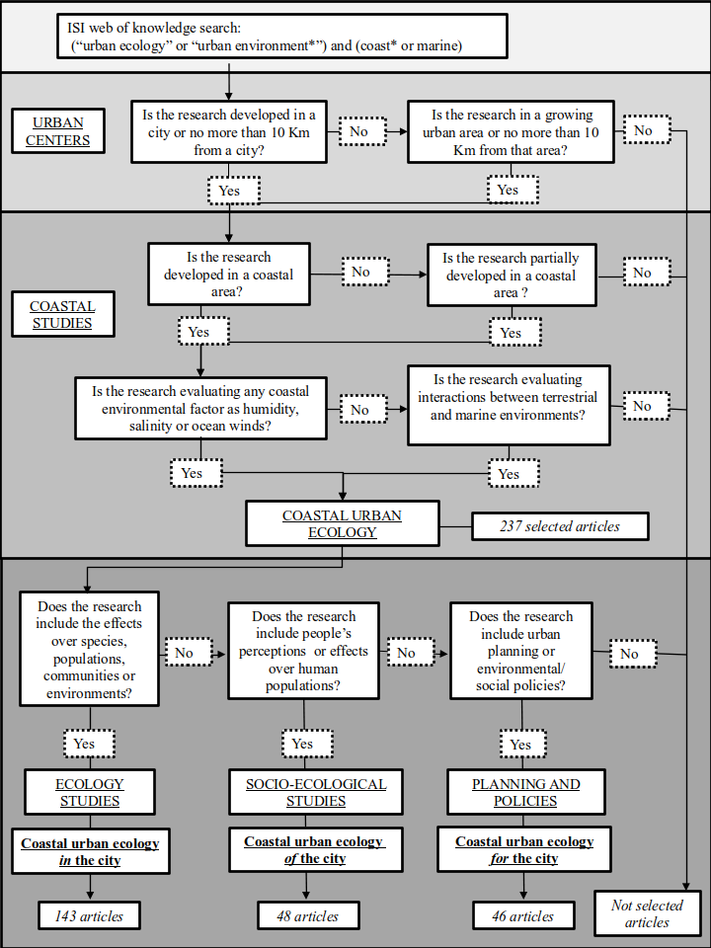

*Fig 1: Decision tree of articles selected for coastal urban ecology in literature.*

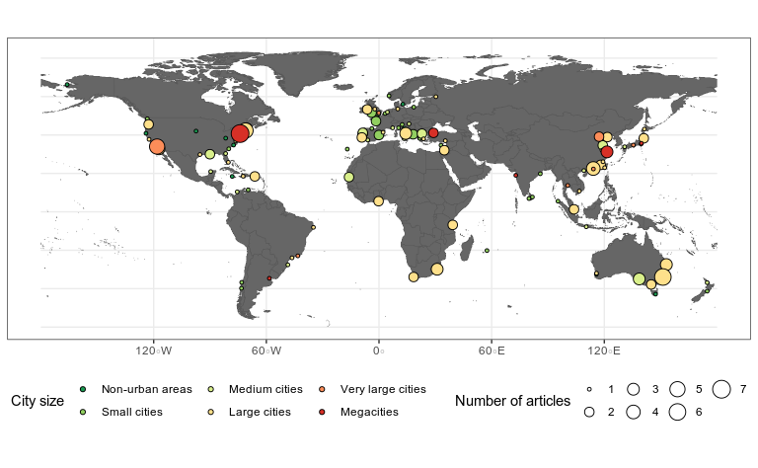

*Fig 2.* *Map of the world where the articles published in coastal urban ecology are presented according to the city where the investigations were carried out, the population size of each city and the number of articles published in them. For each city the size of the circle represents the number of articles published (increasing size with the number of articles, from 1 to 7) and the colour of the circle represents the size of the city given its population (city’s population data were obtained from United Nations 2019 and urban centres classification was modified from United Nations 2014 and Barragán & Andrés 2015).*

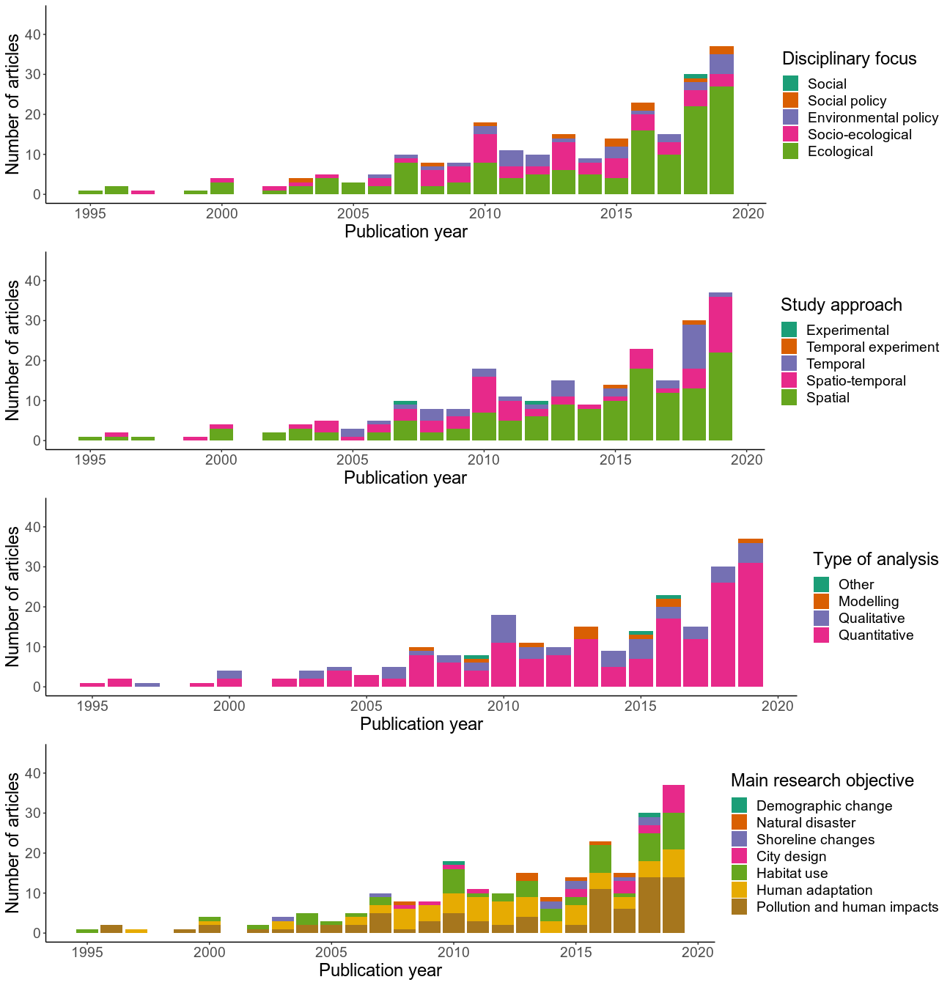

a

b

c

d

*Fig 3. Distribution of articles during the years according to disciplinary focus, research approach, type of analysis, and main research objectives.*

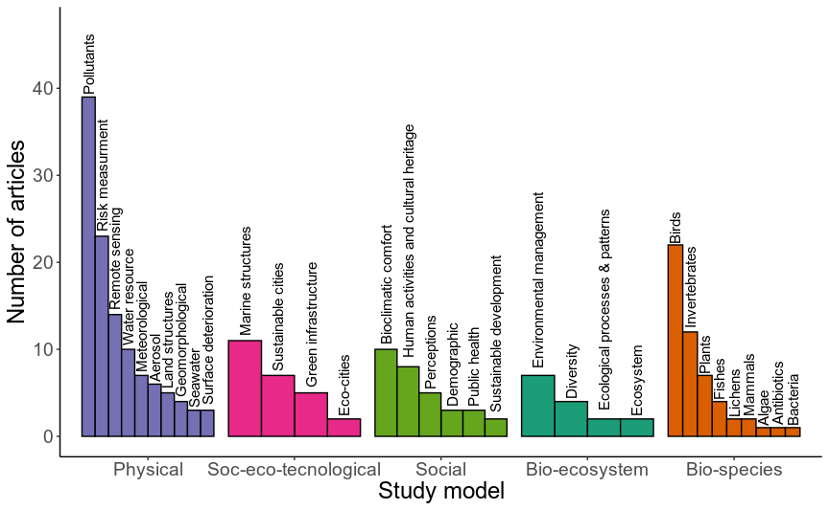

Fig 4. Distribution of articles, according to study models of research: Physical, Social-Ecological-Tecnological, Social, Biological-ecosystem, and Biological-species.

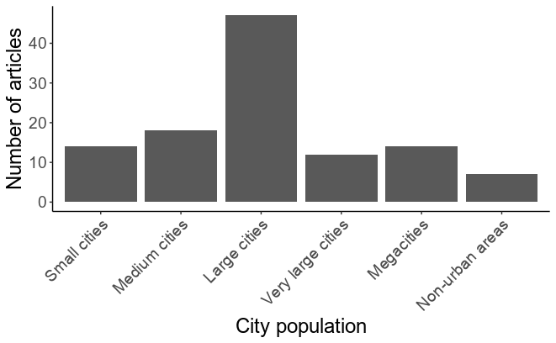

Fig 5. Number of articles for five types of urban centers classification in the world, where research in coastal urban ecology was made.

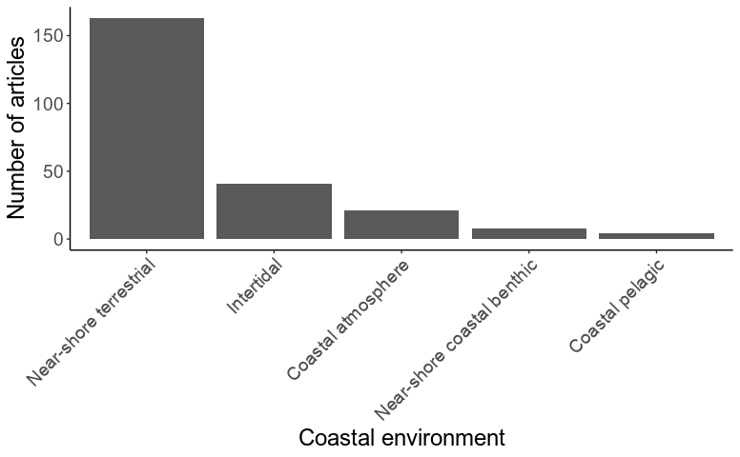

Fig 6. Distribution of articles, according to coastal environments, where research was done.

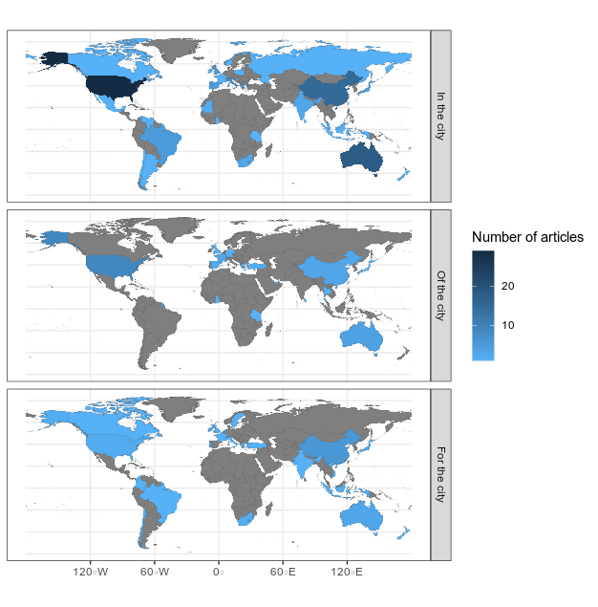

Fig 7. Ecological paradigms in, of, and for the city for coastal urban ecology, according to the number of studies developed in each country. Countries that not present coastal urban ecological articles are show in grey, and those with publications are presented in blue colours from light to dark.

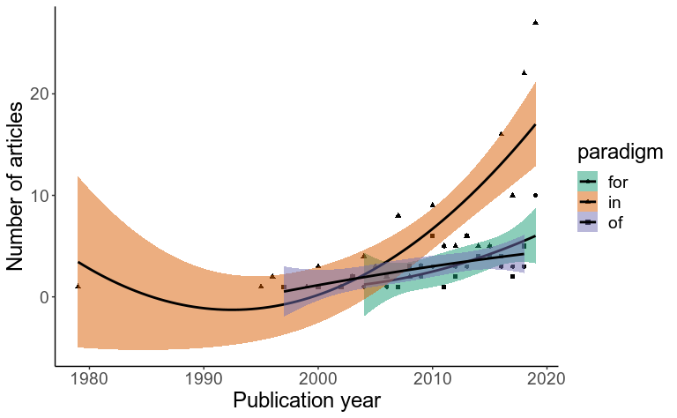

Fig 8. Number of articles published during the years considering paradigms in, of, and for the cities. Trend lines represent quadratic regression fit, colour areas represent the 95% confidence interval.

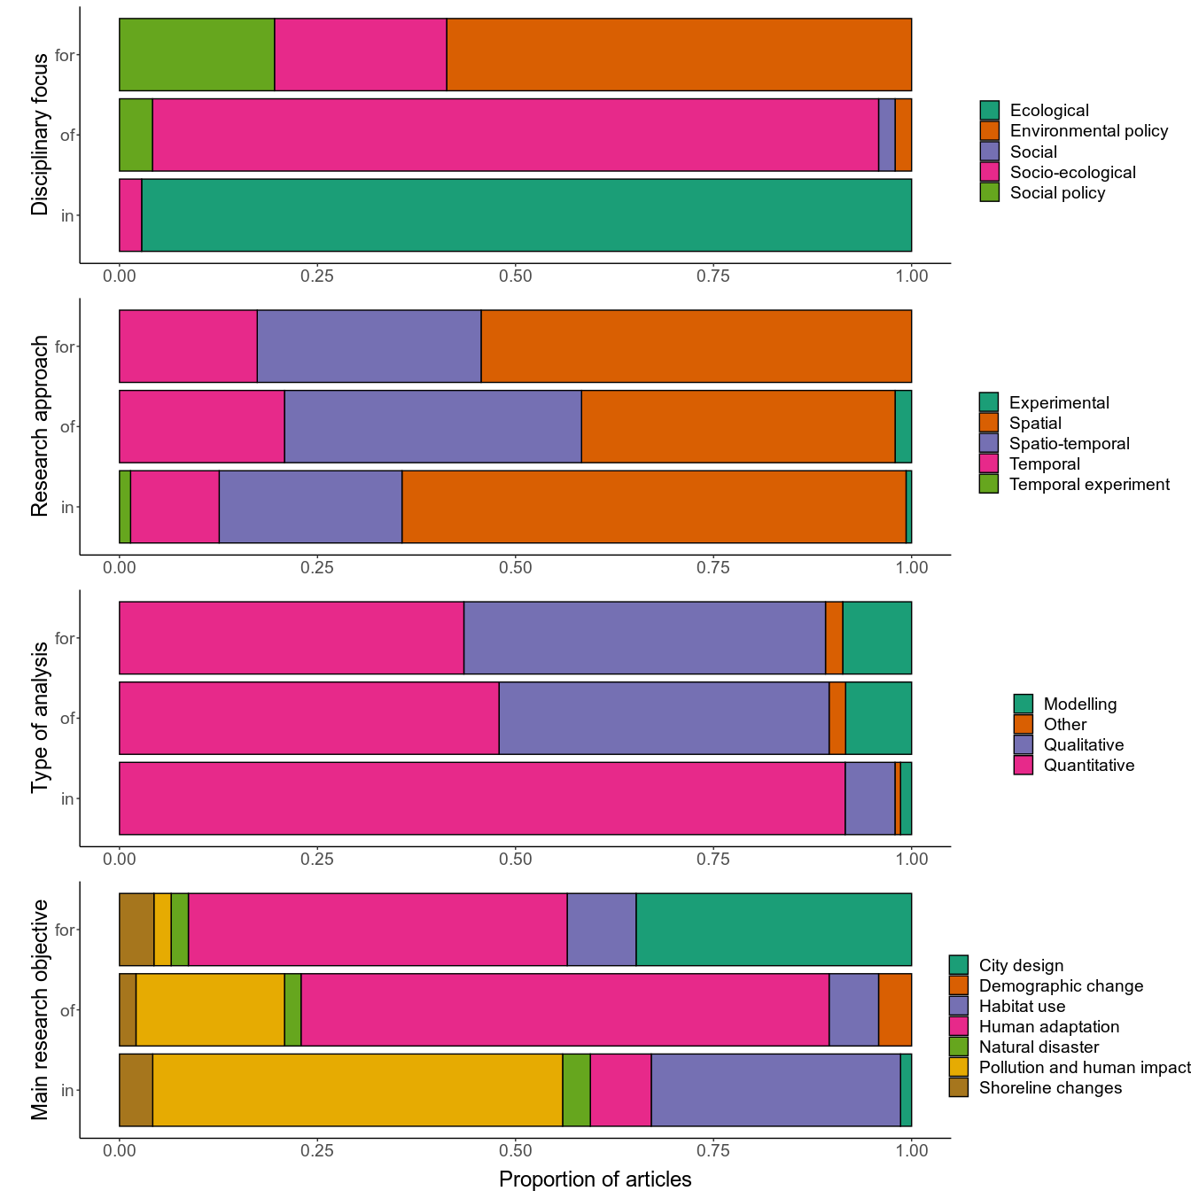

Fig 9. Distribution of articles’ paradigms according to disciplinary focus, research approach, type of analysis, and main research objectives.

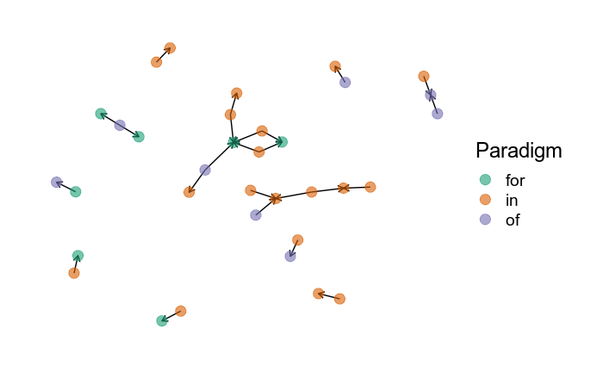

Fig 10. Network analysis for co-citations of articles presented in this coastal urban ecology review, considering the three paradigms proposed. Each dot represent a study and the colour indicates the paradigms (in-, of- and for- the cities). Directed edges go from the article citing to the article being cited.