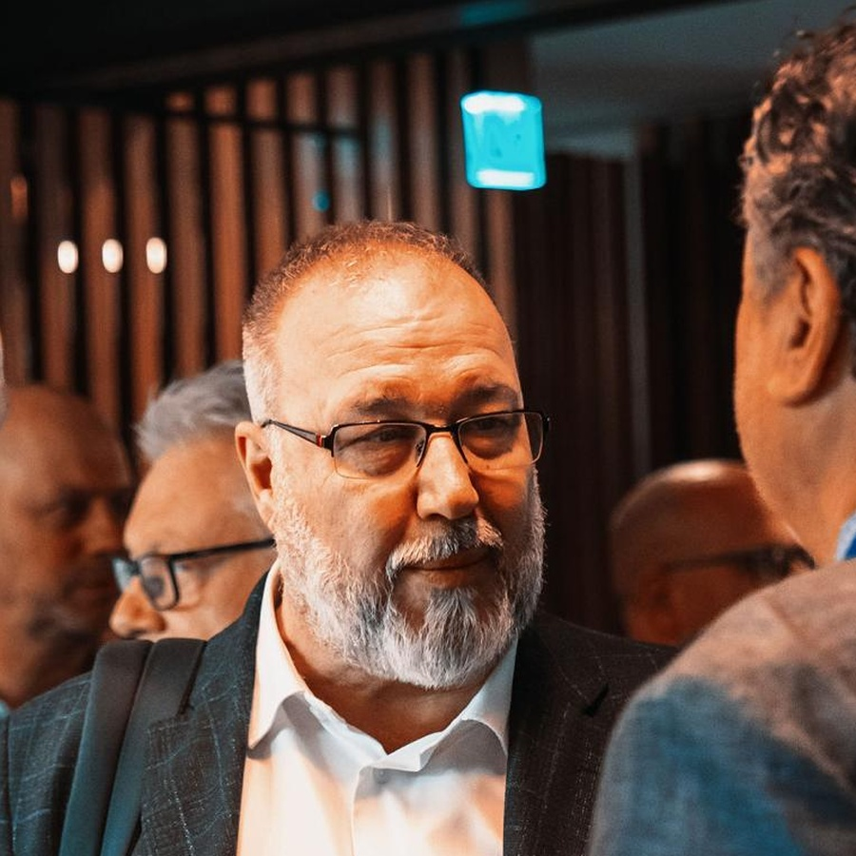 | GIORGIO OGGERO  Senior Consultant, Trainer  for International Business  Export Development | Cross-Cultural Negotiation | GCC/UAE |  Marketing & Sales | CONTACTS  Corso Trapani 25.  10139 Turin. Italy  Mobile: +39 338 7096084  Email: g.oggero@containergroup.eu  LinkedIn: linkedin.com/in/giorgio-  oggero-759992ba

PROFESSIONAL PROFILE
Senior trainer, tutor and consultant with a consolidated experience in international business development, cross-cultural negotiation, sales and marketing, export management and corporate training. Supports companies, executives and sales teams in preparing and managing international negotiations, entering foreign markets and building concrete commercial paths, with a strong focus on UAE/GCC, ICT, tourism and logistics. Practical and business-oriented training style: real cases, role plays, negotiation preparation tools, objection-handling exercises, coaching sessions and frameworks immediately applicable in client meetings and international business conversations.
INTERNATIONAL VALUE PROPOSITION
Negotiation and Training | Export and Market Entry | Sales, Marketing and Operations
• Cross-cultural negotiation  • International business communication  • Role plays and simulations  • Commercial team training | • Entry into GCC/UAE markets  • Internationalization strategy  • Market analysis and positioning  • Local networks and partners | • Commercial strategy and channels  • Pricing, P/L and forecasting  • Logistics and Incoterms  • Customs and export procedures
SELECTED TRAINING AND TEACHING EXPERIENCE
May 2026 - Present | Lecturer - Unis&f Treviso
- Classroom and online training on marketing, sales and supply chain management.
May 2026 - Present | Lecturer - Ciac formazione, Valperga (TO)
- Classroom and online training on marketing, sales and supply chain management.
Oct 2025 - Present | Lecturer - U Form, Milan
- Classroom and online training on marketing, sales and supply chain management.
Jun 2025 - Present | Lecturer - Umana Forma, Venice
- Classroom and online training on marketing, sales and supply chain management.
Apr 2025 - Present | Lecturer - Forema, Padua
- Classroom and online training on marketing, sales and supply chain management.
Mar 2025 - Present | Lecturer - ITS Academy Marco Polo, Venice
- Training on logistics management and marketing for professional education paths.
May 2022 - Present | Lecturer / Tutor - I.C.E. Faculty - ICE Agency
- Training for business development in marketing, internationalization and negotiation for companies.
- Tutoring and in-company support to entrepreneurs, managers and teams engaged in international business development.
2017 - Present | Lecturer - Enaip Piemonte
- Courses on international marketing, logistics, Incoterms, customs procedures, warehouse management, international trade development and business accounting.
2016 - Present | Marketing Trainer / Coach, in Italian and English - Manpower Group / Futurskill
- In-company training on internationalization, entry into foreign markets, market analysis, negotiation techniques, international agreements, business communication and multicultural communication.
2016 - Present | External Expert / Lecturer - SAA - School of Management, University of Turin
- Accredited as external expert, consultant and lecturer in marketing, strategy and sales.

2014 - Present | Lecturer / Coach for corporate courses and projects - Consulman S.p.A.
- Training in Italian and English on marketing, international trade and communication; sales-force training, national/international sales networks, logistics and customs procedures.
SELECTED CONSULTING AND INTERNATIONAL BUSINESS EXPERIENCE
Jul 2023 - Present | Project Manager - Giorgio Oggero / TemPlus - UAEPlus Project
- Co-creator and responsible for UAEPlus, an initiative that supports Italian companies entering GCC markets: United Arab Emirates, Saudi Arabia, Oman, Bahrain, Qatar and Kuwait.
- Coordinates marketing and sales, analysis, training, coaching and go-to-market support for companies in the ICT, mechatronics, tourism, healthcare and logistics sectors;
Oct 2022 - Mar 2024 | Temporary Executive Manager - Tecnocarpent S.r.l.
- Support to ownership during a generational transition, intervening on organization, operating flows, people management, commercial/marketing activities and logistics.
Sep 2021 - Sep 2022 | Temporary Export Manager - Fluiten S.p.A., Milan/Pero
- Creation and organization of the export office, including roles, negotiation-management model, customs expertise, origin of goods, transport procedures, warehouse activities; coaching to commercial managers and teams.
2013 - Present | Senior Export Marketing & Sales Manager - UAE/GCC Business Development Projects
- Supports Italian companies in exporting products and solutions in the ICT, tourism and logistics sectors to GCC/UAE markets, without the need to hire a full-time Export Manager.
- Develops market analysis, business models, P/L, forecast, pricing, positioning and go-to-market strategy; coordinates field activities with a local professional network.
2009 - 2016 | Senior Marketing & Sales Consultant, ICT - Ceipiemonte / Piemonte Agency
- Support to the international development of Piedmont-based SMEs and start-ups in ICT supply-chain projects; search for foreign buyers and organization of business missions, trade fairs and international events.
1990 - 2011 | Senior Roles in Sales, Marketing and Business Development - Canon Italia, Acco Italia, ICS Olivetti, E.motion, Bra Servizi, Rekordata
- Management of direct and indirect Italy/International sales networks, key accounts, dealers, distributors, GDO/GDS, public tenders, pricing, P/L, forecasts, promotions, training, coaching and logistics.
EDUCATION, LANGUAGES AND DIGITAL SKILLS
Education | Languages | Digital Skills
• Degree in Political Science, International Studies - University of Turin  • Commercial Correspondent in Foreign Languages Diploma - Istituto Elio Vittorini | • Italian: native  • English: fluent  • German: Zertifikat Deutsch  • Spanish: basic | • Microsoft Office / Mac Open Office  • Online training platforms: Zoom, Meet, Skype, Botim
PUBLICATIONS, PUBLIC SPEAKING AND POSITIONING STATEMENT
- Author of: Il fascino del dubbio (2025), Il lavoro snobilita l'uomo (2019), Le Superga non erano mie (2011).
- Speaker on cost reduction, corporate coaching, teamwork, communication and inclusive sports training; volunteer as judo coach for athletes with intellectual disabilities since 1994.
- Positioning: I help companies, executives and sales teams negotiate with greater confidence in international contexts, transforming cultural differences, field experience and commercial method into stronger relationships and more concrete business results.

