Communication-Aware Machine Learning for Major Depressive Disorder: Testing a microglia → neuron communication axis from single-nucleus RNA-seq of the human prefrontal cortex
Giorgos Boulogeorgos
Andreas Mici
MLCB Team Project — Re-analysis of Maitra et al. (2023), Nature Communications 14, 2912 — June 2026
Abstract
Maitra et al. (2023) reported that, in major depressive disorder (MDD), the strongest single-nucleus transcriptomic signal is carried by microglia (cluster Mic1) in females and by a deep-layer excitatory neuron (cluster ExN10_L46) in males, and presented these as two separate, sex-specific findings. We test the hypothesis that they are the two ends of a single microglia $→$ neuron communication axis whose apparent sex-specificity is partly an artefact of per-cluster differential-expression analysis treating cell types as isolated. Re-analysing their 71-donor dlPFC dataset ($∼$160k nuclei; GSE213982 + GSE144136), we (A) reproduce the cell-type signal, (B) infer per-donor ligand–receptor networks with LIANA and compress them into five communication programs by non-negative tensor (CP/PARAFAC) decomposition, and (C) train donor-level case/control classifiers on three feature sets—expression-only, communication-only, and combined—under rigorous, leakage-controlled repeated nested cross-validation, with SHAP for interpretation. A single data-driven program (Factor 4, an endothelial + microglia $→$ ExN10_L46 axis) emerges as the dominant, cohort-clean, MDD-leaning communication signal; it is higher in MDD donors of both sexes (stronger in males, standalone AUC 0.702, $p=0.05$) and becomes the #1 communication factor by SHAP once factors are re-estimated inside each fold. However, when these factors compete directly with microglial/neuronal gene expression, feature selection keeps only genes and discards every factor: the axis carries no predictive information independent of microglial transcriptional state at $n=71$. The biology of the hypothesis is directionally supported; the communication representation does not add value over expression for donor-level classification.
Keywords: major depressive disorder; single-nucleus RNA-seq; cell–cell communication; ligand–receptor inference; tensor decomposition; interpretable machine learning; microglia; prefrontal cortex.

Introduction
Major depressive disorder (MDD) is a leading cause of disability whose molecular substrate in the human brain remains poorly resolved. Single-nucleus RNA sequencing (snRNA-seq) of the dorsolateral prefrontal cortex (dlPFC) has made it possible to ask which cell types carry the disease signal. Maitra et al. [1] profiled $∼$160,000 nuclei from 71 donors and found that the strongest case/control differences localise to microglia (fine cluster Mic1) in female donors and to a deep-layer excitatory neuron population (fine cluster ExN10_L46) in male donors. These were reported as two distinct, sex-specific results.

Hypothesis.
We hypothesise that the female microglial signal and the male excitatory-neuron signal are not independent but are two ends of one microglia $→$ neuron communication axis—microglia as sender, deep-layer neuron as receiver. Under this view, the apparent sex-specificity is partly an artefact of per-cluster differential-expression (DEG) analysis, which treats each cell type in isolation and therefore cannot see a signal that lives between cell types. If the hypothesis holds, explicitly modelling cell–cell communication should expose a shared axis that is active in MDD donors of both sexes. This report develops that test end-to-end and reports an honest, leakage-controlled answer.

Scope.
The project was deliberately narrowed from the original proposal: no scVI integration benchmark and no graph neural network ($n=71$ donors is far too few to train one). The core deliverable is the interpretable machine-learning comparison of expression vs. communication features at the donor level.

Materials and Methods

Data
We re-use the combined count matrix released by Maitra et al., which merges the female cohort (GSE213982) and the male cohort (GSE144136) into a single dlPFC (Brodmann area 9) snRNA-seq matrix. Key facts, verified during Phase A (Table 1):
Table 1. Dataset summary (after the authors’ quality control).
Property | Value
Donors (CV unit) | 71
MDD (death by suicide) / Control | 37 / 34
Female / Male | 38 / 33
Female MDD / Control | 20 / 18
Male MDD / Control | 17 / 16
Nuclei (high-quality) | 160,711
Genes | 36,588
Region / assay | dlPFC (BA9), 10x snRNA-seq
Two dataset properties simplified the pipeline. First, the GEO file GSE213982_combined_counts_ matrix.mtx.gz already contains both sexes—the authors merged the male cohort into it—so only the male SOFT metadata is needed for diagnosis labels. Second, the authors’ cell-type annotations are baked into each cell identifier (donor.barcode.broad.fine, e.g. F1.AAAC…-1.Mic.Mic1), giving both 7 broad classes and 41 fine clusters for free. One subtlety was handled explicitly: donor M24 appears twice (M24 + M24_2, two sequencing runs of one individual) and is merged to a single donor, otherwise its two halves could split across CV folds and leak donor identity (72 donor tokens $→$ 71 donors).

Confound to track throughout.
Sex is perfectly confounded with cohort/library (females $=$ GSE213982, males $=$ GSE144136). Any train-on-one-sex/test-on-the-other split is therefore also a train/test across-batch split, so a failure to generalise could be batch rather than biology. This single fact reshaped the evaluation design (Section 2.5).

Pipeline overview
The analysis proceeds in three phases (Figure 1)—reproduction (A), cell–cell communication inference (B) and machine learning (C)—followed by an interpretability and hypothesis-testing layer (Phase D, referred to as Step 4 in the code). Each expensive step is checkpointed so a runtime timeout never costs more than one step.
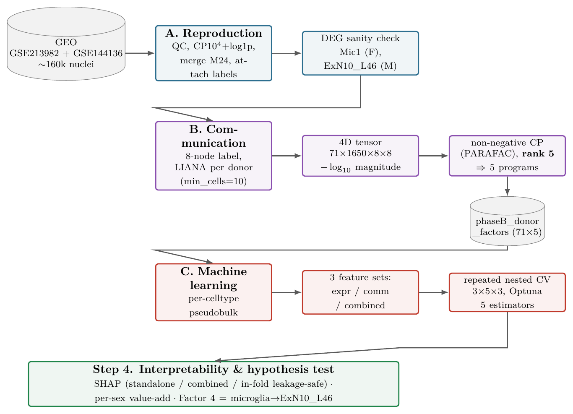
Figure 1. End-to-end pipeline. Phase A loads, normalises and annotates the combined matrix and confirms the cell-type signal. Phase B infers ligand–receptor scores per donor (LIANA), arranges them as a 4D tensor (donor $×$ L–R pair $×$ sender $×$ receiver) and compresses it into five communication programs by non-negative CP decomposition. Phase C builds per-donor pseudobulk expression and compares three feature sets under repeated nested cross-validation. Step 4 interprets the models with SHAP and runs the directed hypothesis test on the microglia $→$ ExN10_L46 program.

Phase A — Reproduction
Because the authors already performed QC and annotation, Phase A is leaner than a full reproduction: we do not re-cluster (which would be stochastic and the authors’ annotations are validated). Phase A (i) streams the $∼$1.1 GB matrix into an AnnData object, parses the cell string into donor/barcode/broad/fine, merges M24_2$→$M24, and attaches sex and diagnosis; (ii) normalises .X to counts-per-${10}^{4}$ then log1p (Scanpy [8]), preserving raw counts in .layers[’counts’] (pseudobulk in Phase C needs raw); and (iii) runs a nucleus-level Wilcoxon DEG sanity check (MDD vs. Control, within sex) on Mic1 and ExN10_L46. Both show strong signal—Mic1 (female) synaptic/adhesion genes up, ExN10_L46 (male) metabolic/synaptic genes (GAPDH, PKM, CKB, VAMP2, SNCB) down.

Honest caveat.
Nucleus-level Wilcoxon pseudoreplicates (nuclei from one donor are not independent), inflating the count of “significant” DEGs. We confirmed the ExN10_L46 signal holds at the donor level (median per-donor expression); definitive donor-level statistics come later via pseudobulk—which is exactly why the authors used pseudobulk rather than nucleus-level tests. The Phase A checkpoint (phaseA_final_for_cellchat.h5ad) carries normalised .X, raw .layers[’counts’], and .obs columns donor_id, cell_type_broad, cell_type_fine, sex, condition, dataset.

Phase B — Cell–cell communication

Three deliberate methodology changes
(agreed before building) moved Phase B away from the original CellChat plan:
- LIANA (Python), not CellChat (R). LIANA’s rank_aggregate.by_sample [2] performs per-donor ligand–receptor inference natively, avoiding fragile rpy2/R setup.
- Per-donor, not per-condition inference. Running four condition-level networks (sex $×$ diagnosis) and projecting onto donors is degenerate: every donor in a group receives an identical communication vector that merely re-encodes (sex, diagnosis), so a classifier would “work” while learning nothing. Per-donor inference gives each of the 71 donors its own L–R scores with real donor-to-donor variation.
- No leave-one-sex-out as the test (the sex $=$ cohort confound, Section 2.5).

Granularity (hybrid, 8 nodes).
A per-donor cell-count diagnostic showed that Mic $≡$ Mic1 in this annotation (microglia have a single fine cluster), so there is nothing to split on the sender side. But ExN10_L46 is only $∼$3.4% of ExN, so a broad Mic$→$ExN edge would be $∼$96.6% off-target. We therefore split only ExN10_L46 out of ExN (remainder $=$ ExN_other) and keep everything else broad. Final nodes: Ast, End, ExN10_L46, ExN_other, InN, Mic, OPC, Oli (Mix dropped, leaving 156,911 of the 160,711 nuclei). With min_cells=10 per donor, focal-edge missingness is balanced across diagnosis (Mann–Whitney $p=0.19$), so it does not leak the label; donors below threshold in a cell type are masked (not imputed).

Tensor decomposition.
The per-donor L–R table is arranged as a 4D tensor (71 donors $×$ 1650 L–R pairs $×$ 8 senders $×$ 8 receivers); masked donor/cell-type slices are left as NaN so the decomposition borrows strength across donors rather than imputing. Following LIANA’s to_tensor_c2c convention, the magnitude_rank score (a rank in $(0,1]$ where small $=$ strong) is transformed by $−\log_{10}(x+ε)$, which both flips orientation (large $=$ strong) and reshapes it; an early bug that omitted this transform left the in-fold factors inverted and collapsed two linear models to chance, and was fixed once diagnosed. A non-negative CP (PARAFAC) decomposition [3, 4] with rank 5 (justified below) yields five communication programs; a donor’s loading on a program measures how active it is in that donor. Each factor’s sender, receiver and L–R loadings give its biological interpretation.

Why rank 5.
Figure 2 plots the reconstruction error as the rank grows. As is typical for CP decompositions of noisy single-cell communication tensors, the error declines smoothly, with diminishing returns rather than a sharp elbow: the first five components capture about two-thirds of the total error reduction available over ranks 1–8 ($0.66​→​0.58$ by rank 5 vs. a further $0.58​→​0.54$ across ranks 6–8), and each component past five lowers the error by progressively less while adding another program to interpret. We therefore do not over-read a kink that is not there; rank 5 is a deliberate parsimony / interpretability choice—small enough that each program admits a clear sender $→$ receiver reading, yet large enough to resolve the dominant batch/cohort structure (Factors 2/3/5) from the diagnosis-leaning biology (Factor 4), matching the low single-digit ranks used in Tensor-cell2cell workflows. The choice is validated post hoc: the five programs cleanly separate batch from biology (Table 2), and the in-fold refit re-estimates a rank-5 decomposition inside every training fold yet recovers the same Factor 4 ($|r|≈0.95$; median $0.97$ across the five factors vs. the frozen all-donor factors).
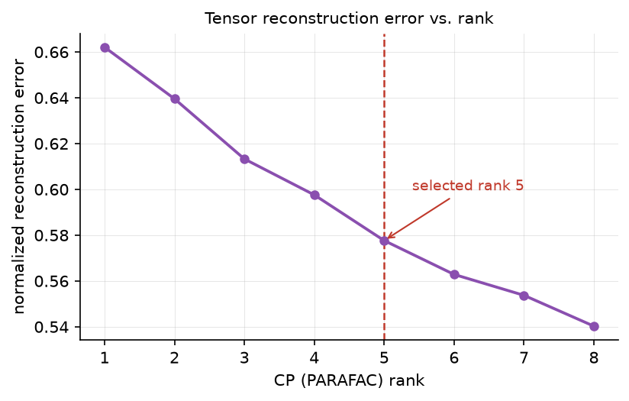
Figure 2. Tensor reconstruction error vs. CP (PARAFAC) rank. Normalised Frobenius reconstruction error over the observed (unmasked) entries of the $71×1650×8×8$ communication tensor, for non-negative decompositions of rank $1$–$8$ (single seed, random_state=0, matching the in-fold projector). The error decreases smoothly with diminishing returns rather than at a sharp elbow; rank 5 (dashed line) captures roughly two-thirds of the reduction available across this range and was fixed for parsimony and interpretability (see text).
Table 2. The five communication programs and their association with diagnosis vs. sex/cohort (per-factor Mann–Whitney $p$). The batch confound self-segregates into Factors 2/3/5 (strongly sex-linked, diagnosis-null) and does not smear into the biology. Factor 4 is the only diagnosis-leaning, cohort-clean program, and it is the one selected a priori as the microglia $→$ ExN10_L46 axis.
Factor | Program (dominant sender $→$ receiver) | $p$(diagnosis) | $p$(sex/cohort) | note
1 | ExN $→$ ExN | 0.348 | 0.778 | no signal
2 | ExN $→$ Ast/OPC | 0.398 | 0.0025 | cohort/batch
3 | OPC/Ast $→$ mixed | 0.479 | 0.0002 | cohort/batch
4 | End + Mic $→$ ExN10_L46 | 0.057 | 0.108 | hypothesis program
5 | mixed $→$ End | 0.886 | 0.00002 | cohort/batch

The hypothesis program (Factor 4).
Factor 4’s senders load on Endothelial (0.79) and Microglia (0.40); its receivers load on ExN10_L46 (0.54) and ExN_other (0.52). Its top ligand–receptor drivers are synaptic-adhesion / glutamatergic / Ca$​^{2+}$ pairs—IL1RAPL1--PTPRD, CALM1--GRM5/GRM7/KCNQ5/RYR2, NRXN3--NLGN1, APP--DCC, CALM1--CACNA1C (CACNA1C and IL1RAPL1 are psychiatric-relevant). Quantifying the microglia-sender $×$ ExN10_L46-receiver product gives loading $0.40×0.54≈0.22$, far above any other factor—hence Factor 4 is the data-driven instantiation of the axis under test.

Honest caveats (carried forward).
$p=0.057$ is a trend, not significance (univariate, one factor). Factor 4’s top sender is actually Endothelial ($0.79$) $>$ Mic ($0.40$), so strictly it is a “non-neuronal (vascular + immune) $→$ deep-layer neuron” program rather than pure microglia. Selecting Factor 4 by biology (not by $p$-value) keeps this a legitimate directed test.

Phase C — Machine learning

Feature sets.
Three donor-level matrices are compared:
- Expression-only — per-cell-type pseudobulk (raw counts summed per donor$×$cell type, then logCPM); the baseline.
- Communication-only — the 5 factor loadings.
- Combined — pseudobulk + 5 factors.

Communication vs. expression, in plain terms.
Expression features are raw gene-activity readouts: for each donor and cell type, how much each gene is switched on (e.g. how much IL1RAPL1 microglia make). Communication features are relational: they score how strongly a ligand from a sender cell type can engage its receptor on a receiver cell type, then compress thousands of such sender$→$ receiver L–R scores into 5 programs. Crucially, communication is computed from expression (a ligand’s “signal” is essentially its gene expression), so the two are not independent—which is exactly why the combined-feature comparison below is the decisive test of whether communication adds anything.

Evaluation: within-sex value-add (not leave-one-sex-out).
Because sex is perfectly confounded with cohort, we evaluate with pooled donor-level CV stratified by sex $×$ diagnosis (diagnosis is balanced within each sex: F 20/18, M 17/16), so a fold never crosses the batch. The hypothesis test becomes: does adding communication beat expression-only, and is Factor 4’s importance shared across sexes?

Model selection and validation.
We use repeated nested cross-validation: 3 rounds $×$ 5 outer folds $×$ 3 inner folds, with 20 Optuna [10] trials per inner search, evaluating five estimators—logistic regression (LR), Gaussian naive Bayes (GNB), linear discriminant analysis (LDA) and random forest (RF) from scikit-learn [9], plus XGBoost [6]. Bootstrap 95% confidence intervals are reported. Feature pipelines are fit inside the training fold: a variance top-1000 prefilter (VarianceTopK) followed by mRMR selection of $k=15$ features (MRMRSelector, relevance $=$ mutual information) [7].

Leakage rules (non-negotiable).
- CV unit $=$ donor, one row per donor (M24 merged), stratified by sex $×$ diagnosis.
- All expression feature selection / variance prefilter / scaling is fit on the training fold only.
- Tensor leakage removed (rigorous path). The Phase B rank-5 decomposition was fit on all 71 donors (unsupervised; the leak is mild). For the headline numbers we re-fit the tensor inside each outer-train fold (TensorFactorProjector: non-negative PARAFAC on train donors, then NNLS projection of held-out donors onto the fixed factors). Because non-negative CP has no sign ambiguity (only permutation), in-fold components are matched to the canonical Factor 1…5 by $|corr|$ Hungarian assignment.

Results

Donor-level classification
Table 3 reports median test AUC (with 95% bootstrap CI) and median MCC for each feature set $×$ estimator under the rigorous CV.
Table 3. Rigorous repeated-nested-CV performance (median AUC [95% CI]; median MCC). Communication-only carries weak but real signal in the linear models (LR/GNB/LDA $≈$ 0.633) and is at chance for tree models; expression is the stronger baseline (XGB 0.714); combined never CI-separates from expression.
 | Communication |  |  | Expression |  |  | Combined
Est. | AUC | 95% CI | MCC | AUC | 95% CI | MCC | AUC | 95% CI | MCC
LR | 0.633 | [0.56,0.73] | 0.04 | 0.646 | [0.61,0.73] | 0.26 | 0.694 | [0.55,0.76] | 0.42
GNB | 0.633 | [0.58,0.69] | 0.17 | 0.643 | [0.50,0.71] | 0.17 | 0.673 | [0.54,0.73] | 0.22
LDA | 0.633 | [0.56,0.76] | 0.05 | 0.667 | [0.57,0.71] | 0.25 | 0.653 | [0.50,0.77] | 0.15
RF | 0.536 | [0.50,0.59] | 0.00 | 0.688 | [0.63,0.76] | 0.20 | 0.667 | [0.57,0.71] | 0.15
XGB | 0.490 | [0.40,0.61] | $−0.14$​ | 0.714 | [0.61,0.73] | 0.29 | 0.714 | [0.63,0.83] | 0.29

Value-add (combined $−$ expression).
Positive on average but not CI-separated: LR $+0.048$ AUC ($+0.158$ MCC), GNB $+0.031$; LDA/RF slightly negative; XGB $0.714→0.714$. The honest read: communication carries weak real signal (linear models only) but adds no statistically demonstrable value beyond expression at $n=71$. These rigorous numbers replace the earlier pragmatic (all-donor-factor) numbers, which were mildly leak-inflated.

Phase D (Step 4) — interpretation and the directed hypothesis test
We probe Factor 4 from three angles with SHAP [5] (signed log-odds contributions; colour $=$ feature value, red high / blue low).

(i) Standalone direction and sex.
Factor 4 is higher in MDD donors in both sexes (consistent direction). Standalone it discriminates MDD with AUC 0.632 overall, concentrated in males (AUC 0.702, Mann–Whitney $p=0.05$) more than females (0.578, $p=0.42$). In the communication-only LR (the only comm model above chance), linear-SHAP ranks Factor 4 #2 of 5, comparably across sexes (F 0.234, M 0.227) (Figure 3).
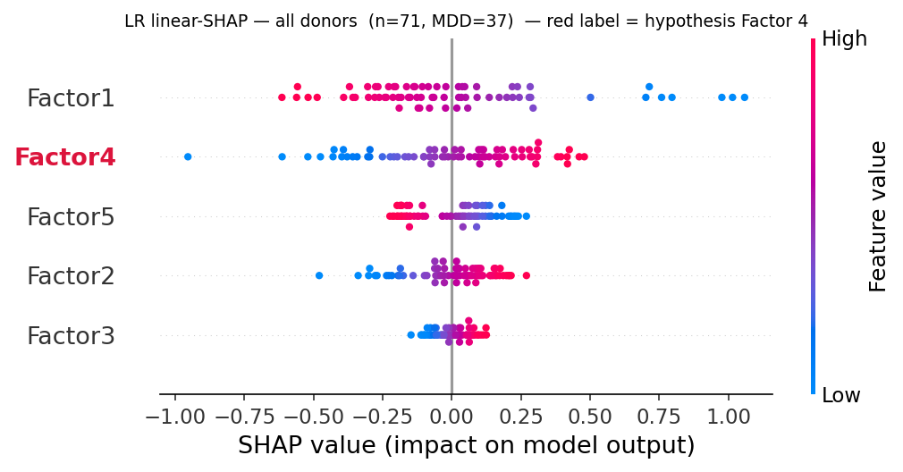
Figure 3a. All donors ($n=71$).
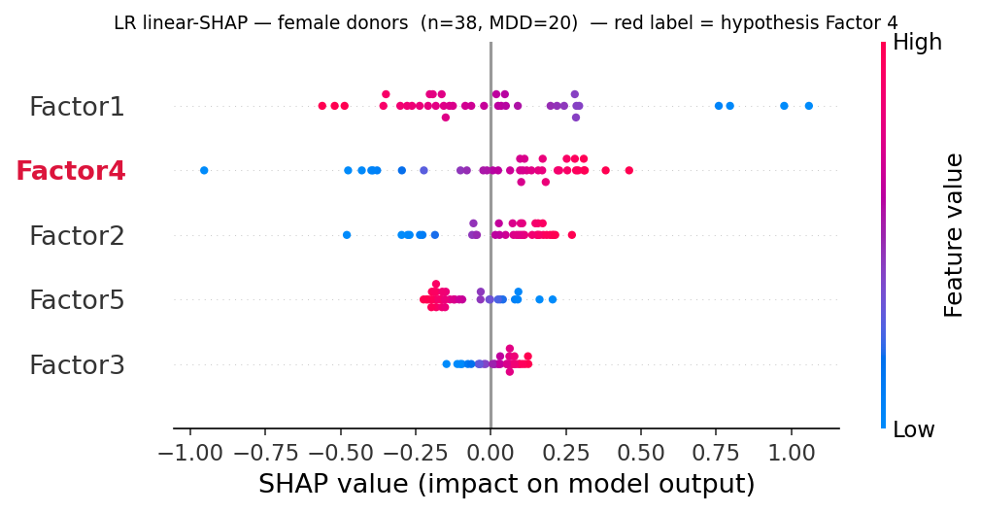
Figure 3b. Female donors ($n=38$).
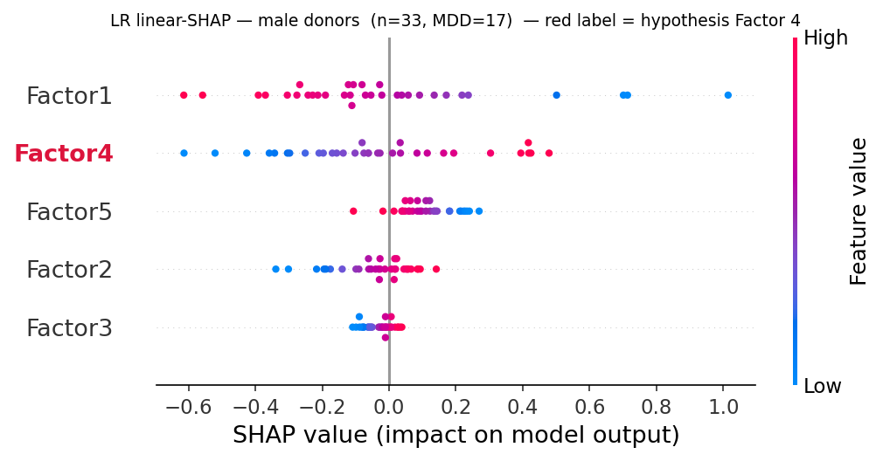
Figure 3c. Male donors ($n=33$).
Figure 3. Communication-only logistic-regression SHAP beeswarm (the five factor loadings). Factor 4 (red label) carries among the largest mean$|$SHAP$|$ and its high values (red) sit on the positive-SHAP side—i.e. a more active microglia $→$ ExN10_L46 program pushes the prediction toward MDD—in both sexes.

(ii) Combined space: does it beat expression?
When the five factors compete directly with microglial/neuronal genes in one model (variance top-1000 genes $+$ 5 factors $→$ mRMR $k=15$), feature selection keeps 15 genes—almost all microglial (Mic__*)—and drops every communication factor; Factor 4 does not survive (Figure 4a). This is the feature-level reason the combined set adds no CI-separated value: the program is a low-rank summary of microglial expression state, captured at least as well by the raw Mic genes.

(iii) In-fold, leakage-safe.
Re-estimating the factors inside each CV fold and computing SHAP on held-out donors gives held-out LR AUC 0.649 (matching the rigorous 0.633, validating the path) and makes Factor 4 the #1 communication factor (mean$|$SHAP$|$ 0.610), again slightly stronger in males (0.651) than females (0.575) (Figure 4b). So the axis is, if anything, more prominent once the mild all-donor leakage is removed.
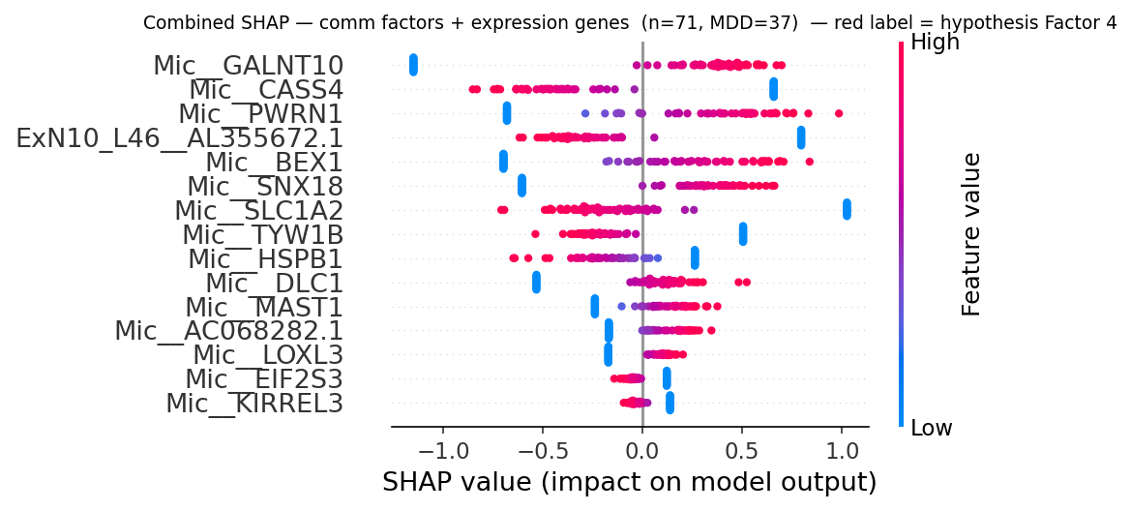
Figure 4a. Combined space: factors vs. genes. mRMR keeps 15 genes (mostly Mic__*); all 5 factors are dropped.
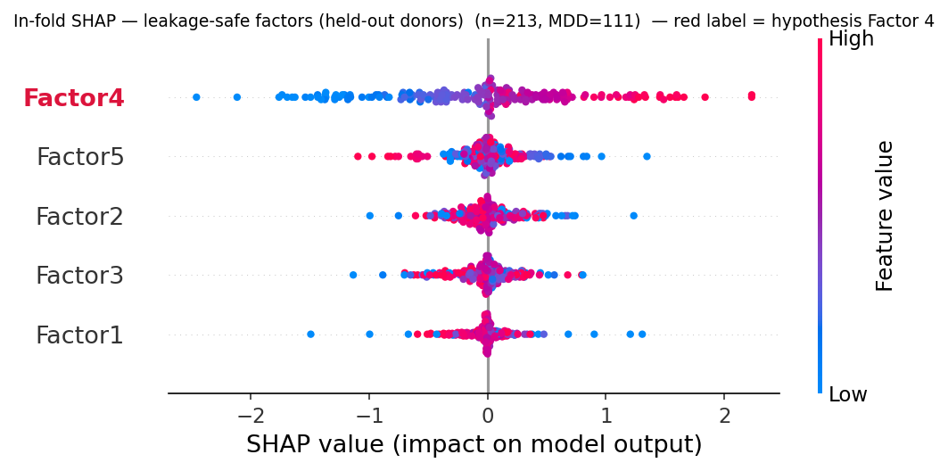
Figure 4b. In-fold leakage-safe factors on held-out donors, pooled across the 3 CV rounds ($71×3=213$ held-out predictions): Factor 4 becomes the #1 communication factor.
Figure 4. The two extended SHAP views. Left: when factors and genes compete, the genes win and Factor 4 is redundant for prediction. Right: among communication features alone (leakage-safe), Factor 4 dominates.

Discussion
The results form a coherent, non-contradictory picture. The microglia $→$ ExN10_L46 communication program (Factor 4) is the dominant, reproducible communication signal in this dataset: it self-separates from the strong cohort/batch confound (which collapses into Factors 2/3/5), it leans toward MDD in both sexes, and it becomes the single most important communication feature once factors are re-estimated leakage-free. This directionally supports the central hypothesis that a shared microglia $→$ neuron axis—not two unrelated sex-specific findings—underlies the female-microglial and male-neuronal signals reported by Maitra et al. The L–R drivers (synaptic-adhesion, glutamatergic and Ca$​^{2+}$ signalling, including the psychiatric-risk genes CACNA1C and IL1RAPL1) are biologically sensible for a microglia–neuron synaptic interface.
But the communication representation adds no predictive value over expression. When factors and genes compete, mRMR discards every factor in favour of microglial genes, and the combined classifier never CI-separates from the expression baseline. This is expected rather than paradoxical: communication is derived from expression, and a rank-5 program is a compressed, lossy summary of the same microglial transcriptional state that the raw Mic__* genes encode at full resolution. At $n=71$ the compression buys interpretability, not discriminative power. The signal is real but not independent. Note the comparison is, if anything, conservative: the expression baseline already includes per-cell-type pseudobulk for ExN10_L46—the very receiver of the hypothesis axis—so the factors compete against a baseline deliberately favourable to the hypothesis and still add nothing.

Limitations
- Sample size. $n=71$ donors with $∼$50/50 labels gives wide bootstrap CIs; a $+0.05$ AUC value-add is not resolvable. This is the binding constraint and the reason no GNN was attempted.
- Sex $=$ cohort confound. Females and males come from separate libraries, so cross-sex generalisation cannot be cleanly tested; we use within-sex pooled CV instead, which tests value-add but not transfer.
- Factor 4 is not pure microglia. Its top sender is Endothelial (0.79) above Microglia (0.40); it is best described as a non-neuronal (vascular + immune) $→$ deep-layer-neuron program. The directed test is justified by a priori biological selection, not by the $p$-value.
- Trend-level univariate signal. Factor 4’s diagnosis association is $p=0.057$ (a trend), and the male standalone $p=0.05$ is borderline.
- Microglia recovery is sex/cohort-skewed (female 46 vs. male 16 median nuclei/donor), a batch effect reinforced by Factors 2/3/5.
- Pseudoreplication affects the nucleus-level DEG sanity check; donor-level pseudobulk is the fix used everywhere downstream.

Conclusion
Modelling cell–cell communication explicitly recovers a single, reproducible microglia $→$ ExN10_L46 program that is elevated in MDD donors of both sexes and is the most important communication feature under leakage-safe estimation—directionally supporting the hypothesis that the female-microglial and male-neuronal MDD signals are two ends of one axis. The biology is supported. However, this communication representation carries no predictive information independent of microglial gene expression at $n=71$: when the two compete, expression wins and the factors are dropped. The honest conclusion for a course project is therefore a qualified yes—the shared axis is visible and real, but it is a low-rank shadow of microglial transcriptional state rather than an independent, value-adding signal.

Data and code availability

Data.
All data are public. The dlPFC snRNA-seq count matrices and metadata were obtained from the Gene Expression Omnibus under accessions GSE213982 (female cohort; the released combined counts matrix also contains the male nuclei) and GSE144136 (male cohort metadata), published by Maitra et al. [1]. No new data were generated by this project.

Code.
All analysis code is openly available at
https://github.com/GiorgosBoulogeorgos/MLCB_team_project
organised as src/ (library modules), notebooks/ (phase-by-phase runners) and report/ (this manuscript and its figures). Key modules: src/functions.py (Phases A/B), src/pseudobulk.py (donor-level pseudobulk), src/tensor_features.py (in-fold tensor projector), src/rncv.py (repeated nested cross-validation), src/feature_selection.py (VarianceTopK, MRMRSelector), src/estimators.py (the five classifiers and their Optuna search spaces) and src/shap_step4.py (Phase D interpretability); the end-to-end rigorous run is reproduced by run_rigorous_local.py. Raw data and intermediate checkpoints are not committed (they exceed repository limits) and are regenerated from GEO by the Phase A notebook.

Reproducibility settings.
Rigorous run: seed 42, 3$×$5$×$3 repeated nested CV, 20 Optuna trials per inner search, per-fold tensor refit; LIANA 1.7.3 / cell2cell 0.8.4 for Phase B. Each expensive step is checkpointed, so a runtime timeout never costs more than one step.

Author contributions
G.B. conceived the study: he wrote the original project proposal, formulated the microglia $→$ neuron shared-axis hypothesis and designed the proposed pipeline, which was then discussed and refined jointly with A.M. A.M. carried out Phase A (data loading, annotation, QC and the reproduction of the cell-type signal). G.B. carried out Phase B (per-donor LIANA inference, tensor construction and the non-negative CP decomposition) and Phase C (pseudobulk feature construction, the three feature sets, the leakage-controlled repeated nested cross-validation and the in-fold tensor projector), and contributed to Phase D. A.M. completed Phase D (SHAP-based interpretation of the models and of Factor 4, and the directed hypothesis test), led the interpretation of the results and prepared the presentation slides. Both authors wrote the manuscript jointly, discussed the methodology throughout, reviewed the analyses, and read and approved the final version.

AI usage disclosure
In line with good scientific practice, we disclose that generative AI (Anthropic’s Claude) was used as a coding and writing assistant during this project. Specifically, it was used to (i) produce the initial scaffold of the analysis pipeline (module and notebook skeletons, function signatures, boilerplate); (ii) debug code, most substantially in the Phase B LIANA / tensor-decomposition stage (e.g. diagnosing the missing $−\log_{10}$ transform of the magnitude_rank score, which had inverted the in-fold factors); (iii) generate figures (the plotting code for the SHAP beeswarms, the reconstruction-error curve and the pipeline diagram); and (iv) perform code review of the analysis modules.
No AI system was used to generate data, to fabricate or alter results, or to decide the scientific conclusions. The study design, hypothesis, methodological choices, evaluation protocol, interpretation of the results and the claims made in this manuscript are the authors’ own. All AI-assisted code was read, tested and validated by the authors, and all AI-assisted text was reviewed and edited by them. The authors take full responsibility for the entire content of this work.

Competing interests
The authors declare no competing interests.

References
[1] M. Maitra et al., “Cell type specific transcriptomic differences in depression show similar patterns between males and females but implicate distinct cell types and genes,” Nature Communications 14, 2912 (2023). GEO: GSE213982, GSE144136.
[2] D. Dimitrov et al., “Comparison of methods and resources for cell-cell communication inference from single-cell RNA-Seq data,” Nature Communications 13, 3224 (2022). (LIANA.)
[3] E. Armingol et al., “Context-aware deconvolution of cell–cell communication with Tensor-cell2cell,” Nature Communications 13, 3665 (2022).
[4] J. Kossaifi, Y. Panagakis, A. Anandkumar, M. Pantic, “TensorLy: Tensor learning in Python,” Journal of Machine Learning Research 20(26), 1–6 (2019).
[5] S. M. Lundberg and S.-I. Lee, “A unified approach to interpreting model predictions,” Advances in Neural Information Processing Systems (NeurIPS) 30 (2017). (SHAP.)
[6] T. Chen and C. Guestrin, “XGBoost: A scalable tree boosting system,” Proc. 22nd ACM SIGKDD, 785–794 (2016).
[7] H. Peng, F. Long, and C. Ding, “Feature selection based on mutual information: criteria of max-dependency, max-relevance, and min-redundancy,” IEEE Trans. Pattern Analysis and Machine Intelligence 27(8), 1226–1238 (2005). (mRMR.)
[8] F. A. Wolf, P. Angerer, F. J. Theis, “SCANPY: large-scale single-cell gene expression data analysis,” Genome Biology 19, 15 (2018).
[9] F. Pedregosa et al., “Scikit-learn: Machine learning in Python,” Journal of Machine Learning Research 12, 2825–2830 (2011).
[10] T. Akiba, S. Sano, T. Yanase, T. Ohta, M. Koyama, “Optuna: A next-generation hyperparameter optimization framework,” Proc. 25th ACM SIGKDD, 2623–2631 (2019).

