Game Design Document

Fill up the following document

1. Write the title of your project.

Hero vs Villains

1. What is the goal of the game?

To kill and rid the villains of existence

1. Write a brief story of your game.

You are a normal person and one day everything changes (obviously what do you expect)then you have to fight a group of villains(because of the story)and be a saviour.

1. Which are the playing characters of this game?

* Playing characters are the ones who respond to the user based on the input from the user.
* Cars, monkeys, dinos, wizards, etc., are the playing characters in the game.

|  |  |  |
| --- | --- | --- |
| Number | Character Name | What can this character do? |
| 1 | Sir que | It destroys villains in one hit(but very low stamina) |
| 2 |  |  |
| 3 |  |  |
| 4 |  |  |
| 5 |  |  |
| 6 |  |  |
| 7 |  |  |
| 8 |  |  |

1. Which are the Non-Playing Characters of this game?

* Non-Playing characters are the ones that don't have an action or behavior when the user interacts with the game.
* Hurdles, stones, bananas, coins, etc., are non-playing characters in the game.

|  |  |  |
| --- | --- | --- |
| Number | Character Name | What can this character do? |
| 1 | Maestro bou | Neglet attacks |
| 2 | Nitrous | Can move very fast |
| 3 | BE.erderly | Shield |
| 4 |  |  |
| 5 |  |  |
| 6 |  |  |
| 7 |  |  |
| 8 |  |  |

Draw your imagination of this game. What does this game look like?

* Draw the game either on your computer or on paper.
* Add images of the game scenes to show each of the playing and non-playing characters at least once.

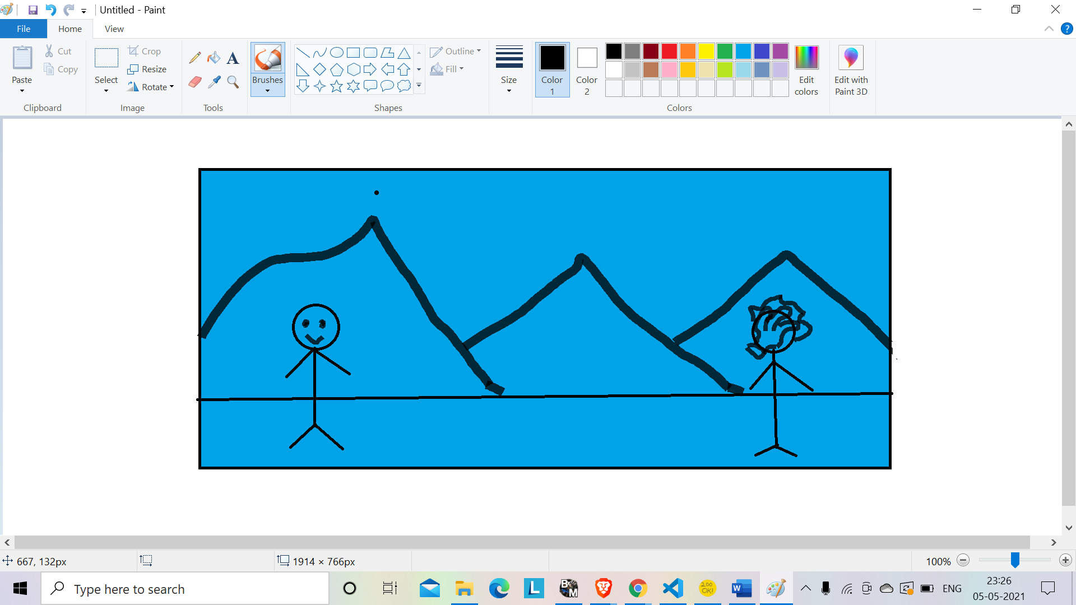

How do you plan to make your game engaging?

by giving it good background music