**Smart Traffic Management Using Generative AI at the Edge**

**Conceptual Development Document**

**1. Objective**

This project concept focuses on designing a smart traffic system powered by generative AI in an Edge/IoT environment. The system will leverage real-time video feeds from traffic cameras, sensor data from roads, and GPS telemetry to analyze traffic flow and proactively reroute users through integrated GPS apps. The core idea is to reduce congestion, lower travel times, and improve road efficiency—without relying heavily on centralized cloud servers.

The agent running this system is autonomous, operating on edge devices like Jetson Nano or Coral boards, and is capable of real-time decision-making. By simulating traffic reroutes using generative AI and reinforcement learning, it will guide drivers dynamically through alternate paths, increasing total traffic bandwidth across urban areas. The concept blends edge intelligence, local simulation, and privacy-preserving data collection to achieve city-scale benefits.

**2. Scope and Desired Outcomes**

This project proposes a non-deployable, theoretical plan for building and deploying a smart, generative AI-based agent for managing city traffic. While the system is not being built here, the planning involves how the AI agent would:

- Ingest real-time video, sensor, and GPS data.

- Use generative models to simulate multiple future traffic states.

- Reroute users dynamically via third-party navigation APIs.

- Operate on low-power edge hardware near intersections or highways.

Outcomes include:

- Shorter commute times across major roads.

- Decreased fuel consumption and carbon output.

- Faster emergency response routing.

- Reduced congestion and increased safety in high-traffic zones.

This concept is designed with scalability in mind—from intersections in small towns to dense urban highways.

**3. System Architecture (Conceptual)**

Data Flow Overview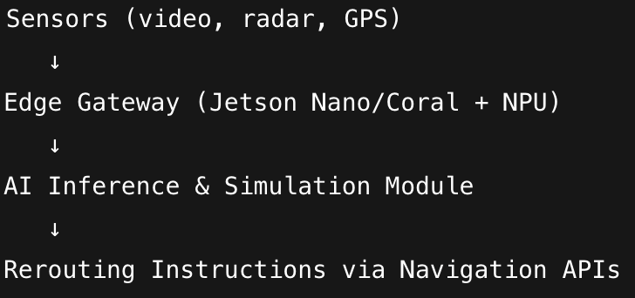

Hardware and Sensor Inputs

- Traffic Cameras (RTSP stream) for vehicle counts and movement analysis.

- Radar/Loop Sensors for real-time speed measurements.

- GPS Telemetry (from opted-in users) for route history and live road usage.

Edge Device

- Runs locally at key road junctions or highways.

- Example devices: NVIDIA Jetson Nano, Google Coral Dev Board.

- Executes on-device inference to keep processing latency low.

**Communication and Security**

Protocols:

- MQTT for lightweight sensor and telemetry transfer.

- RTSP for video stream intake.

- HTTPS with OAuth2 for API calls to external GPS services.

Security:

- TLS 1.3 encryption for all communication.

- Device authentication via certificates.

- Locally performed anonymization (face/license blurring) to protect identities.

**4. AI Model Development (Conceptual)**

**Model Types**

- **Generative Adversarial Networks (GANs**): Used to simulate future traffic states under various hypothetical rerouting strategies or disruptions.

- **Diffusion Models**: Generate highly plausible traffic scenarios and fill data gaps in regions with poor visibility or broken sensors.

- **Synthetic Data Generators**: Create artificial training data for edge cases (pileups, flooding, construction detours).

**Decision-Making Framework**

- **Reinforcement Learning**: Trained in simulation environments (e.g., SUMO, CARLA), the agent learns optimal rerouting behaviors by trial and reward.

- **Rule-Based Triggers**: Override system when hard-coded constraints are met (e.g., emergency services routing, road closures).

- **Fallback ML**: In the event of generative model failure, CNNs and LSTMs handle direct object detection and traffic prediction.

**Possible Tools (if implemented)**

- **TensorFlow** Lite: Lightweight inference on edge devices.

- **Edge** **Impulse**: For low-footprint model training and deployment.

- **OpenCV**: Real-time visual processing of camera feeds.

**5. Security and Ethical Considerations**

**Data Security**

- All transmissions are encrypted using modern standards (AES-256, TLS).

- Inference results and model outputs are hashed and signed to prevent tampering.

- All models stored on the device are encrypted and protected from external access.

**User Privacy**

- No facial recognition or identity tracking.

- License plates and faces blurred at the edge before any analysis.

- GPS telemetry used only from opted-in users, with full anonymization.

**Ethical Considerations**

- Bias in Simulation: Generative models could unintentionally disadvantage underserved neighborhoods if not properly balanced during training.

- Surveillance Boundaries: The project enforces strict limits on data storage, monitoring periods, and requires transparent public communication about system presence.

- Routing Transparency: Explainability modules would be included to allow auditing of routing decisions.

**6. Implementation & Testing Plan (Theoretical)**

Deployment Model

- Edge agents placed at high-traffic junctions or highway entry points.

- Real-time video feeds processed locally, with lightweight metadata shared to a federated coordination server.

- Rerouting suggestions made to GPS providers through integrated API calls.

**Testing Strategy**

Simulations

- SUMO (Simulation of Urban Mobility) used to simulate traffic based on real-world maps and conditions.

- Edge agents trained in synthetic environments to evaluate impact of rerouting decisions.

Stress Testing

- Test scenarios with simulated accidents, detours, and extreme congestion.

- Measure latency of data ingestion → action loop.

Security Testing

- Simulate man-in-the-middle attacks, data spoofing, and unauthorized access.

- Ensure fail-safe fallback if connection is interrupted or AI model crashes.

Performance Metrics

- Average Time Saved per Vehicle

- Rerouting Success Rate (%)

- Model Inference Time (ms)

- System Uptime and Fault Tolerance

**7. Architecture & Visual Summary**

High-Level Flowchart

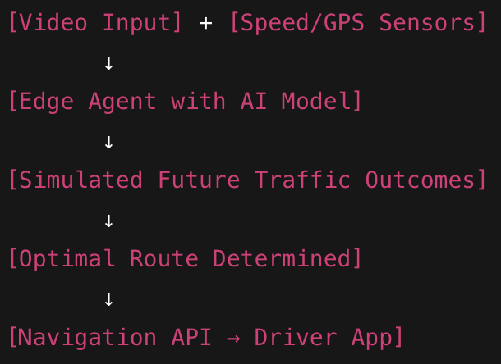

**Challenges & Trade-Offs**

- Hardware Limitations: Real-time generative modeling is computationally expensive. Edge devices may need acceleration (TPU/NPU).

- Data Freshness: GPS data must be current; stale reroutes could worsen congestion.

- Integration Complexity: GPS providers (e.g., Google Maps, Waze) may have API restrictions that limit direct routing instructions.

**Lessons Learned**

- The synergy of generative AI + reinforcement learning is powerful but must be tempered with rules for safety.

- Operating on the edge introduces unique security risks and benefits—latency is low, but protection must be high.

- Human factors matter: rerouting logic should consider driver psychology, not just shortest time.

**8. Conclusion**

This conceptual project envisions a traffic management system that is decentralized, intelligent, and ethical. By fusing edge computing with generative AI and real-time routing feedback, cities could unlock a more dynamic, responsive road network. The technical blueprint covers the entire system pipeline—from sensor inputs to decision outputs—and anticipates real-world security, bias, and operational challenges. While no code is written here, the design is implementation-ready and offers a clear vision for next-gen smart city infrastructure.