Courses
Thursday, March 26, 2020
11:43 AM

<<Courses - Spreadsheet.xlsx>>
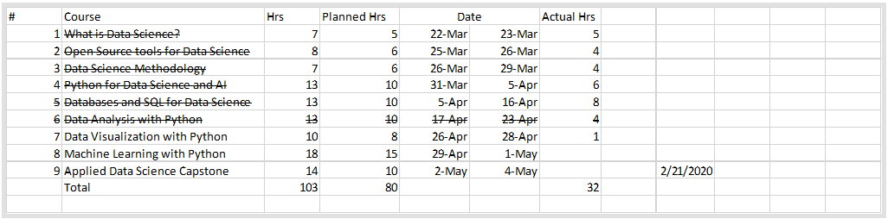

IBM cloud API key:
QuNcAVXzvsrR-8im-xpVDtgES8HUjaJmPgDiMAC1BabL
https://api.us-south.speech-to-text.watson.cloud.ibm.com/instances/18070760-abc0-4146-9f93-f2d1e0e96c82

Lang Transl
2Wnly8nETXLdnkVUoSjKIJhvDLRp3w_8Y9wf3-DthhOY
https://api.us-south.language-translator.watson.cloud.ibm.com/instances/9933dca8-73e1-41f0-89d0-c6e900073081

Good Stuff
Monday, March 23, 2020
9:27 PM
- use the keyboard shortcuts: [a] - Insert a Cell Above; [b] - Insert a Cell Below.
- https://github.com/adam-p/markdown-here/wiki/Markdown-Cheatsheet

- max_value = df.['colname].idxmax() --> highest value in column
  - item_w_max_value = df.at[ max_value , 'item_col_name]

Structural Bioinformatics Laboratory

https://github.com/sbl-sdsc

What is Data Science?
Monday, March 23, 2020
9:11 PM

Tools
Monday, March 23, 2020
9:16 PM

https://labs.cognitiveclass.ai/login?next=https%3A%2F%2Flabs.cognitiveclass.ai%2F

https://towardsdatascience.com/interactive-visualizations-in-jupyter-notebook-3be02ab2b8cd
https://github.com/jupyter/jupyter/wiki/A-gallery-of-interesting-Jupyter-Notebooks

R :
In your R script window, type "x <- 1" or "x = 1". Both do the same thing, but in R, variables are traditionally assigned using the "<-" syntax, which resembles a leftward-pointing arrow.

From <https://www.coursera.org/learn/open-source-tools-for-data-science/ungradedLti/bVDJr/lab-rstudio-the-basics>

You can register for IBM Watson Studio here: https://cocl.us/Watson_Studio_Coursera_DS0105

Zapellin notebooks, you can use multiples languages in the same notebook

DS Methodology
Thursday, March 26, 2020
9:17 PM

John Rollins
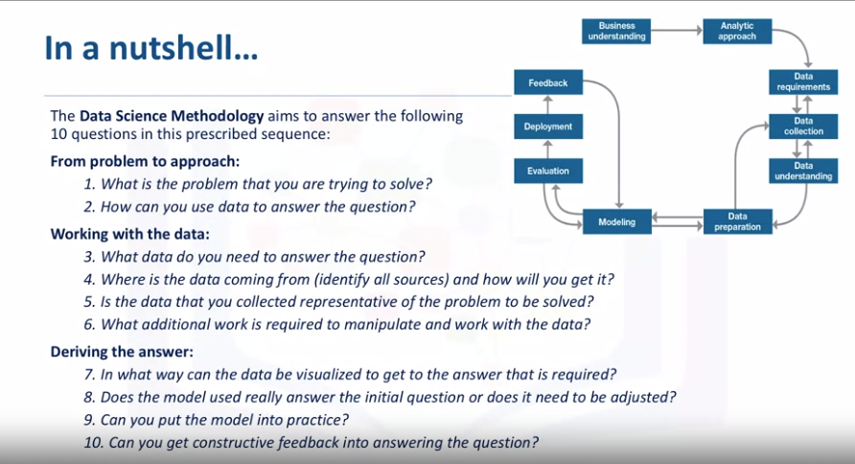

CRISP-MD
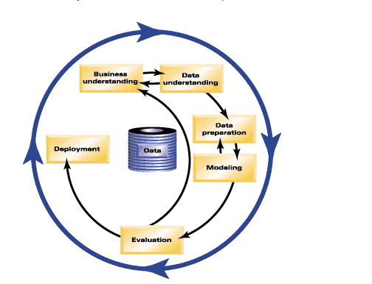

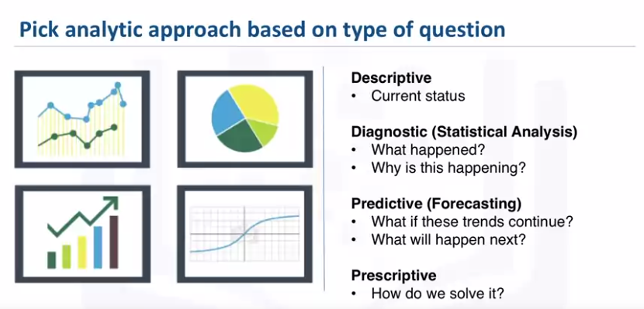

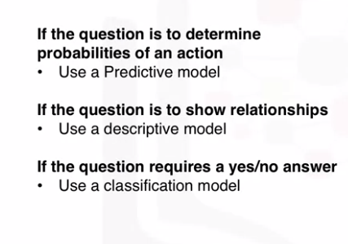

Decision trees
- Decision trees are built using recursive partitioning to classify the data.
- When partitioning the data, decision trees use the most predictive feature (ingredient in this case) to split the data.
- Predictiveness is based on decrease in entropy - gain in information, or impurity

- A tree stops growing at a node when:
  - Pure or nearly pure.
  - No remaining variables on which to further subset the data.
  - The tree has grown to a preselected size limit.
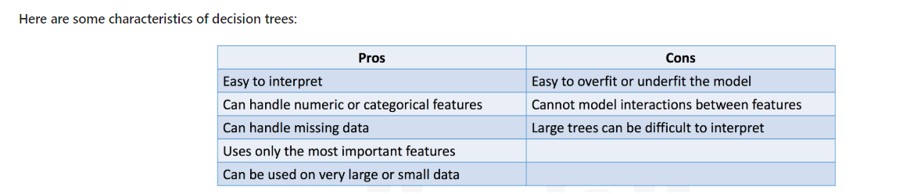

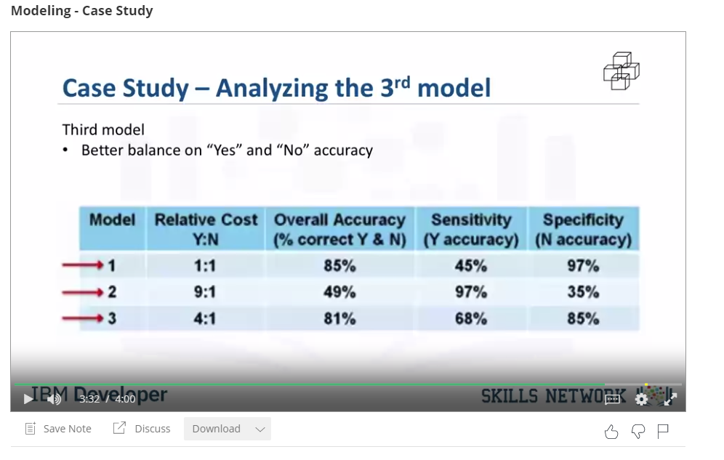

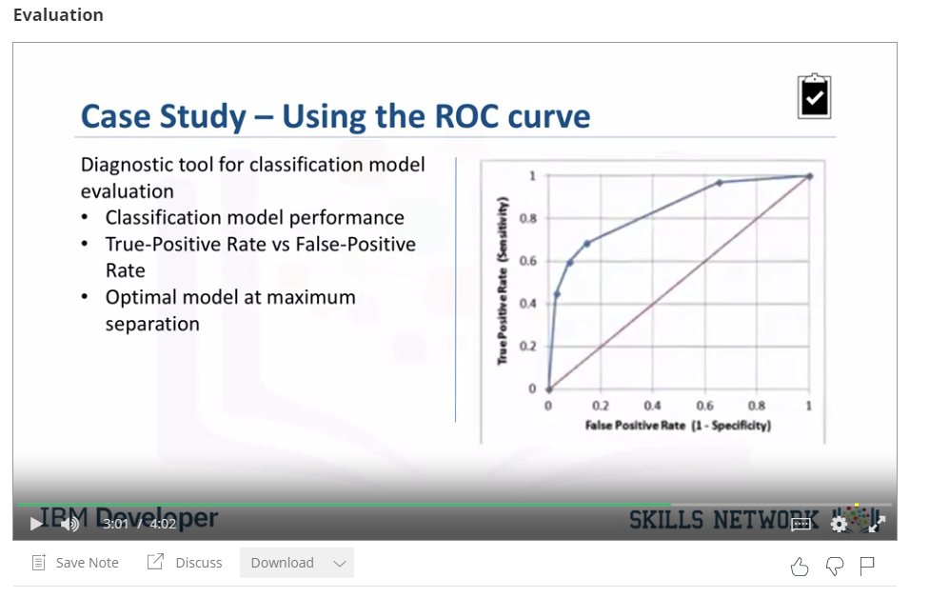
Optimal = further distance

Python Intro
Tuesday, March 31, 2020
9:25 PM
help(var) gives me info on all the methods I can use on this var type

  - Types
    - type(var) : gives me the type of a variable
    - Typecasting : changing the type of a variable
    - Boolean needs to have a capital first letter , int(True) = 1 and bool(1) = True
    - 25//6 = 4 (It does integer division and rounds )

  - Strings
    - Strings: \ is an escape character or use the letter r before the string
    - Strings have sequence methods and string methods
      - String methods B=A.method() , e.g fimd , replace
    - Strings use [beg, end, step]
    - len(var) is used for size
    - Immutable
    - Split strings to list e.g "A,B,C,D".split(",") = ["A","B","C","D"]

  - Tuples
    - Ordered sequences
    - Tuples are created with ( ) but accessed with [beg, end, step]
    - len(var) is used for size
    - Immutable
    - Methods : sorted

  - Lists
    - Ordered sequences : indexes - elements
      - Indexes need to be integers
    - Lists are created with [ ] and accessed with [beg, end, step]
    - len(var) is used for size
    - Mutable
    - Method : extend , del, append on the same list L.append
      - Append only adds one element to a list
        - A=[1] , A.append([2,3,4,5]) gets [1,[2,4,5,6]] wih only2 elemetns
    - Aliasing : multiple var are referring to the same list (e.g. B=A)
    - Cloning : referencing a copy of a list (e.g. B=A[:])

  - Dictionaries
    - Unordered sequences : keys - values
      - Keys are immutable and unique
    - Dictionaries are created with { } and accessed with [beg, end, step]
      - {key1 : value1 , key2 : value2} ; keys are usually strings so they are in ""
    - Key3 in my_dictionary : checks if the key3 exists as a key in my_dictionary (result True/False)
    - del(my_dictionary['Key3 ']) deletes that entries

  - Sets
    - Unordered sequences
    - Sets only have unique elements
    - Sets are creates with { }
      - My_set = { 0, 5, 10, 7, 5, 7} --> {0, 10, 5, 7}
    - Typecast a list to a set set(my_list)
    - Methods: my_set.add("a") -->{0, 10, 5, 7, "a"} / my_set.remove(10) -->{0, 5, 7, "a"} / 5 in my_set --> True
    - Logic Operators : Can use & to find intersection of 2 sets / Union : seta.union(setb) /seta.issubset(setb)
  - Loops
    - Range(N)--> list [0, 1, 2, .. N] ; range(2,5)--> [2, 3, 4]
    - for i,x in enumerate --> prints index and value

  - Function
    - Len on str or dict or list
    - A variable created inside a function with the keyword global can be used outside without returning it
def printer(artist):
global internal_var
  - dir() lidt all functions , dir(nameofoblect): list of methods

  - Open
    - You can get properties of the file object such as name/mode
    - With open(file,"r") as filename: --> better than just open because it closes the file
    - Readline(n) read n characters , if there is no n it reads a line of the file

  - Pandas
    - loc is primarily label based df.loc[0, "ColName"]
    - iloc is integer-based. You use column numbers and row numbers to get rows or columns at particular positions in the data frame. df.iloc[0, 2]
    - By default, ix looks for a label. If ix doesn't find a label, it will use an integer. This means you can select data by using either column numbers and row numbers or column headers and row names using ix. In Pandas version 0.20.0 and later, ix is deprecated.

  - Numpy
    - 1D list-like accessed with [] = array
    - Dtype gives the type of the elements
    - Asttributes : size = # of elem, ndim=# of dim, shape= size of array in each dimensions
    - Basic operation are faster and contain less memory in np than python, like Vector addition or linear combination
    - 2d : nested lists
    - Hadamant product --> multiplication of every element || dot product = [m,p]x[p,n]=[m,n]

SQL
Sunday, April 5, 2020
6:26 PM
  - Statements
    - DDL (Data Definition Languages) : Define, change & drop data
      - create table TABLENAME (
COLUMN1 datatype,
COLUMN2 datatype,
COLUMN3 datatype,
...
) ;

  - DML (Data Manipulation Languages) :Read & modify data
    - select COLUMN1, COLUMN2, ... from TABLE1 ;
      - select * from TABLE1 where condition ;
      - select COUNT(*) from TABLE1 ; ==> number of rows matching
      - select DISTINCT colname from TABLE1 ; ==>remove duplicates
      - select * from TABLE1 LIMIT x; ==> limit to only x rows
    - insert into TABLENAME
(colname 1, colname 2. …)
values
( val1_col1, val1_col2, ..)
( val1_col1, val1_col2, ..)
  - update TABLENAME
set Colname = Value
Where Condition
  - Delete TABLENAME
Where Condition

  - Primary ID: uniquely identifies each tuple or row in a table
    - A Primary Key is a unique identifier in a table, and using Primary Keys can help speed up your queries significantly.
  - It is quite common to issue a DROP before doing a CREATE in test and development scenarios.
  - Where clause is like an if loop : The WHERE clause can be added to your query to filter results or get specific rows of data

  - Relational models
    - Informational : abstract model for designers and operators --> relationships
      - Hierarchical model
    - Data model : Concrete/detailed model for implementors
      - Relational model : Data is organized in tables with entity relationships
        - data independence
        - stored in tables
      - Entity-Relationship(ER) model
        - Entities and attributes
    - Relationships:
      - Entities sets : rectangle
      - Attributes : ovals
      - Relationship sets : diamond
      - Crows foot notations
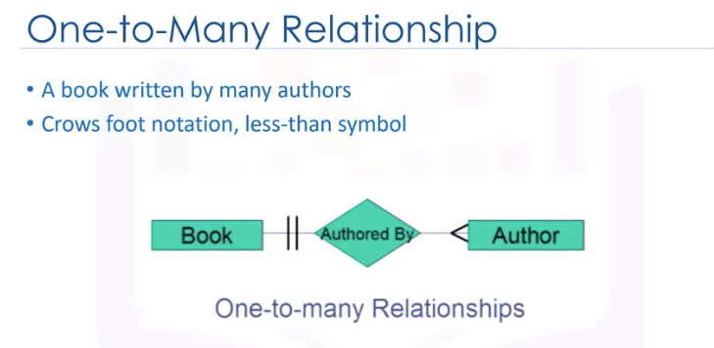

  - Entity --> Table | Attributes --> Columns
  - Relation=Table | Sets: unordered collection if distinct elements
  - Relation Schema : name of relation and attributes
  - Relation Instance: table made of the data
    - Degree = # of columns
    - Cardinality= # of tuples or rows

  - Retrieving Data
    - Patterns & ranges:
      - Where com like 'R% ' : all rows whose col element starts with R l
      - Where col >= 10 AND <=12
      - Where col between 10 and 12 : same as above , inclusive
      - Where col='a' or col='b'
      - Where col in ('a', 'b', 'c')
    - Sort
      - Add order cause in a select command
      - Order by col desc
      - Order by 2 : sorts by the 2nd col
    - Remove duplicates/ group/count:
      - Select distinct(col) from table
      - Add group close to group
        - Group by col
      - Group & Count
        - Select count(col) from table group by col
        - Select count(col) as count from table group by col
      - Add condition to a group by clause:
        - Select count(col) as count from table group by col having count(col)>4
        - Having works only with group, where works only with whole set
  - Build in functions: Databases dependent
    - Aggregate : sum , min, max - cannot use in the where clause
    - Scalar: length , ucase, lcase
    - Date:
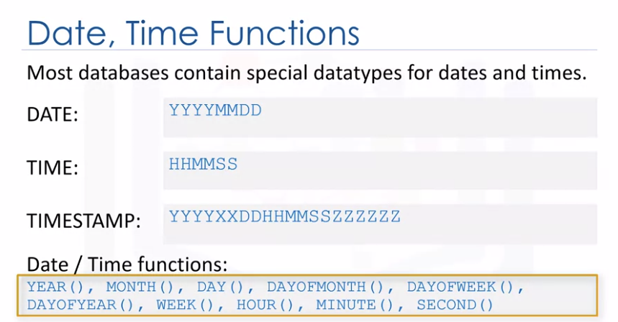
  - Also allows for date arithmetic

  - Sub-Queries and Nested Selects
    - Needed subqueries for an aggregate function
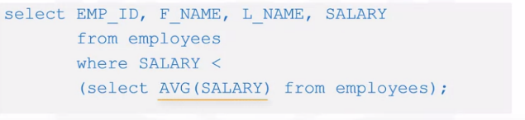

  - Column expressions: substitute col name w a sub query
  - Derived Tables or Table expressions : substitute the table name w a sub query
  - Multiple Tables
    - Implicit join : select from 2 tables --> full or Cartesian join
      - Every row in the first table is joined with every row in the 2nd table

  - Relational Model
    - Foreign key = col in a table that is a primary key in another table
    - Parent Table = a table containing a primary key related to at least a foreign key
    - Dependent Table = a table containing one or more foreign keya
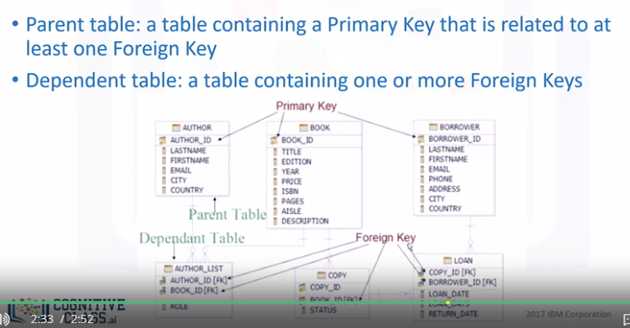

  - Constrains:
    - Entity Integrity Constraint : PK is unique and not NULL
    - Referential Integrity Constraint : e.g. one book need to be written by at least 1 author
    - Semantic Integrity Constraint : correctness of the data
    - Semantic Constraints: defined by the user/business case not schema:
      - Domain constraint: similar type
      - NULL constraint: specific attributes cannot be NULL
      - Check constraint: limit values , eg not a year beyond current year

  - Python
    - dbAPI = python database API
    - Connection object : how to connect
    - Cursor operates like a file handle in that it enables you to scan through a result set of a query.
    - % sql magic
      - Load with %load_ext sql
      - You can use python variables in your SQL statements by adding a ":" prefix to your python variable names.
country = "Canada"
%sql select * from INTERNATIONAL_STUDENT_TEST_SCORES where country = :country

  - Join
    - dbAPI = python database API
    - Inner join : intersection --> only row s that match

  - select A.col1, B.col2, C.col3
from tableA A
inner join tableB B on A.colm = B.colm
inner join tableC C on B.colx = C.colx

  - Left Outer join or left join: intersection --> all rows from left & any matching from right

  - On the rows that don't match in the right table the values are null
  - Full Outer join or left join: intersection --> all rows from all tables
    - On the rows that don't match in the right table the values are null
  - 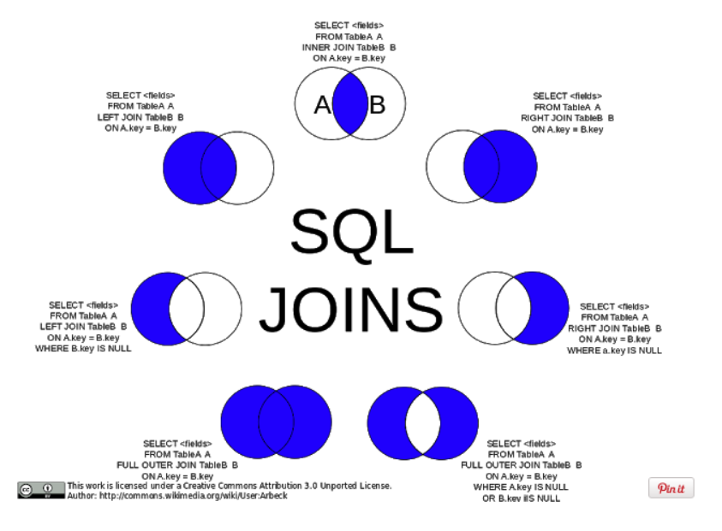

Python Data Analysis
Thursday, April 16, 2020
10:02 PM

Pandas
- df.dtypes returns the datatypes of each column
- df.describe() returns df statistics , df.describe("all") will incule info about objects too
- df.info : shows top and bottom 30 rows
- df['col_name'].value_counts() --> which values are present in col_name
  - df['col_name'].value_counts().idxmax() --> most common value

Data Wrangling
- Missing Values : Drop values / Replace w average value of the column or similar type, by frequency, based on other columns
  - df.dropna(), axis=0 or axis=1 drops rows or columns
  - df.replace(mis value, new value)
- Normalization:
  - 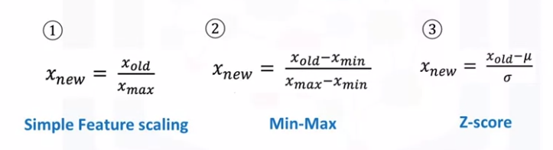
  - Range of the above normalized values is 0-1, 0-1, usually -3 to 3
- Binning
  - 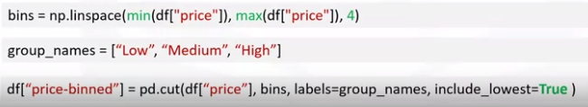
- Categorical to numerical
  - one hot encoding
  - get_dummies()

Exploratory Data Analysis (EDA)
- Descriptive Statistics:
  - df.describe() , df.describe(include=['object'])
  - value_counts()
  - boxplot for statistics & scatter plot for relationships
- Group by:
  - uses categorial variables
  - pivot table if grouping by more than 1 categories
  - Hetamap: plot target variable over multiple variables
  - get_froup returns the values for each group
- Correlation:
  - regplot line --> fitted regression line for data
  - df.corr() --> calculate the correlation between variables of type "int64" or "float64
  - Pearson correlation
    - 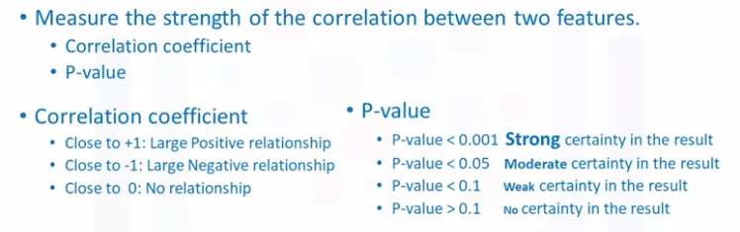
    - correlation heatmap : heatmap with pairwise corelation across all variables (including target variable as well)
  - ANOVA : analysis of variance --> corelation between categorical variables
    - F-Test : correlation btw the averages of two groups wrt their the variance
    - we want large F test values and small p value
      - F-test score: ANOVA assumes the means of all groups are the same, calculates how much the actual means deviate from the assumption, and reports it as the F-test score. A larger score means there is a larger difference between the means.
      - P-value: P-value tells how statistically significant is our calculated score value.

Regression
- Model evaluation with visualization:
  - seaborn resplot - residual plot : error vs x--> if there is no pattern (not spread randomly or variance is dependent to x) then linear regression is good
  - distribution plots : binning of x and y ==> distribution plot of the actual vs predicted values
- 1D Polynomial Regression:
  - 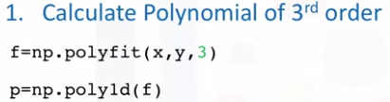
  - Print (p) shows the symbolic form of the equation
- Multidimensional polynomial
  - use the preprocessing module to transform the features to all the possible terms (e.g. X1, X2, X1^2, X2^2, X1*X2
  - use the preprocessing library to normalize the features
- Use a pipeline to sequence perform normalization --> polynomial transformation --> linear regression
- In sample evaluation of a model:
  - MSE : mean_squarred_error
    - SLR has higher MSE than MLR, that has higher than polynomila because there are more elements (?)
  - R^2 : % of variation explained in the linear model - lm.score(X,Y)

Evaluation - out of sample
- train_test_split
- generalization error : error of prediction vs test data
- Cross validation:
  - Data is split to groups (folds)
  - some folds are used for training some for testing
  - cross_val_score --> R2 scores of cross validation , cross_val_predict() --> yhat of cross validaton
- Ridge Regression : bias fit in training data to fit the test data the best
- Grid search - hyperparameters iteration with cross validation
  - split in training, test and validation
  - use training and test with cross validation
  - then use validation test to choose hyperparameter value
  - 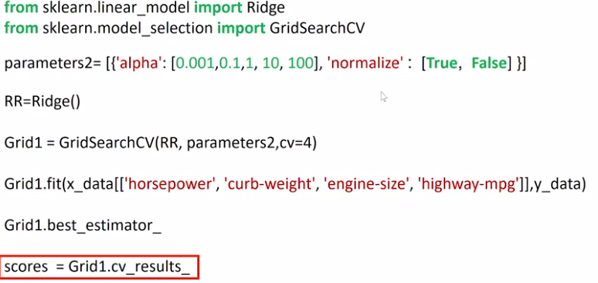

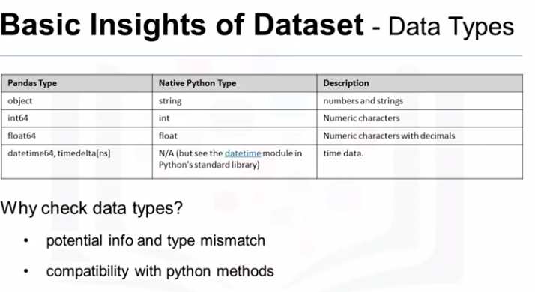

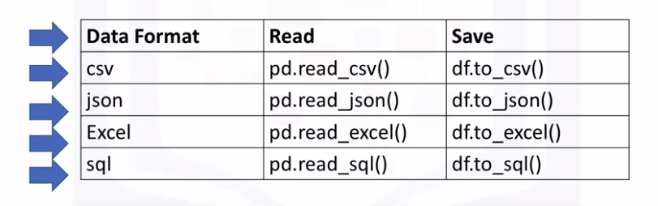

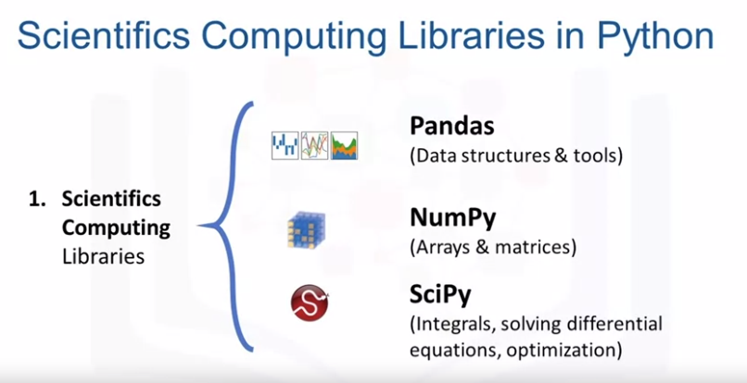
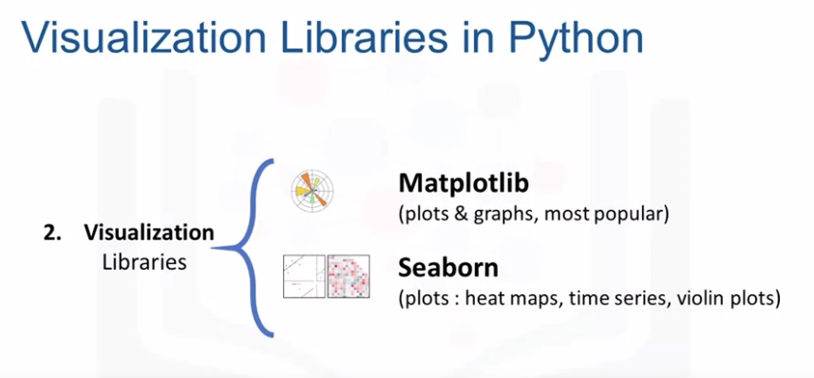
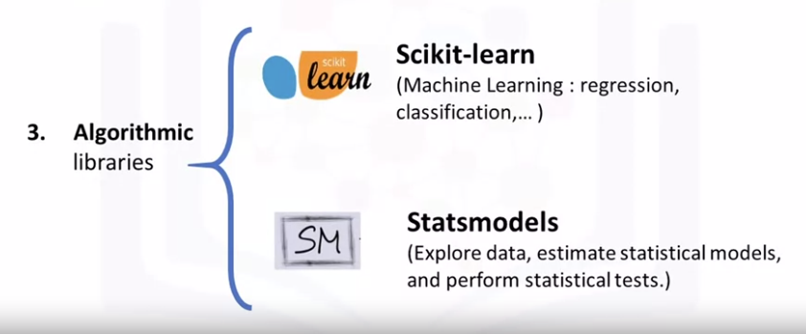

Data Visualization
Thursday, April 23, 2020
10:54 PM
MatplotLib
- 

 