
Politecnico di Milano
A.A. 2015-2016
Software Engineering 2 Project

My Taxi Service
Requirement Analysis and Specification Document
(RASD)

Giovanni Brena (858328), Andrea Canale (858638)
Contents
- Introduction
  - Purpose ……………………………………………………………. 3
  - Actual System ……………………………………………………... 3
  - Scope ……………………………………………………………… 3
  - Domain properties ……………………………………………… 3
  - Stakeholders ……………………………………………………… 4
  - Actors ……………………………………………………………… 4
  - Goals …………………………………………………………………4
  - Definitions, Acronyms, Abbreviations ……………………………6
  - Reference Documents ……………………………………………..7
  - Used Tools ………………………………………………………7
- Overall description
  - Product Perspective …………………………………………………
  - User Characteristics …………………………………………………
  - Constrains ……………………………………………………………
  - Assumptions and Dependencies …………………………………
  - Future extensions and additional goals ……………………………
- Specific requirements
  - Functional requirements ……………………………………………
  - Non-functional requirements ………………………………………
  - Scenarios ……………………………………………………………..
  - UML models and use cases models ………………………………
  - State Chart diagrams ………………………………………………
- Alloy modeling
  - Signature ……………………………………………………………..
  - Facts ……………………………………………………………..
  - Assertions ……………………………………………………………..
  - Predicates ……………………………………………………………..
  - Run …………………………………………………………………….
  - View models …………………………………………………………..

1 Introduction
1.1 Purpose
The intent of this document is to provide a detailed description of MyTaxiService system starting from analysis of the problem and the concerned domain assumptions to reach a clear Requirement Analysis. It will focus on software goals and objectives, functional and non-functional requirements, limits and possible future extensions. This document has to be intended as guideline for developers and analysts who will take care of implementation, as product overview for customers and stakeholders.
It will also offer previews of some UI elements required by the system and many scenarios of typical use of the software.
1.2 Actual System
An existing physical taxi service is supposed to be already present in the city, MyTaxiService will integrate it offering new interactive tools for customers and will use information given by the existing service.
1.3 Scope
MyTaxiService main scope is to offer an easy, fast, secure and attractive way of interaction between taxis and their customers. It provides both a Web Client and mobile App. Users have the possibility to request a taxi from everywhere in the city, easily follow its position on a map, know the waiting time amount and pay the run using their preferred payment method. They can also submit reservations specifying origin, destination, day and hour. Easiness and smartness also concern taxi drivers who are automatically informed by the system about incoming calls. Through mobile app drivers can accept or reject calls, retrieve information about customer and pick up destination, easily manage payments. Fairness between taxi drivers is guaranteed by the system using a specific queue management system.
1.4 Domain Properties
These properties has been considered as assumptions of the domain:
- Information about taxi drivers are supposed to be held by the existing system. MyTaxiService will not take care of verify licenses, vehicles or any information about drivers
- Taxis positions are real time monitored by GPS system and always available. GPS is supposed to be precise enough not to cause ambiguity in any case
- Every driver is supposed to have all the necessary hardware and software tools working before to start a run
- Incoming calls are always supposed to come from city areas covered by the service
1.5 Stakeholders
- Governament of the city
- Taxi service management
- Developers and technicians
1.6 Actors
Below are listed all possible entities interacting with the system:
- VISITOR [V]
Accesses to the system defined as VISITOR are those made by anyone not recognized as registered.
VISITORs are allowed to interact only with the Web Client public area, with mobile application Login Screen and registration form.

- REGISTERED USER [U]
Registered users are accesses to the system made by submitting correct login data for private customers service. They have access to Web Client public area, personal area, services area and to full functionalities of mobile application (customer version).
- REGISTERED DRIVERS [D]
Registered drivers are accesses to the system made by submitting correct login data for drivers service. They have access to Web Client public area, personal area and to full functionalities of mobile application (drivers version).

- SYSTEM ADMINISTRATOR [A]
Privileged actor reserved to taxi system management. Can modify data about drivers, add new ones and see run history. Has no access to users data.
1.7 Goals
List of MyTaxiService application goals:
- EACH ACTOR should be able to:
- Easly find info about system functionality and contacts/support for the system (tutorial, infoline, email)
- VISITOR should be able to:
- [G-V1] Became a REGISTERED USER or REGISTERED DRIVER through a registration form

- REGISTERED USER and DRIVER should be able to:

- [G-UD1] Log into the the application through his username and password
- [G-UD2] See/Update personal informations

- REGISTERED USER should be able to:
- [G-U1] Perform an immediate taxi call, cancel a pending call, know request status and reserved taxi position
- [G-U2] Request a taxi reservation, cancel a reservation and see reservation info
- [G-U3] Choose payment method for each taxi run (cash, credit card, paypal…) and accept payment

- REGISTERED DRIVER should be able to:
- [G-D1] Inform the system about his availability / unvailability
- [G-D2] Accept or reject a taxi call
- [G-D3] Know information about accepted calls (customer position and personal info)
- [G-D4] Set payment import after each run using method choosed by customers and confirm payment
- [G-D5] Inform the system about problems related to runs

- SYSTEM ADMINISTRATOR should be able to:
- [G-A1] Add, remove or update taxi driver profiles
- [G-A2] Have full visibility of calls, runs and reservations
1.8 Definitions, Acronyms, Abbreviations
Here are defined keywords often used within this document:
- USER
Identify a REGISTERED USER [U] actor.

- DRIVER
Identify a REGISTERED DRIVER [D] actor.
- SYSTEM
If not differently specified, it identify MyTaxiService system.

- APP
Identify MyTaxiService mobile client for USER use.
- DRIVER APP
Identify MyTaxiService mobile client for DRIVERS use.

- RUN
A single taxi journey using the system.
- RESERVATION
A single reservation made by a user.
- TAXI AREA
One of the city’s areas in which available taxis are divided.
- TAXI QUEUE
Referred to a taxi area identify the ordinated queue of available taxis in that area.
- ETA: Estimated time of arrival

- TD :Taxi Driver

- TC: Taxi Code
- DBMS: Data Base Management System

These are the used abbreviations:
- [V], [U], [D], [A] : Visitor, User, Driver, Administrator
- [G] : Goal
- [G-Yn] : Goal of index n referred to actor Y (Y is in Actors{V,U,D,A}).
These are acronyms:
- RASD: Requirement Analysis and Specification Document
- DB: Database
- API: Application Programming Interface
- OS: Operating System
1.9 Reference Documents
- Specification document: Assignements 1 and 2 (RASD and DD).pdf
- RASD guidelines: IEEE Standard For Requirement Specification.pdf
- Given examples: examples of RASD documents

1.10 Documents Related
These are all document related to myTaxiService in order to organize the work better and provide to stakeholders the main ideas during the development:

- RASD: Requirement Analysis and Specification Document, where the problem is analyzed in order to define which are the main goals and how to reach them.

- DD: Design Document, where the real structure of the web application its defined.

- Testing Document: a report of testing of another myTaxiService project.

1.11 Used Tools
- Microsoft Word 2013 :to redact and to format this document.
- Gliffy (http://www.gliffy.com/): to create Use Cases Diagrams, Sequence Diagrams, Class, Diagrams and State Machine Diagrams
- Alloy Analyzer(http://alloy.mit.edu/alloy/): to prove the consistency of our model.
- Adobe Photoshop (http://www.photoshop.com/): to modelling some image.
- Balsamiq Mockups(http://balsamiq.com/products/mockups/): to create mockups.

2 Overall Description
2.1 Product perspective
Application modules will be as following:
- A Web Service will contains system logic implementation and will offer methods to client applications
- DBMS will collect and provide system data. It will accessible only by the Web Service
- A Web Client will be accessible from the web and will offer a User Interface providing services to recognized users
- A Mobile Application will offer services to users and drivers

2.2 User characteristics
Target users are people of any ages and any type living or moving inside the city of domain. They must be able to use web browser or mobile app and they need internet connection.
2.3 Constrains
2.3.1 Regulatory policies
The system will be work under the rules and limitations given by taxis regulatory. Position is required. Use of personal information will be regulated by a privacy policy subscribed by users during registration process.
2.3.2 Hardware limitations
Usage of the system requires to have a smartphone or a tablet running one of the supported OS and supported versions. It requires also internet connection.
2.3.3 Interfaces to other applications
Mobile app has some interfaces to third party applications:
- GPS and Maps applications such as “Google Maps”
- SMS and texting applications
- Mail app
2.4 Assumptions and Dependencies
- The system do not allow new taxi requests for users who already have a pending request to be processed or another taxi run on progress
- Each run has maximum of 4 people partecipating
- In case of requests from areas in which no taxis are currently available the system will scan queues from adjacent areas. If unvailability persist the user is notificated and the request canceld.
- Supported payments methods are cash or electronic payments
- Amount of payment is typed by drivers inside the application at the end of the run. Both passenger and driver are notificated about the payment outcome
- System will not handle or pursue problems related to nonpayment by passengers
- A taxi call is “active” if it has been sent to the system, processed and if a driver has been accept it, otherwise the call is “pending”. When the taxi journey starts the call switch to status “in progress” while at the end of the run it goes to “closed”
- In any time users can have information about a taxi call (availability changes between various status). The system will show status, position of the driver, driver’s profile public section, expected arrival, actual journey distance and time, final price
- Reservations can’t be modified. Changes on date/time/location will require to cancel reservation and create a new one
- In this Document we define as TaxiException events who lead a taxi driver to reject a previously accepted Call, these can be a “Car BreakDown” or also “Rejected Call”. The system will just save these in order to provide a view of taxi driver’s behavior to the stakeholder.
2.5 Future extensions and additional goals
These goals are not considered into this RASD but mentioned as possible extensions:
- Allow users to choose BOOKING OPTIONS as type/dimensions of car, multiple taxis/taxi bus, eco/electric vehicols, driver rating…
- Let the users to RATE drivers after their taxi experience
- Let the user to register some routes as FAVORITES
- Let the users to register FAVORITE DRIVERS
- Let the system prevent the misuse of the application by User who cancel a Taxi Call repeatedly and by Taxi Driver who raises TaxiException repeatedly.
3 Specific Requirements
3.1 Functional Requirements
3.1.1 [G-V1] Visitor should be able to became a registered user through a registration form.
- [R1] Visitor can only access to login screen and sign up screen
- [R2] Visitor must provide a valid email address not already present in the system
- [R3] Visitor must choose a username not already present in the system
- [R4] Visitor must choose a password according to the minimum security rules
- [R4] Visitor must confirm registration through a link sent to the provided email address
- [R5] Visitor is asked to provide electronic payments information (credit card information or PayPal account). In case of no info provided the user will be able to pay only through cash
- [R6] Visitor must accept Privacy Policies
3.1.2 [G-UD1] Registered user/driver should be able to log into the application through his username and password.
- [R1] Username and password couple must be present in the system
- [R2] System must provide a password retrieving service
- [R3] No login attempts limit will be implemented
3.1.3 [G-UD2] Registered user/driver should be able to see and update personal information
- [R1] User/driver must be logged into the system
- [R2] Modify username is not allowed
- [R3] Modify email address will require new email verification
3.1.4 [G-U1] Registered user should be able to perform an immediate taxi call, cancel a pending call, know request status and reserved taxi position
- [R1] User must be logged
- [R2] Users are allowed to perform a call only if they do not have any other pending or active calls associated to their profile
- [R3] User can cancel a taxi call if the status is “pending” or “active”
3.1.5 [G-U2] Registered user should be able to request a taxi reservation, cancel a reservation and see reservation info
- [R1] User must be logged
- [R2] Users can perform a reservation correctly providing these information: date and hour of departure, departure position, arrival position
- [R3] Date and time must be in the future and almost 120 min later than actual time.
- [R4] Reservation can be canceled if departure time is at least 15 minutes later than actual time
3.1.6 [G-U3] Registered user should be able to choose payment method for each taxi run and accept payment
- [R1] User must be logged
- [R2] User must be at the end of a run
- [R3] Electronic payment is allowed only for users who have provided credit card or paypal information
3.1.7 [G-D1] Registered drivers should be able to inform the system about his availability or unvailability
- [R1] Driver must be logged
- [R2] Driver must not be currently associated with an active taxi call
3.1.8 [G-D2] Registered drivers should be able to accept or reject a taxi call
- [R1] Driver must be logged
- [R2] Driver state must be “available”
- [R3] Driver must have received a taxi call
3.1.9 [G-D3] Registered driver should be able to know information about accepted calls (customer position and personal info)
- [R1] Driver must be logged
- [R2] Driver must have an active taxi call associated
3.1.10 [G-D4] Registered driver should be able to set payment import after each run using method choosed by customers and confirm payment
- [R1] Driver must be logged
- [R2] Driver must have a closed taxi call associated
- [R3] Payment method selection requires import to be defined
- [R4] Electronic payments confirm require customer confirm
3.1.11 [G-A1] System administrator should be able to add, remove or update taxi driver profiles
- [R1] System Administrator must be logged

3.2 Non-Functional Requirements
3.2.1 User Interfaces
We sketch now some UI samples to show how the system presentation should be designed, both on Website and mobile application side.
3.2.1.1 – Website Homepage
Here an example of MyTaxiService website hompage. It should contain links to app stores to download application, a link to the login page and a short descrtiption of system features.

3.2.1.2 – Login form
Log in form allow access to registered user’s services. Users have to provide username and password generated during registration. Links to sign up and password recovering process have to be present. This screen will be included both in website and app.

3.2.1.3 – Sign in form
This screens show first part of Sing In process. Website also allow new drivers requests while application only allow user subscriptions.

3.2.1.4 – Profile section
Profile section will contain personal user information. Here is possible to edit part of these information.

3.2.1.5 Reservation Screen
Allows taxi reservation. Require information about date, hour, departure and destination.

3.2.1.6 – Call taxi action screen
Perform call action. This screen should be as more simple as possible in order to inspire ease and safety to users.

3.2.1.7 – Call screen flow DRIVER
This UI flow shows how does a call action should be handled by driver.

3.2.1.8 – Call screen flow USER
This UI flow shows how does a call action should be handled by user.

3.3 Scenarios
3.3.1 Scenario 1
Rob after a party needs a taxi to go home. He open "myTaxiService" on his phone,login in it and accept the request "allow the application to use Geolocalization".Then he click on "Call Taxi" button and he was asked to wait a moment. After few seconds ,a pop-up appear with ETA and TC. Since Rob arrived at home the driver communicates him the ride fare, Rob pays it with cash and driver notify payment to the system.
3.3.2 Scenario 2
Sansa has to take a plane on Sunday for work but she realizes that no one could take her to the airport. She has to book a Taxi ,so she open "myTaxiService" from his laptop and click on "Reserve a Taxi ".
She select the pick-up place(=Winterfell),destination(=airport),date and departing time. At the time she chosen the taxi arrived and brings her to airport. After she was communicated the fare she chooses to pay with credit card previously registered on app.Once she left she was notified on her phone the fare drawn from his credit card.
3.3.3 Scenario 3
Mark is a Taxi Driver who is logged in myTaxiService through his mobile phone.He is bottled up in traffic jam due to a demonstration in DownTown.He receives a call from a new passenger but he decides to decline it due the fact that it will take too much time to reach him.After a while Mark can go away from the traffic,he receives a call from a new passenger .He accepts it and follows the GPS.

3.4 UML models and Use Cases models
3.4.1 Class Diagram
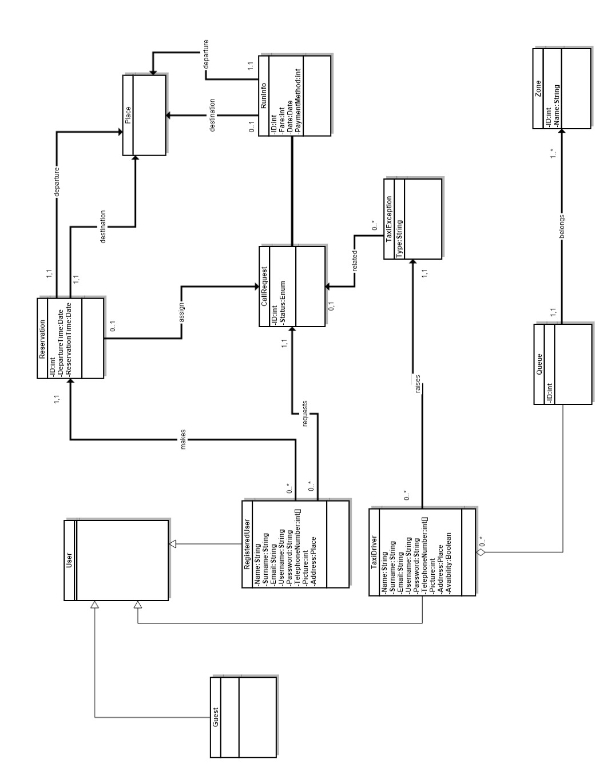
3.4.2 Use Cases diagram
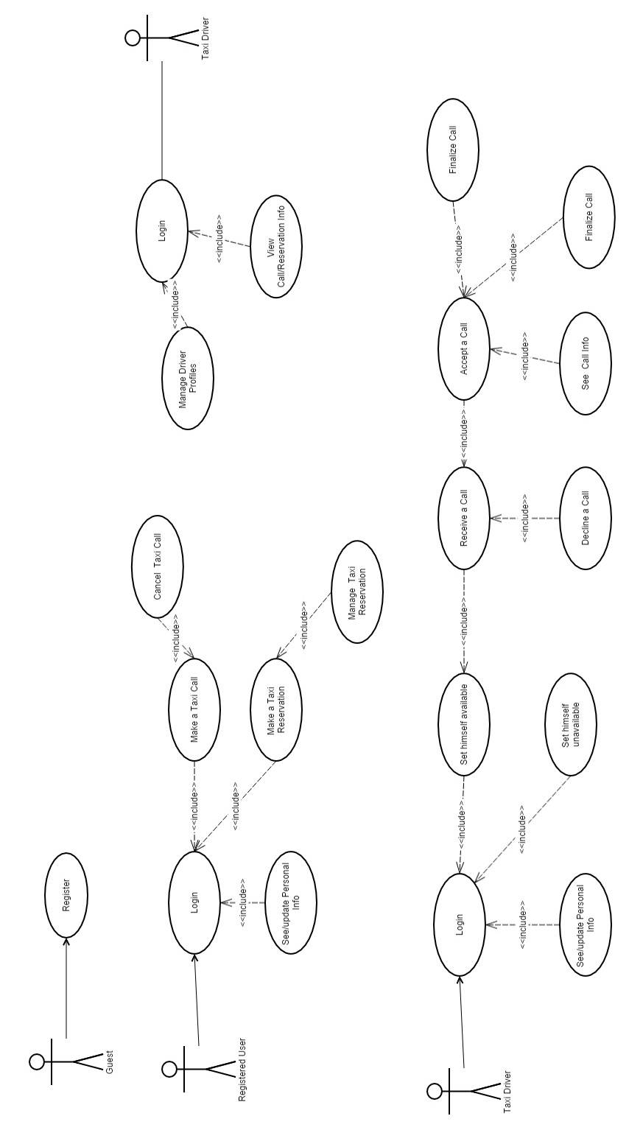
3.4.2 Use Cases Description

In this paragraph some use cases will be described in a detailed way .These use cases can be derived from the scenarios and Use Case Diagram.

[G-V1] Guest registration:
NAME | Guest Registration
Actor | GUEST
Goal | [G-V1]
Input Condition | Null
Event Flow | - Guest on the homepage clicks on “register” button to start the registration process  - Guest visit fills at least all mandatory fields.  - Guest clicks on “Confirm” button.  - The application will save the data on DB.
Output Condition | Guest is successfully ends registration and become a Registered User. From now he/she can log in to the application using his/her credential and start using  myTaxiService.
Exception | - The Guest is already a Registered User.  - One or more mandatory fields are not valid.  - Username chosen is already used by another user.  - Email chosen is already associated to another user.

NAME | Login
Actor | Registered User, Taxi Driver
Goal | [G-V1]
Input Condition | User/Taxi Driver are already registered in the system.
Event Flow | - User on homepage clicks on “Login” button.  - User fill “username” and “password” fields
Output Condition | The system show the user his personal page.
Exception | The password and/or username inserted by the user are wrong.The system shows an error message to the user.
[G-V1] Login:
[G-U1]Taxi call:
NAME | Make a Taxi Call
Actor | Registered User
Goal | [G-U1]
Input Condition | - User is already logged in the application.  - User enabled GPS localization.
Event Flow | - User clicks on “Call a Taxi” button.  - System show “Call a Taxi ” page.  - User clicks on “Call Taxi Now” button.
Output Condition | The system show user “Call info”
Exception | 1.If the GPS localization is not enabled, the system before showing “Call a Taxi ” page will ask to user to enable it showing the browser/OS related pop-up for enable it.  2. If system doesn’t find any TD or time exceed ,the system show a message of noFoundTD to User.

NAME | See Call Info
Actor | Registered User
Goal | [G-UD2]
Input Condition | - User has made a Call for a taxi  - User is waiting for Response
Event Flow | - Application finds an available Taxi Driver and retrieve his information.  - Application show the information to the User.
Output Condition | The system show to User:  - ETA  - Taxi Code
Exception | If System don’t find a Taxi Driver in a “reasonable” Time it notify user and invite him to try again later.

[G-UD2] Call info:
[G-D2]Accept call:
NAME | Accept a Call
Actor | Taxi Driver
Goal | [G-D2]
Input Condition | - TD is already logged in the application.  - TD set himself as “available”.
Event Flow | - System show a “Call ” pop-up on TD application with two button:  - “Accept” button.  - “Refuse” button.  - TD clicks on “Accept” button.
Output Condition | The system assign the TD to the call,removing it from the queque.
Exception

[G-D2] Refuse call:
NAME | Refuse a Call
Actor | Taxi Driver
Goal | [G-D2]
Input Condition | - TD is already logged in the application.  - TD set himself as “available”.
Event Flow | - System show a “Call ” pop-up on TD application with two button:  - “Accept” button.  - “Refuse” button.  - TD clicks on “Refuse” button.
Output Condition | The system forward the request to another TD and move the TD in last position of the queque.
Exception

[G-U2] Taxi reservation:
NAME | Make a Taxi Reservation
Actor | Registered User
Goal | [G-U2]
Input Condition | - User is already logged in the application.  - User click on “Reserve a Taxi button”.
Event Flow | - System show him the form that the user has to fill with the following information:  - Destination Place  - Starting Place  - Day  - Hour  - Payment Option  - User fill the previous fields and click on “Reserve”
Output Condition | The system add the reservation into the database and shows a confirmation message.
Exception | If any of the fields is not correct, the system shows an error message to the user.//data e time 2 ore prima della corsa

[G-U2] Cancel taxi reservation:
NAME | Cancel a Taxi Reservation
Actor | Registered User
Goal | [G-U2]
Input Condition | - User is already logged in the application.
Event Flow | - User clicks “Reservation List” button.  - User selects a Reservation.  - User clicks on “Cancel Reservation” at least,and start deleting process.
Output Condition | The system delete the reservation from the DB and from Reservation List of the User
Exception | If User clicks “Cancel Reservation” less than 15 minutes before the scheduled departing time the system will show an error message.

[G-U1] Cancel taxi call:
NAME | Cancel a Taxi Call
Actor | Registered User
Goal | [G-U1]
Input Condition | - User is already logged in the application.  - User is in “Call info” page.  - User clicks on “Cancel Call” button.
Event Flow | - System show a Confirmation pop-up with two button:  - Yes  - No  - User clicks on “Yes” button
Output Condition | The system //bo
Exception | If User clicks “Cancel Reservation” the system will show an error message.

[G-D1] Driver Availability:
NAME | Set himself available
Actor | Taxi Driver
Goal | [G-D1]
Input Condition | TD is already logged in the application.
Event Flow | - TD request Status Page.  - System show Status Page.  - TD clicks on “Set available” button.
Output Condition | The system shows the updated Status page and assign the TD to the queue accordingly to his position.
Exception

    - Sequence Diagrams
Here the Sequence Diagrams of the previous descibed use cases .
[G-V1] Register diagram:
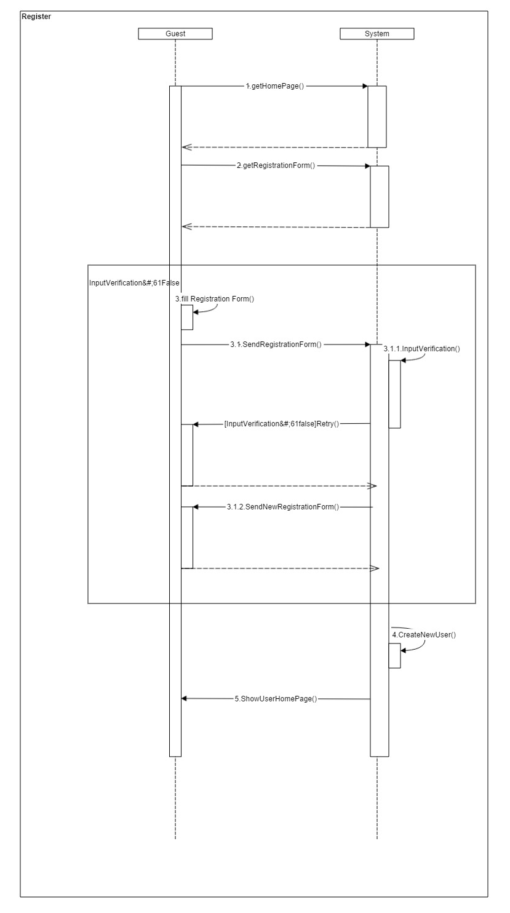

[G-V1] Login Diagram:
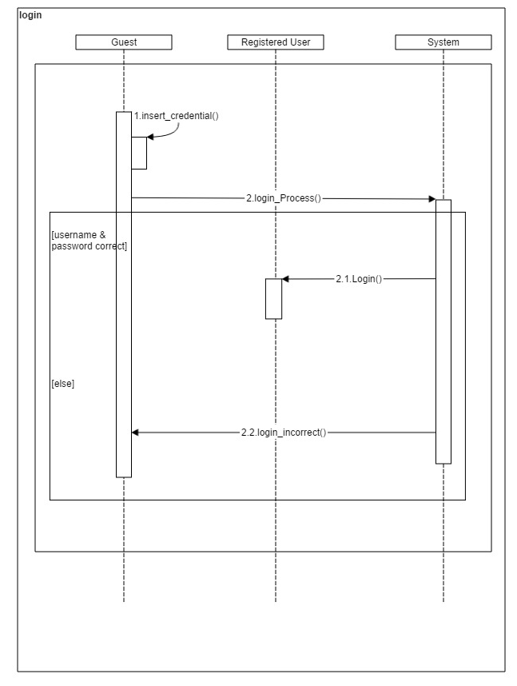

[G-U1] Taxi Call diagram:
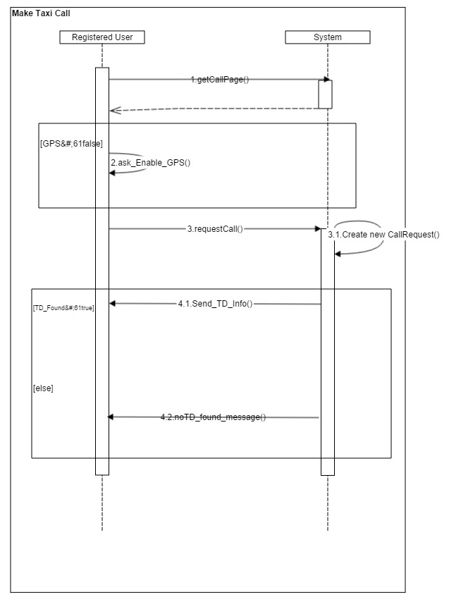

[G-U2] Reservation diagram:
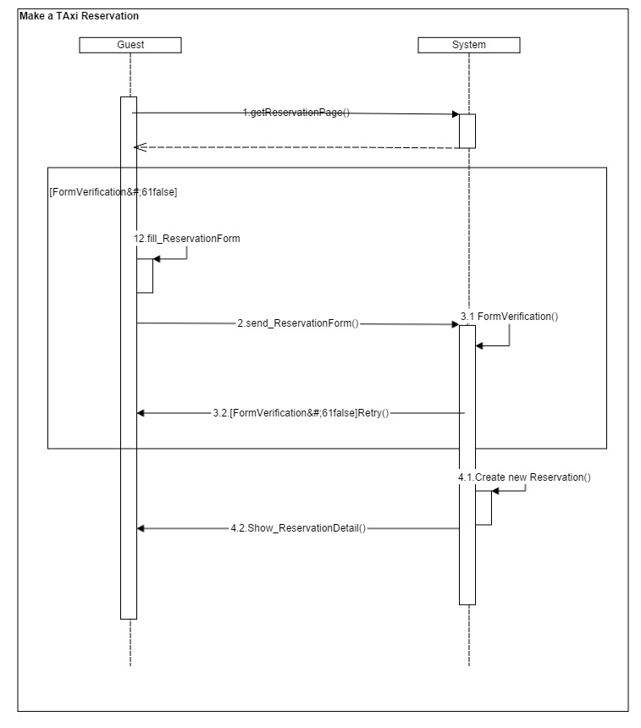

[G-U2] Reservation Cancel diagram:
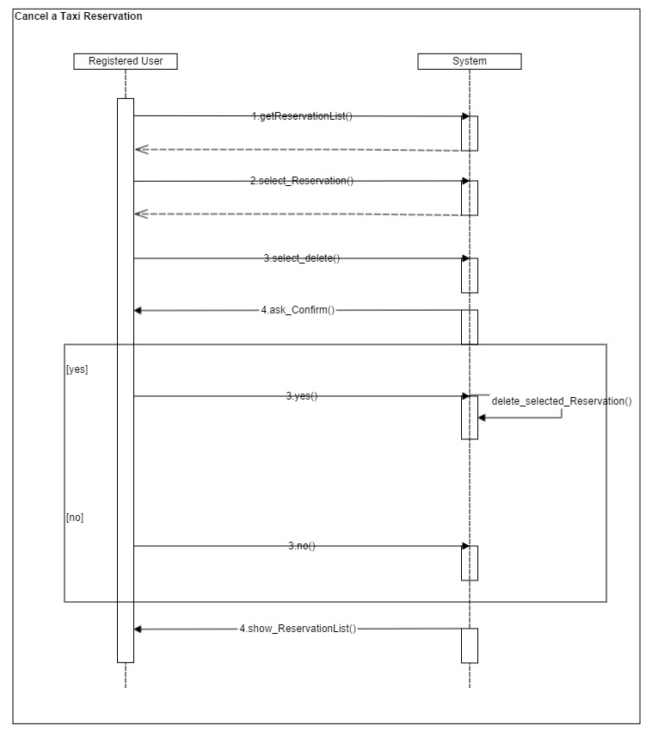

[G-D2] Taxi accept or refuse call diagram:
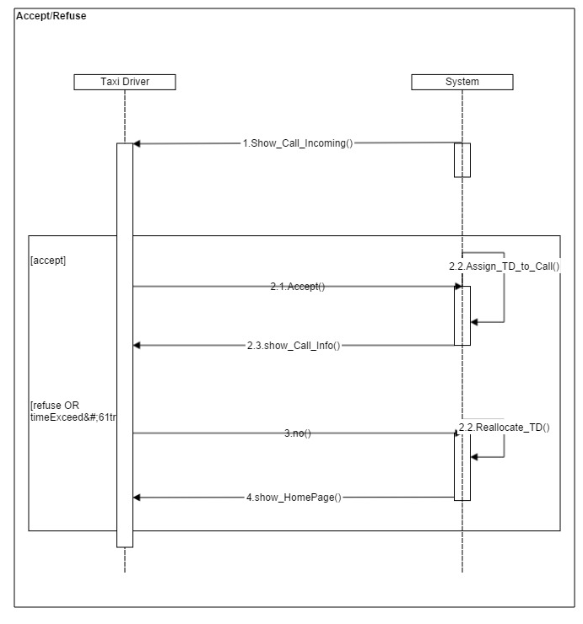

[G-D1] Driver set Availability diagram:
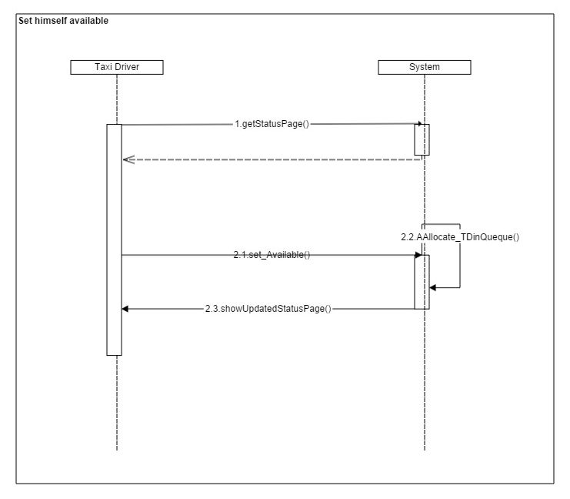

3.5 State Chart Diagrams
3.5.1 Taxi call state digram
Here is shown how a Call object can evolve through its possible status.

4 Alloy Modeling
The complete alloy file (.als) could be find on our Google code repository. The following alloy model has been created using class diagram. We divied the code into part logic parts (signatures, facts, asserts and predicates). The last section contain generated worlds.
4.1 Signatures
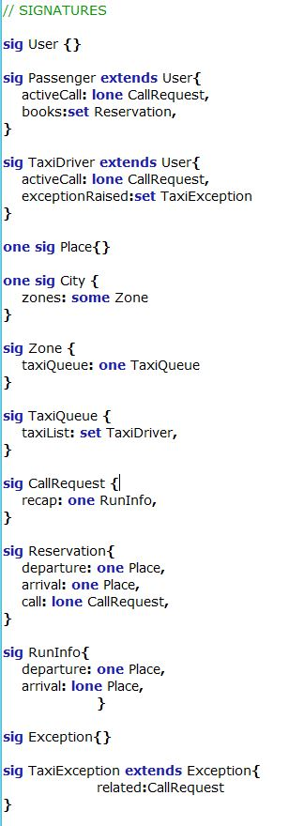
4.2 Facts
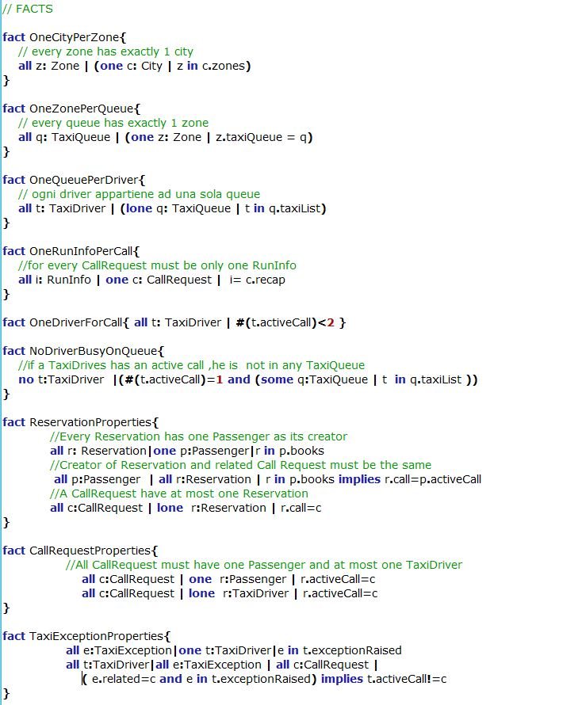
4.3 Predicates
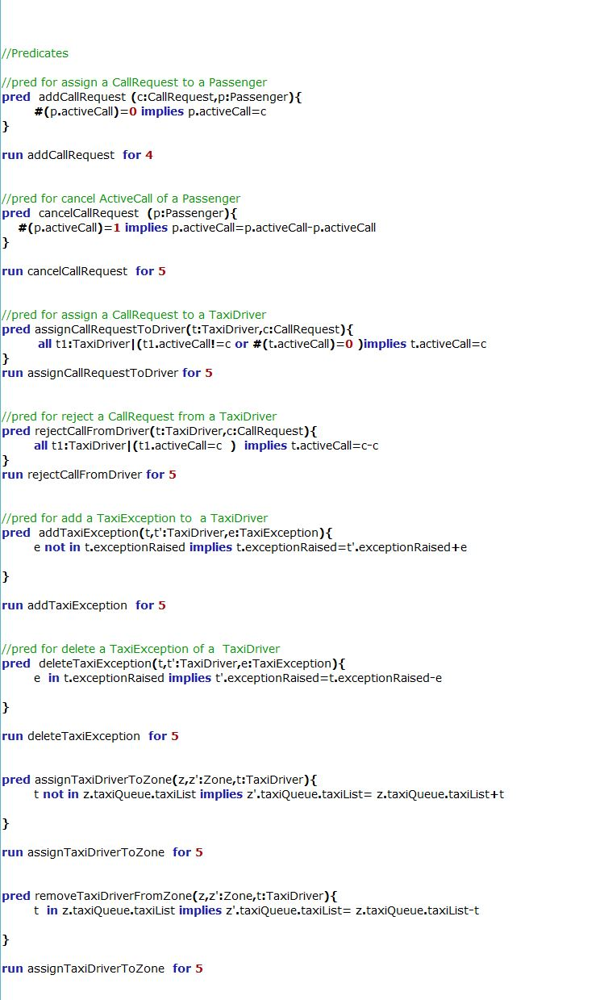
4.4 Assertions
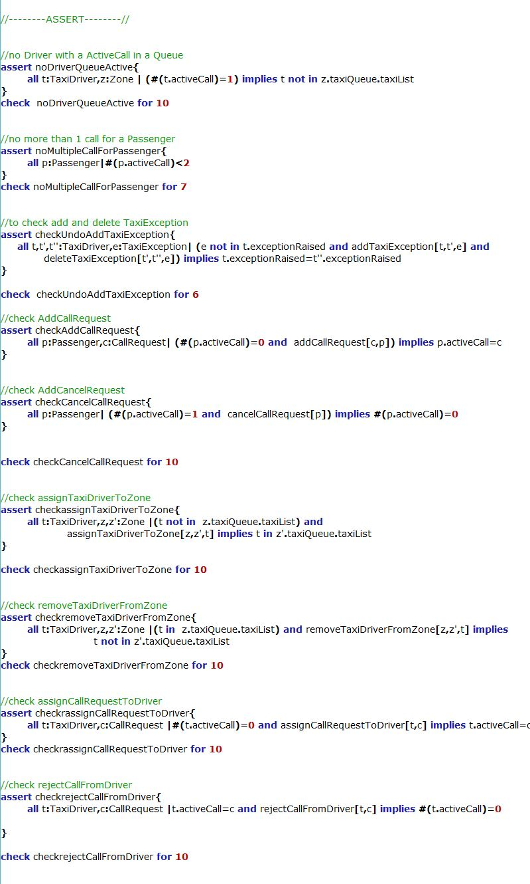
4.5 Show
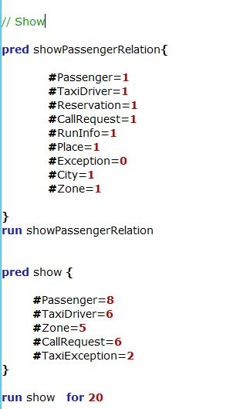

4.6 View models
- 4.6.1 This diagram shows all entities and relations in our Alloy Model.
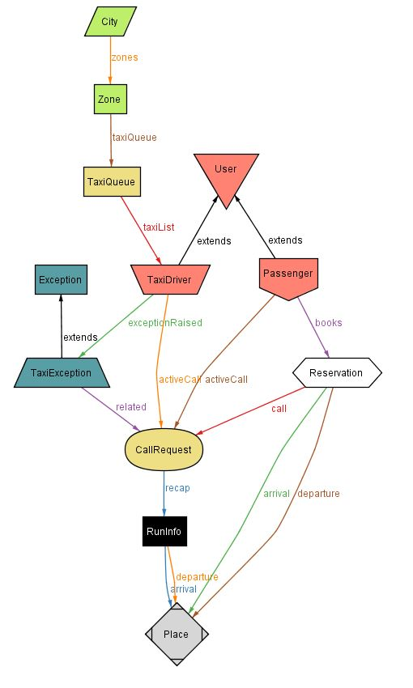

- 4.6.2 This diagram show in a clearer way how the class CallRequest are related to classes Reservation,Passenger and TaxiDriver.
.
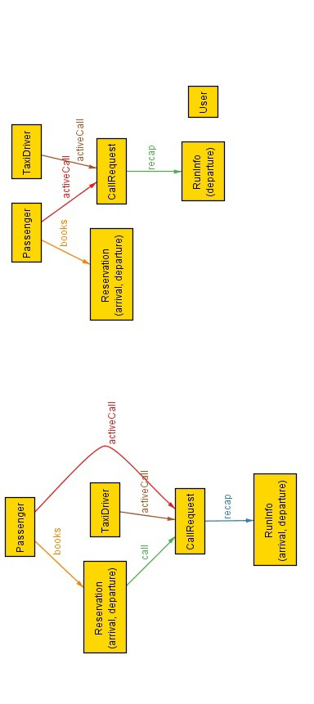
- 4.6.3 Scenario1: This is a full scenario
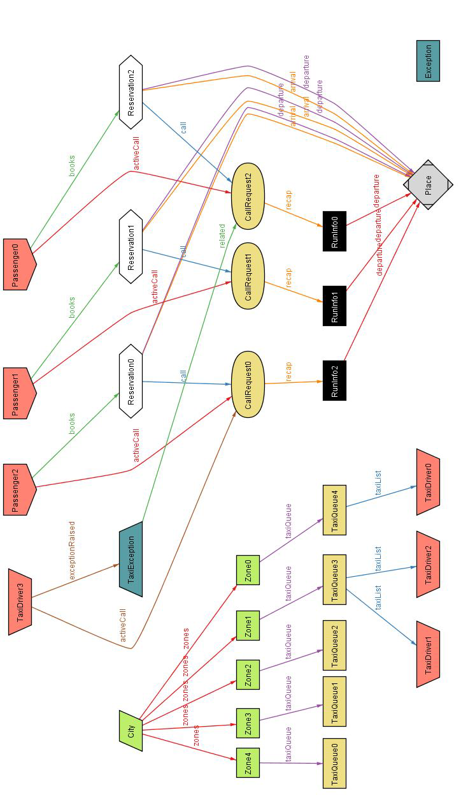

- 4.6.4 Scenario2: This is a full scenario
