|  |  |
| --- | --- |
| MOLECULAR CALCULATION REPORT | Generated by quchemreport |

**1. MOLECULE**

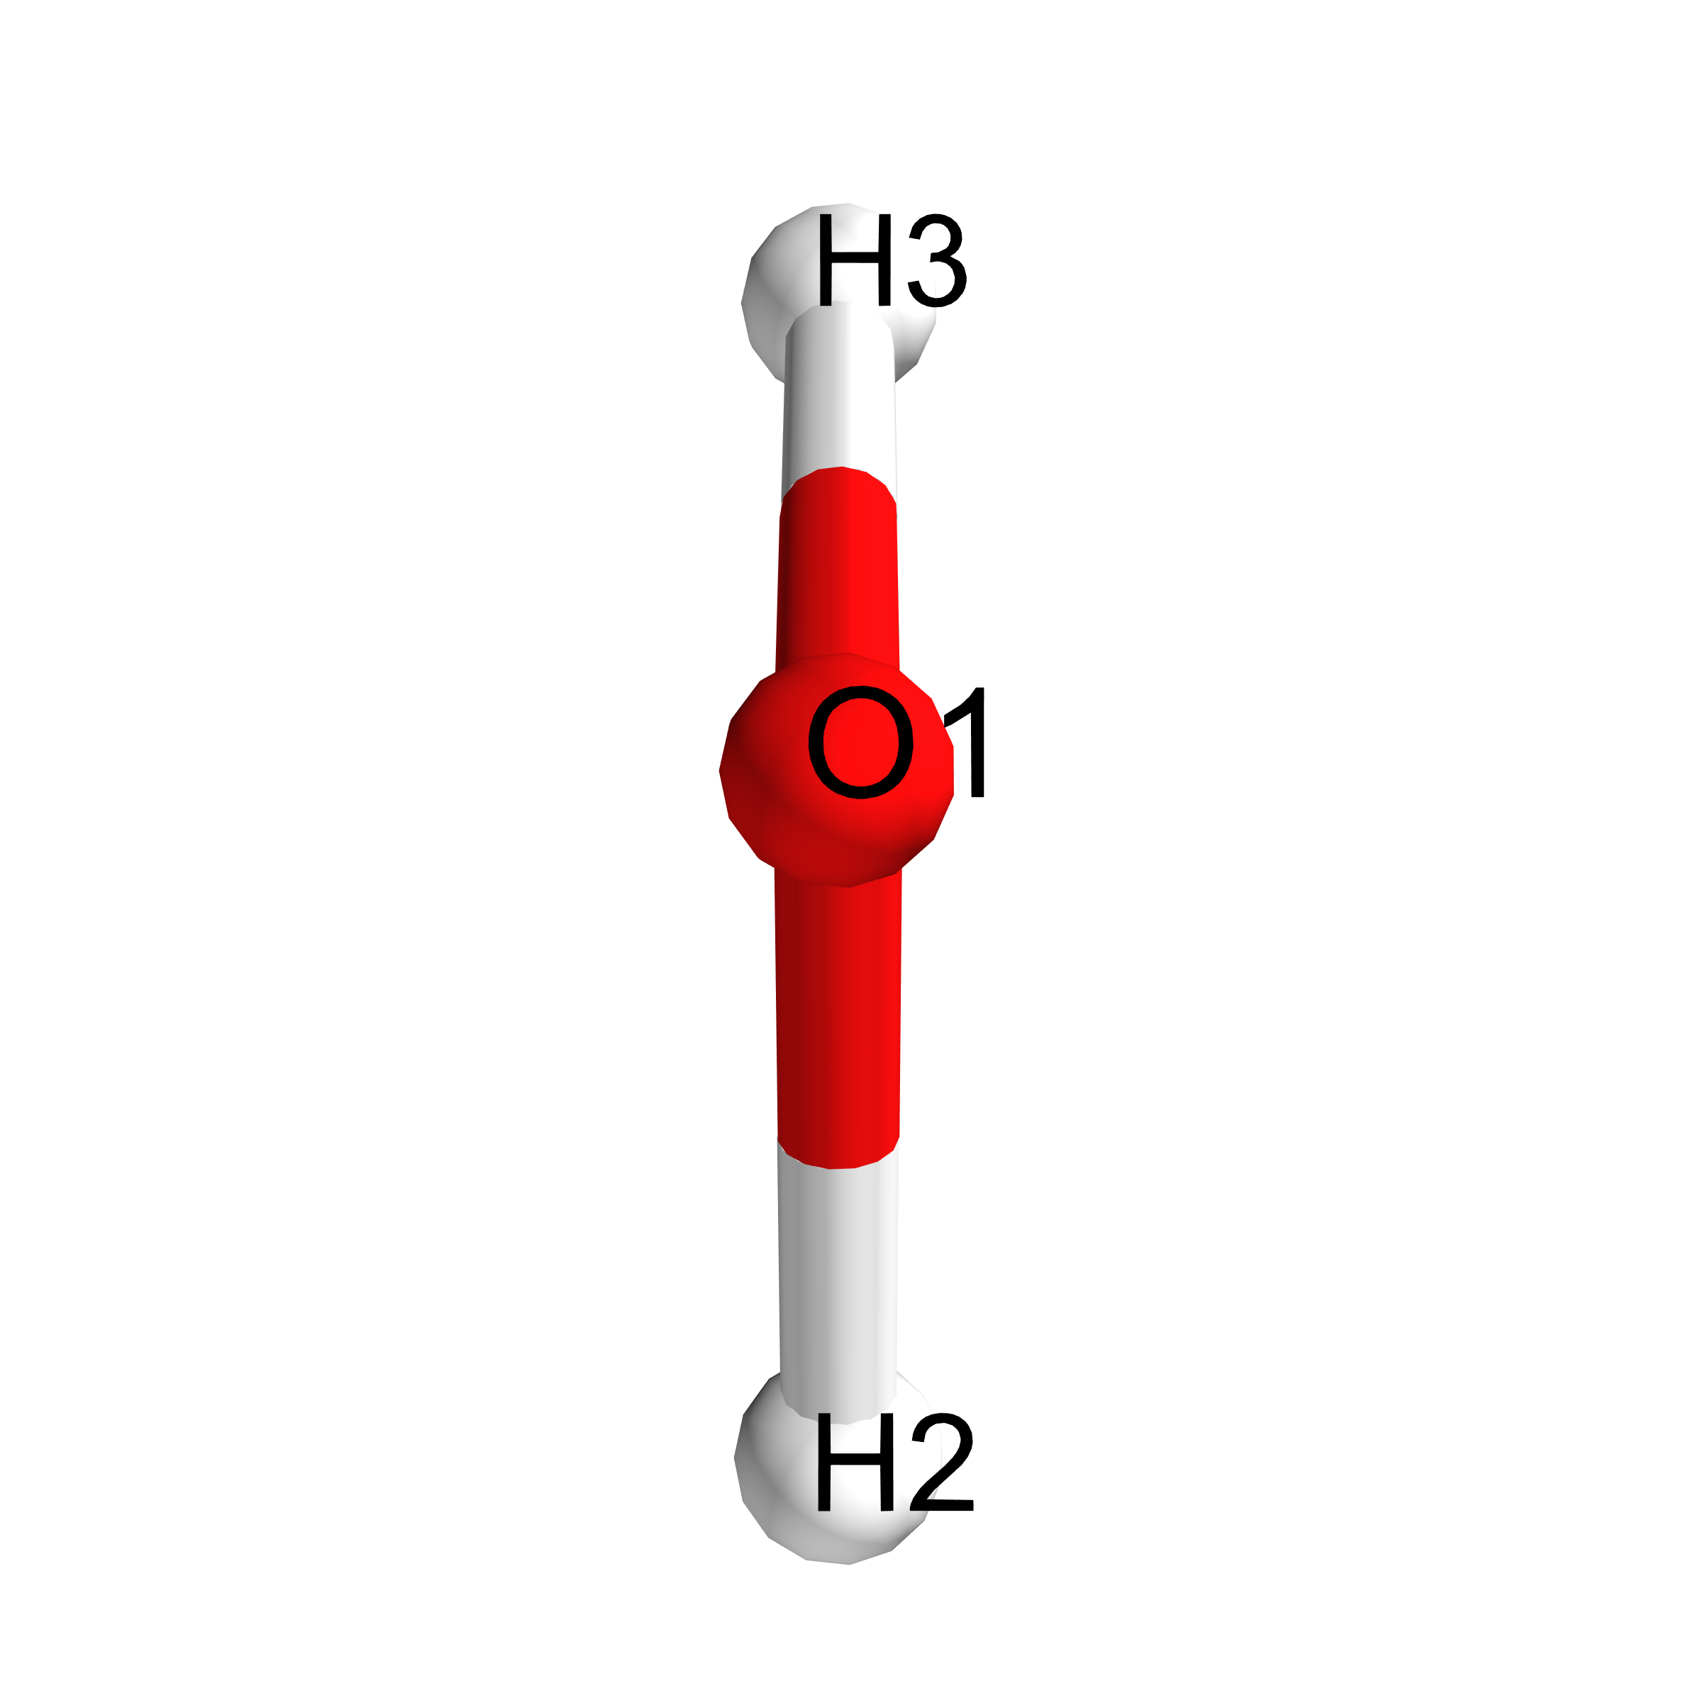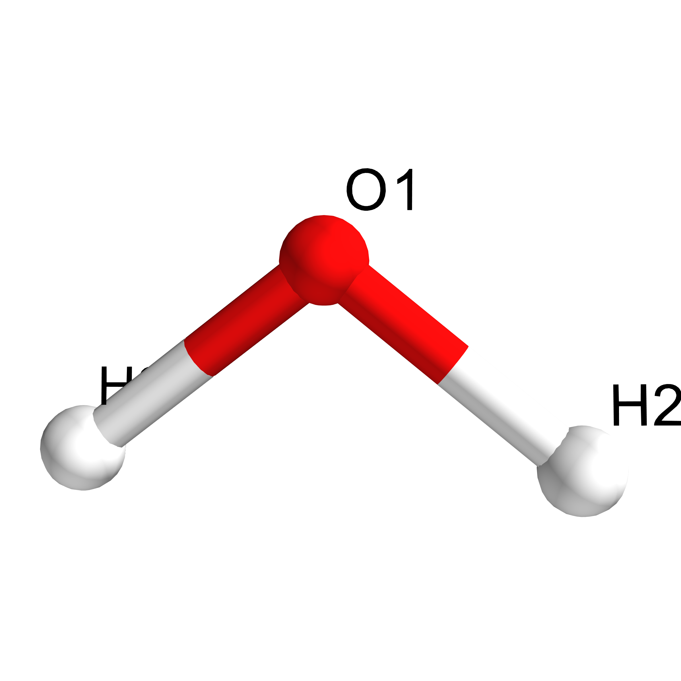

Figure 1: Chemical structure diagram with atomic numbering from two points of view.

|  |  |
| --- | --- |
| Directory name  Formula  Charge  Spin multiplicity  Monoisotopic mass InChI  SMILES | QuChemReport  H2O  0  1  18.01056 Da  1S/H2O/h1H2  O |

**2. COMPUTATIONAL DETAILS**

|  |  |  |
| --- | --- | --- |
| Software  Computational method  Functional  Basis set name  Number of basis set functions  Closed shell calculation  Requested SCF convergence on RMS and Max density matrix Requested SCF convergence on energy  Job type: Time-dependent calculation  Number of calculated excited states and spin state | Gaussian  DFT  B3LYP  6-31G(d)  19  True  1e-08  1e-06 | (2009+D.01) |
| 1e-06 |
| 5 | [’Singlet-A1’’Singlet-A2’  ’Singlet-B1’ ’Singlet-B2’] |
| Job type: Geometry optimization  Max Force value and threshold  RMS Force value and threshold  Max Displacement value and threshold RMS Displacement value and threshold | 0.000156  0.000101  0.000578  0.000550 | 0.000450  0.000300  0.001800  0.001200 |
| Monday 12thMay, 2025 12:13 |  | Page 1 |

|  |  |
| --- | --- |
| MOLECULAR CALCULATION REPORT | Generated by quchemreport |

**3. RESULTS**

|  |  |  |
| --- | --- | --- |
| Total molecular energy  HOMO number  LUMO+1 energies  LUMO energies  HOMO energies  HOMO-1 energies | -76.40895 hartrees 5  4.03 eV  1.70 eV -7.92 eV -10.13 eV | 0.5475 e- Mulliken charge -0.774  Mulliken charge |
| Geometry optimization specific results Converged nuclear repulsion energy | 9.08784 Hartrees |
| Mean Mulliken atomic charge and standard deviation  Atoms with negatives charges under the standard deviation | 0.0000 e- NÂ° O 1  NÂ° |
| Atoms with positives charges over the standard deviation |

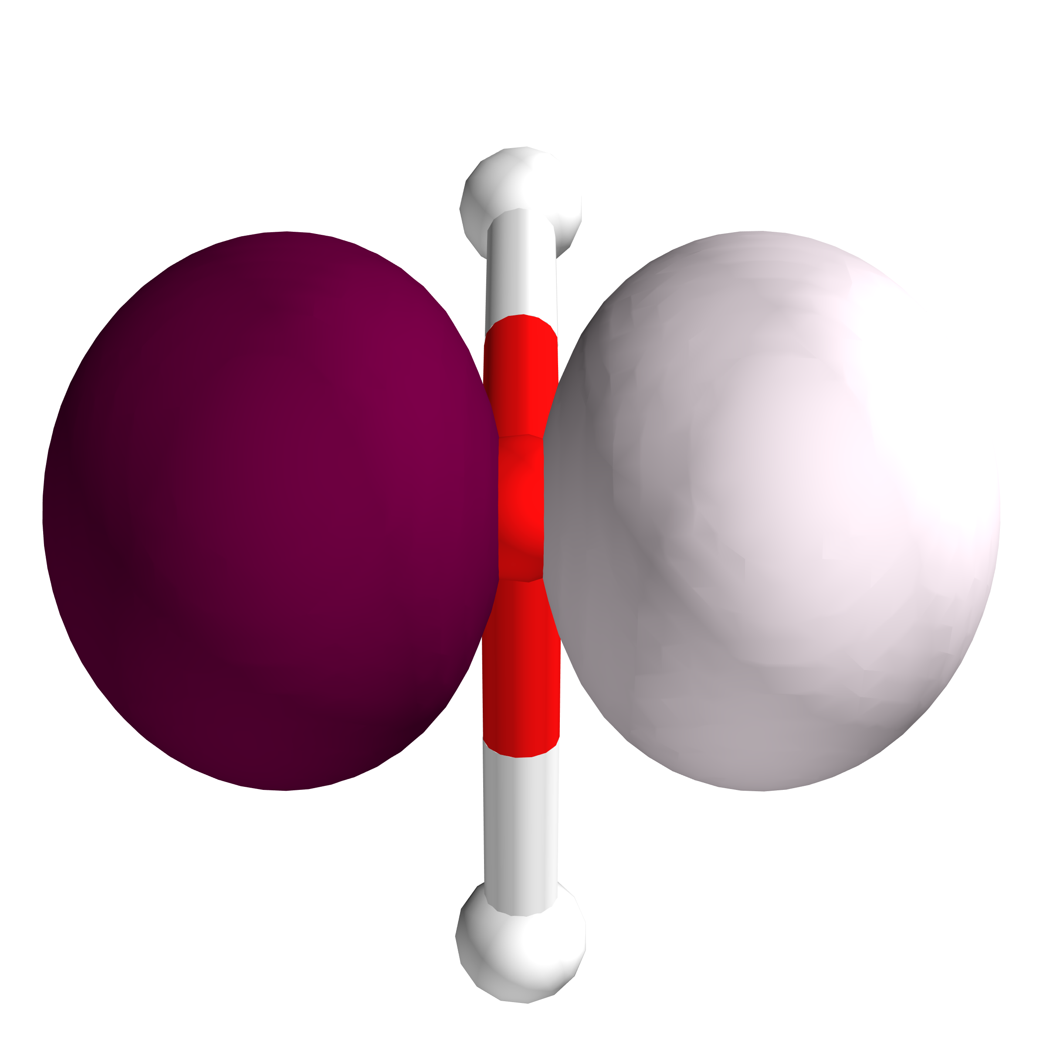

Figure 2: Representation of the HOMO from two points of view.

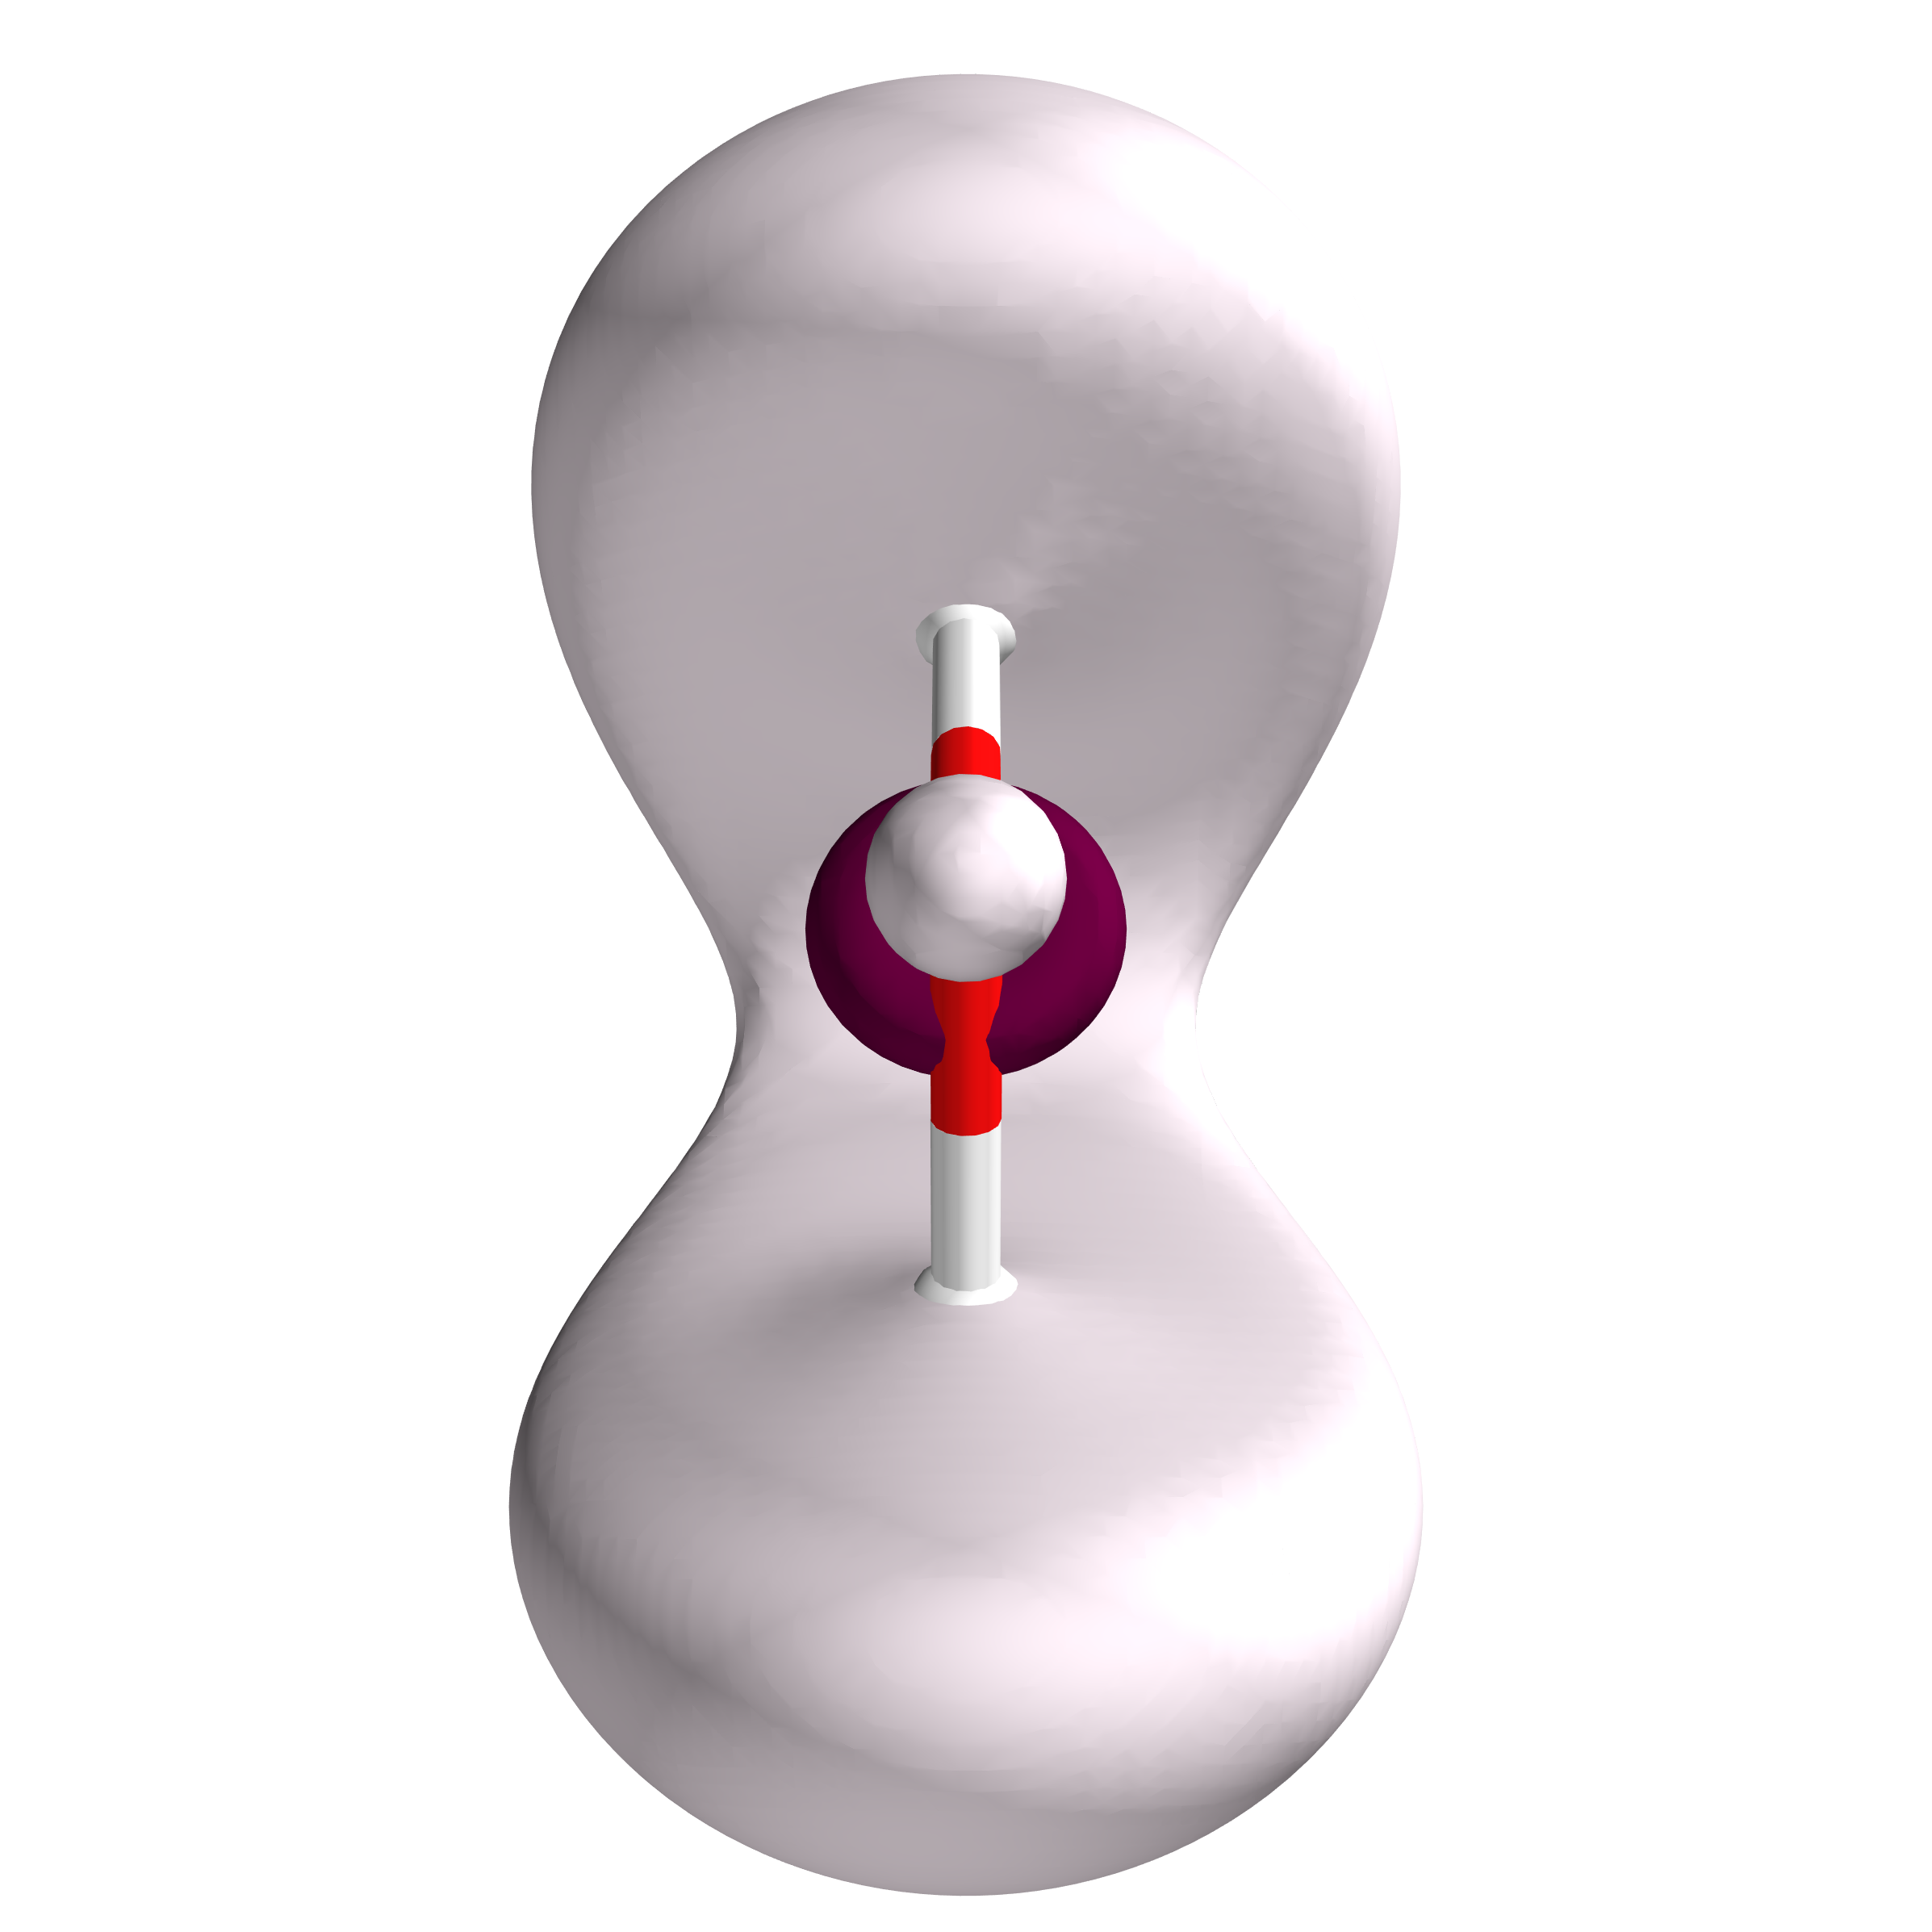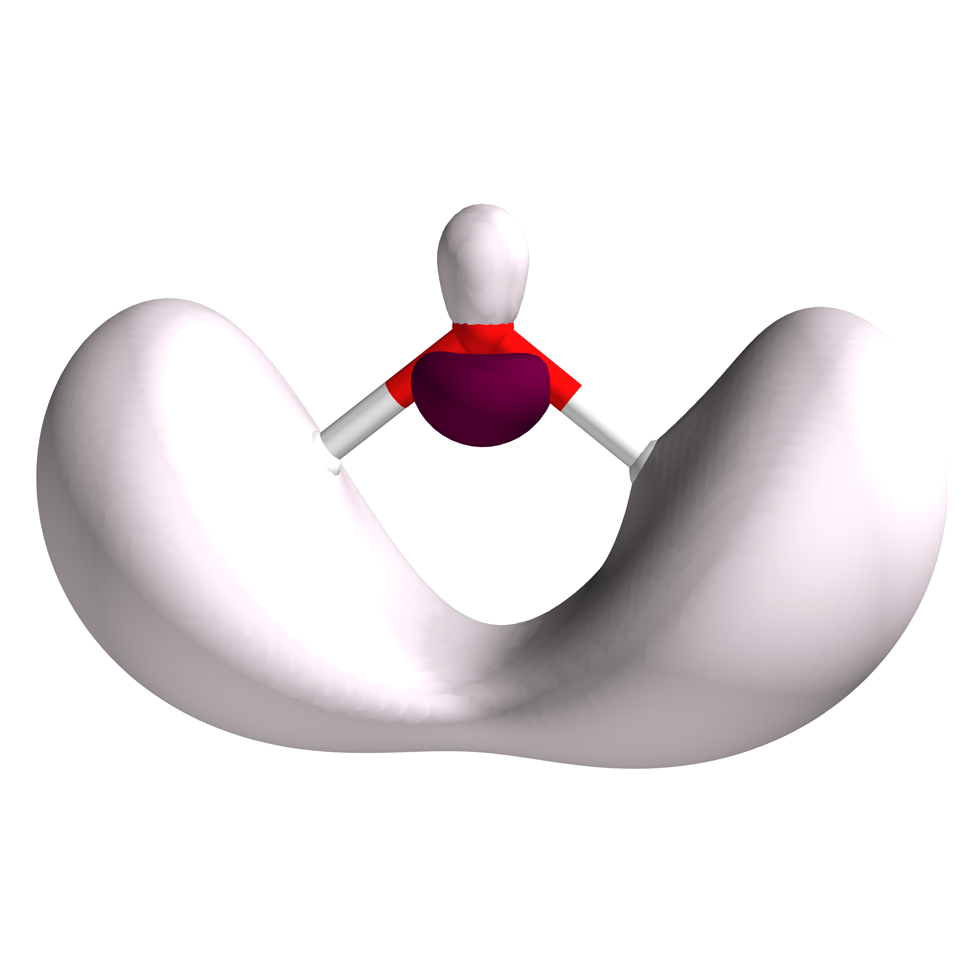

Figure 3: Representation of the LUMO from two points of view.

|  |  |  |  |
| --- | --- | --- | --- |
| E.S. | Symmetry | Table. Results concerning the calculated mono-electronic excitations.  nm cm*−*1 *f* R Λ d*CT* q*CT*  Excitation description : initial OM - end-  ing OM (% if > 5%)  156 63850 0.014 0.0 0.41 88.49 0.82 5-6(100);  124 80171 0.000 0.0 0.38 80.85 0.82 5-7(99);  118 84705 0.095 0.0 0.53 111.71 0.72 4-6(98);  97 102261 0.072 0.0 0.53 104.36 0.72 4-7(95);  85 117079 0.398 0.0 0.59 76.69 0.68 3-6(95); | |
| 1  2  3  4  5 | Singlet-B1 Singlet-A2 Singlet-A1 Singlet-B2 Singlet-B2 |
|  |  |
| Monday 12thMay, 2025 12:13 | | | Page 2 |

|  |  |
| --- | --- |
| MOLECULAR CALCULATION REPORT | Generated by quchemreport |

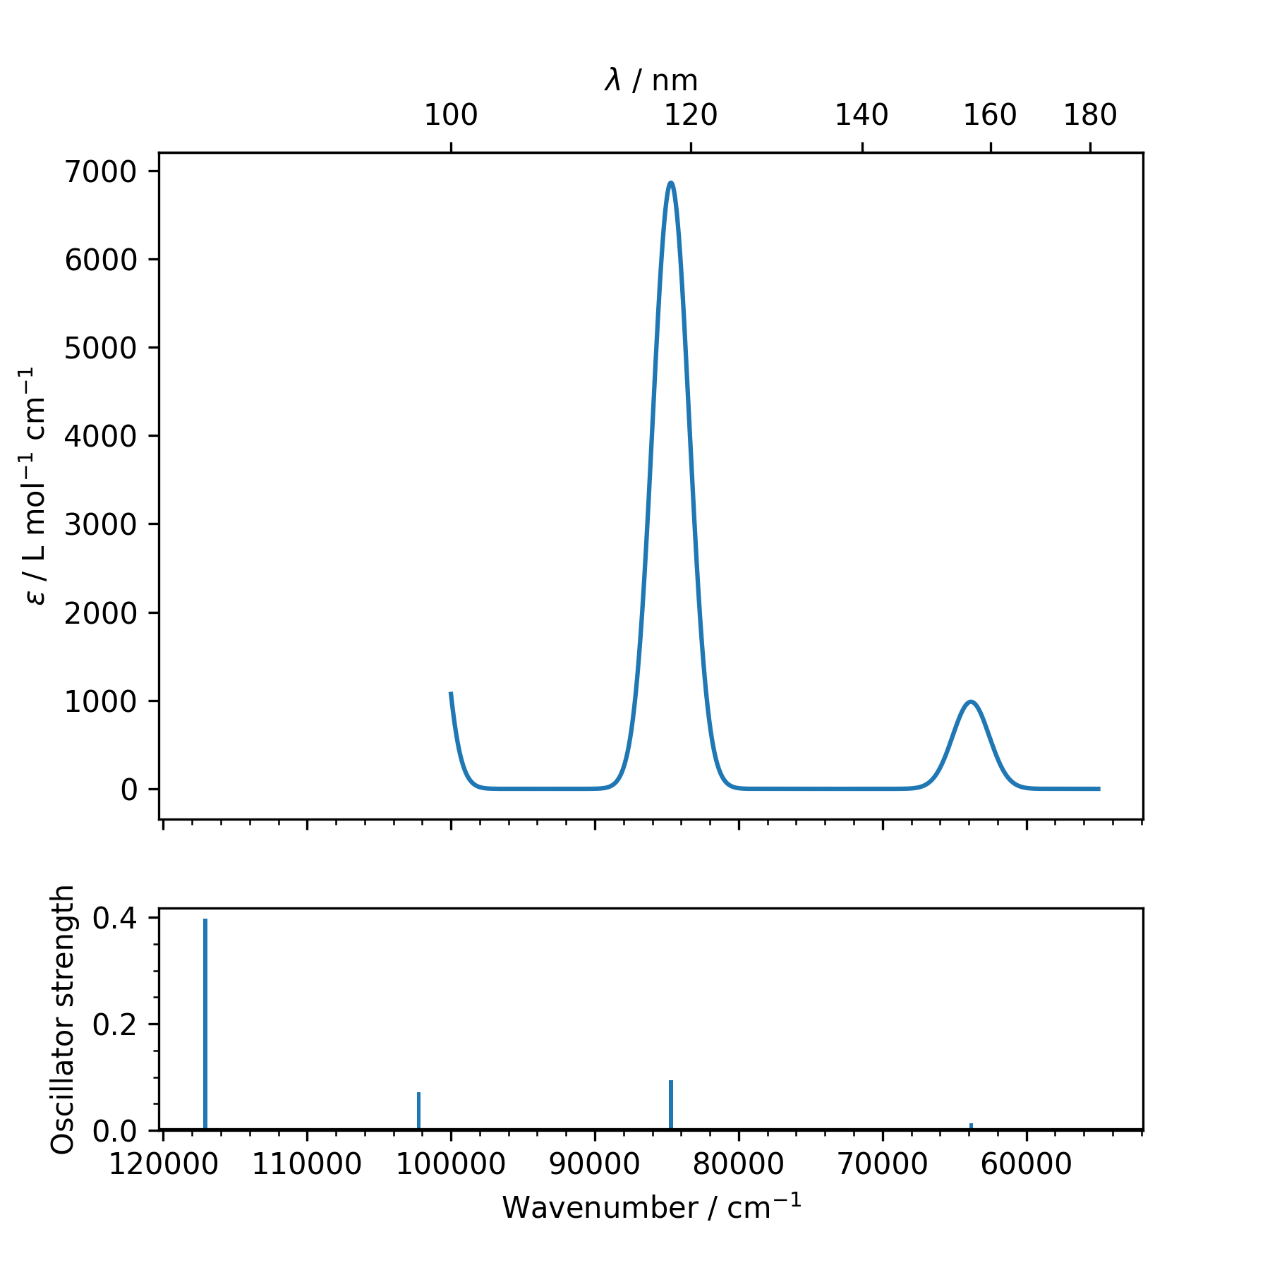

Figure 4: Calculated UV visible Absorption spectrum with a gaussian broadening (FWHM = 3000 cm-1)

|  |  |  |
| --- | --- | --- |
| Monday 12thMay, 2025 12:13 | Table. Converged cartesian atomic coordinates in Angstroms  Atom X Y Z  O 0.0000 0.0000 0.1198  H 0.0000 0.7613-0.4792  H 0.0000 -0.7613-0.4792 | Page 3 |

|  |  |
| --- | --- |
| MOLECULAR CALCULATION REPORT | Generated by quchemreport |

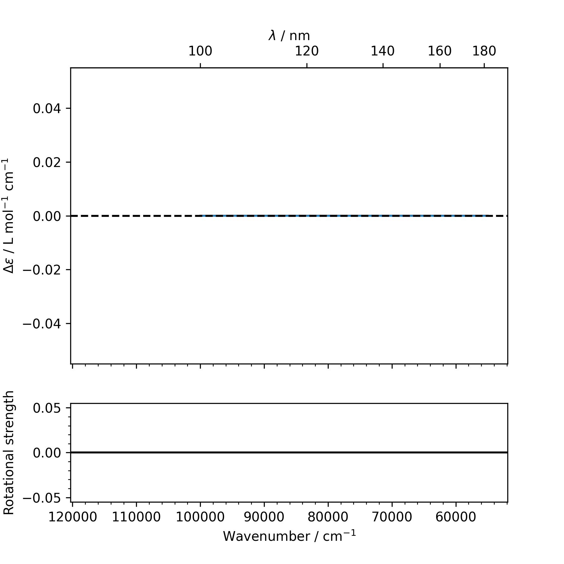

Figure 5: Calculated Circular Dichroism spectrum with a gaussian broadening (FWHM = 3000 cm-1)

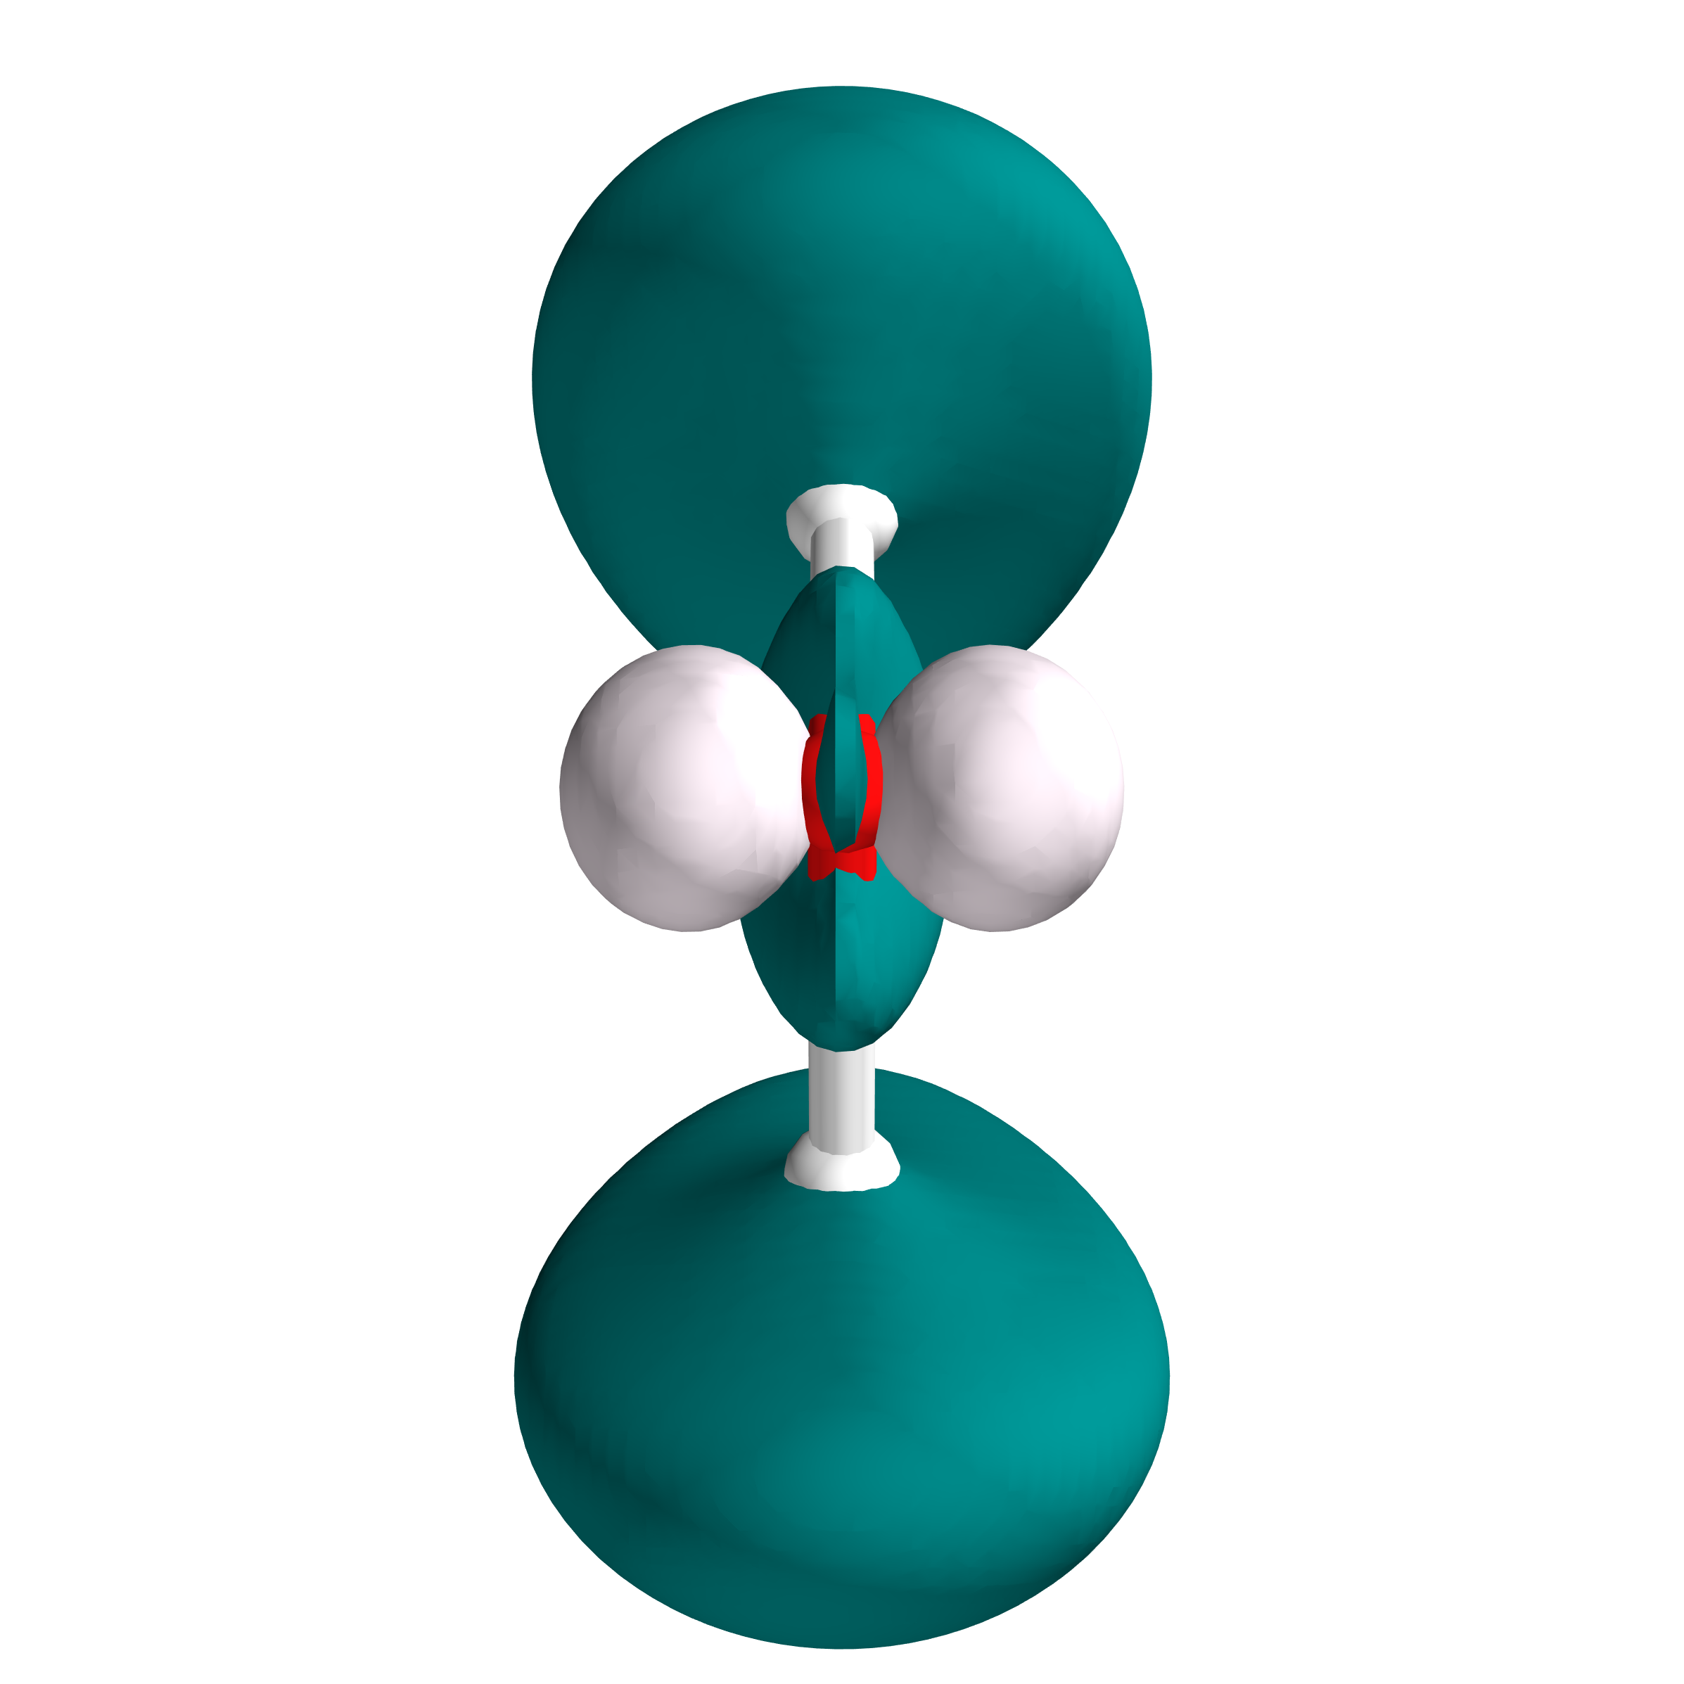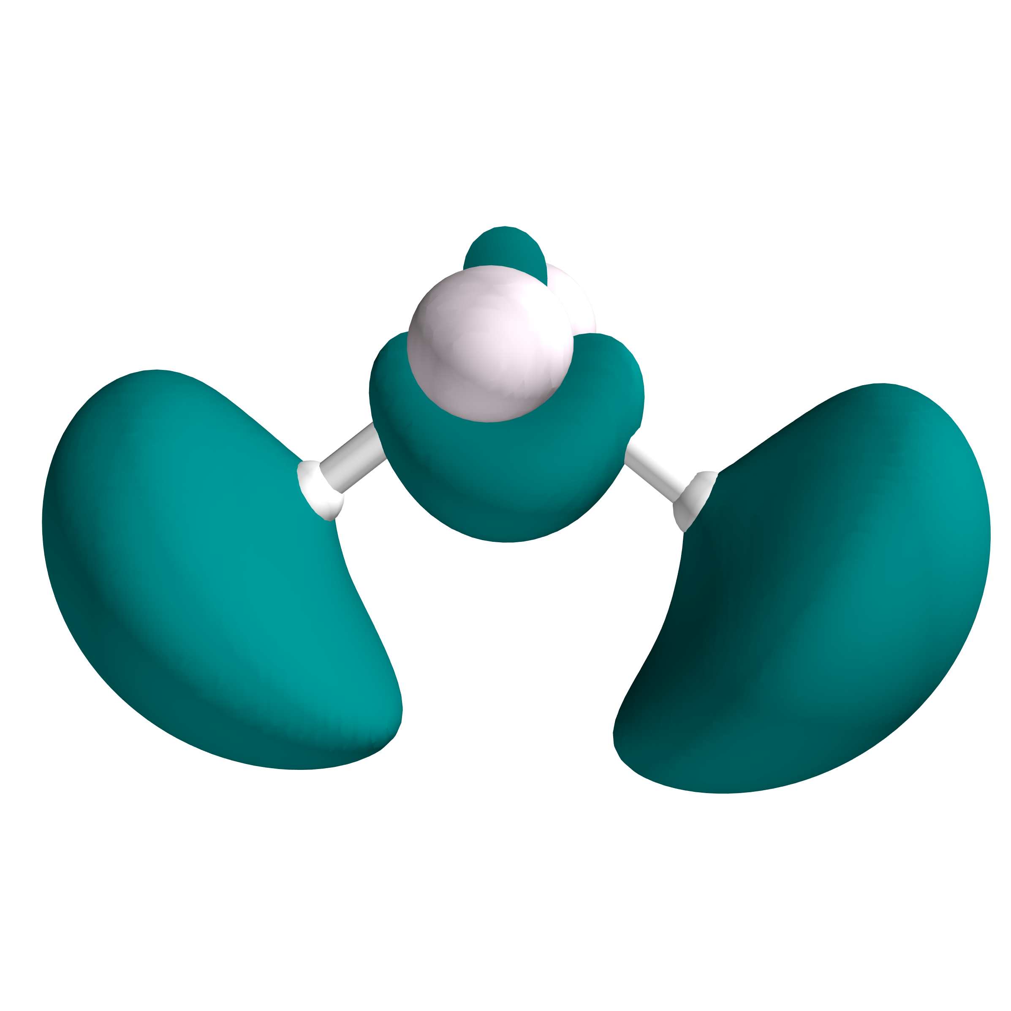

Figure 6: Representation of the Electron Density Difference (S1-S0) from two points of view.

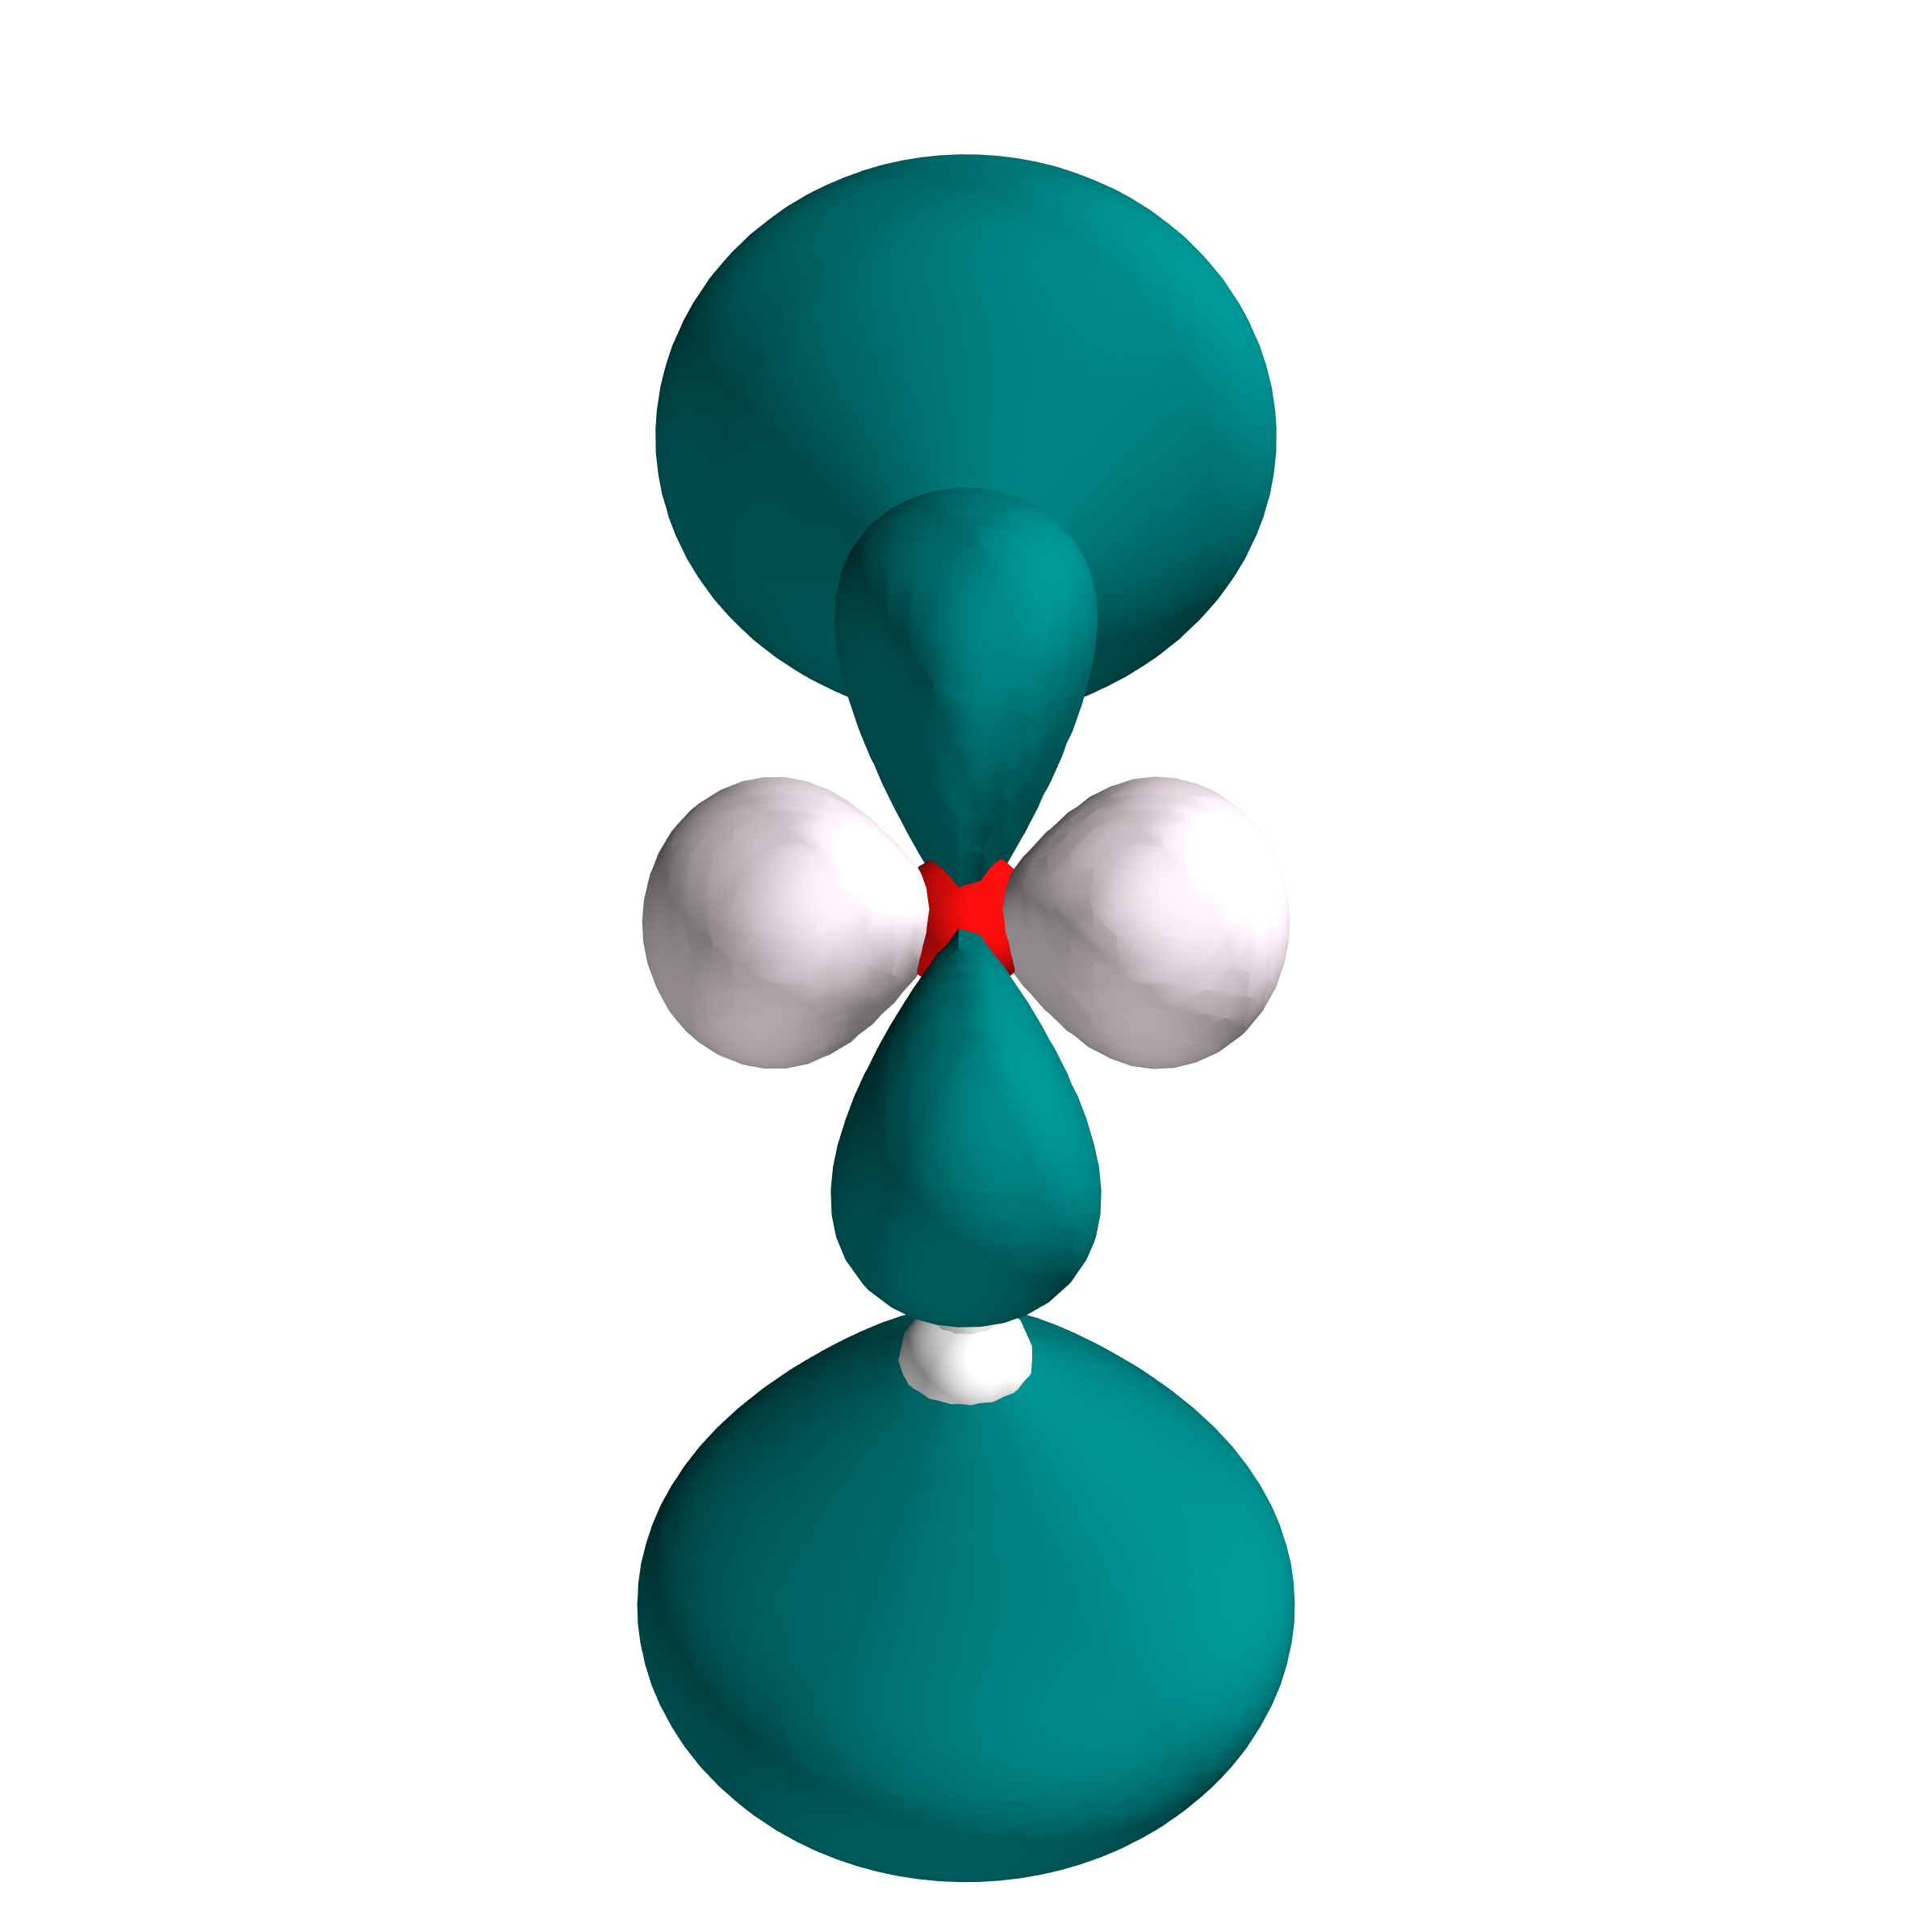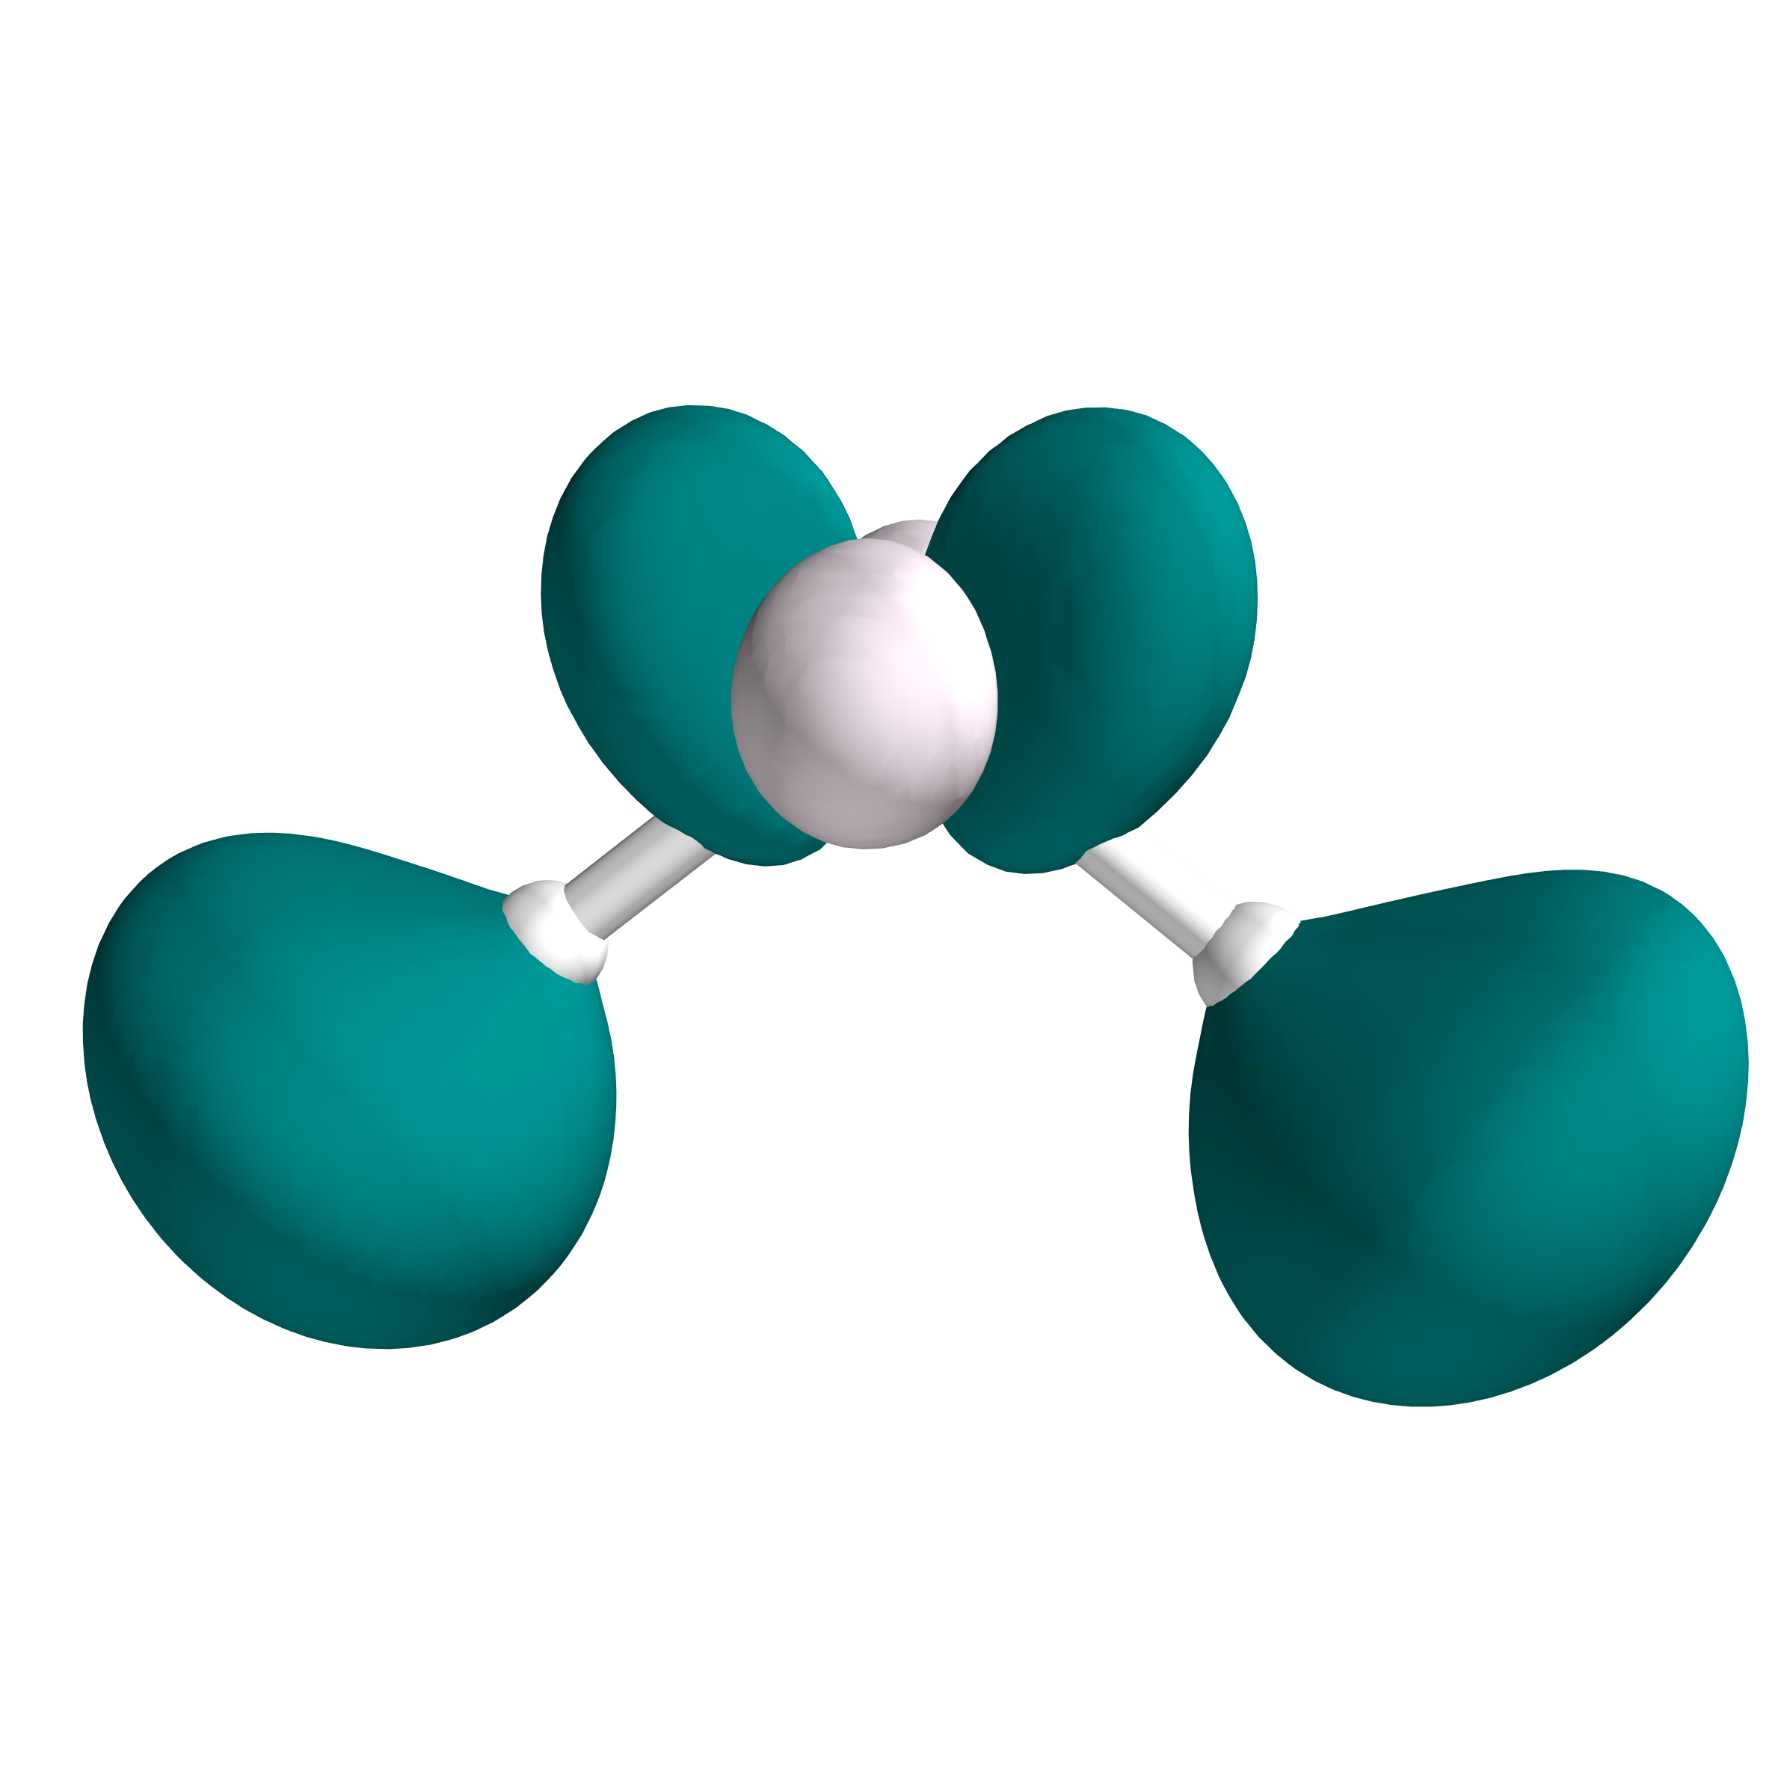

Figure 7: Representation of the Electron Density Difference (S2-S0) from two points of view.

|  |  |
| --- | --- |
| Monday 12thMay, 2025 12:13 | Page 4 |