**MOLECULAR CALCULATION REPORT**

**1. MOLECULE**

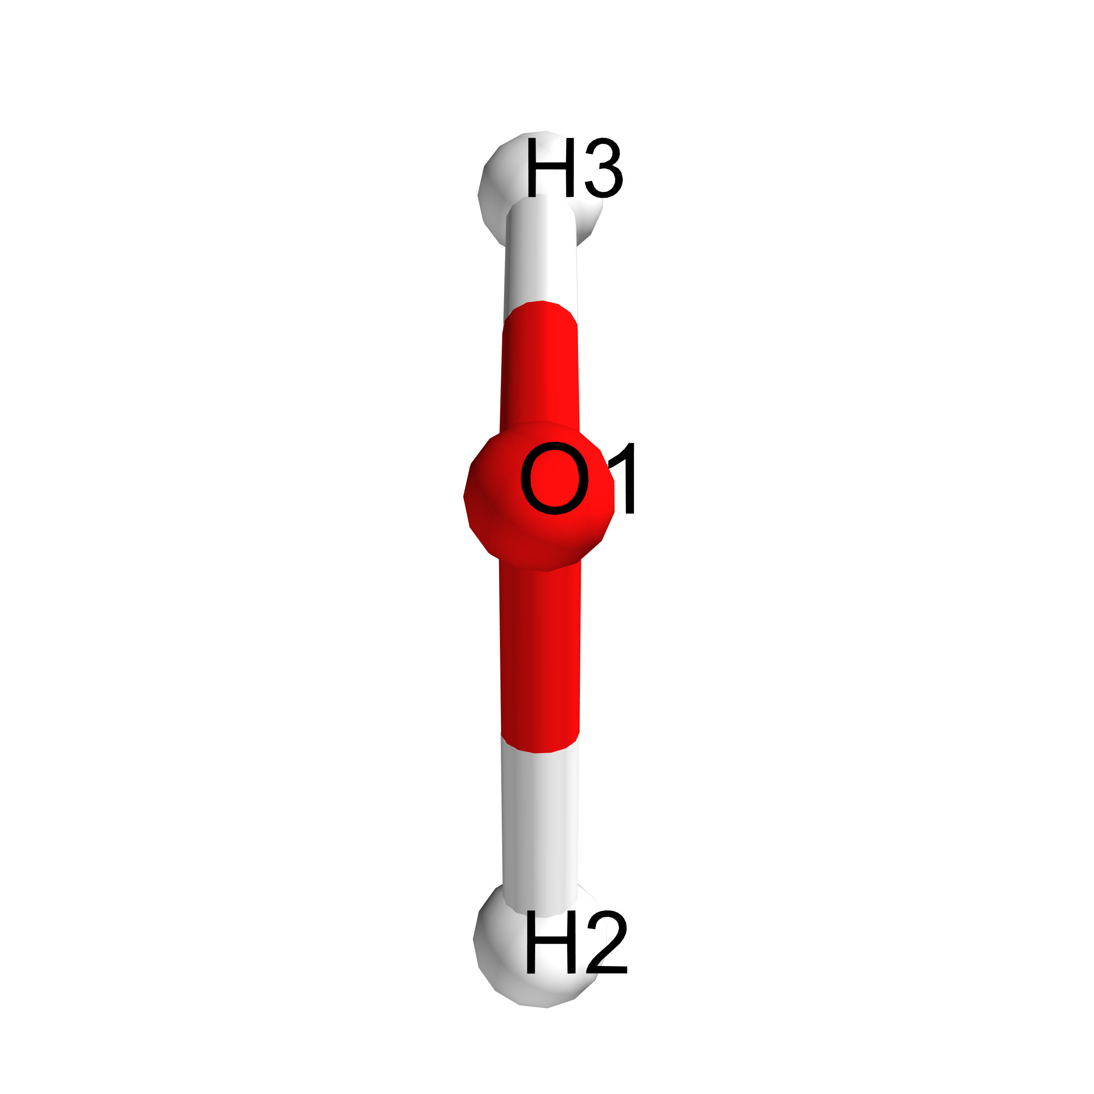

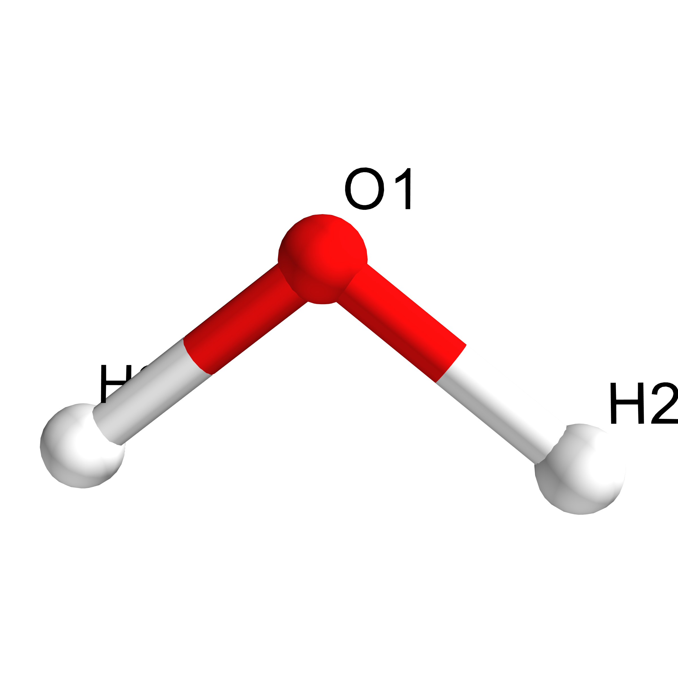

Figure 1: Chemical structure diagram with atomic numbering from two points of view.

|  |  |
| --- | --- |
| Directory name | QuChemReport |
| Formula | H2O |
| Charge | 0 |
| Spin multiplicity | 1 |
| Monoisotopic mass | 18.01056 Da |
| InChI | 1S/H2O/h1H2 |
| SMILES | O |

**2. COMPUTATIONAL DETAILS**

|  |  |
| --- | --- |
| Software | Gaussian |
| Computational method | DFT |
| Functional | B3LYP |
| Basis set name | 6-31G(d) |
| Number of basis set functions | 19 |
| Closed shell calculation | True |
| Requested SCF convergence on RMS and Max density matrix | 1e-08 |
| Requested SCF convergence on energy | 1e-06 |
| Job type | Time-dependent calculation |
| Number of calculated excited states and spin state | 5 |

Job type: Geometry optimization

|  |  |
| --- | --- |
| Max Force value and threshold | 0.000156 |
| RMS Force value and threshold | 0.000101 |
| Max Displacement value and threshold | 0.000578 |
| RMS Displacement value and threshold | 0.000550 |