# CS 255 System Design Document Template

This template lays out all the different sections that you need to complete for Project Two. Each section has guidance to prompt your thinking. You will need to continually reference the interview transcript as you work to make sure that you are addressing your client’s needs. There is no required length for the final document. Instead the goal is to complete each section based on what your client’s needs are. Remove this note when you are finished, and replace all bracketed text with the relevant information.

## UML Diagrams

### UML Use Case Diagram

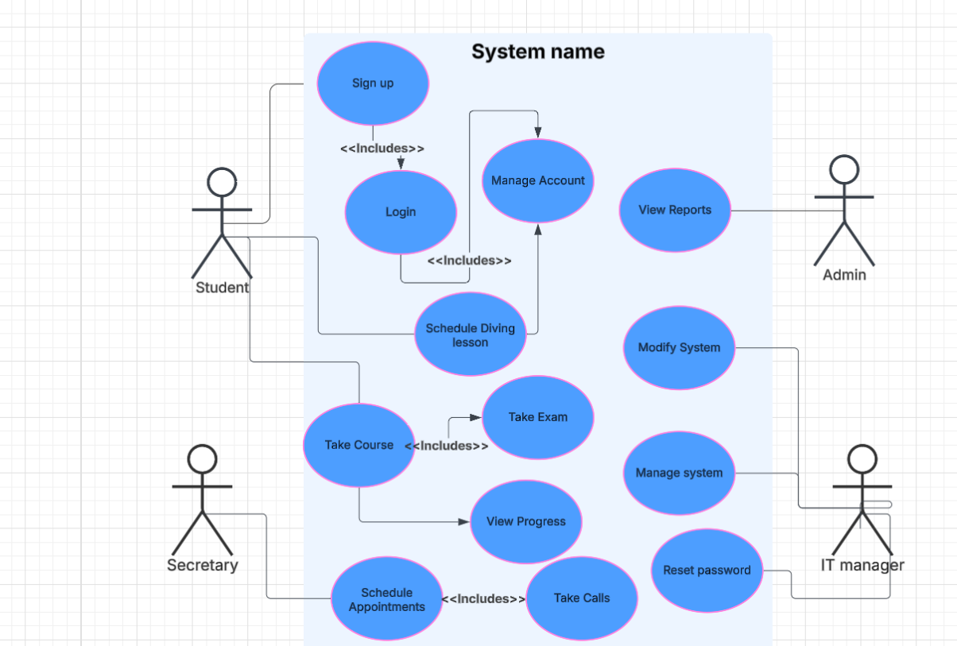

### UML Activity Diagrams

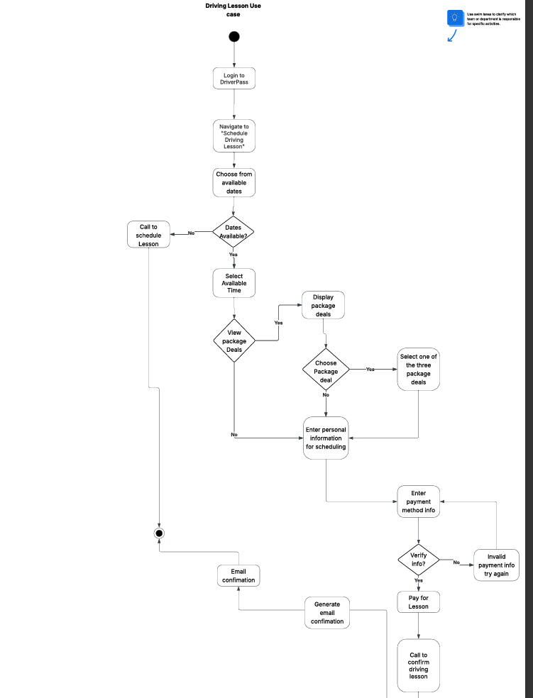

### UML Sequence Diagram

### UML Class Diagram

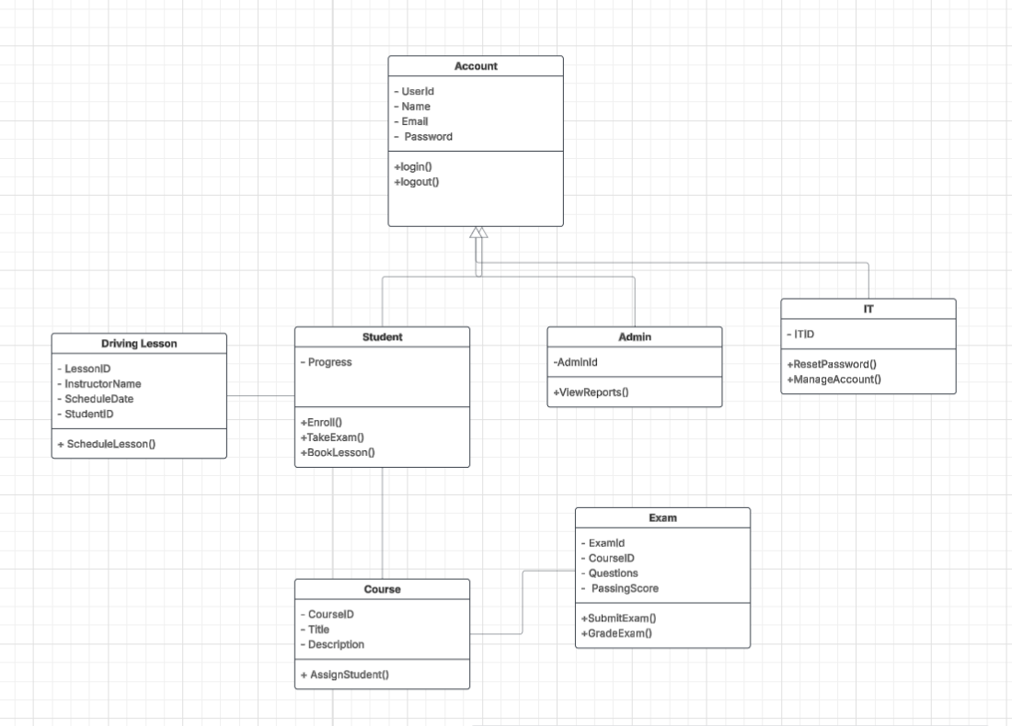

## Technical Requirements

*The technical requremnets for the driverpass system would be that the system needs to be a web-based application that runs on high-level servers. The system needs to be able to handle multiple requests at the same time due to many users on the website. The frontend should be created using some framework such as react.JS or angular. There will need to be multiple webpages to make the website interactive and display different information. The system will also need a database that can hold user information as well as course, exam, and driving lesson information. This would probably work best with a relational database. For the backend, we could utilize python and the use of API to keep DMV information updated. You can also make the website through python’s flask development with Django. There needs to be an authentication system such as session-based logins. Also, user role authorization through different logins. The database should be run through a cloud infrastructure to access information from almost anywhere. For security measures something like HTTP and secure cookies should be used for tracking and website security. Passwords could utilize hashing and role-based authentication can help with access control as well. Email verification is also a good security measure to ensure users log in securely.*