TASK 1:

To begin I used the command printenv to print out all of my environment variables. It printed out all of my environment variables. Including the name of an environment variable at the end will just display that one variable specifically.

The export and unset commands are next. The intended use of export is to include a variable after it to make it an environmental variable. When used alone it prints a list of all variables that have been exported. The unset command is used to remove the environment variable status from a variable. It does nothing when inputted alone.

TASK 2:

Step 1:
The following screenshots are the code snippets for this step:
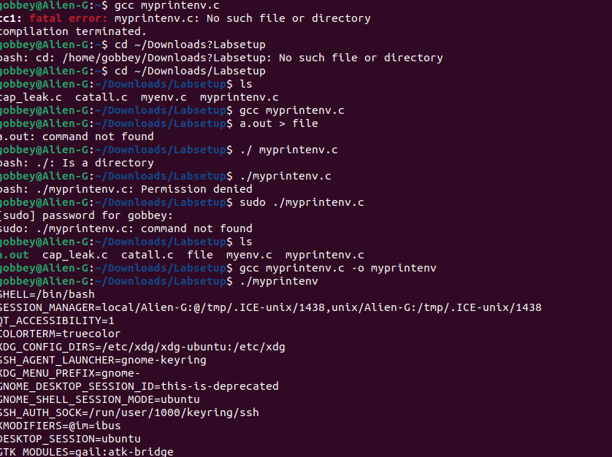
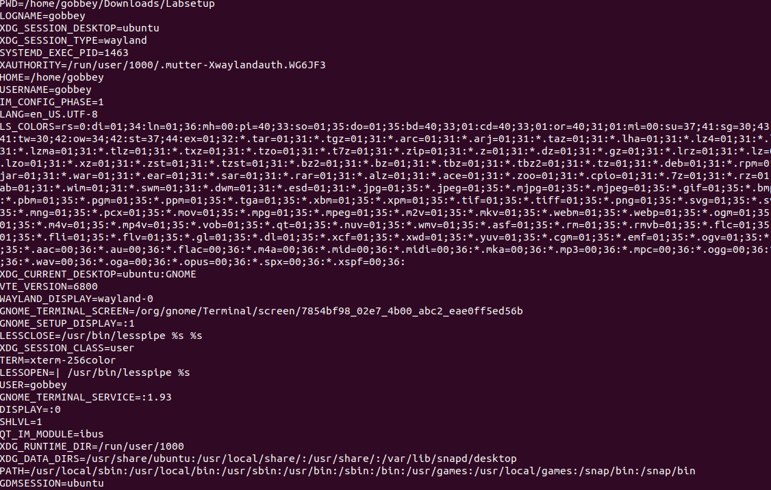
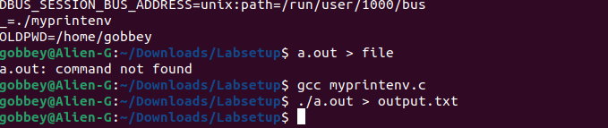
These code snippets showcase my struggles of trying to figure out how to compile and run the c program. It also includes me changing directories so I can run the program in the first place. But in the end I successfully compiled and ran the program, and saved the output into the output text file.

Step 2:
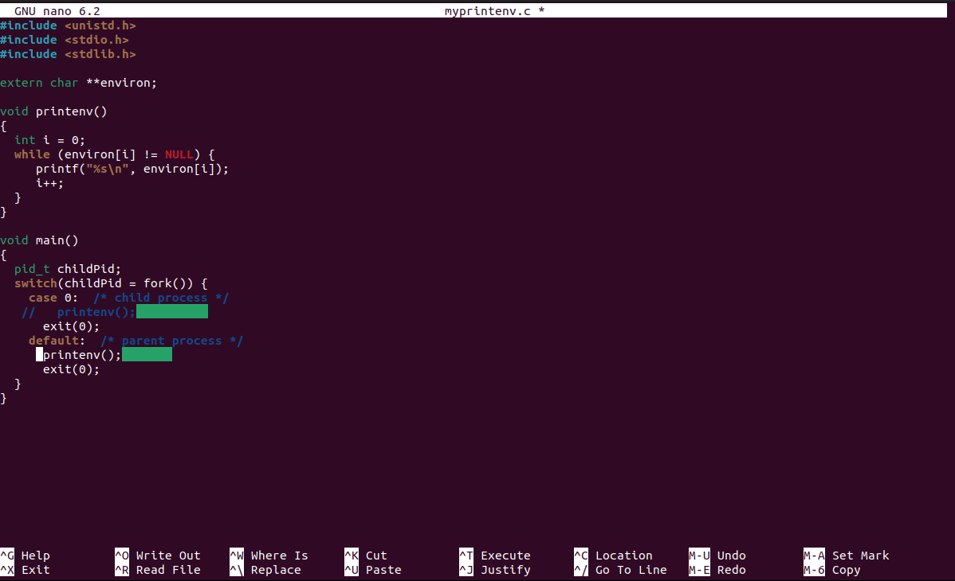
Using the nano command I went into the myprintenv.c program and commented out line 1, and uncommented out line 2.

After saving my changes in nano, I re-compiled and ran the program, saving this new output into output2.txt.

Step 3:
I ran the diff command and I have gotten no output, which leads me to believe that there is no difference in the two outputs.

TASK 3:
Step 1:
I have compiled and ran the c program myenv and have gotten no output.

Step 2:
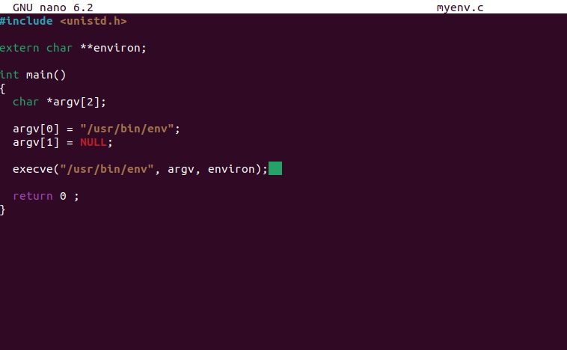
I have made changes to the code, switching NULL to environ.
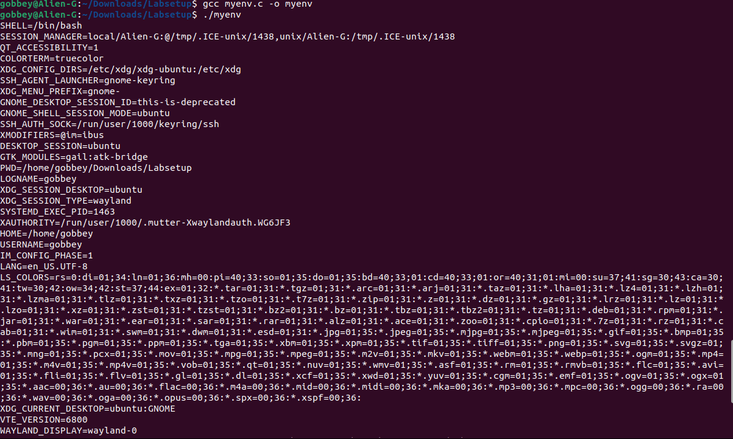
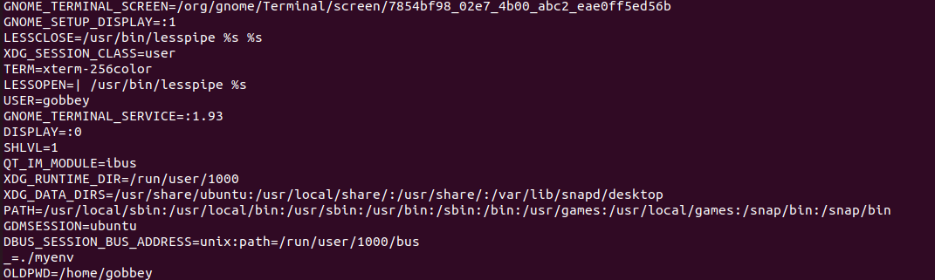
After running the new program, I see that I actually get an output this time. I can observe that the previous NULL was preventing the program from giving me an output.

Step 3:
When this new program is executed using the execuve system call, its environment depends on the 3rd argument passed through execuve. When it was NULL, the program printed nothing since there was no environment, but when it was environ, it had an actual environment to go through.

TASK 4:
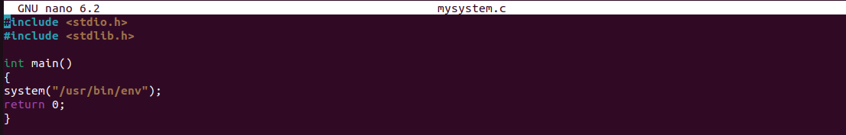
Here is me creating the c program mysystem using nano.
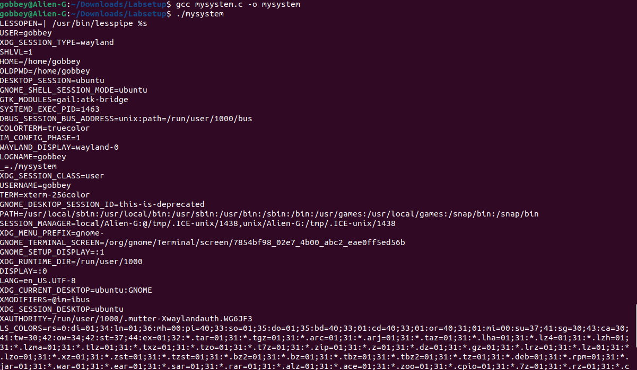
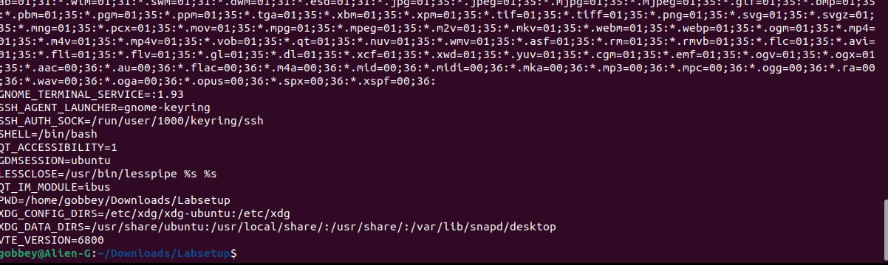
This is the output after compiling and running the program. I noticed that the output is very similar or exactly the same as when I ran /usr/bin/env before.

TASK 5:
Step 1:
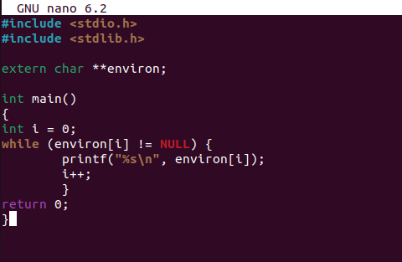
This is the written c program foo

Step 2:
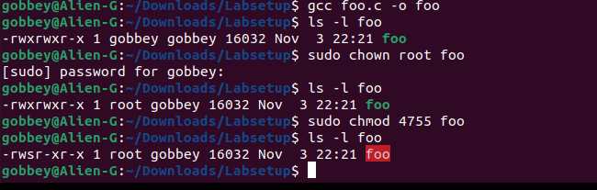
Here I compiled the program, changed the owner to root and made it a set-uid program. I used ls -l throughout this step to ensure what I was doing was going through properly.

Step 3:
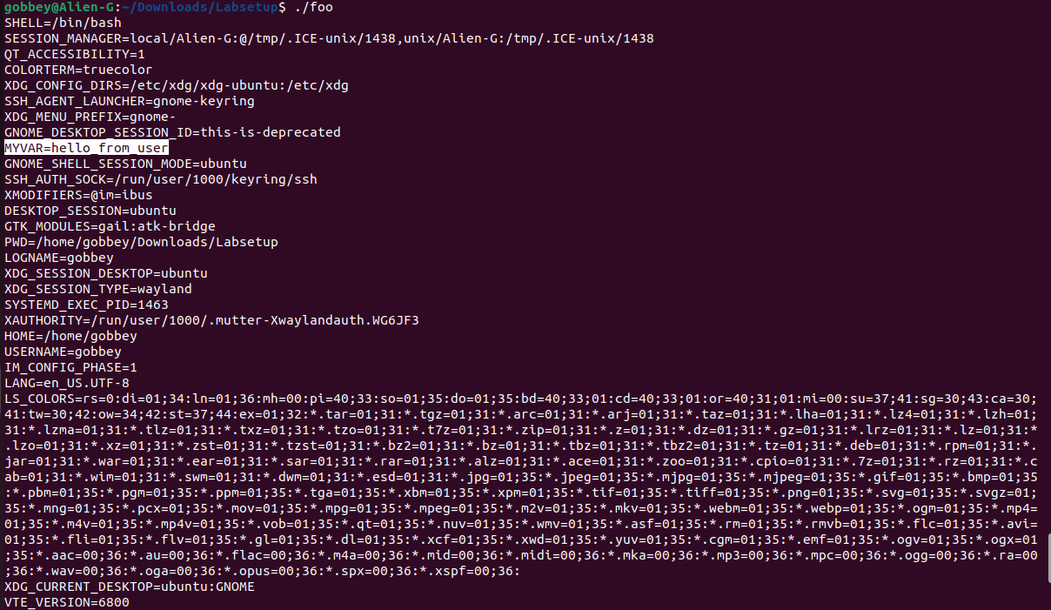
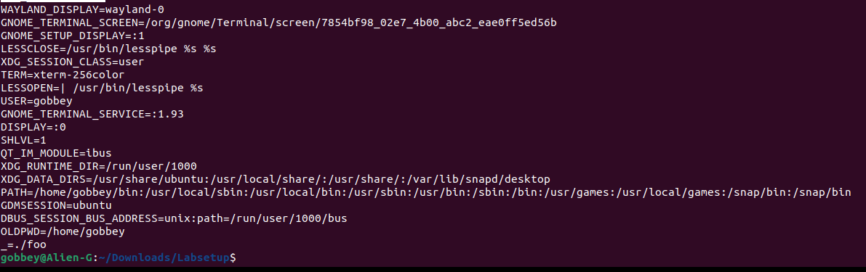
The code snippets show me setting 3 environment variables and then running the foo.c program. After running foo, I have observed that PATH has appeared but is different, MYVAR appears and is not changed, but LD_LIBRARY_PATH has not appeared. I can see that environment variables are passed from parent to child, but Set-UID programs are exceptions. I am surprised that LD-LIBRARY_PATH was just entirely removed and is not present.

TASK 6:
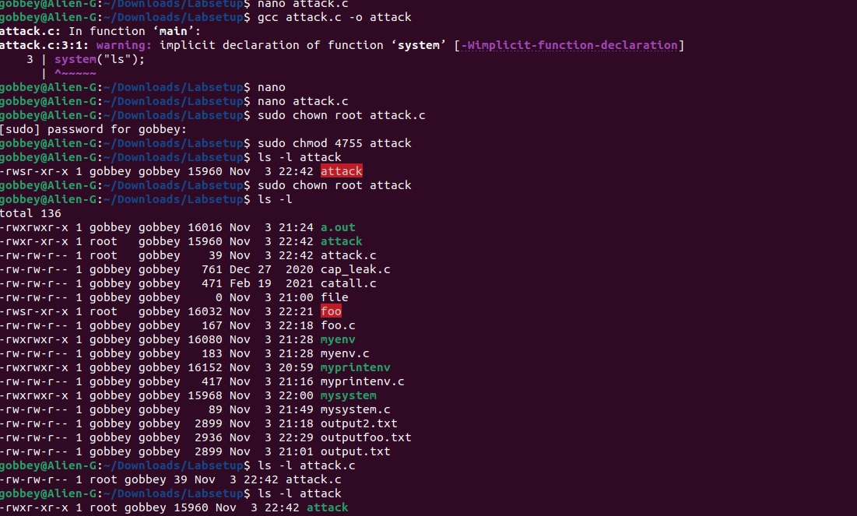
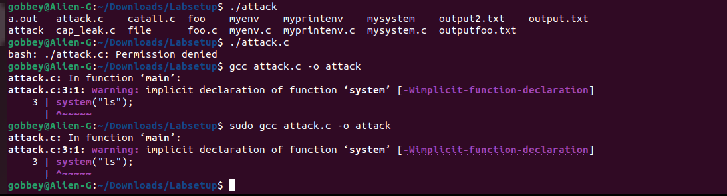
This is the code for me trying to make a malicious code and to attempt an attack. My attack did not work and I was met with a permission denied message. I was also not able to compile my program either. I am unsure if this attack had failed due to something I did not include, or just because Ubuntu had enough protection against the attack, but I am leaning towards the reasoning that I did not conduct the attack properly.

TASK 7:
Step 1:
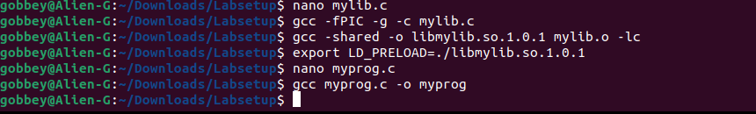
This is the code snippet of me making the mylib.c and myprog.c programs, and compiling them both, and setting an environmental variable.

Step 2:
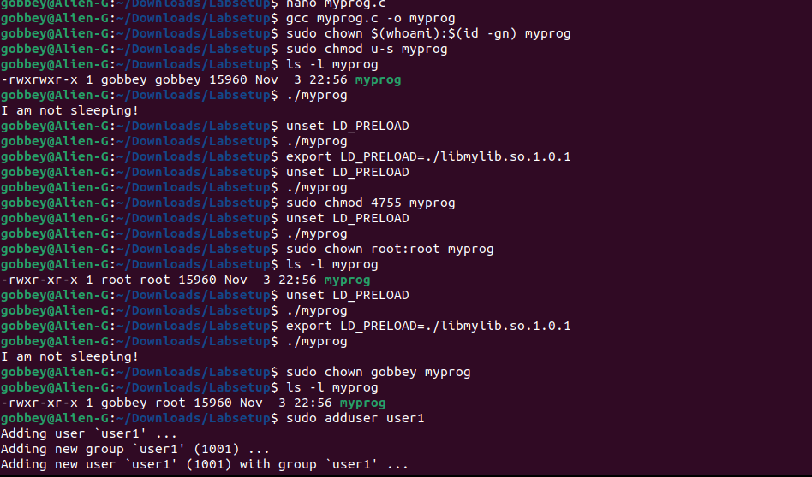
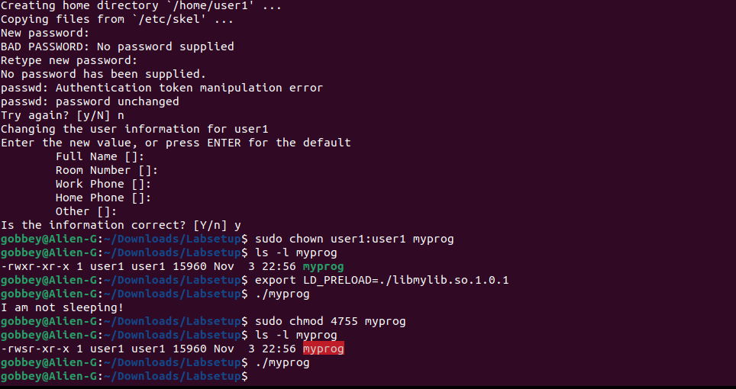
Regular program, regular user = No output
Set-UID root program, regular user = No output
Set-UID root program, LD_PRELOAD exported = “I am not sleeping!”
Set-UID user1 program, LD_PRELOAD exported = No output

I have observed that LD_PRELOAD successfully overrides functions for normal dynamically linked programs when exported in the invoking shell.

Step 3:
The difference is caused by Set-UID privilege changes, which makes the loader ignore LD environment variables, so the child process does not inherit them. The experiment could be to run myprog with and without LD_PRELOAD as a normal user, then turn it into a Set-UID with the owner being root or another user, and observe that preload only works with the normal program.

TASK 8:
Step 1:
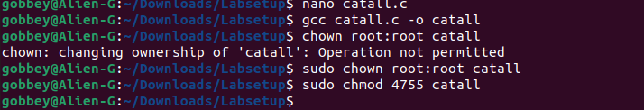
If I were Bob, I could compromise the integrity of the system. By using system(command) with command being from a user, it makes the Set-UID program vulnerable to command injection from the shell.

Step 2:
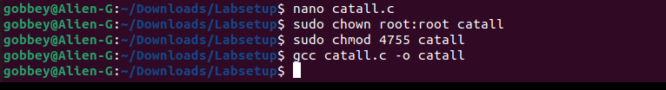
By replacing system() with execve(), the program no longer invokes a shell, so a simple shell command injection attack is no longer possible. I have learned from this that you should never pass untrusted strings to system() in privileged programs, and you should use execve() with absolute paths and to avoid Set-UID where you can.

TASK 9:
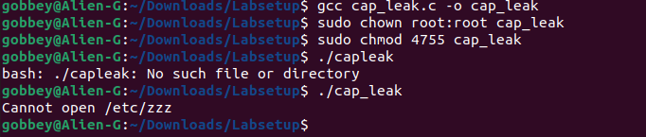
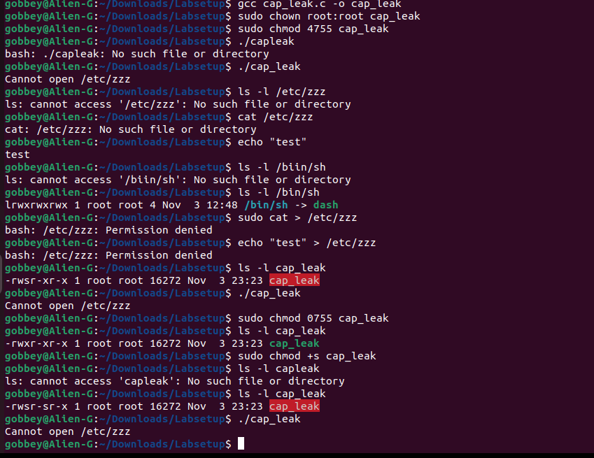
I cannot exploit the capability leaking in this program, but I do know it is possible. I once again think it is my strategy and sequencing that is the reason I cannot exploit the vulnerability. Also I may not have all the knowledge I require to complete it either.

