Test 1:

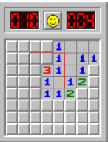

{-2, -2, -2, -2, 1, 0, 0, 0},

{-2, -2, -2, -2, 1, 0, 1, 1},

{-2, -2, -2, 3, 1, 0, 1, -2},

{-2, -2, -2, 1, 0, 1, 2, -2},

{-2, -2, -2, 1, 1, 2, -2, -2},

{-2, -2, -2, -2, -2, -2, -2, -2},

{-2, -2, -2, -2, -2, -2, -2, -2},

{-2, -2, -2, -2, -2, -2, -2, -2}

Output:

panels that will be flagged:

(3, 1)

(7, 2)

(6, 4)

panels that will be revealed:

Test 2:

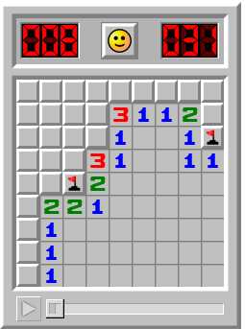

{-2, -2, -2, -2, -2, -2, -2, -2, -2},

{-2, -2, -2, -2, 3, 1, 1, 2, -2},

{-2, -2, -2, -2, 1, 0, 0, 1, -1},

{-2, -2, -2, 3, 1, 0, 0, 1, 1},

{-2, -2, -1, 2, 0, 0, 0, 0, 0},

{-2, 2, 2, 1, 0, 0, 0, 0, 0},

{-2, 1, 0, 0, 0, 0, 0, 0, 0},

{-2, 1, 0, 0, 0, 0, 0, 0, 0},

{-2, 1, 0, 0, 0, 0, 0, 0, 0}

Output:

panels that will be flagged:

(3, 2)

(2, 3)

(1, 4)

panels that will be revealed:

(8, 1)