

**CREATE A BATCH FILE (RANOREX)**



## DOCUMENT HISTORY

**Document History**

|  |  |  |  |  |  |
| --- | --- | --- | --- | --- | --- |
| Version | Release Date | Author | Description of Change | Reviewed By | Approved By |
| 1.0 | 10-APR-2012 | Mayank Bothra | Initial Draft |  |  |

**Distribution List**

|  |
| --- |
| **Details** |
| All employees of Headstrong and its subsidiaries covered by the Headstrong Quality System.  Mode of distribution will be through the HQ. <https://hq.headstrong.com/index.cfm> . This document is controlled through a configuration management tool by Corporate Quality Manager and its revisions are identified by its version number. |

**Reference Documents**

|  |
| --- |
| **Document Name** |
|  |
|  |
|  |

## 1.1 ABOUT RANOREX

**Ranorex** is a Windows GUI test automation framework for testing many different application types including **Web 2.0 applications, HTML5, Silverlight, Qt, Win32, MFC, WPF, Flash/Flex, .NET** and **Java (SWT)**. Ranorex doesn't have a scripting language of its own. The user can use the functionalities of the programming languages like C# and VB.NET as a base, and enlarge it with the GUI automation functionality of Ranorex.

## 1.2 HOW TO CREATE A BATCH FILE

Follow the steps as mentioned to create a batch file which can be scheduled using a scheduler:

* Open the main directory(folder) where the test solution(.rxsln) is placed.

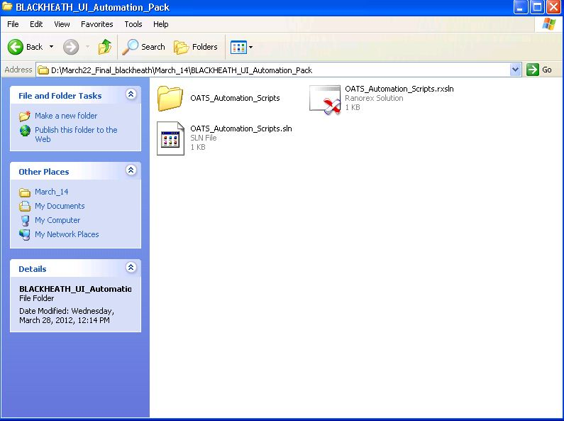

* Click on the folder with the solution name.

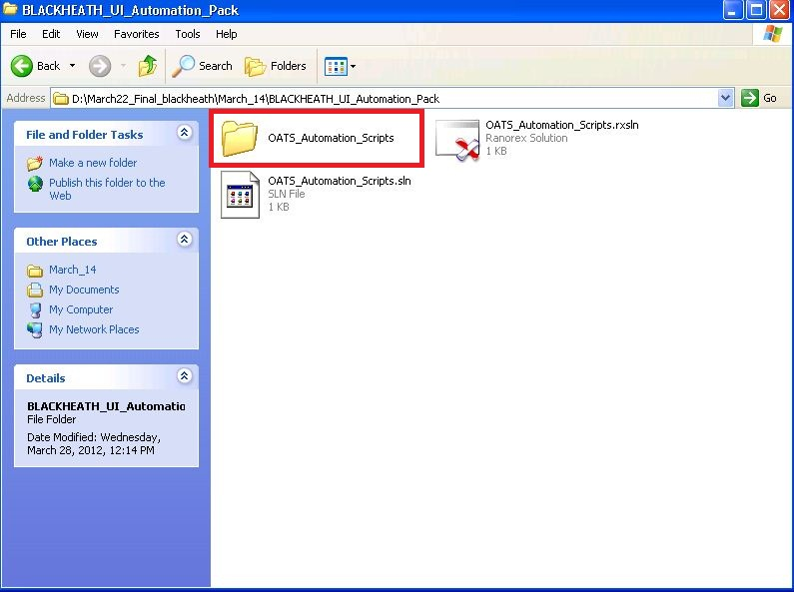

* Click on the bin folder residing under the solution folder

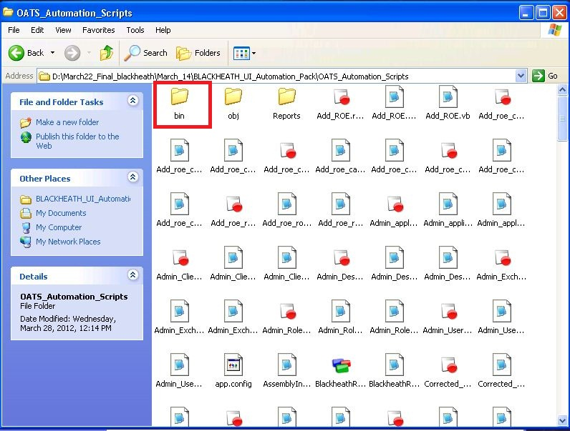

* Click on the debug folder residing under the bin folder.

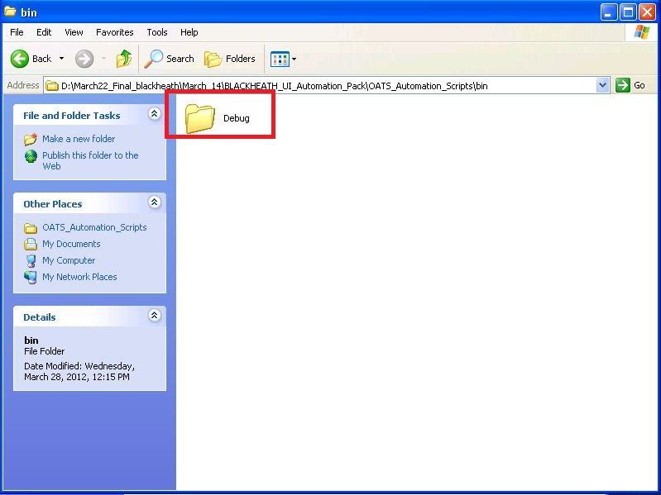

* Check for the .exe file under the Debug folder (same name as the solution).

Example- OATS_Automation_Scripts.exe

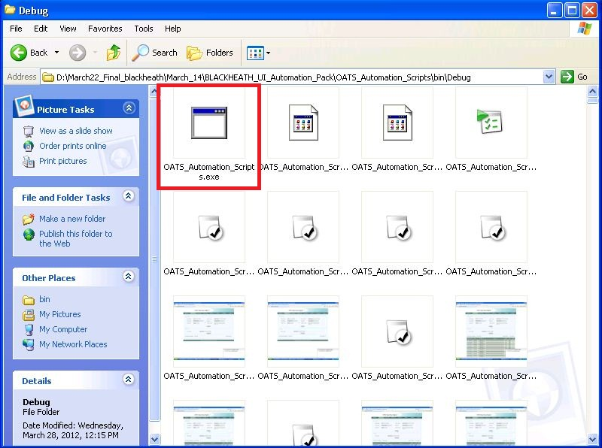

* Copy the entire path of the .exe file (under Debug folder) to a notepad file.

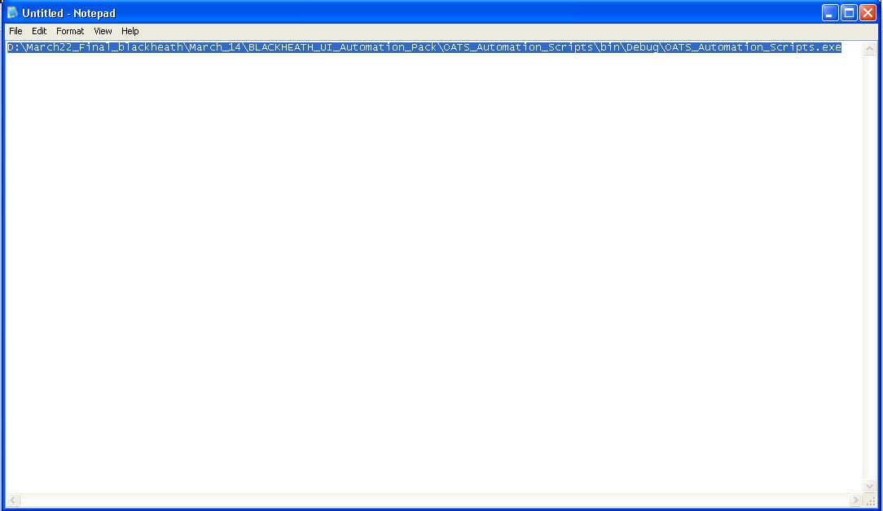

* Save the file as a batch file (.bat). The batch file can be scheduled using a windows scheduler to run the scripts at a particular time.