

**Ranorex report to bugzilla CSV converter** - TESt AUTOMATION guide



## DOCUMENT HISTORY

**Document History**

|  |  |  |  |  |  |
| --- | --- | --- | --- | --- | --- |
| Version | Release Date | Author | Description of Change | Reviewed By | Approved By |
| 1.0 | 10-APR-2012 | Mayank Bothra | Initial Draft |  |  |

**Distribution List**

|  |
| --- |
| **Details** |
| All employees of Headstrong and its subsidiaries covered by the Headstrong Quality System.  Mode of distribution will be through the HQ. <https://hq.headstrong.com/index.cfm> . This document is controlled through a configuration management tool by Corporate Quality Manager and its revisions are identified by its version number. |

**Reference Documents**

|  |
| --- |
| **Document Name** |
|  |
|  |
|  |

## 1.1 ABOUT RANOREX

**Ranorex** is a Windows GUI test automation framework for testing many different application types including **Web 2.0 applications, HTML5, Silverlight, Qt, Win32, MFC, WPF, Flash/Flex, .NET** and **Java (SWT)**. Ranorex doesn't have a scripting language of its own. The user can use the functionalities of the programming languages like C# and VB.NET as a base, and enlarge it with the GUI automation functionality of Ranorex.

## 1.2EXISTING RANOREX SUITES

The document covers on how to run the following Ranorex Test Solutions-

* Ranorex report to Bugzilla CSV Converter.

## 1.3 PREREQUISITES

The understated conditions need to be fulfilled in order to run the Automation packs:

* DB should be cleared and proper automation data should be pushed.
* A local copy of the scripts needs to be taken if the scripts are located on a shared location and the user should run the scripts from the local machine.
* Current version of the Application under test should be open.
* Multiple instances of the Application under test should not be opened.
* SWF files need to be added in the Webapps folder under the Tomcat directory when Flex/Flash applications need to be tested.
* The screen should not be locked/minimized when the scripts are executing which will lead to the tool not identifying the objects.
* Make sure that the view size in the browser is 100%.
* The Application under Test should not be on a remote machine since the tool is unable to identify objects on a Remote Machine.
* The browser view should not be full screen before running any of the packs and should be normal (100%).

## 1.4 GETTING STARTED- Steps to run the Test Solution

The following steps need to be followed in order to run any of the Automation test solutions successfully:

**Step 1-Double click and open the Ranorex solution file (.rxsln)**

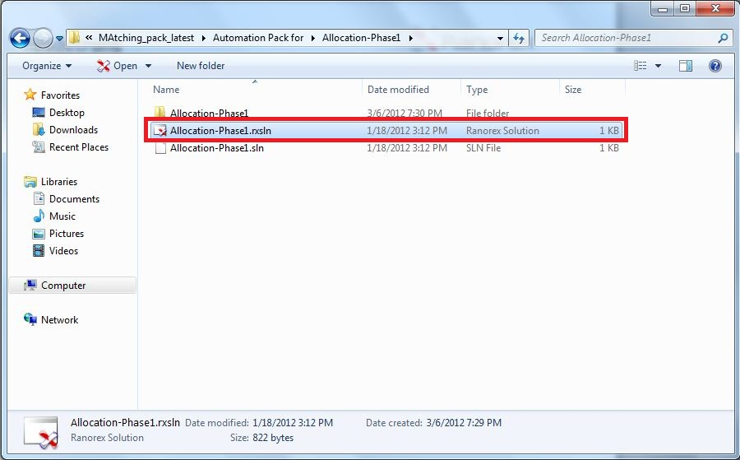

After double clicking, the following test panel opens up in Ranorex Studio.

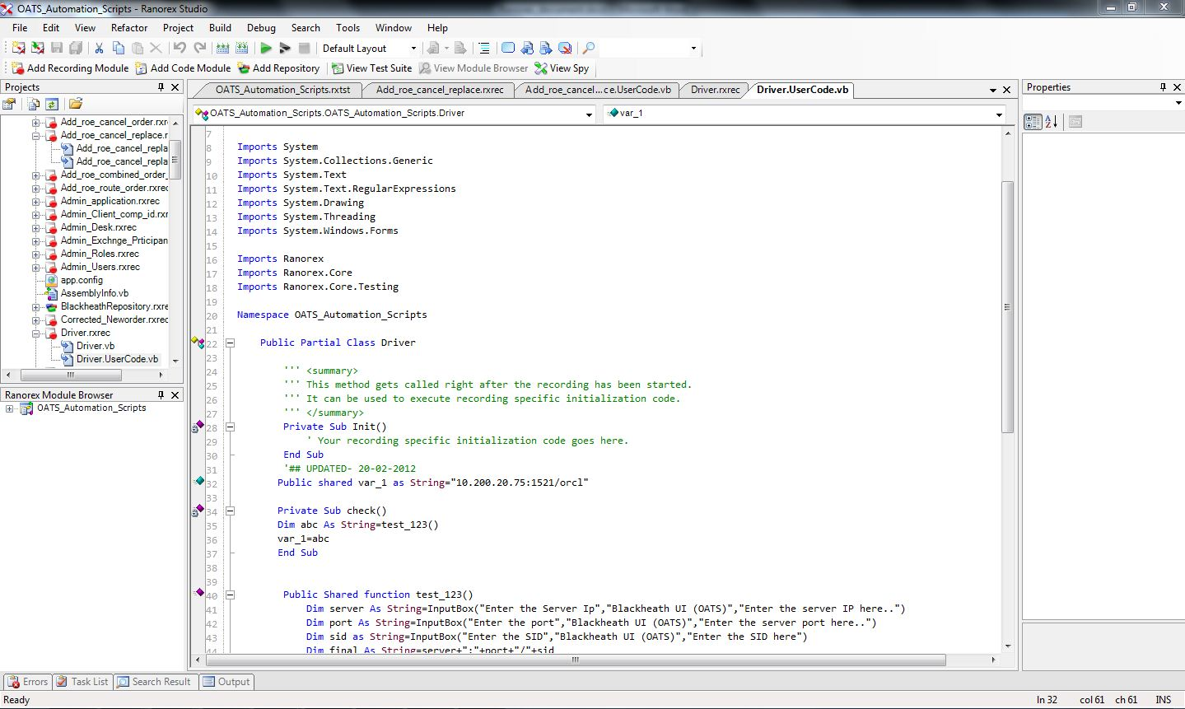

**Step 2-Click on the VIEW TEST SUITE option.**

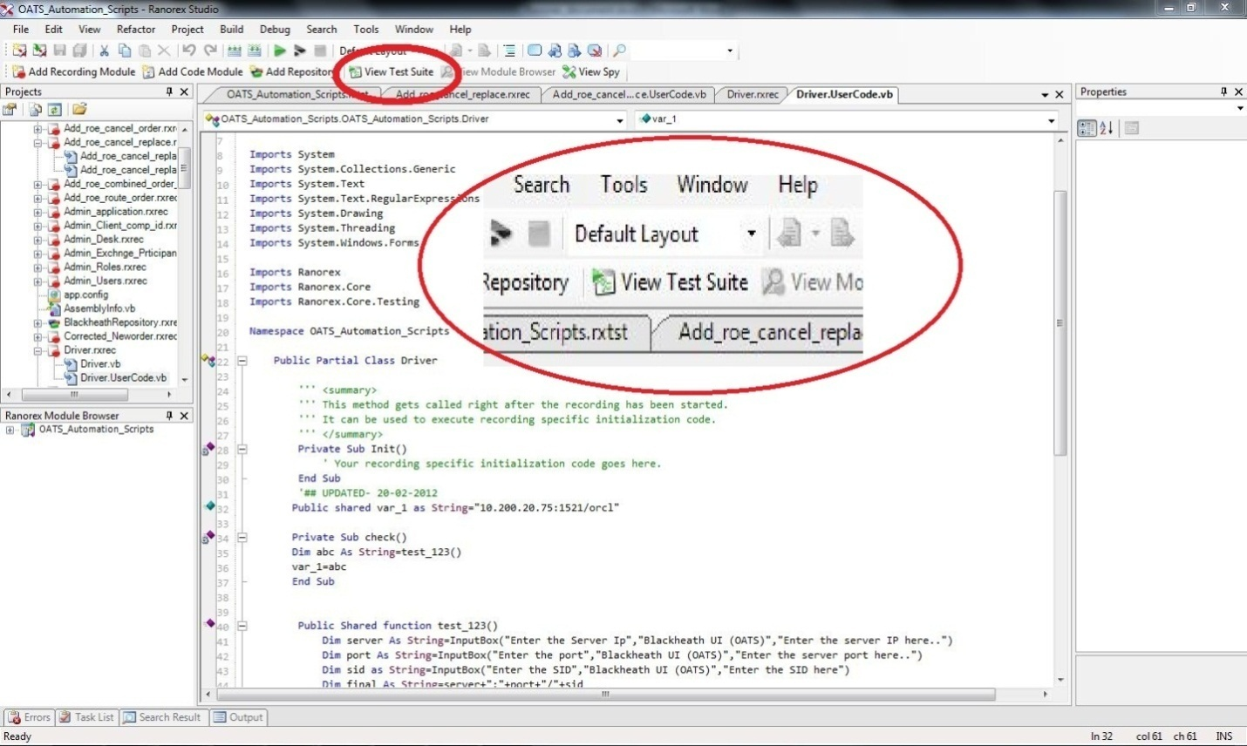

A branched view of the Test Suite should appear as follows –

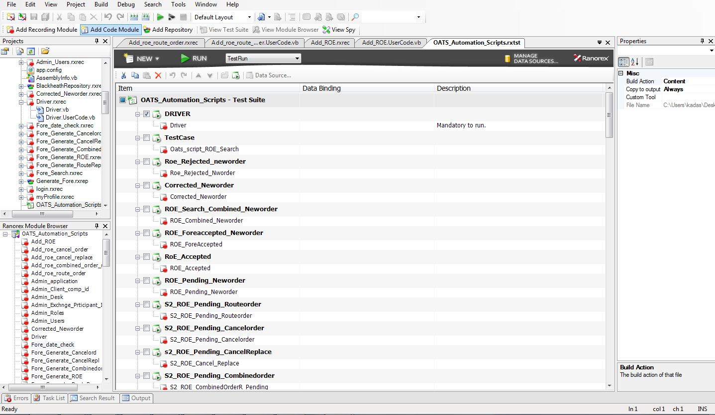

The Test Suite allows the user to check the Test Cases to be executed.

**Step 3-Check the main Parent checkbox.**

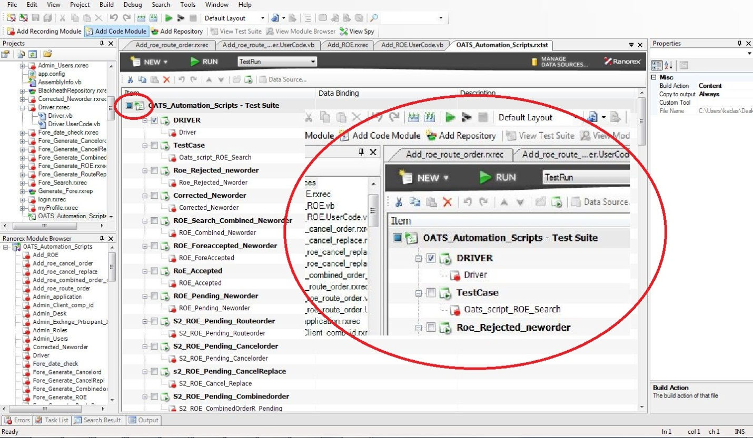

Once the Parent Checkbox is checked, all the child test cases falling under the Parent test case gets checked.

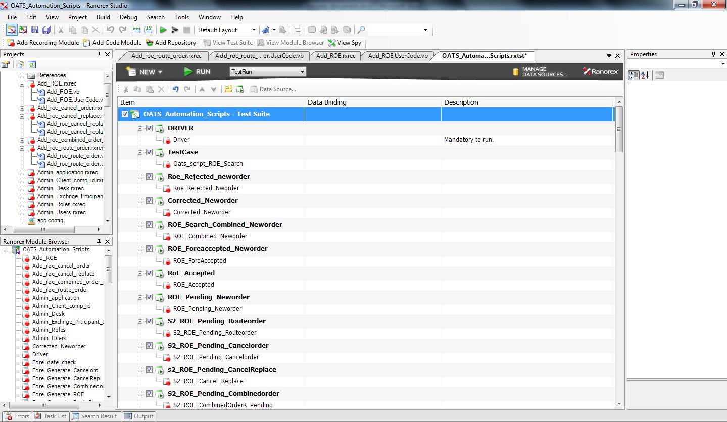

**Step 4-Click on the Run Button or Press F5 key.**

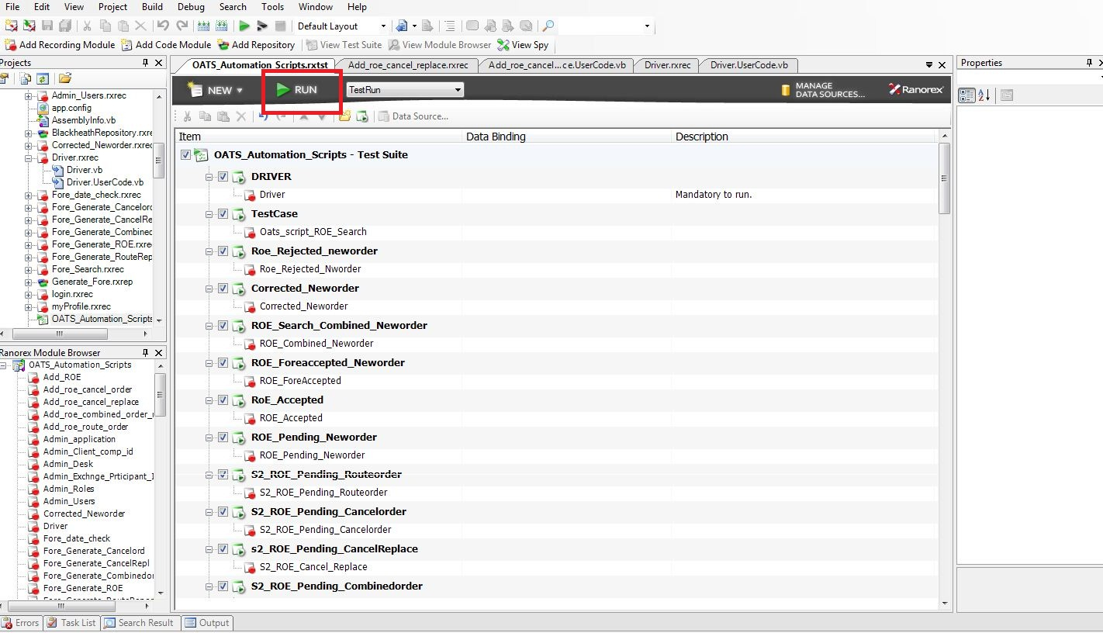

After pressing the Run button, Ranorex builds the solution and compiles the code.

**Step 5-Enter the entire path of the Report generated.**

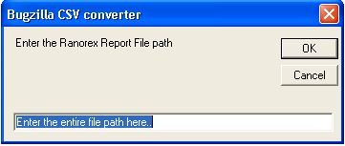**.**

**Example**: D:\Configuration\Configuration\Reports\Configuration_20120327_195500.rxlog

After specifying the report path, a CSV file is generated which is compatible with Bugzilla. A pop up appears specifying the location path of the CSV file generated.

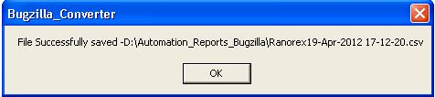

A CSV file is generated with a short description of all the bugs/issues encountered.

