

**TEEVRA** and **Blackheath (UI)** - TESt AUTOMATION DEBUGGING guide



## DOCUMENT HISTORY

**Document History**

|  |  |  |  |  |  |
| --- | --- | --- | --- | --- | --- |
| Version | Release Date | Author | Description of Change | Reviewed By | Approved By |
| 1.0 | 10-APR-2012 | Mayank Bothra | Initial Draft |  |  |

**Distribution List**

|  |
| --- |
| **Details** |
| All employees of Headstrong and its subsidiaries covered by the Headstrong Quality System.  Mode of distribution will be through the HQ. <https://hq.headstrong.com/index.cfm> . This document is controlled through a configuration management tool by Corporate Quality Manager and its revisions are identified by its version number. |

**Reference Documents**

|  |
| --- |
| **Document Name** |
|  |
|  |
|  |

## 1.1 USER CODE FOR TEST CASES

* To **check if any of the functions/subs are called for a particular test case in the test suite**, double click on the recording module (.rxrec) under the Projects panel. A panel opens up displaying all the functions and subs which are called within the user code.

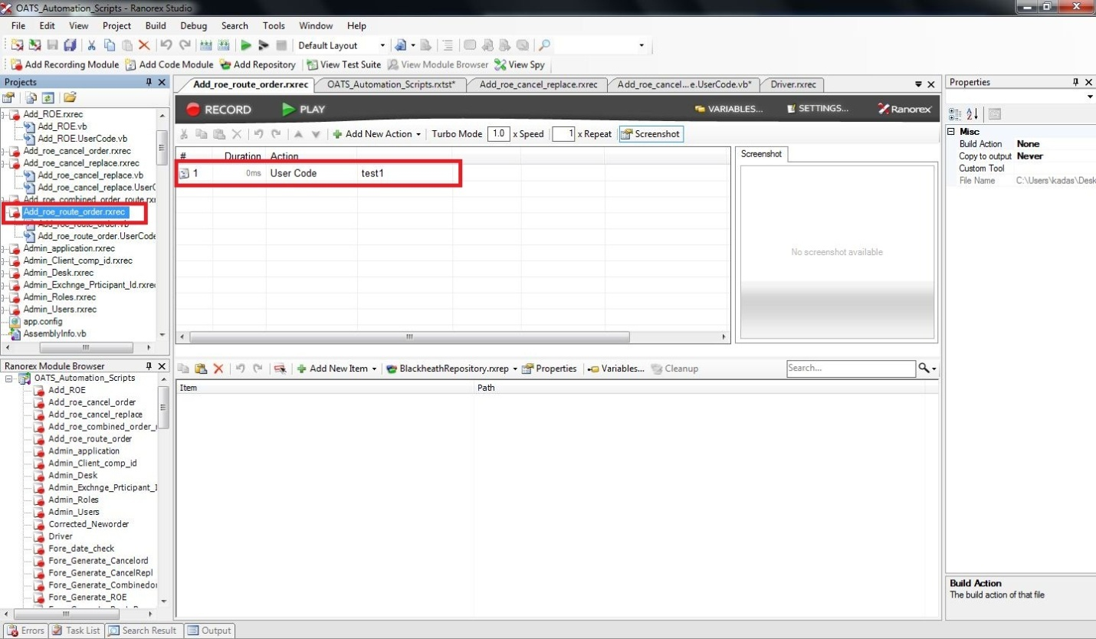

* To **access any of the user code** expand (plus sign) the recording module under the projects panel and double click on the usercode file(with the extension .usercode.vb)

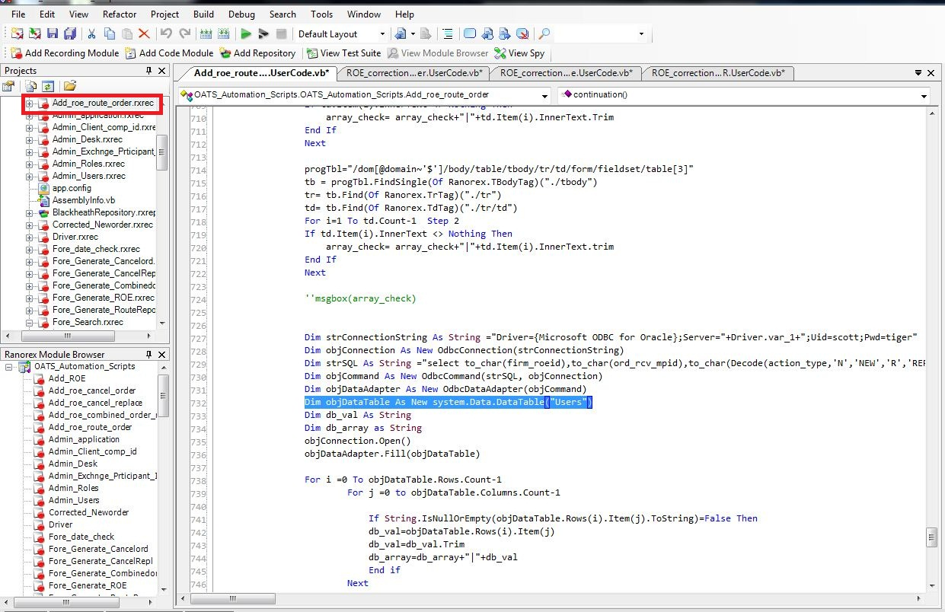

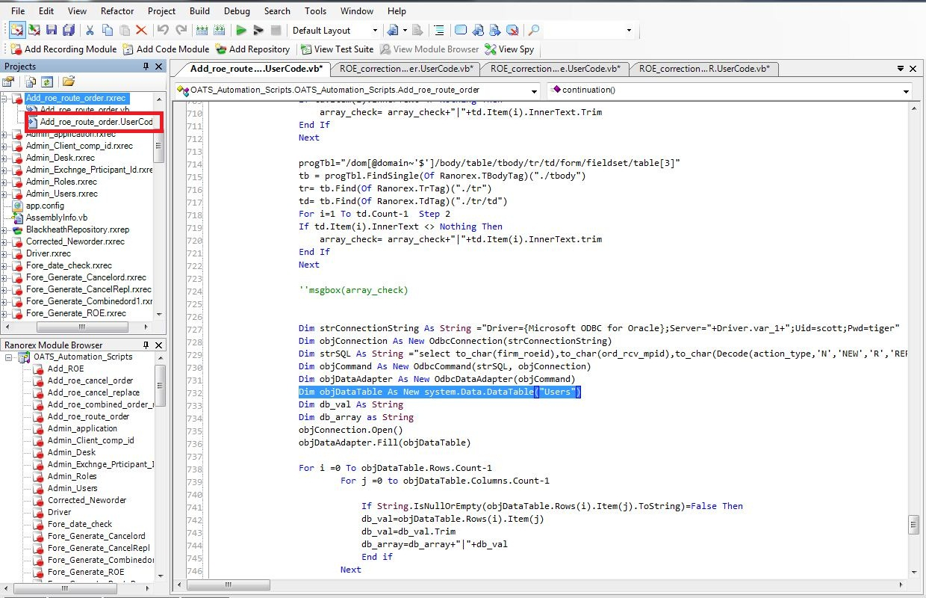

* All the **functions/subs called within the code are placed in the same usercode** file below the main sub, usually at the bottom.

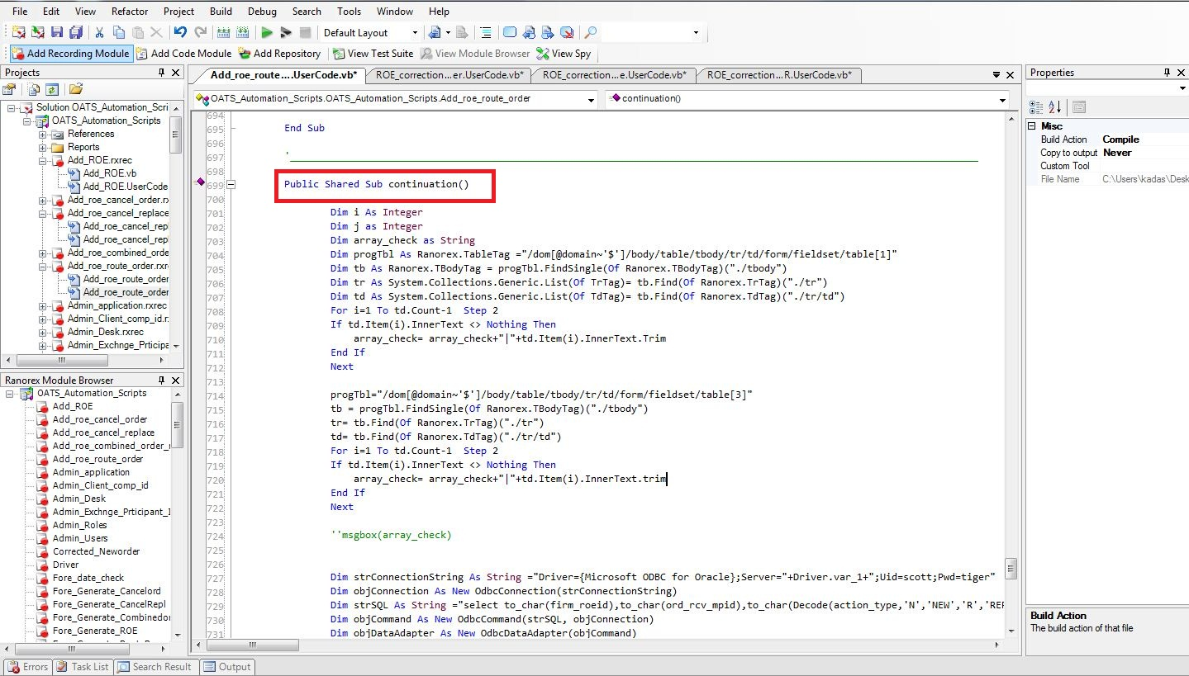

* To **debug any of the scripts** which have failed, go to the report generated and check the step where the test case has failed. Go to the top-right panel of the failed step and click on ‘**Jump to Item’** which will take the user to the code for the same step.

