

**TEEVRA** and **Blackheath (UI)** - TESt AUTOMATION guide



## DOCUMENT HISTORY

**Document History**

|  |  |  |  |  |  |
| --- | --- | --- | --- | --- | --- |
| Version | Release Date | Author | Description of Change | Reviewed By | Approved By |
| 1.0 | 10-APR-2012 | Mayank Bothra | Initial Draft |  |  |

**Distribution List**

|  |
| --- |
| **Details** |
| All employees of Headstrong and its subsidiaries covered by the Headstrong Quality System.  Mode of distribution will be through the HQ. <https://hq.headstrong.com/index.cfm> . This document is controlled through a configuration management tool by Corporate Quality Manager and its revisions are identified by its version number. |

**Reference Documents**

|  |
| --- |
| **Document Name** |
|  |
|  |
|  |

## 1.1 ABOUT RANOREX

**Ranorex** is a Windows GUI test automation framework for testing many different application types including **Web 2.0 applications, HTML5, Silverlight, Qt, Win32, MFC, WPF, Flash/Flex, .NET** and **Java (SWT)**. Ranorex doesn't have a scripting language of its own. The user can use the functionalities of the programming languages like C# and VB.NET as a base, and enlarge it with the GUI automation functionality of Ranorex.

## 1.2EXISTING RANOREX SUITES

The document covers on how to run the following Ranorex Test Solutions-

* Teevra Matching Sanity Pack ( EUREX, ICE and LIFFE)
* Teevra Matching Regression Pack ( EUREX, ICE and LIFFE)
* Teevra Matching Configuration Pack
* Teevra Matching Pagination Pack
* Teevra Allocations Pack
* Teevra Matching TVLC Pack
* Teevra Matching Archival Pack
* Teevra Matching Normalization Pack (LIFFE)
* Blackheath (UI) Dump insertion Pack
* Blackheath (UI) Automation Pack

## 1.3 PREREQUISITES

The understated conditions need to be fulfilled in order to run the Automation packs:

* DB should be cleared and proper automation data should be pushed.
* A local copy of the scripts needs to be taken if the scripts are located on a shared location and the user should run the scripts from the local machine.
* Current version of the Application under test should be open.
* Multiple instances of the Application under test should not be opened.
* SWF files need to be added in the Webapps folder under the Tomcat directory when Flex/Flash applications need to be tested.
* The screen should not be locked/minimized when the scripts are executing which will lead to the tool not identifying the objects.
* Make sure that the view size in the browser is 100%.
* The Application under Test should not be on a remote machine since the tool is unable to identify objects on a Remote Machine.
* The browser view should not be full screen before running any of the packs and should be normal (100%).

## 1.4 GETTING STARTED- Steps to run the Test Solution

The following steps need to be followed in order to run any of the Automation test solutions successfully:

**Step 1-Double click and open the Ranorex solution file (.rxsln)**

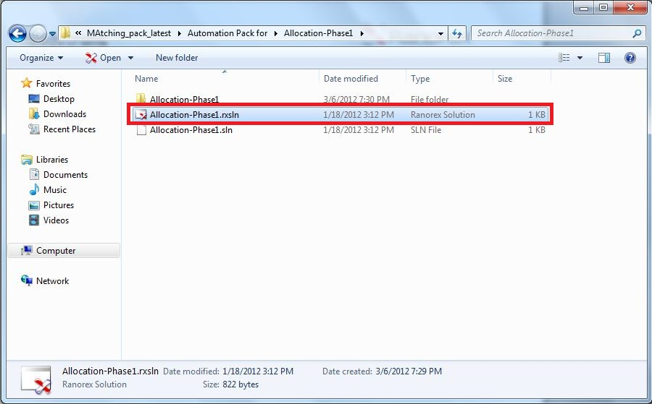

After double clicking, the following test panel opens up in Ranorex Studio.

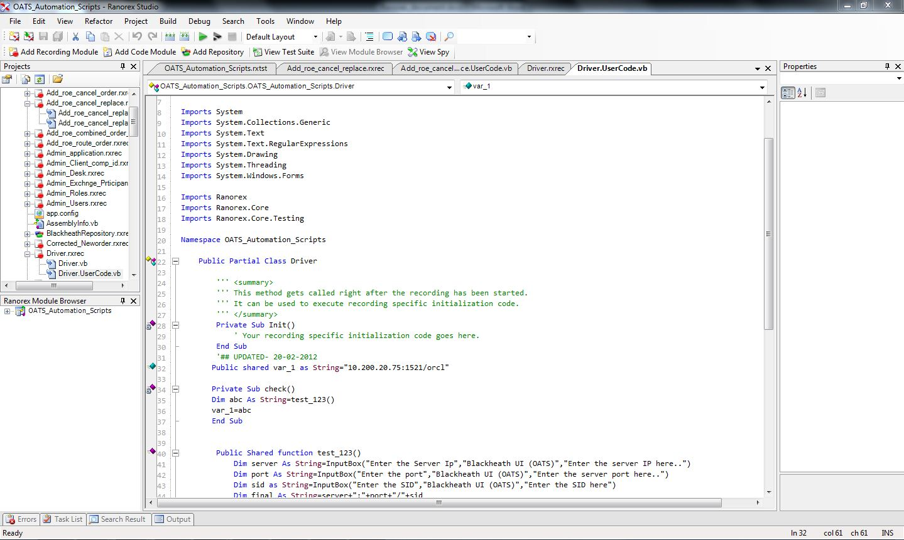

**Step 2-Click on the VIEW TEST SUITE option.**

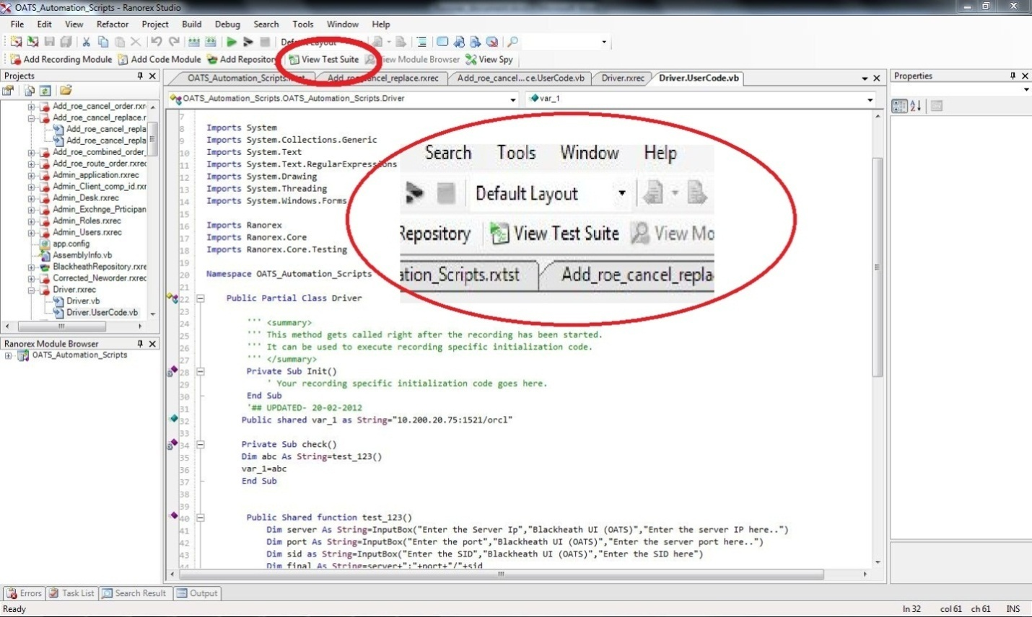

A branched view of the Test Suite should appear as follows –

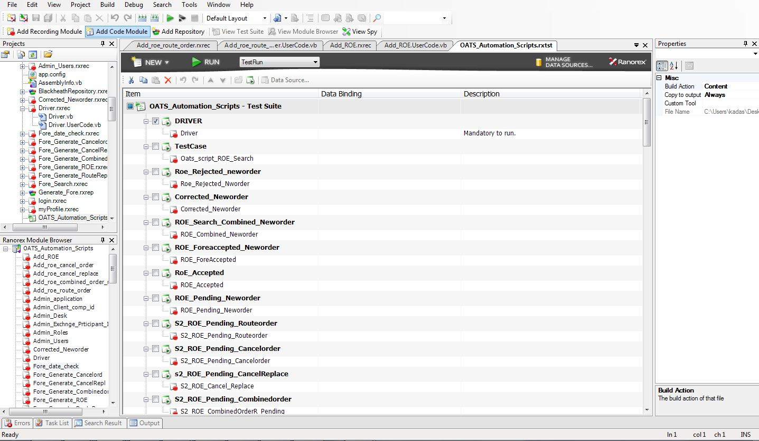

The Test Suite allows the user to check the Test Cases to be executed.

**Step 3-Check the main Parent checkbox.**

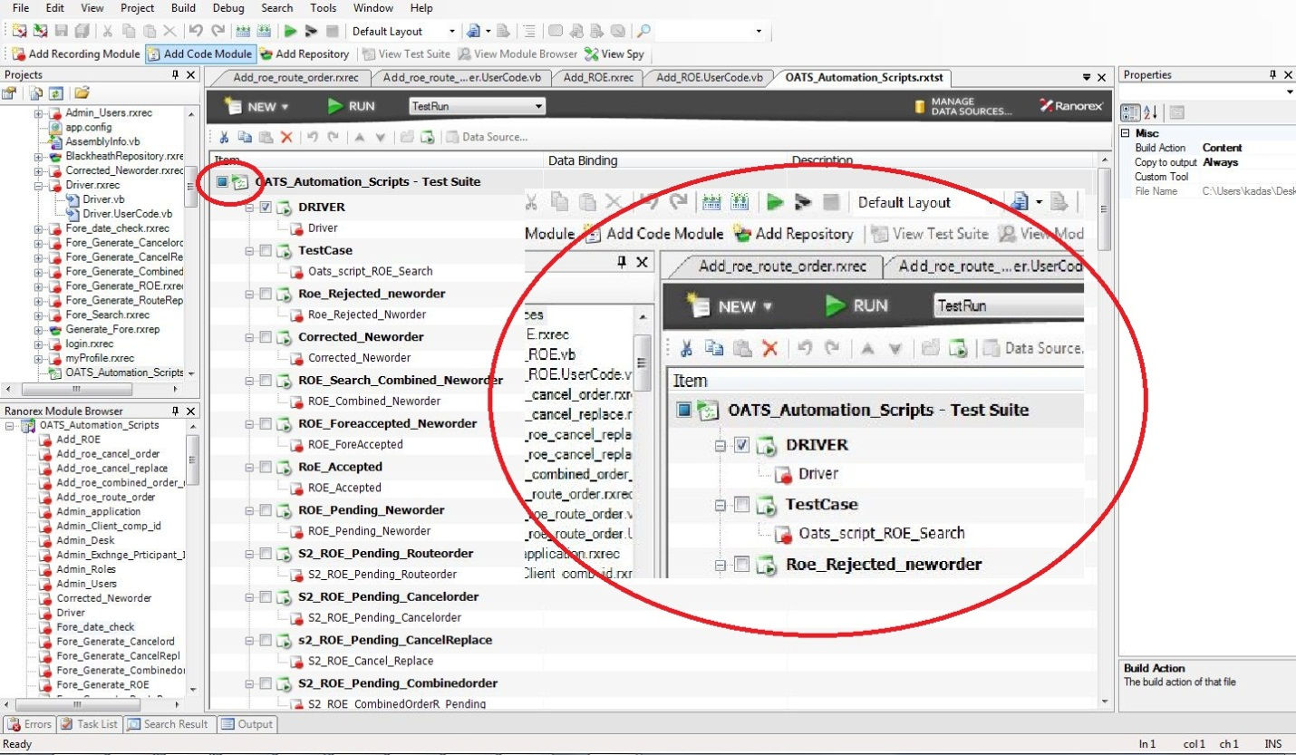

Once the Parent Checkbox is checked, all the child test cases falling under the Parent test case gets checked.

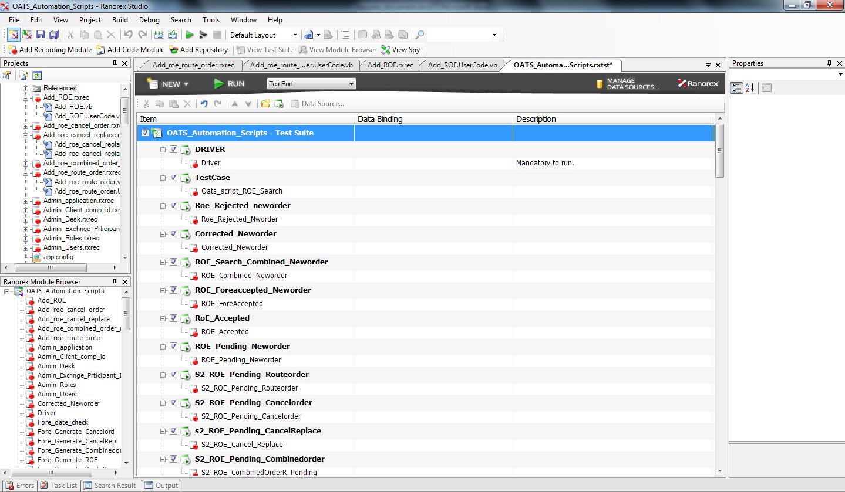

**Step 4-Click on the Run Button or Press F5 key.**

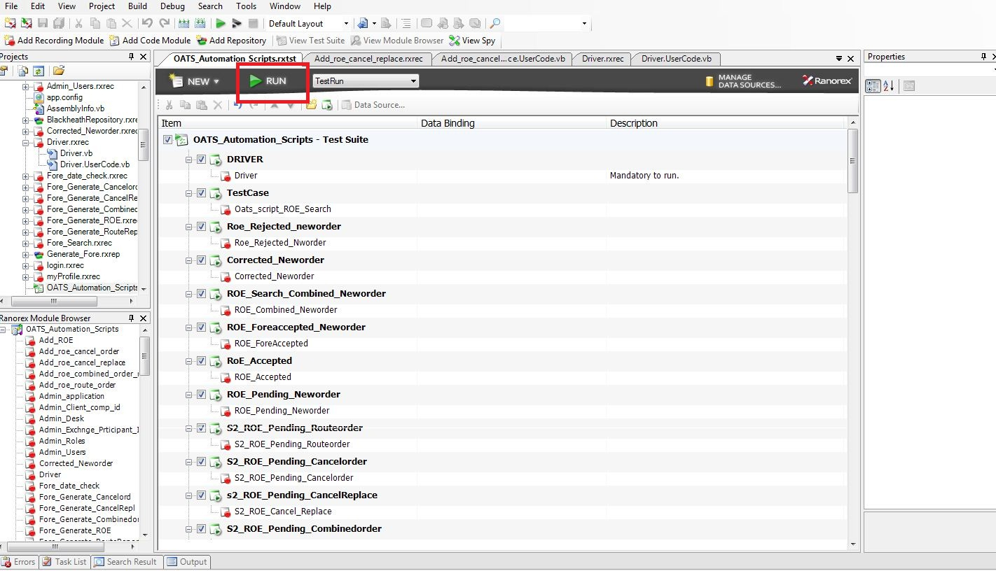

After pressing the Run button, Ranorex builds the solution and compiles the code.

**Step 5-Enter the Database Server IP for the Application under Test.**

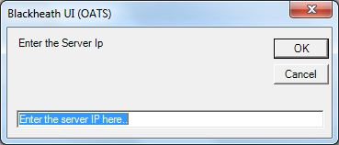

Example: 10.200.20.85

**Step 6-Enter the Port Number for the Database Server for the Application under Test.**

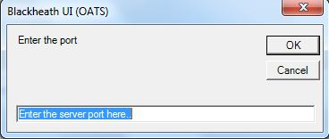

Example: 1521

**Step 7-Enter the SID for the Database Server for the Application under Test.**

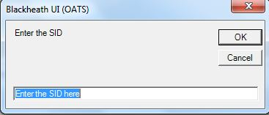

Example: orcl

**Step 8*-Enter the market for which Sanity/Regression needs to be done (ONLY FOR TEEVRA MATCHING).**

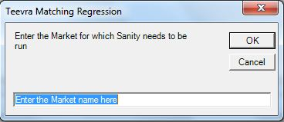

For Teevra Matching, three Markets have been added till date, namely- EUREX, ICE and LIFFE.

The same needs to be added here.

Example: EUREX

The tool will execute the code only if no errors are encountered while compiling.

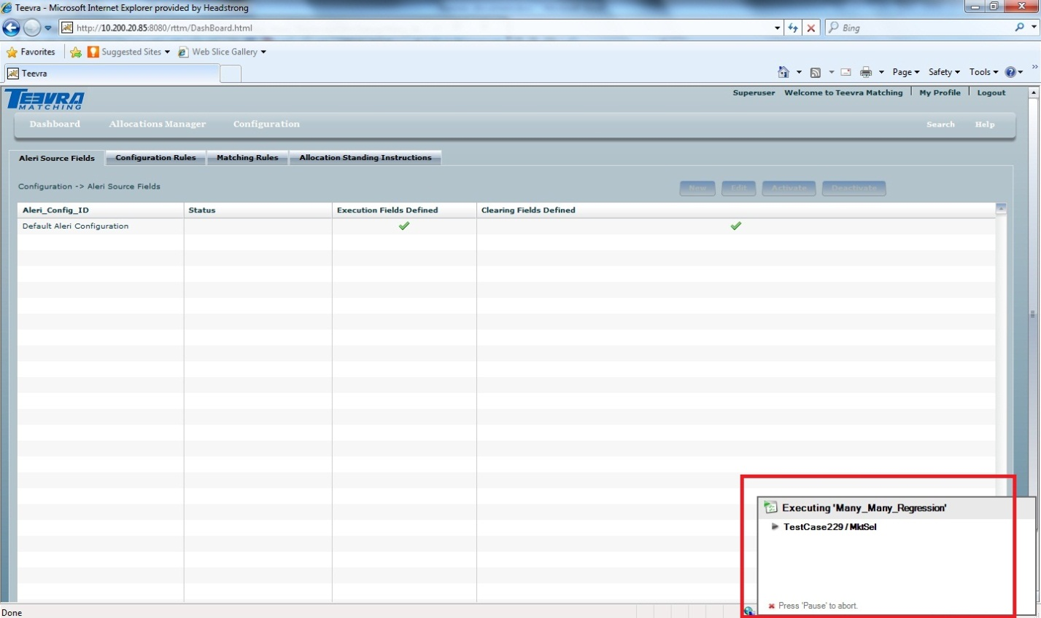

The user can abort the run by pressing Pause/Break key.

After entering all the necessary details, the tool will run all the Test Cases checked. A detailed report is generated after all the Test Cases are executed.

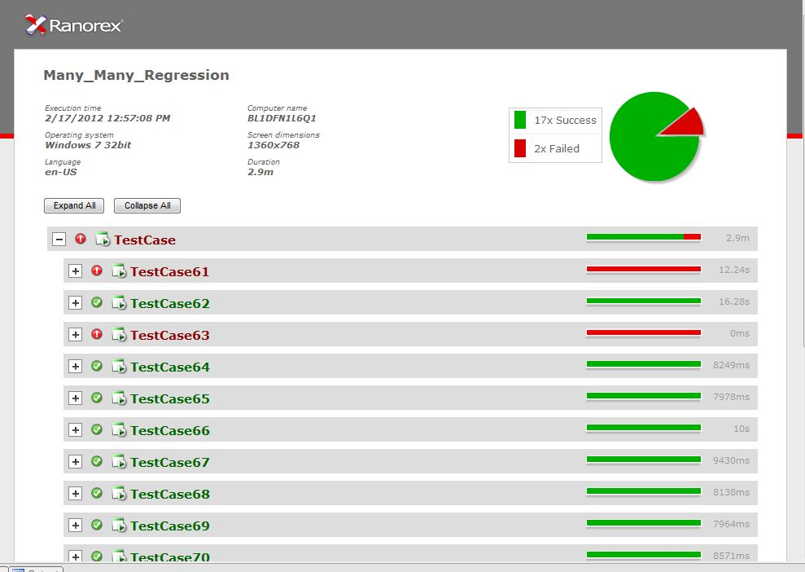

Further details are exhibited when the expand button for a particular Test Case is clicked.

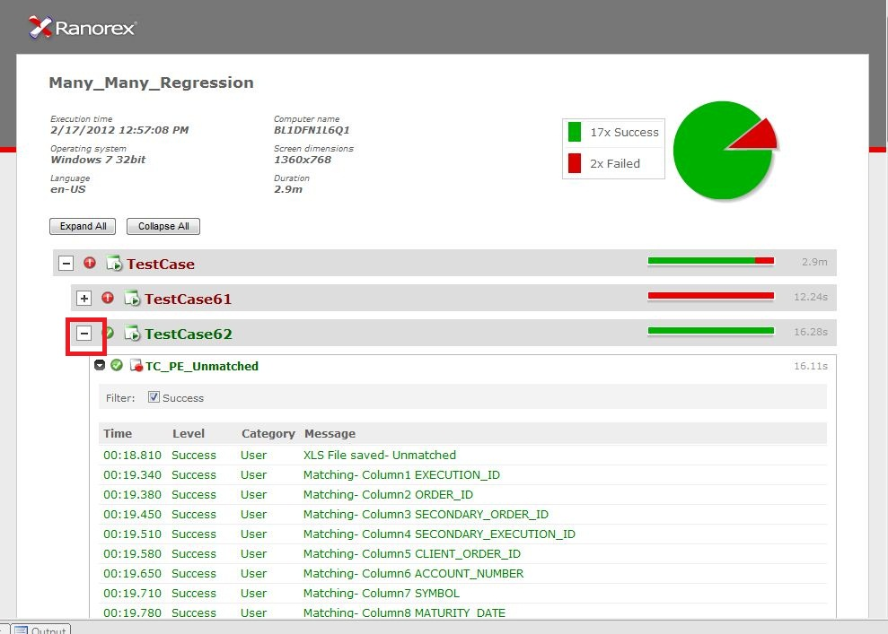

By default the Report generated is saved inside the Reports folder in the solution directory with the Timestamp attached to it. The report can also be saved manually.

**Step 9-Save the Report by right-clicking on the Report tab (.rxlog) and clicking on Save As...**

