

**TEEVRA** **Core** **(UI)** - TESt AUTOMATION guide





## DOCUMENT HISTORY

**Document History**

|  |  |  |  |  |  |
| --- | --- | --- | --- | --- | --- |
| Version | Release Date | Authors | Description of Change | Reviewed By | Approved By |
| 1.0 | 10-APR-2012 | Ramesh Sundaram &  Lalitha Sree Nowpada | Initial Draft |  |  |

**Distribution List**

|  |
| --- |
| **Details** |
| All employees of Headstrong and its subsidiaries covered by the Headstrong Quality System.  Mode of distribution will be through the HQ. <https://hq.headstrong.com/index.cfm> . This document is controlled through a configuration management tool by Corporate Quality Manager and its revisions are identified by its version number. |

**Reference Documents**

|  |
| --- |
| **Document Name** |
| TeevraGateways-Core-Regression-TestCases.xlsx |
|  |
|  |

## 1.1 ABOUT RANOREX

**Ranorex** is a Windows GUI test automation framework for testing many different application types including **Web 2.0 applications, HTML5, Silverlight, Qt, Win32, MFC, WPF, Flash/Flex, .NET** and **Java (SWT)**. Ranorex doesn't have a scripting language of its own. The user can use the functionalities of the programming languages like C# and VB.NET as a base, and enlarge it with the GUI automation functionality of Ranorex.

## 1.2 EXISTING RANOREX SUITES

The document covers on how to run the following Ranorex Test Solutions-

* Template_Creations
* Process_Creation
* UI_TC

## 1.3 PREREQUISITES

The understated conditions need to be fulfilled in order to run the Automation packs:

* DB should be cleared and the build should be newly installed on the DB.
* All the necessary DB Scripts for the build should be executed before running Scripts.
* Schemas and Server Admin should be created before running the test solutions.
* A local copy of the scripts needs to be taken if the scripts are located on a shared location and the user should run the scripts from the local machine.
* Current version of the Application under test should be open.
* Multiple instances of the Application under test should not be opened.
* SWF files need to be added in the Webapps folder under the Tomcat directory when Flex/Flash applications need to be tested.
* The screen should not be locked / minimized when the scripts are executing which will lead to the tool not identifying the objects.
* Make sure that the view size in the browser is 100% and open the Application under Test in Full Screen.
* The Application under Test should not be on a remote machine since the tool is unable to identify objects on a Remote Machine.

## 1.4 GETTING STARTED- Steps to run the Test Solution

The following steps need to be followed in order to run any of the Automation test solutions successfully:

**Step 1- Double click and open the Ranorex solution file (.rxsln)**

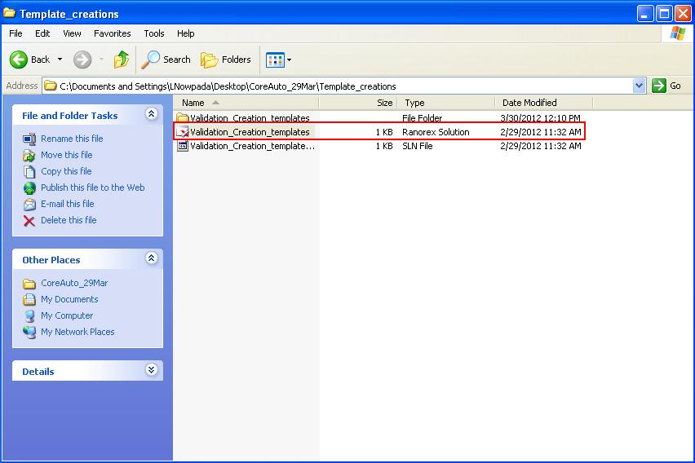

After double clicking, the following test panel opens up in Ranorex Studio.

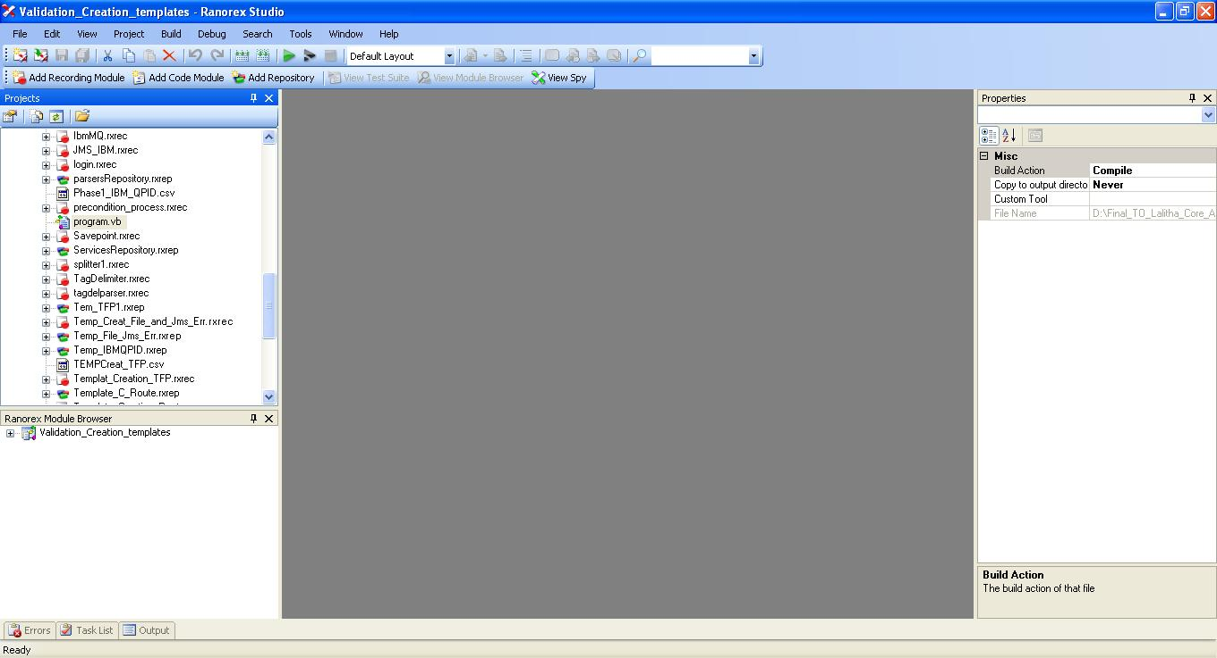

**Step 2- Click on the Program (.vb or .cs) file under the Projects panel.**

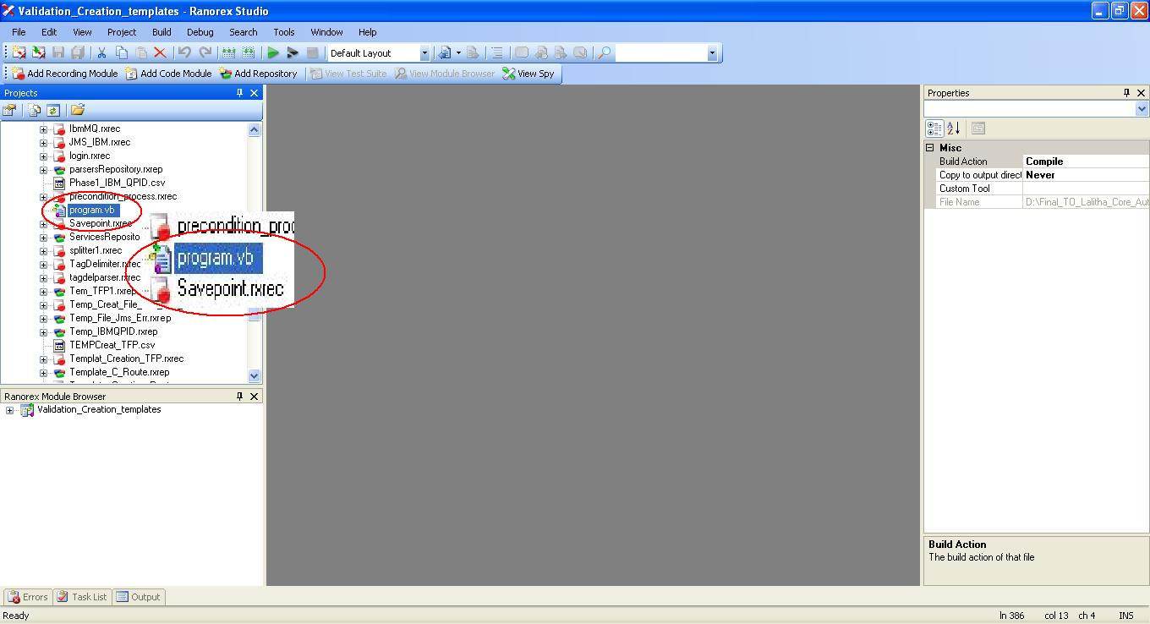

After double clicking on the program.vb or program.cs, the following program page will open. 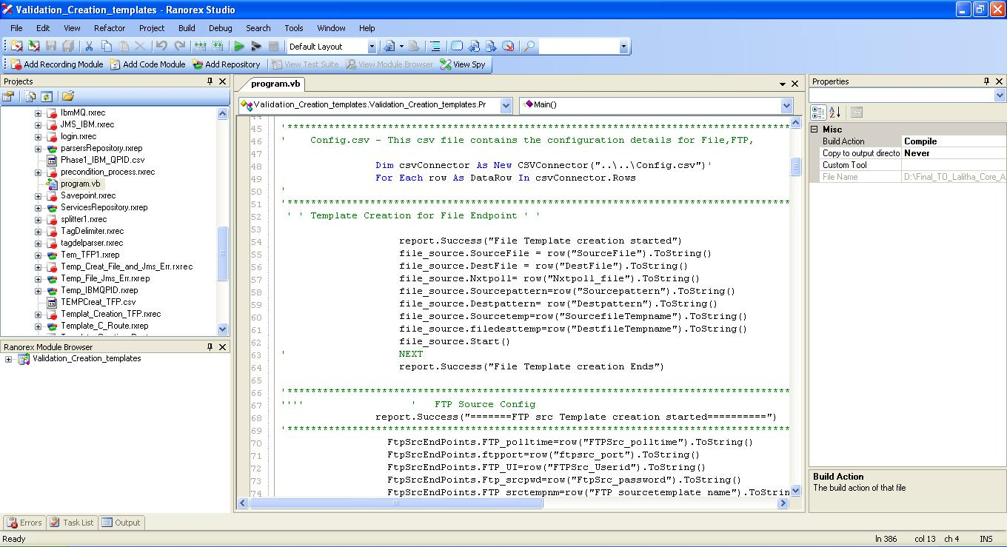

**Step-3 Open and edit the .csv file and give input details and save the .csv file**

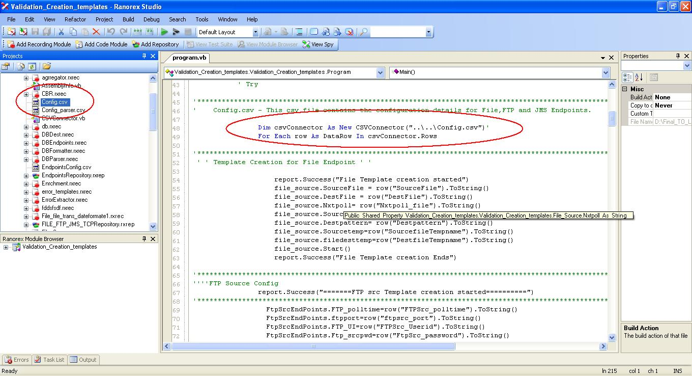

Double click on the Config.csv file to open it

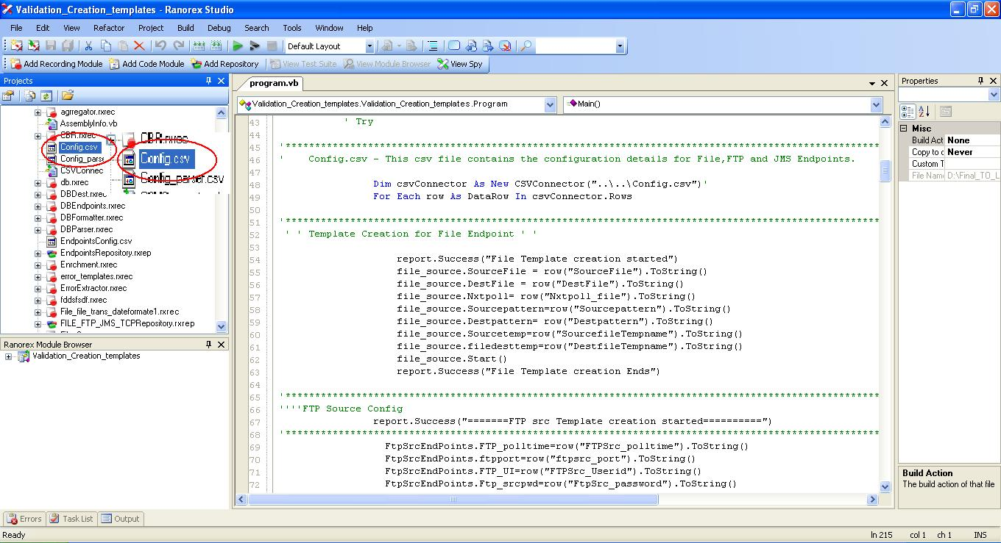

The Config.csv file which contains the input data opens as shown in below screen, make the necessary changes if needed and save it.

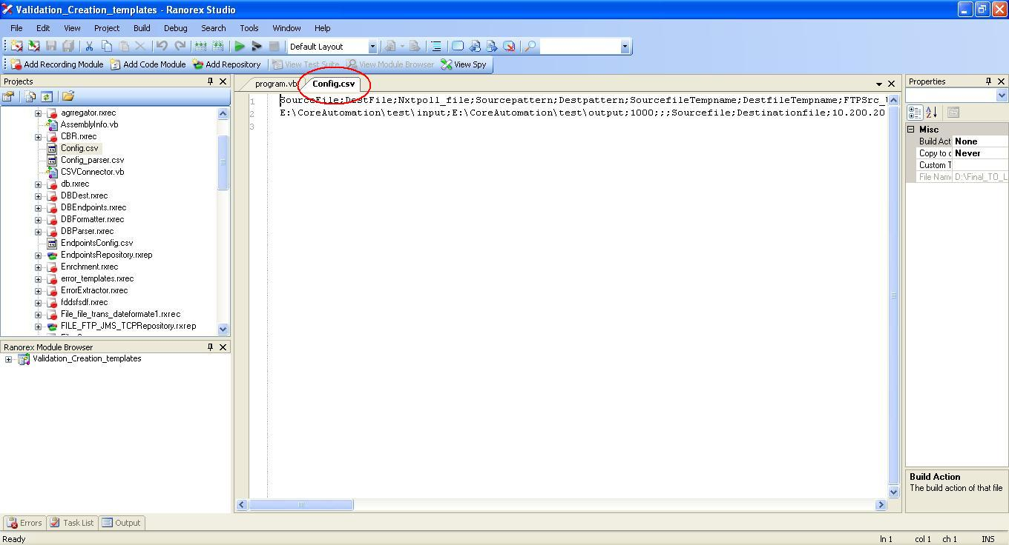

**Step 4- Click on the RUN Button.**

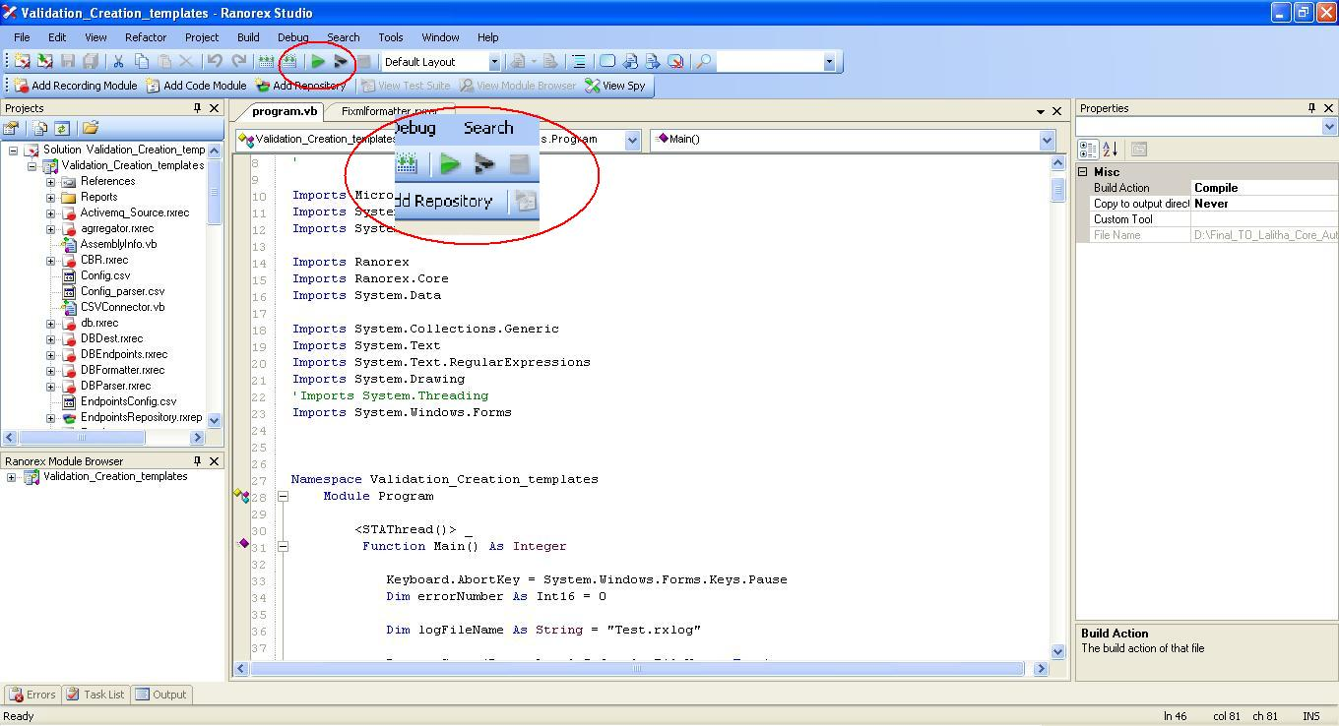

* After pressing the Run button, Ranorex builds the solution and compiles the code.
* The tool will execute the code only if no errors are encountered while compiling.
* The user can abort the run by pressing Pause/Break key.
* After clicking the run button, the tool will run all the Test Cases written in Program file.

A detailed report is generated after all the Test Cases are executed.

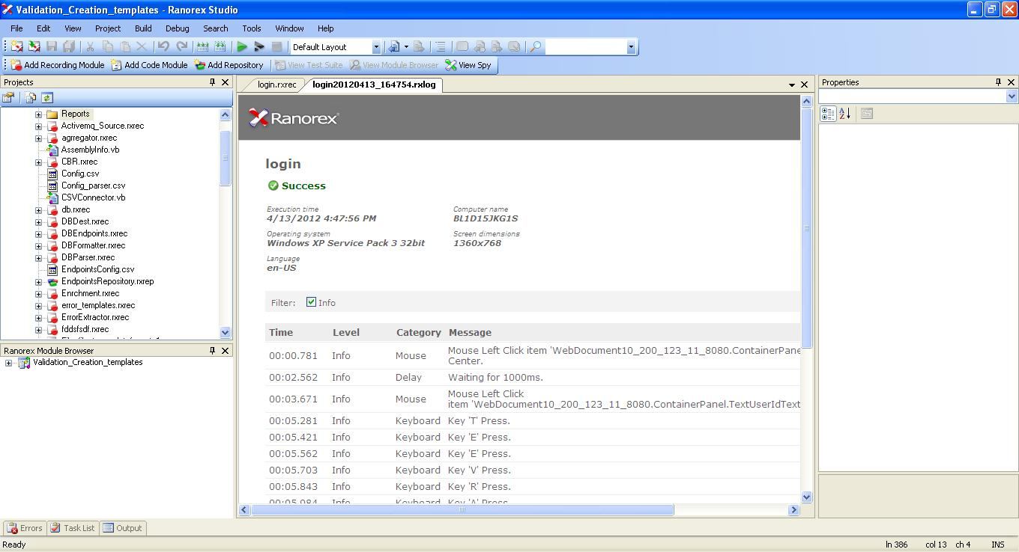

By default the Report generated is saved inside the Reports folder in the solution directory with the Timestamp attached to it. The report can also be saved manually.

**Step 5- Save the Report by right-clicking on the Report tab (.rxlog) and clicking on Save As...**

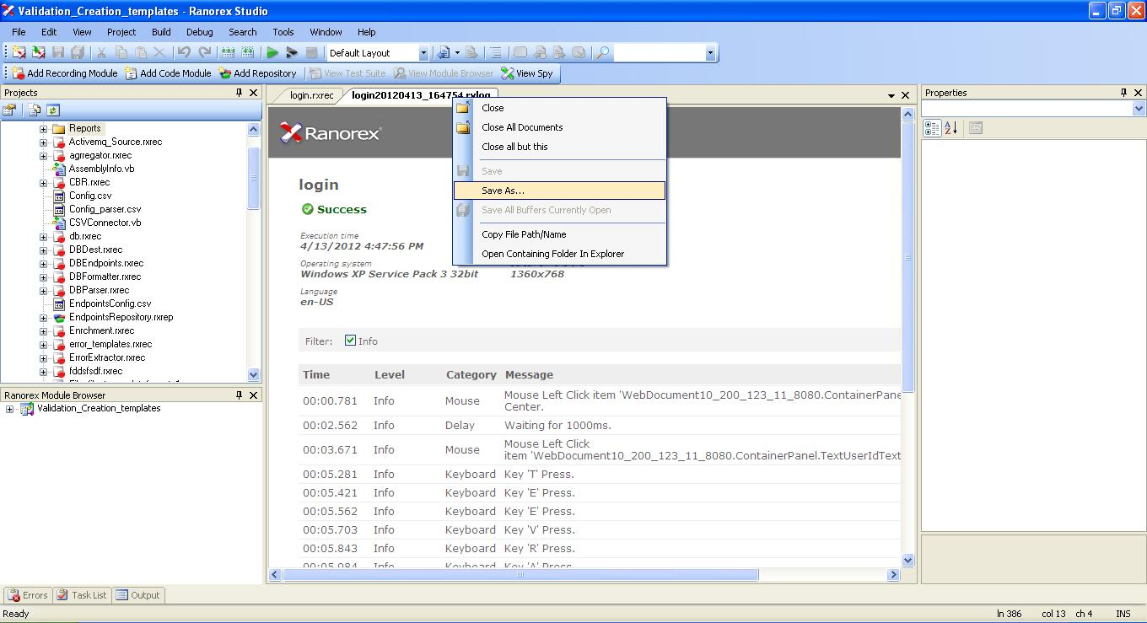

Similar way, we can run the process creation scripts and UI validation scripts.

Note: Run the scripts in the following order

* **Template_Creations** - Validation_Creation_templates.rxsln
* **Process_Creation** - Finetuned.rxsln
* **UI_TC** - UI_TC.rxsln