*FOR:*

**Headstrong**

*CONTENT:*

Teevra Installation Guide

*April 18, 2013*

L



**DISCLAIMER**

**This document contains confidential and proprietary information belonging to Headstrong Corporation and the same is distributed only in pursuance of and subject to the terms of the license agreement entered into with Headstrong Corporation. No part of this document may be copied, reproduced, distributed or disseminated in any form (electronic or otherwise) without the prior written permission of Headstrong Corporation. No intellectual property rights, copyright on the provided documents are conferred to the recipient. The disclosure of the information contained herein does not lead to the legal conferring or granting of rights, unless provision is expressly made for this.**

**Headstrong reserves all rights to make changes to the information described in this document at any time without notice and obligation to notify any person of such changes.**

**© 2009 Headstrong Corporation. All rights reserved.**

**Document History**

|  |  |  |  |
| --- | --- | --- | --- |
| Version | Release Date | Author | Description of Change |
| 0.1 | 06-Aug-2009 | Headstrong | First draft |
| 0.2 | 14-Oct-2009 | Headstrong | Added command line installation instructions. |

**Reference Documents**

|  |
| --- |
| **Document Name** |
| None |

**TABLE OF CONTENTS**

1 Introduction 6

2 System Requirements 7

3 Installation through Wizard-based installer 7

3.1 Installation Overview 7

3.2 Starting Teevra Installation 7

3.3 Selecting the Application 8

3.4 Specifying Teevra Application Home 9

3.5 Specifying Teevra Cluster details 9

3.6 Selecting database provider 11

3.7 Specifying database server configuration 11

3.8 Selecting Authentication provider 12

3.9 Specifying Teevra UI Application install directory 13

3.10 Specifying Teevra Server install directory 13

3.11 Selecting Database Scripts for execution 14

3.12 Installation progress 16

3.13 Creating and Initializing DB Schema 17

4 Installation through Command Line Installer 18

4.1 Starting Teevra installation 18

4.2 Selecting the Application 18

4.3 Setting Teevra Home directory 18

4.4 Selecting Cluster or Stand alone mode 19

4.5 Specifying Teevra Cluster details 19

4.6 Selecting database provider 19

4.7 Specifying database server configuration 20

4.8 Selecting Authentication provider 20

4.9 Providing LDAP configuration 20

4.10 Specifying Teevra UI Application install directory 20

4.11 Specifying Teevra Server install directory 21

4.12 Setting up Teevra Database 21

5 Environment settings 21

5.1 Setting up the workstation for Teevra EUREX component 21

5.2 Library path for LCH.Clearnet SA Connectivity 21

5.3 Database error reporting configuration 22

5.4 Registration of Teevra server 22

5.5 Configuration of pre-built orchestrations / processes 23

# Introduction

Teevra provides a single gateway for financial institutions to connect to different entities – clearing houses, industry utilities and counterparties – across asset classes using diverse formats and communication protocols. Following diagram presents various components of Teevra.

1. UI Layer – This is a Rich Internet Application that runs on Flash player inside a web browser. This requires Flash Player 9 or above.
2. Services and Persistence Layer – This is the backend web component for our UI Layer and it runs within a Java Servlet container (web server).
3. Teevra Fusion Framework – Also called as Teevra Server. This is the backend server having all the required components for message flow and processing.
4. Teevra DB – Any JDBC compliant database shared by both Teevra Web application and Teevra server (Fusion Framework)

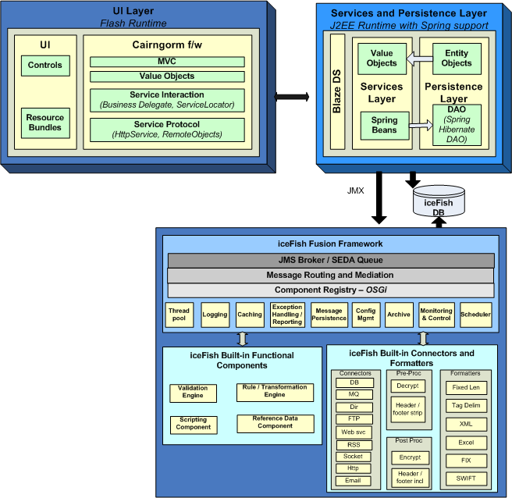

Figure 1: Block Diagram

Teevra.jar is the installation package / setup file for Teevra. This installer can be used to install both Teevra Server and Teevra UI applications. This guide will take you through all the steps for completing the installation of Teevra applications.

# System Requirements

OS – Windows XP / Windows 2003 Server / Solaris 10 on SPARC

Tomcat – 5.5 or above.

Java – JDK 1.6

Database – Oracle 10g or above / Postgres8 or above

# Installation through Wizard-based installer

## Installation Overview



Figure 2 Installation Overview

## Starting Teevra Installation

Teevra.jar is the installation package / setup file for Teevra. It allows user to pick the various components that user needs to install. Either double Click on Teevra.jar or type **java –jar Teevra.jar** in the command prompt to start Teevra installation. This opens up the welcome page which contains the Teevra Version Number, Organization Name and other details as shown below.

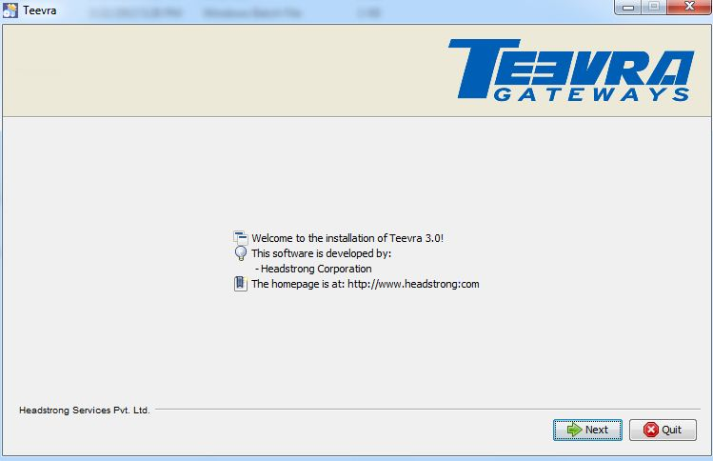

Figure 3:Welcome Page

## Selecting the Application

This screen will provide the option to select which component user want to install - either Teevra Web Application i.e. UI , Teevra Server Application or both or Enable Http Service.

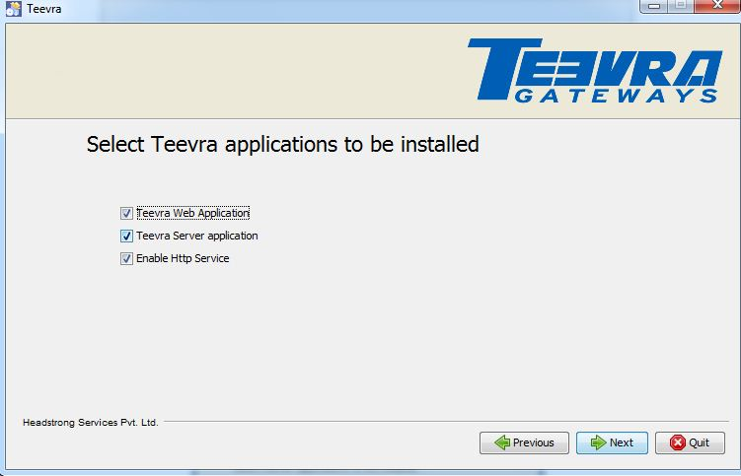

Figure 4: Teevra Application

Suppose user only wants to install Teevra Web Application, he can select Teevra Web Application checkbox and click on Next. Option to install database scripts will be available only when Teevra server application checkbox will be selected. Option to install database scripts will not be available if only Teevra Web Application will be selected.

One can install from Http when Http Service is checked.

After selecting required set of applications which needs to be installed, click on Next.

## Specifying Teevra Application Home

Specify the complete path for the Application Home directory. Application Home directory is used to store the Log files, Process Cache (has all the deployed processes), Process runtime cache (has which processes are in running and stopped state) and also the application cache used by Teevra.

Ensure that forward slash “/” is used as the file (or directory) separator character.

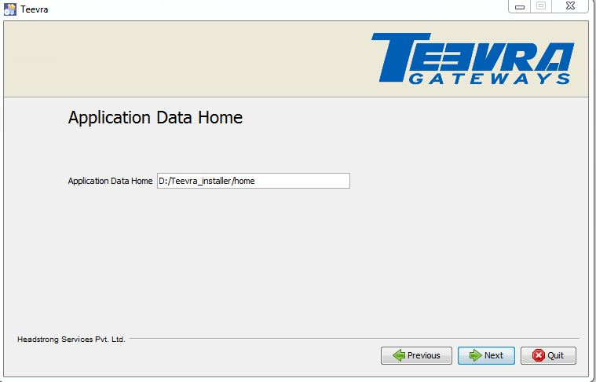

Figure 4 Specifying Application Home Directory

## Specifying Teevra Cluster details

This screen will ask user, how he wants to install Teevra. Teevra as a cluster mode or as a non cluster mode.

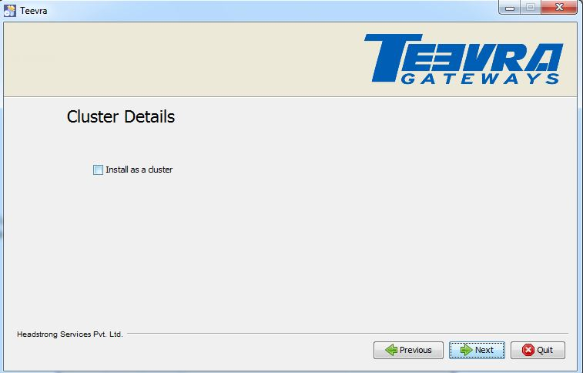

Figure 5: Cluster Details

If user selects the checkbox i.e. he wants to install as a cluster then user needs to provide the details of cluster as shown below.

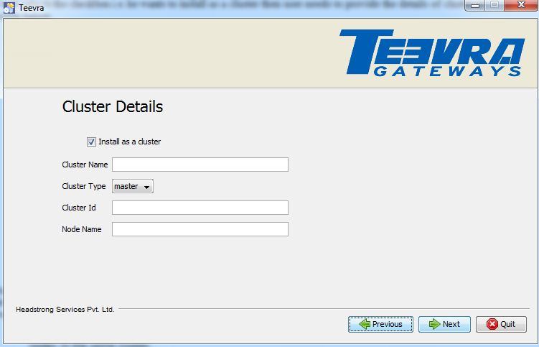

Figure 6: Cluster Details

User can configure as many Teevra servers in a cluster mode. One server will act as a master and others will be slave. Master and slave configuration is only used to give control when every node in the cluster starts. Once started, every node in the cluster is homogeneous. After providing all the details of cluster, click on Next.

1. Cluster Name – Name of the cluster. It can be anything. Cluster Name should be same for all nodes in the same cluster.
2. Cluster Type – It can be either Master Node or Cluster Node depending upon, how user wants to install the Teevra. If user wants to install Teevra as a master then user needs to select Master Node option else Cluster Node option if user wants to install Teevra as a cluster mode.
3. Cluster Id – Id of the Cluster.
4. Node Name – Name of the Node. It can be anything

## Selecting database provider

This screen has the information about the database. User has the option to select the database from the list of database Name.

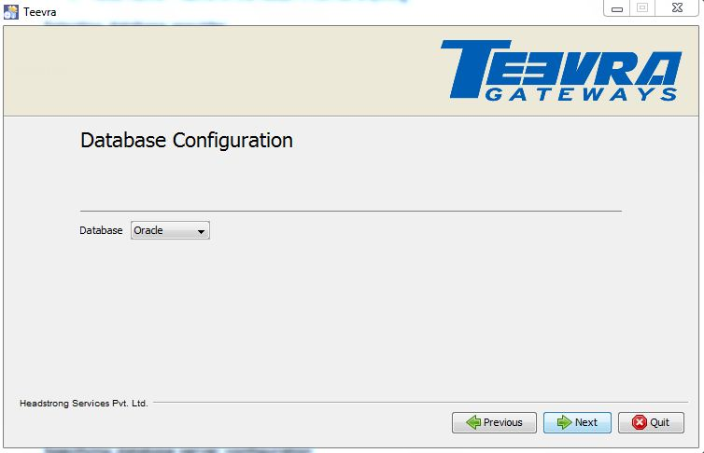

Figure 7: Database Configuration

Select the appropriate database Name click on Next.

## Specifying database server configuration

In this screen user needs to provide the encryption key path for password decryption as shown below.

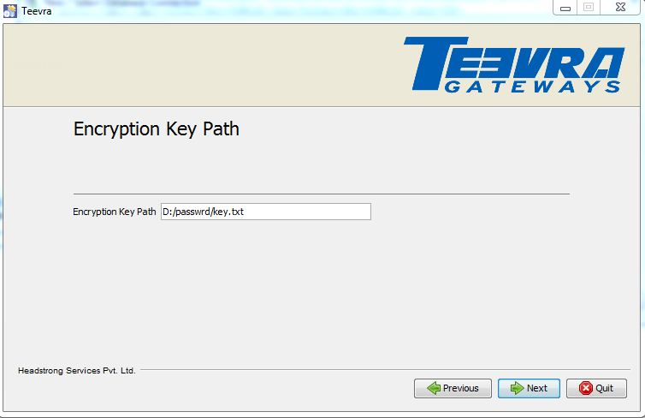

In this screen user needs to provide the database configuration such as Database URL, User Name, password etc as shown below.

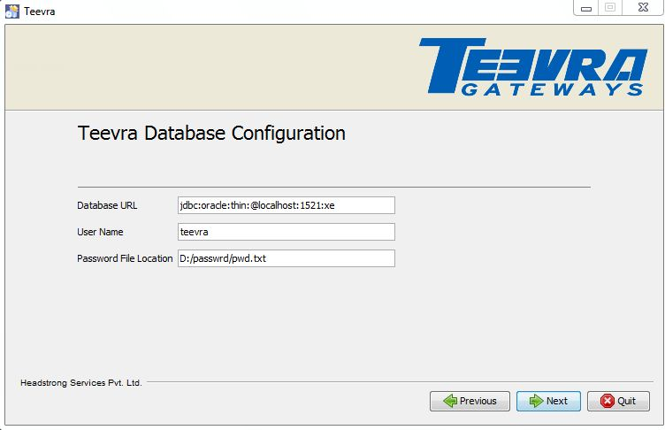

Figure 8: Database configuration Details

After providing all the details of Database such as Database URL, user Name, and password click on Next.

1. Database URL – URL of the database server
2. User Name – User name of the database
3. Password – password of that database user

## Selecting Authentication provider

This screen has the option to select Authentication Provider.

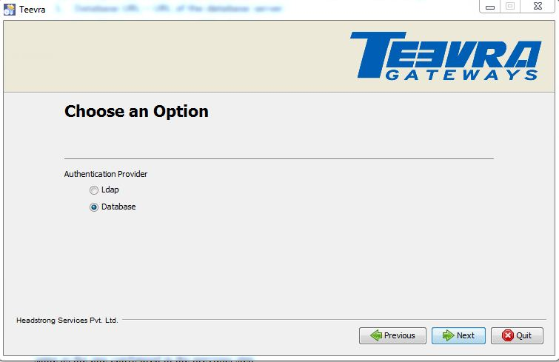

Figure 9: Authentication Provider

User has the option to select Authentication mechanism for authenticating users logging in Teevra UI Application - through LDAP or from Database.

So, if user wants to authenticate the user name through LDAP, select the radio button LDAP and click on Next. If you want to authenticate from Database select the radio button Database and click on Next. This database would be same as the one configured in the previous step.

## Specifying Teevra UI Application install directory

In this screen user needs to provide the complete path, where user want to deploy the Teevra Web Application. This path should point to the root directory of Tomcat web server (parent folder of webapps).

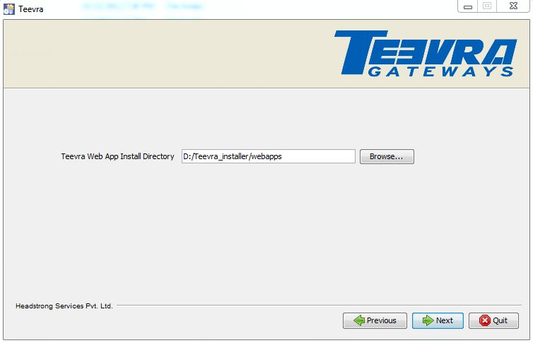

Figure 10: Web Application Install directory

After giving complete path, click on Next.

## Specifying Http Server Configuration

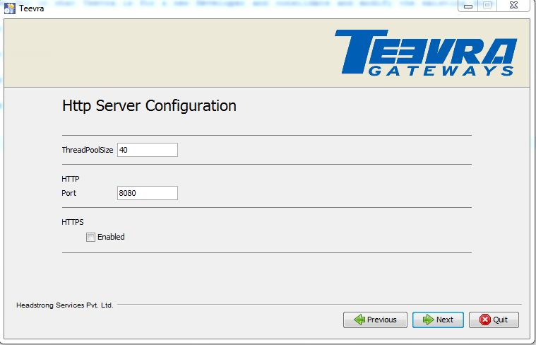

## Specifying Teevra Server install directory

In this screen user needs to provide the complete path where Teevra Server Application has to be installed.

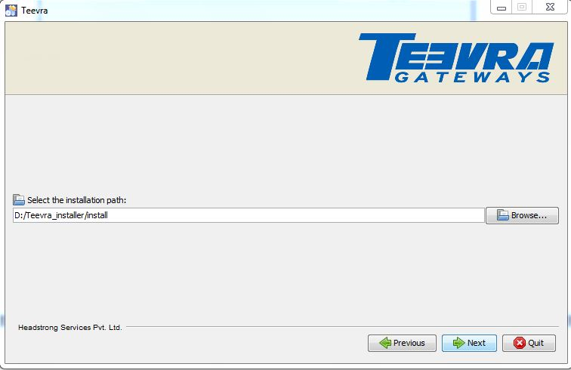

Figure 11: Server Installation Path

After giving complete path, click on Next.

## Selecting Database Scripts for execution

If user wants Database script to be executed, select the check box Database Scripts and click on Next. If the database already exists and user doesn’t want it to be overwritten, don’t select the Database Scripts option.

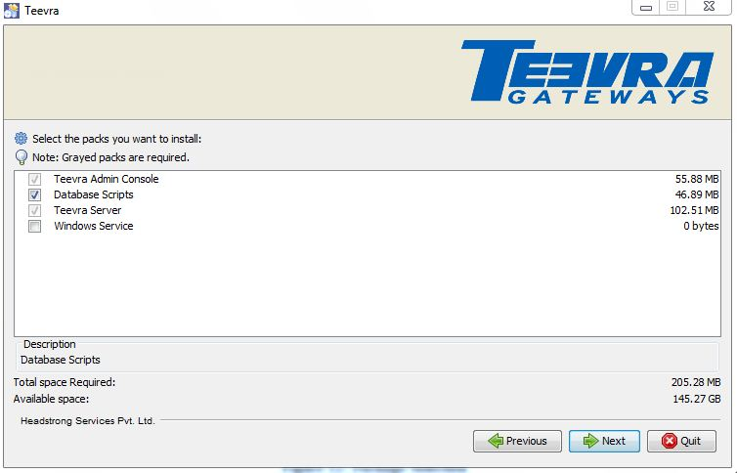

Figure 12: Package Selection

## Installation progress

Following step shows the progress of Teevra components installation.

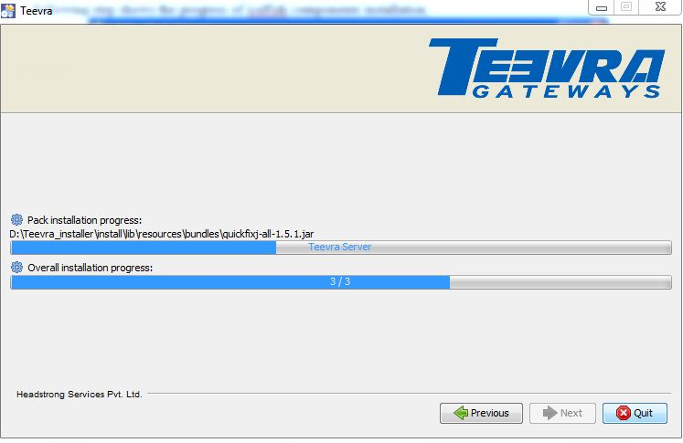

Figure 15: Installation Progress Bar

## Creating and Initializing DB Schema

This step is exclusively for database scripts execution

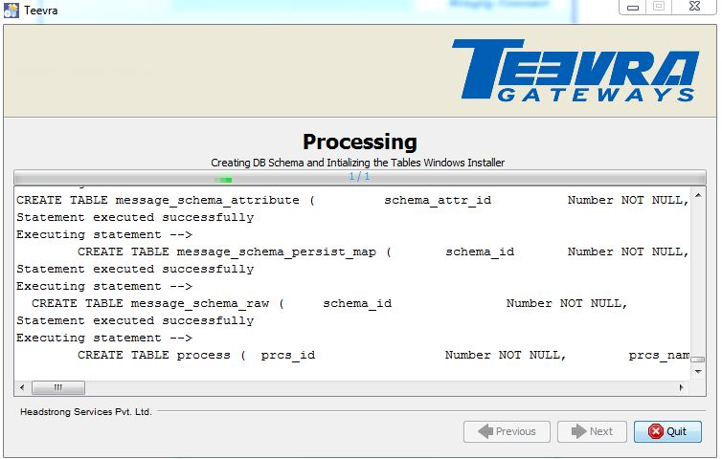

Figure 16: Execution of Database Scripts

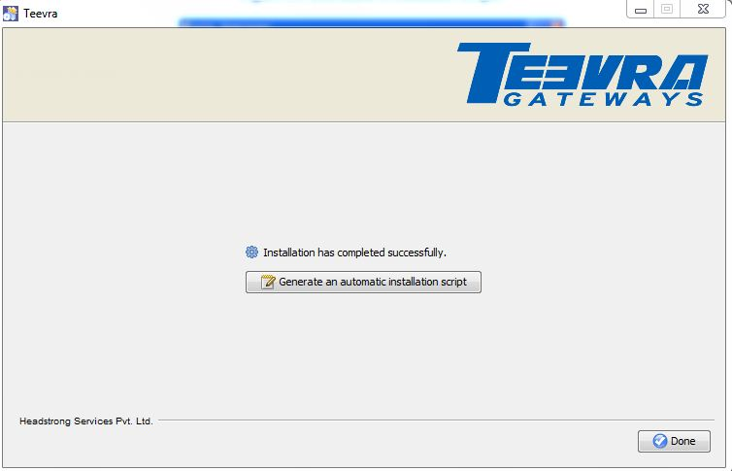

Figure 7 Installation Successful

Congratulations. You have successfully installed Teevra.

# Installation through Command Line Installer

## Starting Teevra installation

To start the installation type “***java –jar Teevra.jar –console”*** in the command prompt. A welcome notice listing the details like Version Number of the product, Organization Name and other details will be displayed. Along with that, a message like below will be displayed with the options to continue, quit or redisplay of the previous step. .   
 **“press 1 to continue, 2 to quit, 3 to redisplay”.**

This option will be displayed at the end of every step followed during installation. To proceed with the installation, press 1 to continue the installation or 2 to quit the installation or 3 to redisplay the previous step (which will be useful to reselect the option selected in previous step).

## Selecting the Application

In this step, the list of applications will be listed like below:.

0 [ ] Teevra Web Application

1 [ ] Teevra Server

2 [ ] Both Web Application and Server

Enter “0” to install only the Teevra Web application or “1” to install the server application or “2” for installing both Web and Server applications. On selecting the applications to be installed, the confirmation message will be displayed with options to continue, quit or redisplay. On continuing the installation, follow the steps based on option selected

1. If selected option is 0 - skip the following steps and go to Section 4.6
2. If selected option is either 1 or 2 – continue with section 4.3

## Setting Teevra Home directory

On selecting the option 1 or 2 in the previous step, the below message will be displayed asking for Application data home

Enter Application Data Home []

The folder mentioned will be used to store log file and graph of the processes assigned to the server instance. It will be the Teevra Server home directory. Ensure that forward slash (“/”) is used as the directory separator. After entering the Application Data Home enter 1 to proceed to the next step.

Note: In case of multiple server instance running (ex. cluster mode), separate folders need to be created in home directory for each instance and the Application Data Home path should be pointing to the respective folders created for the instance.

## Selecting Cluster or Stand alone mode

On continuing the installation, the options to select the mode in which Teevra server need to be installed will be displayed like

0 [ ] Install as Stand Alone Server

1 [ ] Install As Cluster

Enter “0” will install the server in Standalone mode and “1” will install it in clustered mode. On selecting Stand alone mode, step 4.5 is not required and can go to step 4.6 directly else continue from step 4.5 for installing in Clustered mode.

## Specifying Teevra Cluster details

In this step, the user will be asked to enter cluster details like Cluster Name

Cluster Name []

Once the name of the cluster is entered, the following options will be displayed to choose installing the node as master or slave. Following the selection of node type, the details like Cluster Id & Node Name will be asked to enter.

Cluster Id []

Node Name []

press 1 to continue, 2 to quit, 3 to redisplay

## Selecting database provider

The database type needs to be selected from the options listed as below

0 [ ] Oracle

1 [ ] PostGre SQL

input selection:

Enter “0” for Oracle and “1” for Postgres. Then enter 1 to continue configuring selected database properties.

## Specifying database server configuration

For the selected database, enter the configuration details like Database URL, user name and password on display of below messages

Database URL []

User Name []

Password []

press 1 to continue, 2 to quit, 3 to redisplay.

For oracle database, enter the complete URL in the format below ***jdbc:oracle:thin:@databaseip:port:databasename*.**

Ex: ***jdbc:oracle:thin:@10.200.20.36:1521:Testinstaller*.**

## Selecting Authentication provider

Select the user authentication provider from the list of options provided as below.

0 [ ] Ldap

1 [ ] Database

input selection:

For LDAP authentication(0) continue step 9 and for Database authentication(1) go to step 10.

## Providing LDAP configuration

On authentication through LDAP, configure the below details like LDAP URL, Root Directory, User DSN and password.   
  
 For Ex: LDAP URL: ldap://10.200.41.16:10389  
 Root Director: o=Teevra  
 User DSN: uid=admin, ou=system .

## Specifying Teevra UI Application install directory

This step will be displayed to enter the Web App install Directory on selecting the option 0 or 2 (install Teevra Web application or Both web application and server) in **step 4.2**. Specify the path of Tomcat Home folder where the installer will copy the teevra.war file to Tomcat webapps folder.

## Specifying Teevra Server install directory

The step will be displayed to enter the Teevra Server install directory on selecting the option 1 or 2(install Teevra Server or Both web application and server) in **step 4.2.** Specify the path of the folder where the Teevra Server related files should be copied.

Installer will start unpacking all files and finally the status as “Install was successful” will be displayed on successful installation.

## Setting up Teevra Database

After completing the installation of Teevra Server and UI applications, run the script “Launchsql.sh’ file located in ***$ teevra Server/scripts/db*** folder where the Teevra Server has been installed. On successfully running the script, all required database objects will be placed in the Teevra database specified during installation along with Teevra system data required for running the server.

*Note: When the above script is run, it will create all database tables related to Teevra. Incase if these tables already exist they will be dropped and recreated. Please make sure that if you want to start fresh and recreate the DB schema then run this file. All nodes in cluster point to the same database.*

# Environment settings

## Setting up the workstation for Teevra EUREX component

GATE service has to be installed in the system where Teevra containing the EUREX component is deployed. It needs to be installed as a standalone mode and should have the configuration file from the MISS server. Access to EUREXSIM – EUREX simulator has to be accessible from MISS server. As EUREX libraries are available only on Windows and Linux platform we have to install Teevra with EUREX components only on those environments.

## Library path for LCH.Clearnet SA Connectivity

In Solaris environment, Teevra Server’s library directory has to be part of LD_LIBRARY_PATH. Following is the command to set the same in Solaris environment where <install_dir> is Teevra Server’s installation directory.

***export LD_LIBRARY_PATH=$LD_LIBRARY_PATH:.:/usr/local/lib/:/usr/lib/:<install_dir>/lib***

## Database error reporting configuration

In case Teevra has to be configured for logging all the error reports in database, following database table should exist in the database specified in the error reporting configuration. Following is the SQL script for PostgresSQL database.

CREATE TABLE errorreport (

  error_type             character varying(256),

  service_id             character varying(256),

  component_type         character varying(256),

  time_stamp             timestamp with time zone ,

  error_stacktrace       text,

  resorce                character varying(256),

  additional_information text

)

## Registration of Teevra server

Teevra server has to be registered with Teevra UI Application so that message flow processes modeled through Teevra UI can be deployed and executed on it. Use “Administration -> Server Admin -> Register” in Teevra UI to register the Teevra server instance. Following details of the server has to be specified

1. Server Name: Logical name to identify the server to deploy and monitor
2. JMX URL: It should be “*service:jmx:rmi:///jndi/rmi://< Teevra _server_ip>:8004/jmxrmi*” where <Teevra_server_ip> is the IP address of the Teevra server system. To change the port number in which Teevra server is listening, change the same in *“<install_dir>/conf/wrapper.conf”* file for the property *“-Dcom.sun.management.jmxremote.port”* where “<install_dir>” is the path to Teevra server’s installation directory.

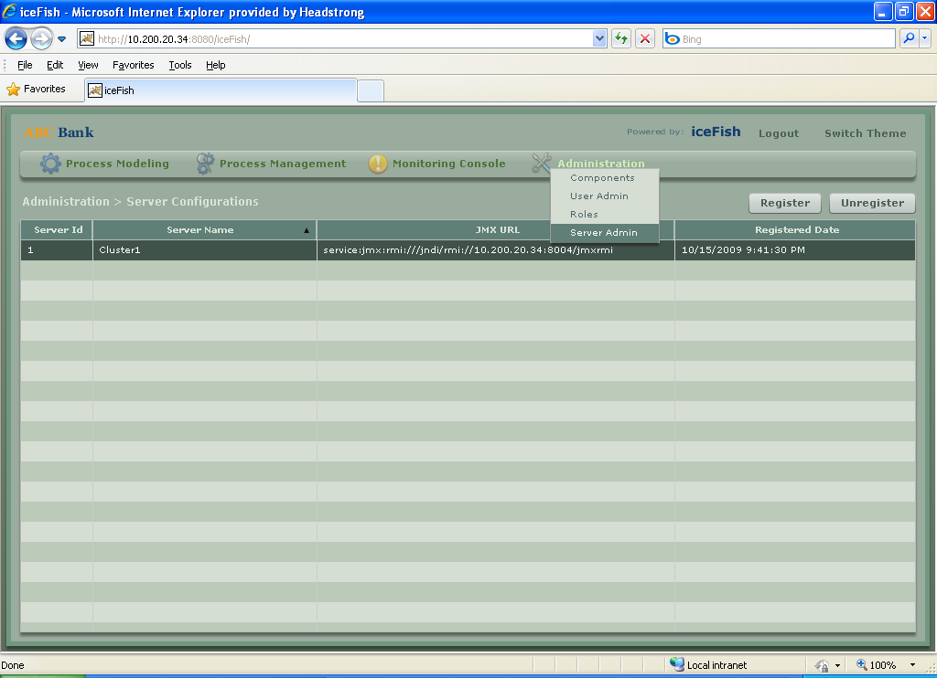

Figure 8 Teevra Server Registration

## Configuration of pre-built orchestrations / processes

Teevra installation might contain pre-built orchestrations / process flows that need to be configured as per the deployment environment. Especially configurations of the end point and error reporting components in the message flows that are responsible for connecting to the external systems have to be changed ex. JMS endpoint (for message provider URL, etc), database endpoint (like connection string, driver, etc). This can be achieved by opening the respective process from *“Process Modeling -> Processes”*.

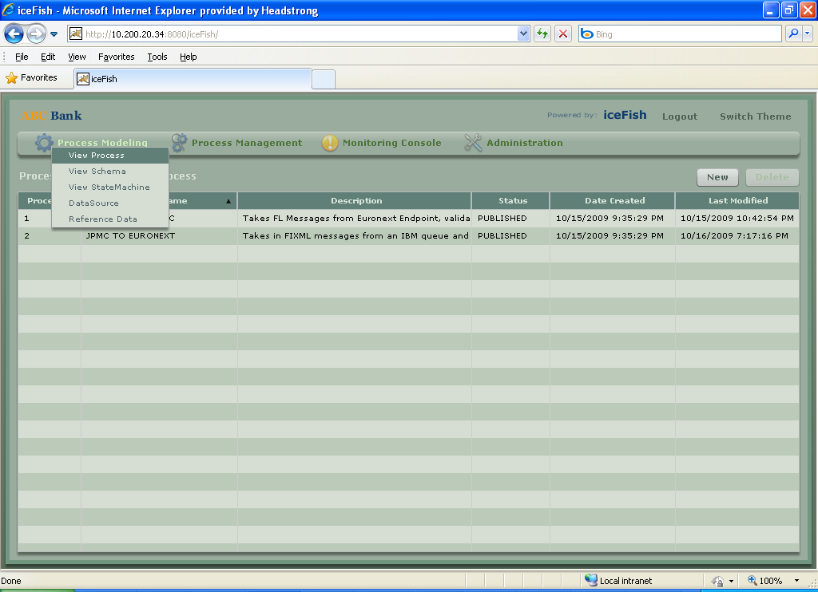

Figure 9 Viewing pre-built Orchestrations

Once configuration details of individual components in orchestrations are changed and reviewed, user needs to “Publish” the process to generate the required orchestration model for the process that can be deployed on to a server. This can be achieved by selecting “Publish” button on the Process Model Graph screen.

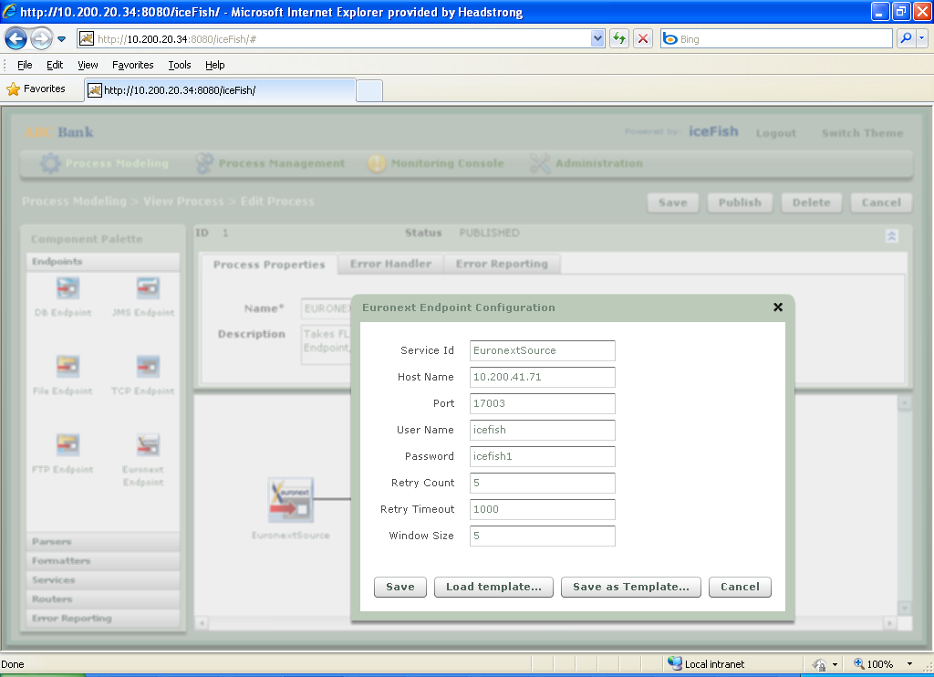

Figure 10 Configure and Publish Process

Successfully published processes can now be deployed on to the Teevra server from the “Process Management -> Process Status” screen. Follow the steps mentioned below to deploy and start the process:

1. Select the process to be deployed from the table
2. Select the registered server from the dropdown on top of the table
3. Select the button “Assign”
4. After the screen refreshes, status of the process should read “STOPPED”
5. Now select the process to be started and select “Start” button.

Teevra Server is now ready to receive / send messages from / to its endpoints.