*FOR:*

**Headstrong**

*CONTENT:*

Teevra Screen shots

*April 18, 2013*

L



Figure 1 Process Modeling -> View Processes 3

Figure 2 New Process 5

Figure 3 Process Orchestration 5

Figure 4 File / Directory Endpoint Configuration 6

Figure 5 DB Endpoint Configuration 7

Figure 6 XML Parser Configuration 8

Figure 7 Multisection (uniform format) Parser Configuration 9

Figure 8 Tag delimited Formatter Configuration 10

Figure 9 Validator Configuration 11

Figure 10 Transformer Configuration 12

Figure 11 Content Based Router Configuration 13

Figure 12 Error Reporting through JMS 14

Figure 13 Error Handling at Process Level 15

Figure 14 View Schema (Field specification for every message exchanged) 16

Figure 15 Schema Definition 17

Figure 16 View Datasource 18

Figure 17 Add Datasource 19

Figure 18 View Reference Data 20

Figure 19 Add Reference Data 21

Figure 20 Process Monitoring and Management (Deploy, Start, Stop, Schedule, View Errors) 22

Figure 21 Monitoring for errors 23

Figure 22 Error Details 24

Figure 23 Administration -> View list of components in the deployment 25

Figure 24 Hot deploy new component into Teevra 26

Figure 25 Managing User Roles 27

Figure 26 Adding New Role 28

Figure 27 User Administration 29

Figure 28 Adding New User 30

Figure 29 Register / Unregister Teevra Server instances to monitor and manage them 31

Figure 30 Registration of New Teevra Server instance 32

Figure 31 Switch Themes (Themes easily pluggable) 33

Figure 32 A Sample alternative theme 34

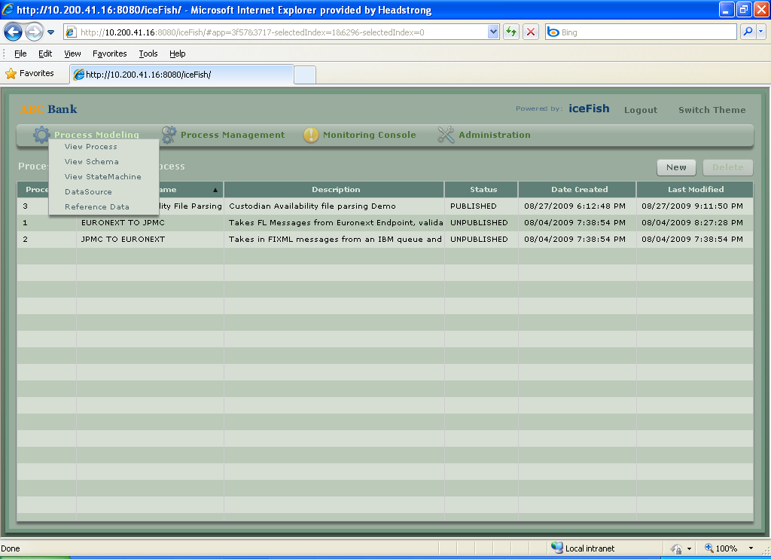

Figure Process Modeling -> View Processes

By default it will open this screen, when you login to this link. Here on can see all the processes created by him or to get some others’ system process, we need to copy process graph of theirs’ process table of the particular process into our own table.

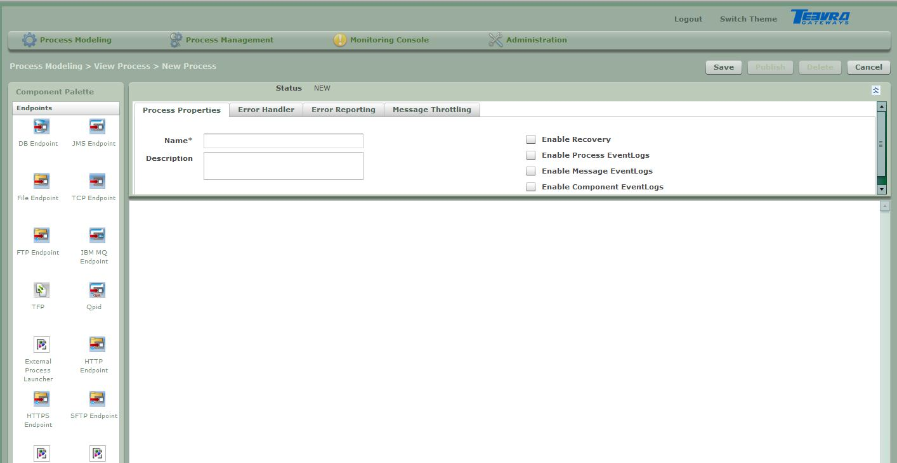

Figure 2 New Process

To create new process, click on new. Then drag the components from left hand side window. All the components are in the Component table and service class name for all the process written in the table corresponding to which same service class will be there in code in which all the functionality is written. After creating process , save the process. If you want to run the process , publish the process.

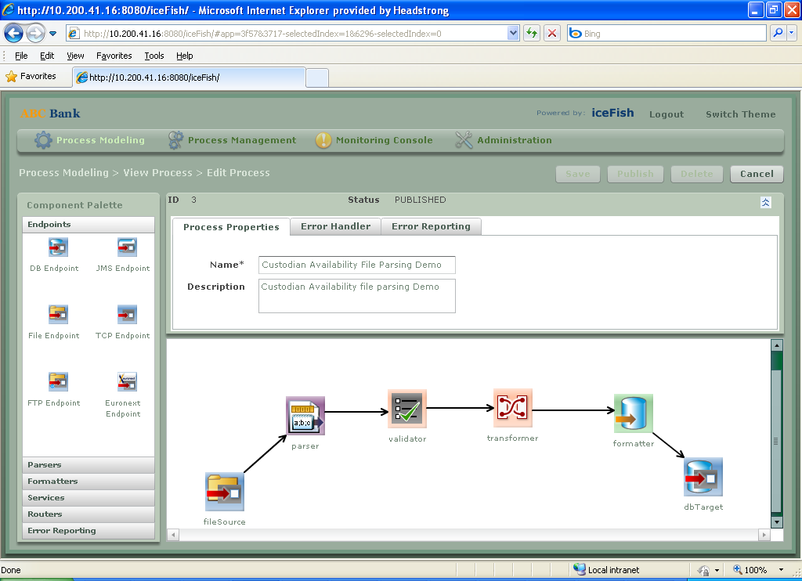

Figure 3 Process Orchestration

Process can be created by dragging as many components as required and joining it using connectors under Routers tab of left hand side window.

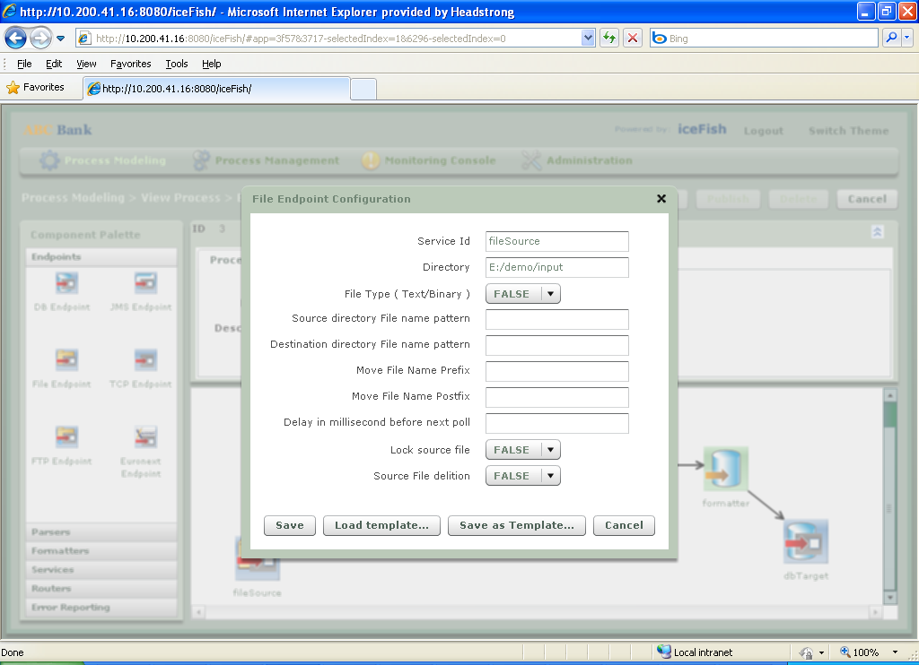

Figure 4 File / Directory Endpoint Configuration

File Endpoint is to store any file coming from the process (Producer) and going inside process (Consumer).

Source File deletion – when true, it deletes the file from the folder specified in the *Directory* path.

*Service Id- Any name given to the component.

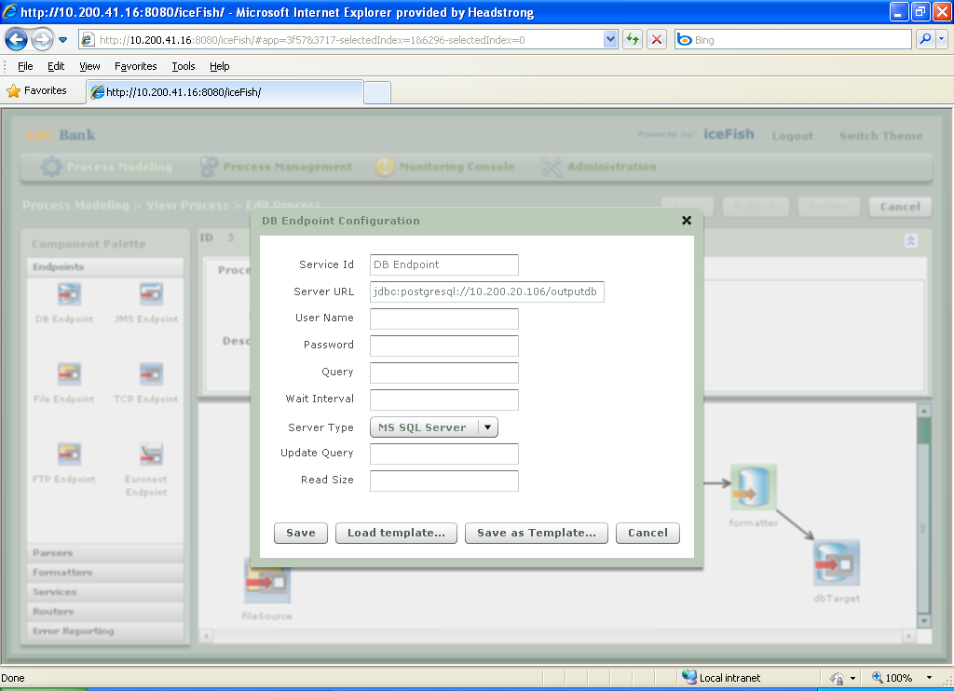

Figure 5 DB Endpoint Configuration

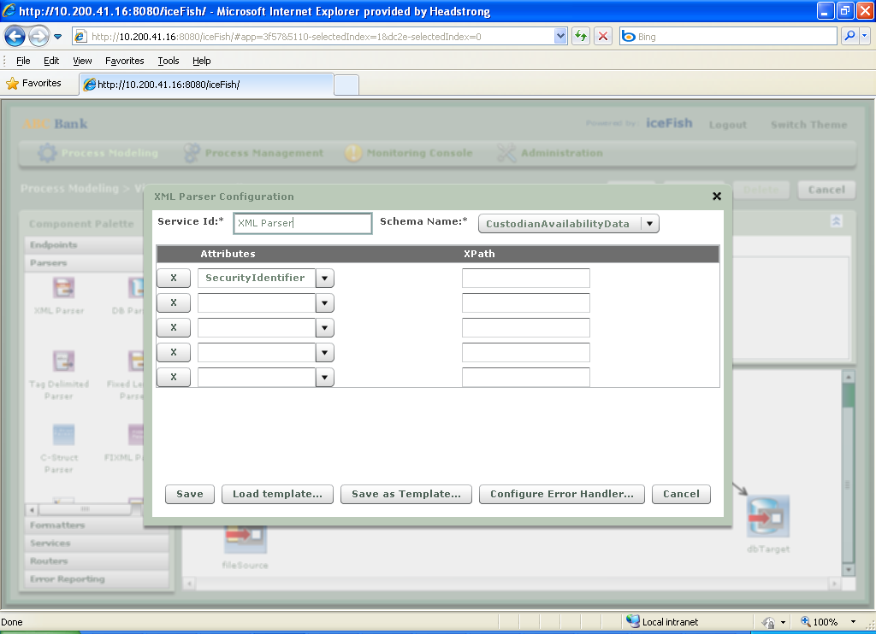

Figure 6 XML Parser Configuration

XML Parser- parses the xml document coming in this component.

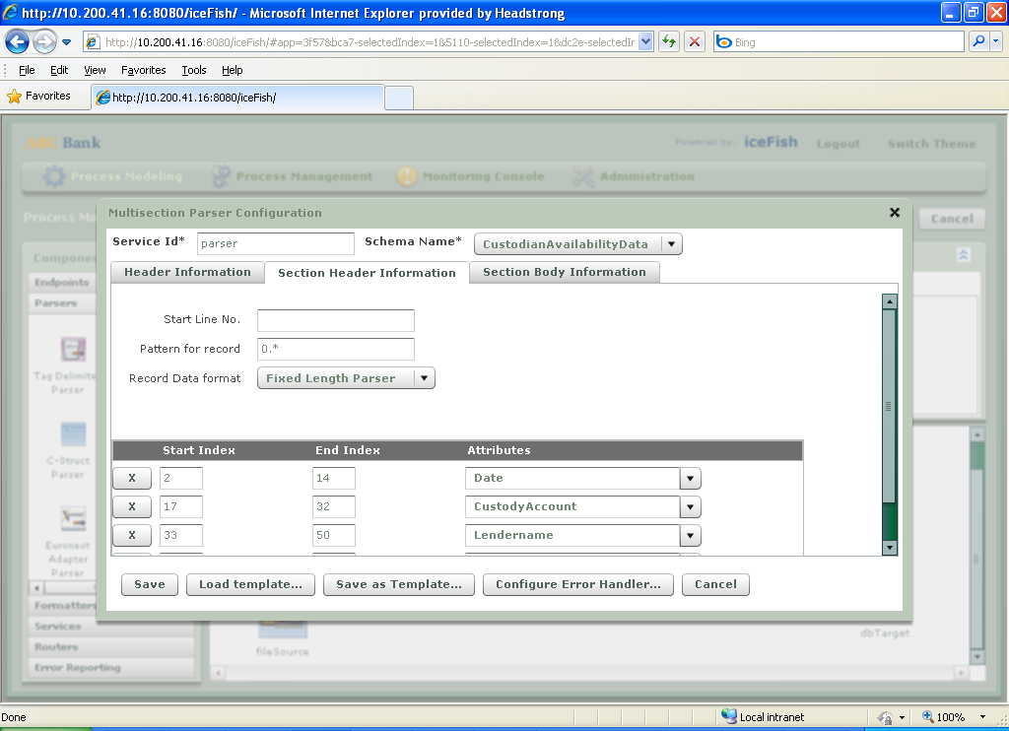

Figure 7 Multisection (uniform format) Parser Configuration

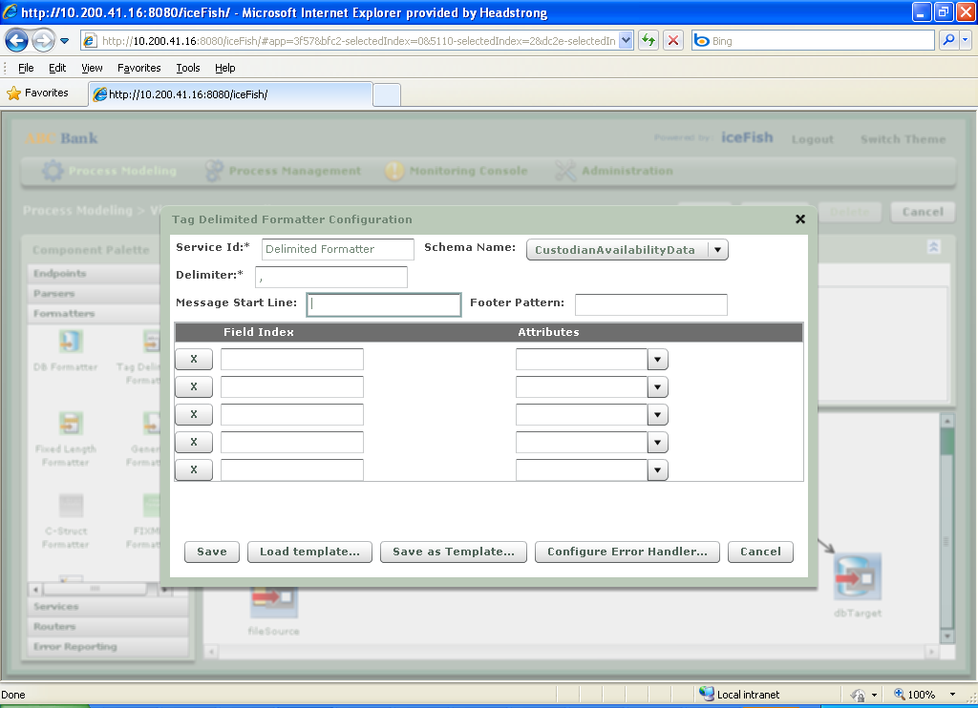

Figure 8 Tag delimited Formatter Configuration

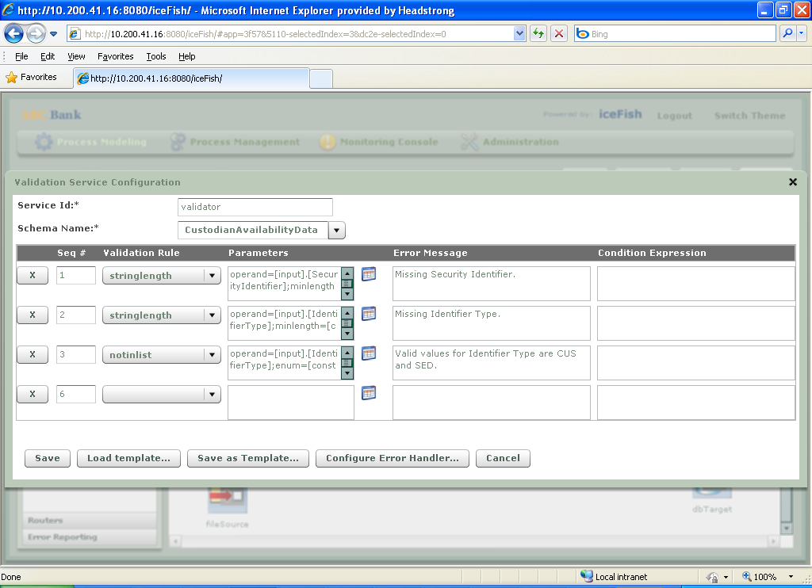

Figure 9 Validator Configuration

Validator- used to set some conditions on the incoming message to this component.

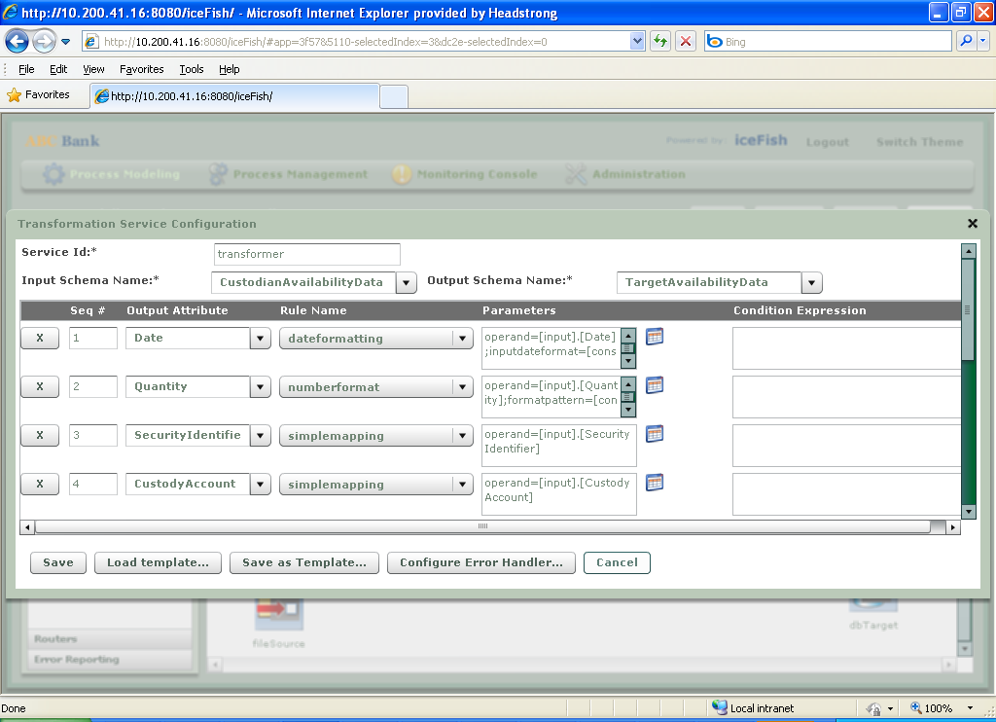

Figure 10 Transformer Configuration

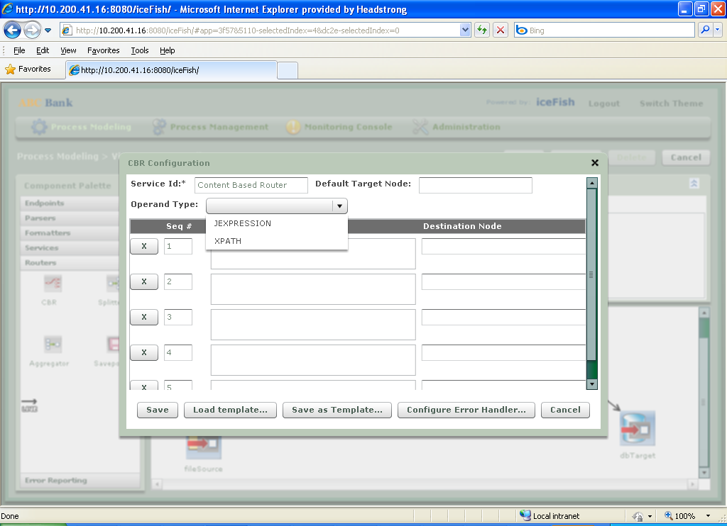

Figure 11 Content Based Router Configuration

CBR- It passes the message to the next component based on the condition written. If no condition matches, it will go to the component specified in *Default Target Node*.

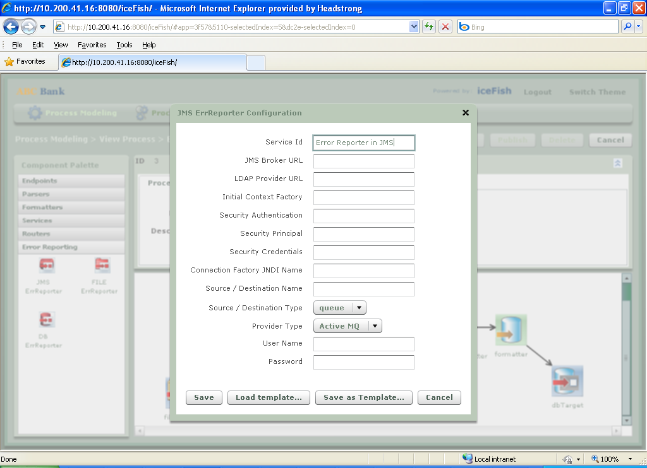

Figure 2 Error Reporting through JMS

For this, click on Error reporting tab, then select any error reporter from the drop down and configure.It will report all the errors coming in the process to the destination (destination specified by the selection of error reporter).

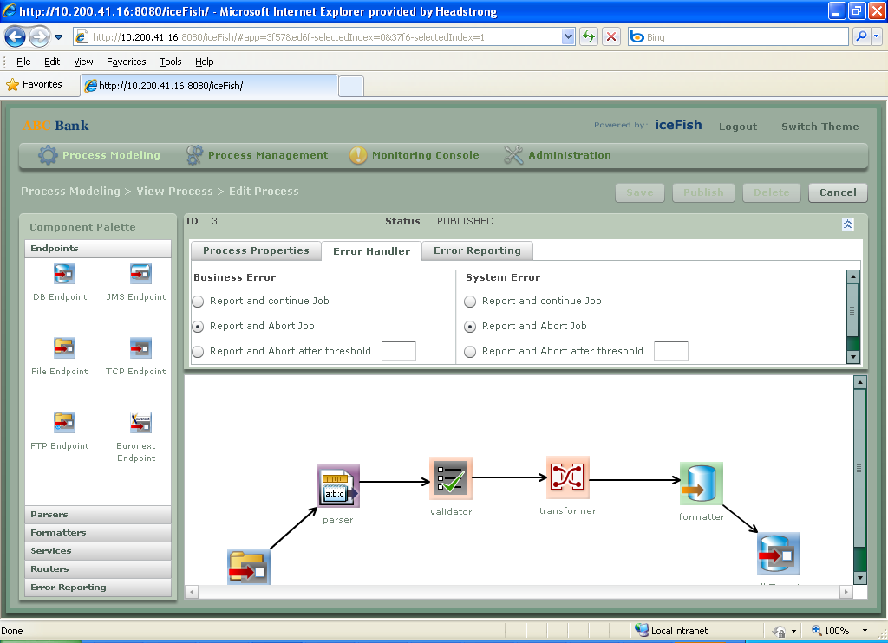

Figure 13 Error Handling at Process Level

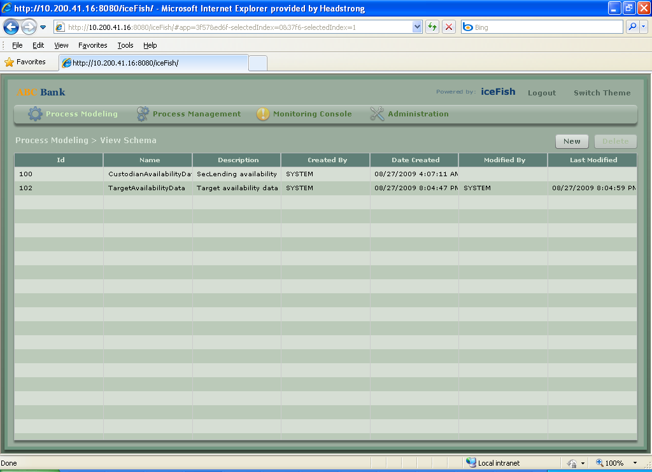

Figure 14 View Schema (Field specification for every message exchanged)

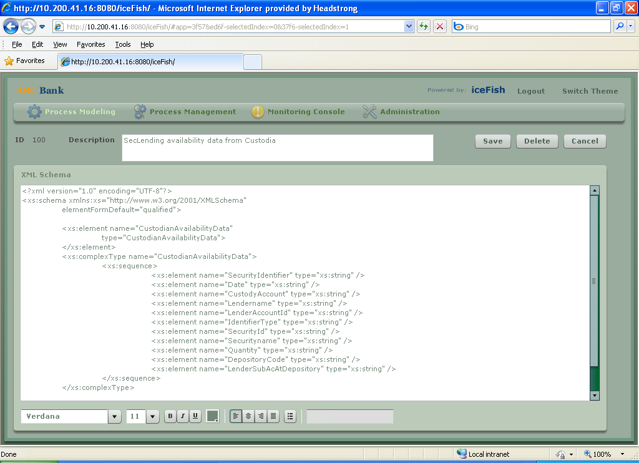

Figure 15 Schema Definition

Schema can be defined for XML components.

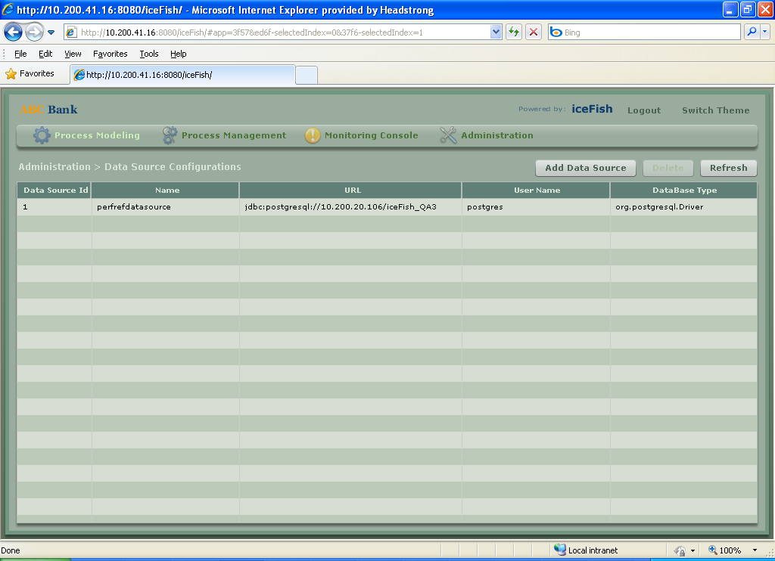

Figure 16 View Datasource

Process Modeling > Data Source

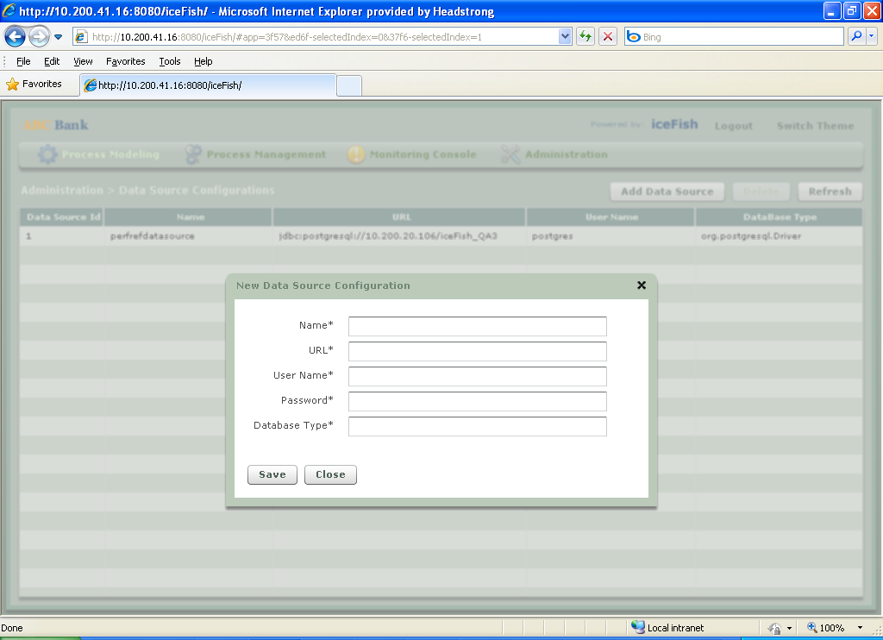

Figure 17 Add Datasource

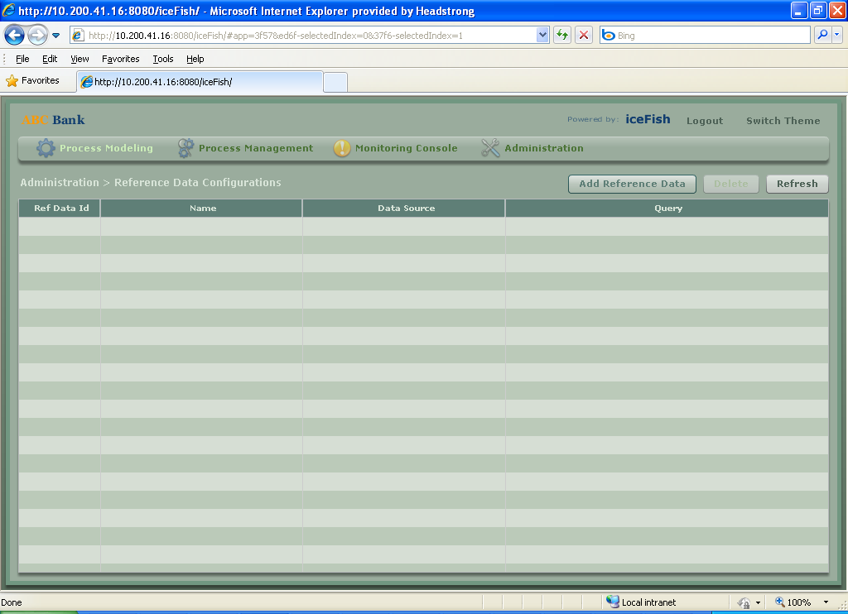

Figure 18 View Reference Data

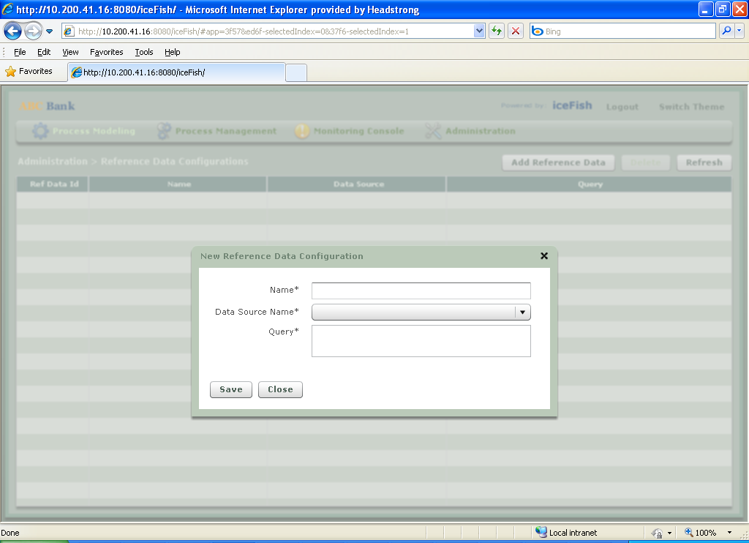

Figure 19 Add Reference Data

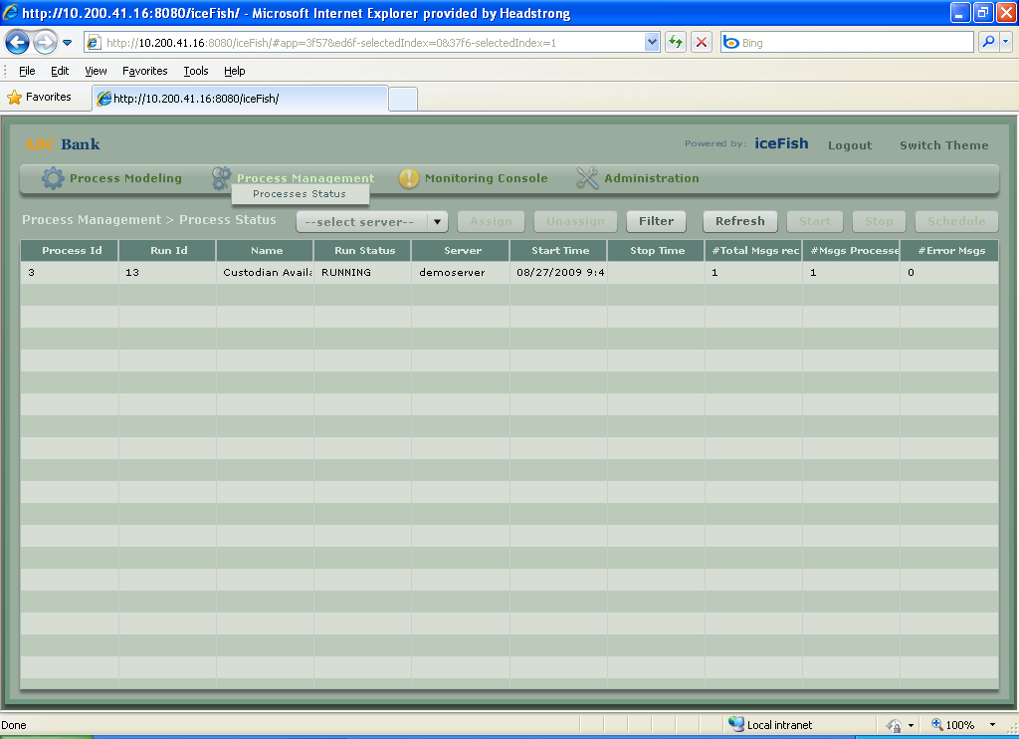

Figure 20 Process Monitoring and Management (Deploy, Start, Stop, Schedule, View Errors)

**To Assign the server** - In order to run the server, one need to assign server to that process.

Go to Administration > Server Admin- change the jmx url to this *service:jmx:rmi:///jndi/rmi://localhost:8004/jmxrmi*

**To run the process**-

Go to Process Management > Process Status - It will list of the processes which are saved and published. In order to run the process, select the particular process you want to start and select server. It will assign the server to that process. Then click on start. It will do the job based on the components of the process. To stop the process click on stop.

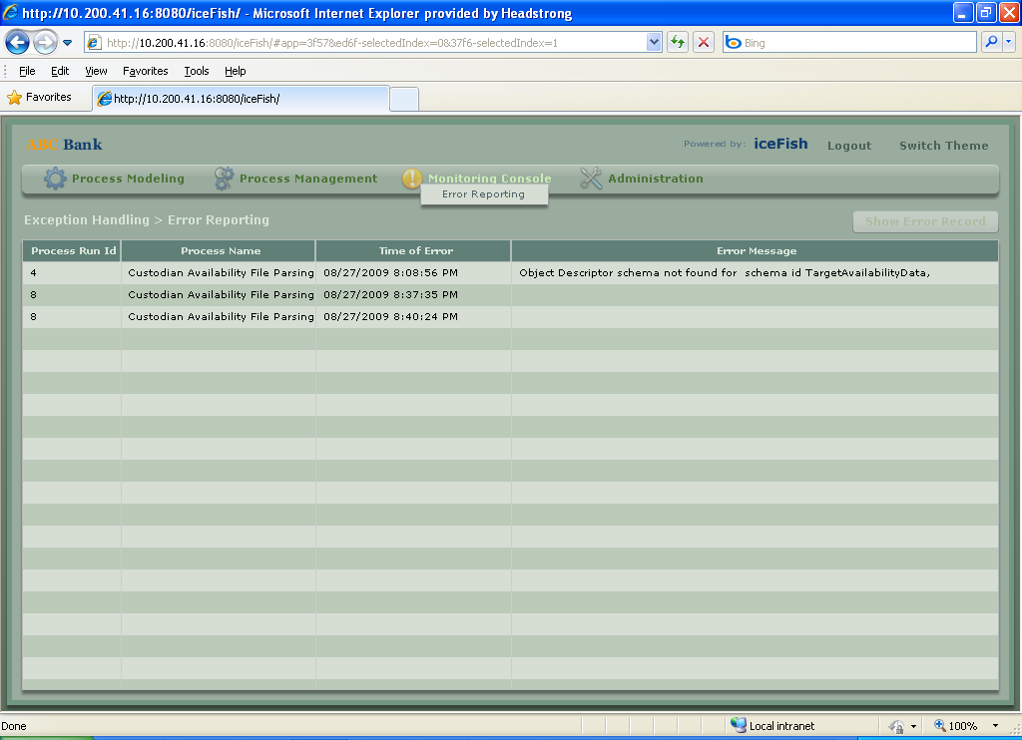

Figure 21 Monitoring for errors

Monitoring Console > Error Reporting

If process fails due to some reason, it will mark as red. Then, this screen will display the errors coming in the process.

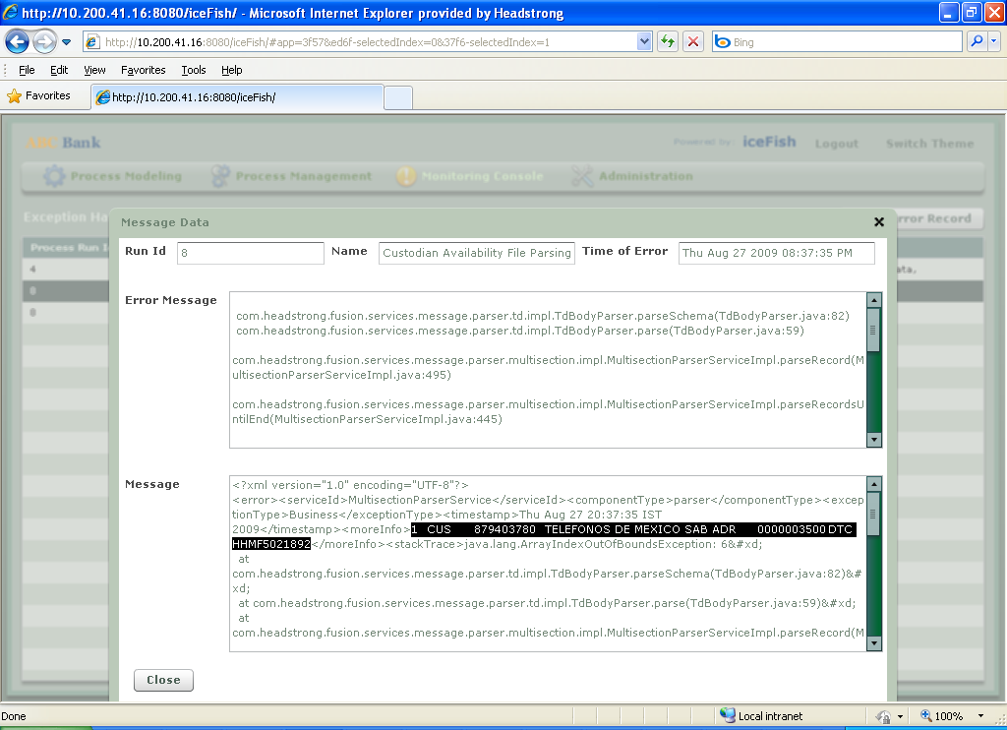

Figure 22 Error Details

Error Details- It will display the error of the process if any error comes and the whole stack trace of the error origination with the java code line.

*One can debug the code and find out the cause for the error.*

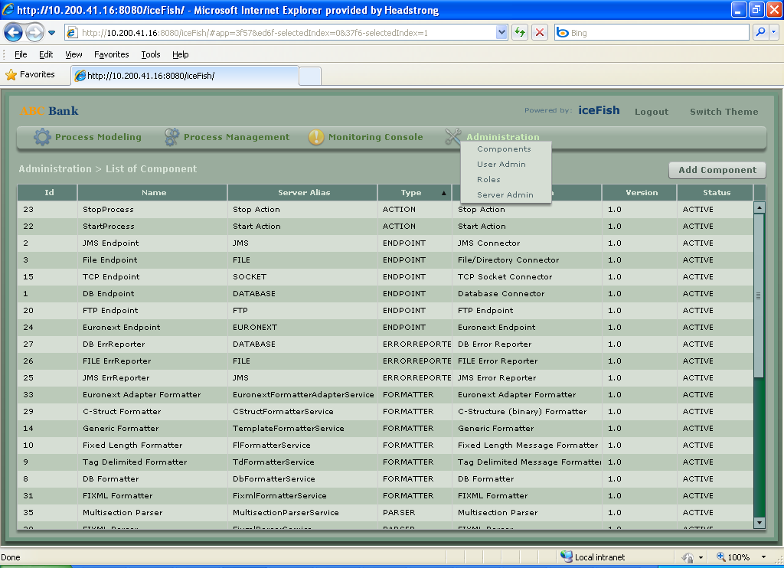

Figure 23 Administration -> View list of components in the deployment

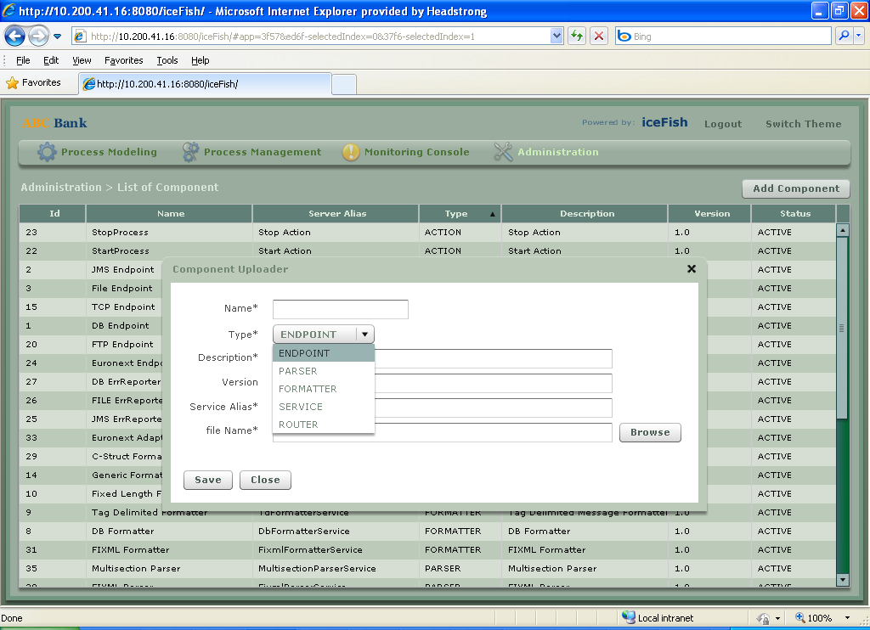

Figure 24 Hot deploy new component into Teevra

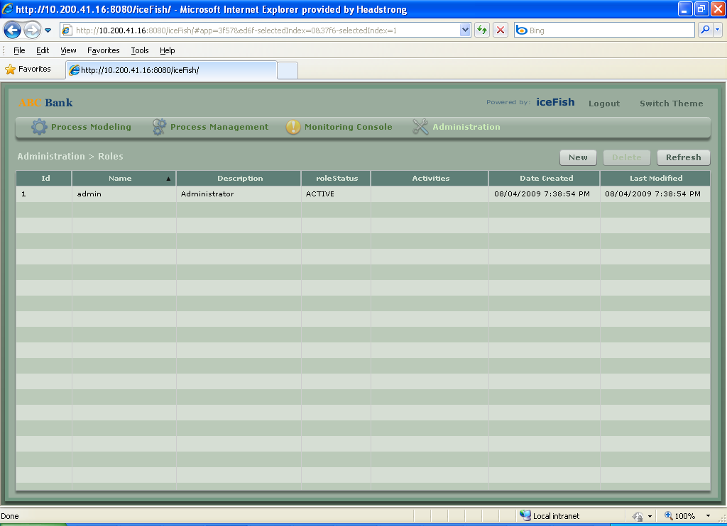

Figure 25 Managing User Roles

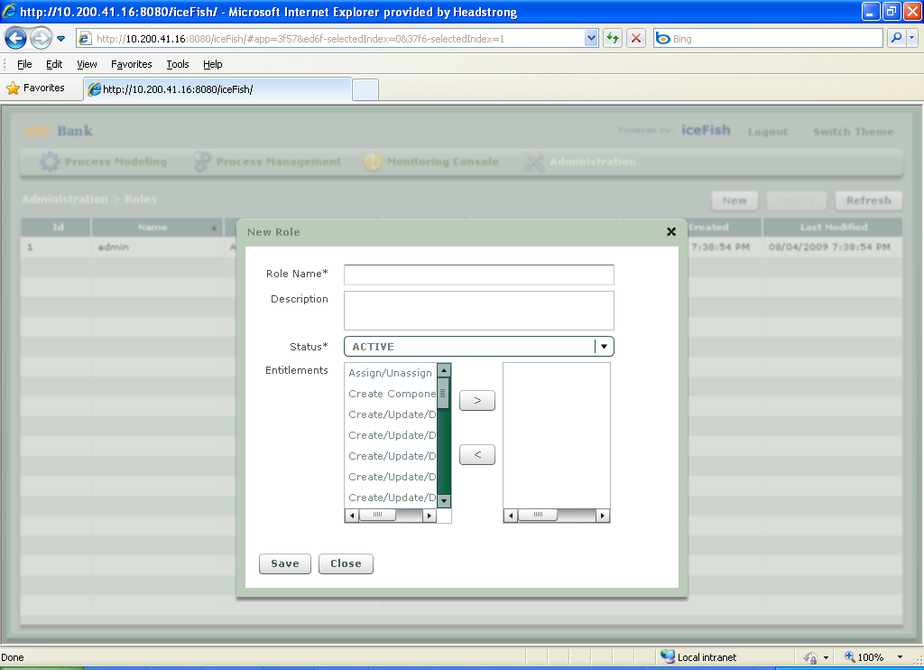

Figure 26 Adding New Role

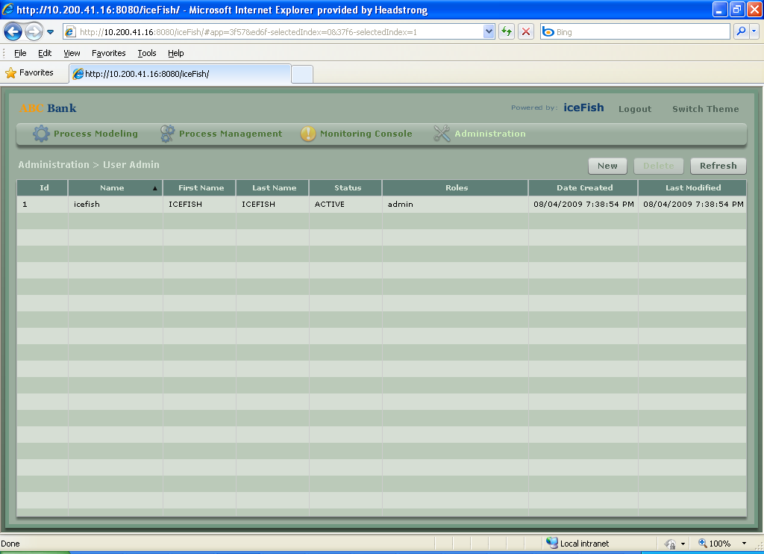

Figure 27 User Administration

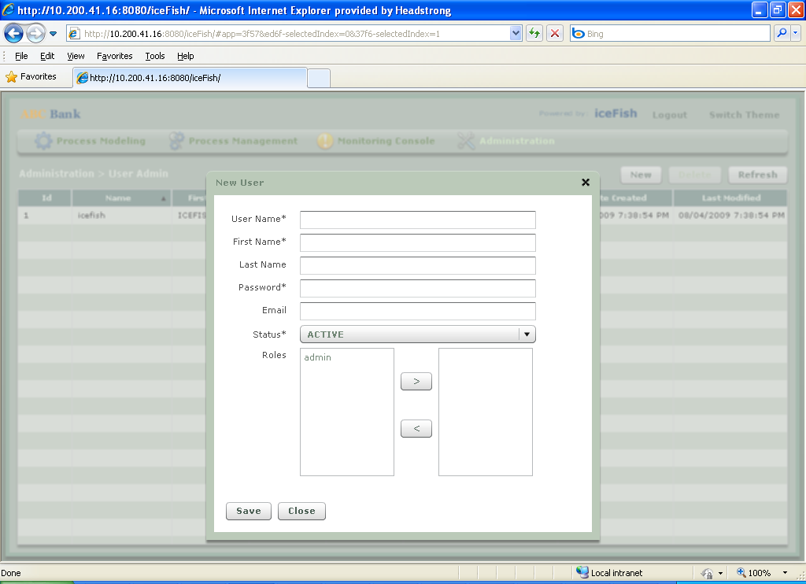

Figure 28 Adding New User

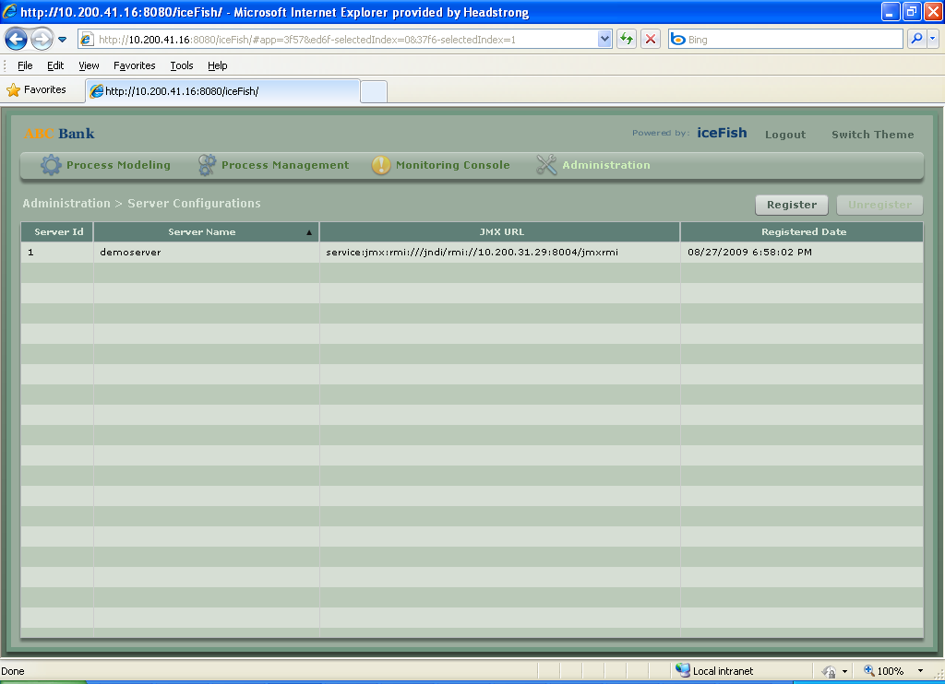

Figure 29 Register / Unregister Teevra Server instances to monitor and manage them

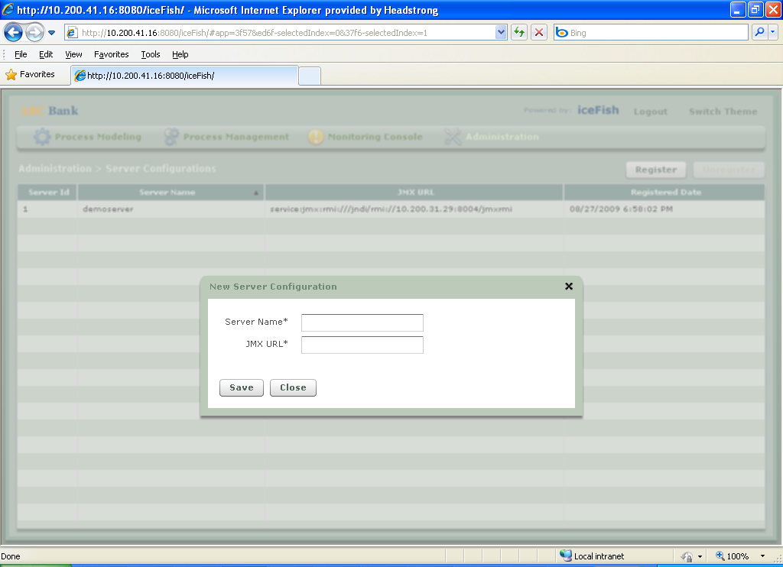

Figure 30 Registration of New Teevra Server instance

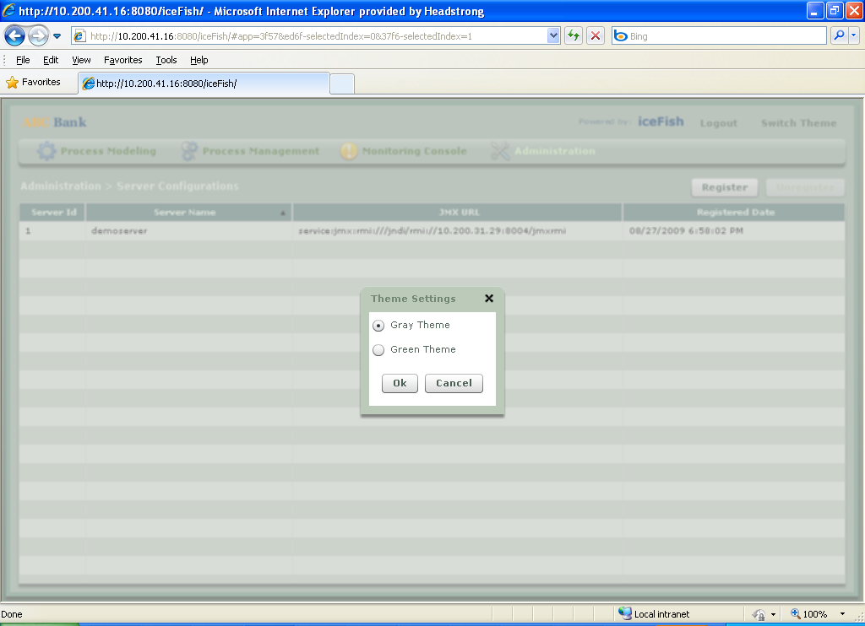

Figure 31 Switch Themes (Themes easily pluggable)

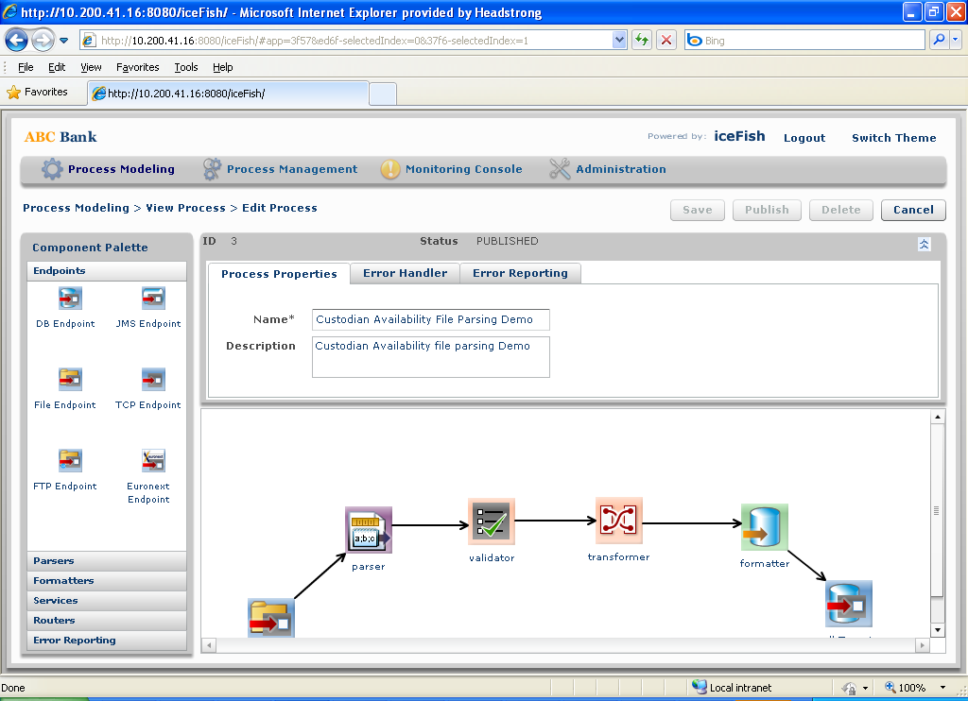

Figure 32 A Sample alternative theme