*FOR:*

**Headstrong**

*CONTENT:*

Teevra Release 1.0

Teevra User Manual Guide

*April 18, 2013*

L



**Document History**

|  |  |  |  |
| --- | --- | --- | --- |
| Version | Release Date | Author | Description of Change |
| 0.1 | 22-May-2009 | Arun Kumar | First draft |
| 0.2 | 10- Aug-2009 | Manish Tiwari | Updated with new template |

**Reference Documents**

|  |
| --- |
| **Document Name** |
|  |

**TABLE OF CONTENTS**

1 Process Modeling 4

1.1 View Process 4

1.2 New / Edit Process 5

1.3 Component Configuration – Generic 6

1.4 Component Configuration – Specific 7

2 Process Management 10

2.1 Process Status 10

3 Exception Handling 11

3.1 Error Reporting 11

4 Administration 13

4.1 Components 13

# Process Modeling

User uses this section to create / edit / view / delete processes and message schema.

## View Process

This screen shows the list of processes the user has created in the system.

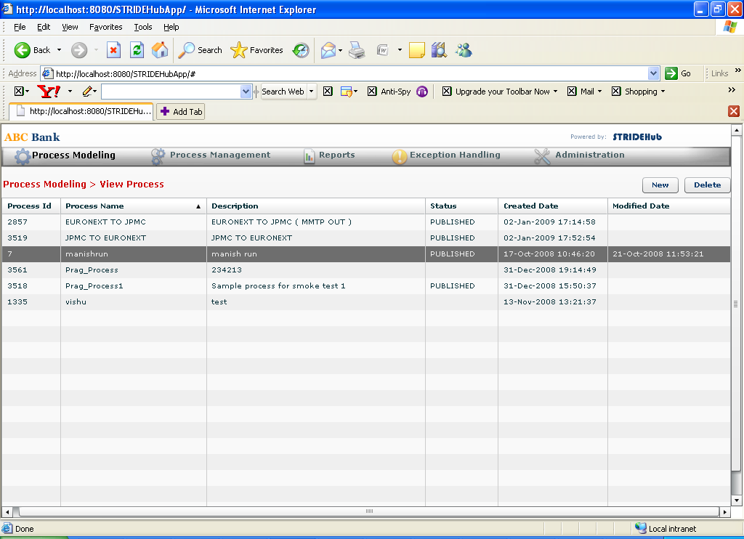

Figure 1 Process Modeling -> View Process

## New / Edit Process

User uses this screen to model the process and publish them so that it is ready for execution. User can build the graph by dragging and dropping them on the graph canvas. User can configure them by pressing Ctrl + Left Click on the dropped components. User can connect them by first selecting the “Line” icon from the left palette and then dragging the mouse from one component to another. User can delete the added component by selecting Alt + Left Click.

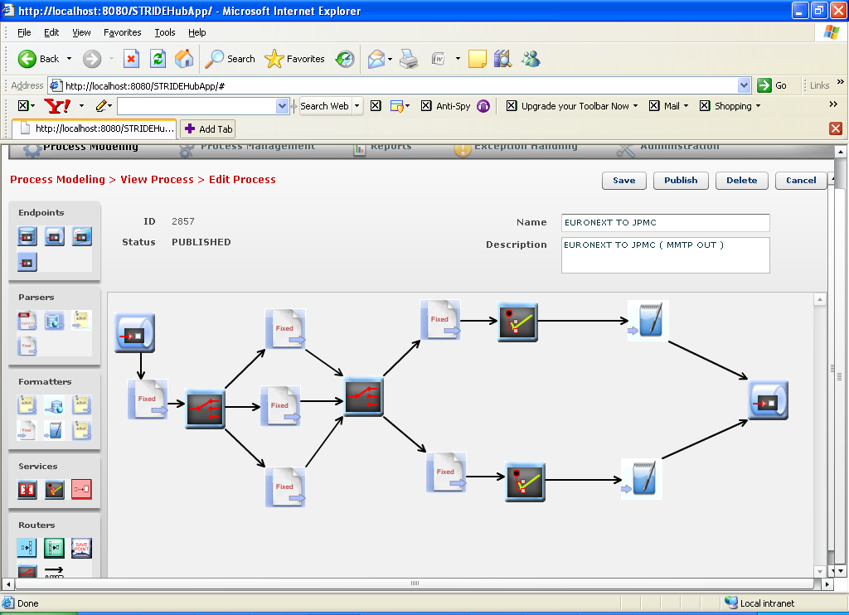

Figure 2 Process Modeling -> New / Edit Process

## Component Configuration – Generic

Components that are added to the graph need to be configured specifying how it needs to be used in the process. Generic configurations are those straight forward / simple configurations that have a configuration key and a corresponding value. All the other components have a UI specific to them. Following screen shows the generic configuration screen for a JMS / MQ Endpoint.

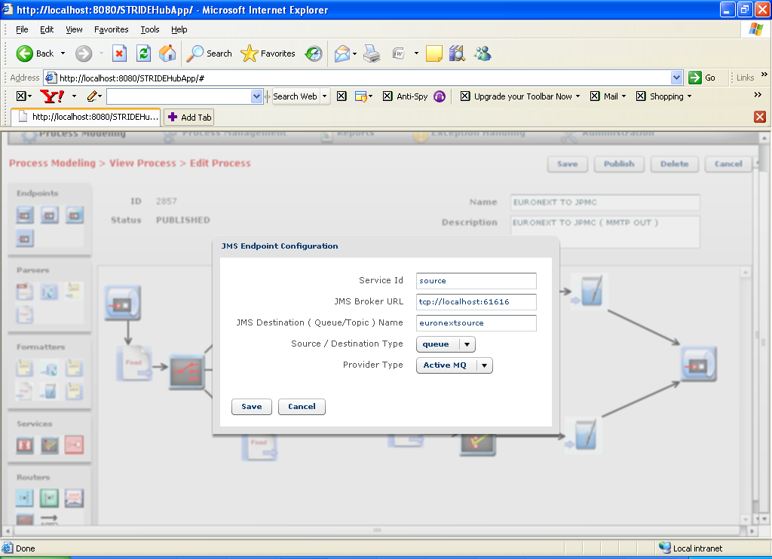

Figure 3 Generic Component Configuration - JMS Endpoint

## Component Configuration – Specific

Components of type Parsers, formatters and Services have complex configurations and hence they have their own screen / SWF file that gets opened when they need to be configured. Among them, the screen looks similar for all parser & formatter components (except generic formatter, including content based router from routers) and all service components. Following list of snapshots presents screen from each category.

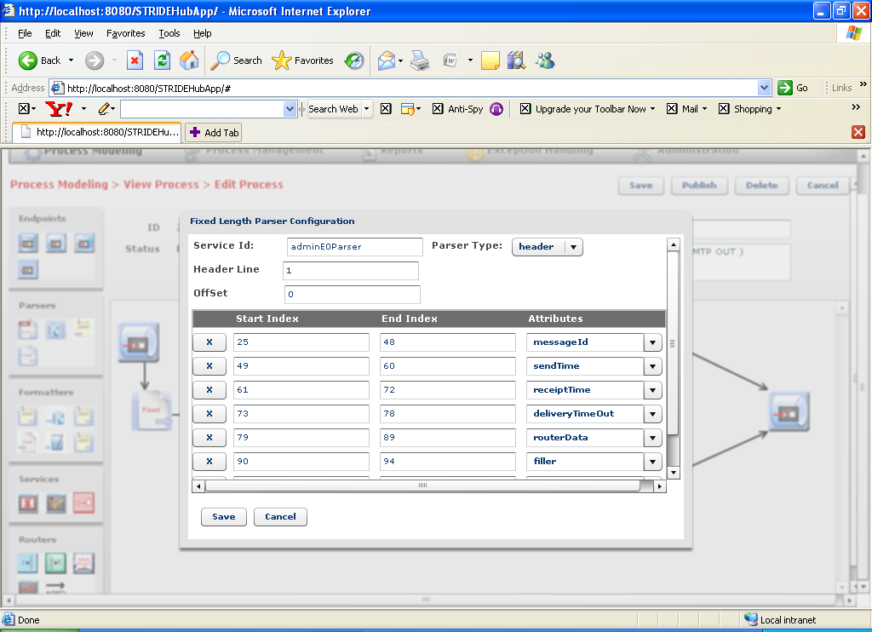

Figure 4 Specific Component Configuration - Fixed Length Parser

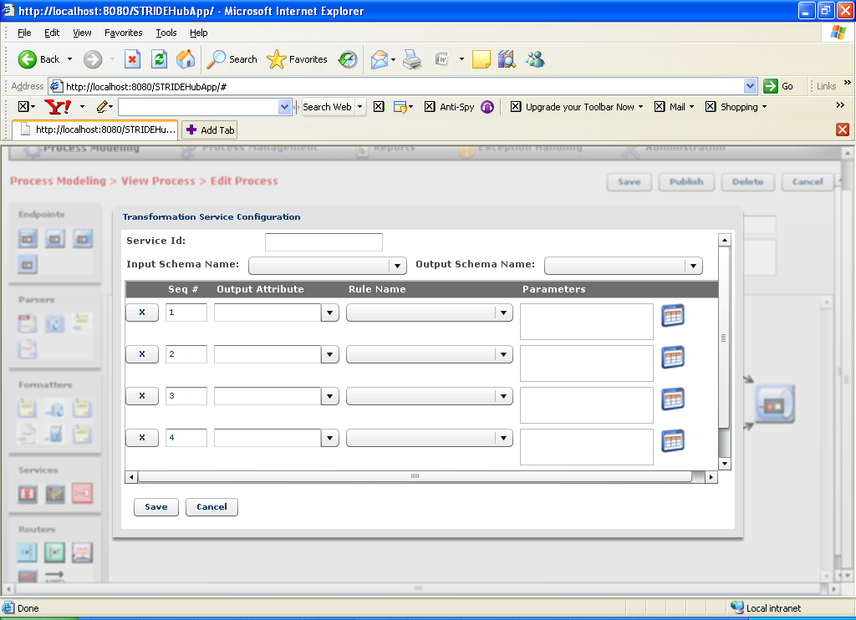

Figure 5 Specific Component Configuration - Services – Transformation

User selects a rule name from the drop down. To specify input arguments to the selected rule, user can take the help of parameter entry dialog by selecting the icon to the right of parameter entry field. Following screen shot shows the parameter entry dialog that is opened for a substring rule.

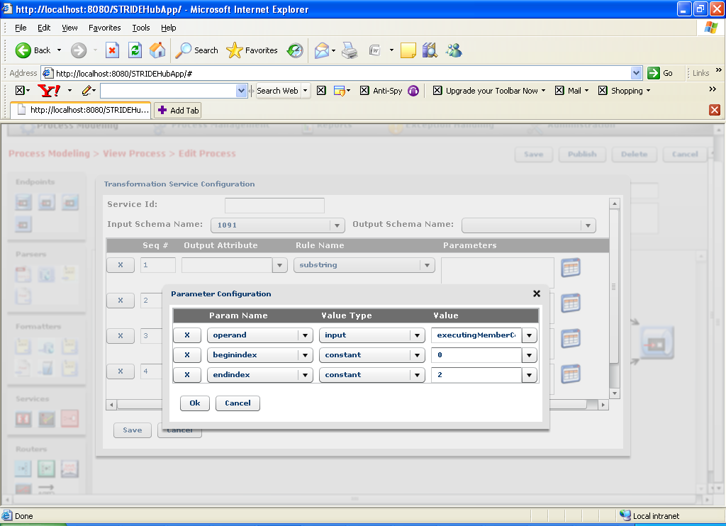

Figure 6 Screen to specify parameters for a transformation rule – Substring

User can configure a Content Based Router (CBR) component to (conditionally) branch to different routes based on the contents in the message.

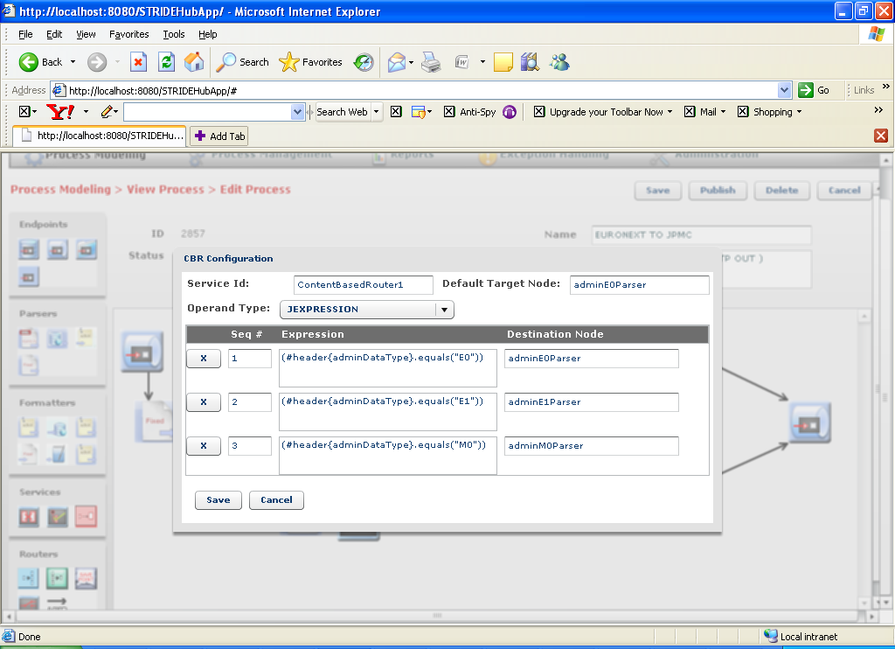

Figure 7 Specific Component Configuration - Content Based Router

In case the format of the message that needs to be sent outside is complex, user can take the help of Generic formatter. Here, the user can place a sample output file and replace the contents that need to be substituted from the contents of the message with the help of program constructs at the place holder.

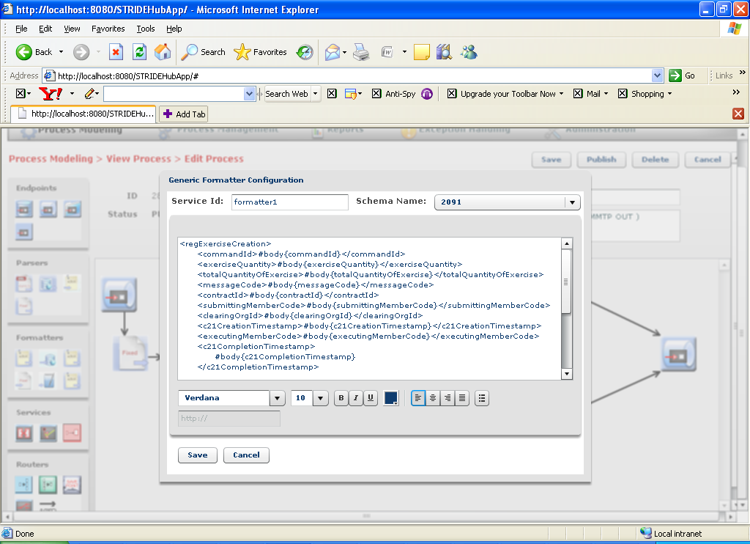

Figure 8 Specific Component Configuration - Generic Formatter

# Process Management

User uses this section to view the running state of individual process and also to Start / Stop / Schedule published processes. In case if errors have occurred in the process , the error message column would highlight the number of messages that have encountered error. On double click the user will see all the error records corresponding to that process.

## Process Status

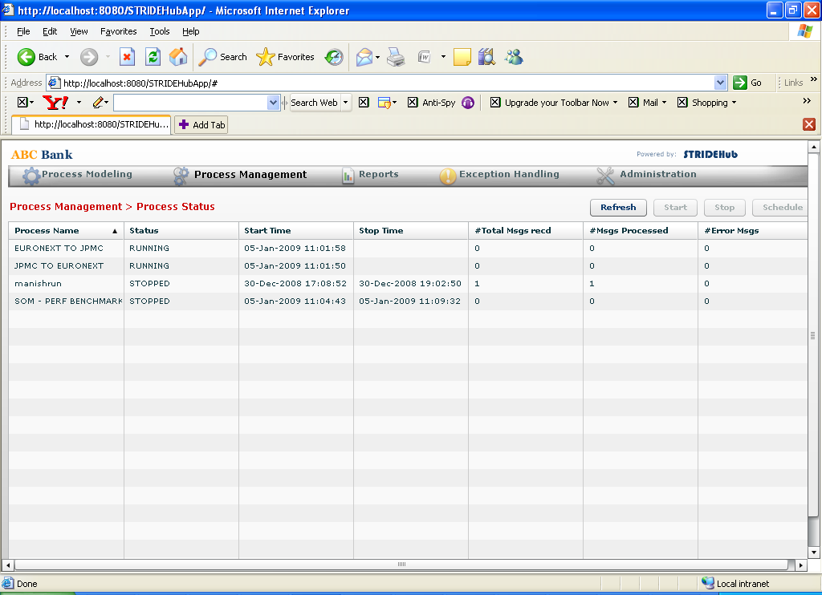

Figure 9 Process Management -> Process Status

# Exception Handling

## Error Reporting

This section shows all the error messages in all the processes. On double click, it presents the details of the error record and the description of the error.

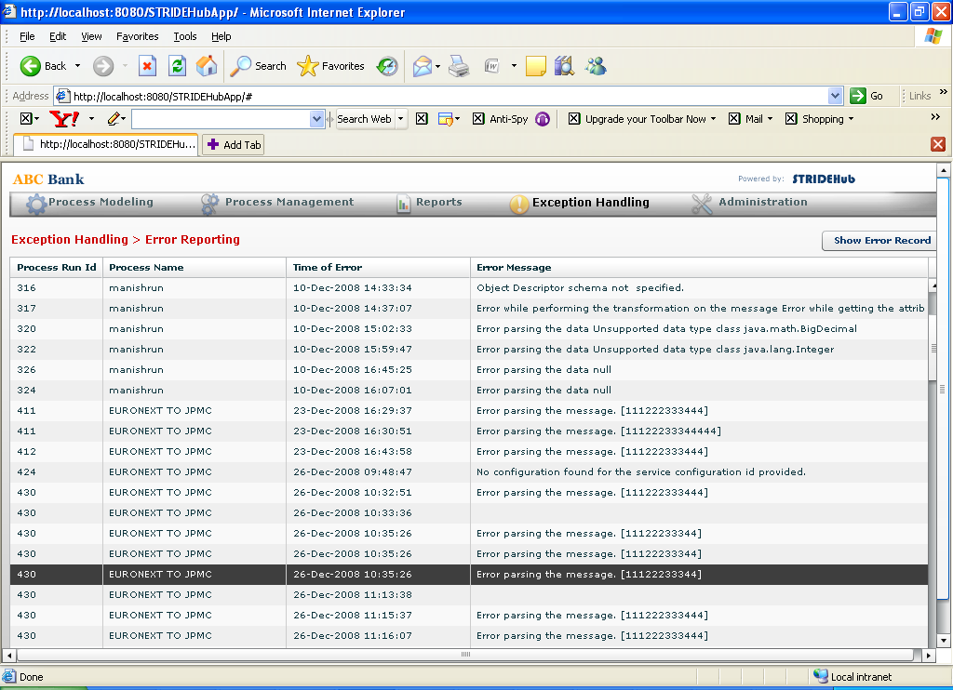

Figure 10 Exception Handling -> Error Reporting

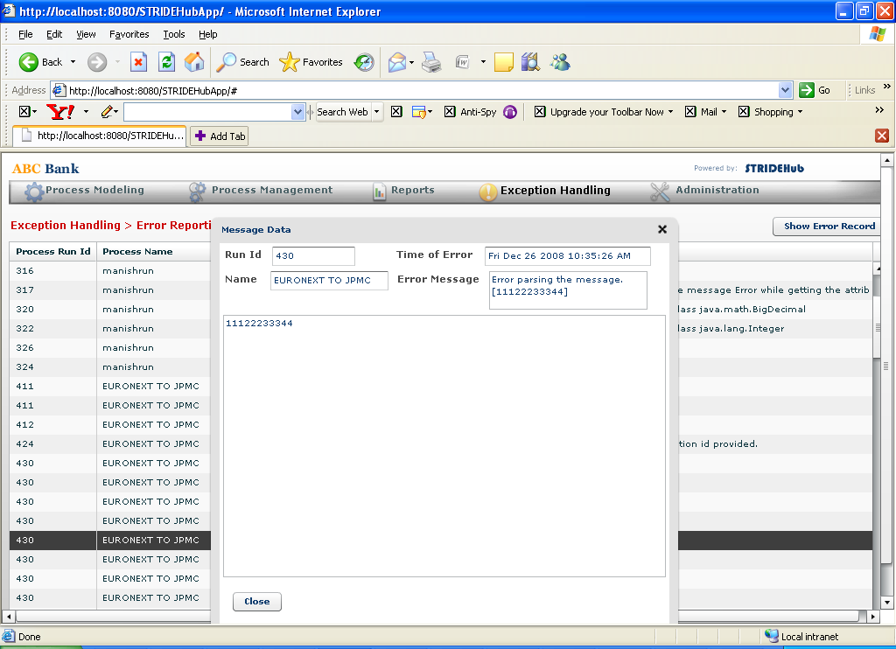

Figure 11 Error record details

# Administration

## Components

This section is used to view all the deployed components in the system. User can also add a new component by uploading component’s bundle (jar file), the configuration UI (SWF file) and an icon for it (an image file).

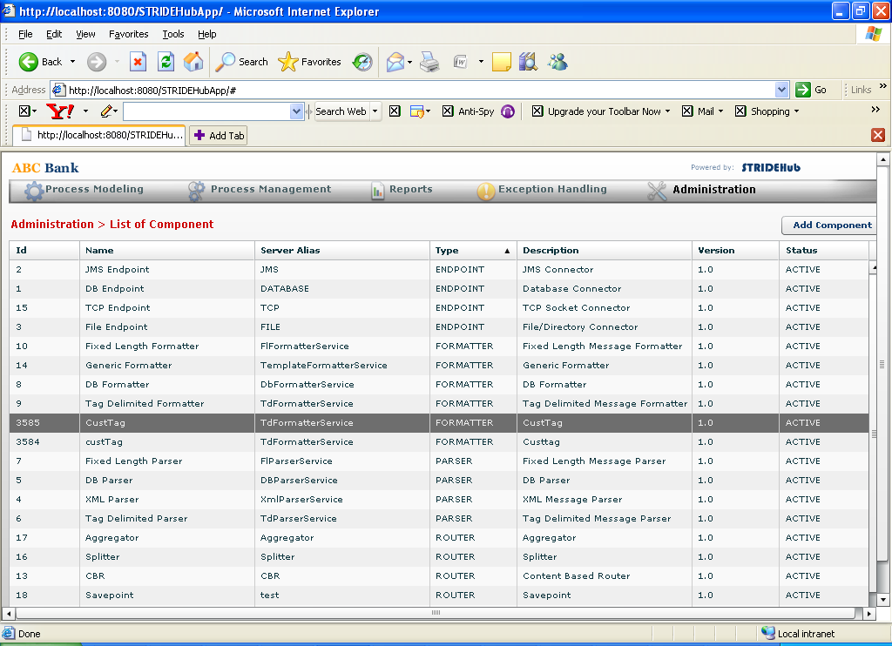

Figure 12 Administration -> Components

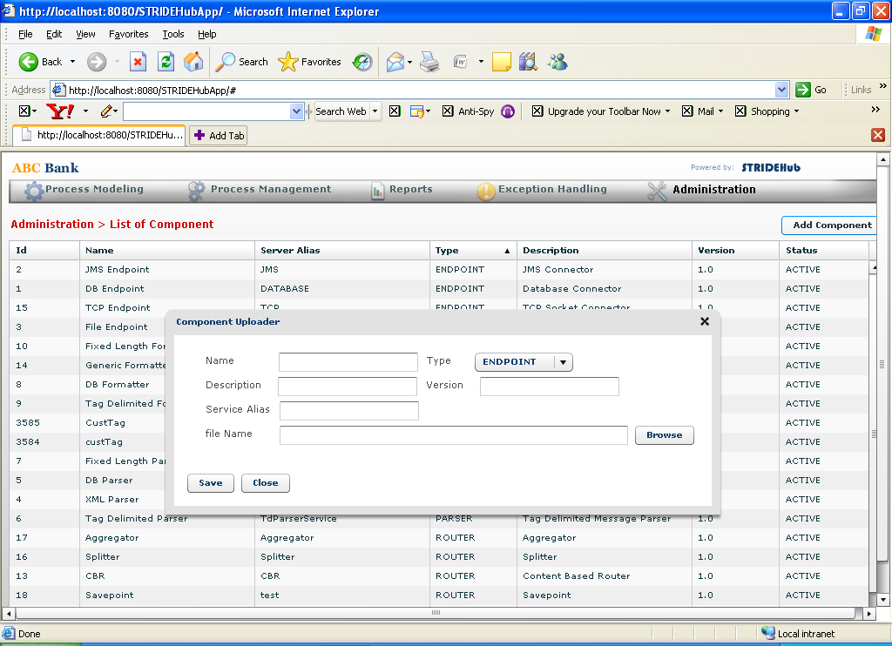

Figure 13 Add Component

# 