

FOR:
Headstrong

CONTENT:

Design Document For

Teevra – Server

ENG-TEM-09

Version 1.3

01-Sep-2008

L

Document History

Version | Date | Author | Description of Change | Reviewed By | Approved By
1.1 | 23-Oct-2008 | Som Krishan Soni | Initial Version | Arunkumar K. | Shyam Kurien
1.2 | 23-Feb-09 | Manish Bafna | Update C API Connectivity for Euronext. | Som Soni | Arunkumar K
1.3 | 03-Mar-09 | Som Krishan Soni | Update State Machine design | Arunkumar K | Arunkumar K
1.4 | 30-Apr-2009 | Som Krishan Soni | Update with splitter details related to IF-CR-034 | Arunkumar K | Arunkumar K
1.5 | 04-May-09 | Manish Bafna | Added Binary Structures parser and formatter  Modified Validator and Transformer component design  Also renamed STRIDEHub to Teevra
1.6 | 12-May-09 | Som Soni | Error Handling. | Arunkumar K
1.7 | 03-Aug-09 | Som Soni | Updated for Euronext Adapter (IF_CR_035) , Conditional Validator (IF_CR_036), FIXML Validator (IF_CR_037) , FIXML Error Formatting (IF_CR_038 ), Arithmetic Expression rule (IF_CR_039) | Arunkumar K | Arunkumar K

Distribution List
Details
All employees of Headstrong and its subsidiaries covered by the Headstrong Quality System.
Mode of distribution will be through the HQ. https://hq.headstrong.com/index.cfm . This document is controlled through a configuration management tool by Corporate Quality Manager and its revisions are identified by its version number.

Reference Documents
Document Id | Document Name
Requirements | http://projman/svn/repos/STRIDEHubReEngg/trunk/ReEngineering/Docs/ProductManagement/Roadmap/Teevra_ProductFeatureList.xlsx
UI Wire frames | http://projman/svn/repos/STRIDEHubReEngg/trunk/ReEngineering/Docs/Requirements/STRIDEHub_UI_WireFrames.xlsx
Data model | http://projman/svn/repos/STRIDEHubReEngg/trunk/ReEngineering/Docs/Architecture/STRIDEHub_DataModel.xlsx

TABLE OF CONTENTS

1 introduction 10
1.1 Purpose 10
2 Audience 10
3 Scope 10
4 System Overview 10
5 FUSION Architecture 14
5.1 OSGi (Open Services Gateway Initiative) Container 14
5.2 Message Oriented Middleware 15
5.2.1 Message Bus 16
6 Fusion Components 17
6.1 Launcher 17
6.1.1 Bootstrapping Fusion 17
6.1.2 Initial Configuration 17
6.1.3 Class Diagram 18
6.1.3.1 FusionLauncher 18
6.1.3.2 Fusion 18
6.1.3.3 BootstrapInstaller 19
6.1.4 Sequence Diagrams 19
6.1.4.1 Standalone Mode 19
6.1.4.2 Embedded Mode 21
6.2 Logger 22
6.2.1 Initial Configuration 22
6.3 Admin 22
6.3.1 Admin Module class diagram 23
6.3.2 Non-clustered Start-Up 23
6.3.3 Clustered Start-Up 24
6.3.3.1 Member Start-up Activation Sequence 24
6.3.3.2 Master Activation on failover 25
6.3.3.3 State replication 25
6.4 Fusion Core 25
6.4.1 Message Mediation and Routing 25
6.4.1.1 Connector 26
6.4.1.2 Mediator 26
6.4.1.3 Router 26
6.4.2 Message Flow 26
6.4.2.1 ST 26
6.4.2.2 SEDA 26
6.4.2.3 JMS 26
6.4.3 Process Configuration 27
6.4.4 Configuration Elements 27
6.4.4.1 Process Sequence 27
6.4.4.2 Routes 27
6.4.4.3 Connector 28
6.4.4.4 Mediator 28
6.4.5 Process Configuration Model Class Diagram 29
6.4.5.1 ProcessConfigurationModel 29
6.4.5.2 Process 29
6.4.5.3 EndPointConfig 29
6.4.5.4 RouterConfig 30
6.4.6 Process Model Generation 30
6.4.6.1 Process generation 30
6.4.6.2 Process Modeler 30
6.4.6.3 ProcessFlowModeler 31
6.4.6.4 Seda flow creation sequence diagram 33
6.4.7 Process Administration 34
6.4.7.1 Process start sequence diagram 34
6.4.7.2 Process stop sequence diagram 35
6.4.8 Process Scheduling 35
6.4.8.1 Process scheduler class diagram 36
6.4.8.1.1 ProcessScheduler 36
6.4.8.1.2 QuartzProcessScheduler 36
6.4.8.2 Process schedule sequence diagram 37
6.4.9 Component Management 37
6.5 Recovery Manager & Activity Monitor 39
6.5.1 Activity Monitor 39
6.5.1.1 Sequence Diagram 39
6.5.2 Recovery Manager 41
6.5.2.1 Sequence Diagram 41
6.5.3 Component Manager 42
6.6 State Machine 42
6.6.1 Finite State Model 42
6.6.2 State 42
6.6.3 Transition 42
6.6.4 Event 42
6.6.5 Condition 42
6.6.6 Action 43
6.6.7 Class Diagram 43
6.6.7.1 StateMachine 43
6.6.7.2 StateMachineManager 43
6.6.7.3 Event 43
6.6.7.4 SCXMLCustomAction 44
6.6.8 Registering a new state machine 44
6.6.9 Triggering an Event on state machine 44
6.7 Splitter 44
6.7.1 Configuration 44
6.7.2 Splitter Strategies 44
6.7.2.1 Partition Key Strategy 44
6.7.2.2 Batch Split Strategy 44
6.7.3 Class Diagram 44
6.7.3.1 SplitterService 45
6.7.3.2 PartitionKeySplitter 45
6.7.3.3 BatchSplitter 45
6.8 Error Handling/Reporting 45
6.9 Configuration 45
6.9.1 Exception Type 45
6.9.2 Class diagram 45
6.10 Error Handling 46
6.10.1 Class Diagram 46
6.10.2 Sequence Diagrams 47
6.10.2.1 Mediation Service 47
6.10.2.2 Endpoint 47
6.10.2.3 Process 47
6.11 Error Reporting 47
6.11.1 Error Route Configuration 48
6.11.2 Error Route Modeling 48
6.11.3 Class Diagram 49
6.12 Euronext Adapter 49
6.13 FIXML Validator 50
6.14 Expression Evaluator 50
7 Built-in Components 50
7.1 Poller and Writer 50
7.1.1 Database - JDBC 50
7.1.2 Message Queue 51
7.1.3 Directory / File System 51
7.1.4 File Transfer Protocol (FTP) 51
7.1.5 Web services 51
7.1.6 Socket 51
7.1.7 Http 52
7.1.8 Email 52
7.1.9 C API Connectivity for Euronext Clearing House 53
7.1.10 Custom 54
7.2 Pre-Processor and Post-Processor 54
7.2.1 Pre-Processor 54
7.2.2 Post-Processor 54
7.3 Parser and Formatter 54
7.3.1 Fixed Length 54
7.3.2 Tag Delimited 55
7.3.3 XML 55
7.3.4 FIXML 55
7.3.4.1 Parser 55
7.3.4.1.1 Configuration 56
7.3.4.1.2 Class Diagram 56
7.3.4.2 Formatter 57
7.3.4.2.1 Configuration 57
7.3.4.2.2 Class Diagram 57
7.3.4.3 Formatter 58
7.3.5 Binary Structure ( C Structure) 58
7.4 Validation Engine 59
7.4.1 Class Diagram 59
7.4.2 Rule Manager 59
7.4.3 Validator 59
7.4.4 Rules 60
7.4.5 Conditional Rules 60
7.5 Transformation Engine 60
7.5.1 Class Diagram 60
7.5.2 Rule Manager 61
7.5.3 Transformer 61
7.5.4 Rules 61

Table of Figures

Figure 1 Teevra High Level Architecture 12
Figure 2 High level overview of Fusion Framework 13
Figure 3 OSGi Framework 14
Figure 4 Message Oriented Middleware 15
Figure 5 Fusion Launcher Class Diagram 17
Figure 6 Sequence diagram of Fusion launcher in standalone mode 19
Figure 7 Sequence diagram of Fusion launcher in embedded mode 20
Figure 8 Admin startup in non-clustered mode sequence diagram 22
Figure 9 Admin startup in Clustered mode sequence diagram 23
Figure 10 process configuration model class diagram 28
Figure 11 Process generation sequence diagram 29
Figure 12 Camel Process modeler class diagram 30
Figure 13 Process Flow Modeler class diagram 31
Figure 14 SEDA flow creation sequence diagram 32
Figure 15 Process start sequence diagram 33
Figure 16 Process stop sequence diagram 34
Figure 17 Process scheduler class diagram 35
Figure 18 Process scheduling sequence diagram 36
Figure 19 install bundle sequence diagram 37
Figure 20 Sequence - Activity Monitor 39
Figure 21 Sequence - Recovery Manager 40
Figure 22 State Model diagram 42
Figure 23 State Machine class diagram 42
Figure 24 Splitter Configuration class diagram 43
Figure 25 Splitter Service class diagram 44
Figure 26 Error handling/reporting configuration class diagram 44
Figure 27 Error Handler class diagram 45
Figure 28 Sample Error Reporting Route 47
Figure 29 Error Route Modeling sequence diagram 47
Figure 30 Error Reporting module class diagram 48
Figure 31 C API Connectivity 51
Figure 32 Fixml Parser class diagram 54
Figure 33 Fixml Formatter Class Diagram 56
Figure 34 Validation Engine Class Diagram 57
Figure 35 Transformation Engine class diagram 59

- introduction

  - Purpose

This document explains the end to end design for Teevra server. Teevra server has all the components and run time required to execute the integration processes. Integration process would typically involve external system interaction through various protocols, data exchange in various formats, business & data validation / transformation, data persistence, error handling / reconciliation.

- Audience

- Headstrong Product Manager
- Headstrong Product Development Team
- Headstrong Chief Architect
- Headstrong Domain Specialist

- Scope

This document describes the design of Teevra server that comprises of fusion Framework and pre-built server components of Teevra. Teevra server is the execution engine of integration processes.
The document doesn’t address the design of Teevra UI application that is used to model and monitor integration processes.

- System Overview

Teevra server offers the following feature
- Process Registration
  - New Process registration
  - Process definition updation
  - Process definition removal
  - Fetch list of all the processes currently registered with the system
- Process Administration
  - Start process
  - Stop Process
  - Monitoring current process status (resolved, scheduled, running, stopped etc.)

- Process creation and resolution
  - Resolution of persisted process definition by the fusion.
  - Creation of SEDA flow for the process.
  - Creation of Recovery flow for every process.
  - Creation of fault handling routine for the process.
- Process Scheduling
  - Initialization of persisted schedule by the fusion.
  - Starting scheduler on framework startup.
  - Creating a new process schedule.
  - Process start/stop based on the schedule.
  - Stopping scheduler on framework shutdown.
- Event Logging
  - Logging of process start/stop event.
  - Logging of session id/message id.
  - Logging of every incoming message with the delivery status.
  - Logging of any exception/error occurred during message processing.
- Message Recovery
  - Recovery of message on unsuccessful delivery.
  - Recovery of message if system goes down before successful delivery.
- Data read/write using End Points
  - Reading/writing data using JMS endpoint.
  - Reading/writing data using file endpoint.
  - Reading/writing data using Directory endpoint.
- Message Routing
  - Content Based Routing
- Message Parsing/Formatting
  - Parsing/Formatting XML data.
  - Parsing/Formatting data in excel.
  - Parsing/Formatting fixed length data.
  - Parsing/Formatting tag delimited data.
- Message Validation
  - Message validation as per the validation rules setup for the message.
- Message Transformation
  - Message transformation as per the transformation rules.
- Message persistence
  - Message persistence based on the message schema.
Teevra UI Application is used by following actors
- Business Process Modelers –View processes, create / modify processes by pulling in and configuring various Teevra components or extending pre-built process templates of Teevra. These are mostly technical people.
- Business Users – View various business reports generated on top of the data that went through the system while the processes are executed
- Business Process Administrators – These users inherit functionalities from Business Process Modelers and in addition they can start / stop / schedule process, monitor process status and view errors, if any, generated from the process.
The defined processes are executed by the Teevra Server built on Fusion framework.
The following diagram explains the architecture of Teevra server.
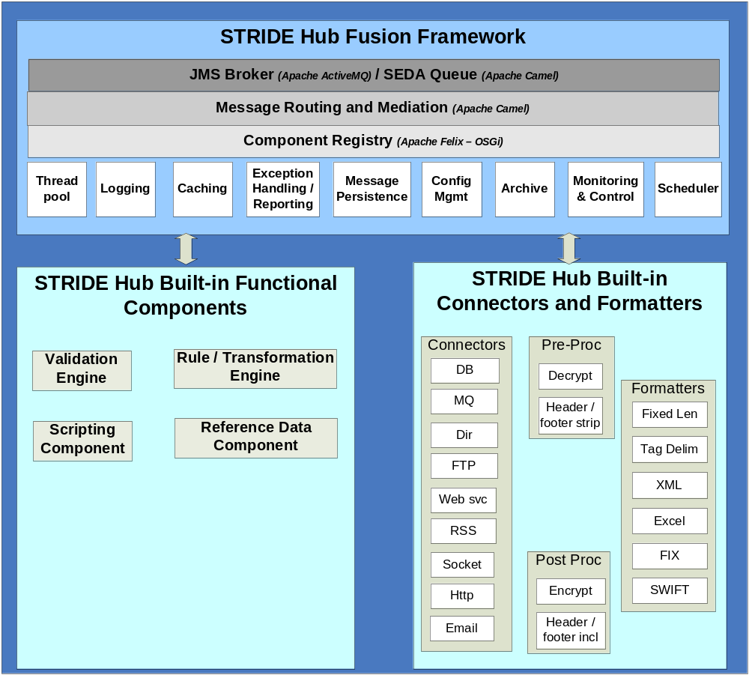
Figure 1 Teevra High Level Architecture

- FUSION Architecture

Fusion is a message oriented framework built on top of OSGi (Open Services Gateway Initiative) based runtime. This section and the following section detail the design of core components of Fusion middleware. It also provides details about the development and deployment of bundles (or components) in the Fusion middleware.
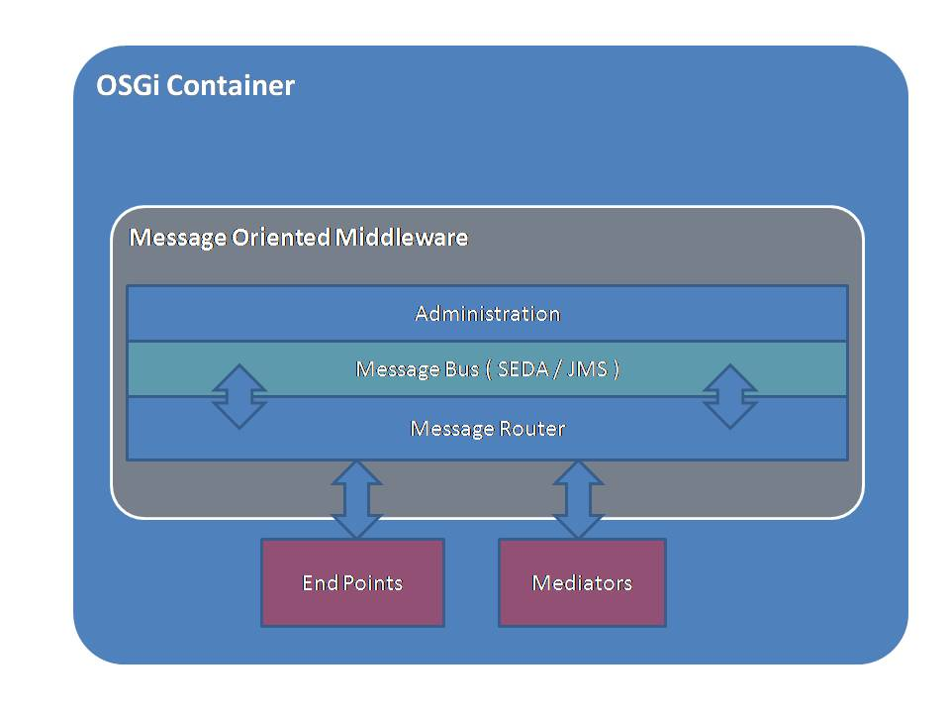
Figure 2 High level overview of Fusion Framework

  - OSGi (Open Services Gateway Initiative) Container

OSGi technology is the dynamic module system for Java™. The OSGi Service Platform provides functionality to Java that makes Java the premier environment for software integration and thus for development. Java provides the portability that is required to support products on many different platforms. The OSGi technology provides the standardized primitives that allow applications to be constructed from small, reusable and collaborative components. These components can be composed into an application and deployed.
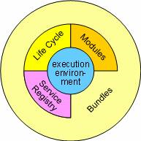
Figure 3 OSGi Framework

The OSGi Service Platform provides the functions to change the composition dynamically on the device of a variety of networks, without requiring restarts. To minimize the coupling, as well as make these couplings managed, the OSGi technology provides a service-oriented architecture that enables these components to dynamically discover each other for collaboration.

The core component of the OSGi Specifications is the OSGi Framework. The Framework provides a standardized environment to applications (called bundles). The Framework is divided in a number of layers.
- L0: Execution Environment
- L1: Modules
- L2: Life Cycle Management
- L3: Service Registry a ubiquitous security system is deeply intertwined with all the layers.

The L0 Execution environment is the specification of the Java environment.

The L1 Modules layer defines the class loading policies. The OSGi Framework is a powerful and rigidly specified class-loading model. It is based on top of Java but adds modularization. The module layer is fully integrated with the security architecture, enabling the option to deploy closed systems, walled gardens, or completely user managed systems at the discretion of the manufacturer.

The L2 Life Cycle layer adds bundles that can be dynamically installed, started, stopped, updated and uninstalled. Bundles rely on the module layer for class loading but add an API to manage the modules in run time.

The L3 layer adds a Service Registry. The service registry provides a cooperation model for bundles that takes the dynamics into account. Bundles can cooperate via traditional class sharing but class sharing is not very compatible with dynamically installing and uninstalling code.

  - Message Oriented Middleware

Middleware allows different software components (applications, enterprise java beans, servlets, and other components) that have been developed independently to interact with one another. Conceptually, middleware resides between the application layer and the platform layer (the operating system and underlying network services).

Message Oriented Middleware or MOM-based middleware allows distributed applications to communicate and exchange data by sending and receiving messages. MOM-based systems allow for a looser coupling of components and allow communication to happen through the asynchronous exchange of messages.

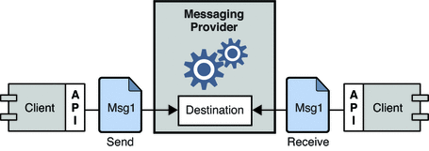
Figure 4 Message Oriented Middleware

Fusion middleware uses JMS and SEDA queue as the message bus. Different application components (bundles) deployed in the OSGi container communicates using the Fusion routing API.

    - Message Bus

Components deployed in the container communicate with other components using message bus. Every message is first passed to the run time and based on the routing definition it is sent to the appropriate message queue.

Framework uses JMS/SEDA queue as messaging platform based on the process configuration. By default if the components are deployed in the same runtime it uses SEDA queue, which can be forced to use JMS.

- Fusion Components

  - Launcher

Fusion may be launched as a standalone application using the Fusion Application or as a Web Application running inside any Servlet API or newer Servlet Container.

The Fusion Application is a standalone Java Application. It contains some helper classes to launch Apache Felix as the OSGi Framework. Apache Felix Framework libraries as well as the OSGi Core and Compendium libraries are part of the Fusion Application. To enable bootstrapping, the Fusion Application also contains three bundles, which are also by default deployed into the started framework: The log bundle, the assembly bundle and the Apache Felix Bundle Repository bundle. As these bundles are deployed using the OSGi Lifecycle Layer, they may of course be updated if need be. Additionally other bundles are also deployed using OSGi Lifecycle Layer as configured.

The Fusion Servlet is an extension of the Fusion Application in that it contains a simple Servlet calling into the Fusion Application Launcher to launch Fusion inside the Servlet Container.

    - Bootstrapping Fusion

The Fusion launcher (standalone or web application) only contains core classes and bundles to get a first launch. After the launch, the bundle activator of the fusion-assembly bundle will look at the framework properties to try to install further bundles and thus bootstrap fusion. It performs list of tasks on startup mentioned below.

- Initial configuration is loaded
- The list of bundles embedded in the application is set to the felix.autostart.1 property. This will automatically install and start these bundles.
- Bundle start level is set to the Start-Level specified. If nothing is specified default start level is set.
- The Apache Felix framework is launched.
- As soon as the Framework has been started, the fusion-assembly bundle inspects the Framework properties available through the BundleContext.getProperty(String) method to install bundles from configured OSGi Bundle Repositories.

    - Initial Configuration

The lifecycle of the OSGi framework implemented by an instance of the org.apache.felix.framework.Felix class is managed by the Fusion launcher class. This class is used by the standalone main class and the Fusion Servlet to control the lifecycle.

The Fusion launcher is responsible to provide the Framework properties to the OSGi framework. The properties are prepared as a Map<String, String> instance as follows (later steps may overwrite properties defined in earlier steps):

- Load core properties from the embedded fusion properties file.
- Overwrite with any properties provided by the main class or the Fusion Servlet.
- Make sure the fusion.home property is set defining a sensible default value if missing
- Load the contents of the ${fusion.home}/fusion.properties file
- Overwrite properties with Java system properties. This step only considers system properties of the same names as properties already existing. That is, the system properties are not just copied into the properties here. Additionally this step may be omitted if the fusion.ignoreSystemProperties property is set to true.
- Resolve any property file inclusions. This may be used to provide more configurability depending on the integration.
- Handle OSGi boot delegation support.
- Resolve property references of the form ${propName}
- Store the properties as ${fusion.home}/fusion.properties to be re-used on next startup
- Setup Bundle auto installation for the Felix Framework

The only property really required is actually the fusion.home property, which defines the file system location where runtime files will be placed. The default if this property is missing will be fusion in the current working directory as defined the user.dir system property.

    - Class Diagram

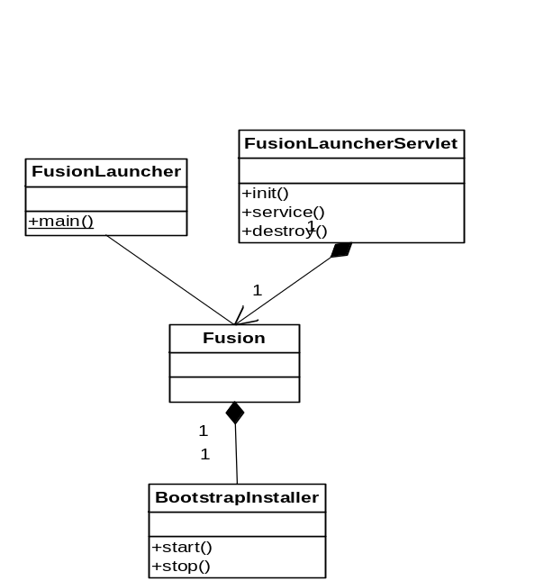
Figure 5 Fusion Launcher Class Diagram

      - FusionLauncher

This is the Launcher class that will be used to launch Fusion application in standalone mode. It contains a main method which performs following activities.
- Parse the command line parameters and create a property map of passed parameters.
- Create a Logger
- Create a new instance of Fusion passing the property map and logger
- Add a new shutdown hook to terminate the Fusion incase of shutdown.

      - Fusion
This is the main class that launches OSGi container in embedded mode. This class serves as a starting point for Fusion. The constructor launches Apache Felix as OSGi implementation we use. On startup it performs following activities.

- Apache Felix requires configuration parameters to be specified for startup. This class builds the list of parameters from three locations.
  - Fusion.properties file is read from the class path, this file contains default settings.
  - Extension of this class may provide additional properties.
  - Finally web application init parameters are added to the properties overwriting the existing properties in case of web application mode.
- Add the custom activator list in the bundle context. ( Fusion and BootstrapInstaller )
- Create a new Felix instance passing all the properties.
- Start the Felix instance.

      - BootstrapInstaller

This class implements OSGi BundleActivator interface. While starting the Felix instance an instance of this class is also registered with OSGi bundle context as a bundle activator. So the lifecycle methods of the BundleActivator are called on Felix start/stop. Below is the list of activities it performs.

- On startup check all the core bundles and bundles in the path if already installed or not.
- If not already installed, install the bundles set their start level to 1 and start.
- Any bundle already installed is not installed again and will also not be started here.

    - Sequence Diagrams

As previously explained fusion can be launched either in standalone mode or embedded mode. In Embedded mode FusionServlet is initialized on application startup which in turn launches OSGi container using Fusion.

      - Standalone Mode
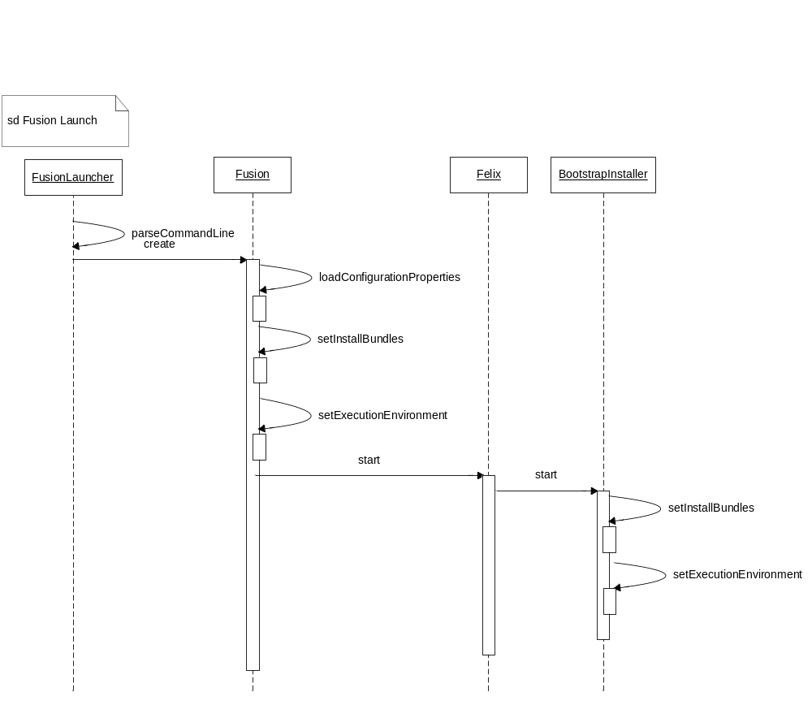
Figure 6 Sequence diagram of Fusion launcher in standalone mode

- FusionLauncher is the main class that is invoked to start the Fusion in standalone mode.
- FusionLauncher first parses the command line parameters and creates a property map.
- FusionLauncher initialized Fusion class and passes this property map as the parameter.
- Fusion loads the configuration.
- It checks for auto start bundle.
- Sets the execution environment.
- Sets the embedded execution property as true so it does not exit the VM when terminating.
- Add fusion and BootstrapInstaller instances as bundle activator in the bundle activator list.
- Create Felix instance and pass the properties and bundle activator list.
- Starts Felix container.
- Felix container in-turn calls the start method on bundle activators in this Fusion and BootstrapInstaller’s start method will be invoked.
- BootstrapInstaller’s start method installs any Bundles missing in the current framework instance.
- The Bundles are verified by the Bundle location string. All missing Bundles are first installed and then started in the order of installation.

      - Embedded Mode

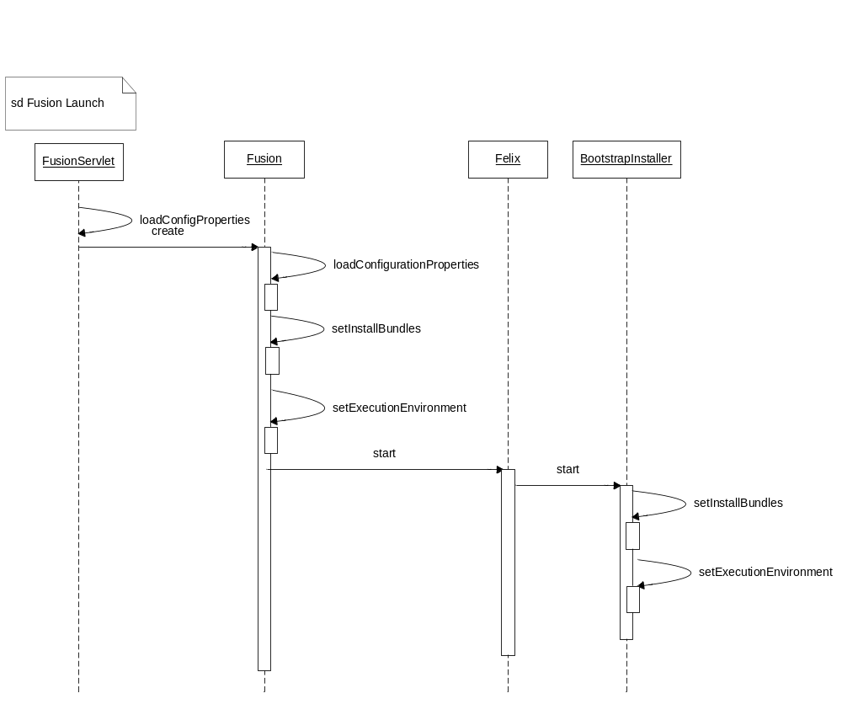
Figure 7 Sequence diagram of Fusion launcher in embedded mode

- FusionServlet is loaded on servlet container startup.
- It loads the configuration properties to overwrite default properties.
- It Instantiates Fusion class passing property map as parameter.
- After this the sequence of operation is same as standalone mode.

  - Logger

Logging in Fusion is supported by com.hs.fusion:fusion-logger bundle which is one of the first bundle installed and started by Fusion Launcher. Logger bundle has following tasks.
- Implements the OSGi Log service specification and registers the LogService and LogReader services.
- Exports three logging APIs.
  - Apache Commons Logging
  - Simple Logging Façade for java (SLF4j)
  - LOGBack
    - Initial Configuration

Property | Default | Description
com.headstrong.fusion.logger.level | INFO | Sets the initial logging level of the root logger. This may be any of the defined logging levels, which are by default DEBUG, INFO, WARN, ERROR and FATAL.
com.headstrong.fusion.logger.file | undefined | Sets the log file to which log messages are written. If this property is empty or missing, log messages are written to System.out.
com.headstrong.fusion.logger.pattern | {0,date,dd.MM.yyyy HH:mm:ss.SSS} *{4}* [{2}] {3} {5} | The logging pattern to be set for the PatternLayout of root logger appender.

  - Admin
Admin module has the responsibility of managing the state of the application. If the application is started in clustered mode it creates the communication infrastructure for the application node to join and send/receive messages with other nodes in the cluster.

Fusion can be started in normal as well as clustered mode, if the server is started in normal mode by default the application state is set to active which is changed to running by the core module after successful startup.

    - Admin Module class diagram

    - Non-clustered Start-Up

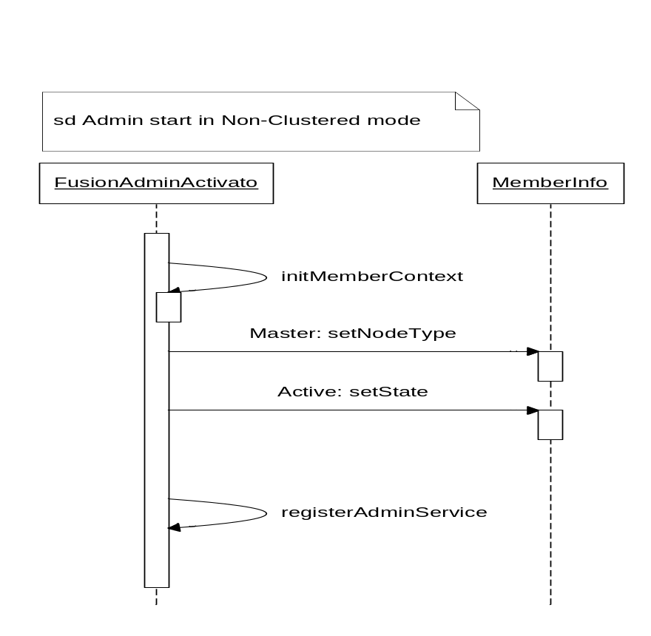
Figure 8 Admin startup in non-clustered mode sequence diagram

- Admin activator checks for the clustered property if set to false the application is started in non-clustered mode.
- MemberContext and MemberInfo are initialized.
- Member node type is set to Master and state is set to Active.
    - Clustered Start-Up
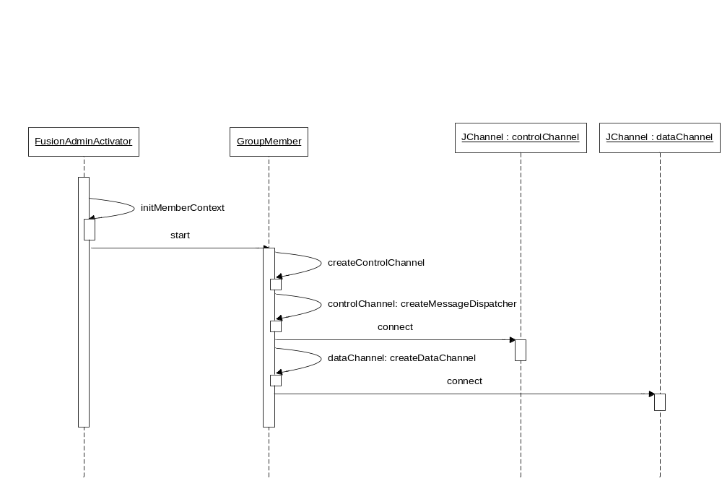
Figure 9 Admin startup in Clustered mode sequence diagram

- Admin activator checks for the clustered property if set to true the application is started in clustered mode.
- MemberContext, MemberInfo and GroupMember are initialized.
- GroupMember is started which in-turn creates control channel and data channel (both are Jgroups JChannel).
- Message dispatcher is created for control channel which may require both synchronous and asynchronous communication with other nodes in the cluster.
- Admin connects to both Control Channel and Data Channel connects to the cluster name specified in the property file (property name: cluster.name).
- On successful connection this node sends member registration request to all the other nodes in the cluster with its information.
- If node type is specified as Master in the property file (property name: cluster.node.type) it follows the member activation sequence described in section Error: Reference source not found.
- If the node type is Master and activation is successful the Member node type is set to Master and state is set to Active.
- Otherwise Member node type is set to Slave and state is set to Stand-By.
      - Member Start-up Activation Sequence
- On server start every node multicasts a synchronous member registration request to all the other nodes in the cluster.
- Every other node in response back to this request sends its own member information.
- If the node type of server is Master it checks all the response for the member state.
- If none of the nodes are in Active state Member node type is set to Master and state is set to Active.
- Otherwise Member node type is set to Slave and state is set to Stand-By as some other node is already active.
      - Master Activation on failover
- A view of cluster is shared across all the nodes in the cluster and any change in the view is published to GroupMembershipListener of all the nodes.
- On view change each node checks for the dropped members.
- If there are no dropped members each node updates the local cluster information with this new view.
- Else each node checks if the dropped member was Master or not.
- If Master node is down node in the view by default would be selected as the master.
- Since each node shares the same view (guaranteed by Jgroups) there won’t be any conflict in master selection.
- Selected Master node would multicast a self activation request to all other nodes in the cluster.
- If no negative responses are received Member node type is set to Master and state is set to Active.
- All state observers receive the state change event.
- Bootstrap of application is delegated to these state observers.
      - State replication
In clustered mode any persistent state change in the master should be replicated in all other stand-by nodes so that when one of these makes a transition to Active state it should be in the same state as last running master node.
- Admin provides infrastructure to multicast the state changes to all the stand-by nodes.
- Data channel is used to send the data requests to all other stand-by nodes.
- A clustered state request is created for any persistent state change to be replicated.
- State request also contains the handler name which would be invoked by the admin when the request is received on the other end.
- Handler should be registered with the Admin module beforehand.
- Requests are queued if the handler is not registered with the admin against the handler name which would be executed on the handler registration.
- Master Node sends a state change request to all the other nodes in the cluster whenever there is a state change in the master node which should be replicated across the cluster.
- Whenever there is a new node added to the cluster master sends a synchronization request to all the nodes in the cluster. This replicates the master state to rest of the nodes in the cluster.

  - Fusion Core

    - Message Mediation and Routing

Process in fusion is defined as a collection of connector, mediator and routing services. Fusion allows users to dynamically create and deploy processes using built-in components. It can be extended to add new services as required.

Process contains three types of component Connector, Mediator and Router.

      - Connector

Component that provide or consume services using some sort of communication protocol are called connector. These components sit at the boundary of the process and communicate with the environment outside the application.

Connector Components provide protocol independence for transport or communication. They access remote services using a specific protocol, and place those services onto the Fusion Message Router. Other Fusion components can then access these services from the Message Router.

Connector Components are specialized for specific external protocols, such as HTTP, JMS, and others. This allows any other component to communicate over any protocol or transport available from Connector Components deployed to the Fusion runtime environment. There is no need to implement these protocols separately in business logic.

      - Mediator

Mediators provide or consume services locally within the Fusion runtime environment, enabling services such as business logic, processing and transformation services.

For example, some Mediators might execute long-lived business processes, while others provide data transformation or validation.

      - Router

Routers provide ability to determine/change message at run time based on the message content or other parameters. Some of the routing components are.

- Content Based Router
- Splitter
- Aggregator
    - Message Flow

Messages consumed by Connector are sent to other components by the Runtime using on the below mentioned strategies as defined by the user.

      - ST

MessageExchange is routed straight to its destination with no staging or buffering. A straight through flow is best suited for the cases where latency needs to be as low as possible.

      - SEDA

The SEDA flow introduces a simple event staging between the internal processes in the Message Broker. A Seda flow is the default flow used by most components and, is suited for general deployment. The additional staging is well suited buffering exchanges between heavily routed to components.

      - JMS

A JMS flow is used for cases where you need collaboration between more than one Fusion containers. For example, an application that needs to have fail-over capability or an application that needs to balance its endpoints among several machines would need to have one or more Fusion container working in concert.

    - Process Configuration

Fusion engine is driven off a set of simple text/xml configuration files. This allows the configuration to be easily hand edited, backed up from the file system, or even included into version control for easier management and control (e.g. moving a configuration from development, through QA, staging and into production).

Process configuration defines Connectors, Mediators, Routers and the Message flow information. The process configuration is converted into a process configuration model understood by process modeler.

- Connectors are defined under Connector element.
- Connector properties are defined in the property element with name attribute as the property name and value as the property value.
- All connectors are assigned a unique id which would be used in the process definition.
- Multiple configurations can be specified for the same type of connector with different ID. Both the configuration would represent two different connectors.
- Mediators are defined under Mediator element.
- Mediator properties are defined in the property element with name attribute as the property name and value as the property value.
- All mediators are assigned a unique id which would be used in the process definition.
- Multiple configurations can be specified for the same type of mediator with different ID. Both the configuration would represent two different mediators.
- Routers are defined under router tag.
- Process definition contains Routes for message flow.
- Route defines message flow from one endpoint to another endpoint.
    - Configuration Elements

      - Process Sequence

A process sequence is a collection of routes that would define a complete process. In fusion core a process sequence is a complete logical entity that can be controlled by the client. I.e. the user can start/stop a process independently of the other processes. An individual route in the complete process can’t be stopped once started.

This process definition has references to Service Endpoints and Targets, that will be resolved using the Endpoint definition provided in the same XML.

      - Routes

A route is a combination a source and target endpoints. It contains following attributes.

- from: is the source of message for the route. Mediation and Binding endpoints can be specified in the from tag.
- to: can be any Endpoint including a mediation endpoint. Any message received by the from Endpoint will be passed on the to endpoint that in turn can send it to other Endpoint.

      - Connector

Component is used to communicate with other systems. Following attributes and properties are defined for the connector.

- Type: It’s a mandatory attribute. This is required to resolve the actual component.
- Id: It’s a mandatory attribute. This is required to uniquely identify the endpoint in the process.

      - Mediator

A Mediation endpoint is a functional component that offers a message mediation service. Following are the properties that are defined with the mediator endpoint.

- Type: It’s a mandatory attribute. This is required to resolve the actual component.
- Id: It’s a mandatory attribute. This is required to uniquely identify the endpoint in the process.
    - Process Configuration Model Class Diagram
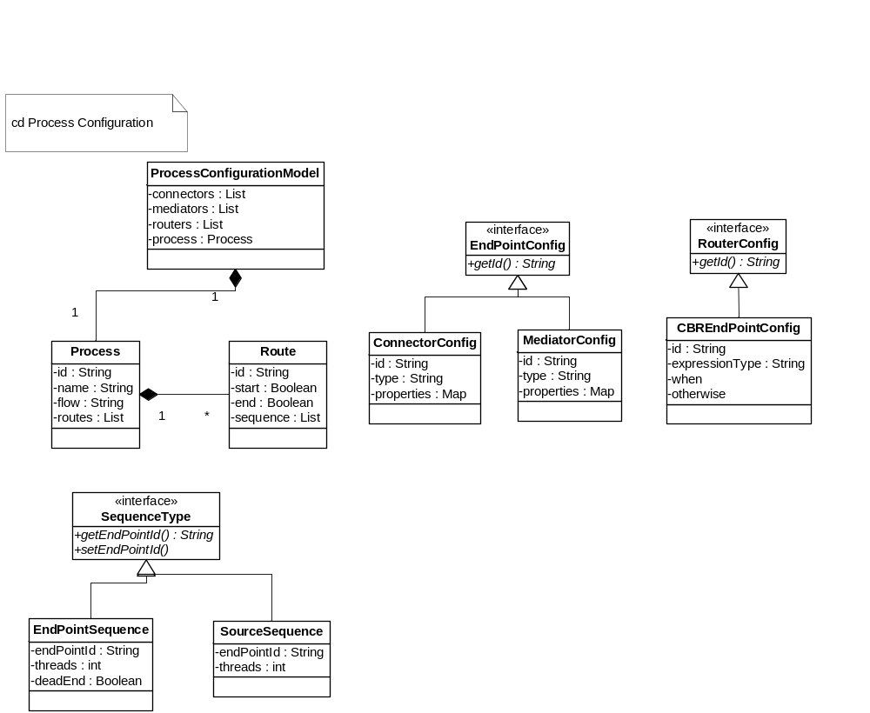
Figure 10 process configuration model class diagram

      - ProcessConfigurationModel

- This is the main class that contains process configuration model details.
- It contains configuration of Connectors, Routers, Mediators and Process.
      - Process

- It Contains information about process flow, which is represented in the form of Routes.
- Route contains Source and Destination endpoint Id which is used to create a Camel Route for message flow.
By default the flow type is SEDA, so for any component there is one staging queue created.

      - EndPointConfig

- Any component configuration in Fusion implements this interface. Classes which implement this interface are ConnectoConfig, MediatorConfig.
      - RouterConfig

- All routing component configuration e.g. Content Based Router implements this interface which in turn extends EndPointConfig.
    - Process Model Generation

- Fusion provides multiple interfaces for process registration.
- User can copy the file to process temp directory (property: fusion.process.temp.dir). Framework automatically registers the process.
- It also provides JMX interfaces which can be remotely invoked for process registration. One of the interfaces accepts byte array while another one accepts string.
- Process definition files are copied to process directory (property: fusion.process.dir) on successful registration of the process.
- The file name convention followed is {processs id}.xml.
- Process details are also copied to Fusion configuration

      - Process generation
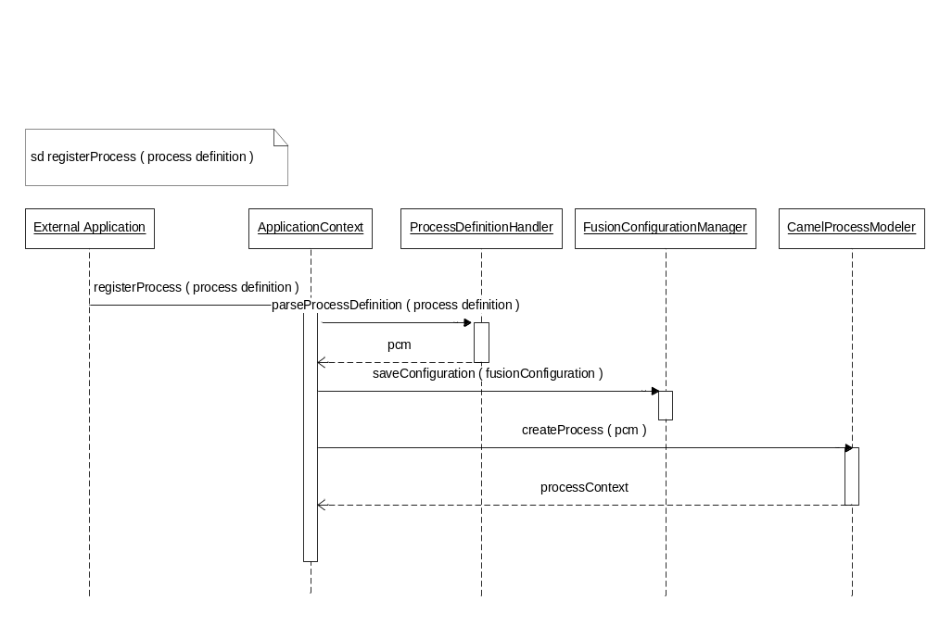
Figure 11 Process generation sequence diagram

      - Process Modeler
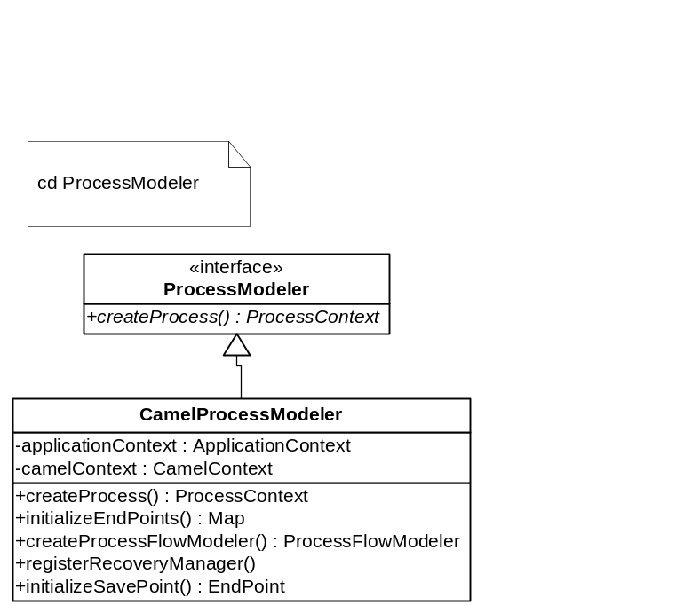
Figure 12 Camel Process modeler class diagram

- ProcessModeler interface is responsible for creation of Fusion ProcessContext.
- CamelProcessModeler is the implementation of ProcessModeler based on Apache Camel message mediation and routing.
- It initializes the components in the processes with the corresponding configurations.
- Creates ProcessFlowModeler based on the flow type. By default SEDA flow is created for the process.
- Creates CamelContext and adds routes generated by ProcessFlowModeler.

      - ProcessFlowModeler
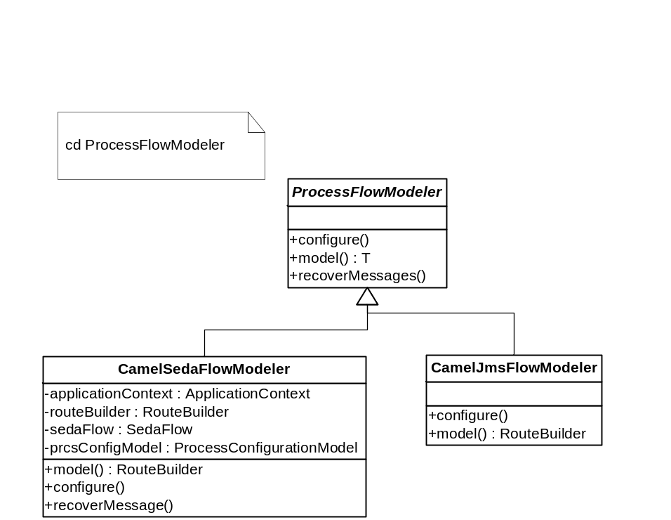
Figure 13 Process Flow Modeler class diagram

- ProcessFlowModeler is an abstract class that defines two public methods model and recoverMessage.
- ProcessFlowModeler also defines an abstract method ‘configure’ which is invoked by FusionCamelRouteBuilder class.
- Configure creates Apache Camel routes based on the process configuration model.
- Staging queue is also created for the components which creating routes as the flow type is SEDA.
- ProcessModeler invokes model method which returns Apache Camel RouteBuilder.
- CamelJmsFlowModeler implementation is pending.
      - Seda flow creation sequence diagram
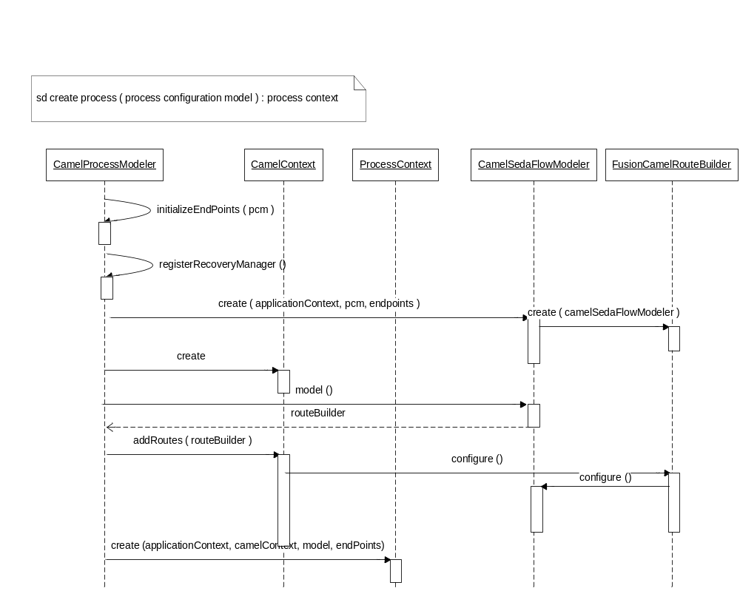
Figure 14 SEDA flow creation sequence diagram

- SEDA stands for Staged Event Driven Architecture.
- For every component a staging queue is created.
- ProcessModeler initializes all the End Points with the corresponding configuration.
- Registers the recovery manager for the process.
- Create SEDA flow modeler which in turn creates FusionCamelRouterBuilder.
- Creates CamelContext and adds route builder returned by CamelSedaFlowModeler.
- CamelContext internally calls configure method of the route builder (FusionCamelRouterBuilder).
- FusionCamelRouteBuilder configure method calls configure method of CamelSedaFlowModeler.
- CamelSedaFlowModeler iterates through the list of all the routes in the process model.
- Creates camel route based on the process route definition.
    - Process Administration

Process administration capabilities are also exposed as JMX interface. User can start/stop the process using the process id of the process.

      - Process start sequence diagram
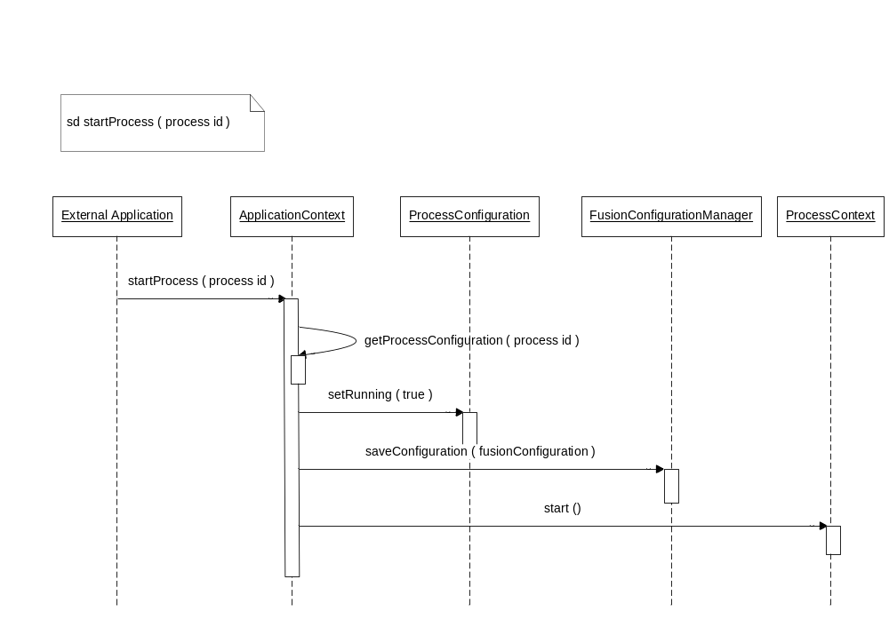
Figure 15 Process start sequence diagram

- External applications send a process start request providing the process id.
- Fusion updates the configuration setting process status running as true.
- Retrieves the process context from the process map using the process id.
- Start the process.
      - Process stop sequence diagram
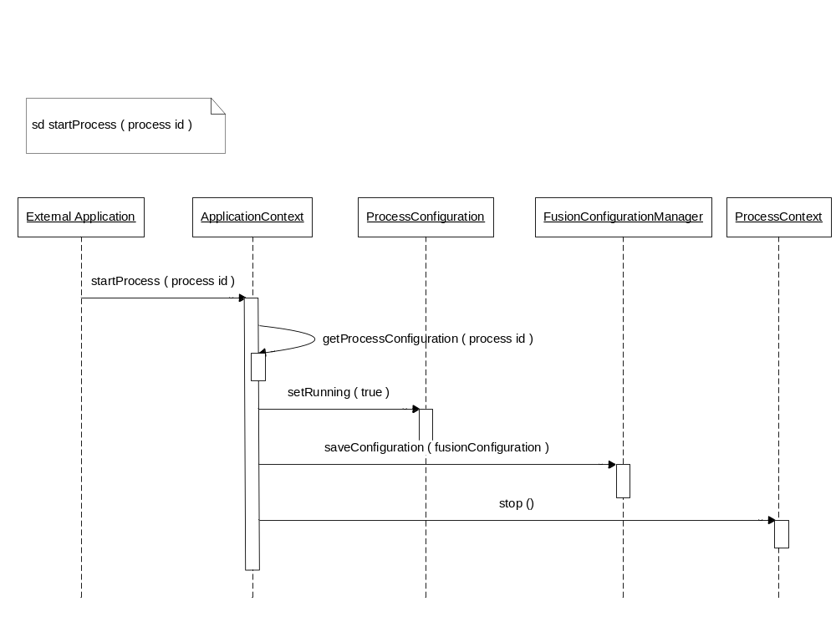
Figure 16 Process stop sequence diagram

- External application sends a process stop request providing the process id.
- Fusion updates the configuration setting process status running as true.
- Retrieves the process context from the process map using the process id.
- Stop the process.
    - Process Scheduling

Process scheduling by default works on top of Quartz scheduler, but Fusion provides an extra layer of abstraction which give flexibility to add new implementation for process scheduling.
      - Process scheduler class diagram
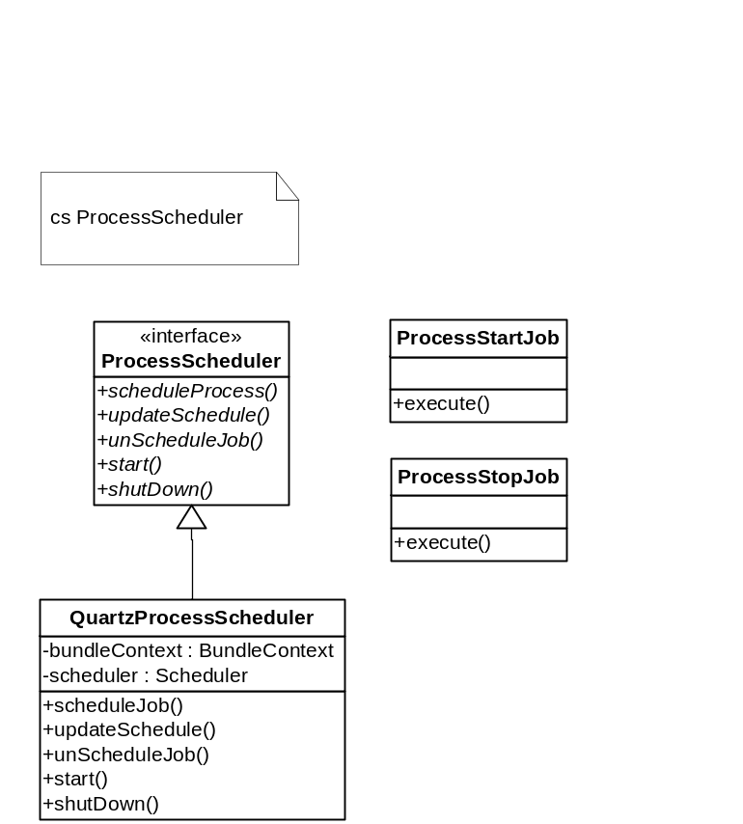
Figure 17 Process scheduler class diagram

        - ProcessScheduler

- ProcessScheduler is the scheduling interface provided by Fusion for process scheduling.
- It defines scheduleProcess, updateSchedule and unSchedule methods.
        - QuartzProcessScheduler

- It’s the default implementation of the ProcessScheduler that works on Quartz process scheduler.
- It uses standard quartz scheduler factory.
- For every process schedule it creates two schedules one to start the process and another to stop the process.
      - Process schedule sequence diagram
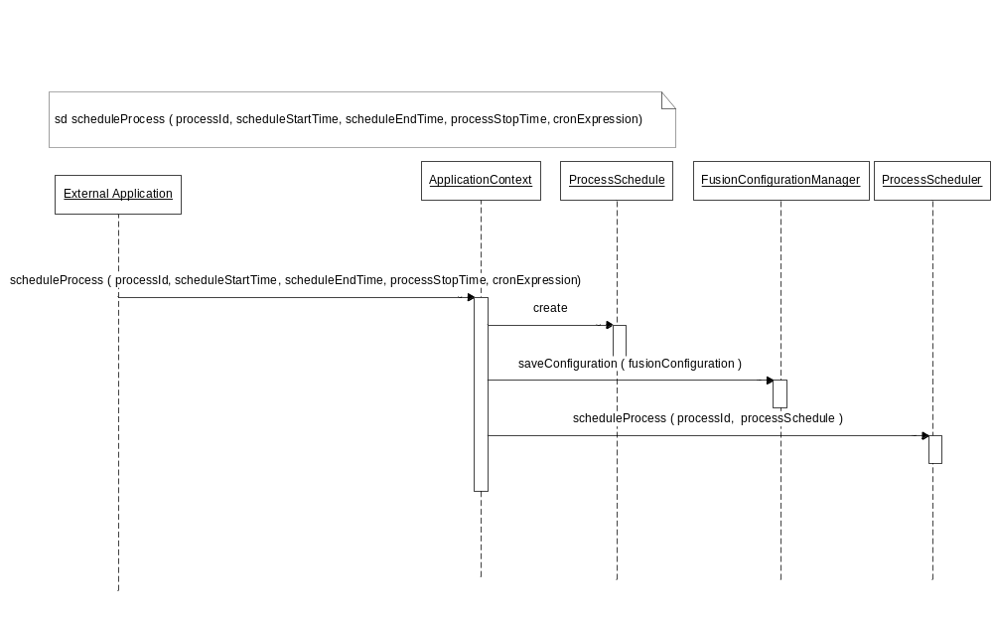
Figure 18 Process scheduling sequence diagram

- External application sends a process scheduling request with process start/stop time and scheduling cron expression.
- Fusion persist the process schedule.
- Checks for the process in the process map.
- Sends a process scheduling request to process scheduler.
- Process scheduler (Quartz process scheduler) creates two triggers.
- One for process start and another one for process stop.
- Starts the schedule.

    - Component Management

It supports dynamics installation and updation of new services. New services can be added to the framework without bringing the system down. These services once installed can be used in any process with system restart.

It provides a standard interface which has be to be implemented by these components to be used by the process.

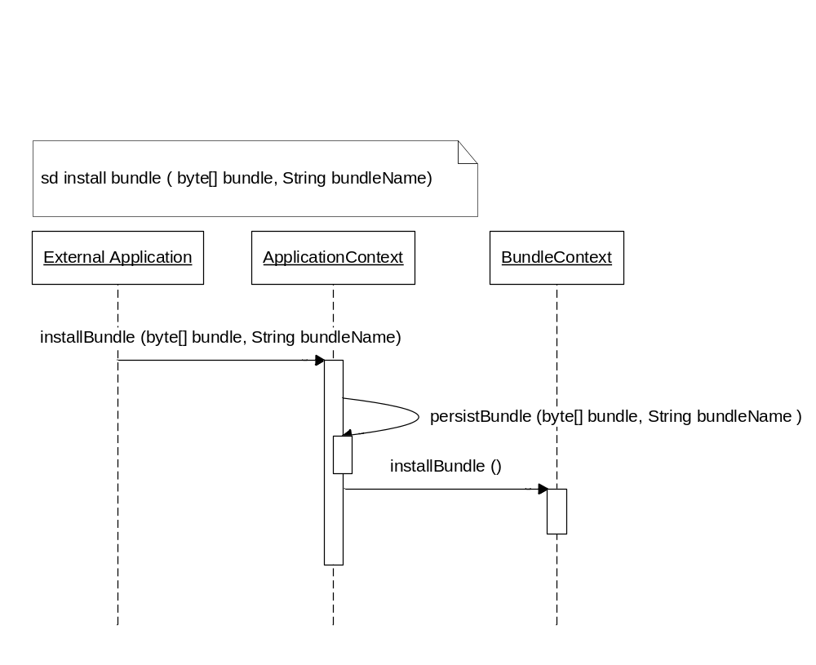
Figure 19 install bundle sequence diagram

  - Recovery Manager & Activity Monitor

    - Activity Monitor

Activity monitor is used to keep track on how the message is being transformed from input message to output message. Each Endpoint can optionally send the message to named save point. The save point can then send the message to other services for further processing.

- Upon receiving the message at save point service, one message is sent to the activity monitor system and another to the next service.
- The activity monitor system will log the save point information in database along with other information like save point name, messageid and time.
- The activity monitor system will also put the messages in the server’s file system.
- The binding service will always send message to the activity monitor system to monitor the messages received or sent from the application.
- The exception listeners will also send messages to the activity monitor system to monitor the exceptions that has happened during the lifecycle of the transformation.

      - Sequence Diagram
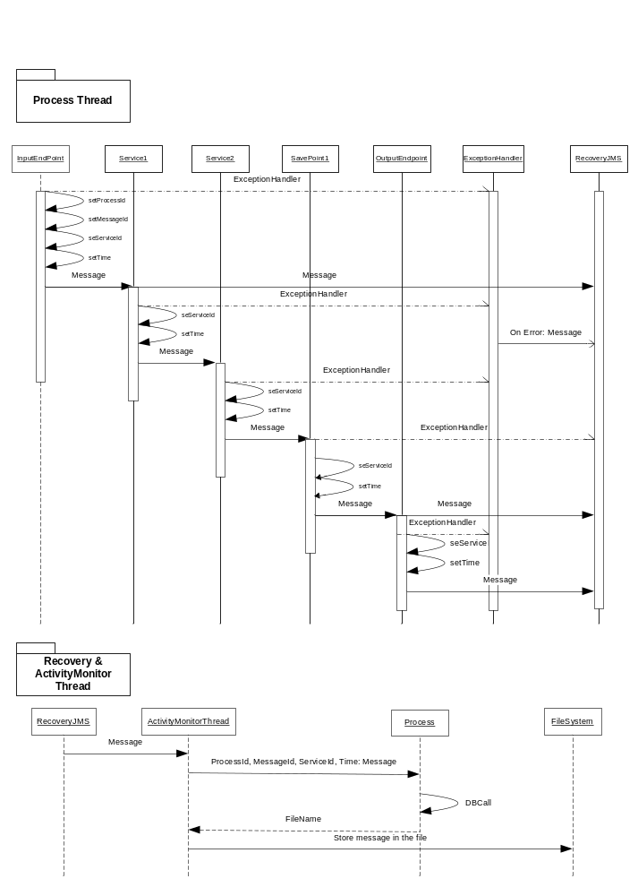
Figure 20 Sequence - Activity Monitor
    - Recovery Manager

Recovery thread recovers those messages which were not processed completely during the last run. This thread is executed after all the services in the process are initialized.

- After the services and process are initialized, recovery thread is executed.
- Recovery thread makes a call to database and identifies all those messages that need to be recovered.
- It gets these messages from server’s file system.
- It identifies the savepoint from where the message needs to be processed again and sends it to the savepoint for further operation on the message.

      - Sequence Diagram

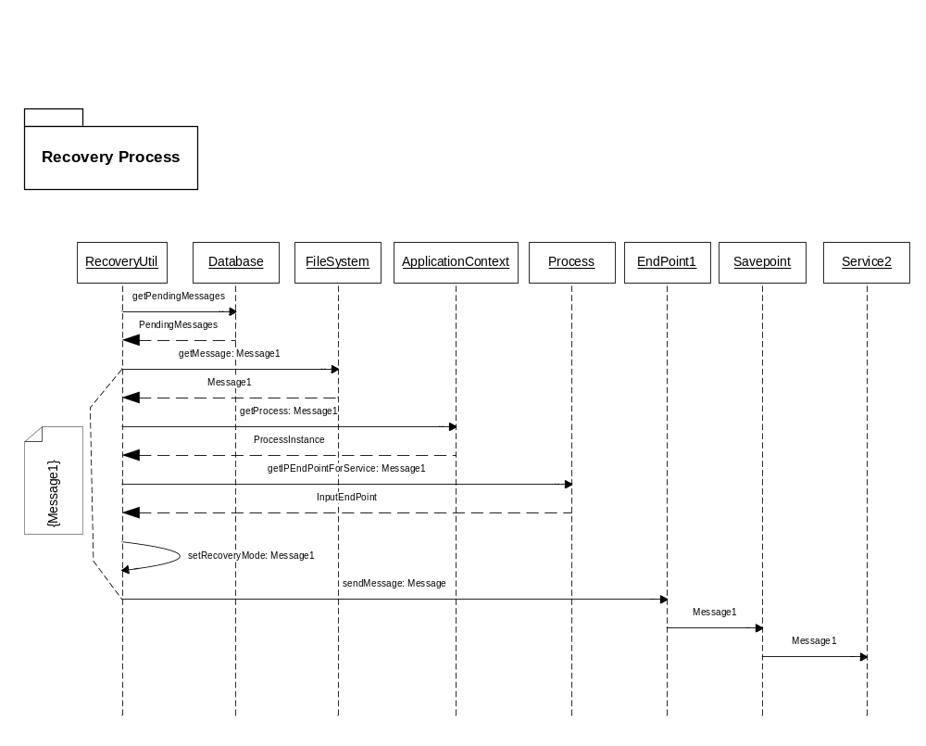
Figure 21 Sequence - Recovery Manager

    - Component Manager

Application runtime is built on top of OSGi container so every module is deployed as an OSGi bundle. This module provides an application layer which assists in remote/local administration and management of bundles. Some of the features it provides are.

- Deployment of new components.
- Deployment of new version of existing components.
- Administration of component.
- Monitoring of component.
- Lifecycle management of components.

  - State Machine

A finite state machine (FSM) or finite state automaton (plural: automata) or simply a state machine, is a model of behavior composed of a finite number of states, transitions between those states, and actions. A finite state machine is an abstract model of a machine with a primitive internal memory.

An FSM can be represented using a state diagram (or state transition diagram) as in figure 1 above. Besides this, several state transition table types are used. The most common representation is shown below: the combination of current state (B) and condition (Y) shows the next state (C). The complete actions information can be added only using footnotes. An FSM definition including the full actions information is possible using state tables.

State transition table
Current State →  Condition | State A | State B | State C
Condition X | ... | ... | ...
Condition Y | ... | State C | ...
Condition Z | ... | ... | ...
Table 1 State Transition Table

    - Finite State Model
Finite State Machines view systems as a set of well defined states, inbound and outbound events, Conditions, and Actions. FSM technology provides a set of rules for evaluating and processing the events, Conditions, and Actions.
    - State
State represents the “mode of being” for the system at any given time. States contain a set of entry events and exit events. The entry events are published or broadcasted when the state is entered. Exit events are published when the state is exited.
    - Transition
Transition describes a single pathway from a given state to another state. The set of all transitions describe all possible paths among the defined states. A transition contains an event that it is subscribing to, a condition, and an action. A transition also contains the state from which the transition is exiting (i.e. the “from” state) and the state to which the transition is entering (i.e. the “to” state).
    - Event
Event is the mechanism that the system uses to interact with external systems and with itself.
    - Condition
Condition represents a set of logic that evaluates to a Boolean result. It is used to determine if a transition is to be activated.
    - Action
Action is the processing to be performed with a transition is activated.

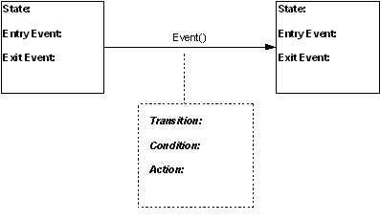
Figure 22 State Model diagram

    - Class Diagram

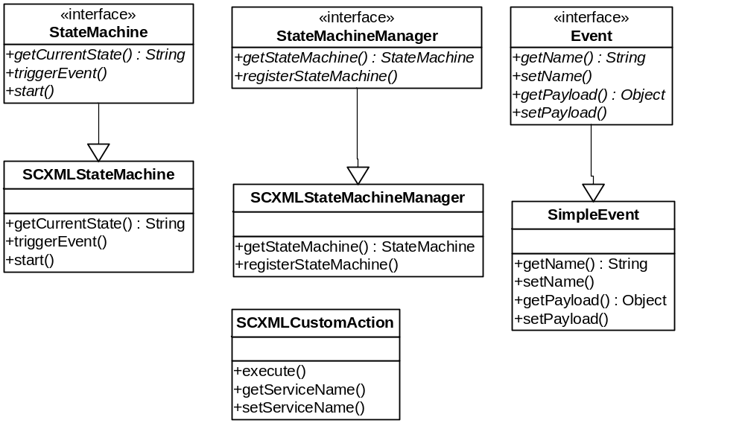
Figure 23 State Machine class diagram
      - StateMachine
StateMachine class represent individual state machine in the server. User can trigger events on the state machine. It also allows the check its current state.
Currently SCXMLStateMachine is the only implementation of this interface which works on Apache Commons SCXML project 0.9.
      - StateMachineManager
It manages all the state machines. Any new state machine would be registered with the StateMachineManager. User can also get the state machine providing the state machine id.
      - Event
Event interface represent a trigger event.

      - SCXMLCustomAction
SCXMLCustomAction extends Apache Commons SCMXML 0.9 Action abstract class. Any state machine can define this action in the state model. This action internally can call other Action provided as the “serviceName” parameter in the configuration.
Any Action provided in the configuration has to be registered with OSGi bundle context as a service. It should also implement Action interface defined in the state machine module.
    - Registering a new state machine
- StateMachineManger service is registered with OSGi bundle context. This service can be used to register a new state machine.
- Unique state machine id and state model definition is provided.
- StateMachineManager creates a new state machine and registers the same with StateMachinStore.
- If the id is not unique UniqueStateMachineException is thrown.
- State machine is initialized.
- State machine is started.
    - Triggering an Event on state machine
- Events can be triggered on the state machine.
- Using the state machine id state machine is retrieved from the db.
- A trigger event is created using the event name provided.
- Event is fired on the state machine synchronously.
- Once the transition is complete state machine is again serialized to the db.
  - Splitter
Splitter component splits the input message using the splitter strategy specified in the configuration.
    - Configuration
Each configuration requires an id to uniquely identify the component. It also contains the splitter strategy configuration. Below is the list of splitter strategies supported by the splitter.
- Partition Key Strategy
- Batch Split Strategy
    - Splitter Strategies
Splitter strategy defines the guidelines for the Splitter service. Below is the list of strategies supported.
      - Partition Key Strategy
Partition key strategy expects a list of normalized message as input and based on the list of attributes it splits the input message into multiple messages.
For each unique set of attribute values (partition key attributes) it’d create a message and put corresponding normalized message in that.
      - Batch Split Strategy
Batch split strategy also requires a list of messages as input and based on the batch size specified it creates multiple subsets.
    - Class Diagram
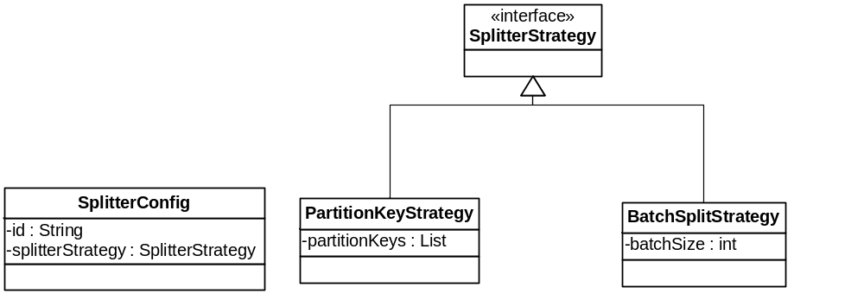
Figure 24 Splitter Configuration class diagram

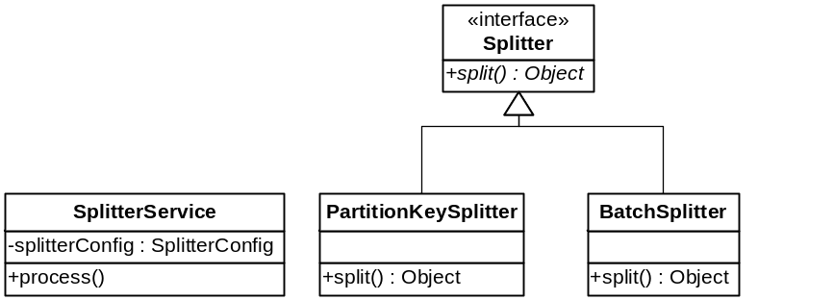
Figure 25 Splitter Service class diagram
      - SplitterService
Splitter service is configured with the splitter configuration Based on the configuration appropriate splitter is picked up from SplitterFactory.
      - PartitionKeySplitter
PartitionKeySplitter splits the message based on the partition keys. It expects a list of Normalized messages as input. For each distinct set of values for partition keys it creates a separate list of normalized records.
      - BatchSplitter
BatchSplitter expects a list of records as input. It splits the records based on the batch size.

  - Error Handling/Reporting
Error handling/reporting can be configured to instruct the server how it should respond to an error that has occurred in the input message or with the system with which it talks to. This section details the design of Error Handling and Error Reporting in fusion.
  - Configuration
Error Handling/Reporting can be configured at process level or at component level. Following set of rules apply to Error Handling and Reporting.
- On the event of exception component specific configuration takes precedence over process level configuration.
- For any Exception type if no configuration is provided at component level, Process level configuration will be used.
- For any Exception type if no Error Reporting is configured at component level, Process level Error Reporting configuration for that Exception Type will be used.
- If no Error configuration is specified at process level or component level Default server Error Handling and Reporting will be used.
    - Exception Type
Error configuration can be categorized based on the Exception type. Currently only two categories are supported by the server.
- Business
- System
Separate Error configuration can be provided for individual Exception Type for the same component.

    - Class diagram
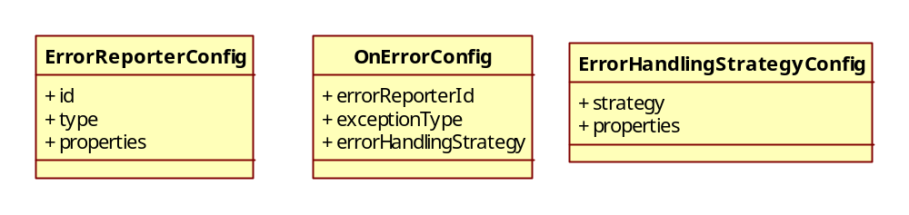
Figure 26 Error handling/reporting configuration class diagram

OnErrorConfig
- Used to store Error configuration.
- exceptionType is the type of exception for which this configuration will be used. Currently the server throws only System and Business exceptions.
- errorReporterId is the unique id that identified the Error Reporter configured in the process configuration model.
- Single Error Configuration can contain multiple ErrorReporterId. Same Error will be reported to all the ErrorReporters.
- errorHandlingStrategy is the strategy to be used to handle the error on the event of exception.
ErrorReporterConfig
- Used to store configuration of the Error Reporter service (e.g. JMS, DB )
- Id is used to uniquely identify the configuration. OnErrorConfig uses this Id to specify the Error Reporter.
- Properties is map of error reporter specific configuration.
ErrorHandlingStrategyConfig
- Used to store information about the error handling strategies.
- Strategy is one of these four strategies.
  - ReportAndContinueJob
  - ReportAndAbortJob
  - ReportAndAbortJobIfThresholdCrossed
  - ReportAndStopProcess
- Map of properties for strategy specific configuration if required.
  - Error Handling
On error event server provides following error handling strategies.
- Report the error and continue processing rest of the messages in the job.
- Report the error and abort the job.
- Report the error and abort the job if the threshold configured is crossed. Threshold currently is number of error messages.
- Report the error and stop the process.
Error handling will be taken care of by the Error handler passed to all the services. Error handler will decide if processing has to be continued or not based on the error reported and the strategy configured.

    - Class Diagram
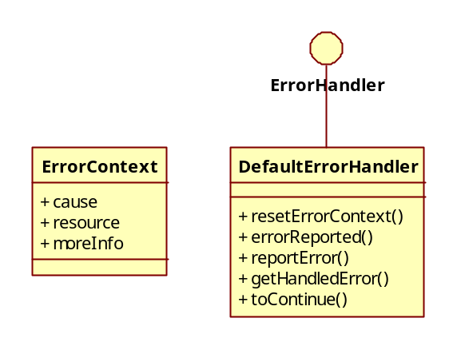
Figure 27 Error Handler class diagram
ErrorContext
- Bean to store the information of the Error event.
- cause if the cause of the error.
- resource is any message/data that might have caused the error.
- moreInfo is any additional data if required.
ErrorHandler
- All error handlers implement this interface.
- reportError method can be called to report any error that has to handle as per the error configuration.
- toContinue checks the current status of the error context and returns true if processing can be continued or not.
- errorReported checks the error context and returns true if any error was reported to the error handler.
- getHandledError returns a HandledFusionException.
- resetErrorContext will clear the previous error context and create an empty error context which can be used for next set of processing.
DefaultErrorHandler
- Default implementation of ErrorHandler interface.
    - Sequence Diagrams
      - Mediation Service

- GenericProcessor is an Apache Camel Processor which is a wrapper around fusion Mediation service.
- Process method of GenericProcessor is invoked for message processing.
- GenericProcessor retrieves the Mediation Service from OSGi context.
- process method is invoked.
- Error handler is also passed to the mediation service.
- Mediation service may either directly throw an Exception or may use Error Handler to control the execution on Error events.
- Following are the steps to be followed for batch processing if error handler is being used.
  - Iterate over the batch of records.
  - For each record check if processing has to be continued by calling toContinue method on the error handler.
  - Stop processing if false is returned.
  - Or else continue processing the batch.
  - If there is some exception thrown during the processing report the error to Error Handler by called reportError method on the Error Handler.
  - reportError will put the reported error in to the configured Error Route.
  - If nothing is configured reportError method throws the Exception to be handled by the Default Exception handler of the server.
- On the event of unchecked Exception catch by GenericProcess catch block reportError method on ErrorHandler will be called to see if some Error Route is configured.
- If nothing is configured Default Error handling of server will take control.
      - Endpoint
- Error handling is not configurable for endpoints.
- For the endpoints Error route will be configured as per the configuration.
- Since the flow is synchronous Error Route configured will be applicable only for the endpoint.
      - Process
- Process level error handling will be configured at the Camel context level.
- Any unhandled error at any service or endpoint level be caught at this level and sent to the input queue of the configured error route.
  - Error Reporting
Error reporter module takes the error data formats the data as per the requirement of the Error Endpoint and sends it the EndPoint. Currently following Error Reporting Endpoints are supported.
- JMS
- File
- Database
    - Error Route Configuration
For every Error Reporter in the Process Configuration Model a route is configured. It reads from an Error Reporter specific SEDA queue and sends the data to the Error Reporter specific formatter, that after formatting the data sends the data to the Error Reporter Endpoint.
Error Route is completely decouple from actual Error handler. Error handler sends the Error Details to Error Reporter specific SEDA queue for Reporting.
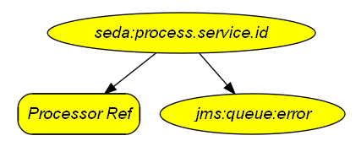
Figure 28 Sample Error Reporting Route

    - Error Route Modeling
For every Error Reporter in Process Configuration Model a separate route will be created and added to the context.
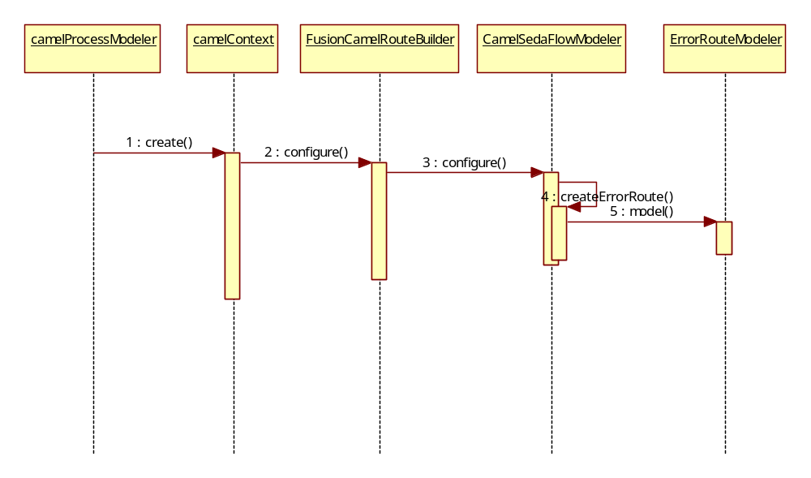
Figure 29 Error Route Modeling sequence diagram

- CamelProcessModeler creates CamelContext with FusionCamelRouteBuilder as the Route Builder attached to the camel context.
- FusionCamelRouteBuilder call configure method on Process Flow modeler (default is CamelSedaFlowModeler).
- For each Error Reporter it creates the Error Route calling model method on ErrorRouteModeler.
- ErrorRouterModeler creates the Route based on the Error Reporter configuration.

    - Class Diagram
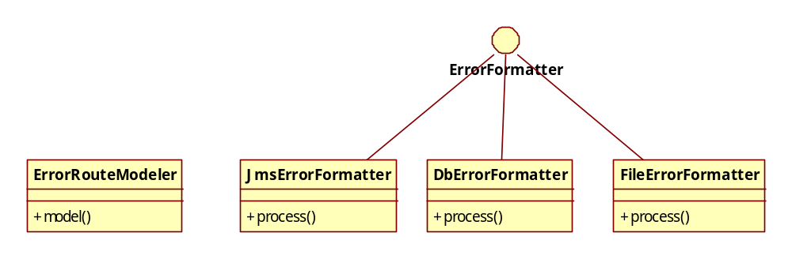
Figure 30 Error Reporting module class diagram
ErrorRouteModeler
- For ever instance of ErrorReporter in Process Configuration Model a new Error Route is created by ErrorRouteModeler.
- Based on the configuration Route Modeler selects process error formatter and corresponding Error Reporting Endpoint.
- Configures route as explained in Figure 28 Sample Error Reporting Route
ErrorFormatter
- ErrorFormatter is an interface which extends Apache Camel Processor.
- All exceptions reported to Error Handler need to be formatted before being sent to the Error Reporting endpoint.
- All these formatters will implement this interface.
XML Error Formatter
- Formats the error context into an XML format.
DbErrorFormatter
- ErrorFormatter implementation that formats the Error for Database Error Endpoint.
FIXML Error Formatter
- ErrorFormatter implementation that formats the Error into FIXML format.
e.g.
<FIXML>
<Error ErrorCode="TEEVRA"
ErrorMessage="Error message received from Euronext"
ErrorType="Business" Source="******"
Timestamp="***********">
<ErrorDesc>*****************</ErrorDesc>
<ErrorRecord>
incoming record
</ErrorRecord>
</Error>
</FIXML>.
  - Euronext Adapter

Euronext (LCH.Clearnet SA) has close to 100 of messages. As it would be difficult to configure everything on UI with multiple routes through Content Based router, it would be better to bundle them in a single package which would check the header, pick the configuration, parse it based on the configuration and transform it to FIXML object. This approach would also scale across horizontally for other clearing houses too.

Euronext adapter is a two way service. It converts data to fixed length format as expected by Euronext endpoint from, also converts the fixed length message received from Euronext to the normalized message format.

Adapter has built in configuration for all types of messages for Euronext process. On receiving the message it checks for the configuration and uses the same to do the conversion. It uses Fixed-length parser/formatter services underneath.

  - FIXML Validator
Build a FIXML validator component on top of validator component which would choose the right set of validation rules configuration based on the input FIXML message and validate the FIXML message.

  - Expression Evaluator
Conditions evaluation requires and expression builder and evaluator. This component parses the expression and evaluates the expression value based on the input provided.

Same is being used for any conditional evaluation in all the components (e.g. conditional validator)

- Built-in Components

  - Poller and Writer
Various systems can be integrated with Teevra as the source of any data exchange. Following sections describe the capabilities of various built-in connectors provided in Teevra to interface with external systems to get data into the system.

    - Database - JDBC

Teevra as a DB Poller
Teevra can pick up messages from database through
- Stored procedures
- SQL queries
Teevra keeps polling database in regular intervals and checks if any result set is returned from the stored procedure. If so, then it will take those messages and send it for processing. The parameters that can be configured for DB poller includes:
- Driver class name
- URL of the database server
- Username of the database
- Password (Teevra should give an option to test the connection)
- Name of the stored procedure which returns resultset.
- Polling time (how frequent the polling needs to be done)
- SQL Query

Teevra as DB Writer
Teevra can also write messages to database by means of stored procedures. Teevra can receive messages from transformation engine as a tag delimited messages. These messages are sent to stored procedures as a single input parameter. The stored procedure also has one output parameter defined which returns a success or error indicator with optional description. Teevra logs this description along with the message if there is any error during db operation. The parameters that need to be configured for DB writer include:
- Driver class name
- URL of the database server
- Username of the database
- Password
- Name of the stored procedure that can accept input and output parameters.
- Batch size (number of messages that can be sent as a single string)
- Name of the stored procedure that needs to be called to do exception handling.

Should also be able to populate tables directly by mapping output field sets with the database columns.

    - Message Queue

Message Queue can also be placed as the endpoints to Teevra. Teevra can listen to a single queue per process and intimate the system whenever it receives data. Teevra can also post messages to different queues depending on the customization. The parameters that can be configured for MQ are:
- Channel Name
- Queue Manager Name
- Queue Name
- Username
- Password
- Port
- Type of encoding – ASCII / Unicode

    - Directory / File System

This transport allows Teevra to read/ write files to the directories on the local file system. This can be configured to filter the file it reads, and the way files are written. The parameters that need to be configured are:
- Directory Name (readfrom and writeto directory)
- File Pattern ( On input side, which file to be chosen and on output file, what needs to be the file pattern)
- Polling frequency

    - File Transfer Protocol (FTP)

This Transport allows Teevra to read / write files on the remote server using FTP. User can also configure if it is a secure FTP or not. The FTP Transport can be configured using:
- Path (file location on remote server)
- Username
- Password
- Hostname
- Port
- Polling frequency
- File patterns
The user needs to specify key, passphrase, private and public key in case the FTP is secure remote server.

    - Web services

Teevra can expose components as web services and can act as SOAP Clients. Teevra can also invoke remote web services on the writer side.

    - Socket

TCP Socket can be used to send / receive data packets via network. On the Poller side, Teevra will create server sockets and will listen for events to occur. On writer side, Teevra will send data packets to the server host configured. The various configuration parameters are:
- Hostname (in case of writer)
- Port

    - Http

Http transport provides support for exposing services over http or https and making http client requests from Teevra to external services. The parameters that need to be configured for making http client request include:
- Proxy host
- Proxy port
- Protocol
- Host (URL)
- Port
- Username
- Password
- Require authentication (y or n)
- Validation URL (if authentication required)
- Servlet Handler (Path of the url)
- Params to Servlet
- Content type

    - Email

Teevra as Email reader
Teevra can receive messages from IMAP/ POP3 inboxes using javax.mail apis. When message arrives to mail box, Teevra periodically polls the box to check if any messages are present. If present, it will then check whether it matches the match criteria specified. If so, it will move the folder to backup folder and will extract all the attachments and process them. The parameters that need to be configured for Email as a reader are:
- Mail box folder
- Backup folder
- Server address
- Username
- Password
- Subject filter
- Polling frequency

Teevra as Email writer
Teevra can send messages over SMTP using javax.mail apis. The messages to be sent through email are attached as a file attachment and will be sent to the configured addresses. The implementation supports TO, CC, Bcc, ReplyTo addresses. The parameters that need to be defined are:
- Mail box folder
- Server address
- Username
- Password
- From Address
- To Addresses
- Cc Addresses
- Bcc Addresses
- Reply to Address
- Default Subject

    - C API Connectivity for Euronext Clearing House
Teevra can send or receive messages using C API to and from third parties. Teevra uses JNI to communicate to C based third parties.

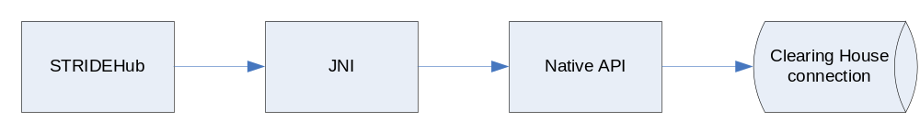
Figure 31 C API Connectivity

      - Teevra creates a new thread and initiates during the start of the process.
      - The thread makes a connection request to the third party using JNI.
      - The control remains in the JNI layer so that all handshakes between the client and server is made. .
      - Java provides in memory queue to which it can send data for transmission. For sending, Java will send messages to the queue and JNI will periodically poll the queue to see if there is any data to be sent. For receiving, JNI will push data to the queue and Java will poll the queue to send it further.
      - For Euronext, the queue will contain the data message and the message id. Sequence number will be generated by the JNI layer.
      - Java layer will also provide persistence of messages so that recovery and synchronization is possible.

The parameter that needs to be configured for Euronext includes:

- Server address
- Port Number
- Username
- Password
- Data source where the message can be persisted and retrieved.
The API provided by Java and JNI layer of Teevra to enable communication to the clearing house includes:

- Value Object:
  - For Sending, a Value Object needs to be defined containing the various fields that need to be populated by Java side. For Euronext, the VO contains fields MessageId and Data. MessageId is populated (incremented by 1) whenever Java pushes the data to the queue. Data is a fixed length message passed from the formatter.
  - For receiving message using C API, a different kind of VO needs to be defined. These fields are populated by JNI layer. For Euronext, VO contains fields for MessageId, Data, and Sequence No. No automatic generation of any field is done in this case.

- Push method :
  - For send, push method contains logic to generate the MessageId, persist the incoming message and keep the message available in the queue.
  - For receive, push method will contain logic to check if the sequence of the message received is proper or not, and if proper, then will persist the message. It will also keep the message in the queue so that it can be read by Java thread.

- GetNext method:
  - For Send, GetNext method will be called by JNI to get the next message to be sent. It will return null if no messages available or return VO if any message is pending to be sent.
  - For receive, GetNext method will be called by Java and will perform similar operation but on the Java / receive side.

- Flush method:
  - This method is called to flush out the queue. For Euronext, it is called upon receiving synchronization acknowledgement.

- Init Method:
  - This method is called during the load to initialize the message id counter

- SetLastMsgIdSent Method:
  - This method is called upon receiving synchronization acknowledgement. It reinitializes the last sent message id so that retransmission of messages can be done if required.

    - Custom
Any custom reader / writer components can be plugged in to Teevra architecture easily on top of the Fusion Framework.

  - Pre-Processor and Post-Processor
    - Pre-Processor

Any message passing through Stride-Hub will first be processed by a Pre-Processor. It performs following activities on the message/file received.
- In case of encrypted data decrypt the data.
- Perform basic level of validation on the input message file.
- If validation fails pass the message file to Exception Handling module.
- Determine the message type based on the configuration.
- Remove Header/Footer if required.
- Pass the message file to Router.

    - Post-Processor

Any message before being written to the destination will pass through the post-processor. It performs following activities.
- Encrypt the data if configured.
- Add Header/Footer if required.

  - Parser and Formatter
Various formats of data can be processed by Teevra. The formats that are supported by Teevra are:

    - Fixed Length

Fixed length message consist of fixed number of characters and each field has pre-defined start and end index. For every field the parameter that needs to be defined are:
- Start Index
- End Index

    - Tag Delimited

Tag delimited message consist of fields separated by pre-defined delimiter. Therefore to define a tag delimited string, the delimiter is configurable. Also index needs to be specified for every field.
- Tag String
- Index for each field

    - XML

Teevra can also process XML (Extended markup language) data. The parameters that need to be defined for every field include:
- XPATH
    - FIXML
      - Parser
Teevra FIXML parser converts the incoming FIXML message into a normalized message format. It is based on the FIXML application message version 5.0 as published by FIX Protocol.
        - Configuration

<binding>
<schema name="PosMntReq" binding="PostMntReq">
<attribute name="ReqID" binding="ReqID"/>
<attribute name="TxnTyp" binding="TxnTyp"/>
<attribute name="Pty" binding="${Pty}"/>
</schema>
<schema name="Pty" selector="Pty">
<attribute name="ID" binding="ID"/>
<attribute name="R" binding="R"/>
<attribute name="Sub" binding="${Sub}"/>
</schema>
<schema name="Sub" selector="Sub">
<attribute name="ID" binding="ID"/>
<attribute name="Typ" binding="Typ"/>
</schema>
</binding>

- Schema configuration will not skip any element hierarchy in the XML.
- schema Refers to a message schema.
- binding is the binding name for the attribute/schema. In case of attribute it’s the attribute name and for element it’s the name of the element.
- attribute contains the binding information about the child attributes.
- If binding is simple selector would directly refer to the element/attribute name in the xml. The element value will directly be assigned to the field.
- If complex it refers to the corresponding configuration using $ symbol.
        - Class Diagram
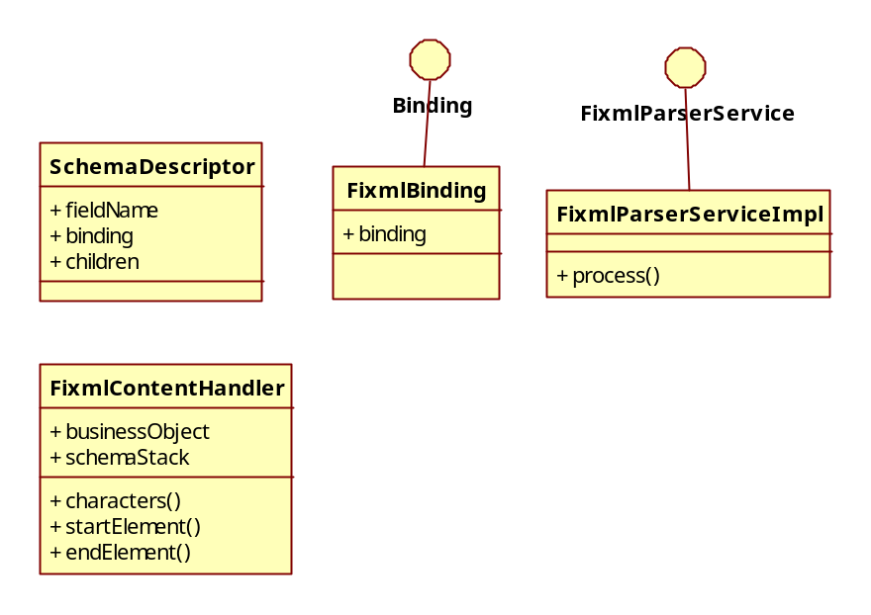
Figure 32 Fixml Parser class diagram
- SchemaDescriptor
  - This is the main class that contains the FIXML parser configuration.
  - fieldname is the attribute name in the object schema.
  - children contains the schema descriptor of the child attributes of the schema.
  - Binding refers the XML binding for the attribute. It is the element / attribute name in the XML.
- FixmlBinding
  - Contains the Binding information for the attribute/field.
  - Binding can either be the element name or the attribute name as applicable.
- FixmlParserService
  - FIXML Parser service interface.
- FixmlParserServiceImpl
  - Default implementation of FIXML parser service.
  - It creates a Business object for the incoming message.
  - Assigns the FIXML schema to the business object.
  - Reads the FIXML configuration.
  - Reads the FIXML to decide on the message type.
    - Gets the actual schema descriptor from the parent FIXML schema descriptor.
    - Creates the business object hierarchy for the message type.
    - Filling up of this child business object will be taken care of by FixmlContentHandler.
  - Creates FixmlContentHandler and assigns BusinessObject, SchemaDescriptor.
  - Invokes SAX Parsing.
  - Sets the output Business object into the message exchange.
- FixmlContentHandler
  - It’s the SAX event handlers.
  - Receives different XML events while parsing.
  - Updates the business objects using the schema descriptor information.
      - Formatter
Teevra FIXML formatter converts the incoming business object into FIXML message. It is based on the FIXML application message version 5.0 as published by FIX Protocol.

        - Configuration
<binding>
<schema name="PosMntReq" binding="PostMntReq">
<attribute name="ReqID" binding="ReqID" type=”attribute”/>
<attribute name="TxnTyp" binding="ReqID" type=”attribute”/>
<attribute name="Pty" binding="${Pty}" type=”element”/>
</schema>
<schema name="Pty" selector="Pty">
<attribute name="ID" binding="ID" type=”attribute”/>
<attribute name="R" binding="R" type=”attribute”/>
<attribute name="Sub" binding="${Sub}" type=”element”/>
</schema>
<schema name="Sub" selector="Sub">
<attribute name="ID" binding="ID" type=”attribute”/>
<attribute name="Typ" binding="Typ" type=”attribute”/>
</schema>
</binding>
        - Class Diagram
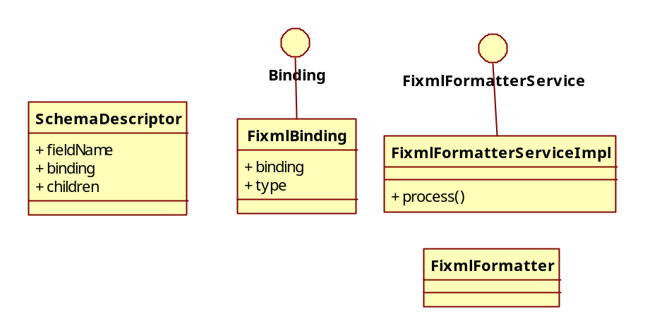
Figure 33 Fixml Formatter Class Diagram
- SchemaDescriptor
  - This is the main class that contains the FIXML parser configuration.
  - fieldname is the attribute name in the object schema.
  - children contains the schema descriptor of the child attributes of the schema.
  - binding refers the XML binding for the attribute. It is the element / attribute name in the XML.
- FixmlBinding
  - Contains the Binding information for the attribute/field.
  - Binding can either be the element name or the attribute name as applicable.
  - Type identifies if the field is an attribute or a element.
- FixmlFormatterService
  - FIXML Parser service interface.
- FixmlFormatterServiceImpl
  - Default implementation of FIXML formatter service.
  - It creates a Business object for the incoming message.
  - Assigns the FIXML schema to the business object.
  - Reads the FIXML configuration based on the message type.
  - Passes the business object and the schema information to the FixmlFormatter.
  - Sets the output FIXML into the message exchange.
- FixmlFormatter
  - Reads the attributes from the business object.
  - Based on the configuration creates the FIXML message.
      - Formatter

Teevra can also process XML (Extended markup language) data. The parameters that need to be defined for every field include:
- XPATH

    - Binary Structure ( C Structure)

Teevra can also process C Structures. Binary Structure Formatter can convert the business object into C Structure and pass the byte array of the same to the next component. Similarly, the parsers can convert the byte array of the structure into business object.

Binary Structure parser/formatter will require the C Structure definition in the XML format. It will contain information of the structure, the various members in it and their data structure.

Additionally, a mapping between the C Structure member and the business object attribute is also provided. The C Structure member is defined using the doted notation if there are inner structures.

  - Validation Engine

User will be given the provision to specify the validations that can be performed on data. It can be performed both on Input and output business data. All the validation rules are configurable.

The business data can be passed through the set of validation rules and with every rule an error message is configured. When the validation rule fails, the validation engine passes the error message as an exception message.

    - Class Diagram

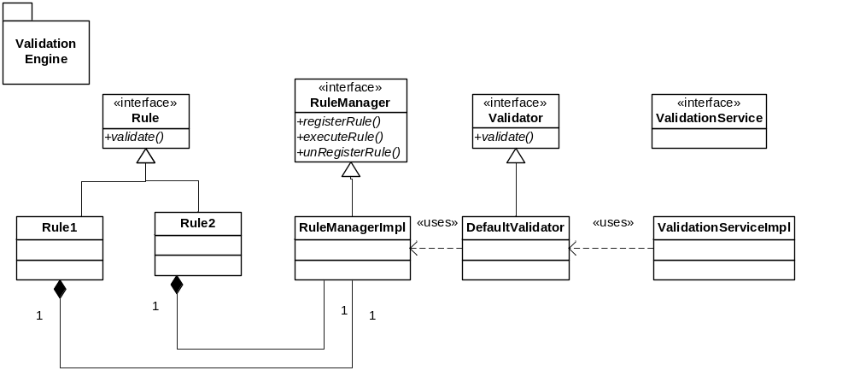
Figure 34 Validation Engine Class Diagram

    - Rule Manager

Validation Rule Manager manages the various instances of the validation rules and therefore pools the rule instances. The rules are registered to the rule manager using an alias name. When the rule needs to be executed, the validation component calls the rule manager to execute the rule. The rule manager executes the rule and passes the output back to the validator.

    - Validator

Validator is invoked on every message in the validation component. It calls the rule manager to execute the set of rules using the parameters provided. It also checks whether the rules failed or succeeded. If failed, it will identify the error message associated with it and pass it forward to be handled. If success, it will execute the next rules.

    - Rules

Rules are independent classes implementing the interface Rule. It validates the data based on the rule and passes the output back to the caller. Rule gets registered itself with the rule manager with an alias name.

Below is the list of validation rules

Rule Name | Rule Desc | Iteration Planned
Integer | The field should be an integer. Also if the min value or/and max value is provided, it should check the range of the integer value | Iteration 1
IsNotNull | The data should not be null. If null, return false else return true | Iteration 1
IsNull | The data should be null. If null, return true else return false | Iteration 1
InList | The data specified should belong to the list. The list is also passed as an parameter | Iteration 1
NotInList | The data specified should not belong to the list. The list is also passed as an parameter | Iteration 1
StringLength | The data passed should be between the min length and max length specified. | Iteration 1

    - Conditional Rules

With any rule a condition can also be provided. If the condition is provided validation engine first evaluates the condition if passed then only the rule will be executed.

  - Transformation Engine

Transformation Engine components transforms data from one form to another using the set of transformation rules. The process is configured either using transformation engine or enrichment engine. If transformation engine is used, the rules are applied on the input business object and new output business object is created. If enrichment is used, the rules are applied on the input business object and the outputs of the rules are saved on the same business object.

    - Class Diagram

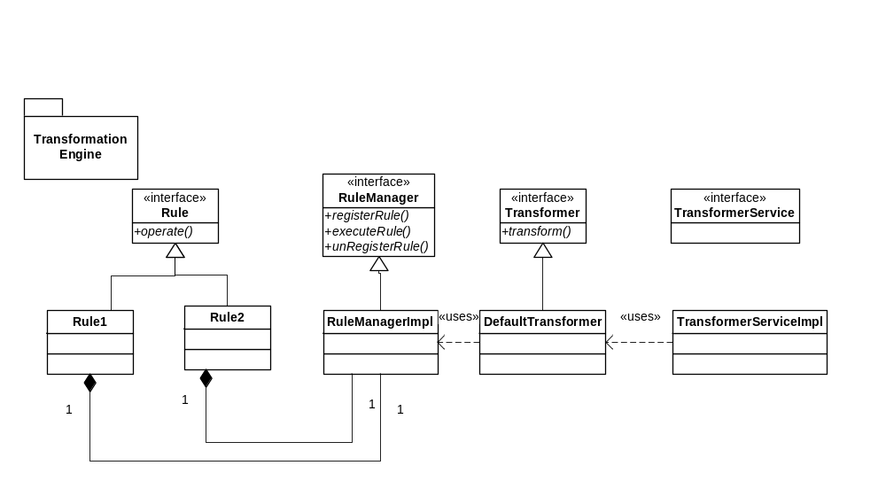
Figure 35 Transformation Engine class diagram
    - Rule Manager

Transformer Rule Manager manages the various instances of the transformation rules and therefore pools the rule instances. The rules are registered to the rule manager using an alias name. When the rule needs to be executed, the validation component calls the rule manager to execute the rule. The rule manager executes the rule and passes the output back to the transformer.

    - Transformer

Transformer is invoked on every message in the Transformation component. It calls the rule manager to execute the set of rules using the parameters provided. It also enters the output of the rule in the specified business object.

    - Rules

Rules are independent classes implementing the interface Rule. It executes the data based on the rule and passes the output back to the transformer component. Rule gets registered itself with the rule manager with an alias name.

Category | Rule Name | Description | Iteration
Arithmetic Rules | Add fields Rule | It adds all the input field values to produce an output field. | Iteration 1
Arithmetic Rules | Subtract Rule | Subtracts all other fields from the first one | Iteration 1
Arithmetic Rules | Divide Rule | Divides all the fields other than first one from the first
Arithmetic Rules | Multiply Rule | Multiple up all the input fields, minimum 2 fields (values are parsed as double values) and writes the result to the output field | Iteration 1
Arithmetic Rules | Parse Double Rule | Input field is parsed to a Double and mapped to the output field.
Arithmetic Rules | Number Formatting rule | Formats the input number based on the number format specified. | Iteration 1
String manipulation Rules | String concatenation Rule | Concatenates the string values of the given input fields into one output string and assigned to the output field | Iteration 1
String manipulation Rules | String to List Rule | Converts the string to the list based on a delimiter | Iteration 1
String manipulation Rules | Sub String Rule | Trims the input string to output strings based on given configuration parameters | Iteration 1
String manipulation Rules | Simple Mapping Rule | Directly maps the input field to the output field | Iteration 1
Date manipulation Rules | Date Formatting Rule | Converts the input date fields (of format specified at inputDateFormat) to a format specified at outputDateFormat. | Iteration 1
Date manipulation Rules | Date Sub String Rule | Reads a Eclipse specific string format for trade date, gets the trade date out of the input String and writes out in configured String-Date format to output field
Date manipulation Rules | Current Date Rule | Current date will be assigned to all the given output fields in the format specified at the DateFormat field under config parameters | Iteration 1
Lookup rules | Execute SQL Rule | It retrieves the output field values from the database based on the SQL specified and the input data.
Lookup rules | Database Cache Lookup Rule | Maps a particular input value to a specific output value based on the cache created from the database | Iteration 1
Conditional Rules | Conditional Value Rule | Value of the Input Field is compared against value of ConditionalValueField or ConditionalValue (whichever is specified. If both are specified then first compares value of ConditionalValueField, if it is null or empty, then compares with ConditionalValue).If comparison succeeds then Output field value is set to value of field MatchValueField or MatchValue (whichever is specified . If both are specified then first in this order - value of MatchValueField, if it is null or empty, then set to MatchValue). If comparison fails, and if MisatchValueField/MisatchValue are configured then set Output Field to value of field MismatchValueField or MismatchValue (whichever is available in that order, same condition apply as matchvalue) | Iteration 1

