STRIDEHUBTM

Build and Deploy Guide
Version: 1.0

Copyright Information

This document contains confidential and proprietary information belonging to Headstrong Inc. and the same is distributed only in pursuance of and subject to the terms of the license agreement entered into with Headstrong Inc. No part of this document may be copied, reproduced, distributed or disseminated in any form (electronic or otherwise) without the prior written permission of Headstrong Inc. No intellectual property rights, copyright on the provided documents are conferred to the recipient. The disclosure of the information contained herein does not lead to the legal conferring or granting of rights, unless provision is expressly made for this.

Headstrong reserves all rights to make changes to the information described in this document at any time without notice and obligation to notify any person of such changes.

STRIDEHUB™ is a trademark of Headstrong Inc. Headstrong does not claim any right over any trade name, trademark, logo, image or symbol belonging to third parties that may have been referred to herein.

© 2007 Headstrong Inc. All rights reserved.
Table of Contents

1. Assumption 1
2. Steps To Build the StrideHub application 1
3. Steps to deploy the application on the Tomcat server 2

Assumption

- %STRIDEHUB_HOME%: This refers to the StrideHub application’s home location.
- %TOMCAT_ROOT%: This refers to the Tomcat root location.

Steps To Build the StrideHub application
Build is a process of compiling the code and creating a byte code which can be
configured to be deployed on any system.

Note : Build is independent of the system and environment in which it has to be deployed.

- From the command prompt, go to %STRIDEHUB_HOME%/ server/src folder.

- Make sure the below file and folders are present in this folder (path mentioned in point 1) before the build process
  - Build.xml
  - Src folder
  - Lib folder

- Enter the command ‘ant buildJar’ in the command prompt and press (enter) to execute the build process

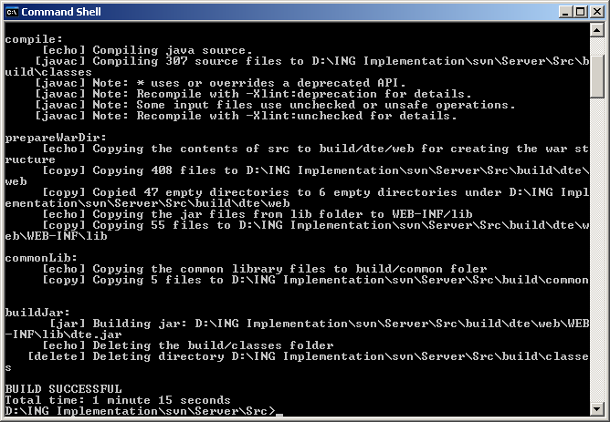

- On successful completion of the command, a new folder ‘Build’ will be created in %STRIDEHUB_HOME%/server/src folder.

Steps to deploy the application on the Tomcat server
Deploy is the process of using the compiled code, updating it with the configuration required.

- From the command prompt, go to %STRIDEHUB_HOME%/server/src folder.

- Make sure the below file and folders are present in this folder (path mentioned in point 1) before the deploy process

  - Build.xml
  - Build.properties
  - messagehub.config.in.na.dev
  - build folder

Note : If this operation is being carried out in different system other than where it is to be deployed, then ‘Build.properties’ and ‘messagehub.config.in.na.dev’ file should be copied from the respective systems (development or production).

- Execute the command ‘ant buildWar’ from the command prompt.

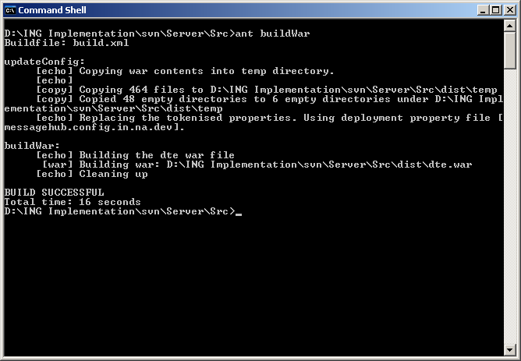

- On successful completion of the command, new folder named ‘dist’ will be created in %STRIDEHUB_HOME%/server/src folder.
- The folder ‘dist’ will contain dte.war file.
- Stop the tomcat server.
- Copy the ‘dte.war’ file to %TOMCAT_HOME%/webapps folder.
- Start the tomcat server (Ensure that this start happens atleast 5 minutes after the initial stop of TOMCAT server)

