# Intermittent cell division dynamics in regenerating Arabidopsis roots reveals complex long-range interactions

T. Fallesen, S. Amarteifio, G. Pruessner, H. J. Jensen, G. Sena

**ABSTRACT**

In this work, we present a quantitative comparison of the cell division dynamics between populations of intact and regenerating root tips in the plant model system *Arabidopsis thaliana.* To achieve the required temporal resolution and to sustain it for the duration of the regeneration process, we adopted a live imaging system based on light-sheet fluorescence microscopy, previously developed in the lab. We offer a straightforward quantitative analysis of the temporal and spatial patterns of cell division events and draw general and biologically relevant conclusions on the underlying regulatory mechanisms.

**INTRODUCTION**

Tissue regeneration, or the re-establishment of the form and function of a damaged or lost structure, is an example of post-embryonic morphogenesis. The history of regeneration research is long and rich in breakthroughs {Dinsmore.1991} and some of the key molecular and mechanical details have been understood in recent decades (see reviews {Elchaninov.2021, Sugimoto.2019, Ikeuchi.2016}).

The role of cell proliferation in the reestablishment of lost structures has long been recognised as central to the process of regeneration {Morgan.1901}. At the most fundamental level, there are basic yet unanswered questions regarding the type of dynamics and the parameters controlling it. For example, does cell proliferation during regeneration follow unique dynamics, distinguished from the one driving other types of morphodynamics such as embryonic development or post-embryonic organogenesis like metamorphosis in animals or flower formation in plants? Is regeneration a smooth process or does it go through sharp transitions, perhaps analogous to phase transitions observed in many complex dynamical systems? It can be difficult to obtain sufficient temporal and spatial statistics to identify the collective correlations associated with phase transitions and criticality, so here we focus on how the cell division deviate from uncorrelated Poisson behaviour. This is immediately identifiable from the spatial distribution of the dividing cells.

Unfortunately, after more than one hundred years after the first observations, a complete quantitative description of cell proliferation dynamics during organ regeneration is lacking, impeding our efforts to understand how biological shapes and functions are established and maintained.

Here, we present a quantitative analysis of cell divisions in regenerating root tips of the plant model system *Arabidopsis thaliana.*Given the relatively long duration of root regeneration following full tip excision {Sena.2009}, we adopted light-sheet microscopy for sustained, high-resolution, time-lapse imaging. This method has been recently adapted to *Arabidopsis* roots {Sena.2011, Maizel.2011} and later to various plant tissues (see recent reviews {Sozzani.2020, Ovecka.2018, Berthet.2016}).

Quantitative analyses of cell divisions in intact, *i.e.*not regenerating, *Arabidopsis*roots have a long history. Modern imaging methods span from simple light microscopy {Baskin.1998} to confocal microscopy {Campilho.2006, Lavrekha.2017, Rahni.2019}, and light-sheet microscopy {Sena.2011, Wangenheim.2016, Balaguer.2016, Buckner.2019}, but no comparison has been attempted between these dynamics and the one in regenerating roots.

Algorithms to track cell divisions in light-sheet microscopy 4D datasets have been developed multiple times {Sena.2011, Buckner.2019, Amarteifio.2021}. For this work, we adopted hardware and software previously developed in our lab {Baesso.2018, Amarteifio.2021}.

By comparing the dynamics of cell proliferation in a growing intact root with that in a regenerating one, in this work we are addressing the following fundamental questions: Is there a quantitative difference between the dynamics of cell divisions in an uncut root and that in a regenerating one? Is there a clear transition between different “phases” in cell division dynamics during root regeneration?

**RESULTS**

***The temporal sequence of mitotic events is intermittent***

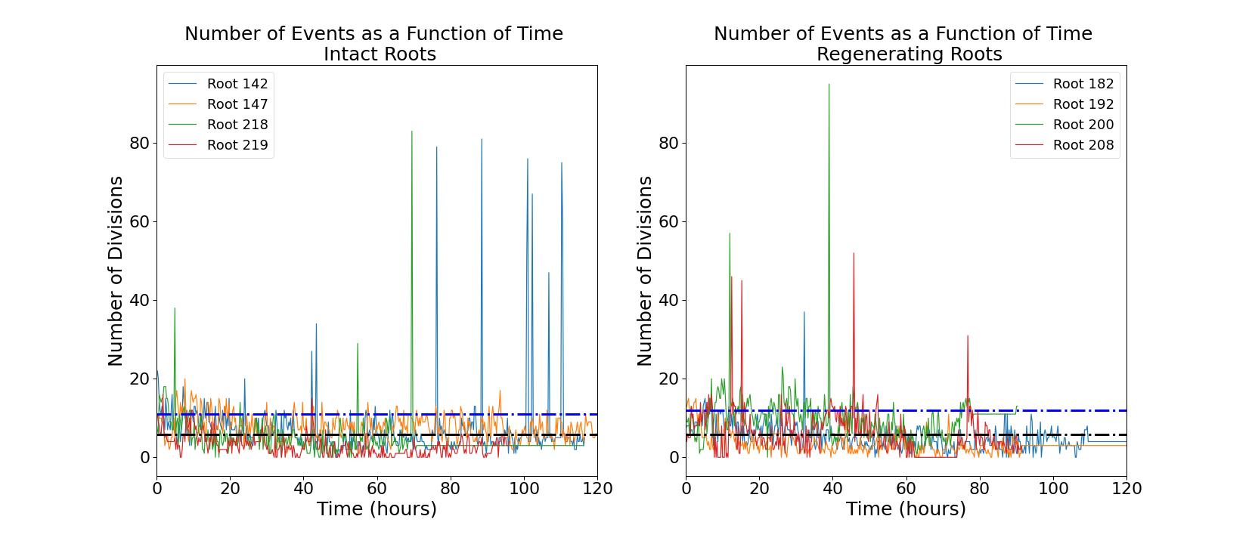

Figure 1. Number of mitotic events detected in intact (left panel) and regenerating (right panel) root tips. Four independent roots are shown for each group. Black dotted line, mean; blue dotted line, mean + standard deviation

The cyclin-dependent protein kinase CYCB1;1 is commonly used as a reporter of the G2/M transition in the cell cycle and, indirectly, of mitotic events {Reddy.2004}. Transgenic *Arabidopsis* plants expressing CYCB1;1::GFP {Reddy.2004} were mounted on a home-built light-sheet microscope setup {Baesso.2018} specifically designed for imaging and tracking a single root tip every 15 minutes (see Methods).

The raw images (supplemental Figure S1) were processed using our previously published routine {Amarteifio.2021} to track and count the mitotic events in 3D. The number of cell divisions detected in each frame follows an intermittent temporal pattern with a noisy baseline below 20 events per frame punctuated by a few isolated bursts of much higher activity (Fig. 1).

***Regenerating and intact roots exhibit different distributions of temporal "bursts" of mitotic events***

The intermittent nature of the temporal series in Fig. 1 is interesting and can be further quantified. We define a “burst” as a significant peak in the temporal series. More specifically, a collection of mitotic events occurring in a single time-point and at least one standard deviation higher than the mean of events observed in the entire temporal series. The size of the burst is simply the total number of cell divisions captured in that time-point. The distribution of burst sizes for intact and regenerating roots is significantly different (Fig. 2; p<0.01) and indicates that regeneration is on average characterised by larger bursts of cell division activity.

If the mitotic events were completely uncorrelated from each other, these distributions would be indistinguishable from Poisson distributions. This is not what we observe: The Poisson distribution looks very different from the experimental one with the same maximum, both for intact roots and regenerating ones (Fig. 2). 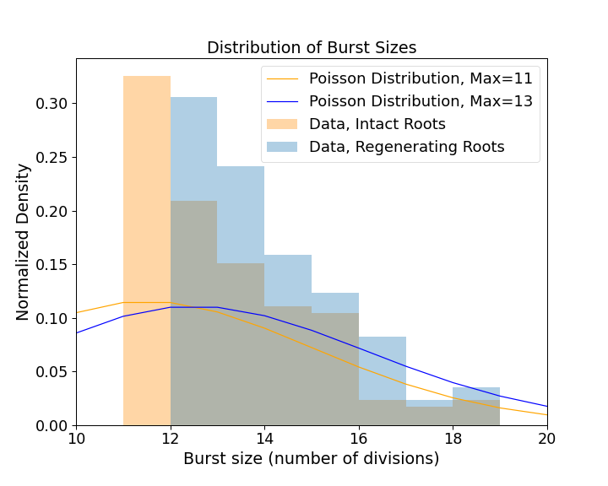

Figure 2. Distribution of burst size (i.e. number of division events in that burst) in intact and regenerating root tips. Experimental data (histograms) and Poisson distributions with max at 11 (yellow) and 13 (blue).

***Regenerating and intact roots exhibit different periodicities of mitotic events***

To reveal hidden periodicities in the pattern, we generated a periodogram, or a standard spectral analysis of the temporal series of single mitotic events (see Methods). Briefly, periodograms show a distribution of fundamental periodicities in a time series. Our analysis indicates strong fundamental periodicities corresponding to 4, 6 and 24 hours for the intact roots, and 11 and 16 hours for the regenerating roots (Fig. 3). Since we enforced a 24 hour light cycle (16 hour light : 8 hour dark) on all the the plants during germination, a 24 hours periodicity and subdivisions of 24 hours (*i.e.*12, 6, 4, etc.) might be expected and irrelevant. The peak at 16 hours observed in the periodogram of regenerating roots, and not in the one of intact roots, suggests a non-trivial periodicity specific to the regeneration process.

Although the cause of these periodicities remains unclear, the spectral analysis suggests fundamental differences in the cell division dynamics in unperturbed and regenerating tissues.

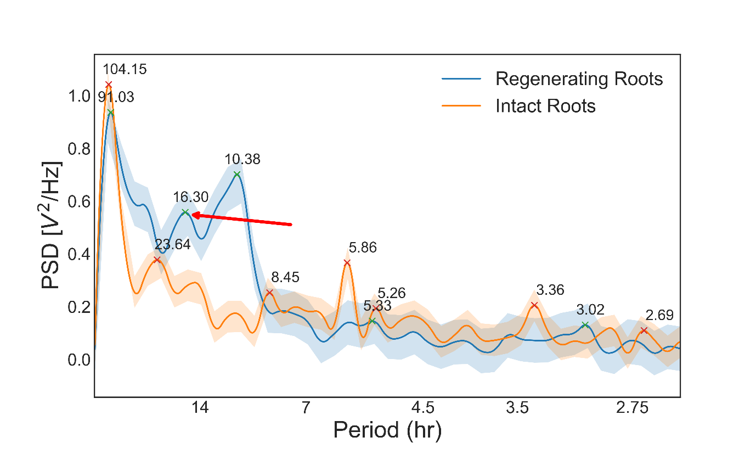

Figure 3. Periodogram of the temporal series shown in Fig.1, for intact and regenerating root tips. PSD, power spectral density. Red arrow, 16-hour period in regenerating roots suggesting non-trivial periodicity.

***A difference in the distribution of mitotic events per frame between regenerating and intact roots emerges only 24 hours after excision***

To further characterise the dynamics of mitotic events in both intact and regenerating roots, we compared the distribution of mitotic events in each frame, *i.e.*the probability of detecting a mitotic event in a single time point (Fig. 4A). The two distributions are statistically different over the entire duration of our observation (p<0.001), further supporting the hypothesis that the underlying dynamics of cell divisions is different in intact roots than in regenerating roots.

While both distributions peak around 3.5 divisions per frame and are skewed towards higher values, the regenerating roots’ distribution shows a “shoulder” around 11 divisions per frame, which is not as clear in the intact roots’ sample (Fig. 4A). This suggests the existence of two unresolved sub-populations of events in the regenerating roots: one with a maximum around 3.5 divisions per frame, like in the intact roots, and a second one centred around 11 divisions per frame. This second peak is unmatched in the data from the intact roots, suggesting a unique feature of self-organising tissue.

To address whether root regeneration is a single continuous process or, instead, is made of distinct developmental phases, we asked whether the highly active time points with 11 division per frame occurred throughout the entire regeneration process or only at specific moments.

We re-analysed the data into temporal bins, 0-6 hours, 6-24 hours, 24-72 hours and greater than 72 hours after the excision. The distributions of divisions per frame are statistically indistinguishable between intact and regenerating roots during the first 6 hours (Fig. 4B; p=0.21) and between 6 and 24 hours (Fig. 4C; p=0.83). Crucially, between 24 and 72 hours after excision the two distributions are statistically different (Fig. 4D; p=0.025), with the one for the regenerating roots showing a longer tail between 10 and 20 divisions per frame. Finally, the two distributions remain statistically different after 72 hours from the excision (Fig. 4E; p<0.001). Taken together, this data indicates that the main difference in cell division dynamics between regenerating and intact roots appears only 24 hours after the tip excision, with the regenerating roots showing an excess of 10-15 events per time point.

Figure 4. Distributions of mitotic events detected in one frame, in intact and regenerating root tips. (A)**,** all events; (B), events detected in the first 6 hours; (C), events detected between 6 and 24 hours; (D), events detected between 24 and 72 hours; (E), events detected after 72 hours. Histograms, experimental data; lines, kernel density estimation to the experimental data (smooth fitting).

***Mitotic events occur in small spatial clusters that are more abundant in regenerating roots***

The lack of a persistent reference point across time frames makes the spatial localisation of the mitotic event relative to biologically significant landmarks in the root intractable. Instead, the spatial information allows the calculation of relative distance between events. One important question from the developmental point of view is whether these occur uniformly within the tissue or, rather, in clusters.

To define a spatial cluster of events, first we determined the centre of mass of each event using our tracking algorithm {Amarteifio.2021}. Around each centre of mass we modelled a 6 µm X 4 µm X 4 µm cell, with a “diameter” (maximum distance between two points) equal to 8.24 µm. We used the DBScan algorithm {Ester.1996} to identify all events within three cell diameters (ε = 3 x 8.24 µm = 24.72 µm) from each other as part of a single cluster. Finally, we plot the distribution of cluster sizes, or how many clusters of which size we detected in a single time point, for the populations of intact and regenerating roots (Fig. 5). In both distributions, most of the time points contain 1-3 spatial clusters made of 2-4 events each and, at any given time, regenerating roots are more likely to contain a higher number of clusters (up to 4-5) of the same 2-4 cell size (Fig. 5). This subtle distinction suggests a sharp limit in the correlation length among cell division events (i.e., small clusters of cell divisions), but also a propensity of regenerating roots to exhibit a higher number of foci of mitotic activity.

Figure 5. Distribution of cluster numbers and their size, in a single time point. The size of each point represents the frequency. (A), Intact roots; (B), Regenerating roots.

**The density of mitotic event clusters is constant and analogous in regenerating and intact roots**

We measured the mean pairwise distance between the centres of mass for the clusters, to elucidate what the spatial distribution of these clusters of events is and, perhaps more importantly, whether it changes during the regeneration process. This essentially quantifies the density of cell division clusters in the tissue. Both intact and regenerating roots show a similar density of clusters [stats at t>72h?], with an average pairwise distance of about 50 µm throughout the entire duration of our observation (Fig. 6).

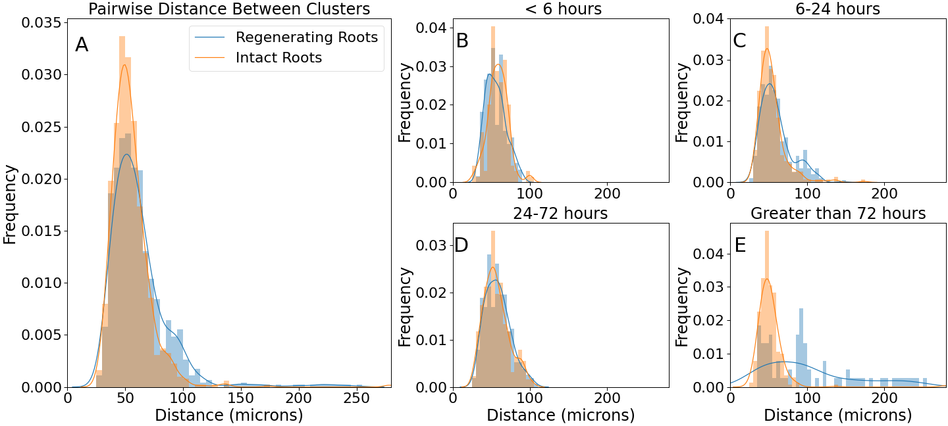

Figure 6. Distributions of pairwise distances between clusters’ centers of mass. Histograms, experimental data; lines, kernel density estimation to the experimental data (smooth fitting).

**DISCUSSION**

We presented a quantitative characterisation of the temporal and spatial distribution of cell divisions in intact and regenerating *Arabidopsis* root tips. Several biologically relevant observations can be extracted from the data.

First, the intermittent nature of the temporal sequence of mitotic events (Fig. 1) indicates that mitotic events are not randomly distributed in time. In other words, the underlying dynamics of cell divisions in the tissue cannot be explained simply by perfectly uncoupled cells undergoing a noisy cell cycle. A significant body of work describes the complex genetic networks regulating cell-cell interaction during cell division and differentiation in *Arabidopsis* roots, so the fact that cell divisions are not simply independent random events is perhaps not surprising. An intermittent pattern can be described as a sequence of “bursts”, or periods of activity above an arbitrary threshold. Our data (Fig. 2) shows that regenerating roots tend to produce slightly larger bursts, involving a larger number of cell divisions, compared to intact roots. This indicates that regeneration entails non just more cell divisions, but that these are compacted in discrete periods (bursts) of higher activity.

Second, cell division activity in both intact and regenerating roots shows a superposition of several periodicities, but regenerating roots are characterised by an underlying period of 16 hours which is not detected in intact roots (Fig. 3). Although the regenerating and intact root groups are composed of random individuals taken from the same isogenic seed population and have been germinated and grown under identical conditions, we note that the seedlings are germinated under a regime of 16 hour in light and 8 hour in darkness. Immediately after root tip excisions, the plants are grown and imaged under constant light. Is it possible that a memory of the 16-hour light cycle persists at the cellular level and that it is reflected in the cell division dynamics? If so, our data indicate that this should happen only during tissue regeneration, as no 16-hour periodicity was observed in intact roots. Future experiments carried out with different light/dark regimes might attempt to test this hypothesis.

Third, we found differences between intact and regenerating roots when considering the entire temporal distribution of single mitotic events, or the frequency of single time frames containing a given number of cell divisions, in spite of the described intermittency. More specifically, while in intact roots cell divisions belong to a single mode centred around 3-5 events at any given time point, during regeneration a second mode of divisions emerges, centred around 11 events at any given time point (Fig. 4). This becomes particularly evident 24 hours after root excision, suggesting that after this time point the regenerating tissue undergoes a transition towards a more complex regime of cell division dynamics.

Fourth, the mitotic events appeared to be clustered in space, suggesting the existence of a short-range inducing signal to trigger cell division in neighbouring cells, coupled with a long-range inhibitory signal to separate clusters. Although it is beyond the scope of this work, we suggest that effective diffusion constants of the inducing and inhibiting signals could be estimated computationally with a model based on reaction-diffusion {Turing.1952}.

Fifth, regenerating roots contain slightly higher number of clusters per frame (Fig. 5), while cluster density appears similar in intact and regenerating roots (Fig. 6). This suggests that a wider region of the regenerating tissue is going through cell proliferation, compared to intact tissue, but that the signals leading to cluster formation acts in a similar way in both developmental programs.

Finally, our analysis indicates that the mitotic events in both intact and regenerating roots are not independent events, but that shows signs of correlation (Fig. 2 and 6). This might be expected given the short and long-range cell-cell signaling, but it is an important quantitative visualization.

Overall, the presented data paint an original quantitative picture where the cell division dynamics in regenerating roots evolves faster than in intact roots, possibly revealing a developmental transition around 24 hours after the physical perturbation. Although this is only a first step towards a full quantitative characterisation of tissue regeneration, we believe that the focus on cell divisions is important to capture the complex dynamics driving tissue self-organization.

**METHODS**

***Plant material***

Mitotic events were visualized using an existing Arabidopsis transgenic line, expressing the cyclin-GFP protein fusion CYCB1;1::GFP {Reddy.2004}. Arabidopsis seeds were sterilized, stratified and stored at 4C before sowing on sterile room temperature rectangular plates prepared in sterile conditions with solid media consisting of 0.175% w/v Murashige and Skoog Basal Medium (MS) (Sigma-Aldrich, UK), 0.5% w/v Sucrose (Sigma-Aldrich, UK), 0.05% w/v MES hydrate (Sigma-Aldrich, UK), 0.8% w/v Agar, adjusted to pH 5.7 (KOH) which was sterilized by autoclaving. Plates were placed in vertical racks in a plant growth chamber with 120 μmol/m2/s light intensity on a 16 hours light : 8 hours dark cycle and constant 23°C.

***Microdissection***

Regenerating roots were manually excised using a 100 Sterican 27G needle tip (B Braun) under a Nikon SMZ1000 dissecting microscope, 180x magnification, following published procedures {Sena.2009, Kral.2016}. The excisions were mainly performed at about ~100 µm, with one root being excised at ~50 µm.

***Mounting***

5 days post-germination, plants were moved and mounted in an imaging cuvette as previously described {Baesso.2018}. Briefly, roots were taken and placed on solid media plates with 5% w/v agar, (all other reagents were the same as the germination plates).

Excised and control roots were then both mounted into the corner of an imaging cuvette (manufacturer) by flowing liquid media (0.04375% w/v MS, 0.5% w/v Sucrose, 0.05% w/v MES) and using capillary action to pull the root down the length of the cuvette with the hypocotyl and cotyledons above the top of the cuvette. The root was held in place with a sterile, heat-shrink plastic-coated pin, which was in turn held in place by 2 mm glass beads for 1/3 of the volume of the cuvette, followed by 1mm glass beads until 10 mm from the top of the cuvette. Liquid media was perfused into the chamber at ~1 mL/min through a custom cuvette top with a recessed corner for the cotyledons. A second cuvette with a glass coverslip top and two ~0.5 cm^2 gas-exchange windows covered with gas-permeable sterile tape was placed over the top of the perfusion chamber, allowing for gas exchange and broad-spectrum incident light on the cotyledons. Media temperature was monitored using an infrared thermometer mounted on tubing before the perfusion chamber, and a multi-stage heating element was used to keep the media temperature at 23 oC. All tubing, media, glass beads, pins, perfusion tops and imaging cuvettes were autoclaved before use. Plastic imaging chamber tops were submerged in a bleach solution for 30 s, before multiple rinses with autoclaved sterile water.

***Microscopy***

Imaging was done on a previously described home-built light-sheet microscope {Baesso.2018}. The root was imaged through 60 planes every 15 minutes for up to 7 days. At each plane, 6 images were taken, and the plane of maximum focus was kept. Focusing was enhanced by automatically detecting the edge of the root at the beginning of every image set, moving the focus 30 µm into the root from that plane, automatically detecting the plane of maximum focus, and moving back 30 µm from that point, such that the starting point for the autofocusing step would be at maximum focus in the centre of the root. The root tip is automatically tracked using custom MATLAB code {Baesso.2018}, which in turn will move the cuvette stage in x, y, and z to keep the root in focus and centred in the field of view throughout the experiment. Cell division events were segmented and tracked across time frames using a previously described MATLAB code {Amarteifio.2021}.

***Statistical analysis***

When comparing two samples of measurements, the Two Sample Kolmogorov-Smirnov test was used. Unless stated otherwise, all comparisons were performed assuming independence (unpaired test). All statistical tests were performed in python using the *scipy* statistics package. The code is available at github.com/todd-fallesen.

**REFERENCES**

{bibliography}