This asset supports muti-platform, but best in Android, iOS, Window Phone 8 platform. Select menu File Build Settings. Check all scenes: LoadingScene, HomeScene, MapScene and PlayScene appear or not in Scenes In Build. If not, you need add them to Scenes In Build in Build Settings.
Note: You must index LoadingScene in the first with value is 0.
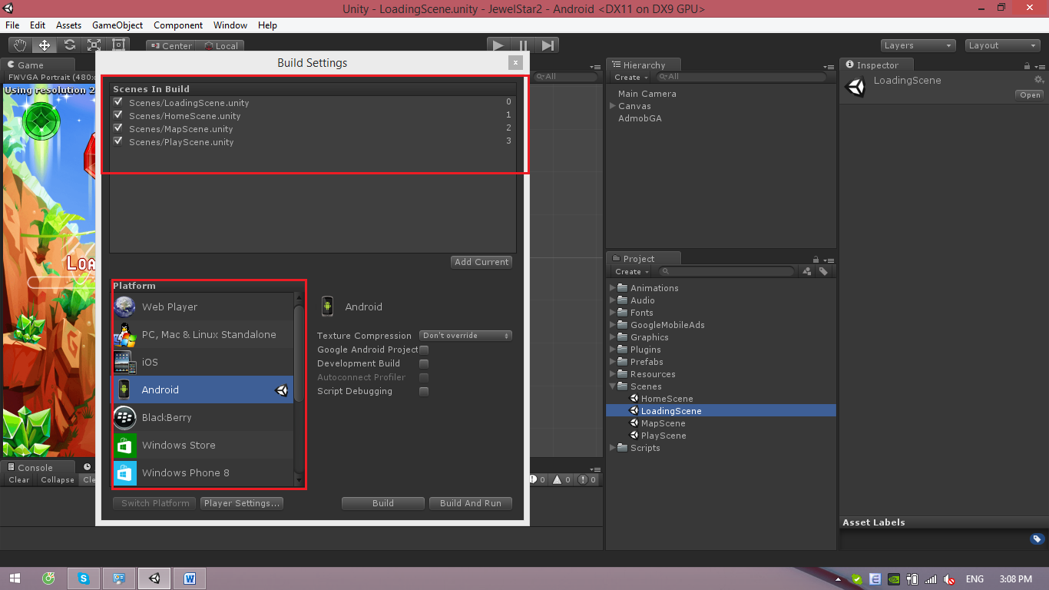

When play game, you must start LoadingScene first. If not, will appear bug as in the follow:
