Bug Report 1 – AcademyBugs
Title: Incorrect spacing in “Return to store” button text
Website: https://academybugs.com
Browser: Chrome
Device: Desktop
Description:
The “Return to store” button contains excessive spacing before the last letter, causing visual inconsistency.
Steps to Reproduce:
- Open https://academybugs.com
- Click “Find Bugs” (blue icon on the right side)
- Select any product
- Open the cart (bottom right corner)
- Empty the cart
Expected Result:
The text “Return to store” is displayed with consistent spacing between all characters.
Actual Result:
There is excessive spacing before the last letter in “Return to store”.
Severity: Low
Priority: Low
Attachment: Screenshot

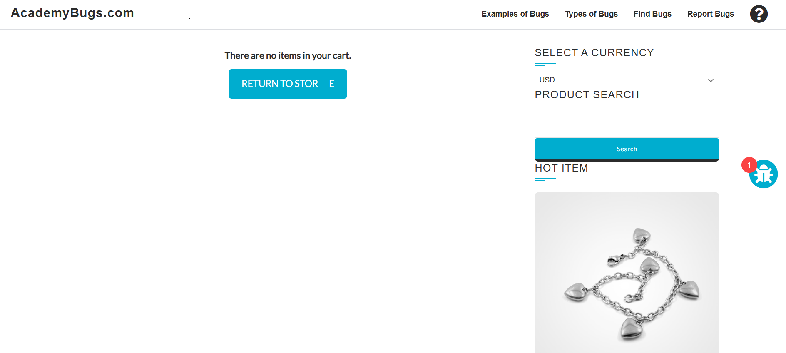

Bug Report 2 – Buggy App
Title: Clicking product image redirects user to homepage instead of opening enlarged image
Website: https://buggy.justtestit.org/
Browser: Chrome
Device: Desktop
Description:
When a user clicks on a product image, the system redirects to the homepage instead of displaying an enlarged version of the image.
Steps to Reproduce:
- Open https://buggy.justtestit.org/
- Select any product
- Click on the product image
Expected Result:
An enlarged version of the selected product image is displayed.
Actual Result:
The user is redirected to the homepage.
Severity: Minor
Priority: Medium
Attachment: Video

