Elma Handžić 23.11.2025.

Vježba OrangeHRM

Feature: Admin

User story 1

As an admin, I want to add, edit, delete, and search user accounts in the User Management section under Admin so that I can maintain accurate access control and ensure that employees have the correct roles and permissions.

TEST CASE 1

ID: ADM03
Title: Searching for an existing user in User Management.
Steps:
1.Log in to OrangeHRM as an Admin.
2.Open Admin tab from the left menu.
3.Go to User Management → Users.
4.In the Username search field, enter an existing username (e.g:”hindd”).
5.Click search.
6.Observe the results table.
Excpected test result: passed
Test priority : medium

TEST CASE 2
ID: ADM04
Title: Changing user status from enabled to disabled
Steps:
1.Log in to OrangeHRM as Admin.
2.Open the Admin tab from the left menu.
3.Navigate to User Management then Users.
4.In the search field, enter a valid existing username (e.g., “hindd”).
5.Click search.
6.In the results table, click the edit (pencil) button for that user.
7.In the status dropdown, change the value from enabled to disabled.
8.Click green save button.
9.Return to the users list and search for the same username again.
10.Verify that the user now appears with status as disabled.
Expected test result: passed
Test priority: high

Bug report
Title: Language partially switches to Chinese after clicking in the Admin section
Description: When clicking, selecting options, generally using application in the Admin section, some interface elements switch to Chinese language, while the rest remain in English.
Steps to Reproduce:
-Open the website: https://opensource-demo.orangehrmlive.com
-Log in as Admin
-Click on the Admin section in the left menu
-Perform a long click or hold the mouse on options within the Admin menu
-Observe the labels and table text
Expected result: All interface elements should remain in English with no unexpected language changes.
Actual Result: Part of the interface switches to Chinese, while the rest stays in English.
Severity: major
Priority: medium
Attachment: screenshot
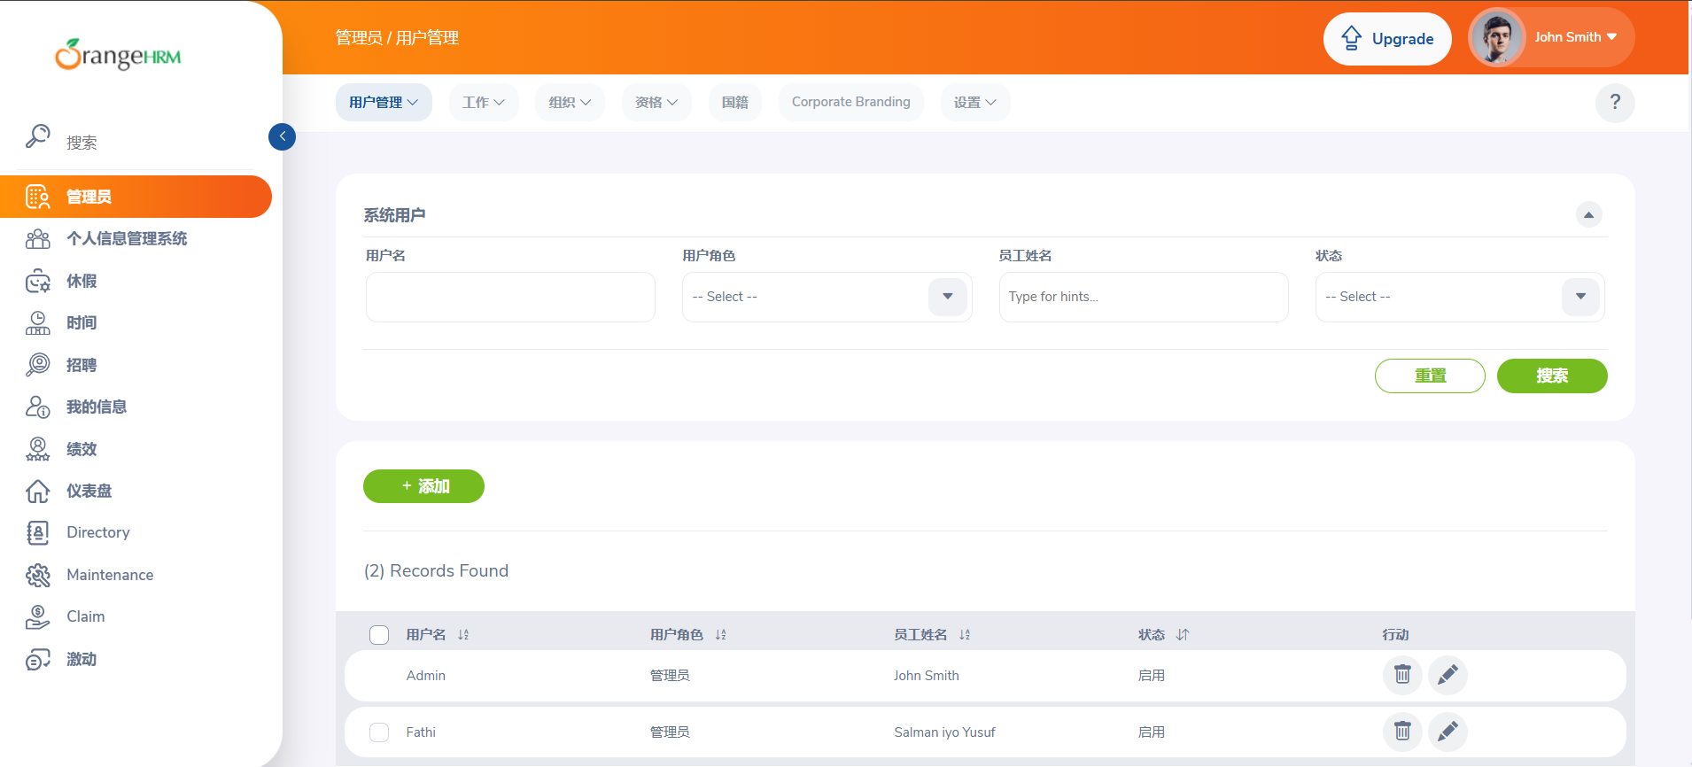

TEST CASE 3
ID: ADM15
Title: Attempt to change a user’s username to an already existing username and verify validation message
Preconditions:
-Admin has valid login credentials.
-In the system already exist at least two different user accounts.
-Both users are visible under Admin, User Management, Users.
Test data:
-Username to edit: username101
-New (duplicate) username to assign: FMLName
Steps:
1.Log in to OrangeHRM as Admin.
2.Open the Admin tab from the left side menu.
3.Navigate to User Management, Users.
4.In the username search field enter “username101”.
5.Click search.
6.In the results table click the edit (pencil) button for user “username101”.
7.In the Username field delete the current username
8.Enter a username that already exists in the system, e.g:FMLName.
9.Click the green save button.
10.Observe the page for validation errors.
11.Return to the Users list and search for “username101” again.
12.Verify that the user “username101” still exists with the original username (no changes applied).

Expected test result:
System displays a clear validation error message indicating that the username already exists (e.g., “Already exists”).
User cannot be saved with a duplicate username.
No changes are made to the original user (“username101”).

Actual result:A red pop-up error message appears saying "Error: Record Not Found", and the system does not allow changing the username to one that already exists. No updates are saved.

Status: Pass

Priority: Medium

Bug report
Title: System shows “Error: Record Not Found” and prevents updating username even when the new username is unique.
Description: When attempting to edit an existing user account and change the username, the system displays a red error pop-up “Error: Record Not Found” and does not allow saving the changes.
The issue occurs even when the new username does not exist in the system (e.g., elma73), meaning the system fails to update valid, unique usernames.
The bug occurs both when entering an already existing username and when entering a new unique username, meaning validation is failing incorrectly.
This blocks one of the core admin functions: editing user accounts.
Steps to Reproduce:
-Log in to OrangeHRM as Admin.
-Open Admin tab from the left menu.
-Navigate to User Management then Users.
-In the Username search field enter an existing user (e.g., hindd).
-Click Search.
-In the results table click the edit (pencil) button.
-In the Username field delete the current username.
-Enter a new valid and unique username, e.g., elma73.
-Click the green Save button.
Expected result: System should allow saving a new username as long as it is unique and valid. A success message should appear. User should be updated with the new username (e.g., elma73).
Severity: minor
Priority: medium
Attachment: screenshot

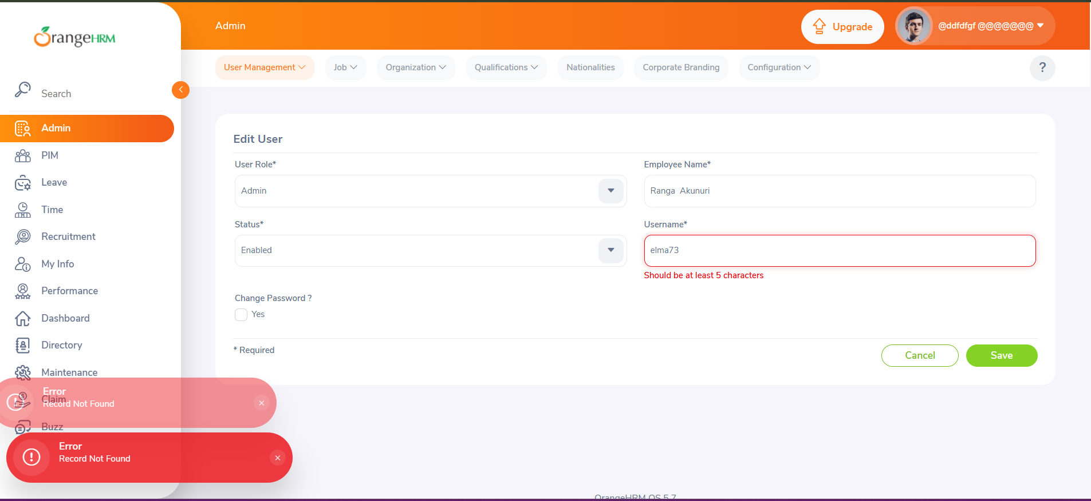

User story 2

As an admin, I want to manage all job settings in the Job section: job titles, pay grades, employment statuses, job categories, and work shifts — so that I can maintain accurate organizational structure, define compensation levels, and know that employee records are classified correctly across the system.

TEST CASE 4
ID: JOB01
Title: Adding a job specification document to a job title

Preconditions:
-Admin has valid login credentials.
Admin is on the OrangeHRM dashboard, on Admin, under Job-Job Titles
-A valid document (e.g., PDF, DOCX) is available on the local device for upload.

Test data:
Job Title: Account Assistant
Job Specification File:”file-example_PDF_1MB” or any supported file type

Steps:
1.Log in to OrangeHRM as Admin.
2.Open the Admin tab from the left menu.
3.Navigate to Job then Job Titles.
4.In the job titles list, locate Account Assistant.
5.Click the edit (pencil) button next to Account Assistant.
6.In the Job Specification section, click Browse (Choose File).
7.Select a valid document from your computer (“file-example_PDF_1MB”).
8.Verify that the file name appears next to the upload field.
9.Click the Save button.
10.Return to the Job Titles list and search for Account Assistant again.
11.Open the job title using the edit (pencil) button.
12.Verify that the uploaded document is visible under Job Specification, with a icon for download option and 3 options for: Keep Current,Delete Current and Replace Current.

Expected test result:

System successfully uploads and attaches the job specification document. Changes are saved without errors. The uploaded file appears correctly under Job Specification.
A Download icon/option confirms the file is stored. A green pop-up notification appears in the bottom-left corner displaying “Success! Successfully updated”.
Status: passed
Priority: medium

