Assignment 1

Carey Hedges (751546)

11 July 2016

## R Markdown

"I love Octocat. She's the coolest cat in town"

Octocat

Octocat

## Assignment 2

data (anscombe)  
dim (anscombe)

## [1] 11 8

colnames (anscombe)

## [1] "x1" "x2" "x3" "x4" "y1" "y2" "y3" "y4"

head (anscombe)

## x1 x2 x3 x4 y1 y2 y3 y4  
## 1 10 10 10 8 8.04 9.14 7.46 6.58  
## 2 8 8 8 8 6.95 8.14 6.77 5.76  
## 3 13 13 13 8 7.58 8.74 12.74 7.71  
## 4 9 9 9 8 8.81 8.77 7.11 8.84  
## 5 11 11 11 8 8.33 9.26 7.81 8.47  
## 6 14 14 14 8 9.96 8.10 8.84 7.04

tail (anscombe)

## x1 x2 x3 x4 y1 y2 y3 y4  
## 6 14 14 14 8 9.96 8.10 8.84 7.04  
## 7 6 6 6 8 7.24 6.13 6.08 5.25  
## 8 4 4 4 19 4.26 3.10 5.39 12.50  
## 9 12 12 12 8 10.84 9.13 8.15 5.56  
## 10 7 7 7 8 4.82 7.26 6.42 7.91  
## 11 5 5 5 8 5.68 4.74 5.73 6.89

summary (anscombe)

## x1 x2 x3 x4   
## Min. : 4.0 Min. : 4.0 Min. : 4.0 Min. : 8   
## 1st Qu.: 6.5 1st Qu.: 6.5 1st Qu.: 6.5 1st Qu.: 8   
## Median : 9.0 Median : 9.0 Median : 9.0 Median : 8   
## Mean : 9.0 Mean : 9.0 Mean : 9.0 Mean : 9   
## 3rd Qu.:11.5 3rd Qu.:11.5 3rd Qu.:11.5 3rd Qu.: 8   
## Max. :14.0 Max. :14.0 Max. :14.0 Max. :19   
## y1 y2 y3 y4   
## Min. : 4.260 Min. :3.100 Min. : 5.39 Min. : 5.250   
## 1st Qu.: 6.315 1st Qu.:6.695 1st Qu.: 6.25 1st Qu.: 6.170   
## Median : 7.580 Median :8.140 Median : 7.11 Median : 7.040   
## Mean : 7.501 Mean :7.501 Mean : 7.50 Mean : 7.501   
## 3rd Qu.: 8.570 3rd Qu.:8.950 3rd Qu.: 7.98 3rd Qu.: 8.190   
## Max. :10.840 Max. :9.260 Max. :12.74 Max. :12.500

## Assignment 3

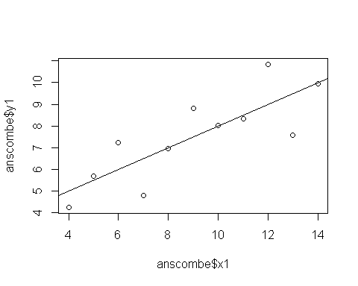

## Assignment 4

### Code Chunk 4

df <- read.csv('analgesic.csv')

### Code Chunk 5

dim (df)

## [1] 40 5

colnames (df)

## [1] "ID" "Group" "Measurement_1" "Measurement_2"  
## [5] "Measurement_3"

head (df)

## ID Group Measurement_1 Measurement_2 Measurement_3  
## 1 1 Analgesic 26 26 21  
## 2 2 Analgesic 29 26 23  
## 3 3 Analgesic 24 28 22  
## 4 4 Analgesic 25 22 24  
## 5 5 Analgesic 24 28 23  
## 6 6 Analgesic 22 23 26

tail (df)

## ID Group Measurement_1 Measurement_2 Measurement_3  
## 35 35 Placebo 17 21 15  
## 36 36 Placebo 19 17 15  
## 37 37 Placebo 14 19 13  
## 38 38 Placebo 17 19 13  
## 39 39 Placebo 11 20 18  
## 40 40 Placebo 15 18 12

summary (df)

## ID Group Measurement_1 Measurement_2   
## Min. : 1.00 Analgesic:20 Min. :10.00 Min. : 8.0   
## 1st Qu.:10.75 Placebo :20 1st Qu.:17.00 1st Qu.:17.0   
## Median :20.50 Median :20.00 Median :20.0   
## Mean :20.50 Mean :20.12 Mean :20.7   
## 3rd Qu.:30.25 3rd Qu.:24.00 3rd Qu.:25.0   
## Max. :40.00 Max. :30.00 Max. :32.0   
## Measurement_3   
## Min. :12.00   
## 1st Qu.:16.00   
## Median :20.50   
## Mean :20.52   
## 3rd Qu.:24.25   
## Max. :30.00

### Code Chunk 6

library(tidyr)

## Warning: package 'tidyr' was built under R version 3.3.1

library(dplyr)

## Warning: package 'dplyr' was built under R version 3.3.1

##   
## Attaching package: 'dplyr'

## The following objects are masked from 'package:stats':  
##   
## filter, lag

## The following objects are masked from 'package:base':  
##   
## intersect, setdiff, setequal, union

df2 <- gather(df,"Measurement", "Value", Measurement_1:Measurement_3) #Change wide to long  
df2

## ID Group Measurement Value  
## 1 1 Analgesic Measurement_1 26  
## 2 2 Analgesic Measurement_1 29  
## 3 3 Analgesic Measurement_1 24  
## 4 4 Analgesic Measurement_1 25  
## 5 5 Analgesic Measurement_1 24  
## 6 6 Analgesic Measurement_1 22  
## 7 7 Analgesic Measurement_1 25  
## 8 8 Analgesic Measurement_1 28  
## 9 9 Analgesic Measurement_1 22  
## 10 10 Analgesic Measurement_1 18  
## 11 11 Analgesic Measurement_1 25  
## 12 12 Analgesic Measurement_1 26  
## 13 13 Analgesic Measurement_1 26  
## 14 14 Analgesic Measurement_1 19  
## 15 15 Analgesic Measurement_1 24  
## 16 16 Analgesic Measurement_1 23  
## 17 17 Analgesic Measurement_1 24  
## 18 18 Analgesic Measurement_1 24  
## 19 19 Analgesic Measurement_1 23  
## 20 20 Analgesic Measurement_1 30  
## 21 21 Placebo Measurement_1 19  
## 22 22 Placebo Measurement_1 10  
## 23 23 Placebo Measurement_1 12  
## 24 24 Placebo Measurement_1 17  
## 25 25 Placebo Measurement_1 18  
## 26 26 Placebo Measurement_1 12  
## 27 27 Placebo Measurement_1 14  
## 28 28 Placebo Measurement_1 20  
## 29 29 Placebo Measurement_1 16  
## 30 30 Placebo Measurement_1 17  
## 31 31 Placebo Measurement_1 18  
## 32 32 Placebo Measurement_1 20  
## 33 33 Placebo Measurement_1 12  
## 34 34 Placebo Measurement_1 20  
## 35 35 Placebo Measurement_1 17  
## 36 36 Placebo Measurement_1 19  
## 37 37 Placebo Measurement_1 14  
## 38 38 Placebo Measurement_1 17  
## 39 39 Placebo Measurement_1 11  
## 40 40 Placebo Measurement_1 15  
## 41 1 Analgesic Measurement_2 26  
## 42 2 Analgesic Measurement_2 26  
## 43 3 Analgesic Measurement_2 28  
## 44 4 Analgesic Measurement_2 22  
## 45 5 Analgesic Measurement_2 28  
## 46 6 Analgesic Measurement_2 23  
## 47 7 Analgesic Measurement_2 25  
## 48 8 Analgesic Measurement_2 21  
## 49 9 Analgesic Measurement_2 26  
## 50 10 Analgesic Measurement_2 25  
## 51 11 Analgesic Measurement_2 29  
## 52 12 Analgesic Measurement_2 25  
## 53 13 Analgesic Measurement_2 25  
## 54 14 Analgesic Measurement_2 30  
## 55 15 Analgesic Measurement_2 20  
## 56 16 Analgesic Measurement_2 24  
## 57 17 Analgesic Measurement_2 32  
## 58 18 Analgesic Measurement_2 17  
## 59 19 Analgesic Measurement_2 25  
## 60 20 Analgesic Measurement_2 18  
## 61 21 Placebo Measurement_2 12  
## 62 22 Placebo Measurement_2 16  
## 63 23 Placebo Measurement_2 11  
## 64 24 Placebo Measurement_2 17  
## 65 25 Placebo Measurement_2 18  
## 66 26 Placebo Measurement_2 16  
## 67 27 Placebo Measurement_2 17  
## 68 28 Placebo Measurement_2 19  
## 69 29 Placebo Measurement_2 19  
## 70 30 Placebo Measurement_2 15  
## 71 31 Placebo Measurement_2 21  
## 72 32 Placebo Measurement_2 13  
## 73 33 Placebo Measurement_2 8  
## 74 34 Placebo Measurement_2 17  
## 75 35 Placebo Measurement_2 21  
## 76 36 Placebo Measurement_2 17  
## 77 37 Placebo Measurement_2 19  
## 78 38 Placebo Measurement_2 19  
## 79 39 Placebo Measurement_2 20  
## 80 40 Placebo Measurement_2 18  
## 81 1 Analgesic Measurement_3 21  
## 82 2 Analgesic Measurement_3 23  
## 83 3 Analgesic Measurement_3 22  
## 84 4 Analgesic Measurement_3 24  
## 85 5 Analgesic Measurement_3 23  
## 86 6 Analgesic Measurement_3 26  
## 87 7 Analgesic Measurement_3 30  
## 88 8 Analgesic Measurement_3 21  
## 89 9 Analgesic Measurement_3 20  
## 90 10 Analgesic Measurement_3 29  
## 91 11 Analgesic Measurement_3 28  
## 92 12 Analgesic Measurement_3 23  
## 93 13 Analgesic Measurement_3 26  
## 94 14 Analgesic Measurement_3 27  
## 95 15 Analgesic Measurement_3 24  
## 96 16 Analgesic Measurement_3 27  
## 97 17 Analgesic Measurement_3 28  
## 98 18 Analgesic Measurement_3 25  
## 99 19 Analgesic Measurement_3 23  
## 100 20 Analgesic Measurement_3 25  
## 101 21 Placebo Measurement_3 18  
## 102 22 Placebo Measurement_3 18  
## 103 23 Placebo Measurement_3 20  
## 104 24 Placebo Measurement_3 18  
## 105 25 Placebo Measurement_3 20  
## 106 26 Placebo Measurement_3 16  
## 107 27 Placebo Measurement_3 17  
## 108 28 Placebo Measurement_3 18  
## 109 29 Placebo Measurement_3 15  
## 110 30 Placebo Measurement_3 13  
## 111 31 Placebo Measurement_3 14  
## 112 32 Placebo Measurement_3 16  
## 113 33 Placebo Measurement_3 21  
## 114 34 Placebo Measurement_3 16  
## 115 35 Placebo Measurement_3 15  
## 116 36 Placebo Measurement_3 15  
## 117 37 Placebo Measurement_3 13  
## 118 38 Placebo Measurement_3 13  
## 119 39 Placebo Measurement_3 18  
## 120 40 Placebo Measurement_3 12

df3 <- group_by (df2, Group) #Group by Placebo and Analgesic  
df3

## Source: local data frame [120 x 4]  
## Groups: Group [2]  
##   
## ID Group Measurement Value  
## (int) (fctr) (chr) (int)  
## 1 1 Analgesic Measurement_1 26  
## 2 2 Analgesic Measurement_1 29  
## 3 3 Analgesic Measurement_1 24  
## 4 4 Analgesic Measurement_1 25  
## 5 5 Analgesic Measurement_1 24  
## 6 6 Analgesic Measurement_1 22  
## 7 7 Analgesic Measurement_1 25  
## 8 8 Analgesic Measurement_1 28  
## 9 9 Analgesic Measurement_1 22  
## 10 10 Analgesic Measurement_1 18  
## .. ... ... ... ...

df4 <- group_by (df3, ID) #Read by ID  
df4

## Source: local data frame [120 x 4]  
## Groups: ID [40]  
##   
## ID Group Measurement Value  
## (int) (fctr) (chr) (int)  
## 1 1 Analgesic Measurement_1 26  
## 2 2 Analgesic Measurement_1 29  
## 3 3 Analgesic Measurement_1 24  
## 4 4 Analgesic Measurement_1 25  
## 5 5 Analgesic Measurement_1 24  
## 6 6 Analgesic Measurement_1 22  
## 7 7 Analgesic Measurement_1 25  
## 8 8 Analgesic Measurement_1 28  
## 9 9 Analgesic Measurement_1 22  
## 10 10 Analgesic Measurement_1 18  
## .. ... ... ... ...

summarise (df4, mean(Value)) #Mean of all replicates

## Source: local data frame [40 x 2]  
##   
## ID mean(Value)  
## (int) (dbl)  
## 1 1 24.33333  
## 2 2 26.00000  
## 3 3 24.66667  
## 4 4 23.66667  
## 5 5 25.00000  
## 6 6 23.66667  
## 7 7 26.66667  
## 8 8 23.33333  
## 9 9 22.66667  
## 10 10 24.00000  
## .. ... ...

# Assignment 5

## Question 1 - Chicken Weights

Ho: Chicken feed has no effect on the rate of chicken growth. H1: Chicken feed has an effect on the rate of chicken growth.

In order to evaluate this claim, an ANOVA will need to be used with a posthoc pairwise t-test to evaluate which chicken feed are better for plumper chickens.

This test assumes that the data are parametric and that there are greater than 3 groups.

library (dplyr)  
library (tidyr)  
library (knitr)  
  
cw <- read.csv ("C:/Users/Carey Hedges/Desktop/Assignment 4 - Stats/chick-weights.csv") #Read Excel Doc and look at data  
head(cw)

## weight feed  
## 1 179 horsebean  
## 2 160 horsebean  
## 3 136 horsebean  
## 4 227 horsebean  
## 5 217 horsebean  
## 6 168 horsebean

colnames(cw)

## [1] "weight" "feed"

dim (cw)

## [1] 71 2

boxplot (weight~feed, data = cw, col = "red", xlab = 'Feed', ylab = 'Chicken Weight', main= "Boxplots of Chicken Weights versus Feed")

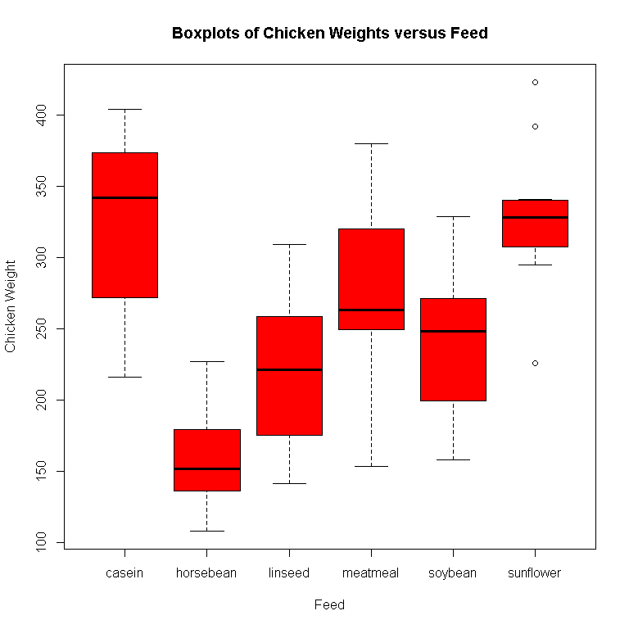

cw2 <- aov(weight~feed, data = cw) #Assign test to variable to allow for summary analysis  
summary (cw2)

## Df Sum Sq Mean Sq F value Pr(>F)   
## feed 5 231129 46226 15.37 5.94e-10 ***  
## Residuals 65 195556 3009   
## ---  
## Signif. codes: 0 '***' 0.001 '**' 0.01 '*' 0.05 '.' 0.1 ' ' 1

pairwise.t.test (chickwts$weight, chickwts$feed, p.adjust.method = 'holm', paired =FALSE) #Always posthoc test for groups

##   
## Pairwise comparisons using t tests with pooled SD   
##   
## data: chickwts$weight and chickwts$feed   
##   
## casein horsebean linseed meatmeal soybean  
## horsebean 2.9e-08 - - - -   
## linseed 0.00016 0.09435 - - -   
## meatmeal 0.18227 9.0e-05 0.09435 - -   
## soybean 0.00532 0.00298 0.51766 0.51766 -   
## sunflower 0.81249 1.2e-08 8.1e-05 0.13218 0.00298  
##   
## P value adjustment method: holm

The anova suggests that the feed affects the rate of chicken growth F(2,65) = 15.37, p<0.001.

The posthoc test indicates that there is a significant difference between different types of feed. Casein and Sunflower feed are comparible in increasing rate of chicken growth. Casein and Sunflower feed is slightly more effective than meatmeal for increase rate of chicken growth. Meatmeal is only slightly more effective than linseed and soybean at increasing rate of chicken growth. The least effective for increasing the rate of chicken growth is Horsebean feed. (Refer to pairwise t.test for test statistics).

## Question 2 - The Heat Zone

Ho: Gastroenteritis is not caused by contaminated water. H1: Gastroenteritis could be caused by contaminated water.

A Chi-squared analysis is necessary to establish if there is a difference in water consumption and illness.

The assumptions that underpin this test are:

1. Values are independent of one another
2. Sampling is random
3. Observed frequencies are approximated by normal distribution
4. Expected values should be 5 in 80% of the cells

library (dplyr)  
library (tidyr)  
library (knitr)  
library (ggplot2)

## Warning: package 'ggplot2' was built under R version 3.3.1

gi <- read.csv ("C:/Users/Carey Hedges/Desktop/Assignment 4 - Stats/gastroenteritis.csv")# Read excel document in order to work with data in R Studio  
summary(gi)

## Consumption Outcome   
## < 1 glasses/day :160 ill :569   
## < 4 glasses/day :411 not ill:525   
## 1 to 4 glasses/day:523

head(gi)

## Consumption Outcome  
## 1 < 1 glasses/day ill  
## 2 < 1 glasses/day ill  
## 3 < 1 glasses/day ill  
## 4 < 1 glasses/day ill  
## 5 < 1 glasses/day ill  
## 6 < 1 glasses/day ill

tail(gi)

## Consumption Outcome  
## 1089 < 4 glasses/day not ill  
## 1090 < 4 glasses/day not ill  
## 1091 < 4 glasses/day not ill  
## 1092 < 4 glasses/day not ill  
## 1093 < 4 glasses/day not ill  
## 1094 < 4 glasses/day not ill

gi2 <- table(gi$Outcome, gi$Consumption) #Cross Tabulate the data  
gi2

##   
## < 1 glasses/day < 4 glasses/day 1 to 4 glasses/day  
## ill 39 265 265  
## not ill 121 146 258

barplot (gi2, col = c("purple", "blue"), main = "Water Consumption and Illness", xlab = "Water Consumption", ylab = "Proportion of Ill Patients")  
legend ('topleft', inset = 0.05, legend = c("Ill", "Not Ill"), fill = c("purple", "blue"), box.col = 'white') #As there are multiple variables, clarity is required by use of colour and a legend.

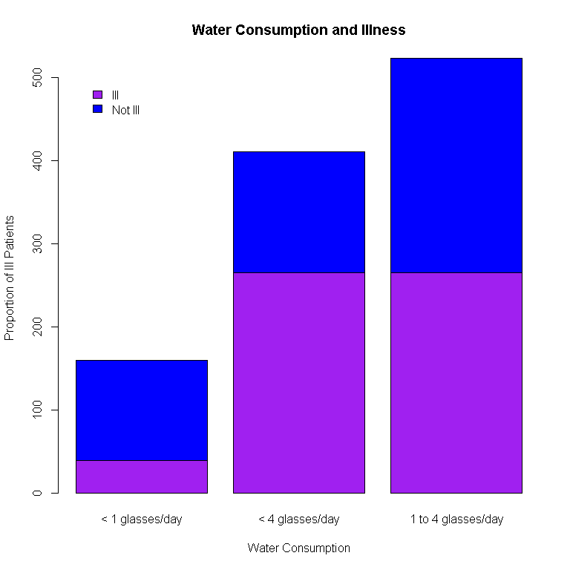

chisq.test(gi2, correct = FALSE) #Sample size is large and does not require a Yates correction

##   
## Pearson's Chi-squared test  
##   
## data: gi2  
## X-squared = 74.925, df = 2, p-value < 2.2e-16

Results for the test indicate that there is a significant effect of water consumption on the development of illness X-squared|(2, n=1094) = 74.93, p<0.001. Data suggest that the water consumption is linked to the likelihood of illness. Analysis of the barplot indicates that drinking more than one glass of water a day increases the likelihood of illness. It is likely that contaminated water causes gastroenteritis.

## Question 3 - Nausea

Ho: The serotonin receptor blocker has no effect on nausea management. H1: The serotonin receptor blocker has an effect on managing nausea.

A Wilcoxon sign rank test is most appropriate. This is due to the small sample size and the likelihood that normality in this population cannot be assumed.

This test assumes that the population is effectively matched, the sample distribution is representative of the population from which the sample is drawn and that the error from the median is independent.

library (dplyr)  
library (tidyr)  
library (knitr)  
  
  
 N <- read.csv ('C:/Users/Carey Hedges/Desktop/Assignment 4 - Stats/nausea.csv')  
 N

## Patient Nausea_before Nausea_after  
## 1 1 3 2  
## 2 2 4 0  
## 3 3 6 1  
## 4 4 2 3  
## 5 5 2 1  
## 6 6 4 1  
## 7 7 5 0  
## 8 8 6 40

dim (N)

## [1] 8 3

N2 <- N [-8,] #Value is outside the subjective numerical scale. It cannot be assumed that the data represents a score of "4" or of "0". The data capture was incorrect. The row needs to be removed in order to appropriately assess statistical significance.   
 N2

## Patient Nausea_before Nausea_after  
## 1 1 3 2  
## 2 2 4 0  
## 3 3 6 1  
## 4 4 2 3  
## 5 5 2 1  
## 6 6 4 1  
## 7 7 5 0

N3<- select (N2, Nausea_before, Nausea_after) # Isolate the data required for staistical test.  
 N3

## Nausea_before Nausea_after  
## 1 3 2  
## 2 4 0  
## 3 6 1  
## 4 2 3  
## 5 2 1  
## 6 4 1  
## 7 5 0

plot(N2$Patient, N2$Nausea_before, main = "Trend in Nausea before and after Serotonin Administration", col = "black", xlab = "Subject", ylab = "Nausea Rating", ylim = c(0,10), xlim = c(0, 8), pch = 2) #Plot the initial values  
  
points(N2$Patient, N2$Nausea_after, col = "red", pch = 8) #Add points to the already plotted graph for comparison  
  
legend ("topleft", inset = 0.05, legend = c("Nausea Before", "Nausea After"), pch = c(2, 8), col = c('black', 'red')) #Add a legend for ease of reference  
  
lines(N2$Patient, N2$Nausea_before) #Illustrate a trend in the reported values  
lines(N2$Patient, N2$Nausea_after, col = 'red')

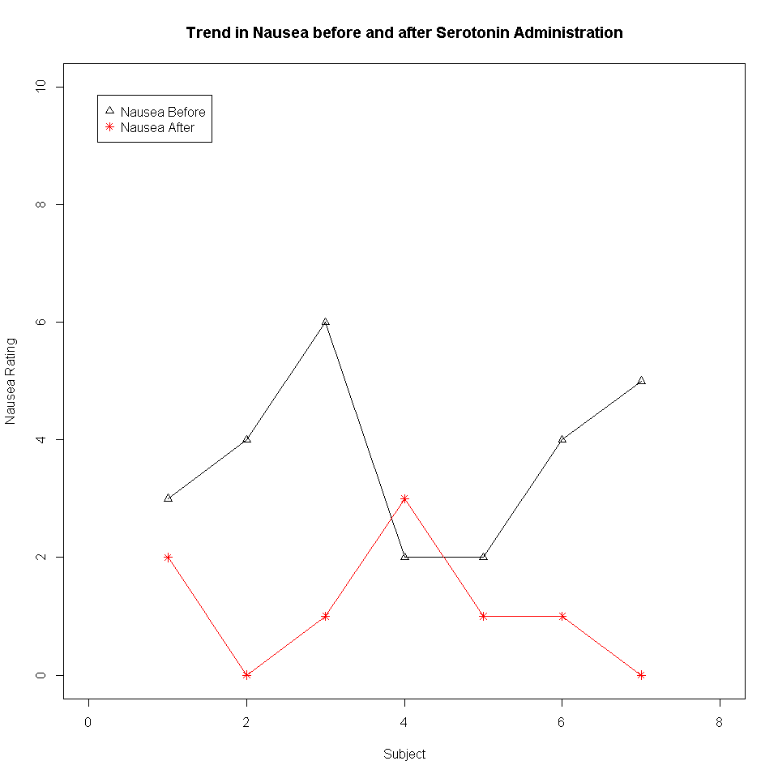

wilcox.test (N3$Nausea_before, N3$Nausea_after, paired = TRUE)

## Warning in wilcox.test.default(N3$Nausea_before, N3$Nausea_after, paired =  
## TRUE): cannot compute exact p-value with ties

##   
## Wilcoxon signed rank test with continuity correction  
##   
## data: N3$Nausea_before and N3$Nausea_after  
## V = 26, p-value = 0.04983  
## alternative hypothesis: true location shift is not equal to 0

Results from analysis indicate that serotonin tablets have a significant effect on nausea management w(7) = 26, p < 0.05 (p=0.04983). The graphical data suggest that the serotonin has a beneficial effect to lower symptoms of nausea. Further investigations with larger sample sizes will be required in order to establish the value in serotonin administration for the management of nausea.

# Assignment 6

Ho:There is an association between interest rate and house price. H1:There is no association between interest rate and house price.

A linear regression will be performed. The assumptions that underlie this test are:

1. A trend exists between house cost and interest rate.
2. Observations are independent of one another.
3. Measurements of the independent variable have been made correctly.
4. Residuals are normally distributed and are homoskedastic (same variance).

library (dplyr)  
library (tidyr)  
library (knitr)  
  
HP <- read.csv('C:/Users/Carey Hedges/Desktop/Mini Assignments - Stats/housing-prices.csv')  
  
head(HP)

## interest_rate median_house_price_USD  
## 1 10 183800  
## 2 10 183200  
## 3 10 174900  
## 4 9 173500  
## 5 8 172900  
## 6 7 173200

tail (HP)

## interest_rate median_house_price_USD  
## 12 7 203200  
## 13 8 230200  
## 14 7 258200  
## 15 7 309800  
## 16 6 329800  
## 17 NA NA

summary (HP)

## interest_rate median_house_price_USD  
## Min. : 6.00 Min. :169700   
## 1st Qu.: 7.00 1st Qu.:173425   
## Median : 8.00 Median :180550   
## Mean : 8.00 Mean :204756   
## 3rd Qu.: 8.25 3rd Qu.:209950   
## Max. :10.00 Max. :329800   
## NA's :1 NA's :1

#HP have NA values in the 17th row - these need to be excluded   
  
HP2 <- HP[-17,]  
HP2

## interest_rate median_house_price_USD  
## 1 10 183800  
## 2 10 183200  
## 3 10 174900  
## 4 9 173500  
## 5 8 172900  
## 6 7 173200  
## 7 8 173200  
## 8 8 169700  
## 9 8 174500  
## 10 8 177900  
## 11 7 188100  
## 12 7 203200  
## 13 8 230200  
## 14 7 258200  
## 15 7 309800  
## 16 6 329800

#Data is not tidy, interest rates should be together to better visualise the data.  
  
HP3 <- arrange (HP2, desc(interest_rate))  
HP3

## interest_rate median_house_price_USD  
## 1 10 183800  
## 2 10 183200  
## 3 10 174900  
## 4 9 173500  
## 5 8 172900  
## 6 8 173200  
## 7 8 169700  
## 8 8 174500  
## 9 8 177900  
## 10 8 230200  
## 11 7 173200  
## 12 7 188100  
## 13 7 203200  
## 14 7 258200  
## 15 7 309800  
## 16 6 329800

plot(HP3,   
 main = "Relationship between Average House Price and Interest Rate",  
 xlab = "Interest Rate",   
 ylab = "Average House Price (USD)",  
 xlim = c(5,11),   
 ylim = c(100000, 400000),   
 pch = 21,   
 col = 'blue') #lm lines should not be used to graphically represent the data as a linear model does not fit the data. presenting such data with a linear model line is misleading (see calculations that follow).  
  
#Graphs that are published require both r and p values to be quoted.  
  
text(10.5, 350000, labels = 'r = - 0.05766')   
text(10.5, 340000, labels = 'p = 0.01937')

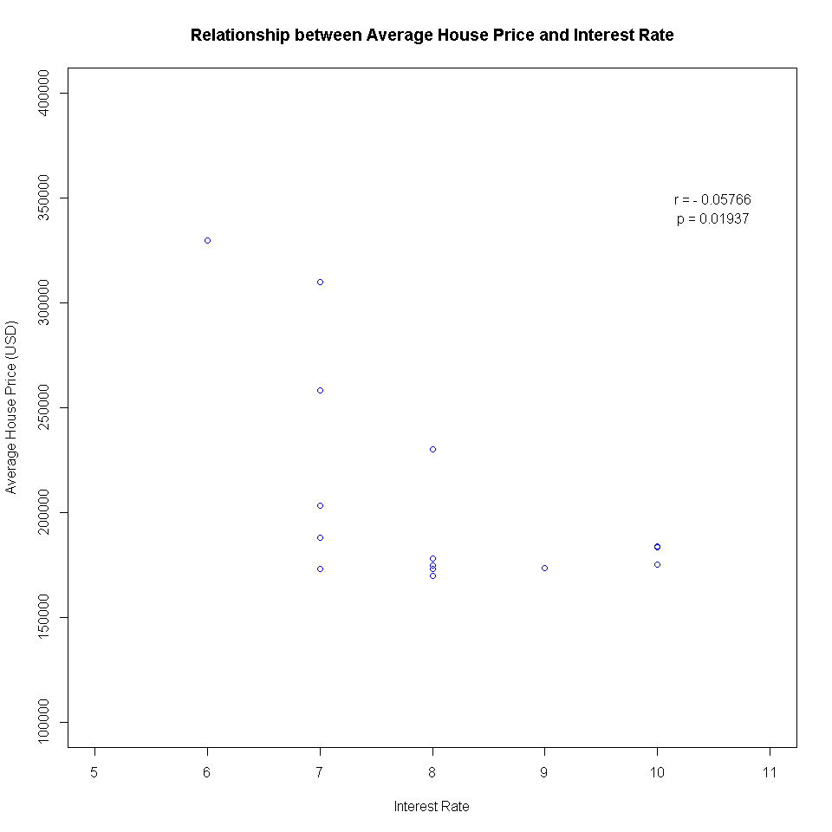

#It is possible that these points are correlated as is shown by graphical representation. A test needs to be performed in order to establish whether there, in fact, is a correlation.   
  
CT <- cor.test(HP3$interest_rate, HP3$median_house_price_USD,  
 method = 'pearson') #There are no leverage points or outliers, thus a Pearson's correlation should be used.  
CT

##   
## Pearson's product-moment correlation  
##   
## data: HP3$interest_rate and HP3$median_house_price_USD  
## t = -2.6409, df = 14, p-value = 0.01937  
## alternative hypothesis: true correlation is not equal to 0  
## 95 percent confidence interval:  
## -0.8339619 -0.1133269  
## sample estimates:  
## cor   
## -0.5766386

#Results of correlation analysis indicate that there is a relatively strong negative correlation. As there is a correlation, a regression analysis can be performed to develop a model that could be involved in possible prediction of further values and interest rates within the data range.   
  
modHP4 <- lm(HP3)  
summary (modHP4)

##   
## Call:  
## lm(formula = HP3)  
##   
## Residuals:  
## Min 1Q Median 3Q Max   
## -1.4316 -0.4467 -0.3285 0.4708 1.7133   
##   
## Coefficients:  
## Estimate Std. Error t value Pr(>|t|)   
## (Intercept) 1.080e+01 1.091e+00 9.900 1.06e-07 ***  
## median_house_price_USD -1.368e-05 5.180e-06 -2.641 0.0194 *   
## ---  
## Signif. codes: 0 '***' 0.001 '**' 0.01 '*' 0.05 '.' 0.1 ' ' 1  
##   
## Residual standard error: 1.024 on 14 degrees of freedom  
## Multiple R-squared: 0.3325, Adjusted R-squared: 0.2848   
## F-statistic: 6.974 on 1 and 14 DF, p-value: 0.01937

#According to the test assumptions residuals need to be normally distributed and homoskedastic. We need to test these assumptions.   
  
#*Test for Normal Distribution*  
  
qqnorm(modHP4$residuals,   
 main = "Data Residuals",  
 pch = 16)  
qqline(modHP4$residuals,   
 col = "red",   
 lty = 3)

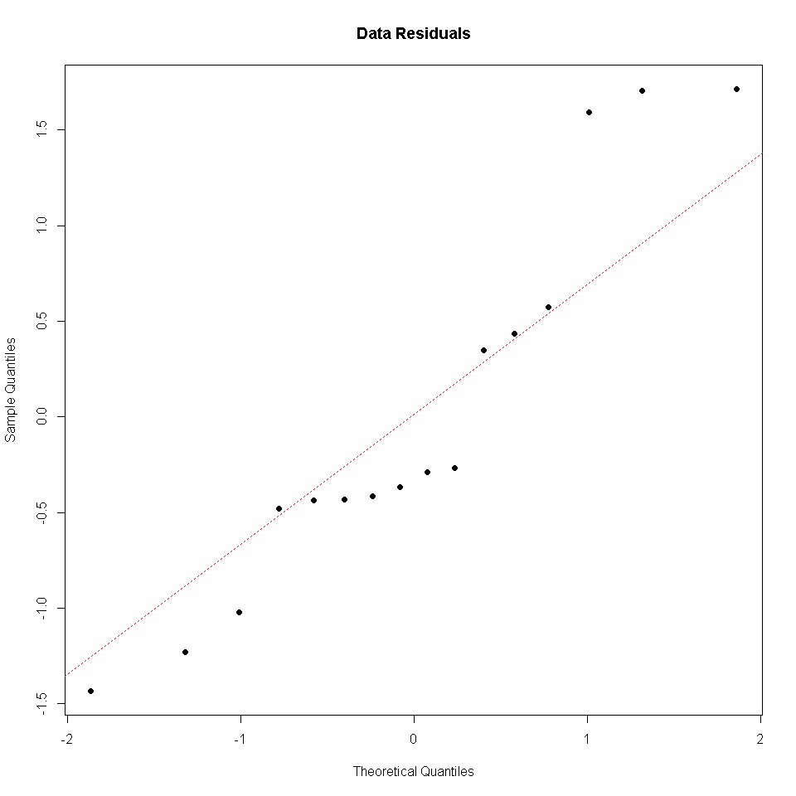

#The data deviates from the normal.  
  
#*Test for Homoskedasticity*  
  
plot(x = modHP4$fitted, y = modHP4$residuals,  
 main = "Standard Deviation Across Measures",  
 xlab = 'Fitted Values',   
 ylab = 'Residual Values',  
 pch = 16)  
abline(h = 0,   
 col = "gray")

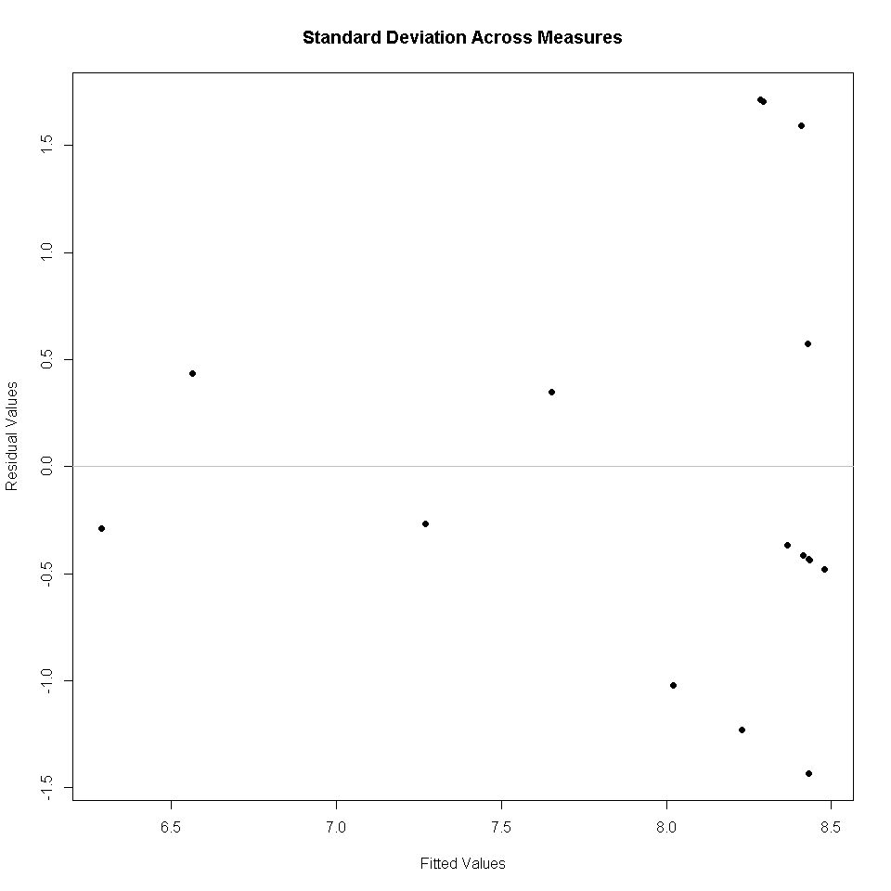

#The plot of standard deviations indicates a conical distribution of deviation, where the gratest deviation is at higher fitted values and a smaller deviation is at lower values.

The results indicate that there is a fairly strong negative correlation between house price and interest rate (r = -0.5766, p = 0.01937). However, a linear regression model fit to this data indicates that the data is heteroskedastic and not drawn from normal populations, as such although a linear regression model does fit the data (p=0.01937), the underlying assumptions for the test are violated and a model should not be fitted.

High interest rates are associated with cheaper homes and vice versa, in this dataset. The predictive value of this data is not beneficial as the data is skewed.