**REPORT OF PROJECT SYSTEM MANAGEMENT**

1. **USE CASE OF THE SYSTEM MANAGEMENT**

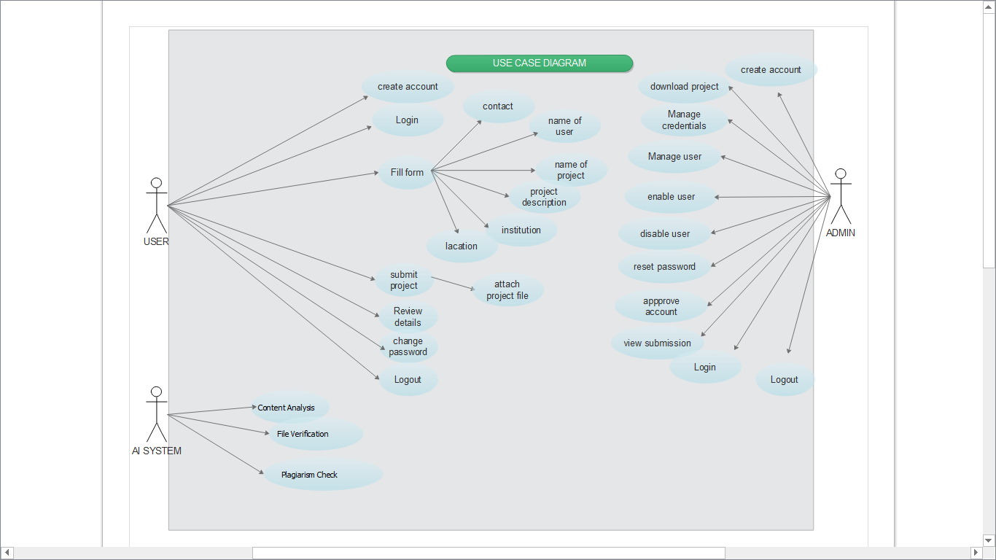

description :

This use case diagram outlines user interactions for account creation, project submission, and system management. Users can log in, fill forms, submit projects, and manage credentials. The system allows file verification, password changes, and logging out. Administrators can enable/disable users, reset passwords, and approve accounts. It also includes features for downloading projects and viewing submissions. The diagram highlights actions like "Plug/let/m Click" and "Context Analysis" for specific functionalities.

1. **FLOW CHART OF THE SYSTEM MANAGEMENT**

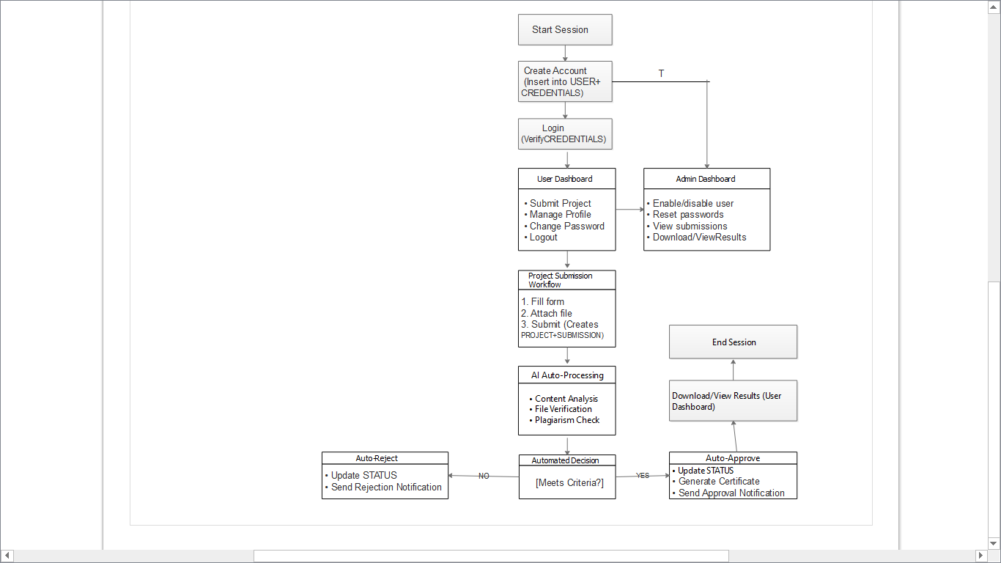

description of This flowchart describes an automated project submission and review system:

1. User actions: Log in, submit projects (fill form + attach file), and manage profiles.

2. AI processing: System checks content, verifies files, and runs plagiarism scans.

3. Auto-decision: Projects are either auto-rejected (status update + rejection notice) or auto-approved (certificate + approval notice) based on criteria.

4. Admin controls: Manage users (enable/disable, reset passwords) and view/download submissions.

5. Outcome: Users access results (approved or rejection details) post-review.

(Flowchart logic: Start → Submit → AI checks → Approve/Reject → Notify → End.)

1. **DATA MODELING DIAGRAM**

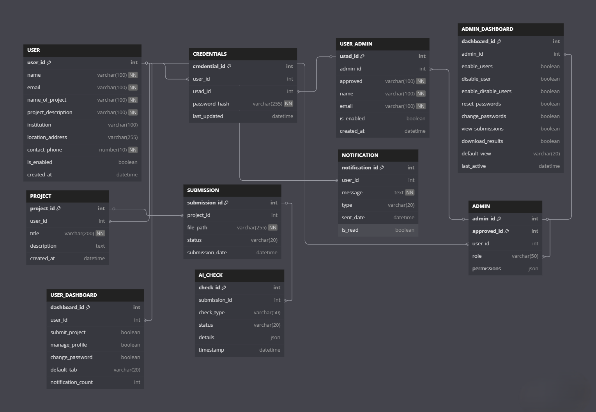

DESCRIPTION:

Here's a concise 5-line description of the data model:

1. The system uses relational tables to connect users, projects, and submissions through foreign keys.

2. Automated validation occurs via AI_CHECK table which stores plagiarism scores and verification results.

3. Role-based access is implemented with ADMIN and USER_DASHBOARD tables controlling permissions.

4. Approval workflows are managed through the SUBMISSION and APPROVED tables with status tracking.