- Data set: annual sales information and number of stores per fast food restaurants in 2018 (data_fastfood_sales.csv) [858b]
data_fastfood_salesCSV File
Download file
Source: Data originally from Hubworks.
The codebook for the data includes 6 variables:
Field name | Description | Data type
`restaurant` | Name of the restaurant | character
`average_sales` | Average US sales per unit (store) in thousands in 2018 | numeric
`us_sales` | U.S. sales in millions in 2018 | numeric
`num_company_stores` | Number of company / corporate-owned stores in 2018 | numeric
`num_franchised_stores` | Number of franchised stores in 2018 | numeric
`unit_count` | Total number of stores (unit counts) in 2018 | numeric

- Data set: nutrition information about entrees from fast food restaurants (data_fastfood_calories.csv) [50Kb]
data_fastfood_caloriesCSV File
Download file
Source: Data originally from the GitHub repository from the Tidy Tuesday project in R4DS online learning community.
The codebook for the data includes 16 variables:
Field name | Description | Data type
`restaurant` | Name of the restaurant | character
`item` | Name of entree item | character
`calories` | Calories | numeric
`cal_fat` | Calories from fat | numeric
`total_fat` | Total fat (g) | numeric
`sat_fat` | Saturated fat (g) | numeric
`trans_fat` | Trans_ fat (g) | numeric
`cholesterol` | Cholesterol (mg) | numeric
`sodium` | Sodium (mg) | numeric
`total_carb` | Total Carbohydrate (g) | numeric
`fiber` | Dietary fiber (g) | numeric
`sugar` | Total sugar (g) | numeric
`protein` | Protein (g) | numeric
`vit_a` | Vitamin A (mcg) | numeric
`vit_c` | Vitamin C (mcg) | numeric
`calcium` | Calcium (mg) | numeric

Review criteria
T​his assignment will be graded by peer review. As part of submitting the assignment, you will be required to upload to Coursera a R Markdown file and a knitted HTML document containing the data visualizations that you will create. You will then review the data visualizations from your peers an determine if they satisfy the criteria listed in the rubric.
Criteria
- Were the R Markdown file and the knitted HTML document uploaded containing the source code and the figures that are produced as the output?
- Does each plot appear correct?
- Does each set of R code appear to create the plot?

Visualizing Data
In this project, we will practice data visualiation skills using the Tidyverse.

Making plots
T​he overall goal is to explore the nutrition of entree items and the sales of fast food restaurants in 2018. Your task is to reconstruct the a set of plots, all of which were constructed using packages in the Tidyverse or packages that integrate with the Tidyverse.
H​ow to submit:
In a single R Markdown file, you should:
- Create five subsections corresponding to the five problem prompts in this Project. There are a total of five Problems.
- U​nder each subsection, write the code to create the plot described in the problem.
When you are with the assignment, you should knit the R Markdown to create a knitted HTML document. In the HTML file, you should show both the code and the plots that you created. These are the files that will be used to evaluate all the problems in this project.
T​he plots that you will create are described and shown in the individual Problem prompts.

Project Title

P​lease upload the R Markdown file containing the source code used for this project.

P​lease upload the knitted HTML file showing both the source code and figures created for this project.

Problem 1
In this problem, re-create this plot:
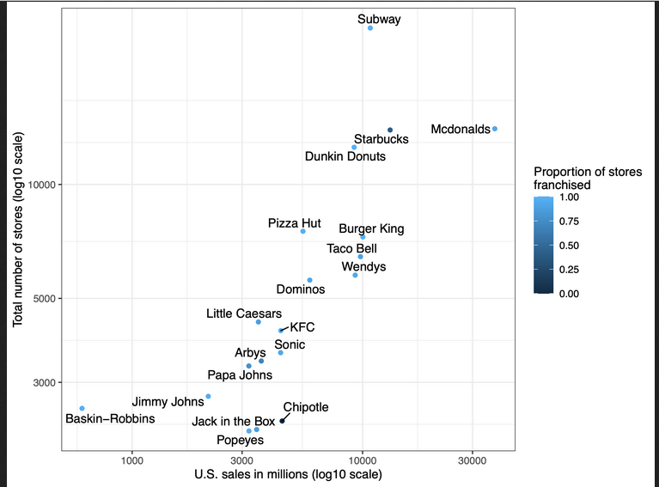
Create a scatter plot with column `us_sales` along the x-axis and the column `unit_count` along the y-axis.
- Each axis should be transformed to a `log10` scale and should be appropriately labeled.
- Color each point by the proportion of franchised stores (i.e. `num_franchised_stores` divided by `unit_count`).
- Label each point with the name of the fast food restaurant using the `ggrepel` package.
- Use the classic dark-on-light ggplot2 theme.
- Rename the legend appropriately.
In the response box below, write the name of the section header in the R Markdown and knitted HTML document that contains the corresponding code and plot for this problem. (Optional: to help the person peer reviewing, you can also write the line numbers from the R Markdown file that contain the code that you wrote).

Problem 2
In this problem, re-create this plot:
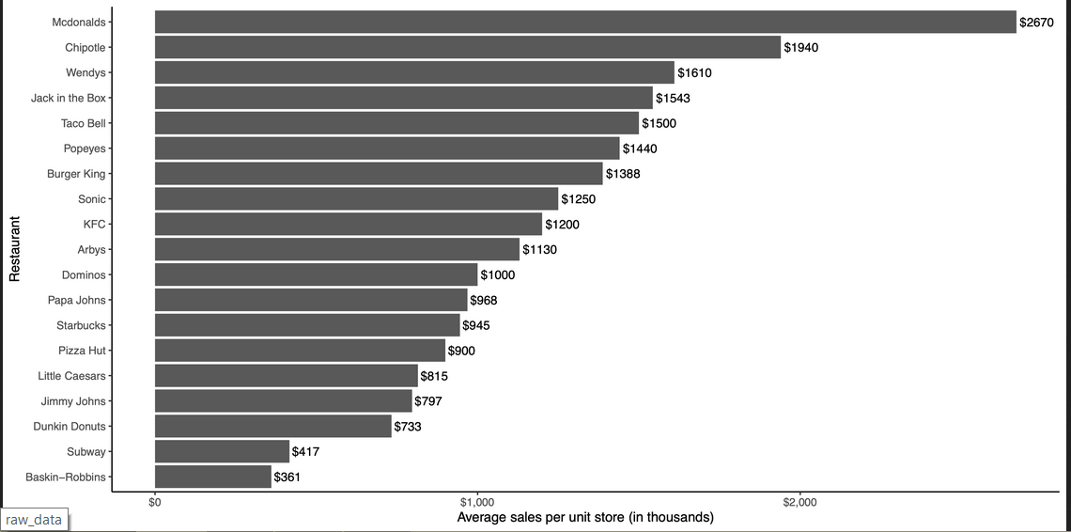
Create a bar plot with the `average_sales` on the x-axis and `restaurant` on the y-axis (Hint: consider using the `coord_flip()` function).
- The order of restaurants on the y-axis should be in decreasing order of average sales with the restaurant with the largest average sales at the top and the restaurant with the smallest average sales at the bottom.
- Add text to each bar on the plot with the average sales (in the thousands) for each restaurant.
- Each axis should be appropriately labeled.
- Along the x-axis, transform the text labels to include a dollar sign in front of each number.
- Use the classic ggplot2 theme.
In the response box below, write the name of the section header in the R Markdown and knitted HTML document that contains the corresponding code and plot for this problem. (Optional: to help the person peer reviewing, you can also write the line numbers from the R Markdown file that contain the code that you wrote).

Problem 3
In this problem, re-create this plot:
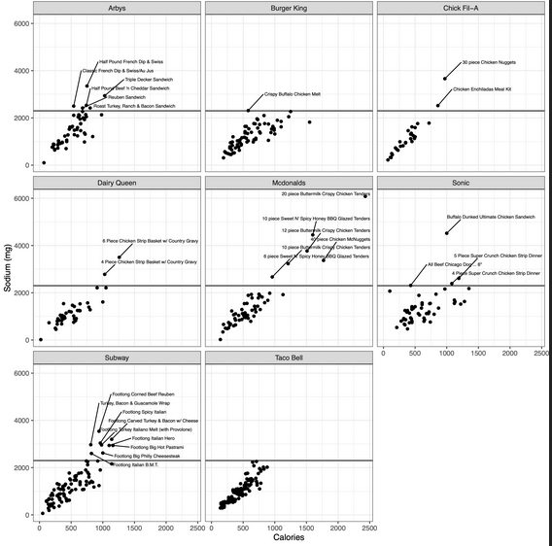
The Centers for Disease Control and Prevention in the US recommend that individuals consume less than 2,300 milligrams (mg) of sodium per day as part of a healthy eating pattern. In this problem, we will explore the relationship between calories and sodium for different entrees and we will label entree items with more sodium than 2300 mg.

Create a scatter plot with the column `calories` along the x-axis and the column `sodium` along the y-axis.
- Each restaurant should have its own scatter plot (Hint: consider the facet functions).
- Add a horizontal line at y=2300 in each scatter plot.
- Each axis of the scatter plot should have an appropriately labeled x-axis and y-axis.
- For all food items with a sodium level of greater than 2300 (mg) (the maximum daily intake from the Centers for Disease Control), add a text label each point with the name of the entree food item using the `ggrepel` package.
- Use the classic dark-on-light ggplot2 theme.
- Rename the legend.
In the response box below, write the name of the section header in the R Markdown . . . . .

Problem 4
In this problem, re-create this plot:
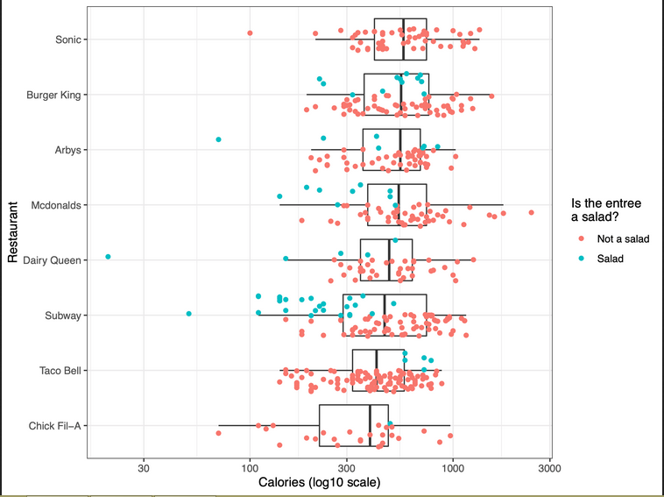
Create a new column titled `is_salad` that contains a `TRUE` or `FALSE` value of whether or not the name of entree food item contains the character string "salad" in it.
- Create boxplots with `calories` on the x-axis and `restaurant` on the y-axis.
- The order of restaurants on the y-axis should be in decreasing order of calories with the restaurant with the median calories at the top and the restaurant with the smallest median calories at the bottom.
- Hide any outliers in the boxplots.
- On top of the boxplots add a set of jittered points representing each food item.
- Each point should be colored based on whether it is an item with the word "salad" in it or not.
- Each axis should be appropriately labeled, the legend should be appropriately labeled, and the x-axis should be transformed to a log10 scale.
- Use the classic dark-on-light ggplot2 theme.
In the response box below, write the name of the section header in the R Markdown and knitted HTML document that contains the corresponding code and plot for this problem. (Optional: to help the person peer reviewing, you can also write the line numbers from the R Markdown file that contain the code that you wrote).

Problem 5
In this problem, re-create this plot:
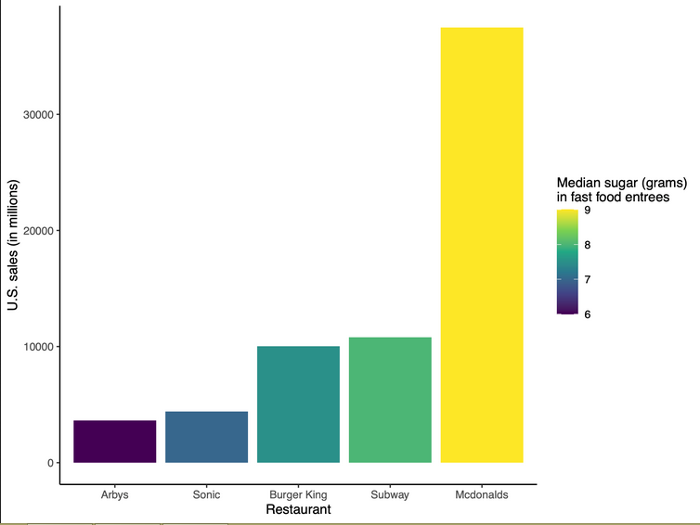
Using the data_fastfood_calories.csv, remove rows that contain the Taco Bell restaurant
- For each restaurant calculate the median amount of sugar in each entree item.
- Using this summarized dataset, combine this summarized dataset with the data_fastfood_sales.csv dataset. The combined dataset should only include restaurants that are included in both datasets.
- Using this new dataset, create a bar plot with `restaurant` on the x-axis and on the `us_sales` y-axis.
- The order of restaurants on the x-axis should be in increasing order of US sales with the restaurant with the largest average sales on the right and the restaurant with the smallest US sales on the left.
- Color the bars by the median amount of sugar in the entree items from that restaurant.
- Each axis should be appropriately labeled.
- Use the classic ggplot2 theme.
In the response box below, write the name of the section header in the R Markdown and knitted HTML document that contains the corresponding code and plot for . . . .

