Non-stationary absorption in a packed bed

A packed bed is filled with perfectly spherical particles with a uniform diameter of d_{p} = 0.005 m. In this bed a polluted gas stream is cleaned by absorbing the pollutant to the particles. The particles possess a finite loading capacity for the pollution. The equilibrium constant for the absorption is given by:

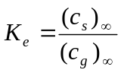

with (c_{g})∞ and (c_{s})∞ the equilibrium concentrations for the gas phase and the particulate phase respectively and K_{e} the equilibrium constant for the absorption. Initially an inert gas flows through the bed, which is filled with unloaded particles. At time t = 0 the inert gas stream is replaced with the polluted gas. A qualitative sketch of the propagation of the gas-phase profile is given in the following figure:

u_{g} c₀
z = L

z

z = 0
1

c_{g}
c₀

0
z = 0z z = L

Additional information:

Bed length L | 1.0 m
Linear gas velocity u_{g} | 0.02 m/s
Bed porosity ε | 0.5 (-)
Concentration c₀ of pollution in the incoming gas stream | 1.0 kmol/m³
Mass transfer coefficient k_{g} of the gas phase to the particles | 0.01 m/s
Equilibrium constant K_{e} | 100 (-)
5
The non-stationary absorption in the packed bed can be described with the following two species balances for the gas-phase and the particulate phase respectively:

Species balance for the gas-phase:

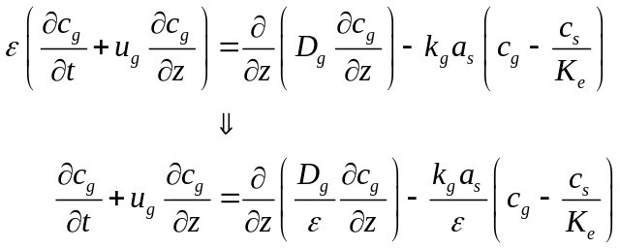

with D_{g} the effective axial dispersion coefficient in the gas phase.

Species balance for the particulate phase:

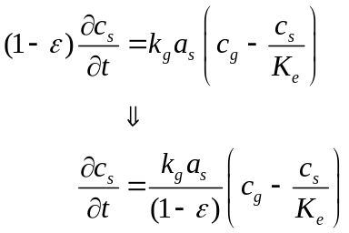

The boundary conditions for this problem are:

Initial condition:

t = 0: c_{g} = 0 c_{s} = 0

Boundary conditions:

x = 0: 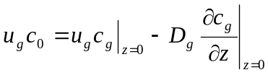

x = L: 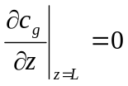

Questions:

- Assume no dispersion in the gas phase and no mass transfer of the pollutant to the particulate phase. In this limit situation the species balance for the gas phase reduces to the following hyperbolic partial differential equation without a source term:

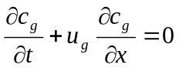

The analytical solution of this equation for the current problem is:

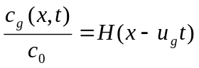

with:
H(y) = 1 y ≤ 0
H(y) = 0 y > 0

Solve the described hyperbolic partial differential equation (PDE) with the programs given below. Use an equidistant grid in both the spatial (number of grid cells np = 100) and the temporal (number of time steps nw = 100) co-ordinate. Use a maximum time t_{max} = 25 s in your calculations.
Hint 1: an equidistant grid means that all grid cells have the same size, both in space and time. Hence, the transformation function is a simple, linear function (use the functions PLA and PAA in the code).
Hint 2: do not forget to check the implementation of α, β and γ in the functions ALPHA, BETA and GAMMA respectively (see documentation of the Pascal programs).

  - FIX-A.PAS
This program solves the PDE with the use of a first order upwind discretization scheme for the convective term:

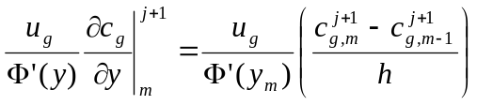

  - FIX-B.PAS
This program solves the PDE with the use of a second order upwind discretization scheme for the convective term:

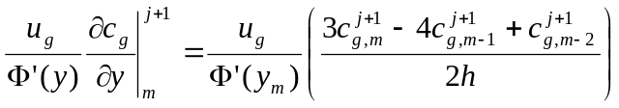

  - FIX-C.PAS
This program solves the PDE with the use of a third order upwind discretization scheme for the convective term:

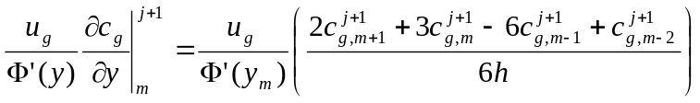

Compare the calculated concentration profiles in the gas-phase obtained under a. b. and c. with the analytical solution. In what respect do the results differ from one another?

- Solve the model equations for the limit situation that mass transfer to the particulate phase takes place, but that there is no axial dispersion in the gas-phase. Use three programs described under question 1. Use an equidistant grid in both the spatial (number of grid cells np = 100) and the temporal (number of time steps nw = 100) co-ordinate. Use a maximum time t_{max} = 2500 s in your calculations. Compare the calculated concentrations of both phases at a height of x = 0.50 m (i.e. halfway the packed bed). Compare the results of the three models with each other. Also compare the results with the values obtained from the following analytical solutions for dimensionless concentration profiles in both phases:

gas-phase:

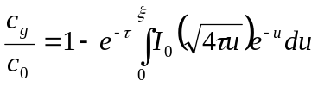

particulate-phase:

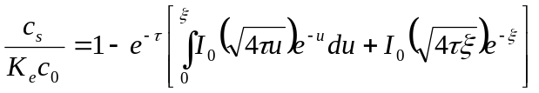

with: 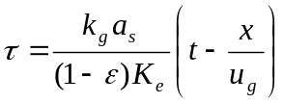

and: 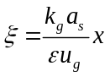

In the given analytical solution I₀ is the modified Bessel function of the first kind and zero order, for which the following series is valid:

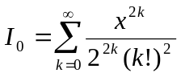
The analytical solution for the dimensionless concentration profiles for both phases is given in the following two figures.

Gas-phase:
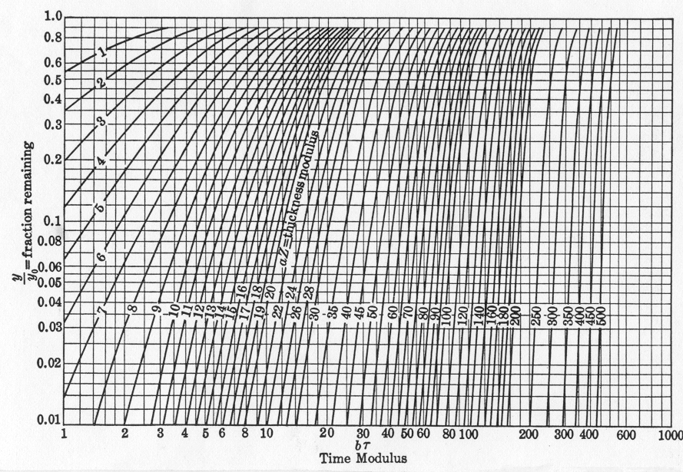
Remark: the quantities y/y₀ (“fraction remaining”), bτ (“time modulus”) and aZ (“thickness modulus”) in this figure correspond to c_{g}/c₀, τ and ξ respectively.
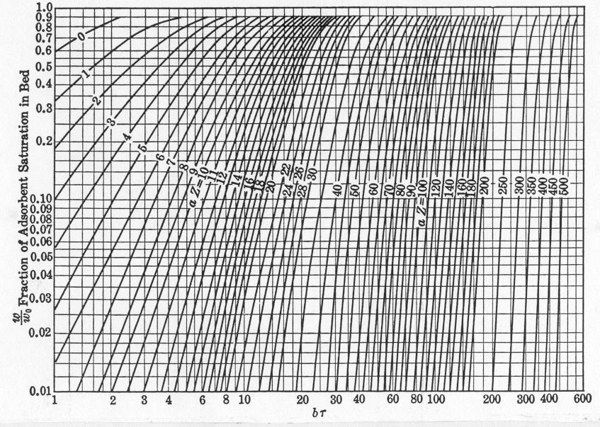
Particulate phase:
Remark: the quantities w/w₀ (“fraction of adsorbent saturation in bed”), bτ (“time modulus”) and aZ (“thickness modulus”) in this figure correspond to c_{s}/(K_{e}c₀), τ and ξ respectively.

- Repeat the calculations of question 2 for the situation that axial dispersion is present in the gas-phase (axial dispersion coefficient D_{g} = 5.10⁻⁴ m²/s).
Answers:

 |  | Analytical solution
a. | FIX-A.PAS: c_{g}(x = 0.40 m, t = 25 s) = 0.933 | 1.000
 | FIX-A.PAS: c_{g}(x = 0.50 m, t = 25 s) = 0.500 | 1.000
 | FIX-A.PAS: c_{g}(x = 0.60 m, t = 25 s) = 0.088 | 0.000
b. | FIX-B.PAS: c_{g}(x = 0.40 m, t = 25 s) = 0.999 | 1.000
 | FIX-B.PAS: c_{g}(x = 0.50 m, t = 25 s) = 0.610 | 1.000
 | FIX-B.PAS: c_{g}(x = 0.60 m, t = 25 s) = 0.000 | 0.000
c. | FIX-C.PAS: c_{g}(x = 0.40 m, t = 25 s) = 0.989 | 1.000
 | FIX-C.PAS: c_{g}(x = 0.50 m, t = 25 s) = 0.388 | 1.000
 | FIX-C.PAS: c_{g}(x = 0.60 m, t = 25 s) = 0.000 | 0.000

Results in graphical form:

sum

- Input file FIX-A.INP, FIX-B.INP and FIX-C.INP corresponding programs:

100 | 1E-8 | 1 | 2500
0.50 | 600 | 1E-2 | 100
0.0 | 1E-2 | 1E-2
1.0 | 0.0 | 0.0
1.0 | 0.0 | 0.0
1.0 | 0.0 | 0.0

Analytical solution for x = 0.50 m:
gas-phase: c_{g} = 0.50 particulate phase: c_{s} = 50.0
Results FIX-A.PAS:
gas-phase: c_{g} = 0.480 particulate phase: c_{s} = 47.2
Results FIX-B.PAS:
gas-phase: c_{g} = 0.497 particulate phase: c_{s} = 48.3
Results FIX-C.PAS:
gas-phase: c_{g} = 0.425 particulate phase: c_{s} = 41.1
- Results FIX-A.PAS:
gas-phase: c_{g} = 0.575 particulate phase: c_{s} = 57.2
Results FIX-B.PAS:
gas-phase: c_{g} = 0.571 particulate phase: c_{s} = 56.8
Results FIX-C.PAS:
gas-phase: c_{g} = 0.571 particulate phase: c_{s} = 56.8

