ReviewLens: A Case Study in Designing an Aspect-Based Product Review Analyzer with Evidence-Grounded Summaries
P. Gireesh Vardhan  Dept. of Computer Science and Engineering  Amrita School of Computing, Amrita Vishwa Vidyapeetham  Coimbatore, India  cb.sc.u4cse24220@cb.students.amrita.edu | CM. Bhanu Teja Reddy  Dept. of Computer Science and Engineering  Amrita School of Computing, Amrita Vishwa Vidyapeetham  Coimbatore, India  cb.sc.u4cse24617@cb.students.amrita.edu
K. Tarun Kumar  Dept. of Computer Science and Engineering  Amrita School of Computing, Amrita Vishwa Vidyapeetham  Coimbatore, India  cb.sc.u4cse24630@cb.students.amrita.edu | T. Senthil Kumar  Dept. of Computer Science and Engineering  Amrita School of Computing, Amrita Vishwa Vidyapeetham  Coimbatore, India

Abstract—A three-star laptop review often holds two opposite opinions: the display is loved and the battery is not. Star ratings and document-level sentiment scores average these opinions away, and a popular product can collect thousands of reviews in a week, which no buyer or product team can read. Existing tools count keywords, need a developer to run them, or write summaries that may mention features nobody wrote about. This case study describes the design of ReviewLens, a pipeline that takes raw English product reviews, tags the product aspects in each sentence with a DeBERTa-v3 sequence labeller, classifies the sentiment toward each aspect as positive, negative or neutral, combines the results across reviews into a smoothed score per aspect, and writes a pros-and-cons summary only from those scores and from quoted review sentences. A code-level check discards any summary that names an aspect that was not extracted or cites a sentence that was not supplied, and aspects with too few mentions are reported as “not enough evidence”. We present the problem, related tools, requirements, the dataset (SemEval-2016 Task 5, Laptop and Restaurant tracks), the architecture and its four stages, the grounding design, a five-question evaluation plan, the dashboard, and a readiness assessment at Technology Readiness Level 2. The dataset is prepared and the dashboard interface is built; the extraction, classification and summary stages are still in development, so no results are reported. We also record the design decisions that narrowed the scope and argue that they make the system easier to check.
Index Terms—aspect-based sentiment analysis, DeBERTa-v3, explainability, hallucination, product reviews, retrieval-augmented generation, SemEval-2016.

I. INTRODUCTION
A reviewer gives a laptop three stars. The text says the display is excellent, the keyboard is fine, and the battery is empty by lunchtime. Another reviewer also gives three stars because the fan is loud and nothing else bothers them. The two ratings look the same and the complaints do not. A buyer who cares about battery life needs the first fact, a buyer who works in a library needs the second, and neither can get it from an average.
Review volume makes this worse. One popular product can collect thousands of reviews a week, and the same sentence often carries several opinions, such as “the software is intuitive, but the hardware feels cheap”. Reading them all is not possible for a shopper, and auditing them by hand is too slow for the small manufacturers and retailers who have no market-research team. Aspect-based sentiment analysis (ABSA) addresses this by attaching a sentiment to each product feature instead of to the whole text [1], [2]. Pre-trained encoders such as DeBERTa-v3 [3] have made the extraction and classification steps accurate enough to build on. The step that is still unreliable is the last one: when a language model is asked to summarise the results, it can write fluently about features that no reviewer mentioned.
ReviewLens is a design for an analyzer that tries to avoid that failure. Reviews go in as text. Aspects, sentiments and per-aspect scores come out of models and counting. A language model is used only at the end, and only to word what the earlier stages have already established, with a code check on its output. Every line on the dashboard can be traced to the review sentences behind it.
This document is a design case study. Its contributions are:
- a requirements analysis for a review analyzer that must explain itself to non-technical users (Section III);
- an architecture in which extraction, scoring, retrieval and generation are separate stages, with abstention and a template fallback as normal outcomes (Sections V–VII);
- an evaluation plan that maps five research questions to test subsets of SemEval-2016 and reports every metric per domain (Section IX);
- an honest readiness assessment, together with a record of the design decisions that limited the scope (Sections X–XI).
II. RELATED SYSTEMS AND LITERATURE
Table I compares ReviewLens with the tools and models closest to it.
TABLE I
COMPARISON WITH RELATED SYSTEMS
System | What it does | What ReviewLens takes or changes
Amazon Review Insights | Frequent terms such as “battery life” as clickable filters; Amazon only. | Scores each mention as positive, negative or neutral instead of counting words; not tied to one store.
Yelp aspect trends | Trends for fixed categories (service, ambiance) from hand-written rules. | Learns aspects from data, so a new feature needs no new rule.
MonkeyLearn | No-code text analysis; extraction and sentiment are separate models; paid tier. | One encoder for both steps, plus aggregation and a grounded summary.
PyABSA [7] | Open-source ABSA models; no interface, no aggregation, no report. | Similar models, wrapped with aggregation, evidence and a dashboard.
BERT-based ABSA models [6], [11] | Strong SemEval results, but they stop at labels for single sentences. | Uses DeBERTa-v3 [3] and adds everything after the labels.

Five findings from the literature shaped the design:
- Sentiment belongs to a target, not a sentence. Surveys of ABSA define the task as finding aspect terms or categories and the opinion expressed about each one [4]. A sentence-level label cannot represent “great performance but awful screen”.
- Attention helps tie an opinion word to its target. Letting the classifier attend to the aspect improved aspect-level sentiment classification over models that ignored it [5], which is why the sentiment stage here is aspect-aware.
- Pre-trained transformers lead on SemEval-style data. Fine-tuning BERT with an auxiliary sentence [6] and post-training it on review text [11] both improved aspect results. DeBERTa changes how position and content are attended to [10] and its third version changes the pre-training objective [3]. We expect, but have not yet shown, that these gains carry over to this task.
- Generators invent details. Surveys of hallucination in text generation describe unsupported content as a common failure of fluent models [9]. Retrieval-augmented generation [8] supplies evidence to the model, but it does not stop the model from ignoring that evidence, so the output still has to be checked.
- Tools that stop at labels leave the user to do the rest. Most published ABSA systems end with tags on single sentences, and the commercial tools in Table I end with keyword counts. None of them produce a per-product score with the evidence next to it.
The model stack builds on DeBERTa-v3 [3], [10] for tagging and classification and on retrieval-augmented generation [8] for the summary.
III. REQUIREMENTS AND SCOPE
A. Users
There are two kinds of users. Shoppers are non-technical, want a pros-and-cons view in seconds, and will not read more than a few sentences. Product and quality teams at small manufacturers or retailers want to see which aspects of their product score worst and need to read the original complaints behind each score.
B. Hard constraints
- Every statement in a summary must be traceable to review sentences that the dashboard can show.
- A summary never names an aspect that the extractor did not find in the reviews of that product.
- Aspect scores come from counted, labelled mentions. The language model does not compute or adjust them.
- An aspect with too few mentions is not summarised; the dashboard says the evidence is thin.
- Every metric is reported per domain, never as a single pooled number.
- Only a public annotated benchmark is used for training and evaluation, and no reviewer identity is stored.
C. First-release scope
The first release reads English reviews from a file that the user uploads. It works at sentence level and covers two domains, laptops and restaurants. It extracts explicit aspect terms, and it also predicts an aspect category for each sentence so that implicit mentions such as “it costs an arm and a leg” are not lost. It outputs per-aspect scores, a pros-and-cons summary and an evidence view on a dashboard. Live scraping of marketplaces, languages other than English, other product domains, image or video reviews, fake-review detection, sarcasm handling and comparisons between two products are all out of scope.
IV. DATASET
ReviewLens uses the SemEval-2016 Task 5 aspect-based sentiment benchmark [2], limited to the Laptop and Restaurant tracks. The corpus contains customer-review sentences annotated by trained annotators. For each sentence it records the target term where one is written in the text (for example “screen” or “i5 processor”), a coarse aspect category such as LAPTOP#PRICE, and a polarity label for every target–category pair. This annotation at the level of a target is what lets a model learn which opinion belongs to which feature.
Four properties of the data drive the design. First, aspect terms are many and varied, so the tagger has to learn patterns and cannot memorise a list of nouns. Second, many sentences carry opposite opinions about different targets, so the dataset is converted into one record per target, and one sentence can contribute a positive and a negative record. Third, some opinions have no target term in the text, and these are only recoverable through the category label. Fourth, the text is web writing, with typos, irregular punctuation and slang, which is one reason for using a pre-trained tokenizer. Table II shows three entries.
TABLE II
SAMPLE DATASET ENTRIES
Sentence | Target | Category | Label
“The battery life lasts up to 9 hours consistently.” | battery life | BATTERY#​OPERATION | Positive
“The aluminum casing looks premium, but it scratches far too easily.” | aluminum casing | HARDWARE#​DESIGN | Positive and negative
“This machine is way too expensive for what it offers.” | machine | LAPTOP#​PRICE | Negative

We keep the official train and test split of each track and hold out a development set from the training portion. The test portion is not used for any tuning. Exact split sizes will be reported once preprocessing is final.
V. SYSTEM ARCHITECTURE
Fig. 1 shows the data flow.
A. Pipeline
- Ingest. Reviews are loaded from a CSV or JSON file. Each review receives an id and is split into sentences, each with its own id (for example s-0381). Near-identical sentences from the same product are dropped.
- Clean. HTML entities and stray whitespace are fixed. Case and punctuation are kept, because the encoder is case-sensitive and punctuation helps separate clauses.
- Extract aspects. A DeBERTa-v3 token classifier marks aspect-term spans with BIO tags. A second, sentence-level head predicts aspect categories so that implicit aspects are still recorded.
- Classify sentiment. For each sentence–aspect pair, an attention-based classifier outputs positive, negative or neutral with a confidence. Predictions below a confidence threshold θ are counted separately and left out of the scores.
- Aggregate. Mentions are grouped under a canonical aspect and turned into a smoothed score and a mention count (Section VI-C).
- Select evidence. For each aspect, the most confident sentences of each polarity are chosen as quotable evidence.
- Generate and check. The language model writes the pros-and-cons summary from the scores and the chosen sentences. Code then verifies the output (Section VI-D). If it fails, a template summary built from the scores alone is shown instead.
- Present. The dashboard shows score bars, the summary, and the source sentence behind every citation.
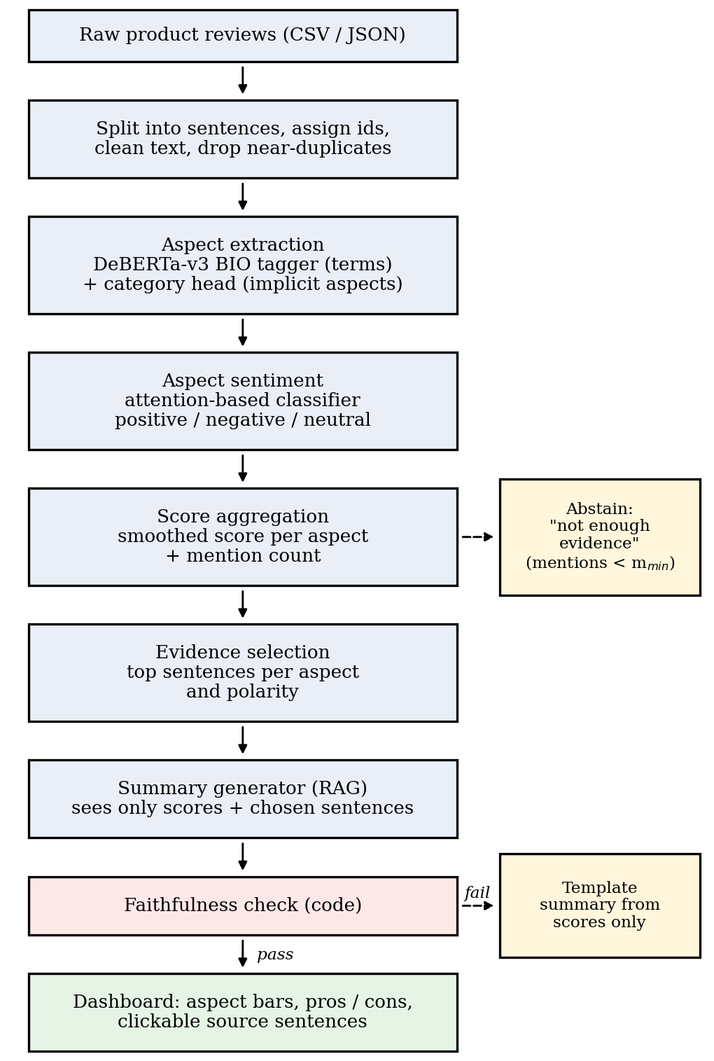
Fig. 1. ReviewLens pipeline. Aspects with too few mentions are reported as low evidence, and a summary that fails the code check is replaced by a template built from the scores.
B. Components
Table III lists the planned components. Choices that are not yet fixed are marked as such, so that the table does not claim more than the project has decided.
TABLE III
TECHNOLOGY CHOICES
Part | Choice | Reason
Encoder | DeBERTa-v3 | Strong pre-trained encoder for tagging and classification [3]; small enough to fine-tune on benchmark-sized data
Aspect tagger | Token classifier, BIO tags | Finds aspect terms as spans, including multi-word terms
Category head | Sentence-level multi-label layer | Recovers implicit aspects that have no term
Sentiment | Attention-based, aspect-aware classifier | Ties the opinion to its target [5]
Data | SemEval-2016 Task 5 [2] | Target-level gold labels; reproducible
Summariser | Instruction-tuned LLM (to be selected) | Wording only; sees no raw reviews
Evidence store | Sentence index keyed by aspect and polarity (to be selected) | Fast lookup of quotable sentences
Interface | Web dashboard | Needs no install; readable by non-technical users

VI. THE FOUR STAGES
Each stage has one job, takes a fixed input and produces a fixed output. A later stage never rewrites the output of an earlier one.
A. Aspect extraction
The tagger treats each sentence as a sequence of sub-word tokens and labels every token as the beginning of an aspect term, inside one, or outside. Using sub-word pieces lets it handle misspellings and product names it has not seen. The category head works on the whole sentence and is trained on the category labels, which cover the cases where the opinion has no explicit target. The main risk is a tagger that finds nouns but not features, for example labelling “weekend” in “I used it all weekend”. The evaluation reports span-level F1 so that this kind of error is counted.
B. Aspect sentiment classification
Sentiment is predicted for a pair, the sentence plus one aspect. The aspect representation is pooled from the tokens of its span and used as a query over the sentence, so the classifier weights the words that sit around the target. This is the mechanism meant to separate “great performance” from “awful screen” in the same sentence. Sentences with opposite opinions about the same aspect are rare in the benchmark and are handled by keeping both records.
C. Score aggregation
Let p_{a}, n_{a} and u_{a} be the counts of positive, negative and neutral mentions of aspect a in one product’s reviews. The score is
s_{a} = (p_{a} − n_{a}) / (p_{a} + n_{a} + u_{a} + κ) (1)
where κ is a smoothing constant. Without it, an aspect with two mentions, both positive, would score 1.0 and rank above an aspect with 400 mentions of which 90% are positive. With an illustrative κ = 5, the first scores 2/7 ≈ 0.29 and the second, with 360 positive, 20 negative and 20 neutral mentions, scores 340/405 ≈ 0.84. The mention count m_{a} = p_{a} + n_{a} + u_{a} is always shown next to the score, and an aspect with m_{a} below a minimum m_{min} is displayed as low evidence. Both κ and m_{min} are set on the development data, by choosing values for which the aspect ranking computed from a random 20% of the reviews agrees with the ranking from all of them (Spearman correlation).
Aspect strings are grouped before counting. Terms that share a category label are merged first, then remaining terms are merged by lemma and a string-similarity threshold, so that “battery”, “battery life” and “batteries” count together.
D. Grounded summary
- The generator input is the list of aspects with their scores and counts, and for each of the top aspects up to two supporting sentences per polarity, each with its id.
- The prompt asks for at most one pro and one con per aspect, each ending with the id of a supplied sentence, and forbids outside knowledge about the product.
- Code checks three things: every cited id was supplied; every aspect named in the text belongs to the supplied list; and a line written as a pro cites a sentence labelled positive, and a con one labelled negative.
- If a check fails, the generator is retried once at a lower temperature. If it fails again, the template summary is used, for example “Battery life: mostly negative (198 mentions)”.
- The ids are replaced by the quoted sentences in the interface.
VII. GROUNDING AND TRUST DESIGN
The model is not asked to be trustworthy. Trust comes from several separate layers around it.
Scores come from counting. The language model never produces a number. A reader who disagrees with a score can inspect the counted mentions that produced it.
Evidence is attached to every claim. Each pro or con links to a sentence, and each sentence is shown with its aspect, its label and the classifier’s confidence.
Thin evidence is not summarised. An aspect with few mentions is shown as low evidence. A short, confident sentence about nine mentions of fan noise would be more misleading than saying nothing.
The generator is checked in code. The checks in Section VI-D turn a hallucination into a fallback and not into a wrong statement on screen.
Known weakness. The checks catch invented aspects and bad citations, but not a wrong label. If the classifier calls a sentence positive when it is negative, the summary will repeat the mistake. This is why the interface shows the confidence, why low-confidence predictions are excluded, and why the classifier is evaluated on its own (Section IX).
Privacy. Reviewer names and profile details are not stored. Training and evaluation use only the public benchmark.
VIII. USER INTERFACE
Fig. 2 shows the dashboard. A product selector sits at the top, a bar chart of aspect scores with mention counts takes the middle, and the grounded pros and cons sit below it. Selecting a citation opens the original sentence with the aspect term, the predicted label and the confidence. Aspects with low evidence are drawn with a dashed bar so they are not mistaken for a neutral score. The interface was built by one team member and is not yet connected to model output.
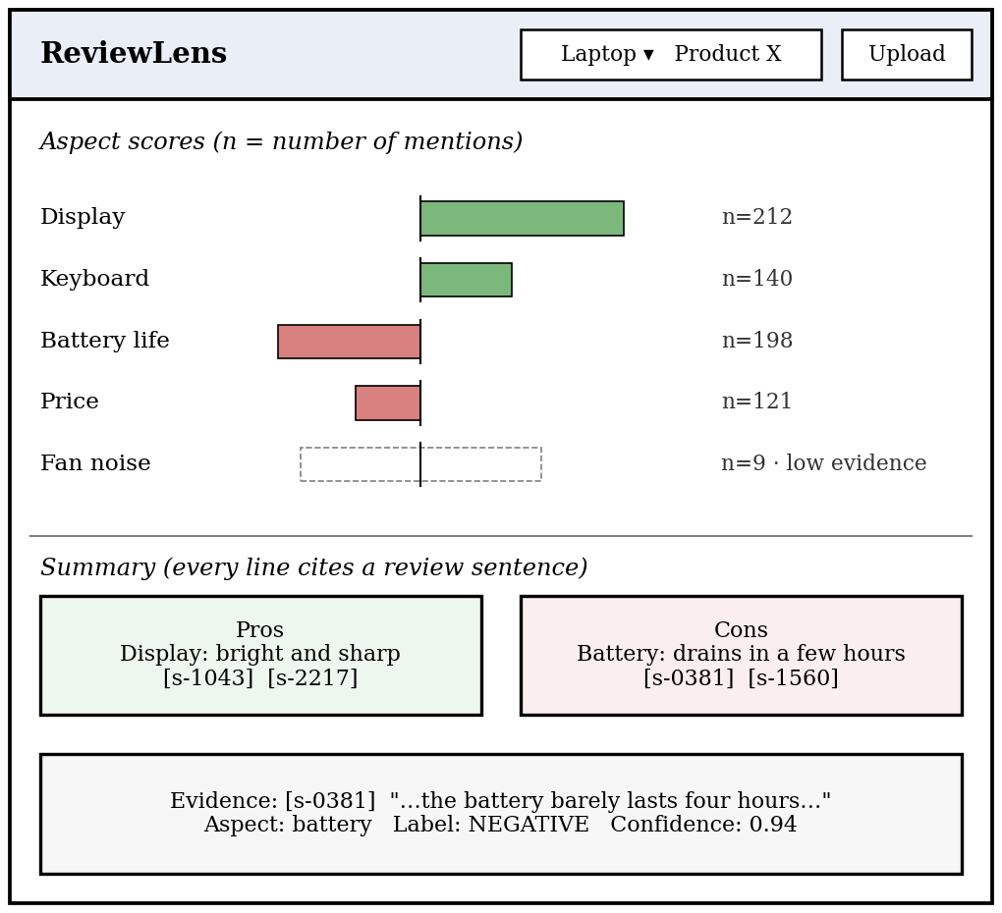
Fig. 2. Dashboard wireframe. Values and sentence ids are illustrative.
IX. EVALUATION PLAN
An evaluation script will run every test subset against the pipeline and write one CSV per subset, so that each table can be regenerated with one command. Table IV maps the research questions to test sets. No results are reported here, because the models have not been trained yet.
TABLE IV
RESEARCH QUESTIONS AND EVALUATION SETS (ALL METRICS REPORTED PER DOMAIN)
Question | Test set | Metrics
RQ1 Does the tagger attach each opinion to the right aspect in multi-aspect sentences? | SemEval test sentences; subset with two or more targets of opposite polarity | Span-level F1 for aspect terms; polarity accuracy and macro-F1, on the full set and on the subset
RQ2 Are implicit aspects recovered? | Test sentences with a category label but no target term | Category F1; share of implicit mentions recovered
RQ3 Are aggregated scores stable and unbiased? | Bootstrap samples of test sentences grouped by category; gold labels as reference | Mean absolute error of predicted vs. gold score; Spearman correlation of rankings from subsamples; effect of κ
RQ4 Are summaries grounded? | Summaries for 20 groups of review sentences per domain, with an unconstrained LLM summary as comparison | Unsupported-claim rate (two raters); unsupported-aspect rate (automatic); citation validity; fallback rate
RQ5 Is the pipeline fast enough for large review sets? | Full test sets, timed on stated hardware | Sentences per second; macro-F1 against latency for each baseline

Baselines are a rule-based lexicon tagger with a sentiment lexicon, a fine-tuned BERT-base model, and a zero-shot LLM. The DeBERTa-v3 pipeline earns its place only if it beats the lexicon baseline clearly and is at least competitive with the other two at lower cost per sentence. If it does not, that result will be reported. For RQ4, two team members rate each summary line as supported or unsupported independently, disagreements are settled by discussion, and the agreement rate (Cohen’s kappa) is reported alongside the results.
X. IMPLEMENTATION STATUS AND TECHNOLOGY READINESS
A. What is done
- The SemEval-2016 Task 5 data for the Laptop and Restaurant tracks has been sourced, its annotations reviewed, and the text preprocessed.
- The approach for aspect extraction, aspect-aware sentiment classification and grounded summarisation has been defined (Sections V–VII).
- The dashboard interface, including the aspect-level pros-and-cons view, has been designed and built.
The fine-tuned tagger and classifier, the aggregation code, the evidence index, the summary generator with its checks, and the evaluation scripts are specified in this document but not yet implemented. The dashboard is not yet connected to model output.
B. TRL assessment
We assess ReviewLens at TRL 2 (technology concept and application formulated). The parts it depends on, a pre-trained encoder, an annotated benchmark and a hosted language model, already exist. The contribution of this project is their combination: aspect-aware scoring, retrieval of evidence, and a checked summary. That combination exists as a design and a prepared dataset. TRL 3 requires the tagger and classifier to run on the held-out SemEval test sets with reported numbers. TRL 4 requires every stage to be connected and evaluated on the subsets in Table IV. TRL 5 would require a supervised trial with real reviews of a product that a business actually sells, which the collaborating computer retailer could provide.
XI. DESIGN DECISIONS AND LESSONS LEARNED
Table V lists the main decisions that limited the scope and the reason for each. Every one of them removed something that the team could not yet check.
TABLE V
DESIGN DECISIONS
Decision | Choice | Reason
Data | SemEval-2016 Task 5 only | It has gold labels for targets and polarity. Reviews collected from stores have no such labels and bring terms-of-use problems.
Language | English only | The dataset and encoder are English; each new language needs its own labelled evaluation set.
Domains | Laptop and Restaurant | One product domain and one service domain show whether the method transfers; each extra domain needs its own evaluation.
Extraction model | Fine-tuned DeBERTa-v3, not a prompted LLM | Labelled data exists for fine-tuning, and a small model is cheaper per review when there are thousands of them. A zero-shot LLM is kept as a baseline.
Scores | Computed by counting | Reproducible and open to inspection; the LLM cannot shift a number.
Summary input | Scores and chosen sentences only | The generator never sees the full reviews or outside knowledge about the product.
Thin evidence | Abstain | A confident sentence built on a handful of mentions misleads more than a gap does.
Output | Dashboard only | An API or browser extension would each need its own testing.

Three lessons stand out so far. First, scope is a control: each language, domain or feature the system claims needs its own evaluation, and a claim without one is a liability. Second, labelled data matters more than volume: reviews are plentiful, but reviews with target-level labels are rare, and the benchmark decided most of the other choices. Third, the generator is the last component to trust: scores, evidence and checks are built from counts and code, and the language model is used only for wording.
XII. SDG ALIGNMENT
The project maps to two of the United Nations Sustainable Development Goals [12]. For SDG 9 (industry, innovation and infrastructure), it gives small manufacturers and retailers, who cannot pay for market research, an open way to turn unstructured customer text into structured feedback on specific product features. For SDG 12 (responsible consumption and production), it lets a buyer check whether a product’s known weakness matters to them before ordering. Fewer mismatched purchases mean fewer returns and less premature disposal of devices, and manufacturers who know that feature-level complaints are visible have a reason to fix them. We have not measured either effect; these are the outcomes the design aims at.
XIII. LIMITATIONS AND FUTURE WORK
The first release has not been tested on real marketplace reviews, so it cannot show real-world benefit. SemEval-2016 data is a decade old and covers two domains, so the models may need adaptation for new product types and newer vocabulary. The pipeline reads English only and works one sentence at a time, which means it misses opinions that depend on the previous sentence. Sarcasm, comparisons between two products, and fake or paid reviews are not handled, and every reviewer counts equally in the scores. Classification errors flow into the summary, and the checks of Section VI-D cannot catch them. Raters for RQ4 are two team members, which limits how far the human results can be generalised.
Planned future work includes a trial with reviews of products sold by the collaborating retailer, additional product domains with their own labelled sets, handling of comparative sentences, review-level weighting such as helpfulness votes, and a multilingual extension once evaluation sets exist.
XIV. CONCLUSION
ReviewLens shows how a student team can design a review analyzer around what it can verify. It scores aspects by counting labelled mentions, shows the evidence behind every line, declines to summarise when mentions are few, and treats the language model as a writer whose output has to pass checks. The system is at TRL 2, with the dataset prepared and the interface built. The evaluation plan states what has to be demonstrated before the next level.
TEAM CONTRIBUTIONS
P. Gireesh Vardhan: NLP concept and modelling, including the DeBERTa-v3 extraction and classification approach, the attention-based alignment strategy and the RAG summary design. CM. Bhanu Teja Reddy: dataset, including sourcing SemEval-2016, annotation review and preprocessing of the Laptop and Restaurant tracks. K. Tarun Kumar: user interface and the aspect-level pros-and-cons dashboard.
ACKNOWLEDGMENT
This work was carried out for the course 23CSE471 Natural Language Processing at Amrita Vishwa Vidyapeetham, Coimbatore, under the guidance of Dr. T. Senthil Kumar. The project’s collaborator is Sarvanam, a local computer retail and sales shop.
TABLE VI
TEAM MEMBERS AND CONTRIBUTIONS
Roll No | Name | Contribution (technical)
CB.SC.U4CSE24220 | P. Gireesh Vardhan | NLP concept and modelling: DeBERTa-v3 extraction and classification, attention-based alignment, RAG summary design.
CB.SC.U4CSE24617 | CM. Bhanu Teja Reddy | Dataset: SemEval-2016 sourcing, annotation review, preprocessing (Laptop, Restaurant).
CB.SC.U4CSE24630 | K. Tarun Kumar | UI and aspect-level pros-and-cons dashboard.

REFERENCES
[1] M. Hu and B. Liu, “Mining and summarizing customer reviews,” in Proc. 10th ACM SIGKDD Int. Conf. Knowl. Discovery Data Mining, 2004, pp. 168–177.
[2] M. Pontiki et al., “SemEval-2016 Task 5: Aspect based sentiment analysis,” in Proc. 10th Int. Workshop Semantic Evaluation (SemEval-2016), San Diego, CA, USA, 2016, pp. 19–30.
[3] P. He, J. Gao, and W. Chen, “DeBERTaV3: Improving DeBERTa using ELECTRA-style pre-training with gradient-disentangled embedding sharing,” in Proc. ICLR, 2023.
[4] W. Zhang, X. Li, Y. Deng, L. Bing, and W. Lam, “A survey on aspect-based sentiment analysis: Tasks, methods, and challenges,” IEEE Trans. Knowl. Data Eng., vol. 35, no. 11, pp. 11019–11038, 2023.
[5] Y. Wang, M. Huang, X. Zhu, and L. Zhao, “Attention-based LSTM for aspect-level sentiment classification,” in Proc. EMNLP, 2016, pp. 606–615.
[6] C. Sun, L. Huang, and X. Qiu, “Utilizing BERT for aspect-based sentiment analysis via constructing auxiliary sentence,” in Proc. NAACL-HLT, 2019, pp. 380–385.
[7] H. Yang and K. Li, “PyABSA: A modularized framework for reproducible aspect-based sentiment analysis,” in Proc. CIKM, 2023, pp. 5117–5122.
[8] P. Lewis et al., “Retrieval-augmented generation for knowledge-intensive NLP tasks,” in Proc. NeurIPS, 2020, pp. 9459–9474.
[9] Z. Ji et al., “Survey of hallucination in natural language generation,” ACM Comput. Surv., vol. 55, no. 12, Art. 248, 2023.
[10] P. He, X. Liu, J. Gao, and W. Chen, “DeBERTa: Decoding-enhanced BERT with disentangled attention,” in Proc. ICLR, 2021.
[11] H. Xu, B. Liu, L. Shu, and P. S. Yu, “BERT post-training for review reading comprehension and aspect-based sentiment analysis,” in Proc. NAACL-HLT, 2019, pp. 2324–2335.
[12] United Nations, “Transforming our world: The 2030 Agenda for Sustainable Development,” A/RES/70/1, 2015.
[13] P. G. Vardhan, C. B. T. Reddy, and K. Tarun Kumar, “ReviewLens: AI-powered aspect-based product review analyzer,” GitHub repository, 2026. [Online]. Available: https://github.com/Gireesh-Vardhan/ReviewLens

